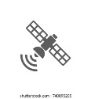

Spatiotemporal Phase

*In-Situ* Automated *IoT* Phase

GEE L8 OLI + MODIS_Aqua

Start

Raw Data Acquisition



Raw Img. Collections

cccclkmlmlmlmlcmllCcmkclmCollectiooinson

Client PC

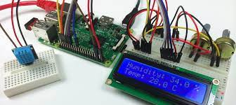 Secure Connection via

**security shell (ssh)**

Study Area Delineation

Raster pre-processing

- Radiometric corrections

- Surface Reflectance­­­ BOA



Image Filtering

Upload *in-situ* data to microcontroller

NO

Above Surface Temp

Lake Surface Temp.

Spatio-temporal Image Fusion

In-Situ Data **>** Temp. Threshold

Image Analysis

Chl-a & Cyanotoxins Detected



Initiate an alert text SMS

