React Basics

Practice in react. Estimated Time: 3 days

2019

1.    React Introduction

The main goal of this task is to obtain basic knowledge of React framework: [https://reactjs.org](https://reactjs.org/). Please follow the instruction below in order to perform this task.

The result of this work should be the following:

Create weather widget using React.

Information should be retrieved using API:

<https://api.openweathermap.org/data/2.5/weather?q=Minsk&appid=a94d0a5ac08570add4b47b8da933f247>  - Weather for 1 day

<https://api.openweathermap.org/data/2.5/forecast?q=Minsk&appid=a94d0a5ac08570add4b47b8da933f247>  - Weather for 5 days

For request you will have to put your account key for appid parameter in query. After registration on <https://openweathermap.org/> you will be able to find your key.

1) create-react-app - template for writing React application.

 npx create-react-app lesson - create a folder lessonN, and put a boilerplate there.

2) It’s better to do Stateful only Weather App (the main class with a [class constructor](https://developer.mozilla.org/en/docs/Web/JavaScript/Reference/Classes#Constructor) that assigns the   initial this.state), the rest - usual simple functional components(Stateless).

3) Date conversion should be implemented with help of  <https://momentjs.com/docs/>  library.

4) fetch should be used for communication with server ( <https://github.github.io/fetch/>)

 Example:   
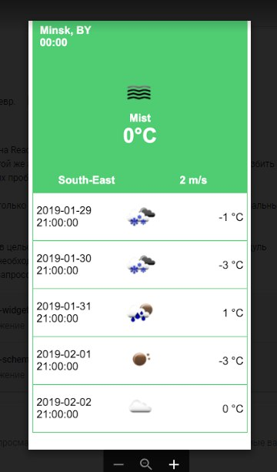

2. Notes with Chuck Norris Jokes API

*divide the application into components:*

*main App (“add”, “remove all” buttons and “input” – implement searching by words, all notes shouldn’t be deleted)

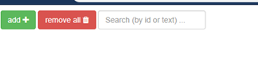

* Note (edit and delete buttons, content)

* Render other notes (use map method)

* Helpers (random color function - each new note should be painted with a random color)

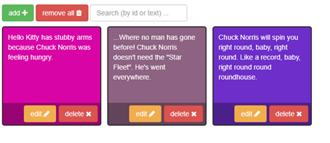

Editing the text of the note in the prompt

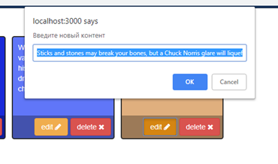

1) Use this API for the initial content of the notes:

GET <https://api.chucknorris.io/jokes/random>

Documentation link :  <https://api.chucknorris.io/>

2) Use axios instead of fetch for queries (<https://www.npmjs.com/package/axios> , <https://alligator.io/react/axios-react/>).

3) Make sure that the notes don’t disappear when the page is updated (use localStorage)