<https://epam-my.sharepoint.com/:w:/p/oleg_zheleznov/EQP_dS5IkaRNtWoc6CbcRuwB_Bav7oFWYKk3MMmjHvlA_g?rtime=pKDoAhFD10g>

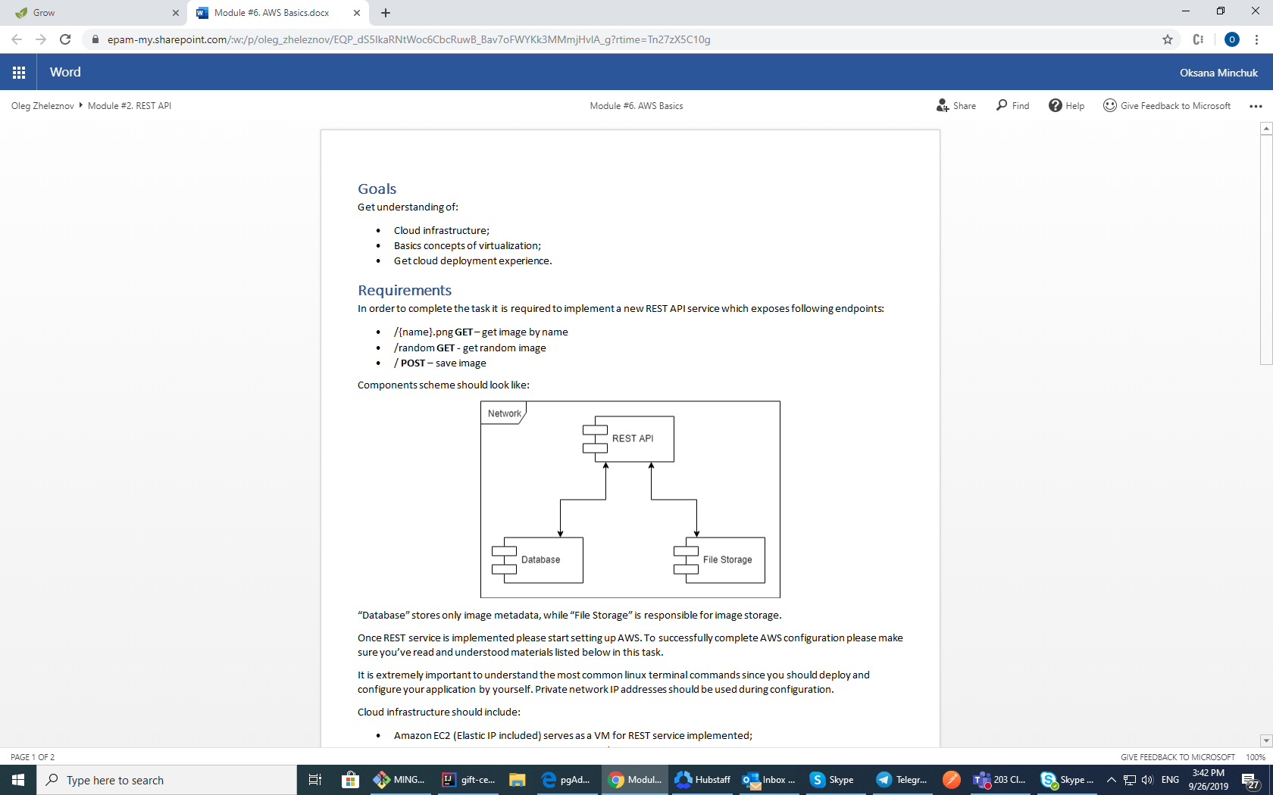

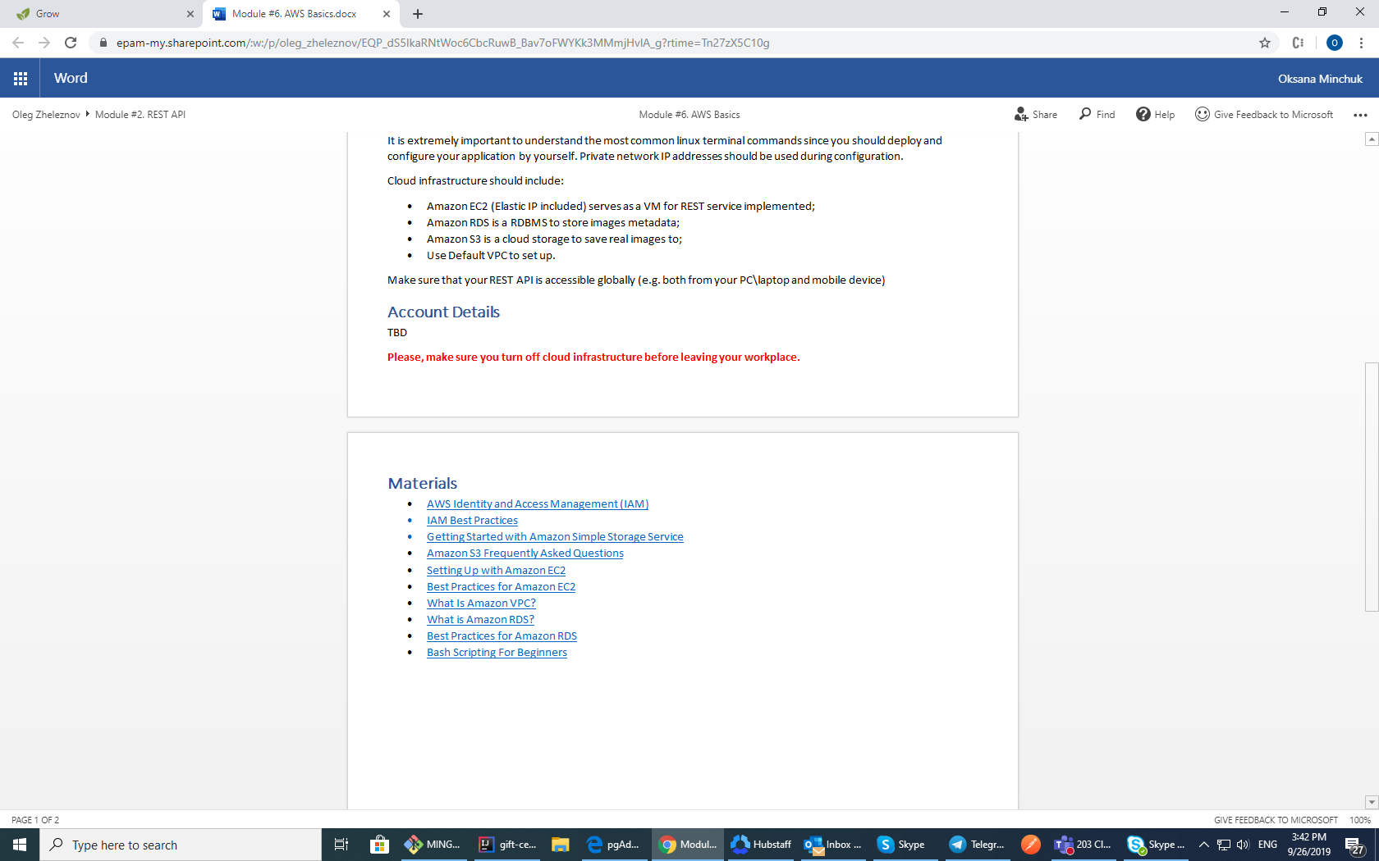

<https://aws.amazon.com/iam/>

<https://docs.aws.amazon.com/IAM/latest/UserGuide/best-practices.html>

<https://docs.aws.amazon.com/AmazonS3/latest/gsg/GetStartedWithS3.html>

<https://aws.amazon.com/s3/faqs/>

<https://docs.aws.amazon.com/AWSEC2/latest/UserGuide/get-set-up-for-amazon-ec2.html>

<https://docs.aws.amazon.com/AWSEC2/latest/UserGuide/ec2-best-practices.html>

<https://docs.aws.amazon.com/vpc/latest/userguide/what-is-amazon-vpc.html>

<https://aws.amazon.com/rds/?nc1=h_ls>

<https://docs.aws.amazon.com/en_us/AmazonRDS/latest/UserGuide/CHAP_BestPractices.html>

<https://linuxconfig.org/bash-scripting-tutorial-for-beginners>

<https://habr.com/ru/post/62362/>

<https://habr.com/ru/post/435180/>

<https://aws.amazon.com/ru/free/?all-free-tier.sort-by=item.additionalFields.SortRank&all-free-tier.sort-order=asc>

<https://aws.amazon.com/blogs/developer/aws-toolkit-for-intellij-now-generally-available/>

docker :

<https://runnable.com/docker/install-docker-on-windows-10>

<https://docs.docker.com/docker-for-windows/>

metadata:

<https://docs.aws.amazon.com/AmazonS3/latest/dev/UsingMetadata.html#object-metadata>

<https://docs.aws.amazon.com/AmazonS3/latest/user-guide/add-object-metadata.html>

<https://docs.aws.amazon.com/AmazonS3/latest/user-guide/view-object-properties.html>

tables

<https://aws.amazon.com/blogs/big-data/how-to-access-and-analyze-on-premises-data-stores-using-aws-glue/>

dot in url

<https://medium.com/@saishav_io/error-406-while-using-and-email-address-as-a-path-variable-in-spring-boot-8caaefc17c7b>

<https://www.baeldung.com/spring-mvc-pathvariable-dot>

linux

<https://putty.org.ru/articles/unix-linux-ref.html>

<https://sysadmins.co.za/aws-java-sdk-detect-if-s3-object-exists-using-doesobjectexist/>