CLRC663 8.41

High Performance NFC reader solution

# Description

* Read/write mode supporting ISO/IEC 14443A/MIFARE
* Read/write mode supporting ISO/IEC 14443B
* Read/write mode supporting ISO/IEC 18000-3 mode 3/ EPC Class-1 HF
* Serial Peripheral Interface (SPI)
* 3V to 5V power Supply
* Up to 8 free programmable input/output pins

# Power

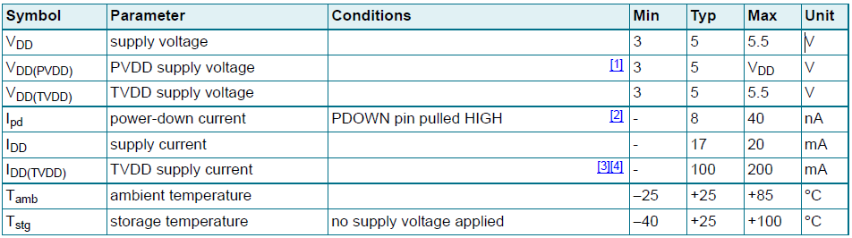

# Block Diagram

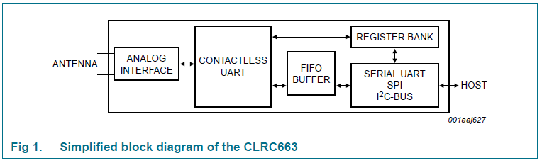

# Pin Layout

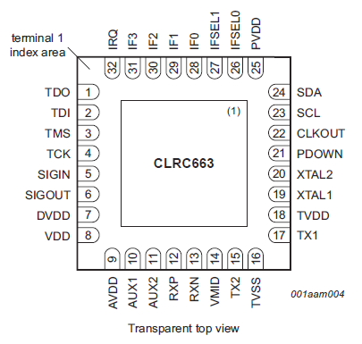

# Interrupt Controller

* Two 8-bit interrupt registers IRQ0 and IRQ1 are implemented
  + Accompanied by two 8-bit interrupt enable registers IRQ0En and IRQ1En

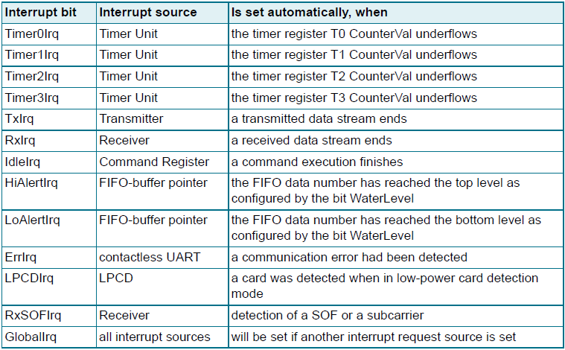

# Timers

## Periodical trigger

If the bit T(x)Control. T(x)AutoRestart is set and the interrupt is activated, an interrupt request will be indicated periodically after every elapsed timer period.

# Communication

## Read Data

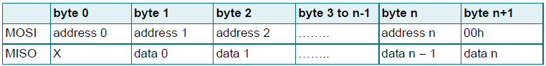

## Write Data

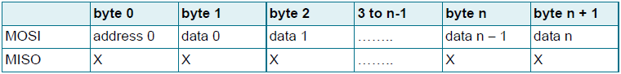

## Address Byte

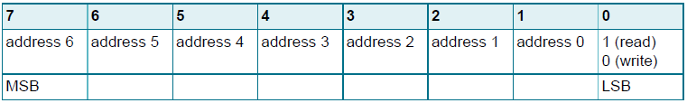

# Clock Generation

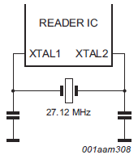

# Crystal Requirements Recommendations

# Interrupts

## IRQ0 Register

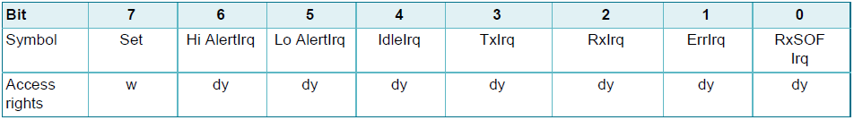

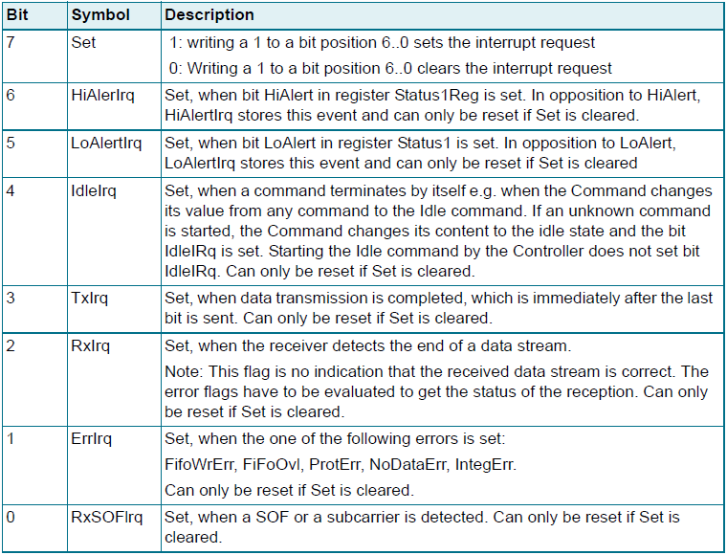

## IRQ1

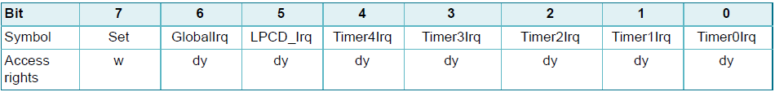

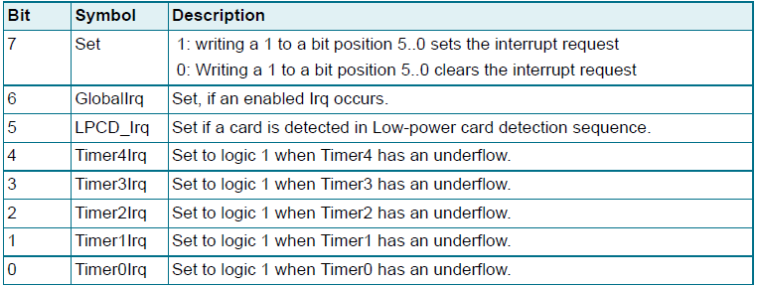

## IRQ0EN

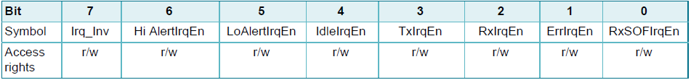  
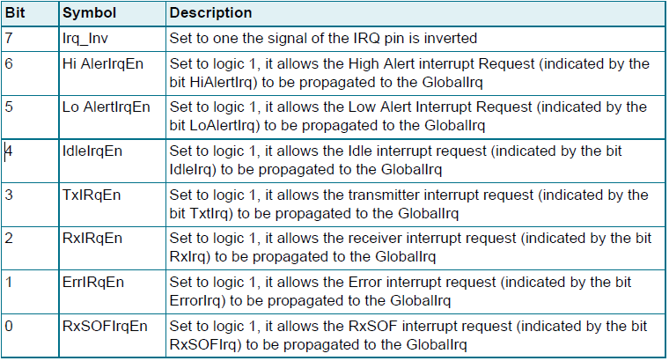

## IRQ1EN

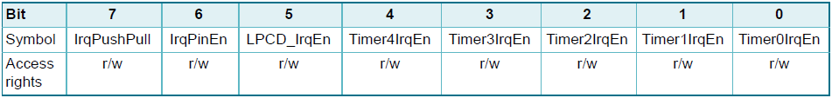

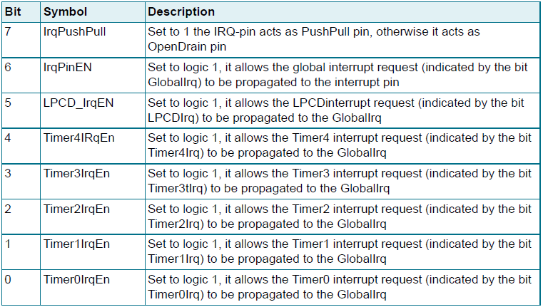

# Timer Registers

## TOControl

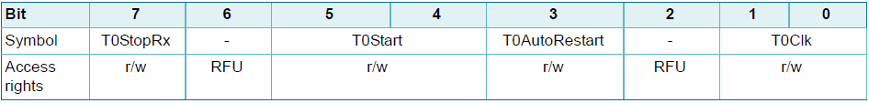

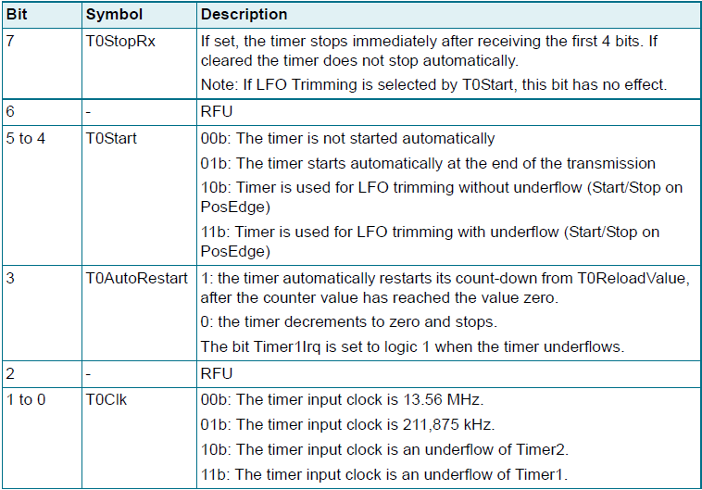

## TOReloadHi

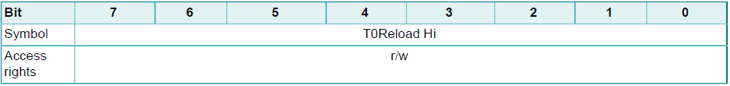

### TOReloadLo

