LIS302DL 3.33

MEMS motion sensor

# Description

* 2.16V to 3.6V supply voltage
* +- 2g/+-8g dynamically selectable full-scale
* I2C/SPI digital output interface
* Programmable multiple interrupt generator
* Click and double click recognition
* Embedded high pass filter
* 10000g high shock survivability
* Measuring rates of 100Hz to 400Hz
* Land Grid Array Package

# Block Diagram

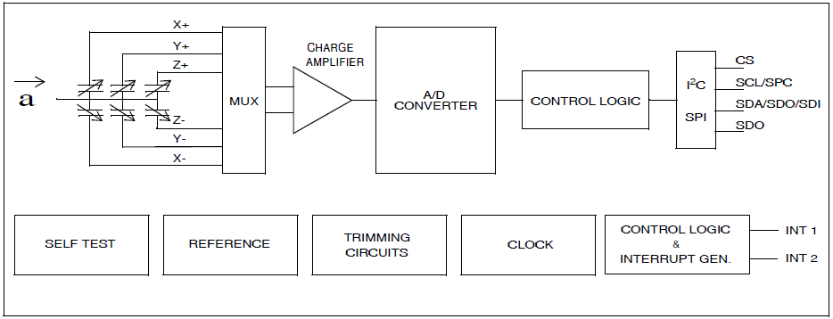

# Pin Connection

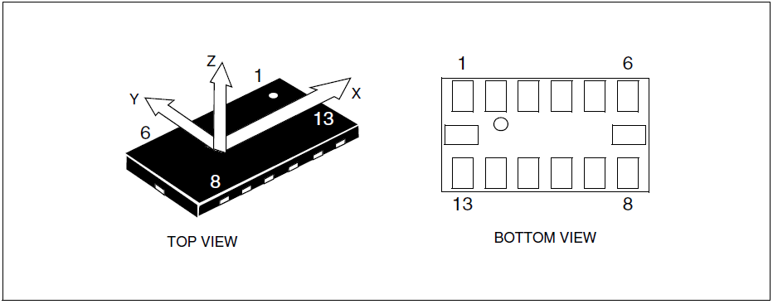

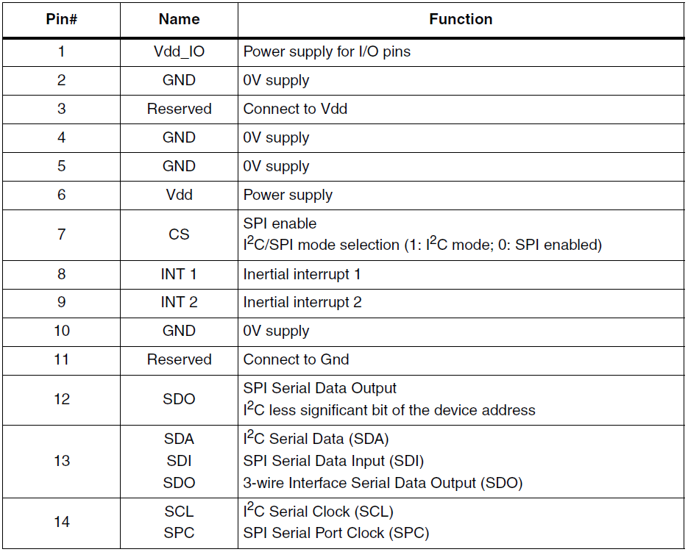

Mechanical Characteristics

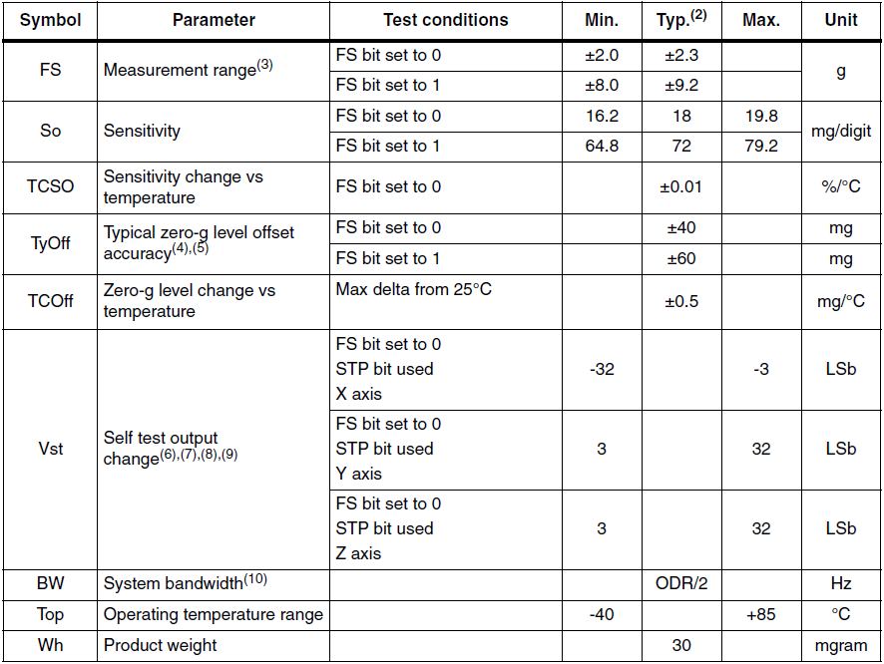

# Electrical Characteristics

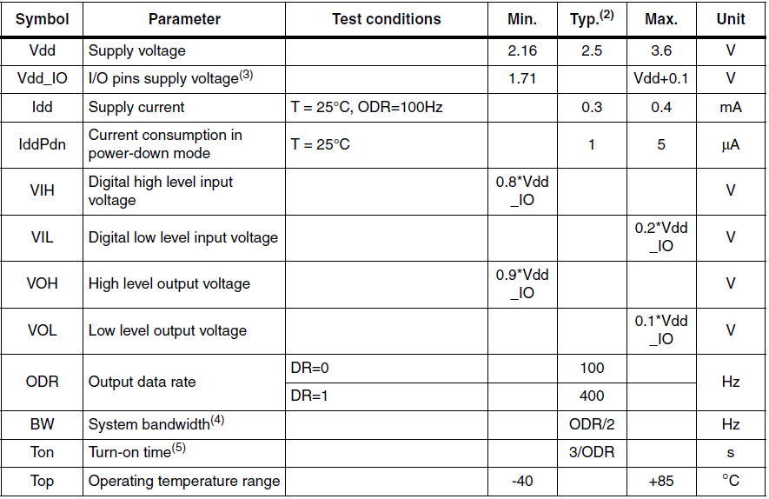

# Schematic

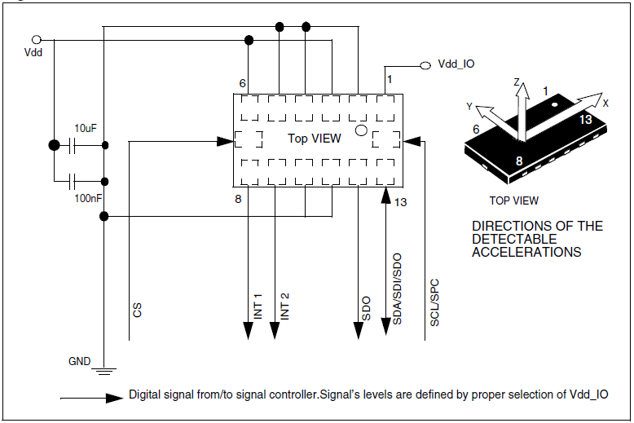

# Interrupts

## CLICK_THSY_X

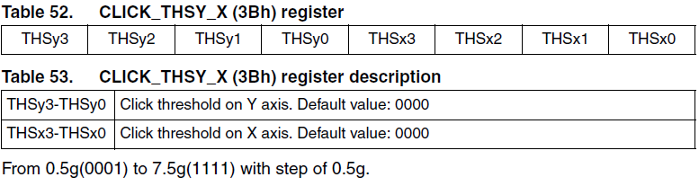

## CLICK_THSY_Z

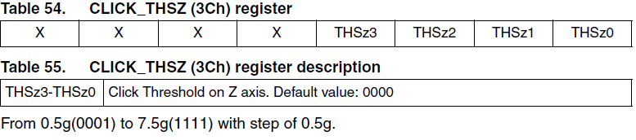

## CLICK_SRC



