MMA8451Q 1.82

3-Axis, Digital Accelerometer

# Description

* 1.95V to 3.6V
* Output Data Rates 1.56Hz to 800Hz
* I2C digital output interface
* Embedded Channels of motion detection
  + Frefall or motion detection
  + Pulse Detection
  + Jolt Detection
* High pass Filter
* 6uA to 165uA current consumption

# Block Diagram

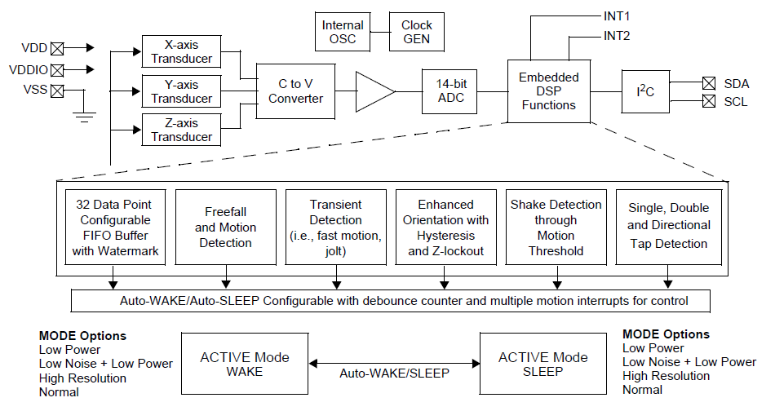

# Pin Connection

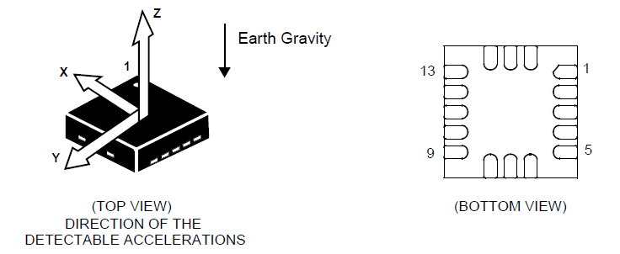 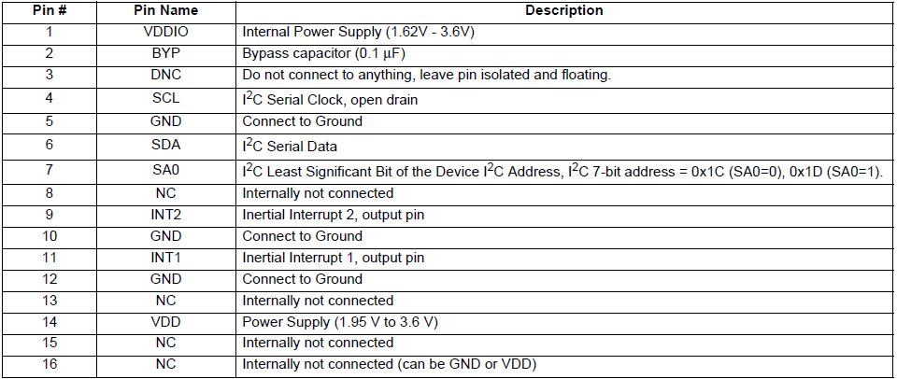

Mechanical Characteristics

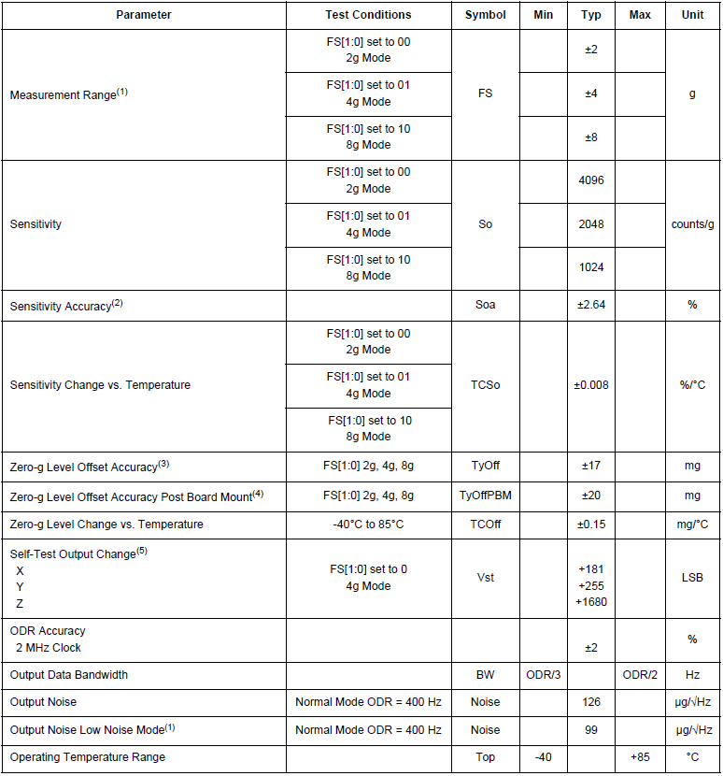

Electrical Characteristics

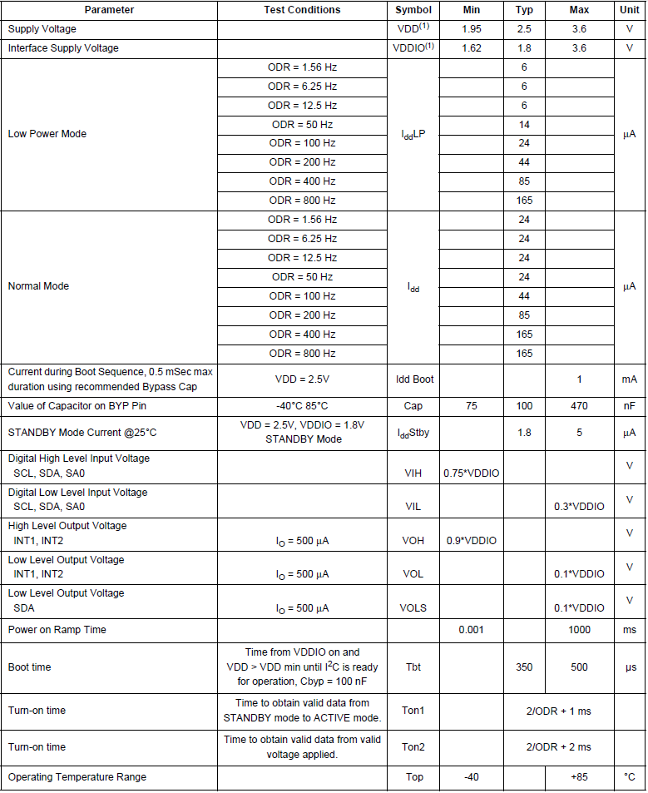

# Schematic

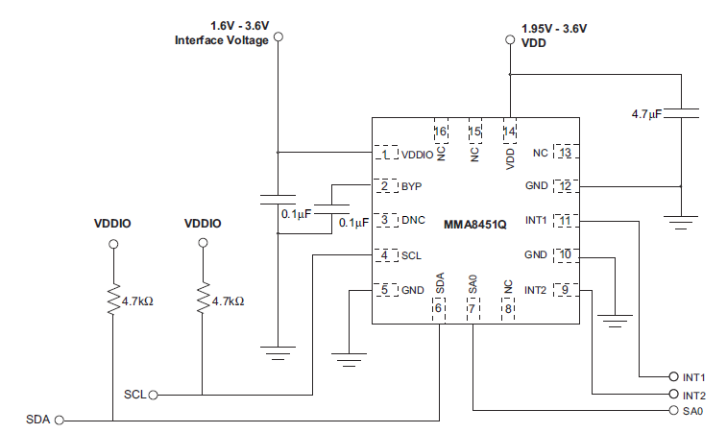

# Interrupt

## INT_SOURCE System Interrupt Status Register



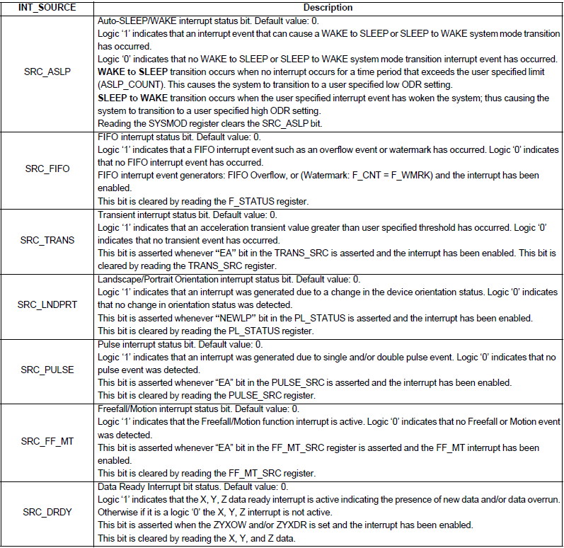

# Transient (HPF) Acceleration Detection

The transient detection mechanism can be configured to raise an interrupt when the magnitude of the high-pass filtered acceleration threshold is exceeded. The TRANSIENT_CFG register is used to enable the transient interrupt generation mechanism for the three axes (X, Y, Z) of acceleration. There is also an option to bypass the high-pass filter. When the high-pass filter is bypassed, the function behaves similar to the motion detection.

## Transient_CFG Register



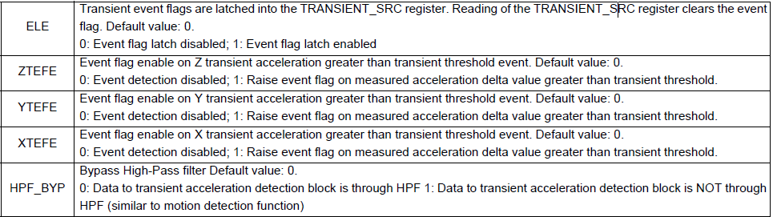

## TRANSIENT_SRC Register



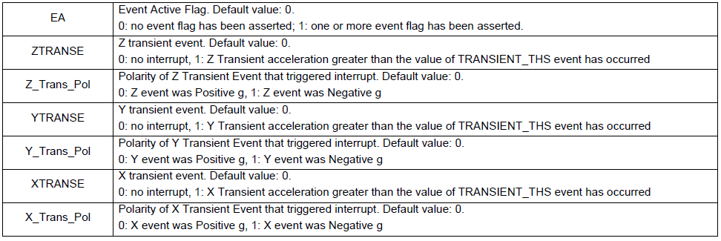

## TRANSIENT_THS Register





The threshold THS[6:0] is a 7-bit unsigned number, 0.063g/LSB. The maximum threshold is 8g. Even if the part is set to full scale at 2g or 4g this function will still operate up to 8g. If the Low Noise bit is set in Register 0x2A, the maximum threshold to be reached is 4g.

# Single, Double and Directional Tap Detection Registers

## PULSE_CFG Pulse Configuration Register



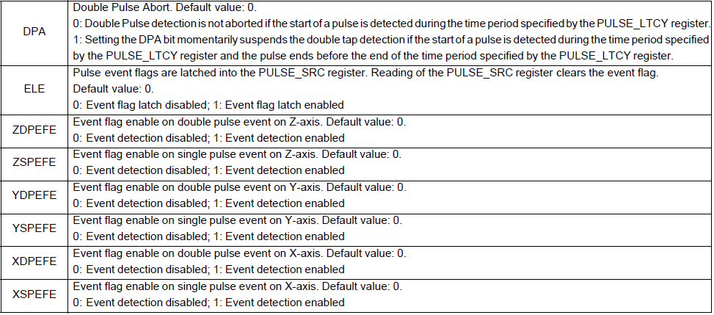

## PULSE_SRC Pulse Source Register



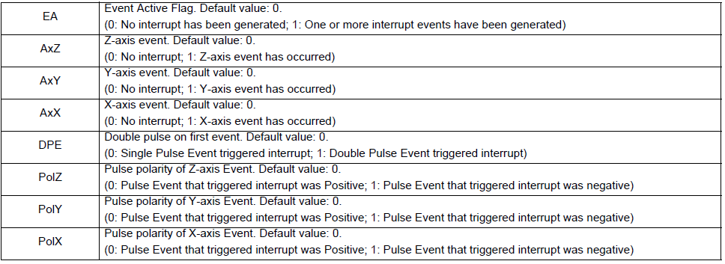

## PULSE_THSX, Y, Z Pulse Threshold for X, Y & Z Registers





The threshold values range from 1 to 127 with steps of 0.063g/LSB at a fixed 8g acceleration range, thus the minimum resolution is always fixed at 0.063g/LSB. If the Low Noise bit in Register 0x2A is set then the maximum threshold will be 4g. The PULSE_THSX, PULSE_THSY and PULSE_THSZ registers define the threshold which is used by the system to start the pulse detection procedure. The threshold value is expressed over 7-bits as an unsigned number.

## PULSE_TMLT Pulse Time Window 1 Register

The bits TMLT7 through TMLT0 define the maximum time interval that can elapse between the start of the acceleration on the selected axis exceeding the specified threshold and the end when the acceleration on the selected axis must go below the specified threshold to be considered a valid pulse.

Min times:

