TRF7970A 7.75

Multiprotocol Fully Integrated 13.56 MHz RFID and Near Field Communication Transceiver

# Description

* Supports NFC, StandardsNFCIP-1 (ISO/IEC 18092) and NFCIP-2(ISO/IEC 21481)
* Supports ISO14443A/B (RFID)
* Input voltage Range: 2.7 V to 5.5 V
* Programmable Output Power: 100mW or 200mW
* Dual Receiver Architecture With RSSI
* SPI Interface

# Power

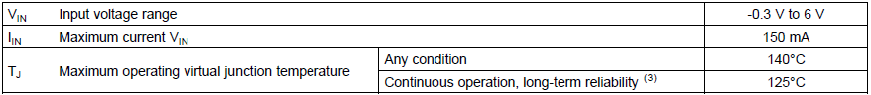

# Block Diagram

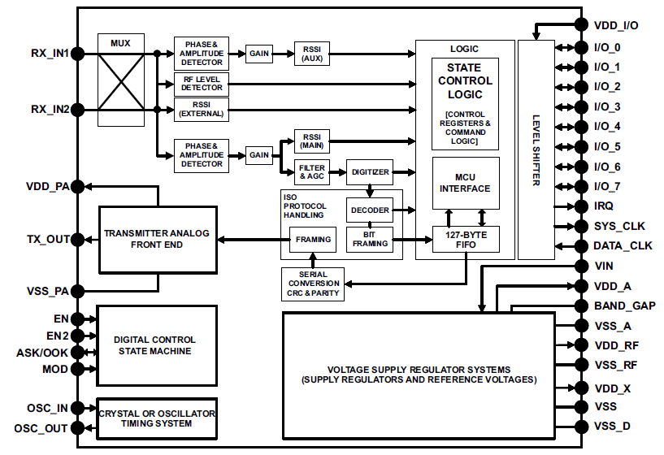

# Pin Layout

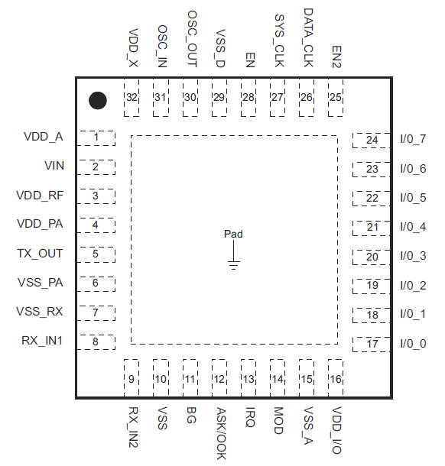

# Clock Generation

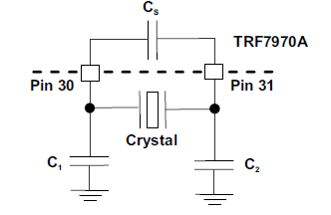

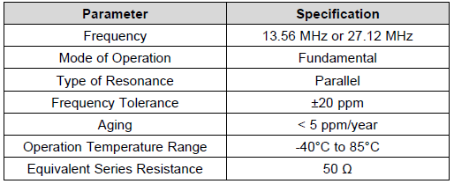

# Registers

## Chip Status Control Register

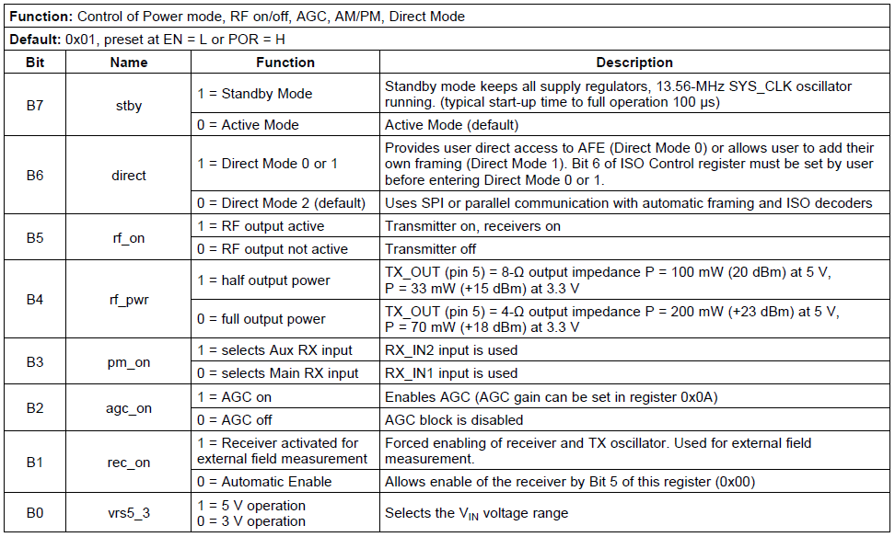

## ISO Control Register

