Database Design Document
AeroNetB Aerospace Supply Chain Management (ASCM)
Conceptual ER Model, Relational Logical Model, and Document Logical Model

Student Name | Angelos Anastasiadis
Student ID | 100735056
Module / Course | 5CM506 Data Driven Systems
Submission Date | 3 April 2026

1. Introduction
AeroNetB Aerospace manufactures critical aircraft components and operates a globally distributed supply chain involving specialized suppliers, certification-heavy engineering data, purchase orders, shipments, quality inspections, and IoT-enabled production and transit monitoring. The current environment relies on fragmented databases, spreadsheets, and manual logs, which leads to duplicated data, poor traceability, and limited real-time visibility across operational and compliance processes.
This document proposes a database design that addresses those issues through a layered approach. First, a technology-agnostic conceptual model is defined to capture the full business domain. Second, that conceptual model is transformed into two logical models: a relational schema for high-integrity transactional data and a document-oriented model for flexible, nested, and semi-structured content such as inspection payloads, certifications, and IoT events.

Design approach
- Extract the core business objects from the scenario: suppliers, parts, specifications, orders, shipments, quality reports, certifications, equipment, IoT devices, users, roles, and audit events.
- Separate common baseline definitions from supplier-specific variants so that one aerospace part can be sourced from multiple suppliers without duplicating the standard specification.
- Use the conceptual model as a single source of truth, then map stable, highly relational entities to a normalized relational schema and variable/nested content to a document model.
- Preserve compliance requirements by incorporating version history, approval status, immutability of finalized records, role-based access control, and complete auditability.

Key design assumptions
- The logical design targets a relational DBMS such as PostgreSQL or MS SQL Server and a document store such as MongoDB.
- Large files such as CAD models, engineering drawings, images, and signed PDFs are stored in object/file storage; the database stores only metadata and secure references.
- The supplied QC JSON and certification PDF confirm that report and certification content varies by type and nesting level, so the design includes JSON/document-oriented payload support for dimensional/NDT findings, environmental test results, signatures, and material traceability.
- High-volume IoT telemetry is expected to grow rapidly; therefore the relational design treats sensor readings as partitionable time-series data.

2. Conceptual Design
The conceptual model is technology-agnostic and focuses on business meaning rather than database implementation details. It captures the key entities, their attributes, and the relationships needed to support procurement, engineering traceability, quality control, shipment visibility, equipment monitoring, and secure access.

2.1 Core conceptual entities
Entity | Representative attributes | Business meaning
Supplier | supplierId, businessName, address, status | Approved external organization providing one or more parts.
Supplier Accreditation | supplierAccreditationId, accreditationCode, certificateNumber, validTo | Formal accreditations such as ISO 9001 or AS9100 held by a supplier.
Supplier Contact | contactId, fullName, email, phone, title | Operational and commercial contacts for the supplier.
Part | partId, partNumber, partName, category, description | Standardized aerospace component definition shared across suppliers.
Baseline Specification | baselineSpecId, versionNo, effectiveFrom, status | Common engineering specification for a part, including properties, process, geometry references and approvals.
Supplier Part | supplierPartId, supplierPartCode, leadTimeDays, approvalStatus | Supplier-specific offering of a standard part, including customizations and approved variant data.
Part Document | documentId, documentType, fileUri, mimeType | CAD references, engineering drawings, images and related files.
Part Note | noteId, noteType, noteText, createdAt | Free-form engineering, handling, inspection, or supplier notes.
Purchase Order | poId, poNumber, orderDate, desiredDeliveryDate, status | Order raised with a supplier.
Purchase Order Line | poLineId, quantity, unitPrice, requiredDeliveryDate | Line item identifying the supplier part, quantity and expected date.
Shipment | shipmentId, shipmentNumber, trackingNumber, ETA, portOfEntry, status | Physical delivery unit associated with one or more order lines.
Shipment Update | shipmentUpdateId, timestamp, location, condition | Checkpoint or sensor-based update during shipment transit.
QC Report | qcReportId, inspectionType, result, versionNo, status | Inspection/testing outcome for delivered parts.
Failure Cause | failureCauseId, code, description | Classified reason for a QC failure for analytics and trend reporting.
Certification | certificationId, certificationNumber, status, currentVersion | Compliance record tied to a supplier part and optionally a shipment or QC outcome.
Certification Version | certVersionId, versionNo, isFinalized, signature | Versioned certification content; finalized versions are immutable.
Material Batch | materialBatchId, batchNumber, originCountry | Raw material traceability record used in a certification.
Equipment | equipmentId, equipmentCode, equipmentType, facility | Production machine or monitored transit container.
IoT Device | deviceId, serialNo, deviceType, isActive | Sensor or gateway attached to equipment or transit assets.
Sensor Reading | readingId, timestamp, metricType, metricValue | Individual telemetry event.
Alert | alertId, alertType, severity, status | Threshold breach or anomaly detected from IoT data.
User | empId, fullName, department, authId, accessLevel | Authenticated system actor.
Role | roleId, roleName | Named functional role such as Procurement Officer or Auditor.
Permission | permissionId, permissionCode | Granular privilege mapped to one or more roles.
Audit Log | auditId, timestamp, actionType, entityType, entityId | Trace of data access, update, approval, export, or review actions.

2.2 Conceptual relationships
Relationship | Interpretation
Supplier 1:M Supplier Accreditation | A supplier may hold multiple accreditations over time.
Supplier 1:M Supplier Contact | A supplier may have multiple business contacts.
Supplier M:N Part via Supplier Part | Many suppliers can provide the same standard part; each supplier may provide many parts.
Part 1:M Baseline Specification | A part may have multiple specification versions across its lifecycle.
Part / Supplier Part 1:M Part Document | Documents can attach to the baseline part or a supplier-specific variant.
Purchase Order 1:M Purchase Order Line | Orders are made of one or more order lines.
Supplier 1:M Purchase Order | Each order is placed with one supplier.
Purchase Order Line M:1 Supplier Part | Each order line references the approved supplier-specific variant of a part.
Shipment 1:M Shipment Update | A shipment produces multiple transit updates.
Shipment M:N Purchase Order Line via Shipment Line | One shipment can fulfill several order lines and one order line may ship in parts.
Supplier Part 1:M QC Report | Delivered supplier-part variants are inspected and tested.
QC Report M:N Failure Cause | A report can record multiple causes for a failed inspection.
Supplier Part 1:M Certification | A part variant may have multiple certification records across lots or revisions.
Certification 1:M Certification Version | Certification content is version controlled.
Certification Version M:N Material Batch | A certification version may reference multiple raw material batches.
Equipment 1:M IoT Device | Equipment or containers may carry multiple devices.
IoT Device 1:M Sensor Reading | Each device emits many readings over time.
Equipment / IoT Device 1:M Alert | Alerts are generated when readings breach thresholds or patterns indicate anomalies.
User M:N Role | Users may carry one or more system roles.
Role M:N Permission | Each role aggregates permissions.
User 1:M Audit Log | Every action is attributable to an authenticated employee ID.

2.3 Conceptual ER model
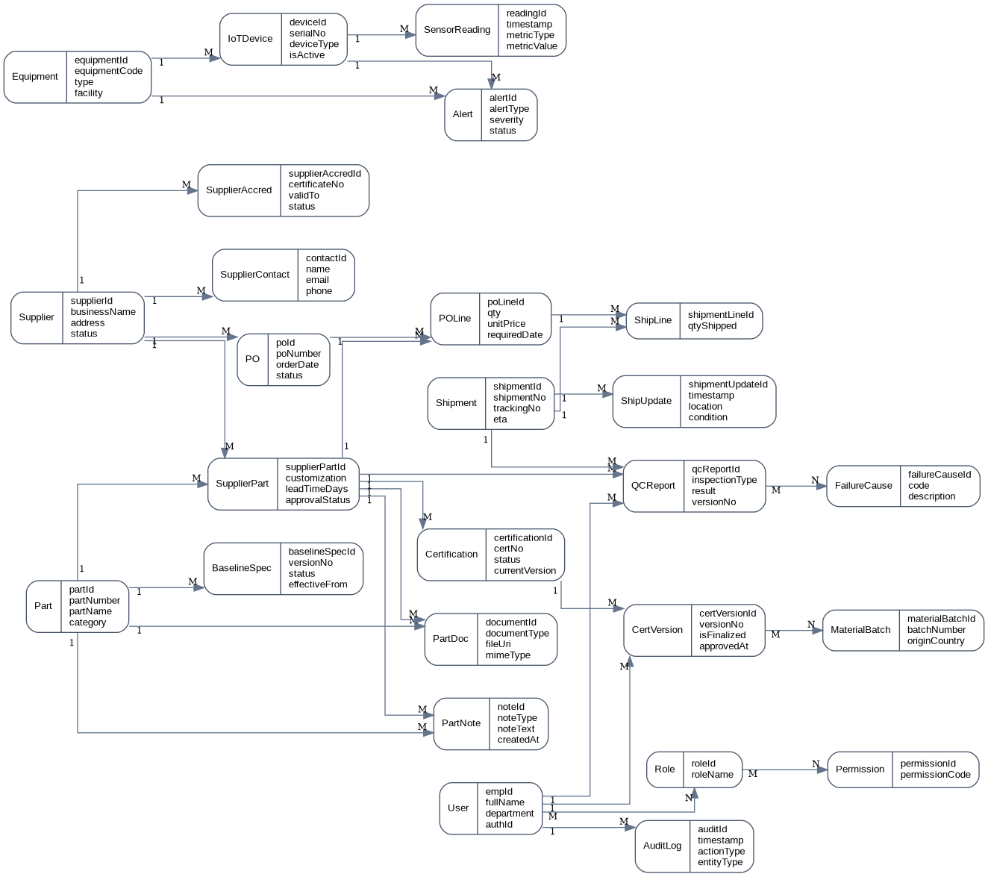
Figure 1. Conceptual ER model for the AeroNetB ASCM domain.
Conceptually, the most important modeling decision is the separation between Part and Supplier Part. The Part entity represents the baseline aerospace definition that all approved suppliers must satisfy, while Supplier Part represents the approved supplier-specific implementation, including custom coatings, packaging, digital twin metadata, or process variations. This avoids duplication of the baseline engineering definition while preserving supplier-specific differences.

3. Logical Design
The logical design translates the conceptual model into two complementary data stores. Structured and highly relational business data is mapped to a relational schema, while the supplied QC and certification samples demonstrate why flexible payload storage is needed for nested inspection measurements, environmental test blocks, approval metadata, and material traceability.

3.1 Heterogeneous data support strategy
Data domain | Preferred model | Reason
Supplier, contacts, accreditations | Relational | Stable attributes, referential integrity, straightforward joins for procurement workflows.
Part master and baseline specifications | Relational + JSON attributes | Part identity and approval status are stable; detailed mechanical/process data can be nested.
Supplier-specific customizations | Relational + JSON | Core references remain relational while custom features vary in structure.
Purchase orders and shipments | Relational | Strong integrity, status transitions, joins, and reporting.
Shipment checkpoints and conditions | Relational + JSON | Checkpoint metadata is structured; condition payloads may vary.
QC reports | Hybrid / Document-friendly | The supplied Dim_NDT and EnvironmentalTest JSON files show different report structures, so searchable headers pair best with flexible payload storage.
Certifications | Hybrid / Document-friendly | The supplied certification PDF demonstrates signatures, approval metadata, traceability, and attachment-style content that fits a hybrid model.
CAD files, images, signed PDFs | External object storage + metadata | Unstructured binaries should not be embedded as table columns or full MongoDB documents.
Equipment and device inventory | Relational | Stable operational master data with clear ownership and lifecycle.
IoT telemetry | Document or partitioned relational time-series | High-volume, timestamped, event-oriented data benefits from time-series patterns.
Users, roles, permissions, audit logs | Relational | Security data requires strict consistency and traceability.

3.2 Relational logical model
The relational model is intended for PostgreSQL, MS SQL Server, MySQL, or a comparable RDBMS. It prioritizes normalization, foreign-key integrity, status control, and role-based security. Semi-structured details are stored in JSON/JSONB columns only where the business structure is variable or deeply nested.

Relational design choices
- Supplier, part, order, shipment, security, and audit entities are fully relational because they drive high-value transactions and joins.
- The QC_Report and Certification_Version tables include JSON fields so that the supplied report structures—such as dimensionalTolerance.measurements, nondestructiveTesting, environmentalTest, approval blocks, and material traceability—can be preserved without creating excessive subtype tables.
- Part_Document stores metadata and file references for unstructured objects, rather than storing binaries inside the database.
- Sensor_Reading is modeled as a time-series/event table and should be partitioned by time to support large-scale telemetry.

Relational schema diagram
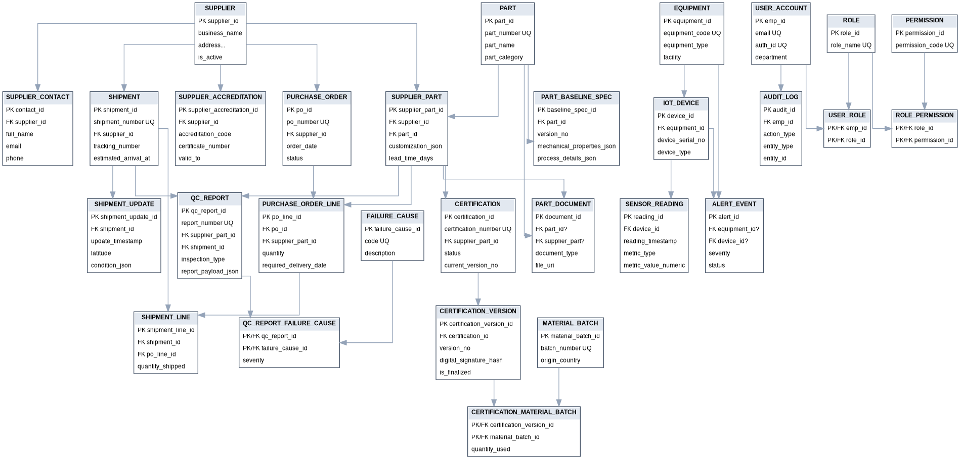
Figure 2. Relational logical model derived from the conceptual ER model.

Core relational tables
Table | Primary key | Purpose
Supplier | supplier_id | Supplier profile, master data, status
Supplier_Accreditation | supplier_accreditation_id | Accreditation history per supplier
Supplier_Contact | contact_id | Operational/commercial contacts
Part | part_id | Common part master
Part_Baseline_Spec | baseline_spec_id | Versioned engineering baseline
Supplier_Part | supplier_part_id | Supplier-specific approved part variant
Part_Document | document_id | CAD/drawing/image/PDF metadata and URIs
Purchase_Order | po_id | Procurement order header
Purchase_Order_Line | po_line_id | Order line linked to supplier part
Shipment | shipment_id | Shipment header and ETA/tracking data
Shipment_Line | shipment_line_id | Shipment-to-order-line allocation
Shipment_Update | shipment_update_id | Transit checkpoints and condition observations
QC_Report | qc_report_id | Inspection/testing header with flexible payload
Failure_Cause | failure_cause_id | Standardized QC failure classification
Certification | certification_id | Certification header and current status
Certification_Version | certification_version_id | Immutable, versioned compliance content
Material_Batch | material_batch_id | Traceable raw material lot
Equipment | equipment_id | Machine/container inventory
IoT_Device | device_id | Device registry
Sensor_Reading | reading_id | Telemetry event stream
Alert_Event | alert_id | Threshold/anomaly alerts
User_Account | emp_id | Authenticated user profile
Role | role_id | Named functional roles
Permission | permission_id | Granular privileges
User_Role | (emp_id, role_id) | User-role mapping
Role_Permission | (role_id, permission_id) | Role-permission mapping
Audit_Log | audit_id | Immutable access and change history

Illustrative relational DDL excerpt
CREATE TABLE supplier_part (
supplier_part_id BIGSERIAL PRIMARY KEY,
supplier_id BIGINT NOT NULL REFERENCES supplier(supplier_id),
part_id BIGINT NOT NULL REFERENCES part(part_id),
supplier_part_code VARCHAR(80),
customization_json JSONB,
lead_time_days INTEGER,
approval_status VARCHAR(30) NOT NULL,
active_from TIMESTAMP,
active_to TIMESTAMP
);

CREATE TABLE qc_report (
qc_report_id BIGSERIAL PRIMARY KEY,
report_number VARCHAR(50) UNIQUE NOT NULL,
supplier_part_id BIGINT NOT NULL REFERENCES supplier_part(supplier_part_id),
shipment_id BIGINT REFERENCES shipment(shipment_id),
inspection_type VARCHAR(40) NOT NULL,
overall_result VARCHAR(20) NOT NULL,
version_no INTEGER NOT NULL,
status VARCHAR(20) NOT NULL,
report_payload_json JSONB NOT NULL
);

Relational integrity and compliance controls
- Unique business keys such as part_number, po_number, shipment_number, and certification_number prevent duplication.
- Foreign keys preserve traceability across suppliers, parts, order lines, shipments, QC reports, certifications, and users.
- Versioned QC and certification records avoid destructive updates; approved or finalized versions are locked from modification.
- Audit_Log records view, insert, update, approve, export, and compliance-flag events by emp_id.
- Role-based access is implemented through User_Account, Role, Permission, User_Role, and Role_Permission.

3.3 Document logical model
The document model complements the relational design by handling variable and nested data structures more naturally. MongoDB is suitable for report payloads, certification packages, and IoT event documents because the supplied files already show heterogeneous quality and certification structures: one QC report contains nested dimensional and ultrasonic findings, another centers on environmental stress results, and the certification record combines test summaries, traceability, approval, and signature data.

Document design choices
- Use embedded arrays for tightly coupled subordinate data such as shipment updates, certification versions, and dashboard preferences.
- Use references for cross-domain links that change independently or are shared across many transactions, such as supplierId, partId, supplierPartId, deviceId, and empId.
- Store only metadata for external files; unstructured binaries remain in secure object storage with document URIs and checksums.
- Preserve the original test and certification payload structure so fields from the supplied samples—such as measurements arrays, environmentalTest blocks, digital stamps, signatures, and material traceability entries—are retained without flattening away useful detail.

Document model nested box diagram
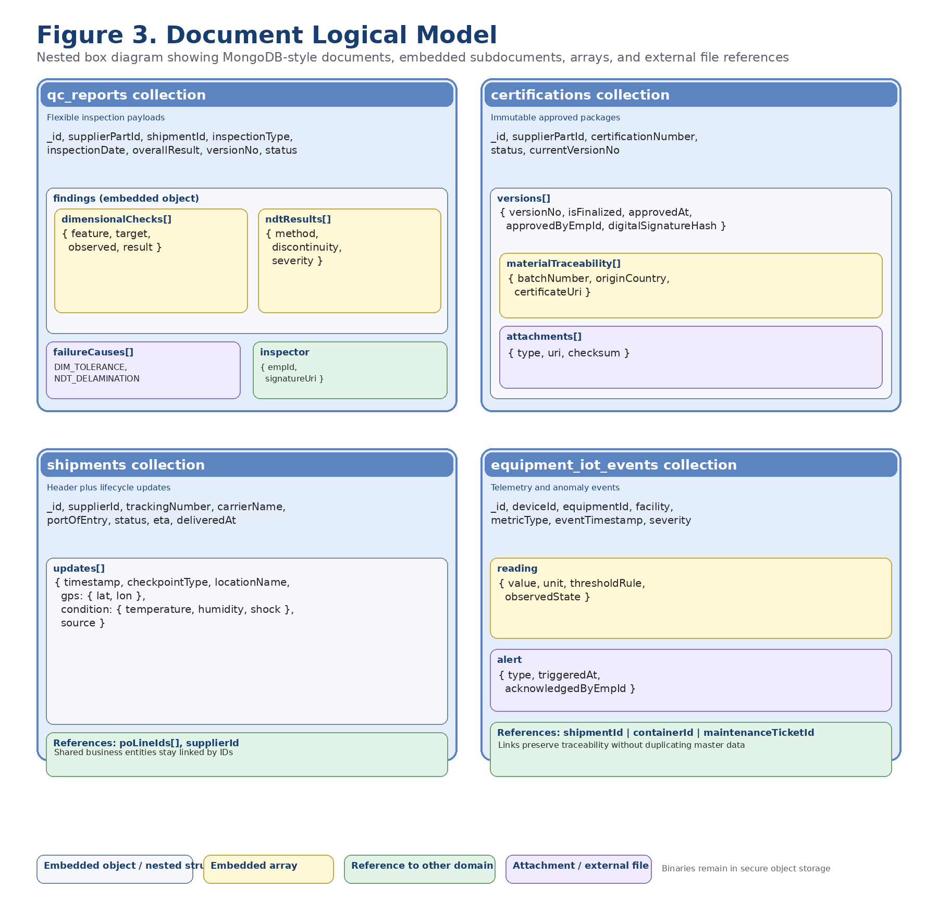
Figure 3. MongoDB-oriented nested box diagram showing embedded subdocuments, arrays, and external file references.

Recommended MongoDB collections
Collection | Purpose
supplier_catalog | Supplier profile, contacts, accreditations, list of supplied parts
part_master | Baseline part definition, specification payload, linked documents and notes
supplier_part_profile | Supplier-specific part customization and approval metadata
purchase_orders | Order header with embedded line items and status history
shipments | Shipment header with embedded updates, checkpoints, and condition snapshots
qc_reports | Inspection header plus full report payload and version history
certifications | Certification package with nested versions, signatures, and material traceability
equipment_devices | Equipment with embedded device registry and threshold rules
sensor_events | High-volume telemetry events, often written in append-only fashion
users_access | User profile, roles, permissions, scope assignments, dashboard preferences
audit_events | Immutable action documents for access and compliance review

Illustrative document structures
The following examples are aligned to the supplied supporting files and illustrate how those concrete payloads would be represented in the document store.

QC report document example
{
"_id": "qc_QC-784512-A1",
"reportId": "QC-784512-A1",
"partId": "A-320-WING-01",
"inspectionDate": "2025-08-28",
"inspector": {
"name": "Jane Doe",
"employeeId": "J.D.753"
},
"results": {
"visualInspection": "Pass",
"dimensionalTolerance": {
"result": "Pass",
"measurements": [
{"dimension": "length", "measured": 15.002, "unit": "m"},
{"dimension": "width", "measured": 3.499, "unit": "m"}
],
"deviation": 0.002
},
"nondestructiveTesting": {
"type": "Ultrasonic",
"result": "Pass",
"comments": "No internal defects detected."
}
},
"certification": {
"certifiedBy": "John Smith",
"certDate": "2025-08-29",
"stamp": "CertifiedOK"
}
}

Environmental test document example
{
"_id": "qc_QC-889234-Z9",
"reportId": "QC-889234-Z9",
"partId": "B-737-FUSE-02",
"inspectionDate": "2025-09-01",
"inspector": {
"name": "Ahmed Khan",
"employeeId": "AK.455"
},
"environmentalTest": {
"temperatureRange": "-55 to 70C",
"humidityExposure": "95% RH for 48 hours",
"result": "Pass"
},
"notes": "Component withstood environmental stress without cracking or warping."
}

Certification document example
{
"_id": "cert_CERT-2025-AX-993",
"certificationId": "CERT-2025-AX-993",
"partId": "A-320-WING-01",
"partName": "Airbus A320 Wing Assembly",
"supplier": "Global AeroParts Ltd.",
"certificationDate": "2025-09-02",
"inspector": {
"name": "Jane Doe",
"employeeId": "J.D.753"
},
"testResults": [
{
"testType": "Dimensional Check",
"result": "Pass",
"details": "Length 15.002m, Width 3.499m, Deviation 0.002m"
},
{
"testType": "Non-Destructive Test",
"result": "Pass",
"details": "Ultrasonic scan: no internal defects detected"
},
{
"testType": "Load Test",
"result": "Pass",
"details": "Withstood load of 150% rated capacity without deformation"
}
],
"materialTraceability": [
{
"material": "Aluminum Alloy 7075",
"batchId": "ALU-BATCH-77X",
"origin": "Germany",
"supplierCertification": "CERT-SUP-2025-442"
},
{
"material": "Composite Resin X1",
"batchId": "RES-BATCH-44P",
"origin": "USA",
"supplierCertification": "CERT-SUP-2025-981"
}
],
"approval": {
"certifiedBy": "John Smith",
"title": "Chief Inspector",
"digitalStamp": "CertifiedOK",
"signature": "Electronically Signed - John Smith"
}
}

3.4 Mapping summary from conceptual model to logical models
Conceptual domain | Relational model | Document model | Rationale
Supplier / Contact / Accreditation | Relational primary | Optional supplier catalog mirror | Master data with stable structure and many joins.
Part / Baseline Specification | Relational primary with JSONB spec detail | part_master document for nested engineering payload | Hybrid representation supports search and variable spec attributes.
Supplier Part | Relational primary | supplier_part_profile document | Cross-domain reference object linking supplier and part.
Orders and Shipments | Relational primary | purchase_orders and shipments documents with embedded history | Transactional integrity is critical; history payloads are naturally nested.
QC Reports | Relational header + JSON | qc_reports collection | The supplied QC JSON samples use different nested structures, so flexible schema support is justified.
Certifications | Relational header/version + file refs | certifications collection | The certification sample combines compliance controls with nested traceability, approval, and signature content.
Equipment / Devices | Relational primary | equipment_devices collection | Master records are stable; device thresholds and nested settings can embed.
Sensor Readings | Partitioned relational or time-series | sensor_events collection | Event-oriented telemetry fits document/time-series patterns.
Users / Roles / Permissions / Audit | Relational primary | users_access and audit_events mirrors if needed | Security and accountability need strict consistency.

4. Conclusion
The AeroNetB scenario requires more than a traditional operational database. It requires an integrated data architecture capable of supporting regulated manufacturing data, supplier performance analytics, shipment visibility, flexible quality and certification payloads, and real-time IoT monitoring. The supplied supporting files reinforce that requirement directly: the Dim_NDT_report and EnvironmentalTest_report JSON samples use different report shapes, while the component certification PDF combines test outcomes, material traceability, approval metadata, and an electronic signature.
From that conceptual foundation, the relational logical model handles the system of record: suppliers, parts, orders, shipments, users, roles, permissions, and audit history. The document logical model complements it by representing variable and nested structures such as QC reports, certification packages, and future IoT events. This hybrid approach provides the integrity needed for aerospace compliance together with the flexibility required for the attached semi-structured quality/certification content and other engineering data.

Key insights and design choices
- Part and Supplier Part are modeled separately to avoid duplication of baseline aerospace standards while preserving supplier-specific enhancements.
- QC reports and certifications are versioned to support history, approvals, and regulatory traceability.
- Finalized certifications and signatures are treated as immutable records.
- Large CAD files, drawings, images, and PDFs are referenced through metadata rather than stored inline.
- IoT telemetry is modeled as high-volume event data suitable for partitioning or a document/time-series strategy.
- Role-based access control and audit logging are designed as first-class data domains rather than application afterthoughts.

End of report

