Assessment 2: Report on Microservice Implementation
1. Introduction
This report documents the design, implementation, and evaluation of a microservice developed as part of the COMP2001 Information Management & Retrieval module. The purpose of this coursework is to extend the database and conceptual work completed in Coursework 1 by implementing a fully functional, containerised microservice that interacts with a relational database and exposes functionality via a RESTful API.
The microservice has been implemented using FastAPI, connects to a Microsoft SQL Server database using pyodbc, and is deployed within a Docker container published to Docker Hub. The report discusses the background context of the Trail Application, the design decisions taken, legal, social, ethical and professional considerations, and evaluates the final solution including testing and future improvements.
GitHub username: OkyanusAlbas
Docker image: <USERNAME>/<IMAGE_NAME> (replace with your Docker Hub image name)

2. Background
The Trail Application is a conceptual fitness and activity-tracking system that allows users to record personal details, preferences, and activity-related information. The overall system is designed as a set of loosely coupled microservices, each responsible for a specific domain of functionality. This architectural approach supports scalability, maintainability, and separation of concerns.
The microservice implemented for this coursework is a User Profile Microservice. Its responsibility is to manage user profile data, including personal information (such as name and email), user preferences (language and measurement units), and related reference data. The service interacts directly with the CW2 database schema and exposes REST endpoints that allow other components of the Trail Application to retrieve and manage user profile data. This service is independent of authentication but demonstrates how it could integrate with an external authentication service via HTTP requests.

3. Design
3.1 Use Case Diagram
The User Profile Microservice supports several core use cases:
- Create a new user profile
- Retrieve all users
- Retrieve a specific user by ID
- Update an existing user
- Delete a user
- Retrieve a complete user profile via a database view
- Retrieve reference data (activities, languages, measurement units)
Screenshot evidence to include here:
- UML Use Case Diagram showing:

  - Actor: Trail Application / API Consumer
  - Use cases listed above
(Insert UML diagram screenshot here)
3.2 Logical Entity Relationship Diagram (ERD)
The logical ERD evolved from Coursework 1 and was refined during implementation. The CW2 schema includes the following core tables:
- Users
- Language
- MeasurementUnits
- Activity
A database view (vw_UserProfile) is used to present a joined representation of user profile data, reducing complexity in the API layer and improving consistency.

Logical ERD diagram
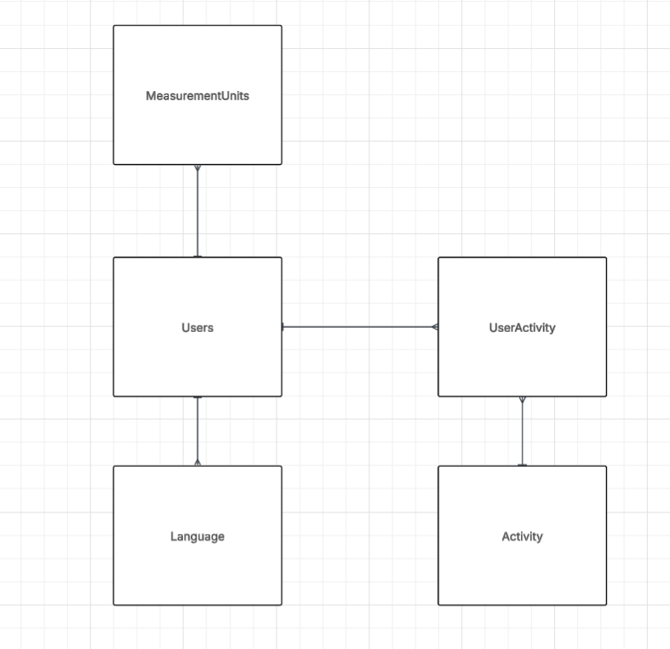
SQL Server diagram or design view
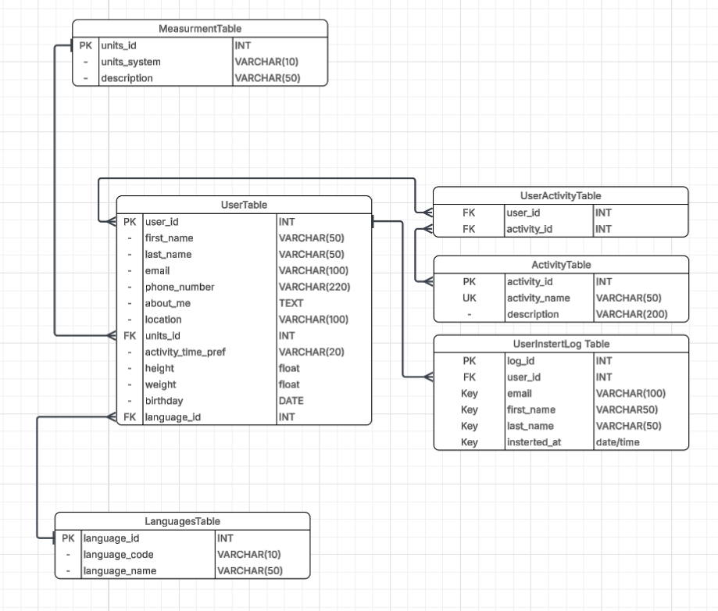

4. Legal, Social, Ethical and Professional (LSEP)
Information Privacy
User data such as names, email addresses, and optional profile information are handled in accordance with data minimisation principles. Only required data is collected, and optional fields are clearly marked. Sensitive credentials are not hard-coded and are instead managed through environment variables using a .env file.
Note for marking I removed .env file from .gitignore as its necessary for that file to be in there to login to the database Normally this file would have been kept locally and not uploaded to the github
Data Integrity
Integrity is enforced through:
- Primary and foreign key relationships in the CW2 schema
- Use of controlled reference tables (Language, MeasurementUnits)
- Validation of input data using Pydantic models (e.g., validated email addresses)
Security
Security considerations include:
- Database credentials stored securely via environment variables
- No credentials committed to version control (.gitignore) (for marking .env has been included)
- Separation of concerns between authentication and profile management
Data Preservation
Data persistence is handled by Microsoft SQL Server, ensuring durability and reliability. The use of a defined schema (CW2) and repeatable SQL scripts ensures the database can be recreated or migrated if required in which these SQL documents are at CW1 Report.
5. Implementation
5.1 Technology Stack
The microservice was implemented using the following technologies:
- FastAPI: REST API framework
- Uvicorn: ASGI server
- Pyodbc: Database connectivity
- Pydantic: Data validation
- Pytest: Automated testing
- Docker: Containerisation
- Docker Hub: Image distribution
5.2 API Implementation
The FastAPI application defines endpoints for CRUD operations on users and retrieval of reference data. Pydantic models (UserCreate and UserUpdate) enforce validation rules and optional fields.
Screenshot evidence to include here:
- FastAPI Swagger UI (/docs)
- Example request and response for /users
(Insert Swagger UI screenshot here)
GET
POST
DELETE
UPDATE

5.3 Database Connectivity
Database connections are managed via a dedicated connection module using pyodbc. Connections are opened only when required and closed after each request to reduce resource usage.
Screenshot evidence to include here:
- Successful /test-db endpoint response
- SQL Server showing CW2 schema
(Insert screenshots here)
5.4 Docker Deployment
The microservice is containerised using a Dockerfile based on Python 3.13 (Debian Bookworm). Required system dependencies and the Microsoft ODBC Driver 17 are installed to enable SQL Server connectivity. The image is built and published to Docker Hub.
Screenshot evidence to include here:
- docker build success
- docker run or docker-compose up output
- Container running and responding
(Insert Docker screenshots here)
6. Evaluation
6.1 Testing
Automated testing was implemented using pytest. Tests verify that the database connection can be established successfully and that the application behaves correctly when the database is available.
Screenshot evidence to include here:
- Pytest output showing passing tests
(Insert pytest screenshot here)

6.2 Reflection and Future Work
The microservice meets the core requirements of the coursework; however, several improvements could be made:
- Add authentication and role-based access control
- Improve error handling and logging
- Add more extensive unit and integration tests
- Implement pagination for large datasets
- Improve API documentation and versioning

7. References
- Fielding, R. (2000) Architectural Styles and the Design of Network-based Software Architectures.
- Microsoft (2024) ODBC Driver for SQL Server Documentation.
- FastAPI Documentation (2024).
- Docker Documentation (2024).

Appendix
- Generative AI Declaration (completed)

