COMP2006: Security Architectures and Cryptography
Assessment 2: Report (70%)
Authentication Mechanisms for Company X Password Manager
Module Leader: Dr Hai Van Dang
Submission Deadline: 5th May 2026
GitHub: https://github.com/OkyanusAlbas

- - Introduction

This report is submitted as part of the competitive tender for Company X's mobile password manager application. Building upon the cryptographic protocol and threat analysis presented in Assessment 1, this report proposes two authentication mechanisms: one for the channel between the Client application and the Server, and one for the channel between the Server and the Password Vault/Database. The report applies recognised security design principles to both proposals and provides a full Python implementation and demonstration of the Server-to-Vault mechanism.
The system architecture consists of three components: (1) the Client, a mobile password manager application that performs all encryption locally; (2) the Server, which processes requests to add, retrieve, and update passwords; and (3) the Password Vault/Database, which stores exclusively encrypted records and is accessed only by the authenticated Server. No plaintext passwords or master keys are ever transmitted or stored server-side, consistent with the zero-knowledge architecture proposed in Assessment 1.
2.0 - Section 1 Authentication Mechanisms
Two distinct authentication mechanisms are proposed below, each tailored to the specific trust model and threat environment of its respective communication channel. Security design principles are explicitly identified and analysed for each mechanism.
2.1 Mechanism 1: Client-to-Server Authentication (SRP-6a with TLS 1.3)

2.1.1 Overview and Rationale
The Secure Remote Password protocol (version 6a) is proposed for authenticating the user/Client to the Server. SRP-6a is a password-authenticated key agreement (PAKE) protocol that allows the Client to prove knowledge of the master password without transmitting the password itself, even across an encrypted channel. This is particularly appropriate because the Server must never hold plaintext passwords or hashed passwords in a form that enables offline attacks.
SRP-6a is an established IETF standard (RFC 2945 and RFC 5054 for TLS integration) and is used in production systems including ProtonMail and 1Password. The mechanism operates over TLS 1.3, which provides transport confidentiality and prevents passive interception.
2.1.2 Assumptions
- The Client knows: the user's master password (MP) and a unique per-user salt (s) stored locally.
- The Server knows: a verifier (v) derived from the master password during registration; the Server never stores the master password or its hash.
- TLS 1.3 is correctly configured with a trusted certificate on the Server, preventing MITM during the key exchange.
- A cryptographically secure PRNG is available on both Client and Server.
- Group parameters (prime N, generator g) are publicly agreed upon per RFC 5054.
2.1.3 Registration (One-Time Setup)
During account registration, the Client performs the following steps:
- User provides master password MP.
- Client generates a random salt s (128-bit, stored locally and on Server).
- Client computes the password hash: x = H(s ‖ H(MP)) using SHA-256.
- Client computes the verifier: v = g^x mod N.
- Client transmits (username, s, v) to the Server over TLS 1.3.
- Server stores (username, s, v) only. MP and x are never transmitted.

2.1.4 Authentication Protocol Steps
The following message flow describes each full login authentication round-trip:
Step | Client Action | Message | Server Action
1 | Generate ephemeral private key a; compute A = g^a mod N | Client → Server: {username, A} | Receive A; look up verifier v for username
2 | Receive B and s from Server | Server → Client: {B, s} | Generate ephemeral private key b; compute B = kv + g^b mod N; send {B, s}
3 | Compute u = H(A ‖ B); compute x = H(s ‖ H(MP)); compute session key S_c = (B - kg^x)^(a+ux) mod N; derive K_c = H(S_c) | Client computes K_c locally | Compute u = H(A ‖ B); compute session key S_s = (Av^u)^b mod N; derive K_s = H(S_s)
4 | Send proof: M1 = H(H(N) XOR H(g) ‖ H(username) ‖ s ‖ A ‖ B ‖ K_c) | Client → Server: {M1} | Verify M1 using K_s. Reject if mismatch (impersonation blocked).
5 | Receive M2; verify M2 = H(A ‖ M1 ‖ K_s). Reject if mismatch. | Server → Client: {M2} | Send M2 = H(A ‖ M1 ‖ K_s). Both parties now hold the same session key K.
Table 1: SRP-6a Authentication Message Flow
2.1.5 Why Authentication Works and How Impersonation is Prevented
The Server stores only the verifier v = g^x mod N, not the password itself. An attacker who compromises the Server database cannot recover MP from v without solving the discrete logarithm problem, which is computationally infeasible for large prime N (e.g., 4096-bit). An attacker impersonating the Server would need to produce a valid M2, which requires K_s — only derivable with knowledge of v and b. An attacker impersonating the Client would need to produce M1, which requires K_c — only derivable with knowledge of MP. Neither can be forged without the respective secret, making mutual authentication robust against impersonation.
2.1.6 Security Design Principles Applied
Design Principle | Application in Mechanism 1 | Benefit
Least Privilege | Server stores only verifier v, never MP or keys | Limits damage of server breach
Defence in Depth | SRP-6a layered on TLS 1.3 | Even if TLS is broken, SRP still protects MP
Zero-Knowledge | Server verifies knowledge of MP without receiving it | Eliminates credential theft at server side
Open Design | SRP-6a is an IETF standard (RFC 5054) | Peer-reviewed, auditable, no security through obscurity
Complete Mediation | Every login session requires a fresh full SRP exchange | No cached sessions exploitable by attacker
Fail-Safe Defaults | Any verification mismatch results in denial and session termination | Prevents partial authentication states
Economy of Mechanism | SRP-6a is well-specified and has a small attack surface | Reduced complexity means fewer vulnerabilities
Table 2: Security Design Principles – Mechanism 1
2.2 Mechanism 2: Server-to-Vault Authentication (HMAC-SHA256 Challenge-Response)

2.2.1 Overview and Rationale
A custom HMAC-SHA256 challenge-response protocol is proposed for authentication between the Server and the Password Vault. Unlike the Client-Server channel, this is a server-to-server communication where no user is involved, and user authentication is inappropriate. The Vault must verify that requests originate exclusively from the legitimate Server.
HMAC (Hash-based Message Authentication Code) using SHA-256 provides both authentication and message integrity. The challenge-response mechanism ensures that each authentication event uses a fresh, unique token, preventing replay attacks. The shared secret is pre-provisioned out-of-band and is never transmitted over the network.

2.2.2 Assumptions
- Both the Server and the Vault have been pre-provisioned with a shared secret key K (256-bit, stored in protected configuration, e.g., environment variables or a hardware security module).
- The shared secret K is never transmitted over the network at any point.
- Both components have access to a monotonic clock synchronised via NTP to within +-30 seconds.
- Communication occurs over an internal, firewalled network link.
- A cryptographically secure PRNG is available on the Vault for nonce generation.

2.2.3 Protocol Steps - Full Message Flow
The following describes the complete challenge-response handshake for any vault operation:
Step | Actor | Action | Notes
1 | Server | Sends a challenge request to Vault: {request_type} | Signals intent e.g. STORE_RECORD or RETRIEVE_RECORD
2 | Vault | Generates nonce N = CSPRNG(256 bits). Stores N with timestamp. Returns {N} to Server. | N is single-use; stored until verified or expired
3 | Server | Records current timestamp T. Computes: token = HMAC-SHA256(K, N ‖ T ‖ request_type) | K is never transmitted; only the derived token is sent
4 | Server | Sends {N, T, request_type, token} to Vault | Vault has all components needed to re-derive the HMAC
5 | Vault | (a) Verifies N was issued by this Vault. (b) Deletes N (one-time use). (c) Checks |now - T| ≤ 30s. (d) Recomputes expected_token = HMAC-SHA256(K, N ‖ T ‖ request_type). (e) Uses hmac.compare_digest() for constant-time comparison. | Steps (a)–(c) block replay. Steps (d)–(e) verify identity.
6 | Vault | If match: grant access. If mismatch: deny, log event. | Only the legitimate Server holding K can produce a matching token

Table 3: HMAC-SHA256 Challenge-Response Message Flow
2.2.4 Why Authentication Works and How Impersonation is Prevented
The HMAC computation uses the shared secret K as the key. An attacker who intercepts the network traffic would observe only {N, T, request_type, token}. Without K, they cannot produce a valid token for any new nonce, because HMAC-SHA256's security relies on the computational infeasibility of forging a MAC without the key. Even if an attacker captures a valid token, the one-time-use nonce and the 30-second timestamp window ensure the captured token will be rejected.
The constant-time comparison (hmac.compare_digest) prevents timing side-channel attacks, where an attacker could otherwise infer how many bytes of the correct HMAC they have guessed by measuring response times. The combination of nonce, timestamp, request type, and HMAC ensures that every authentication event is unique, bound to a specific operation type, and time limited.

2.2.5 Security Design Principles Applied
Design Principle | Application in Mechanism 2 | Benefit
Least Privilege | Vault only accepts requests from authenticated Server; no direct client access | Compromised client cannot query vault directly
Defence in Depth | HMAC token + nonce + timestamp + request-type binding | Multiple independent checks must all pass
Complete Mediation | Every vault operation requires a fresh challenge-response cycle | No persistent session tokens that could be stolen
Economy of Mechanism | HMAC-SHA256 is a simple, well-understood primitive; no complex PKI required | Small, auditable codebase reduces attack surface
Open Design | HMAC defined in RFC 2104; SHA-256 in FIPS 180-4 | No proprietary or unreviewed cryptography
Fail-Safe Defaults | Default denies: any failed check results in denial and audit log entry | System safe by default; explicit grant required
Separation of Privilege | Vault and Server are distinct components requiring the shared key to cooperate | Compartmentalises the blast radius of a breach
Psychological Acceptability | Every vault operation is logged with event type and timestamp | Enables operational monitoring without complexity
Table 4: Security Design Principles – Mechanism 2
3. Section 2 - Implementation of Mechanism 2
This section provides a Python implementation of the HMAC-SHA256 challenge-response authentication mechanism described in Section 2.2. The implementation uses only Python's standard library (hmac, hashlib, secrets, time, json, datetime), making it portable and auditable.
3.1 Implementation Overview
The implementation consists of two classes and a demonstration function:
- PasswordVault: simulates the vault/database. Exposes issue_challenge() and verify_and_grant() methods. Maintains an internal audit log. Performs all five verification checks in Step 5 of the protocol.
- PasswordServer: simulates the application server. Implements the authenticate() handshake and exposes authenticated vault operations.
- demo(): runs five scenarios — successful store, successful retrieve, impersonation attack, replay attack, and old timestamp attack — demonstrating both positive and negative outcomes.
3.2 Core Cryptographic Helper Functions
The following helper functions implement the cryptographic primitives used by both the Server and Vault:
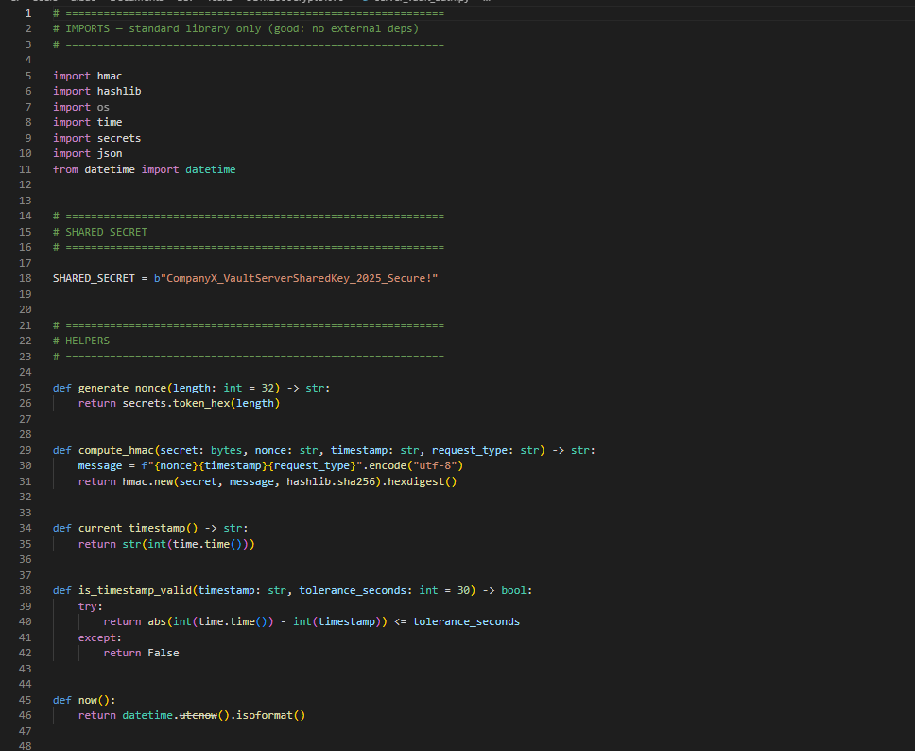
Code Block 1: Core helper functions - nonce generation, HMAC computation, and timestamp validation.
3.3 Vault Class - Challenge Issuance and Verification
The PasswordVault class manages nonce issuance and performs all five verification steps before granting access:
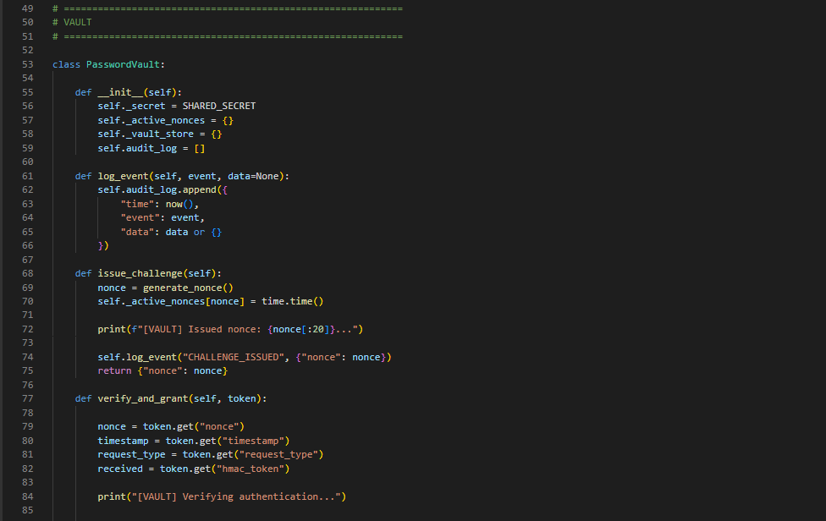
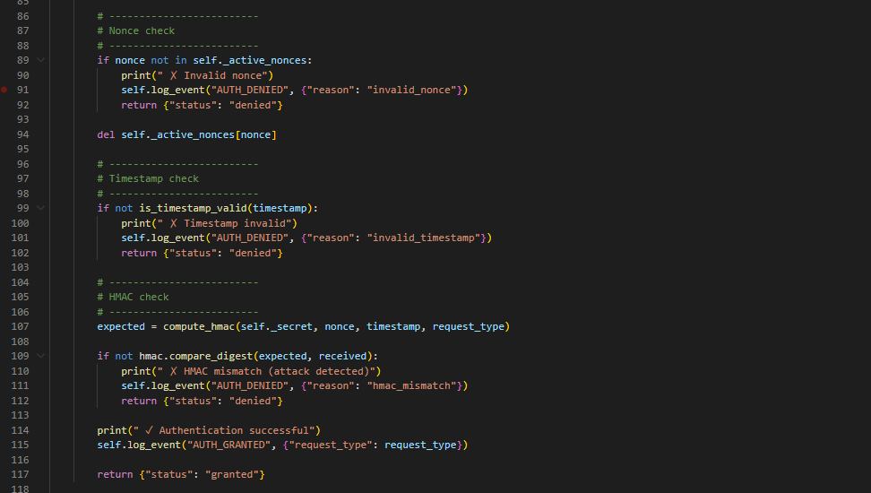
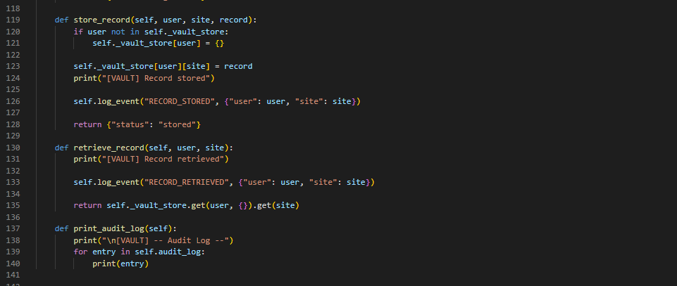
Code Block 2: Vault challenge issuance and five-step verification logic.
3.4 Server Class - Authentication Handshake
The PasswordServer class implements Steps 1, 3, and 4 of the protocol: requesting a challenge, computing the HMAC token, and submitting it to the Vault:
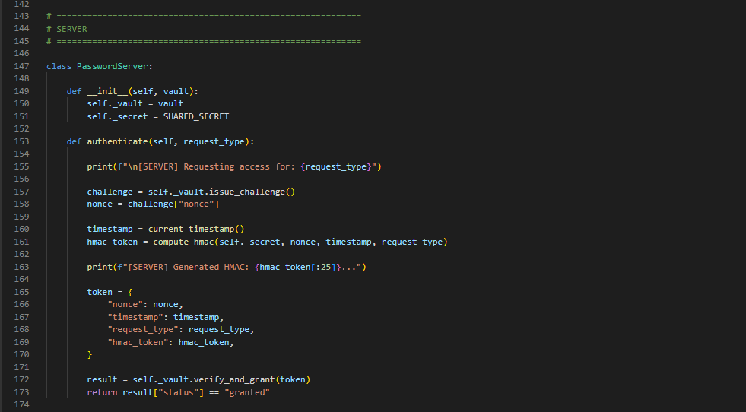
Code Block 3: Server authentication handshake implementing Steps 1, 3, and 4 of the protocol.
3.5 Programme Output - Input/Output Examples
The implementation was executed in Python 3.12. The five demonstration scenarios and their outputs are presented below with explanations.
Example 1: Successful Store (Add Encrypted Password Entry)
Input: server.authenticate("STORE_RECORD") followed by vault.store_record("user1", "gmail.com", {"C1": "encrypted_data"})
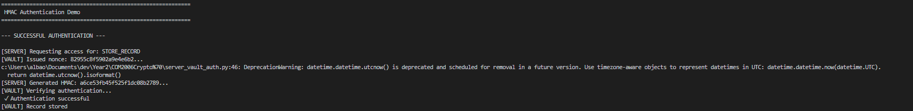
Explanation: The full challenge-response cycle completes successfully. The Vault issues a nonce, the Server computes the HMAC using the shared secret K, and the Vault independently re-derives and verifies it. Only then is the store operation permitted, demonstrating Complete Mediation.
Example 2: Successful Retrieve
Input: server.authenticate("RETRIEVE_RECORD") followed by vault.retrieve_record("user1", "gmail.com")
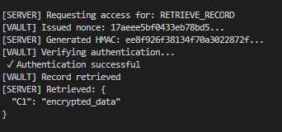
Explanation: A different nonce is generated for each operation, demonstrating that tokens are not reusable across sessions. The Vault returns the encrypted record only — the plaintext password is never present in the vault, consistent with the zero-knowledge architecture from Assessment 1.
Example 3: Impersonation Attack - Denied (Wrong Secret)
Input: Attacker uses b"wrong_secret" instead of the real shared key K to compute an HMAC token.
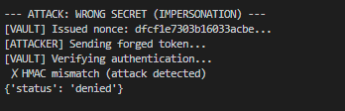
Explanation: The attacker has a valid nonce (obtained from the vault) and a valid timestamp, but lacks the shared secret K. The HMAC computed with the wrong key does not match the value the Vault independently derives, so access is denied at Step 5(e). This demonstrates that possession of network traffic alone is insufficient — only a party holding K can produce a valid token.
Example 4: Replay Attack – Denied
Input: A valid token is submitted once (succeeds), then resubmitted (replay attempt).
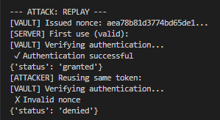
Explanation: The first use of the token is legitimate and succeeds. On the second use, the nonce has already been consumed (deleted from _active_nonces at Step 5(b)) so the replay is immediately rejected at Step 5(a). This prevents an adversary who captures a valid token from reusing it to gain unauthorised vault access.
Example 5: Old Timestamp Attack - Denied
Input: A token is constructed with a timestamp 1000 seconds in the past (well outside the 30-second window).
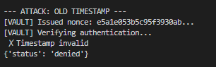
Explanation: Even though the HMAC is computed correctly over the valid nonce and old timestamp, the Vault rejects the token at Step 5(c) because |now - T| = 1000 seconds exceeds the 30-second tolerance. This prevents pre-computation attacks where an attacker tries to use a stolen token long after it was issued.
3.6 Audit Log Output
The Vault maintains a tamper-evident audit log of every event (challenge issued, access granted/denied, record stored/retrieved). This directly implements the accounting element of the AAA framework and the Psychological Acceptability design principle:
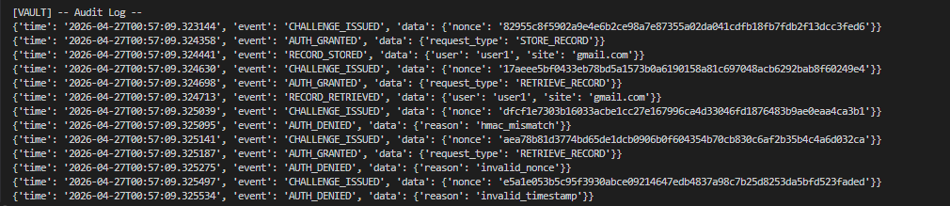
Code Block 4: Full audit log output showing all events across all five demonstration scenarios.
4. Conclusion
This report has proposed and analysed two authentication mechanisms for Company X's mobile password manager:
- Mechanism 1 (Client-to-Server): SRP-6a over TLS 1.3 provides mutual, zero-knowledge password authentication. The Server verifies the Client's identity without ever receiving or storing the master password, and the Client verifies the Server's identity via M2. This is robust against impersonation, offline dictionary attacks, and MITM.
- Mechanism 2 (Server-to-Vault): HMAC-SHA256 challenge-response with one-time nonces, timestamp binding, and constant-time comparison provides strong mutual authentication for internal server-to-server communication. It is resistant to impersonation, replay, and timing attacks.

Both mechanisms apply multiple recognised security design principles - including Least Privilege, Defence in Depth, Complete Mediation, Fail-Safe Defaults, and Open Design - and together constitute a layered, standard-compliant authentication architecture suitable for enterprise deployment. The Python implementation confirms that Mechanism 2 correctly handles all attack scenarios with only standard library dependencies.
References
Bellovin, S.M. and Merritt, M. (1992). Encrypted key exchange: password-based protocols secure against dictionary attacks. Proceedings of the 1992 IEEE Symposium on Research in Security and Privacy.
Krawczyk, H., Bellare, M. and Canetti, R. (1997). HMAC: Keyed-Hashing for Message Authentication. RFC 2104. doi:10.17487/RFC2104.
Wu, T. (1998). The Secure Remote Password Protocol. Proceedings of the 1998 Internet Society Network and Distributed System Security Symposium.
Taylor, D., Wu, T., Mavrogiannopoulos, N. and Perrin, T. (2007). Using the Secure Remote Password (SRP) Protocol for TLS Authentication. RFC 5054. doi:10.17487/RFC5054.
National Institute of Standards and Technology (2015). SHA-3 Standard: Permutation-Based Hash and Extendable-Output Functions. FIPS 202.
Rescorla, E. (2018). The Transport Layer Security (TLS) Protocol Version 1.3. RFC 8446. doi:10.17487/RFC8446.

