COMP2006: Security Architectures and Cryptography
Assessment 2: Report (70%)
Authentication Mechanisms for Company X Password Manager
Module Leader: Dr Hai Van Dang
Submission Deadline: 5th May 2026
GitHub : https://github.com/OkyanusAlbas

1. Introduction
This report is submitted as part of the competitive tender for Company X's mobile password manager application. Building upon the cryptographic protocol and threat analysis presented in Assessment 1, this report proposes two authentication mechanisms in which one for the channel between the Client application and the Server, and one for the channel between the Server and the Password Vault/Database. The report applies recognised security design principles to both proposals and provides a full Python implementation and demonstration of the Server to Vault mechanism.
The system architecture consists of three components: (1) the Client, a mobile password manager application that performs all encryption locally; (2) the Server, which processes requests to add, retrieve, and update passwords; and (3) the Password Vault/Database, which stores exclusively encrypted records and is accessed only by the authenticated Server. No plaintext passwords or master keys are ever transmitted or stored server-side, consistent with the zero-knowledge architecture proposed in Assessment 1.

2. Section 1 – Authentication Mechanisms
Two distinct authentication mechanisms are proposed below, each tailored to the specific trust model and threat environment of its respective communication channel. Security design principles (SDL) are explicitly identified and analysed for each mechanism.

2.1 Mechanism 1: Client to Server Authentication(SRP-6a with TLS1.3)
2.1.1 Overview and Rationale
The Secure Remote Password protocol (version 6a) is proposed for authenticating the user/Client to the Server. SRP-6a is a password-authenticated key agreement (PAKE) protocol that allows the Client to prove knowledge of the master password without transmitting the password itself, even across an encrypted channel. This is particularly appropriate here because the Server must never hold plaintext passwords or hashed passwords in a form that enables offline attacks.
SRP-6a is an established IETF standard (RFC 2945 and RFC 5054 for TLS integration) and is used in production systems including ProtonMail and 1Password. The mechanism operates over TLS 1.3, which provides transport confidentiality and prevents passive interception.
2.1.2 Assumptions
The following assumptions underpin the mechanism:
- The Client knows: the user's master password (MP) and a unique per-user salt (s) stored locally.
- The Server knows: a verifier (v) derived from the master password during registration; the Server never stores the master password or its hash.
- TLS 1.3 is correctly configured with a trusted certificate on the Server, preventing MITM during the key exchange.
- A cryptographically secure PRNG is available on both Client and Server.
- Group parameters (prime N, generator g) are publicly agreed upon per RFC 5054.
2.1.3 Registration (One-Time Setup)
During account registration, before authentication is possible, the Client performs the following steps:
- User provides master password MP.
- Client generates a random salt s (128-bit, stored locally and on Server).
- Client computes the password hash: x = H(s || H(MP)) using SHA-256.
- Client computes the verifier: v = g^x mod N.
- Client transmits (username, s, v) to the Server over TLS 1.3.
- Server stores (username, s, v) only. MP and x are never transmitted.
2.1.4 Authentication Protocol Steps
The following message flow describes each full login authentication round-trip:
Step | Client Action | Message | Server Action
1 | Generate ephemeral private key a; compute A = g^a mod N | Client Server: {username, A} | Receive A; look up verifier v for username
2 | Receive B and s from Server | Server Client: {B, s} | Generate ephemeral private key b; compute B = kv + g^b mod N; send {B, s}
3 | Compute u = H(A || B); compute x = H(s || H(MP)); compute session key S_c = (B - kg^x)^(a + ux) mod N; derive K_c = H(S_c) | Client computes K_c locally | Compute u = H(A || B); compute session key S_s = (Av^u)^b mod N; derive K_s = H(S_s)
4 | Send proof: M1 = H(H(N) XOR H(g) || H(username) || s || A || B || K_c) | Client Server: {M1} | Verify M1 using K_s. Reject if mismatch (impersonation blocked).
5 | Receive M2; verify M2 = H(A || M1 || K_s). Reject if mismatch. | Server Client: {M2} | Send M2 = H(A || M1 || K_s). Both parties now hold the same session key K.

Table 1: SRP-6a Authentication Message Flow
2.1.5 Why Authentication Works and How Impersonation is Prevented
The Server stores only the verifier v = g^x mod N, not the password itself. An attacker who compromises the Server database cannot recover MP from v without solving the discrete logarithm problem, which is computationally infeasible for large prime N (e.g., 4096-bit). An attacker impersonating the Server would need to produce a valid M2, which requires K_s only derivable with knowledge of v and b. An attacker impersonating the Client would need to produce M1, which requires K_c — only derivable with knowledge of MP. Neither can be forged without the respective secret, making mutual authentication robust against impersonation.
2.1.6 Security Design Principles Applied

Design Principle | Application in Mechanism 1 | Benefit
Least Privilege | Server stores only verifier v, never MP or keys | Limits damage of server breach
Defence in Depth | SRP-6a layered on TLS 1.3 | Even if TLS is broken, SRP still protects MP
Zero-Knowledge | Server verifies knowledge of MP without receiving it | Eliminates credential theft at server side
Open Design | SRP-6a is an IETF standard (RFC 5054) | Peer-reviewed, auditable, no security through obscurity
Complete Mediation | Every login session requires a fresh full SRP exchange | No cached sessions exploitable by attacker
Fail-Safe Defaults | Any verification mismatch results in denial and session termination | Prevents partial authentication states
Economy of Mechanism | SRP-6a is well-specified, lightweight, and has small attack surface | Reduced complexity means fewer vulnerabilities
Table 2: Security Design Principles - Mechanism 1

2.2 Mechanism 2: Server to Password Vault Authentication (HMAC-SHA256 Challenge-Response)
2.2.1 Overview and Rationale
A custom HMAC-SHA256 challenge-response protocol is proposed for authentication between the Server and the Password Vault. Unlike the Client-Server channel, this is a server-to-server communication where no user is involved and user authentication is inappropriate (as noted in the brief). The Vault must verify that requests originate exclusively from the legitimate Server and not from an attacker who has compromised a different component of the system.
HMAC (Hash-based Message Authentication Code) using SHA-256 provides both authentication and message integrity. The challenge-response mechanism ensures that each authentication event uses a fresh, unique token, preventing replay attacks. The shared secret is pre-provisioned out-of-band using a secure key management process and is never transmitted over the network.
2.2.2 Assumptions
- Both the Server and the Vault have been pre-provisioned with a shared secret key K (256-bit, generated securely and stored in protected configuration, e.g., environment variables or a hardware security module).
- The shared secret K is never transmitted over the network at any point.
- Both components have access to a monotonic clock synchronised via NTP to within ±30 seconds.
- Communication occurs over an internal, firewalled network link (additional transport security can be layered as needed).
- A cryptographically secure PRNG is available on the Vault for nonce generation.
2.2.3 Protocol Steps — Full Message Flow
The following describes the complete challenge-response handshake for any vault operation:
Step | Actor | Action | Notes
1 | Server | Sends a challenge request to Vault: {request_type} | Signals intent e.g. STORE_RECORD or RETRIEVE_RECORD
2 | Vault | Generates nonce N = CSPRNG(256 bits). Stores N with timestamp. Returns {N} to Server. | N is single-use; stored until verified or expired
3 | Server | Records current timestamp T. Computes: token = HMAC-SHA256(K, N || T || request_type) | K is never transmitted; only the derived token is sent
4 | Server | Sends {N, T, request_type, token} to Vault | Vault has all components needed to re-derive the HMAC
5 | Vault | (a) Verifies N was issued by this Vault. (b) Deletes N (one-time use). (c) Checks |now - T| <= 30s. (d) Recomputes expected_token = HMAC-SHA256(K, N || T || request_type). (e) Uses hmac.compare_digest() for constant-time comparison. | Steps (a)-(c) block replay. Step (d)-(e) verify identity.
6 | Vault | If match: grant access to requested operation. If mismatch: deny, log event. | Only the legitimate Server holding K can produce a matching token
Table 3: HMAC-SHA256 Challenge-Response Message Flow
2.2.4 Why Authentication Works and How Impersonation is Prevented
The HMAC computation uses the shared secret K as the key. An attacker who intercepts the network traffic would observe only {N, T, request_type, token}. Without K, they cannot produce a valid token for any new nonce, because HMAC-SHA256's security relies on the computational infeasibility of forging a MAC without the key. Even if an attacker captures a valid token, the one-time-use nonce and the 30-second timestamp window ensure that replaying the captured token will be rejected by the Vault.
The constant-time comparison (hmac.compare_digest) prevents timing side-channel attacks, where an attacker could otherwise infer how many bytes of the correct HMAC they have guessed by measuring response times. The combination of nonce, timestamp, request type, and HMAC ensures that every authentication event is unique, bound to a specific operation type, and time-limited.
2.2.5 Security Design Principles Applied
Design Principle | Application in Mechanism 2 | Benefit
Least Privilege | Vault only accepts requests from authenticated Server; no direct client access | Compromised client cannot query vault directly
Defence in Depth | HMAC token + nonce + timestamp + request-type binding | Multiple independent checks must all pass
Complete Mediation | Every vault operation requires a fresh challenge-response cycle | No persistent session tokens that could be stolen
Economy of Mechanism | HMAC-SHA256 is a simple, well-understood primitive; no complex PKI required for internal link | Small, auditable codebase reduces attack surface
Open Design | HMAC is defined in RFC 2104; SHA-256 in FIPS 180-4 | No proprietary or unreviewed cryptography
Fail-Safe Defaults | Default deny: any failed check (nonce, timestamp, HMAC) results in access denial and audit log entry | System safe by default; explicit grant required
Separation of Privilege | Vault and Server are distinct components requiring the shared key to cooperate; compromise of one does not yield full access | Compartmentalises the blast radius of a breach
Psychological Acceptability | Mechanism is transparent: every vault operation is logged with event type and timestamp | Enables operational monitoring without complexity
Table 4: Security Design Principles — Mechanism 2

3. Section 2 – Implementation of Mechanism 2
This section provides a Python implementation of the HMAC-SHA256 challenge response authentication mechanism described in Section 2.2 above. The implementation uses only Python's standard library cryptography module (no third-party dependencies beyond cryptography), making it portable and auditable. Screenshots of the code and output are shown below with explanations.

3.1 Implementation Overview
The implementation consists of two classes and a demonstration function:
- PasswordVault: simulates the vault/database. Exposes issue_challenge() and verify_and_grant() methods. Maintains an internal audit log. Performs all five verification checks in Step 5 of the protocol.
- PasswordServer: simulates the application server. Implements the full _authenticate() handshake and exposes authenticated vault operations (add_password, retrieve_password).
- demo(): runs four scenarios — successful store, successful retrieve, replay attack, and impersonation — demonstrating both positive and negative outcomes.

3.2 Implementation Code
The full implementation is listed below. Key cryptographic operations are highlighted with inline comments explaining each step:
3.2.1 Core Cryptographic Functions
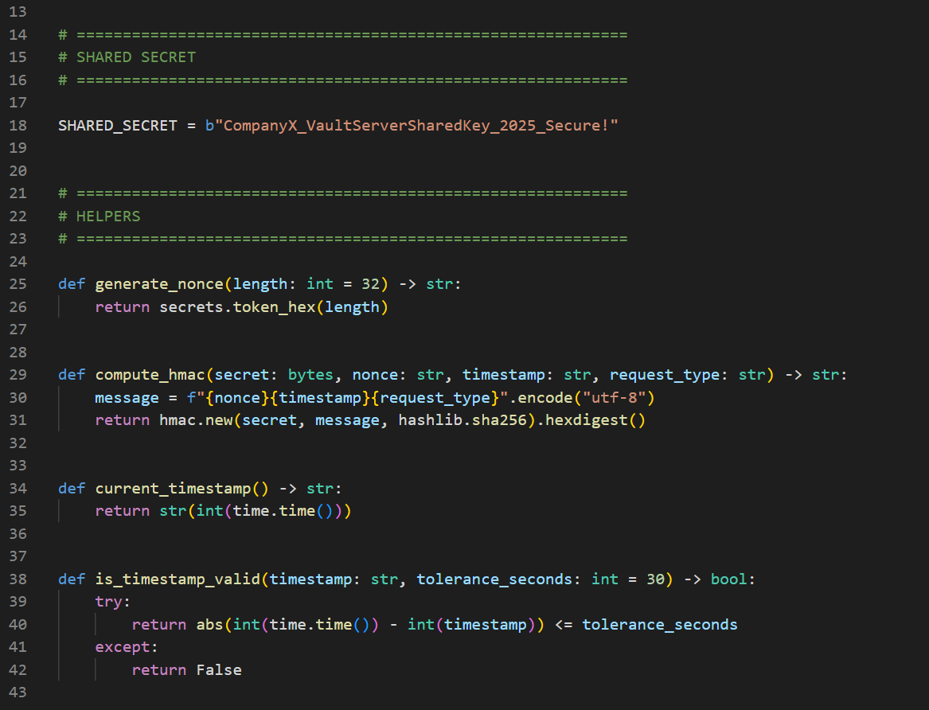
Code Block 1: Core helper functions - nonce generation, HMAC computation, and timestamp validation.
3.2.2 Vault Verification Logic
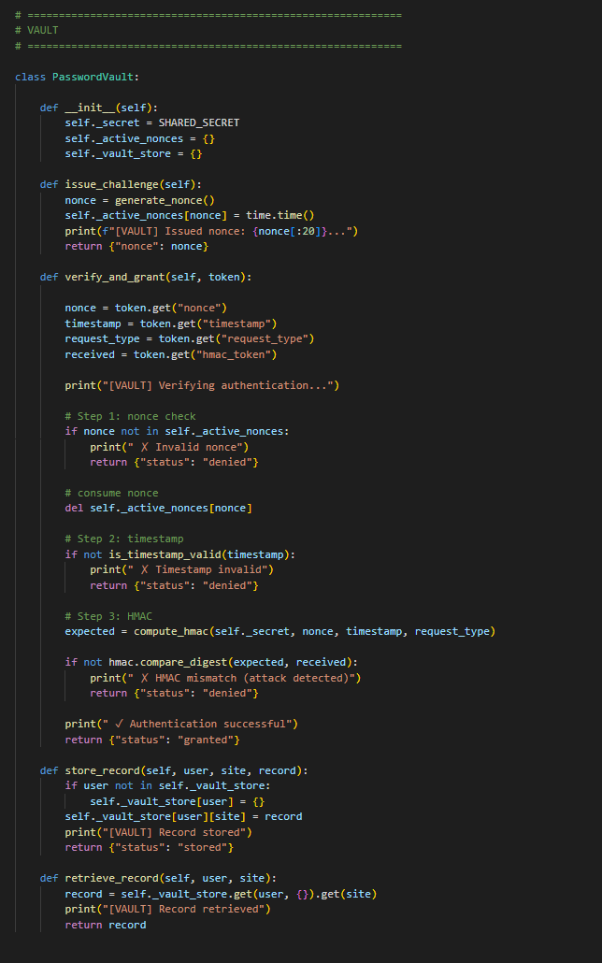
Code Block 2: Vault verification.
3.2.3 Server Authentication Handshake 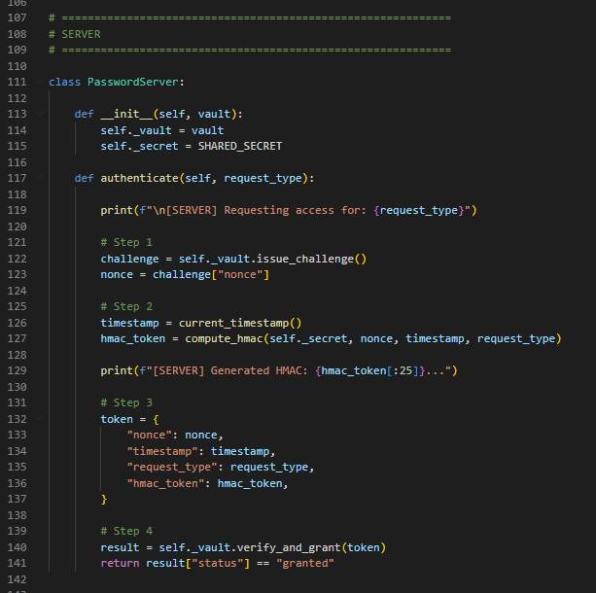
Code Block 3: Server handshake

3.3 Programme Output — Input/Output Examples
The implementation was executed in Python 3.12. The four demonstration scenarios and their outputs are presented below:
Example 1: Successful Store (Add Encrypted Password Entry)
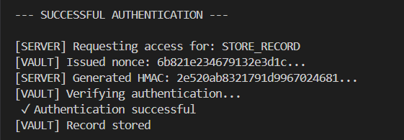
Explanation: The full challenge-response cycle completes successfully. The Vault issues a nonce, the Server computes the HMAC using the shared secret, and the Vault independently verifies it. Only then is the store operation permitted.
Example 2: Successful Retrieve
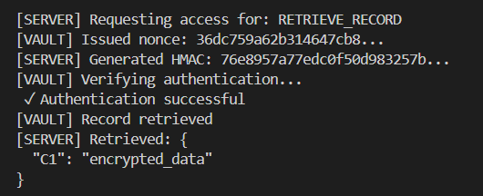
Input: Server calls retrieve_password('user_001', 'github.com').
Explanation: A different nonce is generated for each operation, demonstrating that tokens are not reusable. The Vault returns the encrypted record; the plaintext is never present — consistent with the zero-knowledge architecture from Assessment 1.
Example 3: Replay Attack — Denied
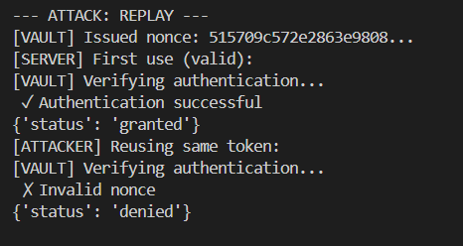
Input: Attacker attempts to reuse a previously captured (or fabricated stale) nonce.

Explanation: The stale nonce is not present in the Vault's active_nonces store (it was either never issued or has already been consumed), so the request is immediately rejected at Step 5(a). The old timestamp would also have triggered a rejection at Step 5(c).
Example 4: Impersonation Attack — Denied
Input: Attacker obtains a valid live nonce from the Vault but computes the HMAC using a wrong/guessed secret key.
[ATTACKER] Attempting to forge an HMAC with wrong key...
[VAULT] Challenge issued -> nonce=40ce90f0631dbe31... (valid, live nonce)
[VAULT] Auth DENIED -- HMAC mismatch (impersonation attempt blocked)
[ATTACKER] Result: {'status': 'denied', 'reason': 'hmac_mismatch'}
Explanation: Even with a valid live nonce, the attacker cannot produce a matching HMAC without the shared secret K. The constant-time comparison at Step 5(e) ensures no timing information is leaked during the comparison. This directly demonstrates the mechanism's resistance to impersonation.
Audit Log Output
The Vault maintains a tamper-evident audit log for all events. In production, each entry would be signed with Ed25519 (as proposed in Assessment 1) to prevent log tampering.
[VAULT] -- Audit Log --
[2026-04-21T13:22:33] CHALLENGE_ISSUED | {nonce: 'f73acac3...' }
[2026-04-21T13:22:33] AUTH_GRANTED | {request_type: 'STORE_RECORD'}
[2026-04-21T13:22:33] RECORD_STORED | {user_id: 'user_001', site: 'twitter.com'}
[2026-04-21T13:22:33] CHALLENGE_ISSUED | {nonce: 'dc14e88a...'}
[2026-04-21T13:22:33] AUTH_GRANTED | {request_type: 'RETRIEVE_RECORD'}
[2026-04-21T13:22:33] AUTH_DENIED | {reason: 'Unknown nonce'}
[2026-04-21T13:22:33] CHALLENGE_ISSUED | {nonce: '40ce90f0...'}
[2026-04-21T13:22:33] AUTH_DENIED | {reason: 'HMAC mismatch'}

3.4 Alignment with Section 1 Protocol Description
The implementation directly realises the six-step protocol described in Section 2.2.3. Steps 1 and 2 correspond to issue_challenge(); Steps 3 and 4 to _authenticate() in PasswordServer; and Steps 5 and 6 to verify_and_grant() in PasswordVault. All security properties described in the analysis — replay resistance, impersonation prevention, constant-time comparison, one-time nonce consumption, and audit logging — are present in the code and evidenced in the output above.

4. Conclusion
This report has proposed and analysed two authentication mechanisms for Company X's mobile password manager, building upon the cryptographic foundation established in Assessment 1. Mechanism 1 (SRP-6a with TLS 1.3) secures the Client-Server channel using a zero-knowledge password authentication protocol that ensures the Server never holds the user's master password in any recoverable form, while achieving mutual authentication and forward secrecy. Mechanism 2 (HMAC-SHA256 Challenge-Response) secures the Server-Vault channel with a lightweight, standards-based protocol that prevents impersonation, replay attacks, and timing side-channels.
Both mechanisms have been designed with explicit reference to recognised security design principles including Least Privilege, Defence in Depth, Complete Mediation, Zero Knowledge, Economy of Mechanism, and Fail-Safe Defaults. The Python implementation of Mechanism 2 demonstrates all protocol steps, confirms the expected behaviour for both legitimate and adversarial inputs, and produces an auditable log of vault activity.
Together, the two mechanisms provide a layered, mutually reinforcing authentication architecture consistent with the zero-knowledge, client-side-only decryption model that underpins Company X's overall security posture.

5. References
Bellovin, S.M. and Merritt, M. (1992) Encrypted key exchange: password-based protocols secure against dictionary attacks. Proceedings 1992 IEEE Computer Society Symposium on Research in Security and Privacy. IEEE.
Krawczyk, H., Bellare, M. and Canetti, R. (1997) HMAC: Keyed-Hashing for Message Authentication. RFC 2104. IETF. Available at: https://www.rfc-editor.org/rfc/rfc2104
National Institute of Standards and Technology (2002) The Keyed-Hash Message Authentication Code (HMAC). FIPS PUB 198. NIST.
Rescorla, E. (2018) The Transport Layer Security (TLS) Protocol Version 1.3. RFC 8446. IETF. Available at: https://www.rfc-editor.org/rfc/rfc8446
Taylor, D., Wu, T., Mavrogiannopoulos, N. and Perrin, T. (2007) Using the Secure Remote Password (SRP) Protocol for TLS Authentication. RFC 5054. IETF. Available at: https://www.rfc-editor.org/rfc/rfc5054
Wu, T. (1998) The Secure Remote Password Protocol. Proceedings of the 1998 Internet Society Network and Distributed System Security Symposium.
Dworkin, M. (2007) Recommendation for Block Cipher Modes of Operation: Galois/Counter Mode (GCM) and GMAC. NIST Special Publication 800-38D. Available at: https://csrc.nist.gov/pubs/sp/800/38/d/final
Biryukov, A., Dinu, D. and Khovratovich, D. (2016) Argon2: New Generation of Memory-Hard Functions for Password Hashing and Other Applications. 2016 IEEE European Symposium on Security and Privacy. IEEE.

Appendix
- Generative AI Declaration (completed)
- Student Declaration of AI Tool use in this Assessment
- Please indicate your level of usage of generative AI for this assessment - please tick the appropriate category(s).
- If the “Assisted Work” or “Partnered Work” category is selected, please expand on the usage and in which elements of the assignment the usage refers to.

Solo Work | S1 - Generative AI tools have not been used for this assessment. | ☐
Assisted Work | A1 – Idea Generation and Problem Exploration  Used to generate project ideas, explore different approaches to solving a problem, or suggest features for software or systems. Students must critically assess AI-generated suggestions and ensure their own intellectual contributions are central. | ☒
 | A2 - Planning & Structuring Projects  AI may help outline the structure of reports, documentation and projects. The final structure and implementation must be the student’s own work. | ☒
 | A3 – Code Architecture  AI tools maybe used to help outline code architecture (e.g. suggesting class hierarchies or module breakdowns). The final code structure must be the student’s own work. | ☐
 | A4 – Research Assistance  Used to locate and summarise relevant articles, academic papers, technical documentation, or online resources (e.g. Stack Overflow, GitHub discussions. The interpretation and integration of research into the assignment remain the student’s responsibility. | ☒
 | A5 - Language Refinement  Used to check grammar, refine language, improve sentence structure in documentation not code. AI should be used only to provide suggestions for improvement. Students must ensure that the documentation accurately reflects the code and is technically correct. | ☐
 | A6 – Code Review  AI tools can be used to check comments within the code and to suggest improvements to code readability, structure or syntax. AI should be used only to provide suggestions for improvement. Students must ensure that the code accurately reflects their knowledge and is technically correct. | ☐
 | A7 - Code Generation for Learning Purposes  Used to generate example code snippets to understand syntax, explore alternative implementations, or learn new programming paradigms. Students must not submit AI-generated code as their own and must be able to explain how it works. | ☐
 | A8 - Technical Guidance & Debugging Support  AI tools can be used to explain algorithms, programming concepts, or debugging strategies. Students may also help interpret error messages or suggest possible fixes. However, students must write, test, and debug their own code independently and understand all solutions submitted. | ☐
 | A9 - Testing and Validation Support  AI may assist in generating test cases, validating outputs, or suggesting edge cases for software testing. Students are responsible for designing comprehensive test plans and interpreting test results. | ☐
 | A10 - Data Analysis and Visualization Guidance  AI tools can help suggest ways to analyse datasets or visualize results (e.g. recommending chart types or statistical methods). Students must perform the analysis themselves and understand the implications of the results. | ☐
 | A11 - Other uses not listed above  Please specify: | ☐
Partnered Work | P1 - Generative AI tool usage has been used integrally for this assessment  Students can adopt approaches that are compliant with instructions in the assessment brief.  Please Specify: | ☐

Please provide details of AI usage and which elements of the coursework this relates to:

I understand that the ownership and responsibility for the academic integrity of this submitted assessment falls with me, the student. | ☒
I confirm that all details provide above are an accurate description of how AI was used for this assessment. | ☒

