Commission for Technical and Vocational Education and Training
(CTVET)

FACILITATING AND LEARNING MATERIALS FOR ACIDS, BASES AND SALTS IN INTEGRATED SCIENCE
FOR NATIONAL CERTIFICATE I

This facilitating and learning material covers all the Learning Outcomes of Acids, Bases and
Salts for National Certificate I Learning outcomes
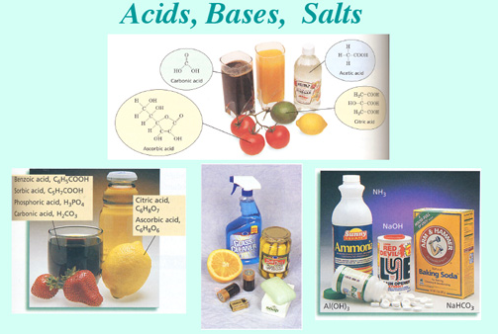

LEARNING OUTCOMES
Demonstrate knowledge in the use of the pH Scale

Demonstrate skill in conduct of photosynthesis experiment

Demonstrate knowledge in dentition

NO. | Table of Contents | Page
1 | Unit Introduction
2 | Icons and their meanings
3 | Learning Outcome 1: Demonstrate skills in identifying acids  - Pc (a) Explain acids  - Pc (b) Investigate physical properties of acids  - Pc (c) Investigate chemical properties of acids  - Pc (d) State the uses of acid in everyday life
4 | Self-assessment
5 | Learning Outcome 2: Demonstrate knowledge in bases  - Pc (a) Explain bases  - Pc (b) State the physical properties of bases  - Pc ( c) Discuss the chemical properties of bases  - Pc (d ) State the uses of bases in everyday life
6 | Self-assessment
7 | Learning Outcome 3: Demonstrate knowledge in salts  - Pc (a) Explain salt  - Pc (b) Explain the types of salts  - Pc (c) state methods of salt preparation.  - Pc (d) state uses of salts.
8 | Self-assessment
9 | Learning Outcome 4: Demonstrate knowledge in the use of the pH Scale  - Pc ( a) Define pH  - Pc (b)Interpret the pH scale  - Pc ( c)State the significance of the pH measurement  - Pc (d) State the limitations of the pH scale
10 | Self-assessment

UNIT INTRODUCTION
You are welcome to this learning material. This material introduces you to
Acids, Bases and Salts. This unit focuses on demonstrating skills in identifying acids, knowledge in bases, salts and in the use of the pH Scale.
This learning material should be used with the unit specification given. The unit specification will guide you on the standards stated with all the range statement. You should also be guided by the evidence requirements so that your learning is relevant to the required standards.
This learning material has been prepared to encourage you to work on your own. .it is full of activities that will help you to work independent and to make decisions concerning how you will approach a task in this unit. Follow the instructions and steps indicated in this learning material and work as independently as possible. We advise you to adhere to safety rules as you carry out activities in the laboratory.
Like road signs which are placed for use by drivers, the next page shows the symbols (icons) that will be used frequently in this material. It also gives the meaning of the icons, so that any time you see the icon, you will understand what it means. Please feel free to ask your facilitator any question you have as you read the material.
Have fun and enjoy your reading.

ICONS AND THEIR MEANINGS
Hello learner, as we discussed above, the following are the icons that you will find in this learning material. The meaning of each icon is provided Table 1. You will come across these icons in the material, and you should know what each of them represents. Carefully observe the icons and their meanings.

Table 1: Icons and their meanings
# | Icon | Meaning
1 |  | Learning Outcome
2 |  | Online
3 |  | Time For Activity
4 |  | Self- Assessment
5 |  | Group Discussion
6 |  | Read

Congratulations for going through this section on the icons and their meanings! We will next look at the activities under LO 1.
Dear learner, welcome to this part of the learning material that deals with the activities in LO 1.

LO 1: Demonstrate skills in identifying acids

You are expected to demonstrate skill in identifying acids in this learning outcome. To achieve this, we will go through PCs (a) – (e).

Now let’s start with PC (a). Have heard the word ‘acids’ before. If yes, explain in your own words what acids are and compare it with what we have here. I believed you had a good attempt. Don’t worry if don’t you know, that is why you have this material.

Let’s continue.

Pc (a) Explain acids

Acids exixt as molecules or ions. They interact with water and dissociate to produce protons. The proton is a positive hydrogen ion, H+. In aqueous solution it combines with water molecule to form the hydroxonium ion, H3O+. An acid is a substance proton donor. Some examples of acids are given below:
HCl_{(aq)} → H⁺ _{(aq)} + Cl⁻ _{(aq)} …………………….1
proton
HNO_{3 (aq)} → H⁺ _{(aq)} + NO₃⁻ _{(aq)} ………………………….2
proton
H2SO4(aq) → 2H+(aq) + SO42-……………………………3
proton
CH3COOH→ H+(aq) + CH3COO…………………………..4
proton

H2CO3 → H+ + HCO3-

Strong acids dissociate fully to give a high concentration of H+(aq) ions while weak acids dissociate partially to give low concentration of H+(aq) ions. The equation for dissociation of strong acid is given in equation (1), (2) and (3) above.

Examples of strong acids are

hydrochloric acid(HCl),

trioxonitrate (V) (nitric acid) acid (HNO₃ ) and

tetraoxosulphate(VI) (sulphuric )acid (H2SO4)

Examples of weak acids are

ethanoic acid (CH3COOH), and

trioxosulphate (IV) acid (H2SO3).

Acids made from mineral sources are mineral acids. Examples of mineral acids include hydrochloric acid,

trioxonitrate (V) acid and

tetraoxophosphate (V) (phosphoric ) acid (H3PO4)

acids which occur naturally and mostly found in plants and animals are organic acids. Examples are :

citric acid from lemon,grape fruit and orange,

lactic acid from sour milk

palmitic acid from palm oil and ethanoic acid from palm wine and most spicy saucces

Acids have been explained by many scientists but we shall look at Arrhenius and Brønsted-Lowry concept. According to Arrhenius, an acid is a compound when dissolved in water forms hydrogen ions (H⁺ ions ) as the only positively charged ions. It increases the number of H⁺ ions in the water.
A Brønsted-Lowry acid is a proton donor.
The three compounds in (1), (2), and (3) above are good examples of strong acids. Strongs acids are acids which are completely ionized in water.
The compound in (4) is a good example of weak acid

Many of the substances we use daily contain acids. For example oranges, palm oil, coconut oil and most spicy sauces.
Some substances that contain acids

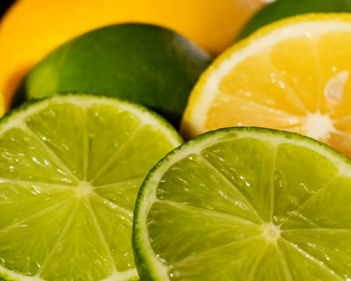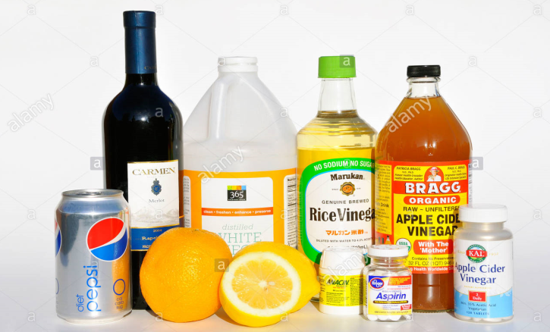

Some examples of acids :

Some examples of acids
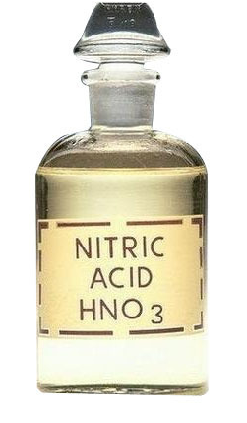  Nitric acid | 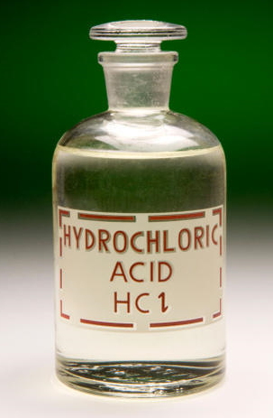  Hydrochloric acid | 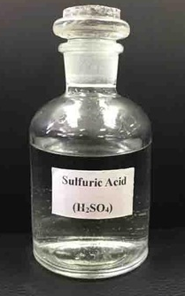  Sulphuric acid
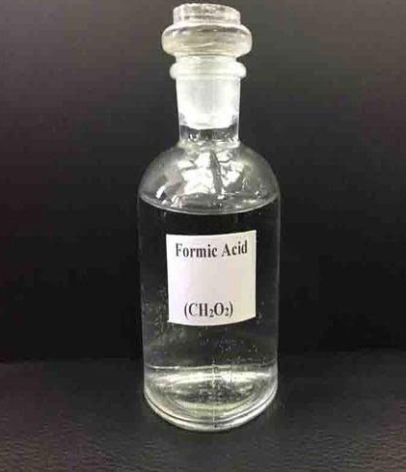  Formic acid/methanoic acid | 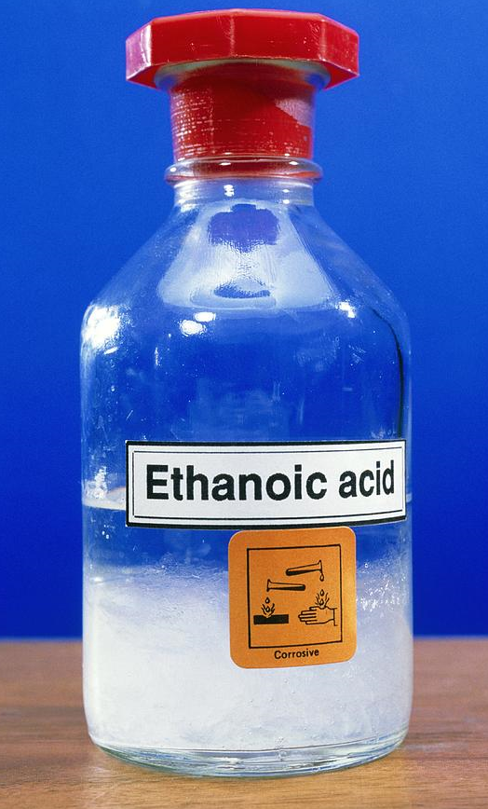  Ethanoic acid | 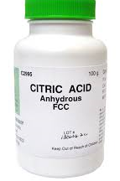  Citric acid

Now let’s continue with the physical properties of acids.

Pc (b) Investigate the physical properties of acids

You need the following materials to investigate the physical properties of acids.

Materials : any dilute acid, any concentrated acid, orange, blue litmus paper, red litmus paper piece of cloth, beaker, pH meter or scale, pure water

We strongly advise you to adhere to these safety precautions as you perform the experiment:
- Wear hand gloves before the activity
- Hand the acid with care.
- Do not let the acid get in contact with the skin.
- Add acid to water.
- If acid or alkali splashes in the eye, wash immediately with clean water.
- Use smaller reactants since dangerous explosions can take place when larger amounts of reactants are used.
- Handle the test tubes with care.
- Handle the base with care

Preform the under listed activities.to investigate the physical properties of acids,
- Pour some dilute acid in a beaker and dip blue litmus paper in it. Repeat the activity with red litmus paper. Record your observation.
- Pour dilute acid in a beaker and measure the pH using the pH scale.

Record your observation.
- Pour some water in a beaker and add some dilute acid to it. Do you see any layer formed? Record your observation.
- Pour some concentrated acid on the piece of cloth. Record your observation.

Well done, for completing the task above. Hope you enjoyed it. Now compare your observation with the following;
- It turns blue litmus to red.
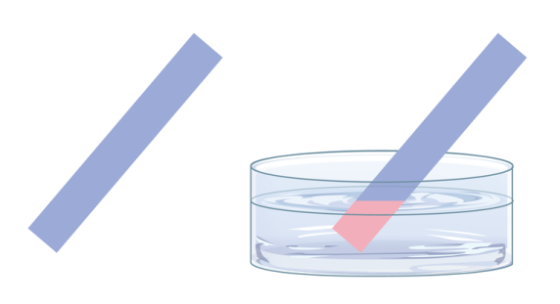
- Have pH of less than 7
- Soluble in water
- Acids are corrosive when concentrated.
The following are other properties :
- It has a sour taste.
- Aqueous solution of acids conduct electricity.
- It turns methyl orange to red.
- Acid are denser than water.
Let’s us now turn to chemical properties of acids.

Pc (c) Investigate chemical properties of acids

Acids have many chemical properties.

You need the following materials to investigate the chemical properties of acids.

Materials : aqueous hydrochloric acid( 1M), spatula, magnesium ribbon, sodium hydroxide, marble chips and sodium hydrogen carbonate, lime water, delivery tube, thermometer and burning splint.

We strongly advise you to adhere to the safety precautions stated in PC(b) above as you perform your experiment.

Preform the under listed activities.to investigate the physical properties of acids,
- Put the following substances in separate test tubes:

Tube A: a 4 cm strip of magnesium

Tube B : a spatula full of sodium hydrogentrioxocarbonate(lV)

Tube C: 5 cm3 of l M sodium hydroxide. plus a drop of litmus solution

Tube D : marble chips
- Add aqueous hydrochloric acid (about i M) to each test tube until any reaction ceases. Check the temperature of the mixture before and after the acid is added by using a thermometer.

Record your observation.
- Test the gas evolved from tube A with a burning splint and that evolved from tube B and tube D with lime water using a gas delivery tube as indicated below

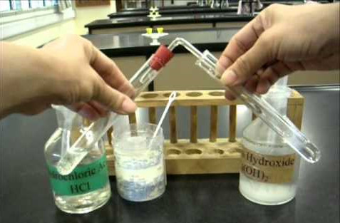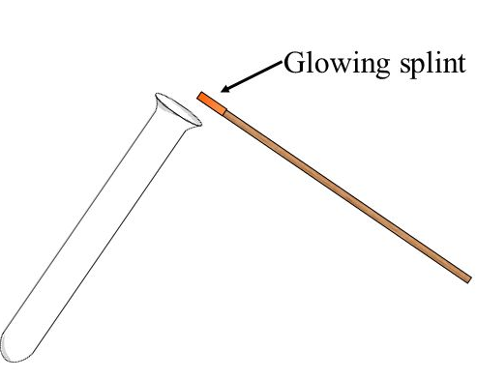

Fig.2aTesting gas using limewater Fig.2b testing gas with glowing splint
- Describe all the tests and record all your observations and gas evolved in a table like the one below. The observations should include colour. l smell, change in temperature and effect on litmus paper.
Tests | Observation | Gas evolved, if any

Test tube A: A small Mg metal was put into a test tube. Dil. HCl was added.

Well done for successfully completing the tasks. Now compare your observations with the following:

- Acids react with many metals such as magnesium, zinc and iron to give off hydrogen gas. Hydrogen gas may be recognized because it gives a pop sound when a burning splint is placed in it.

- Acids react with carbonates e.g. sodium hydrogen trioxocarbonate(lV), calcium carbonate (marble ) to produce carbon (IV) oxide gas. When the gas is bubbled through lime water it turns milky.
- Acids react wiith bases e,g. sodium hydroxide to produce salt and water.

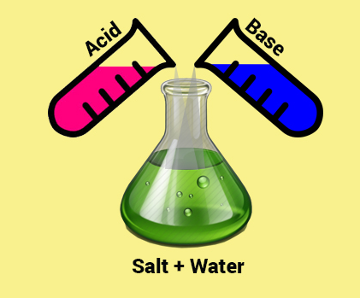

Do you think acids are useful to our everyday lives? If so, write down two ways acids are used in our everyday lives. Now compare your answer with what we have here. Let’s have a look at the uses of some acids.

PC (d) State the uses of acid in everyday life
- Hydrochloric acid (HC)
- Manufacture of chlorocompounds e.g. Polyvinylchloride (PVC)
- For digesting foods. Hydrochloric present in the gastric juices in the stomach of human body helps in digesting the foods. It acidifies the stomach contents.
- Pickling metals (i.e. cleaning off rust or stains from metals


- Nitric acid (HNO3)

Nitric acid is used in the manufacture of :
- fertilizers
- explosives
- dyes

- Sulphuric acids
- Manufacture of fertilizers
- Manufacture of synthetic fibres
- Medicine
- Paints and pigments
- Chemicals and plastics
- Pickling of metals
- Dyestuffs
- Ethanoic acid(acetic acid)
- Manufacture of vinegar
- Brightener in washing
- Flavouring of food
I believed you can state some uses of acids. Now let have a look to how to perform an acid test to complete the LO.
PC (e) Perform acid test
You will need the following materials to test for acid.
Materials: lemon, blue litmus, red litmus, beaker and water
Test A: lemon juice
Test B: acid tablet in water.
Follow the procedures to test for acid.
- Squeeze few drops of lemon juice into a beaker
- Dip blue litmus paper into it
- Dip red litmus paper into the same
- Record your observation and compare it with what we have here.
Expected observation
Acids turn blue litmus paper red. Colour of red litmus paper remain unchanged.

Now assess yourself with the questions below:
- Arrhenius acid is a proton donor. True or false
- State the effect of acid on blue litmus paper
………………………………………………………….
- State two chemical properties of acids.
- ………………………………………….
- …………………………………………
- State two materials made from acids.
- …………………………………………..
- …………………………………………….

I hope you enjoyed the activities we have gone through. We will next look at the activities under LO 2.

LO 2 Demonstrate knowledge in bases

Dear learner you are welcome to the second learning outcome of this unit. You are expected to demonstrate knowledge in bases in this learning outcome. To achieve this, we will go through PCs (a) – (e).
Let’s take PC (a) and discuss therein. But before then, explain bases in your own words in your jotter and compare with what we have below.

Pc (a) Explain bases
Bases have been explained by many scientists but we shall look at Arrhenius and Brønsted-Lowry concept. According to Arrhenius, a base is a compound that produces excess hydroxide ions (OH) in aqueous solution. A Brønsted-Lowry acid is a proton acceptor.

Examples of bases are sodium hydroxide, ammonia and calcium hydroxide.

There are two types of bases:

Strong bases= bases which fully ionized in water.

Weak bases = bases which partially ionized in water.
Many of the substances we use daily contain bases.
Some of substances which contain bases
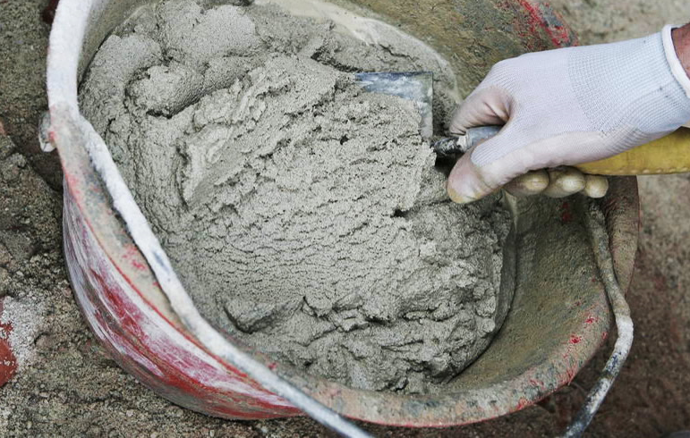  Mortar | 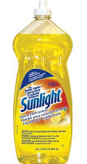  Dish detergent | 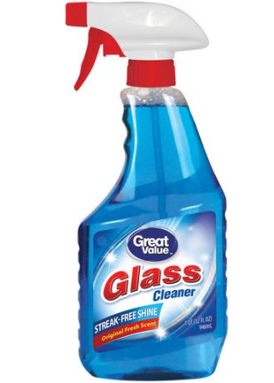  Glass cleaner
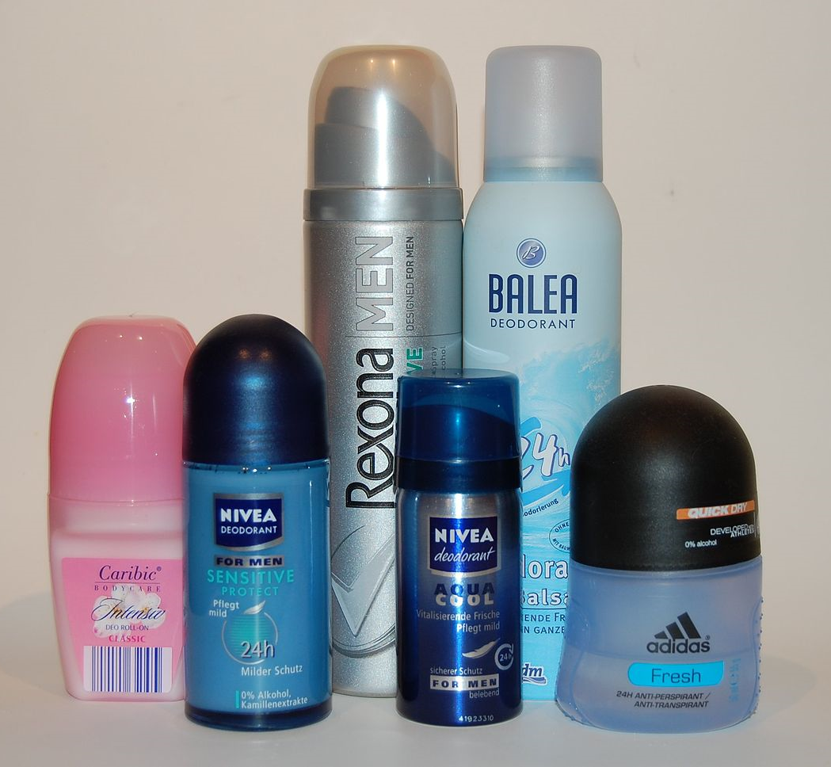  deodorants | 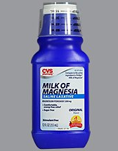  Antacid | 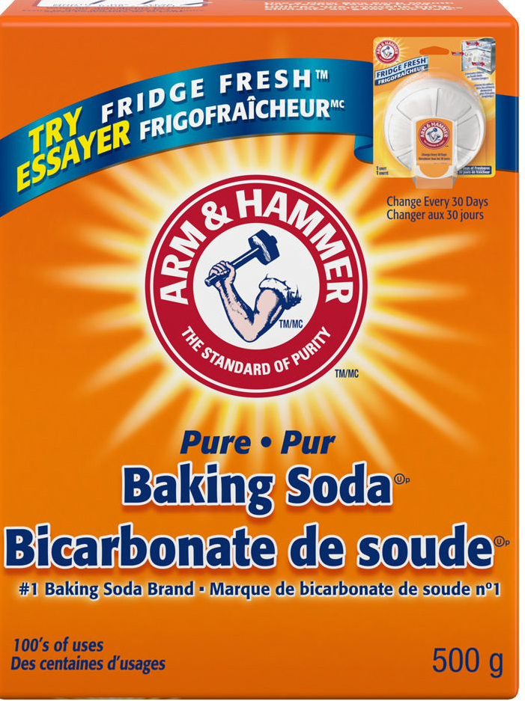  Baking soda

Now let’s proceed to the physical properties of bases.

Pc (b) State the physical properties of bases

Physical properties of bases are:
- Taste bitter
- Their pH is greater than 7
- They have slippery or soapy feel
- They turn red litmus paper blue.
- They are corrosive when concentrated
- They turn colorless phenolphthalein to pink

Now let’s have a look the chemical properties of bases

Pc ( c) state the chemical properties of bases

Chemical properties of bases are as follows:
  - They react with acids to form salt and water.
  - They react with ammonium salts to give ammonia gas.

With the information of bases given above, you write some uses of sodium hydroxide in your jotter and compare it with what we have here. Now let’s have a look at uses of some bases.

PC (d) State the uses of bases in everyday life

Sodium hydroxide
- Manufacture of Soap
- Manufacture of Paper
- Manufacture of Synthetic fabric e.g. Silk and rayon
- In the extraction of aluminium from bauxite
- used in processing cotton fabric, laundering and bleaching,
- Neutralize acids to form mineral salts
- Laboratory reagent

Calcium hydroxide
- It is used in treatment of acidity
- Softening water
- Constituent of mortar, cement and concrete
- Laboratory reagent

At this point you learnt a lot, pause and assess yourself.

Now let’s assess yourself with the questions below:
- Bronsted Lowry explained bases as compounds which produce excess hydroxide ions in dissolved in water.. True or false
- State the effect of a base on blue litmus paper
…………………………………………………………………….
- Bases react with acids to form ………….and ………….
- State two materials made from bases.
- …………………………………
- ……………………………………….

I believed you enjoyed the lesson. We will look at the activities under LO3

LO 3. Demonstrate knowledge in salts

Dear learner you are welcome to the final learning outcome of this unit. You are expected to demonstrate knowledge in dentition in this learning outcome. To achieve this, we will go through PCs (a) – (d).

Let’s take PC (a) and discuss.

Pc (a) Explain salt
A salt is an ionic compound formed when all or part of the replaceable hydrogen ions in an acid is replaced with a metal or ammonium salt. A salt is made up of a metal or ammonium ion that is positive and a negative. The negative ion comes from the acid. Salts also occur widely in nature. The most common salt is sodium chloride which is plentiful in seawater.

Some examples of salts;
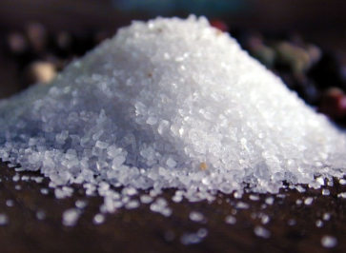  Sodium chloride (NaCl) | 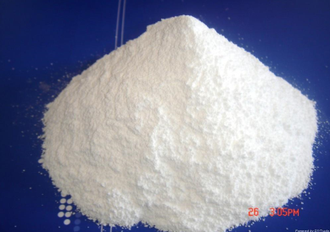  Calcium chloride (CaCl₂) | 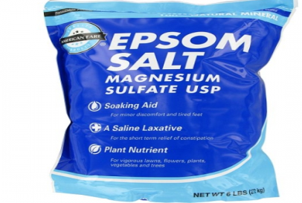  Epsom salt

There are many other examples; we encourage you to visit the internet for more of them..
Now let’s proceed to look at types of salts in our next PC.

Pc (b) Explain the types of salts

Types of salts:
- Normal salt: It is the salt formed when all the replaceable hydrogen ions of an acid have been replaced with a metal or ammonium ion. Normal salts neutral to litmus and therefore has a pH of 7. Examples of normal salts are
    - sodium chloride,
    - calcium chloride,
    - zinc chloride (ZnCl₂)
    - potassium chloride.
- Basic salts: Salt formed when insufficient acid is used to neutralize a given base. Examples of base salts include
basic zinc chloride (Zn(OH)Cl),
basic magnesium chloride (Mg (OH) Cl),
sodium hydrogen carbonate
- Acid salt is a salt in which only part of the replaceable hydrogen ions in an acid is replaced. Examples are:
Sodium hydrogen trioxocarbonate (IV), NaHCO3
Potassium hydrogen tetraoxosulphate (VI), KHSO4
At this point, pause and write some uses of sodium chloride (common slat). Compare your answer with what we have. Now let’s proceed to uses of salts.
PC (c ) State uses of salts.
Salts | Uses
Sodium chloride | Preserving food  Manufacturing sodium hydroxide  Seasoning food
Calcium carbonate | Cement  Mortar  concrete
Sodium trioxocarbaonate (IV) | Manufacturing glass  Soap  Water treatment
Magnesium tetraoxosulphate (VI) | Medicine for stomach upsets

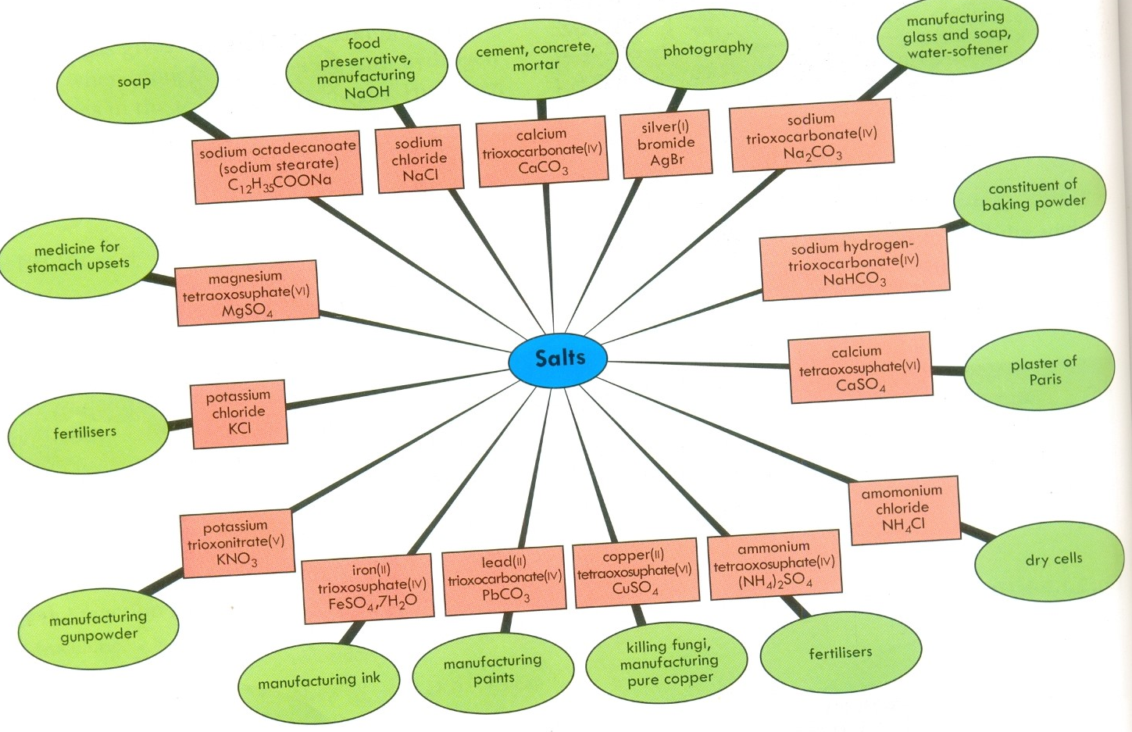

I believed you enjoyed the lesson. We will look at the activities under LO4.
LO 3. Demonstrate knowledge in the use of pH scale.

Dear learner you are welcome to the final learning outcome of this unit. You are expected to demonstrate knowledge in dentition in this learning outcome. To achieve this, we will go through PCs (a) – (d).

Let’s take PC (a) and discuss.

Pc (a) Explain pH
pH is a measure of the hydrogen ion concentration of a solution. pH measures the degree of acidity and alkalinity of dilute solutions with simple numbers.

All aqueous solutions of substances contain some hydrogen, H+, and hydroxyl, OH-, ions. The acidity or alkalinity of the solution are related to each other and also depend on the balance of the concentration of these two ions. For example, the two ions determine the sourness or bitterness of aqueous solutions and how solutions interact with other substances. The measurement of the concentration of the hydrogen ion is used to measure the balance of the two ions in aqueous solutions.

pH is a measure of the acidity or alkalinity of a solution. The pH value states the relative quantity of hydrogen ions (H+) contained in a solution. The greater the concentration of H+ the more acidic the solution and the lower the pH. In this relationship,
Now let’s interpret the pH scale.

PC (b ) Interpret the pH scale
- The pH scale runs from 0- 14 , with The pH scale runs from 0-14, with pH 7 as the
neutral point.

- Solutions of pH below 7 are acidic; the acidity
increases from pH numbers 7 to 0, pH a being
strongly acidic.

- Solutions with pH above 7 are alkaline;
alkalinity increases from 7 to 14, and pH 14 is
very alkaline.

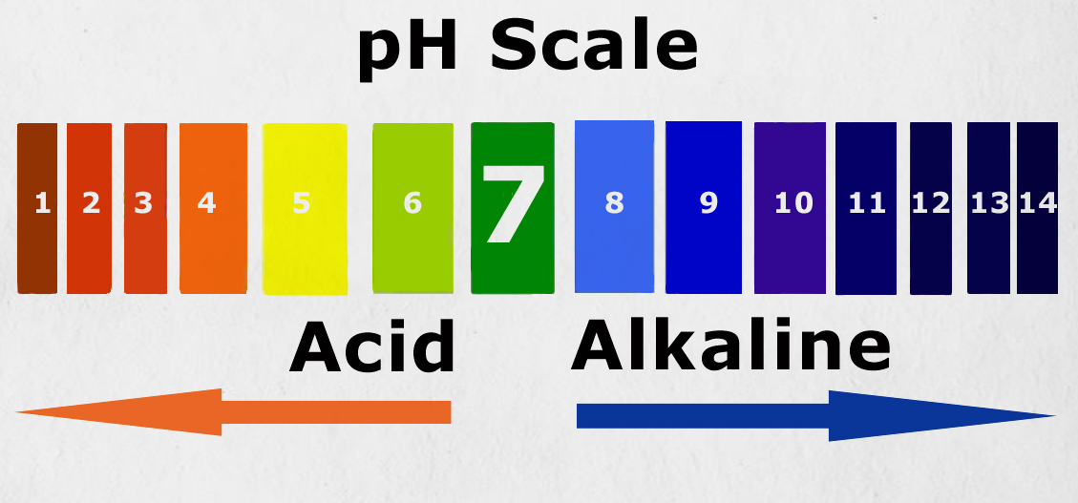

Let’s look at the significance of measuring the pH of solutions.

PC (c ) State the significance of the pH measurement

Significance of measuring pH include

It is used in the soap industry to check if soaps are not too acidic or too alkaline. In the soap industry, the final product should be neutral hence the final soap solution should have a pH of 7.

It is used in water treatment. Pure water has a pH of 7 and neutral.

It is used in pharmaceutical industry to determine the pH of various drug forms. Various drugs are prepared at given pHs which should be determined.

It enables us to determine whether a substance is acidic , alkaline or neutral as well as the degree of the aacicidity or alkalinity of the substance.

In agriculture , siols, which are too acicidic are harmful to crops and tis information is obtained by determining the pH of the soil solution. Neutralizationis carried out in practice by adding some calcium hydroxide to the soil.
To meet regulatory requirements

To avoid causing health problems to consumers

To produce products with consistent well defined properties
+], it clearly plays an important role in food processing. Among the reasons for measuring pH in food processing include:
•To produce products with consistent well defined properties
•To efficiently produce products at optimal cost
•To avoid causing health problems to consumers
•To meet regulatory requirements

PC (d ) State the limitations of the pH scale

pH is a measure of the acidity or alkalinity of a solution. The pH value states the relative quantity of hydrogen ions (H+) contained in a solution. The greater the concentration of H+ the more acidic the solution and the lower the pH. In this relationship,

the pHs of highly diluted or higly concentrated substances are outside the range 0-14 and these can not be determine by the pH scale.

Let complete this unit by assessing what we learnt sa far.

Now assess yourself with the questions below:
- The measure of acidity and alkalinity of a substance is known sas………
- a boy labeled solution with pH between 13 acidic. Is he right?.
- State one reason to measure the pH of a substance.

……………………………………………………………….
- Can the pH scale be used to measure the pH of all substances?

