Commission of Technical and Vocational Education and Training (CTVET)

FACILITATING AND LEARNING MATERIAL FOR INTEGRATED SCIENCE

*NATIONAL CERTIFICATE I*

This facilitating and learning material covers all the learning Outcomes for diversity of matter for National Certificate I

LEARNING OUTCOMES

|  |  |
| --- | --- |
|  | Demonstrate skill in preparing standard solution |
|  | Demonstrate skills in cells |
|  | Demonstrate skills in water treatment |

|  |  |  |
| --- | --- | --- |
| **NO.** | **Table of Contents** | **Page** |
| 1 | ICONS AND THEIR MEANINGS |  |
| 2 | Unit Introduction |  |
| 3 | Learning Outcome 1: Demonstrate skill in preparing standard solution   * Pc (a) Explain matter * Pc (b) state the particles of matter * Pc (c) Explain chemical bonding * Pc (d) explain the mole concept * Pc (e) Calculate the concentration of solution * Pc (f) Prepare a standard solution |  |
| 4 | Self-Assessment |  |
| 5 | Learning Outcome 2: Demonstrate skills in transport of substances in living organisms   * Pc (a) Explain cells * Pc (b) Describe the types cell * Pc (c) Describe the structure of cells * Pc (d) Describe the cell organelles * Pc (e) State the levels of cell organization * Pc (f) Explain specialized cells |  |
| 6 | Self-Assessment |  |
| 7 | **Learning Outcome 3:** Demonstrate skills in treating water   * Pc (a) State the sources of water * Pc (b) State the uses of water * Pc (c) Explain hardness of water * Pc (d) Explain water contamination * Pc (e) Describe methods of water treatment for human consumption * Pc (f) perform an experiment to treat water in the home |  |
| 8 | **Self-Assessment** |  |

UNIT INTRODUCTION

You are welcome once again to this learning materials. This is unit 2 of our learning material. In this unit, learners will be introduced to the diversity of matter. Before we move on the discuss LO 1, let us recap what we learnt in unit 1. Can you recollect the major things we learnt in unit 1? Well done if you were able to do that, however, don’t worry if you were unable to do that. Let me help you. In unit 1, we learnt about demonstrating knowledge in the study of science, living and non-living things, and demonstrating skill in laboratory safety.

Now let us focus our attention on unit 2. In this unit, learners will be required to demonstrate skill in preparing solution, knowledge in cells together with demonstrate skill in water treatment. When you complete this unit successfully, you will be able to prepare solutions of a given concentration, and perform a simple task of treating water in the home.

This learning material should be used with the unit specification given. The unit specification will guide you on the standards stated with all the range statement. You should also be guided by the evidence requirements so that your learning is relevant to the required standards.

We have written this learning material to encourage you to work on your own and it is full of activities that will require you to work independently and to make decisions concerning how you should approach a task. Kindly follow the instructions and the steps indicated in this learning material and work as independently as possible.

You will find on the next page symbols (icons) that will be used frequently in this material. It also gives you the meaning of the icons, so that any time you see the icon, you will understand what it means. Please feel free to ask your facilitator any question you have as you read the material.

Enjoy reading the material!

**ICONS AND THEIR MEANINGS**

Dear learner, it is time to know some of the icons that you will see in this learning material. The meaning of each icon is provided in Table 1. You will come across these icons in the material, and you should know what each of them represents. Carefully observe the icons and their meanings.

Table 1: Icons and their meanings

|  |  |  |
| --- | --- | --- |
| **No** | **Icon** | **Meaning** |
| 1 | j0293844 | Learning Outcome |
| 2 | 🖳 | Online |
| 3 | 🕙 | Time For Activity |
| 4 | 🏋 | Self- Assessment |
| 5 | 👪 | Group Discussion |
| 6 | 📚 | Read |

Congratulations for going through this section on the icons and their meanings! We will next look at the activities under LO 1.

Dear learner, welcome to this part of the learning material that deals with the activities in LO 1.

|  |  |
| --- | --- |
| j0293844 | **LO 1: Demonstrate skill in preparing standard solution** |

📚 You are expected to demonstrate skill in preparing standard solution in this learning outcome. To achieve this, we will go through PCs (a) – (d).

**PC (a) Explain matter**

Before we explain matter, I would like you to write down some of the things you see around you. Beautiful! Now compare your answers with mine: table, pens, chairs, air, books, and so on. Why did we do this exercise? This will lead us to our discussion. Now let us begin by explaining the term matter. Let’s begin by explaining what matter is.

Matter is anything that has mass and takes up space. Matter is all around us. Matter is the air you are breathing. Matter is the textbook you are reading from now. Matter is the stuff you touch and see. Some examples of matter include food, trees, table, cars, animals, tables, stones, water, smoke, vapour, and many more. Since we mentioned mass, I will go further to define mass. Mass is the amount of matter in an object. The standard unit of mass in the International System (SI) is the kilogram (kg).

Mass is not the same thing as its weight. The weight is a measure of the gravitational force exerted on an object. (Gravitational force is the pull or push that act on a body towards the ground. It is gravitational force that makes it possible to sit). At the earth's surface, an object may weigh 1 kilogram for example. But on Mars, the same object may weigh only about 0.4 kilograms, and on Jupiter it may weigh about 2 kilograms.

The figure below gives you further examples of matter.

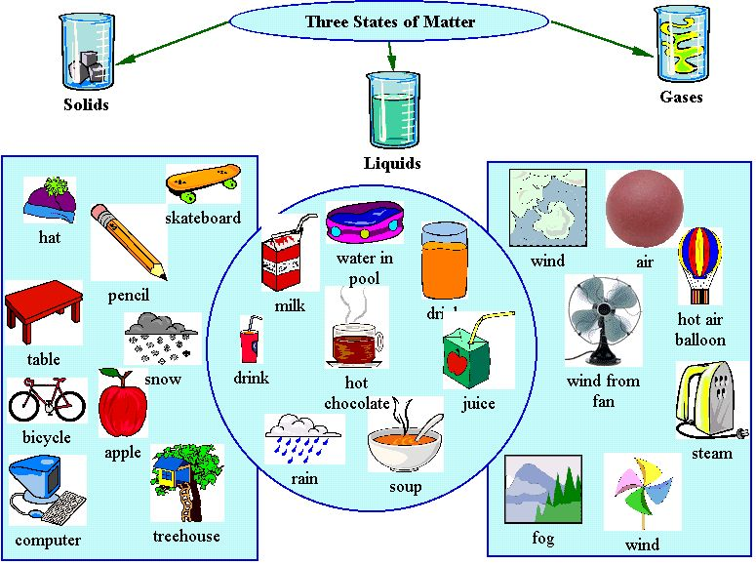

**Figure 1. A photograph showing examples of matter and the state they exist.**

🕙 **Time for Activity**

Hello learner in 10 minutes, with the kind permission of your facilitator, go outside and write down all the matter you can find around your school compound. Welcome back! Show your work to your friend to assess if what you wrote are all matter. Your facilitator will call some of you at random and ask you to tell the class what you wrote down.

**Classification of matter**

You have done very well. Pat your friend on the shoulder and say well done. Let us move on to discuss the classifications of matter. Matter can be classified in two different ways. The classification of matter is according to its:

1. State, and
2. Composition.

**Classification of matter according to its state**

Matter has three states. They are: Solid, Liquid, and Gas

**Solids**

Matter that is composed of particles packed tightly together are known as solids. A solid is distinguished by a fixed structure. Its shape and volume do not change. For example your textbook will not change shape tomorrow. Solids hold their shape at room temperature. In solids, particles are packed together in a fixed arrangement. You cannot walk through a solid wall. The matter is packed so tight that it prevents you from moving through it as you can see in the figure 2 below.

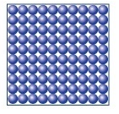

**Figure 2. A photograph showing how the particles of solids are arranged**

Below are some images of solids

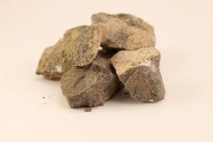 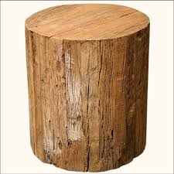 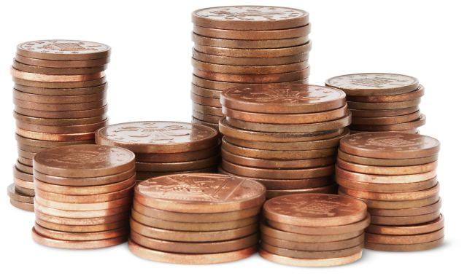

Stone wood coins

**Liquids**

Now let us move from solids to liquids. Liquids do not hold their shape at room temperature. There is space between the particles of liquid and they move slightly all of the time. This allows you to stick your finger into water and pull it back out, letting the water fill back in where your finger once was. Liquids flow or pour and can take on the shape of a container. If the liquid is poured into a wider or narrower container, the liquid will take on that new shape. Imagine going into a restaurant and asking for lemonade. What if the waiter just put the lemonade into your hands ‐ no glass or cup? Could you lay the lemonade on the table to drink in a few minutes? Even water in a river or a lake has a container ‐ the banks, the bottom, the shore ‐ they form the container. Examples of liquids include water, petrol, oil, juice and so on. The arrangement of the particles of liquid are shown below in figure 3.

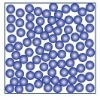

**Figure 3. A photograph showing how the particles of liquid are arranged**

🕙 **Time for Activity**

Dear learner I have provided below some pictures of liquids you see in everyday life. Draw and label these pictures.

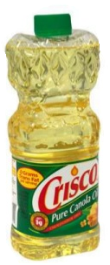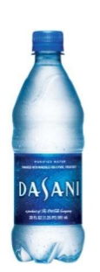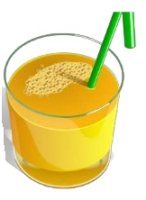

**Gases**

Now proceed to talk about gases. Gases do not hold their shape at room temperature, therefore, do not stay put. Gases are always moving. There is so much space between the particles in gas that you can move around in them easily. When you walk from one side of the room to the other, you have walked through a bunch of gases that make up our air. You barely even know they are there. Gases will take on the shape of their container and can be compressed into a smaller space. Like when we compress air into a balloon ‐ it fills out the balloon shape. Gases will fill up the space too. You don't see only half of the balloon filled with air. With this a gas has no fixed shape and volume. Examples of gases include air, carbon dioxide, water vapour, natural gas, clouds, smoke and many more. Figure 4 below illustrates the arrangement of the particles of gases.

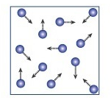

**Figure 4. A photograph showing how the particles of gas are arranged**

🕙 **Time for Activity**

Dear learner this activity aims to help you assess the behaviour of gases. Your facilitator will expose a puff of perfume in front of the class for a period of 3 minutes, 5 minutes, and then 10 minutes. Draw a table as shown below and describe your observation in each column. Draw your conclusion.

|  |  |  |  |
| --- | --- | --- | --- |
| **Time** | **3 minutes** | **5 minutes** | **10 minutes** |
| **Observation** |  |  |  |

Conclusion: ………………………………………………………………………………………………………………………………………………………………………………………………………………………………………………………………………………………………………………………

**Classification of matter according to its composition.**

Matter can be classified into two broad categories. They are:

* Pure substances, and
* Mixtures.

**Pure substances**

A pure substance is a form of matter that has a constant composition (meaning it's the same everywhere). The properties are also constant throughout the sample (meaning there is only one set of properties such as melting point, color, boiling point, etc. throughout the matter). A material composed of two or more substances is a mixture. Elements and compounds are both examples of pure substances. A substance that cannot be broken down into chemically simpler components is an element. Some examples of elements are Aluminum, sodium, calcium, chlorine and so on.

A substance that can be broken down into chemically simpler components (because it has more than one element) is a compound. For example, water is a compound composed of the elements hydrogen and oxygen. Ordinary table salt is called sodium chloride. It is considered a substance because it has a uniform and definite composition. All samples of sodium chloride are chemically identical. Water is also a pure substance. Salt easily dissolves in water, but salt water cannot be classified as a substance because its composition can vary. You may dissolve a small amount of salt or a large amount into a given amount of water.

**Mixtures**

A mixture is a physical blend of two or more components, each of which retains its own identity and properties in the mixture. Only the form of the salt is changed when it is dissolved into water. It retains its composition and properties.

A homogeneous mixture is a mixture in which the composition is uniform throughout the mixture. The salt water described above is homogeneous because the dissolved salt is evenly distributed throughout the entire salt water sample. Often it is easy to confuse a homogeneous mixture with a pure substance because they are both uniform. The difference is that the composition of the substance is always the same. The amount of salt in the salt water can vary from one sample to another. All solutions would be considered homogeneous because the dissolved material is present in the same amount throughout the solution.

A heterogeneous mixture is a mixture in which the composition is not uniform throughout the mixture. Vegetable soup is a heterogeneous mixture. Any given spoonful of soup will contain varying amounts of the different vegetables and other components of the soup. All matter is made up of tiny particles or building blocks. These tiny particles or building blocks are called atoms, molecules and ions.

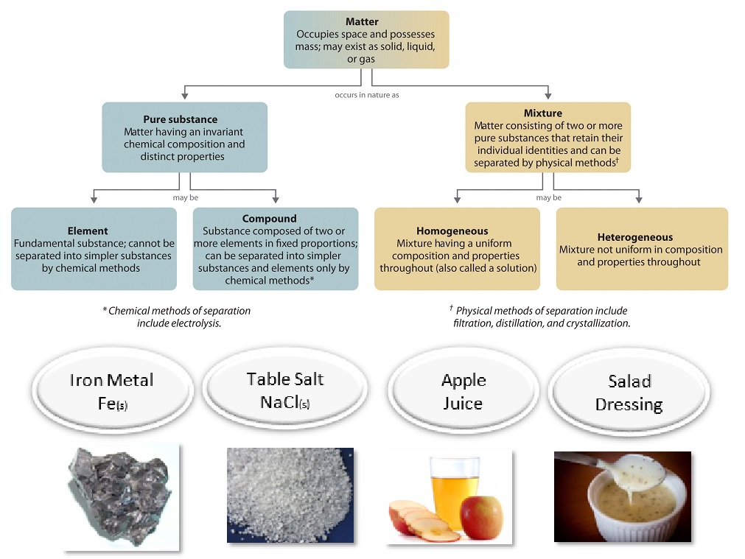

**Figure 5: A photograph showing the relationships between the classification of matter and the methods used to separate mixtures.**

**PC (b) Describe the particles of matter**

Hello learners we now want to move to discuss the particles of matter. Remember that in our previous Pc we mentioned that all matter is made up of tiny particles or building blocks. This Pc deals with the properties of matter. You would be expected at the end of this session describe the particles of matter. Let’s proceed with our discussion.

**The particles of matter**

Matter is made up of extremely tiny particles. These tiny particles are called atoms, ions, and molecules.

**The atom**

The atom is the smallest unit of an element that can take part in chemical reaction and exhibits the properties of that element. The atom is made up of three types of smaller particles called electrons, protons and neutrons.

The protons and neutrons together form the nucleus which is the central part of the atom. The proton is positively charged but the neutron is neutral. Surrounding the nucleus are electrons. The electrons are negatively charged. Protons have a relative charge of +1, while electrons have a relative charge of -1.

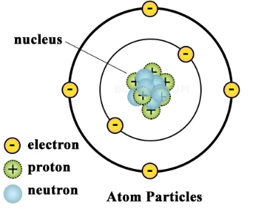 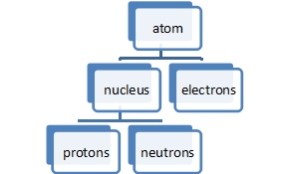

**Figure 6: A pictorial representation and a flow diagram of the atomic structure**

🏋**Self- Assessment**

Why do you think the atom is neutral?

………………………………………………………………………………………………………………………………………………………………………………………………………………………………………………………………………………………………………………………

You did well. Now compare your answer with mine. The total number of electrons in an atom is always the same as the number of protons in the nucleus. This means atoms have no overall electrical charge. The number of protons in an atom is called its atomic number.

**Arrangement of electrons in shells**

We want to process to look at how the electrons are arranged in the atom. Electrons are arranged in energy levels, orbitals or shells, and different energy levels can hold different numbers of electrons. Each shell can hold a certain number of electrons. The first orbit can hold a maximum of two (2) electrons, and all the other shells can hold eight electrons. The maximum number of electrons that a shell can take is given by 2n2 where n is the shell or orbit number.

The proper arrangement of electrons in an atom is called electronic configuration. Therefore, the electronic structure of an atom is a description of how the electrons are arranged. The electronic configuration of carbon is 6. This can be shown in the diagram below. Let’s look at how the electrons are arranged in carbon.

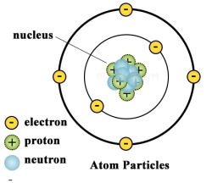

**Figure 7: The electronic configuration of carbon**

🏋**Self- Assessment**

Kindly practice this on your own. This will let me know that you have understood the concept of arrangement of electrons in an atom. Draw the structure of the following elements.

1. Oxygen atom with atomic number 6
2. Sodium atom with atomic number 11
3. Chlorine atomic number 17

**The molecule**

A molecule is the smallest particle of a substance that is capable of existing on its own, and still retains the chemical properties of that substance. A molecule is formed when two or more atoms chemically joined together.

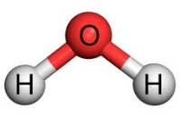

A model depicting a water molecule

**The ion**

An ion is a charged atom or a group of atoms which possess an electric charge. An ion may be positive and this is called cation. This if formed when the atom loses electrons. The diagram below shows how sodium ion is formed. In this diagram, sodium loses one electron to become stable. The result is an ion that has a positive charge.

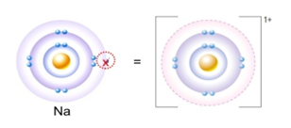

**Figure 8: Formation of sodium ion**

A negative ion is formed when an atom gained electron(s). Anions are atoms or radicals (groups of atoms), that have gained electrons. Since they now have more electrons than protons, anions have a negative charge. For example, chloride ion (Cl-), Bromide ion (Br-), Iodide (I-). These are monovalent anions, meaning they have a combining capacity with only one ion of hydrogen. Similarly there are bivalent anions, and so on. Anions are termed so because they are attracted towards positive ends. All Anions tend to accept a proton H+ thus they are categorized as bases.

**Pc (c) Explain chemical bonding**

I hope you can now describe the particles of matter. This Pc will teach you how elements come together to form compounds. With this knowledge, let us continue with our study and discuss chemical bonding.

**Chemical bonding**

The way in which atoms join to form molecules depends on the type of atom and the number of electrons in the outermost shell. A full shell consists of eight electrons, and a full shell is stable. Atoms join together in a way that makes their outer shell of electrons full and stable. When atoms combine, it is the electrons in their outermost shell that react by either transferring electron(s) from one atom to another or sharing electrons between or among atoms. There are two main ways in which atoms combine to form compounds. These are ionic also known as electrovalent bonding, and covalent bonding.

**Ionic or electrovalent bonding**

Ionic bonding is the formation of compound as a result of a complete transfer of electron(s) from the outermost shell of the one atom to the other atom. The atom that is more electropositive donates the electron(s) and becomes positively charged ion and the electron(s) are/is accepted by the more electronegative atom and becomes a negative ion. The diagram below illustrates how sodium loses an electron to chlorine in order to form a compound. The compound formed is call an ionic compound.

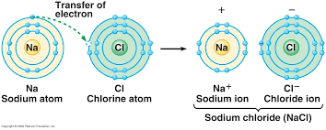

**Figure 8: Formation of sodium chloride**

**Covalent bonding**

Covalent bonding occurs when pairs of electrons are shared by atoms. Atoms will covalently bond with other atoms in order to gain more stability, which is gained by forming a full electron shell. By sharing their outer most (valence) electrons, atoms can fill up their outer electron shell and gain stability. Nonmetals will readily form covalent bonds with other nonmetals in order to obtain stability, and can form anywhere from one to three covalent bonds with other nonmetals depending on how many valence electrons they possess. Although it is said that atoms share electrons when they form covalent bonds, they do not usually share the electrons equally.

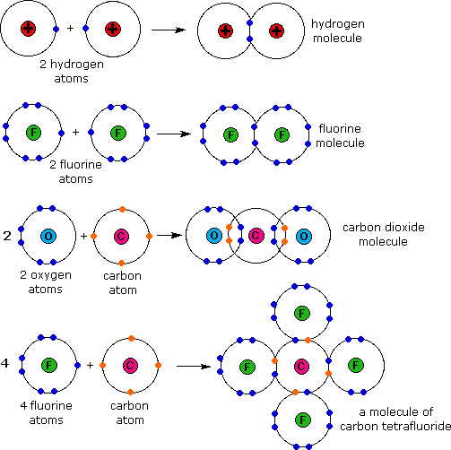

**Figure 9: Formation of covalent compounds**

**The octet rule**

The octet rule requires all atoms in a molecule to have 8 valence electrons, that is, either by sharing, losing or gaining electrons to become stable. For Covalent bonds, atoms tend to share their electrons with each other to satisfy the Octet Rule. It requires 8 electrons because that is the amount of electrons needed to fill L, M or *N* orbital. This phenomenon is also known as a noble gas configuration. Each atom wants to become as stable as the noble gases that have their outer valence shell filled because noble gases have a charge of 0.

**Pc (d) Mole concept**

Having finished with Pc (c), we are ready to consider Pc (d) under this LO. This Pc looks at the mole concept. Follow me through closely and let me take you through the mole concept. To start with, you must be very clear about what exactly a mole represent.

**The mole**

The mole is the unit of measurement in the International System of Units (SI) for amount of substance. 1 Mole is just a number whose value is equal to the Avagadro’s number i.e. 6.022 x 1023. So, when someone claims of a matter to be of 1 mole in quantity, that implies that the matter under consideration contains exactly 6.022 x 1023 number of particles (atoms, molecules, ions, electrons or any other elementary entities). This is very similar to the unit ‘dozen’, which is a common analogy used to explain the concept of mole, a dozen is always equal to 12 irrespective of the object referred to.

**Molar mass**

The molar mass is the mass of one mole of any substance. It is equal to the sum of the relative atomic masses of all the atoms. Its unit is gram per mole. Let find the molar mass of sodium chloride (NaCl) and Hydrogen tetraoxosulphate (VI) acid (H2SO4)given the relative mass of each of the atoms as: [S=32, Na=23, O=16, Cl=35.5, H=1].

Let us solve the questions together.

NaCl = (atomic mass of Na + atomic mass of Cl)

= (23 + 35.5)

= 58.5 g/mol

H2SO4 = (atomic mass of H + atomic mass of S + atomic mass of O)

= ([2x1] + 32 + [16x4])

= (2 + 32 + 64)

= 98 g/mol

🕙 Time for Activity

Practice the following examples on your own. Wish you good luck.

1. H2O
2. CO2
3. PCl5

**Calculating the mole (amount of substance)**

Though mole is defined as a number but it’s not limited to that in calculations. It has various other equivalent definitions with the only difference from each other being that they define mole for different states of matter and at different conditions. The mole or the amount of substance is also given as the ratio of the mass (g) and the molar mass (g/mol).

Therefore, the mole is given as,

**That is**,

For example find the amount of substance in 117g of NaOH if [Na=23, O=16, and H=1]

Using the formula

🕙 Time for Activity

Dear learner let us try our hands on the following questions. Wish you good luck.

1. Find the amount of substance in 20g of Al2O3.

[Al=27, O=16]

1. Top of Form
2. How many moles of Fe2O3 are present in 100g of the oxide?

[Fe=55.8, O=16]

Bottom of Form

**Pc (e) Calculate the concentration of a substance**

Now welcome to the Pc that will discuss calculating concentration. I will lead you through this Pc to teach you how to calculate concentration which will aid you to prepare solution in the next Pc.

Concentration is defined as the amount of substance dissolved in one cubic decimetre of the solution.

It’s calculated using this relation:

The unit of concentration is mol/dm3

For example, let us find the concentration of a 0.2mol NaOH in 500cm3.

Amount of substance= 0.2mol

Volume = 50cm3 = 50/1000 = 0.005dm3

Concentration, c = 0.4 mol/dm3

🕙 Time for Activity

From what we have learnt so far about concentration, I think you can practice this on your own.

What is the concentration of a solution of 0.01mol NaOH in 50cm3?

**Pc (f) Prepare a standard solution**

A standard solution is a solution whose concentration is known accurately. Its concentration is usually given in mol/dm3. When making up a standard solution it is important that the correct mass of substance is accurately measured. It is also important that all of this is successfully transferred to the volumetric flask used to make up the solution. Standard solution is prepared using standard volumetric flask. The following background calculations will help you prepare a standard solution.

**Background calculations**

1. Work out the number of moles needed to make up a solution with the required volume and concentration. Follow your working in the box.

**Moles = concentration x volume**

Concentration is mol dm–3 (M) and volume is in dm3, so if the volume is given in cm3, divide it by 1000 to get dm3. However, if the volume is not given, use the molar concentration. For example 2M solution means 2 mol in a volume of 1dm3

1. Now work out the molar mass, Mr, of the chosen substance.

You learnt how to calculate molar mass from Pc (c). Example the molar mass of NaCl = (atomic mass of Na + atomic mass of Cl)

= (23 + 35.5)

= 58.5 g/mol

1. Calculate the mass of the substance needed using your answers from steps 1 and 2.

That is mass of NaCl = mole x molar mas

= (2 mol x 58.5g/mol)

= 117 g

🕙 Time for Activity

Dear learner, obtain the following apparatus and materials from your facilitator.

**Apparatus and materials**

* 250ml volumetric flask
* Filter funnel
* Stirrer
* Dropper
* Wash bottle containing distilled water
* Chemical balance
* Spatula
* Sodium chloride
* Stopper

Now prepare a 250ml 1M sodium Chloride solution

**Procedure**

1. Calculate the mass of sodium chloride required using the procedure in the background calculation.
2. Weigh the sodium chloride mass required into dry beaker using a balance and record the mass.
3. Dissolve the mass of sodium chloride in a beaker
4. Transfer the solution into a 250ml volumetric flask.
5. Wash the beaker, stirrer and funnel into the volumetric flask. Do this about two times.
6. Add more distilled water till the volume of solution is close to the 250ml mark on the volumetric flask.
7. Use the dropper to top up the solution up till the bottom of the meniscus is in line with the mark.
8. Use cork stopper to cover the solution and shake until there is a uniform mix.
9. Label the solution.
10. Then tidy up!

This procedure is also illustrated in the diagram below.

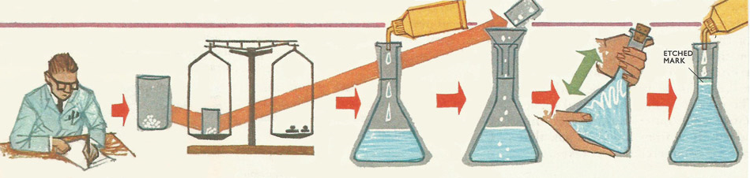

**Figure 10: steps to prepare a standard solution**

**Precautions:**

* Handle the glass ware with care.
* Wash and dry all the glass wares before and after the activity.
* Wear your personal protective Equipment
* The correct mass of substance was accurately measured.
* All the mass was successfully transferred to the volumetric flask

Hello! You are welcome to this next LO under this unit. I can assure you, it is going to be very interesting. Enjoy reading this material.

|  |  |
| --- | --- |
| j0293844 | **LO 2:** : **Demonstrate skill in cells** |

📚 You are expected to demonstrate knowledge in cells in this learning outcome. To achieve this, we will go through PCs (a) – (f).

In Pc (a), I would explain to you what a cell is. But before I do that I would like to find out some few things from you. In your view what building material forms the basic unit of this laboratory? Pause for a while and think about an answer for the question. Did you get the answer right? My answer is the block. If you got it, well done. My next question is, what do you think is the basic unit of living things? Write your answer in your jotter. You will find the answer in this material. Let us now proceed to discuss cells.

**Pc (a) Explain cells**

**Cells**

All living things, large or small, plant or animal, are made up of cells. Some living things are made up of one cell and they are called unicellular organisms. For example amoeba, euglena, fungi, moss, paramecium and others. Many other living things are made up of a large number of different cells. These living things are known as multicellular organisms. Plants and animals are example of this category of cells. Water makes up about two thirds of the weight of cells.

Cells are very small. Most cells can only be seen through a microscope. A cell can be defined as the smallest living units that are capable of reproducing themselves. Each cell in your body was made from an already existing cell. All plants and animals are made up of cells.

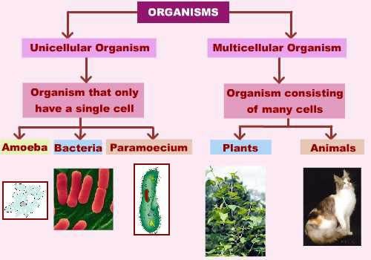

**Figure 11: A flow diagram of organisms and the cell type**

There is no such thing as a typical cell. Your body has many different kinds of cells. Though they might look different under a microscope, most cells have chemical and structural features in common. Cells are the basic structural and functional unit of all living organisms. Each cell is capable of carrying out life processes. A cell in independent of another cell. That means one cell is capable of living alone without the other.

**Pc (b) Describe the types biological cell**

In this Pc we are going to learn about the types of biological cells. You will be able to tell the type of biological cells every organism ids made of. Let us now proceed to learn about the types of biological cells.

**Type biological cells**

There are two basic types of cells in biological organisms. These are:

* Prokaryotic cells
* Eukaryotic cells

**Prokaryotic cells** are simpler and smaller than the eukaryotic cells. The term prokaryote is derived from the Greek word- “prokaryote” meaning before nuclei. These cells lack membrane bound organelles. Prokaryotic cells are unicellular organisms, which reproduce through binary fission. In some cases few prokaryotic organisms also reproduce by budding. Prokaryotic cells have a cell envelope, which generally consists of a capsule, cell wall, cytoplasm, plasma membrane, cytoplasm region or nucleiod region, ribosome, plasmids, pili and flagella.

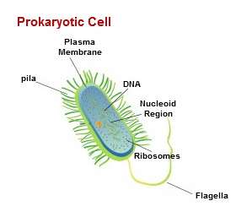

**Figure 12: A diagram of a prokaryotic cell**

**Eukaryotic cell**

Eukaryotic cells are those cells, which are complex and larger than the prokaryotic cells. The term eukaryote is derived from the Greek word- eukaryote meaning true or good nuclei. Eukaryotic cells can be easily distinguished through a membrane-bound nucleus. The life, which is present and visible by our naked eye, is all made up of these cells. Eukaryotic cells are membrane-bound organelles, which have a multiple membrane-bound organelles to carry out specific cell tasks. They have different internal membranes, which are known as organelles. These organelles play a vital role in cell maintenance and other functions. These organelles generally consist of cell wall, plasma membrane, nucleus, mitochondria, chloroplasts (plastids), endoplasmic reticulum, ribosome, Golgi apparatus, lysosomes, vacuoles, cytoplasm, and chromosomes. Organisms that have eukaryotic cells include protozoa, fungi, plants and animals

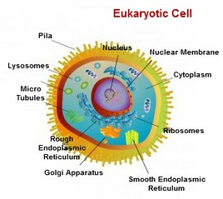

**Figure 13: A diagram of a prokaryotic cell**

**Pc (c) Describe the structure of eukaryotic cells**

Well done for completing Pc (b). I believe you can now tell which type of biological cells make up your body cells. That is great! Since eukaryotic cells are found in complex organisms, let us not take a look at their structure. Therefore, the next Pc will discuss the structure of eukaryotic cells.

**Structure of eukaryotic cells**

Plant and animal cells are composed of protoplasm which is divided into two main parts: the cytoplasm and nucleus. Each cell is bounded by a thin membrane called the cell surface membrane. The cytoplasm is a fluid material that consist of cytoplasmic organelles such as lysosomes, Golgi bodies, mitochondria, vacuole, reticulum, etc. The nucleus is made of a thick dense structure called the nucleolus and bound by the nuclear membrane. In the nuclear membrane are open spaces that allow for the exchange of substances between the nucleus and the cytoplasm.

Though plant and animal cell are all eukaryotic cells, there are some differences between plants and animal cells. The animal cell in addition has centrosomes. The plant cell in addition, also has cellulose cell wall, starch granules, and some plastids (chloroplast).

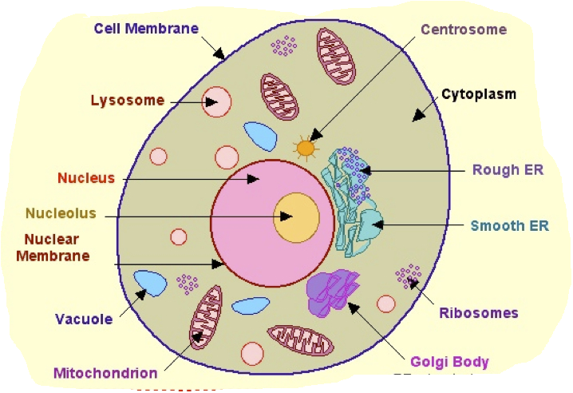 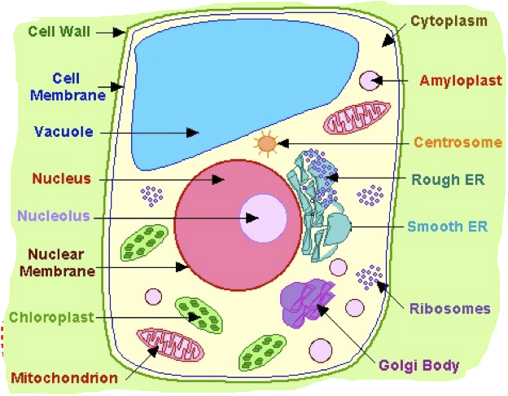

**Figure 14: A photograph of plant and animal cells**

🕙 Time for Activity

Dear learner, you have learnt about the types of biological cells and the types of eukaryotic cells. With this knowledge, let us practice these activities.

1. Tabulate the differences between eukaryotic and prokaryotic cells.
2. Tabulate the differences between plant and animal cells

Visit the library and learn more about the differences between eukaryotic and prokaryotic, plant and animal cells

**Pc (d) Describe cell organelles**

In this Pc you will learn about cell organelles and how they support the cell to function. It is a very interesting area to look at. You will be able to relate this to how your body also functions. Let us now get started and discuss the cell organelles.

**Cell organelles**

An Organelle is a membrane-bound compartment or structure in a cell that performs a special function.  Individual organelles are usually separately enclosed within their own membranes. The name organelle comes from the idea that these structures are parts of cells, as organs are to the body, hence organelle. Organelles are identified by the use of a microscope. There are many types of organelles, particularly in eukaryotic cells.

Below are some organelles and their functions:

* Mitochondria; to produce energy.
* Chloroplast: it site for photosynthesis due to the presence of chlorophyll
* Vacuole: temporary storage of food substances and waste metabolic products.
* Nucleus: controls the activities of the cell and contains hereditary materials (DNA) which is passed on from parent to offspring.
* Ribosomes: synthesize or make proteins

👪 **Group Discussion**

Your facilitator will put you into groups not more than five. Each group is supposed to list the cell organelles and discuss their functions. You will also discuss how their absence in a cell will affect the whole organism. Elect one person the compile your answers and then present them to the facilitator for assessment.

**Pc (e) State the levels of cell organization**

Welcome to this Pc. In this Pc we will talk about the levels of cell organisation. You will learn how the cells organise themselves to form a human being. Now let us proceed with a discussion.

**Level of cell organization**

There are differing degrees of organization within all life forms. Single-celled organisms, such as amoeba and bacteria, subsist in two different ways. The cell must either perform all life functions itself or it must live as a parasite, drawing materials from its host. Multicellular organisms consist of multiple cells performing different functions and working together to ensure the survival of the whole. Within multicellular individuals, cells are organized in five different levels. The higher the level, the higher the organizational complexity.

The first level of cell organization is the cell; it is the highest level of organization for a single-celled organism. Levels two through five apply to all multi-cellular organism, be they plant or animal. Level two is tissues, or groups of similar cells that perform the same function. Examples of tissues include blood and muscle. The third level is organs, which are made up of groups of tissues. Level four is organ systems, or a group of two or more organs that work together to perform a specific function, such as circulation. The fifth level of organization is the organism which is able to perform all of the basic life functions. The level of cell organization as be represented as:

Cell → tissue → organ → organ system → organism

The level of cell organization can be represented diagrammatically as:

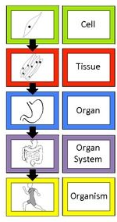

🕙 Time for Activity

Dear learner, the diagram below represent the level of organization in living things. Which term would be represented as X?

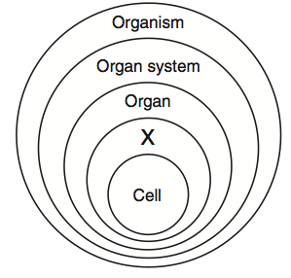

**Pc (f) Explain specialised cells**

You did well with the activity. Clap for yourself. This is the last Pc under this LO and in this Pc, we are going to discuss specialised cells. Let us get going!

**Specialised cells**

Specialised cells are cells which are structurally adapted to perform specific functions. Groups of specialized cells cooperate to form a tissue, such as a muscle. Different tissues are in turn grouped together to form larger functional units, called organs. Each type of cell, tissue, and organ has a distinct structure and set of functions that serve the organism as a whole.  They include stem cells, red blood cells, xylem cells, nerve cells, sperm cells, root tip cell, leaf epidermal and palisade cell. Below are some images of these specialised cells.

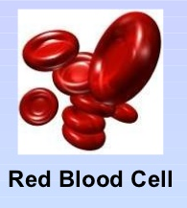 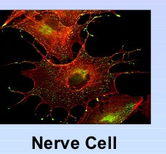 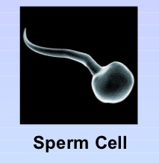

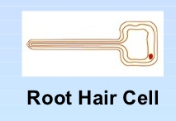 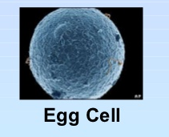

**Figure 15: A photograph of some specialised cells**

🕙 Time for Activity

Dear learner, observe prepared slides of different types of plants and animals cells under the microscope and draw your observation. Your facilitator will guide you through this activity.

**Materials needed**

* Compound light microscope
* Glycerine
* Safranin solution
* Blotting paper
* Onions
* Dropper
* Distilled water
* Forceps
* Needles and brushes
* Cover slip
* Watch glasses
* Glass slides
* Drawing sheet

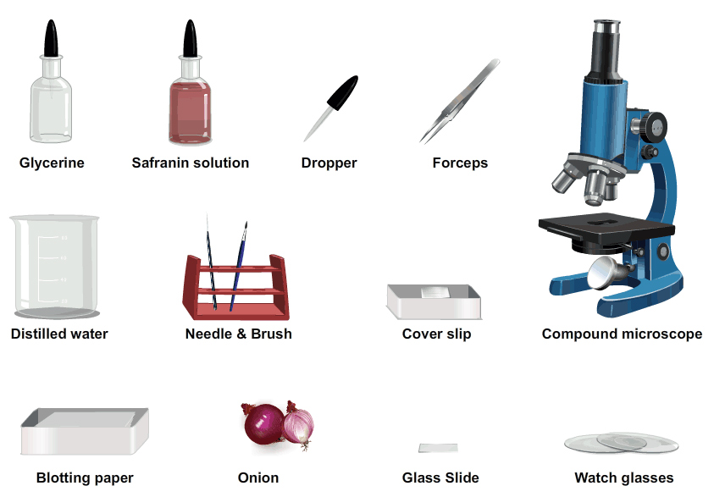

**Procedure**

* Pour some distilled water into a watch glass.
* Peel off a leaf from half a piece of onion and using the forceps, pull out a piece of transparent onion peel (epidermis) from the leaf.
* Put the epidermis in the watch glass containing distilled water.
* Take a few drops of safranin solution in a dropper and transfer this into another watch glass.
* Using a brush, transfer the peel into the watch glass containing the safranin solution.
* Let this remain in the Safranin solution for 30 seconds, so that the peel is stained.
* Take the peel from the Safranin solution using the brush and place it in the watch glass containing the distilled water.
* Take a few drops of glycerine in a dropper and pour 2-3 drops at the centre of a dry glass slide.
* Using the brush, place the peel onto the slide containing glycerine.
* Take a cover slip and place it gently on the peel with the aid of a needle.
* Remove the extra glycerine using a piece of blotting paper.
* Place this glass side on the stage of the compound microscope and view it.

Congratulations! We have come to the end of this LO. Visit the library and the internet to read more on cells.

j0293844 **LO 3: Demonstrate skills in water treatment**

📚 You are expected to demonstrate skills in water treatment in this learning outcome. To achieve this, we will go through PCs (a) – (f).

Hello learner, you welcome to the first Pc of the last LO in this unit. We will be talking about water. We have all seen water or used water before in our lives. Where did the water come from? Did the water you used come from the same source? These are some of the questions we will be answering in this Pc.

**Pc (a) Explain the sources of water**

**Sources of water**

Water is an essential for life on earth. In fact, around two thirds of the human body is made up of water – that is how important it is for us. We use water for many things and without sources of water near to us, we would really struggle to survive. There are various different sources of water out there in the world, and below you will find in depth information on our main water sources. Basically, there are two category of water sources in the world. These are surface water and underground water.

**Surface water**

The water found on the surface of the earth is known as surface water. Examples of surface water are:

* Oceans
* Streams
* Lakes
* Ponds
* Rivers
* Tap water
* Snows
* Rain
* Reservoirs

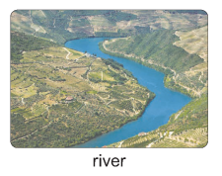 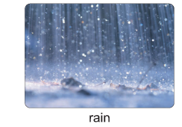  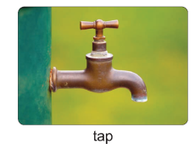

**Figure 3.1: photographs showing examples of surface water**

**Underground water**

The water that is trapped under the earth’s surface is the underground water. Examples of surface water are:

* Wells
* Springs
* Aquifers
* Oases
* Boreholes

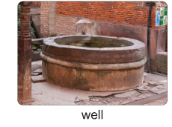 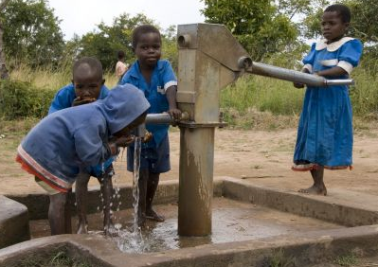

**Community borehole**

**Figure 3.2:** **photographs showing examples of underground water**

Dear learner you are welcome to the next Pc. In this Pc we will discuss the uses of water. Let me ask: have you used water today? What did you use it for? It is interesting how our everyday life plays in our eyes. Isn’t it? Now let us proceed to discuss the uses of water.

**Pc (b) State the uses of water**

**Uses of water**

Water is used for domestic, agricultural, industrial, recreational, and economic purposes.

**Domestic uses of water**

* Washing and cleaning
* Drinking
* Cooking
* Bathing

**Agricultural uses**

* Irrigation,
* Pesticide and fertilizer applications,
* Crop cooling (for example, light irrigation),
* Fisheries

**Industrial uses**

* sewage treatment
* manufacture of chemicals
* bleaching and dyeing
* cooling

**Economic uses**

* Transport. For example travelling on rivers, oceans, lakes, and others using ships, canoes, or boats to travel.
* Generation of electricity or hydroelectric power

**Recreation**

* Swimming
* Rafting
* boating

🕙 Time for Activity

Discuss among yourselves the uses of water.

Thank you for going through this learning material successfully.

We will move on to the next Pc. In this Pc we will discuss hardness of water. It may beat your mind why we are saying water, as a liquid state matter, can be ‘hard’. Yes this is true and I will soon show you how. Follow me attentively through this Pc and I will show you how water can be hard.

**Pc (c) Explain hardness of water**

**Hardness of water**

Water is said to be hard when it does not lather with soap. The simple definition of water hardness is the amount of dissolved calcium and magnesium in the water. In hard water, soap reacts with the calcium to form "soap scum". When using hard water, more soap or detergent is needed for home laundry and washing, and contributes to scaling in boilers and industrial equipment.

Hardness is caused by compounds of calcium and magnesium, and by a variety of other metals. Water is an excellent solvent and readily dissolves minerals it comes in contact with. As water moves through soil and rock, it dissolves very small amounts of minerals and holds them in solution. Calcium and magnesium dissolved in water are the two most common minerals that make water "hard." There are two types of water hardness. These are temporary hardness and permanent hardness.

***Temporary hardness***

Temporary hardness is a type of water hardness caused by the presence of dissolved Hydrogen carbonates minerals (also known as bicarbonates minerals). These dissolved bicarbonates minerals come from calcium bicarbonates, and magnesium bicarbonates. When dissolved, these minerals yield calcium and magnesium cations (Ca2+, Mg2+) and carbonate and bicarbonates anions (CO32−, HCO3−) as shown in equations 3.1 and 3.2 respectively.

H2O (l) + Ca(HCO3)2 (s)  → Ca2+ (aq) + 2HCO-3 (aq)

Water Calcium bicarbonates Calcium ion Bicarbonates anions

H2O (l) + Mg(HCO3)2 (s)  → Mg2+ (aq) + 2HCO-3 (aq)

Water Magnesium bicarbonates Magnesium ion Bicarbonates anions

The presence of these metal cations makes the water hard. This is called temporary hardness of water. Temporary hardness can be reduced either by boiling the water, or by the addition of lime (Calcium hydroxide) through the process of lime softening as shown in equation 3.3 below.

Ca(OH)2 (aq) + Mg(HCO3)2 (aq)  → Ma(OH)2 (s) + 2H2O(l)

Lime Scum/Scale

The Ca2+ ions are unaffected by this reaction, and so we do not include them in the net ionic reaction. However, the Ca2+ ions can also react with lime to form insoluble calcium carbonate. You will see this reaction in equation 3.4.

Ca(OH)2 (aq) + Ca(HCO3)2 (aq)  → 2CaCO3 (s) + 2H2O(l)

Lime Scum/Scale

Boiling promotes the formation of carbonate from the bicarbonate and precipitates calcium carbonate out of solution, leaving water that is softer upon cooling. When hard water is heated, Ca2+ ions react with bicarbonate (HCO3-) ions to form insoluble calcium carbonate (CaCO3), as shown in Equation 3.5.

Ca2+ (aq) + 2HCO3- (aq) → CaCO3 (s) + H2O (l) + CO2 (g)

|  |  |
| --- | --- |
|  |  |

***Permanent hardness***

Earlier we learnt about temporary hardness and how to remove temporary hardness. Now we will focus our attention on permanent hardness. Permanent hardness is hardness that cannot be removed by boiling. When this is the case, it is usually caused by the presence of calcium sulphate/calcium chloride (CaSO4/Ca(Cl)2) and/or magnesium sulphate /magnesium chloride (MgSO4/Mg(Cl)2) in the water, which do not precipitate out as the temperature increases.

Ions causing permanent hardness of water can be removed using a water softener, or ion exchange column. Permanent hardness can also be removed by the addition of sodium carbonate (washing soda) as shown in equations 3.6 and 3.7 respectively.

CaSO4 (aq)  + Na2CO3 (aq)  → CaCO3 (s) + Na2SO4 (aq)

Calcium sulphate sodium carbonate sodium carbonate sodium sulphate

MgSO4 (aq)  + Na2CO3 (aq)  → MgCO3 (s) + Na2SO4 (aq)

Magnesium sulphate sodium carbonate sodium carbonate sodium sulphate

**Effects**

With hard water, soap solutions form a white insoluble substance called soap scum instead of producing lather. Synthetic detergents do not form such scums.

Hard water also forms deposits that clog plumbing. These deposits, called “scales”. Calcium and magnesium carbonates tend to be deposited as off-white solids on the inside surfaces of pipes and heat exchangers. The resulting build-up of scale restricts the flow of water in pipes. In boilers, the deposits impair the flow of heat into water, reducing the heating efficiency and allowing the metal boiler components to overheat. In a pressurized system, this overheating can lead to failure of the boiler.

In swimming pools, hard water is manifested by a turbid, or cloudy (milky), appearance to the water. Calcium and magnesium hydroxides are both soluble in water.

Once again we have come to the end of this learning material. Up to this point, dear learner, I believe you can conveniently explain water hardness. That is very good. Now we will look at water contamination. Enjoy reading.

**Pc (d) Explain water contamination**

**Water contamination**

Water contamination is the process of making water unsafe for human consumption. This occurs when harmful substances, called contaminants are added to the water. Pollution may be caused by natural sources or human activities, but regardless of the cause, the result is the same.

We take for granted that we have easy access to clean water for drinking, washing dishes and cleaning our clothes, but water isn't always clean. A body of water, such as a lake, stream, river, pond, ocean and even the water underground in the soil, can become polluted when it's contaminated by sewage leaks, agricultural runoff or chemical spills.

When water is polluted, it becomes unsafe for human consumption because the water contains dangerous or toxic substances and disease-causing bacteria and organisms. The main sources of contaminant are:

* Domestic waste
* Trade waste
* Industrial and mining waste
* Agricultural waste
* Radioactive waste
* Human excreta washed by rain into water source

Well done! You have finished this learning material under this Pc. You just learnt how water can be contaminated. You realised that they are all human causes. This means that we must change our behaviour as a people in order to protect our water sources. Now we will move on to discuss the methods employed to treat contaminated water.

**Pc (e) Describe methods of water treatment for human consumption**

**Water treatment**

Water treatment is any process that makes water more acceptable for a specific end-use. The end use may be drinking, industrial water supply, irrigation, river flow maintenance, water recreation or many other uses, including being safely returned to the environment. Water treatment removes contaminants and undesirable components, or reduces their concentration so that the water becomes fit for its desired end-use.

Treatment of drinking water for human consumption involves the removal of contaminants from raw water to produce water that is portable enough for human consumption without any short term or long term risk of any adverse health effect. Substances that are removed during the process of drinking water treatment include suspended solids, bacteria, and many more. There are two main methods of water treatment for human consumption. They are: small scale water treatment in households and large scale water treatment for public consumption.

**Small scale water treatment in households**

The most common types of household water treatment systems consist of:

1. **Boiling**

Boiling is one means to treatment water for household consumption. In an emergency, boiling is the best way to disinfect water that is unsafe. Boiling can remove and kill protozoan parasites, bacteria, or viruses present in the water. Boiling should not be used when toxic metals, chemicals (lead, mercury, asbestos, pesticides, solvents, etc.), or nitrates have contaminated the water. Boiling may also concentrate any harmful contaminants that do not vaporize as the water vapour boils off.

1. **Filtration Systems**A water filter is a device which removes impurities from water by means of a physical barrier, chemical, and/or biological process.
2. **Water Softeners**  
   A water softener is a device that reduces the hardness of the water. A water softener typically uses sodium or potassium ions to replace calcium and magnesium ions, the ions that create "hardness."
3. **Distillation Systems**  
   Distillation is a process in which impure water is boiled and the steam is collected and condensed in a separate container, leaving many of the solid contaminants behind.
4. **Disinfection**  
   Disinfection is a physical or chemical process in which pathogenic microorganisms are deactivated or killed. Examples of chemical disinfectants are chlorine, chlorine dioxide, and ozone. Examples of physical disinfectants include ultraviolet light, electronic radiation, and heat.

**Large scale water treatment for public consumption**

In urban areas, many people live close together and they all need water. This creates a demand for large volumes of safe water to be supplied reliably and consistently, and this demand is growing. As urban populations increase, there is a need to find new sources to meet the growing demand. Surface water source will need to be treated to make it safe. For towns and cities, the water supply is then best provided by large water treatment plants that draw water from a large river or reservoir, using pumps. The figure below illustrates a commercial water treatment plant.

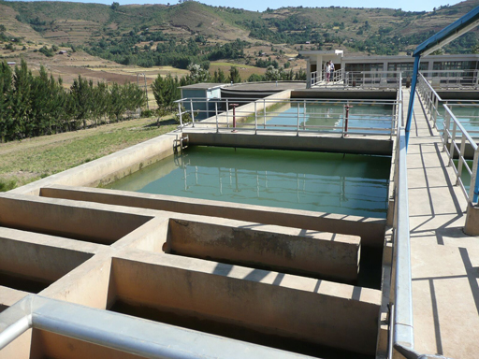

**Figure 2.3.1: A commercial water treatment plant**

There are often seven steps in large-scale water treatment for urban and municipal water supply. The water company ensures by regular analysis of the water that it adheres to quality standards for safe water. The flow diagram below shows the seven stages of water treatment.

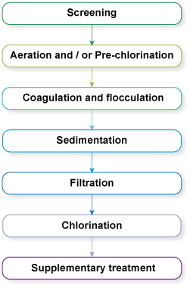

**Figure 2.3.2: The seven steps often used in the large-scale treatment of water**

**Screening**

To protect the main units of a treatment plant and to aid in their efficient operation, it is necessary to use screens to remove any large floating and suspended solids that are present in the inflow. These materials include leaves, twigs, paper, rags and other debris that could obstruct flow through the plant or damage equipment. There are coarse and fine screens.

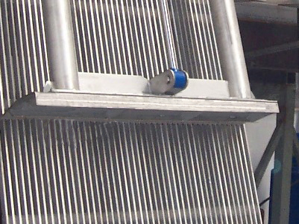

**Figure 2.3.3:  A coarse screen**

**Aeration**

After screening, the water is aerated (supplied with air) by passing it over a series of steps so that it takes in oxygen from the air. This helps expel soluble gases such as carbon dioxide and hydrogen sulphide and also expels any gaseous organic compounds that might give an undesirable taste to the water. In certain instances excess algae in the raw water can result in algal growth blocking the sand filter further down the treatment process. In such situations, chlorination is used in place of, or in addition to, aeration to kill the algae, and this is termed pre-chlorination. This comes before the main stages in the treatment of the water. (There is a chlorination step at the end of the treatment process, which is normal in most water treatment plants).

**Coagulation and flocculation**

After aeration, coagulation takes place, to remove the fine particles that are suspended in the water. In this process, a chemical called a coagulant is added to the water. The addition of the coagulant takes place in a rapid mix tank where the coagulant is rapidly dispersed by a high-speed impeller. The fine particles come together, forming soft, fluffy particles called ‘flocs’. Two coagulants commonly used in the treatment of water are aluminium sulphate and ferric chloride.

The next step is flocculation. Here the water is gently stirred by paddles in a flocculation basin. The flocs come into contact with each other to form larger flocs. The flocculation basin often has a number of compartments with decreasing mixing speeds as the water advances through the basin. These chambers allow increasingly large flocs to form without being broken apart by the mixing blades. Chemicals called flocculants can be added to enhance the process.

**Sedimentation**

Once large flocs are formed, they need to be settled out, and this takes place in a process called sedimentation (when the particles fall to the floor of a settling tank). The water (after coagulation and flocculation) is kept in the tank for several hours for sedimentation to take place. The material accumulated at the bottom of the tank is called sludge; this is removed for disposal.

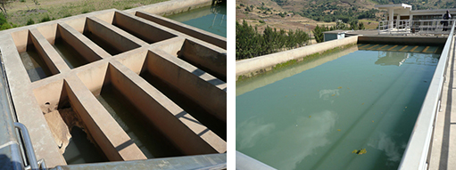

A B

**Figure 2.3.4: Flocculation chambers (A) and sedimentation tank (B) at a water treatment plant**

**Filtration**

Filtration is the process where solids are separated from a liquid. In water treatment, the solids that are not separated out in the sedimentation tank are removed by passing the water through beds of sand and gravel. When the filters are full of trapped solids, they are backwashed. In this process, clean water and air are pumped backwards up the filter to dislodge the trapped impurities, and the water carrying the dirt (referred to as backwash) is pumped into the sewerage system, if there is one. Alternatively, it may be discharged back into the source river after a settlement stage in a sedimentation tank to remove solids.

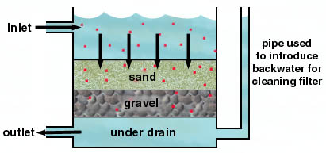

**Figure 2.3.5: Cross-sectional diagram of a rapid gravity sand filter**

**Chlorination**

After sedimentation, the water is disinfected to eliminate any remaining pathogenic micro-organisms. The most commonly used disinfectant (the chemical used for disinfection) is chlorine. When chlorine is added to water it reacts with any pollutants present, including micro-organisms, over a given period of time, referred to as the contact time. The amount of chlorine left after this is called residual chlorine. This stays in the water all the way through the distribution system, protecting it from any micro-organisms that might enter it, until the water reaches the consumers.

**Supplementary treatment**

Supplementary treatment may sometimes be needed for the benefit of the population. One such instance is the fluoridation of water, where fluoride is added to water. It has been stated by the World Health Organization that ‘fluoridation of water supplies, where possible, is the most effective public health measure for the prevention of dental decay’.

**Distribution of water**

One way water is supplied to town residents is that the water department pump treated water from a reservoir or a water tower or directly from the pumping station through pipes all the way to the last house in the community.

🕙 Time for Activity

Your facilitator will organize a visit to a local water treatment plant. You will report a short report on the visit when you come back to school.

**Pc (f) Perform an experiment to treat water in the home**

Dear learner, now you are going to use your knowledge in water treatment to treat water in the home for consumption. Do not worry.  The procedure provided will take you through the steps involved in cleaning and purifying the muddiest of muddy water and make it suitable for drinking and cooking. Your facilitator will put you into groups of five (5) to undertake this experiment. You must feel free, at any point in this experiment, to ask your facilitator any question that may border you.

**Materials and Chemicals**

Bleaching powder (Calcium hypochlorite) or chlorinated water

Aluminium Sulphate, Shortly known as Alum

3 transparent plastic buckets

Measuring cylinder

Weighing balance

Clean white cloth

Teaspoon

**Some tips on usage of Alum and Bleach solution**

* The prescribed dosage of Alum varies from 5 mg per litre for a relatively clear water to 85 mg for a highly turbid waters like industrial waste. However, the normal dosage for drinking water is about 17 mg per litre.
* The dosage of bleaching solution as 2 drops per litre is suggested considering 60 to 70 percent of chlorine available in the bleaching powder. You can increase or decrease the amount by smelling the chlorinated water. More chlorine smell, add some clean water. Add a few more drops in case of no smell.
* Keeping buckets of water mixed with Alum overnight will give you enough clean water in the morning for use.
* Over-dosage of Alum may cause temporary dizziness, diarrhoea and vomiting (but not dangerous). So, take care while adding alum.
* Bleaching solution is corrosive. Take care not to get your skin or cloth in contact with the solution.

**Procedure**

1. Collect about 6 litres of muddy water
2. Brush away most of the floating material with hand
3. Using a fine cloth, filter the muddy water into another vessel. The filtered water contains no floating material and less silt.
4. Take about five litres of water in a plastic bucket and added half a teaspoon of powdered Alum (that is about 50 mg which works out to 10 mg per litre of water) and stirred well.
5. Keep this bucket of water still at a quiet place for about 6 to 7 hours (because you will be in school, you can keep it overnight) so that the sediments get coagulated and settles down at the bottom.
6. Drain out the clean water into another vessel very slowly without disturbing the sediment (at least leave about one litre of water in the bucket with the sediments).
7. Add about eight drops of bleach solution which contains chlorine into the water in the vessel and stirred well (The prescribed normal rate is about 2 drops of bleach solution per litre of water). Please note that this water may smell little bit of chlorine. Therefore, keeping the water open to air and intermittently stirring for about 50 minutes will remove the chlorine smell.
8. If the water is still cloudy at this point, repeat steps 4, 5 and 6.
9. Water is now safe for consumption.

**Well done! We have come to the end of this unit**