Exercises 1.1-1.2
oluola@DrOluyemi:~$ docker container ls -a
CONTAINER ID IMAGE COMMAND CREATED STATUS PORTS NAMES
b32ab0243e86 redis "docker-entrypoint.s…" 10 minutes ago Up 10 minutes 6379/tcp myredis
4e36df6a352c mysql "docker-entrypoint.s…" 14 minutes ago Up 14 minutes 3306/tcp, 33060/tcp mymysql
16a01c593b26 nginx "/docker-entrypoint.…" 30 minutes ago Up 30 minutes 80/tcp mynginx
oluola@DrOluyemi:~$ docker container stop mynginx
mynginx
oluola@DrOluyemi:~$ docker container stop myredis
myredis
oluola@DrOluyemi:~$ docker container ls -a
CONTAINER ID IMAGE COMMAND CREATED STATUS PORTS NAMES
b32ab0243e86 redis "docker-entrypoint.s…" 11 minutes ago Exited (0) 6 seconds ago myredis
4e36df6a352c mysql "docker-entrypoint.s…" 15 minutes ago Up 15 minutes 3306/tcp, 33060/tcp mymysql
16a01c593b26 nginx "/docker-entrypoint.…" 31 minutes ago Exited (0) 19 seconds ago mynginx
oluola@DrOluyemi:~$

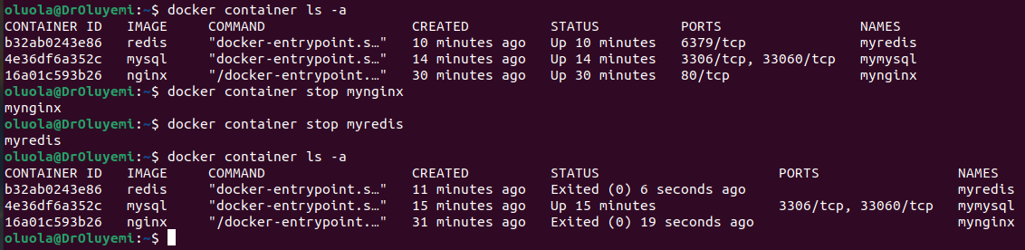
EXERCISE 1.2: CLEANUP
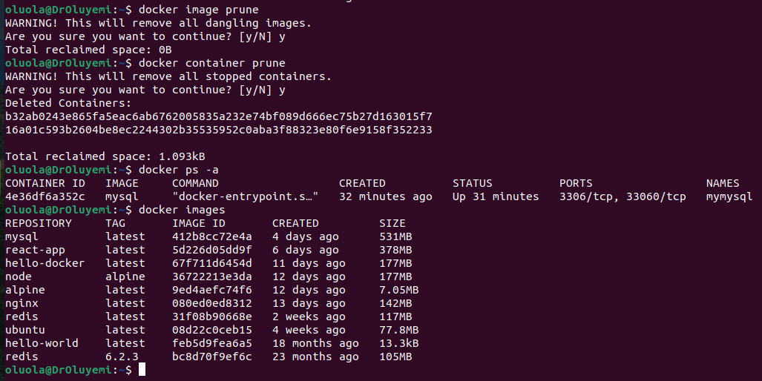

Exercise 1.3​
EXERCISE 1.3: SECRET MESSAGE

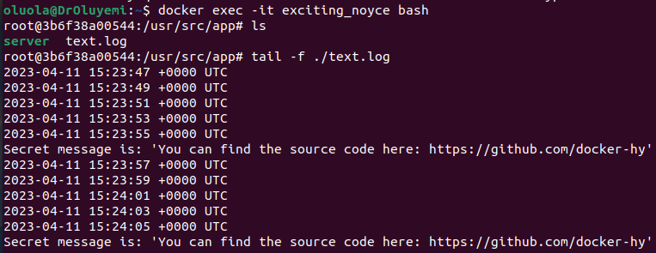
Secret message is: 'You can find the source code here: https://github.com/docker-hy'
Command give: $ docker exec -it exciting_noyce bash &&
$ tail -f ./text.log
Source code: https://github.com/docker-hy/docker-material-exercises/blob/master/exec_bash_exercise_and_first_volume_exercise/index.js

Exercise 1.4​
EXERCISE 1.4: MISSING DEPENDENCIES
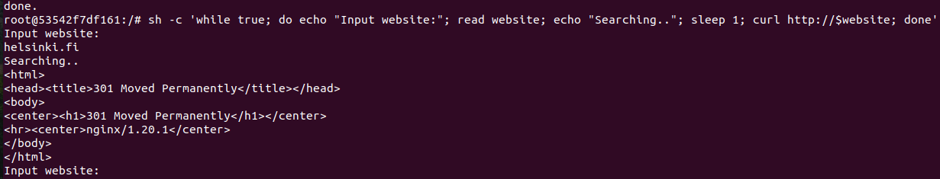

Better (smart) solutions would be:

If you plan to use this command repeatedly, you may want to consider creating a Dockerfile instead. A Dockerfile is a script that contains instructions for building a Docker image. By using a Dockerfile, you can automate the process of setting up a container with all the required packages and configurations.
Here's an example Dockerfile that installs the curl package and sets up a while loop to fetch data from a user-specified website:
FROM ubuntu
RUN apt-get update && apt-get install -y curl
CMD sh -c 'while true; do echo "Input website:"; read website; echo "Searching.."; sleep 1; curl http://$website; done'

You can build a Docker image using the above Dockerfile by running the following command in the same directory as the Dockerfile:

`docker build -t myimage .`

This will build a new Docker image with the name "myimage". You can then start a new container from the image by running:
`docker run -it myimage`

This will start a new container with the while loop that prompts the user to input a website address and fetches data from that website using curl. You can exit the container by typing "Ctrl-C".

Exercises 1.5 ​
EXERCISE 1.5: SIZES OF IMAGES
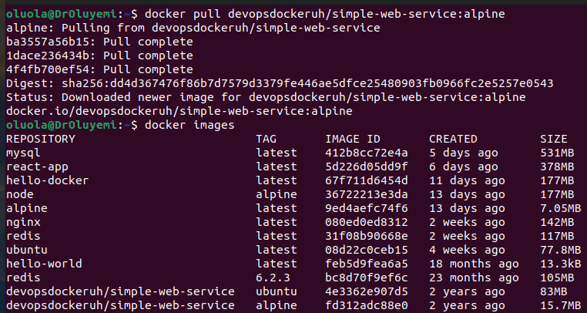
devopsdockeruh/simple-web-service of ubuntu has 83MB of size
devopsdockeruh/simple-web-service of alpine has 15.7MB of size
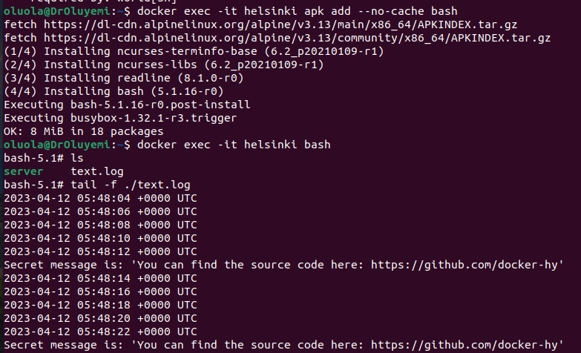
Secret Message for Alpine version

l

EXERCISE 1.6: HELLO DOCKER HUB
The secret message is: "This is the secret message"
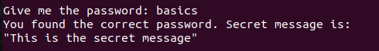

b) Commands that makes it work:
i) docker run -it devopsdockeruh/pull_exercise
ii) docker ps
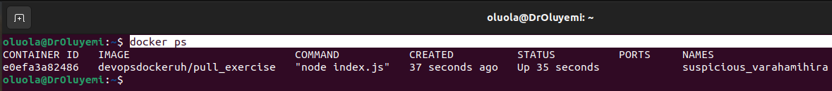
iii) docker exec -it suspicious_varahamihira apk add --no-cache bash

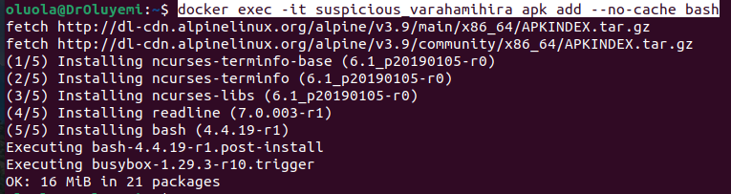
iv)docker exec -it suspicious_varahamihira bash
v) apk update $$ apk add nano
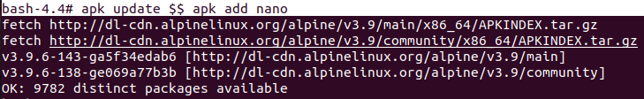
r

vi) apk add nano
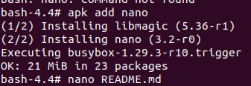

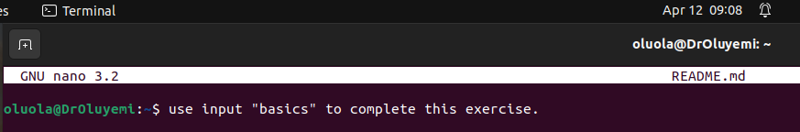
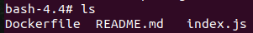
vii) ls

vii) nano README.md

EXERCISE 1.8: TWO LINE DOCKERFILE
