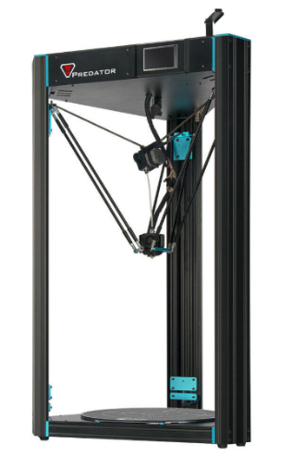

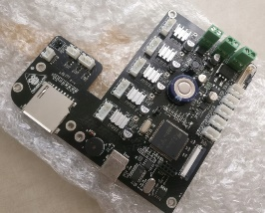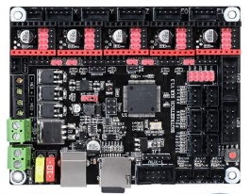Simply manual for swap original anycubic board to SKRv 1.3  
Anycubic Predator Delta 3D Printer

Before you start :

**The author is not responsible for any damage to the device. All changes and modifications are made on your own responsibility. !!**

If you are not sure what are you doing please don’t continue and left printer without any changes or modifications!!

What we need:

* Board SKR v 1.3
* Micro Sd card (included in SKR v1.3)
* TMC 2208 or which you prefer (this tutorial will be for 2208 standalone)
* Display 12864 or LCD2004 + cables exp1 exp2
* PlatformIO
* Marlin 2.0 FW
* Small screwdriver
* Tools set from predator

1, Prepare Marlin configuration

Download mine custom version of Marlin FW from GitHub page.

Instal Platformio for Atom or Visual Studio Code

Open FW folder in Platformio

* If you want setup or resetup whatever you want inside is up to you..

2, fotodocu everything before you fuck it up

3, wiring .. need to change some wires for endstops + and S are wrong for SKR use

4, setup jumpers on SKR correctly it is up to you TMC choice

5, correctly wire up everything ..

6, prepare for first run

* Download FW to SD card
* Place SD card into board slot(FWslot)

7, After First run

* Reset Failsafe
* Try to home – check of endstops working correctly also motors moving correctly !!
* If you are sure motors and edstops run correctly then next steps
* Open configuration and start auto calibration (process could take long time as 5- or more cycles it is up to how correctly calculate Delta parameters)
* If you run Auto Calibration Delta beep for add probe (then connect probe) click on disply for continue
* Delta run calibration process
* After finish beep for unconnected Probe
* Autocalibration finished – check the Z height is correctly set up
* Do auto home
* Then go to move axis and select Z
* Go down to +- Z10 then switch to 0.1mm steps
* And go down until you get 0 and also paper check if the height is correctly
* If not you need to set the Z probe offset actual is -16.10 you maybe need to setup + for go up and – to go deep
* After you set this offset then do again home and try again Z height
* Repeat this until you get height Z0 as you want
* After that go autohome
* And prepare for Bed leveling
* Connect Probe and auto leveling start – if oyu forget Probe printer also beep before run leveling
* After bed leveling also bep for disconnect probe !! DO IT !! or your printer crash !!
* After that try to heat up bed also nozzle for test if PID is ok .. if not setup it
* You are prepare for first test run ..
* Try to print something ( I prefer some kind of circle or something to try if bed level is correct everywhere