**Examination System**

**Abstract**

The paper presents the main aspects and implementation of the examination system, database design and reports. Also, an implementation of multiple choices & True or false questions. This examination system has more than one course & helps the professor to generate tests for student evaluation. The testing system was used to generate items for multiple choice ^ true or false examinations in different engineering courses.

**Introduction**

The student evaluation at the end of a course usually comprises all discussed subjects on course, laboratory, seminars, and projects. When the area of subjects is large, as in general Data Base, a practical idea is to create a multiple-choice examination system. The practice is prevalent because multiple choice examinations provide a relative easy way to test students on a large number of topics. More, for large number of students, a classical evaluation system (written evaluation) consumes a considerable amount of time.

The characteristics of a good MCE are well known. A number of papers on multiple choice randomized examinations in which the order of items (or questions), as well as the order of the possible responses, is randomized independently for each student, have been published.

**Database Design**

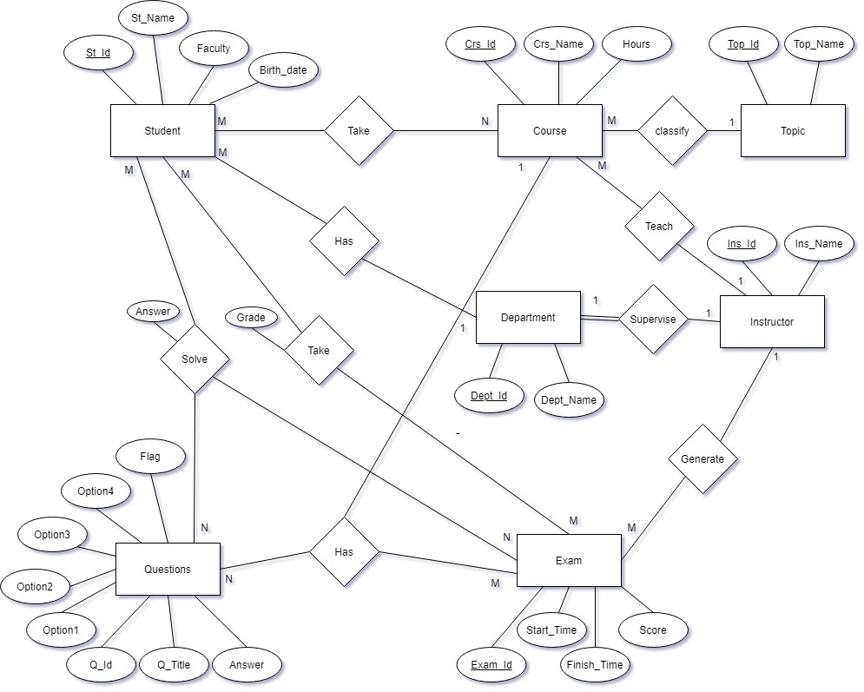The implementation of multiple-choice questions evaluation system uses a relational database.

ERD Diagram

**Tables Procedures:(2 main procedures + 4 (select-insert-update-delete))**

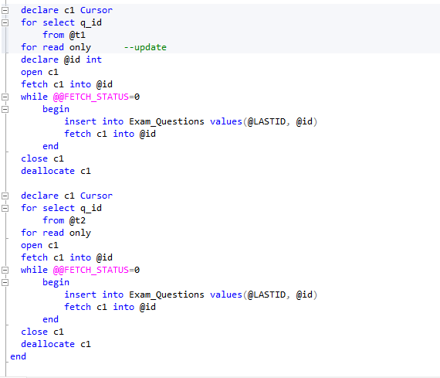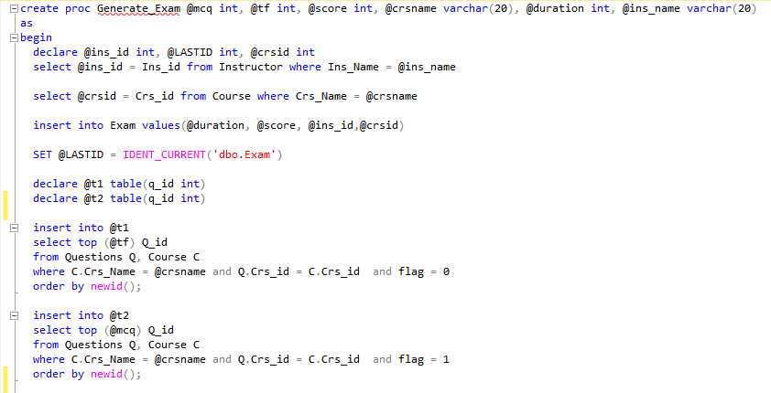**1-Exam Generation Stored procedure:**

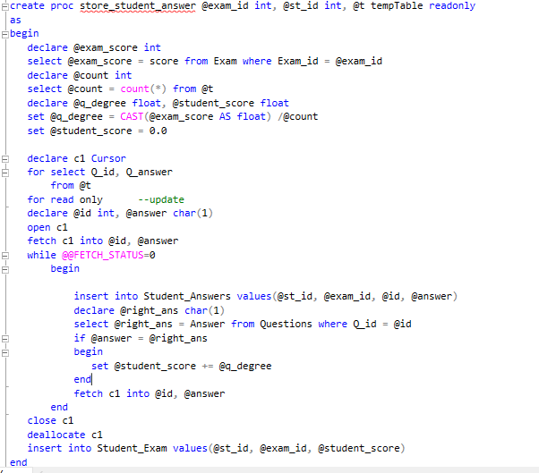**2- Exam Auto Correction Stored procedure:**

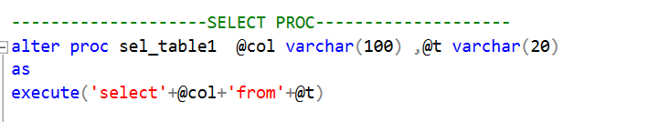**3-Select Stored Procedure (Dynamic SP):**

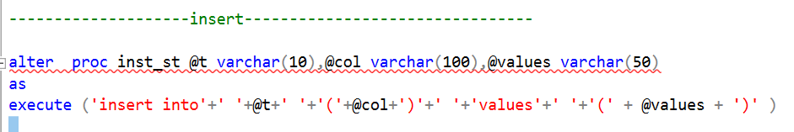**4-Insert Stored Procedure (Dynamic SP):**

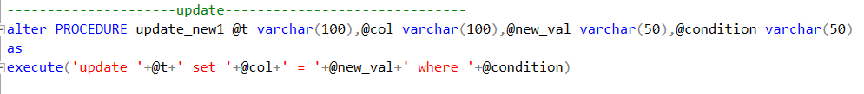**5- Update Stored Procedure (Dynamic SP):**

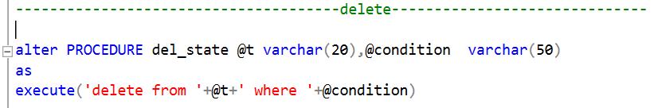**6- Delete Stored Procedure (Dynamic SP):**

**Reports’ procedures & Software used to generate its reports:**

1. 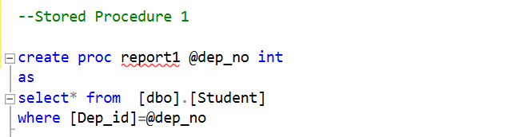**Stored Procedure that returns the students information according to Department No parameter:**
2. **Stored Procedure that takes the student ID and returns the grades of the**

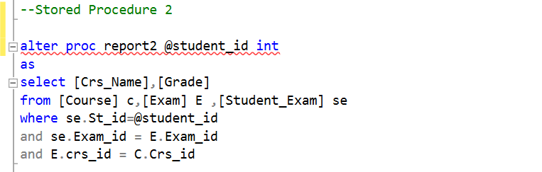**student in all courses:**

1. 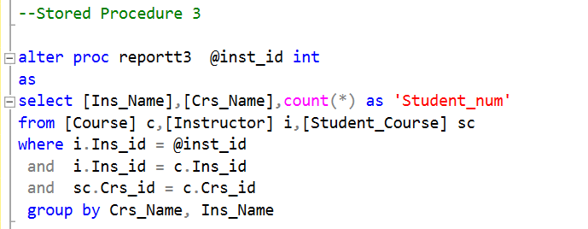**Stored Procedure that takes the instructor ID and returns the name of the courses that he teaches and the number of student per course:**
2. 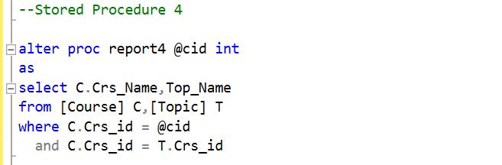**Stored Procedure that takes course ID and returns its topics:**
3. 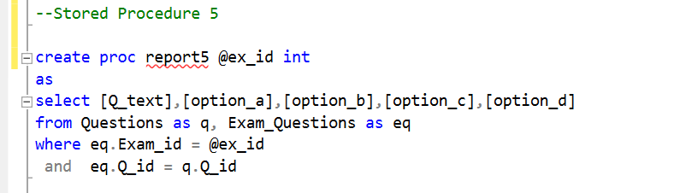**Stored Procedure that takes exam number and returns the Questions in it and choices:**
4. 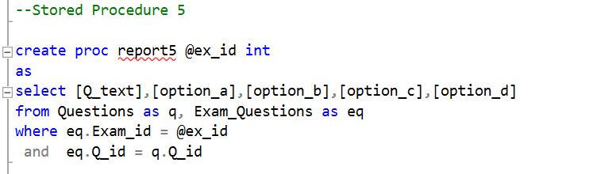**Stored Procedure that takes exam number and the student ID then returns the Questions in this exam with the student answers:**

**Software used to generate its reports: Crystal Reports …**