

Luxor University
Faculty of Computers & Information

ــــــــــــــــــــــــــــــــــــــــــــــــــــــــــــــــــــــــــــــــــــــــــــــــــــــــــــــــــــــــــــــــــــــــــــــــــــــــــــــــــــــــــــــــــــــــــــــــــــــــــــــــــــــ

PROJECT NAME
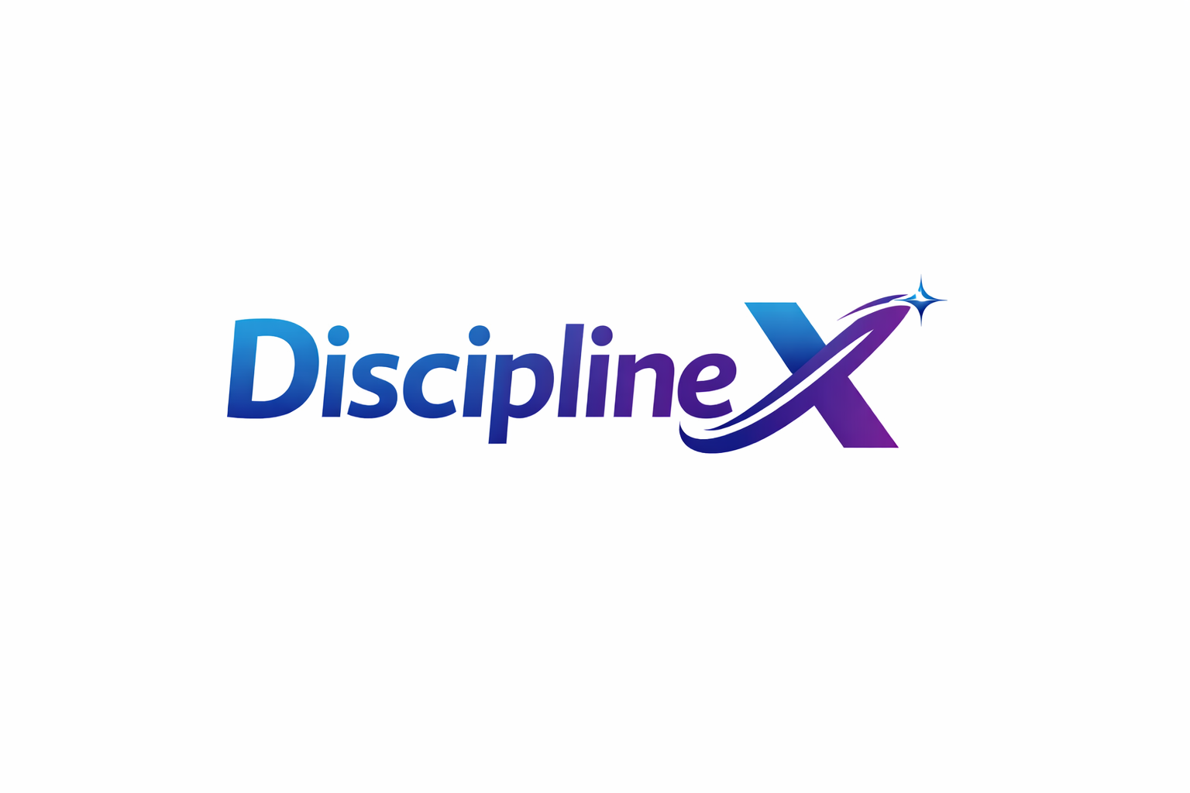
UNDER SUPERVISION
Dr. Bassem Abdelatty Eldeeb
Eng. Abdelrahim Alsadiq

SUBMITTED BY
Ola Jafar Zainap Mohamed
Hussein Yasser Youssef Mohamed
Mostafa Mahmoud Mohamed Ahmed

2026
ABSTRACT
This project presents DisciplineX, an online mentorship and guided learning platform designed to solve common problems in self-learning.
Many students rely on online tutorials but often feel confused, unmotivated, and lack expert guidance. At the same time, many professionals are willing to teach but do not have an organized system to reach learners. DisciplineX addresses this gap by providing a structured and interactive learning environment.
The scope of the system includes mentor discovery, session booking, one-to-one and group mentoring, learning plans, progress tracking, and secure payment management. Students can follow clear learning steps, attend mentoring sessions, receive feedback, and monitor their progress using tools such as streaks and performance charts. Mentors can create structured learning paths, manage sessions, communicate with students, and receive payments through the platform.
The primary users of DisciplineX are students seeking guided learning and mentors who want to share knowledge professionally. Other stakeholders include platform administrators who manage system operations and content quality.
The system improves the learning experience by increasing motivation, clarity, and efficiency. It helps students achieve their goals faster while giving mentors a reliable way to teach and earn income. DisciplineX is implemented as a web-based platform using modern web technologies to ensure accessibility, usability, and scalability. Overall, DisciplineX provides an effective solution for organized, mentor-driven online learning.

TABLE OF CONTENTS
TABLE OF CONTENTS III
1.1 MOTIVATION 2
1.2 PROBLEM STATEMENT 2
1.3 OVERVIEW 3
1.4 OBJECTIVES AND SCOPE 3
1.5 TARGET AUDIENCE AND EXPECTED IMPACT 6
2.1 EXISTING SYSTEMS 8
2.2 COMPARISON & LIMITATIONS 11
2.3 JUSTIFICATION FOR THE PROPOSED SYSTEM 12
CHAPTER 3 SYSTEM REQUIREMENTS & TECHNIQUE 13
3.1 SYSTEM REQUIREMENTS 14
3.1.1 FUNCTIONAL REQUIREMENTS 14
User Management & Profiles 14
Matching & Discovery 14
Learning Management & Progress Tracking 14
Communication 14
Scheduling & Payments 15
3.1.2 NON-FUNCTIONAL REQUIREMENTS 15
User Management & Profiles 15
Matching & Discovery 15
Learning Management & Progress Tracking 15
Communication 15
Scheduling & Payments 16
3.2 TECHNIQUES AND TOOLS 16
CHAPTER 4 PROPOSED SYSTEM & 18
METHODOLOGY 18
4.1 SYSTEM USE CASE DIAGRAM 19
4.2 USE CASE DESCRIPTION (USE CASE SCENARIO) 22
4.3 SYSTEM ARCHITECTURE 37
4.4 DATAFLOW DIAGRAMS 38
4.4.1 CONTEXT DIAGRAM (LEVEL 0) 38
4.4.2 DATAFLOW DIAGRAM (LEVEL 1) 39
Logical 39
Physical 42
4.5 ACTIVITY DIAGRAM 45
4.5.1 Admin 45
4.5.2 Student 45
4.5.3 Mentor 46
4.6 ER DIAGRAM 47
CHAPTER 5 CONCLUSIONS & FUTURE WORK 49
5.1 CONCLUSIONS 50
5.2 FUTURE WORK 51

MOTIVATION
At the current level of development, a large number of people pursue independent cyber learning. Despite the large amount of information available in the cyber environment, a number of problems emerge: lack of certainty about the teaching structure, a loss of motivation, and a lack of expert assessment. This leads to “tutorial hell,” wherein students view a large number of tutorials and experience no gain in mastery.
At the same time, many professionals are keen to teach but struggle to make the right connections with their students. They also need a platform to handle their mentorship operations while monetizing their advice.
DisciplineX aims to solve the problems discussed above. The project assumes that organized mentoring is a crucial element. By creating a system where mentors interact with learners, DisciplineX will enable learners to achieve their goals and will also allow professionals to teach in a more effective manner.

PROBLEM STATEMENT
Current Situation:
Students tend to access a variety of courses and tutorials available through the web and read informative articles. While the use of these sources has value, in most instances, they fail to provide learning assistance and supportive feedback.
Identified Problems:
- Lack of Direction: The learners do not know what actions to take.
- Dropout rates are high because the learner loses motivation to continue studying and thereby stops learning.
- Lack of Standardization.
- Lack of Expert Feedback: The learner will be unable to check the correctness of learning progress.
- Troubles in Engaging with Mentors: Specialists do not have a simple way to connect with learners and handle teaching processes.
Impact:
All the above issues lead to the frustration of learners and barriers to learning progression, and they also inhibit the spread of knowledge from experts. The need for a new platform emerges to offer structure, support, and guidance.

OVERVIEW
The proposed system is an online mentorship and learning website designed to connect students with experienced mentors in a structured and engaging environment. It enables both students and mentors to create detailed profiles that showcase their goals, skills, and experiences. Mentors can manage portfolios, set pricing, schedule sessions, and track student progress through personalized learning roadmaps. Students, on the other hand, can search for mentors based on interests or fields, book orientation sessions, make secure payments, and monitor their progress using tools such as streaks, trackers, and activity heatmaps.
The system aims to provide a more interactive and personalized alternative to traditional online courses by focusing on one-on-one mentorship and measurable progress. It also introduces an efficient ticket-based communication system for questions and feedback, ensuring organized and professional interactions between mentors and students. By integrating structured learning management with motivational tracking tools, the platform helps students stay consistent while offering mentors a professional space to share knowledge and grow their expertise.

OBJECTIVES AND SCOPE

Objectives
- Connect Students with Qualified Mentors within 48 hours of registration:
Build a platform that helps students find mentors who match their learning goals, field of interest, and skill level.
- Enhance learning experience:
Enable mentors to design personalized learning roadmaps, track student progress, and provide feedback through structured steps and milestones.
- Improve Learning Efficiency:
Reduce wasted learning time by offering structured guidance and measurable learning milestones.
- Structured Communication System:
Provide a ticket-based messaging system - where students can send questions and receive organized responses from mentors within set timelines- for organized mentor-student communication while keeping the process professional and focused.
- Support flexible learning:
Allow mentors to specify group or private session pricing and scheduling.
- Encourage Continuous Progress Tracking:
Provide a streak system, progress bar, and heatmap to visualize each student’s learning activity and maintain motivation.
The system aims to increase consistent learning engagement by at least 50% of student users through these progress-tracking features.
- Enhance Trust and Quality through Reviews:
Include a rating and review system for mentors to maintain transparency and encourage quality service.
- Ensure secure transactions:
Integrate a payment gateway (VISA API) for safe and reliable payments.
- Interactive Live Sessions:
Integrate whiteboard and screen-sharing tools for live sessions, improving understanding during mentorship interactions.
- Reduce mentor-student matching time by 40% through effective search and filter systems.
- Achieve a 90% satisfaction rate among students based on review and feedback systems.
- Reduce session cancellation rates by 30% through reminders and structured scheduling.
- Achieve at least 4/5 average mentor rating after three months of launch.

Scope
In the scope:
- User Registration and Profiles:
Both mentors and students can create profiles. Mentors include personal info, experience, certificates, and portfolio files; students include interests , learning goals, calendar tracking, and can rate mentors after sessions.
- Mentor Portfolio Management:
Mentors can upload portfolios that specify pricing, group size, hours per week, and subscription options.
- Search and Filter System:
Students can search for mentors based on criteria such as field, skill level, price, or availability.
- Orientation Sessions:
Students can book a free orientation session to understand the mentor’s teaching style before subscribing.
- Payment Integration:
Payments are processed securely using the VISA API.
- Learning Management Tools:
Mentors can manage each student’s progress through a personal calendar or learning sheet containing:
- Steps (with title, objectives, deadline, notes, status, materials, and guidance)
- Uploaded materials and homework
- Quizzes and session summaries
- Ticket-Based Communication:
Students can send tickets to mentors with questions, attachments, or issues; mentors respond within a pre-agreed time.
- Progress Tracking:
The system includes streaks, points, and heatmaps to visualize progress and encourage consistency.
- Reviews and Ratings:
Students can leave star ratings and written feedback on mentors after sessions.
- Live Sessions:
Live teaching tools will include video calls, whiteboard, screen sharing, and programming collaboration tools.
- Study Mates (Limited Community):
Students working under the same mentor can view each other’s progress sheets to encourage teamwork, but no public community or chat rooms exist.
- Registration and account management services for learners and mentors.
- Mentor profiles that include skills, CV, roadmap, and pricing.
- Searching and filtering tools to find mentors.
- Complimentary session to determine compatibility: 30 minutes.
- Learning paths with weekly activities and resources.
- The ability to track progress through a checklist, a streak feature, and a timer for studying.
- One-on-one learning and group learning options.
- Badges and competitive components for group members.
- Scheduling calendar for sessions.
Out of the scope:
- Public community or open chat:
The system will not support open chats, public groups, or social discussions outside mentor-student communication.
- AI-Based Recommendations:
Mentor recommendations based on AI matching will not be included in the initial version.
- Mobile Application:
The project will be web-based only; mobile app versions may be developed in future phases.
- External Communication Systems:
Integration with external apps like WhatsApp or Telegram will not be built into the system (though mentors can share links manually).
- Automated Grading or Homework Evaluation:
Homework and quizzes will be manually reviewed by mentors, not auto graded by the system.
- Live video calls in the platform (used external links instead).
- Resource recommendations based on AI algorithms.
- Large community forums and/or social networking components.
- Payment processing within the platform (handling by a third-party)

TARGET AUDIENCE AND EXPECTED IMPACT

Target audience
- Learners: Students, professionals, and people wanting to develop new skills (such as programming, design, and marketing) who need learning assistance.
- Mentors: People who want to impart their knowledge and earn money.

Expected Impact
- For learners: Learning trajectory, frustration levels, and educational results will be clearly defined.
- For Mentors: easier access to students, reputation-building chances, and monetization options.
- For the Community: Increased levels of skill and knowledge.

EXISTING SYSTEMS

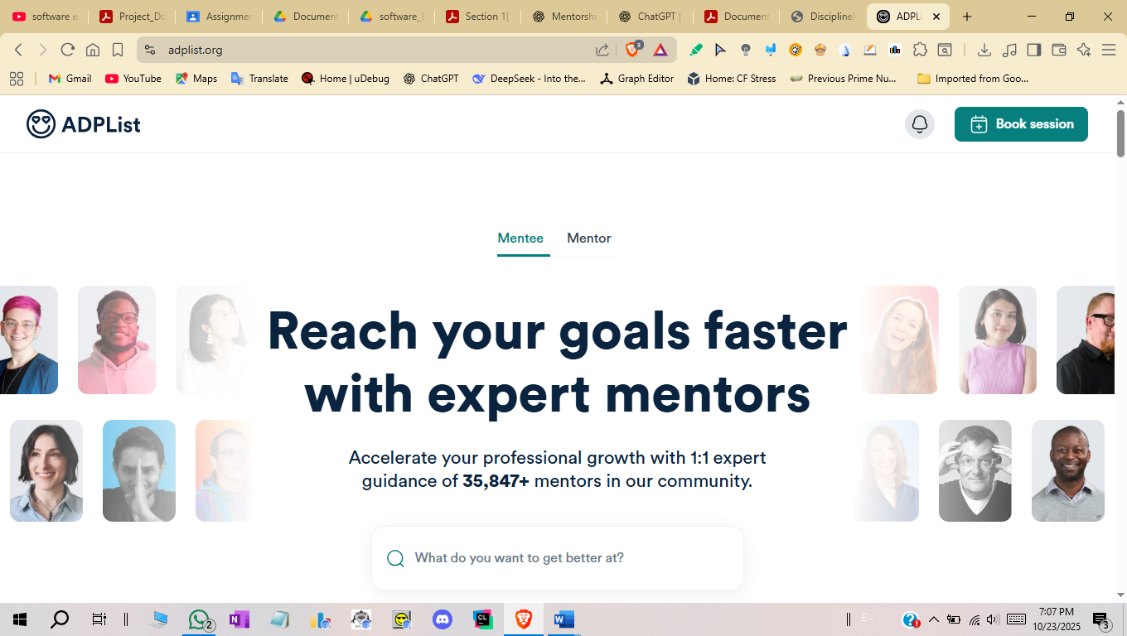

ADPList is an online mentoring platform that connects learners with experienced professionals from different industries, especially in technology, design, and product management. The platform focuses on free, one-on-one mentoring sessions, allowing users to book meetings with mentors based on their interests and career goals. Learners can receive guidance, career advice, and feedback from professionals who have real industry experience. At the same time, mentors use the platform to support the community and help others grow in a structured and friendly environment. ADPList is mainly focused on short mentoring sessions rather than long-term follow-up, which may limit continuous guidance for some users.
ADPList

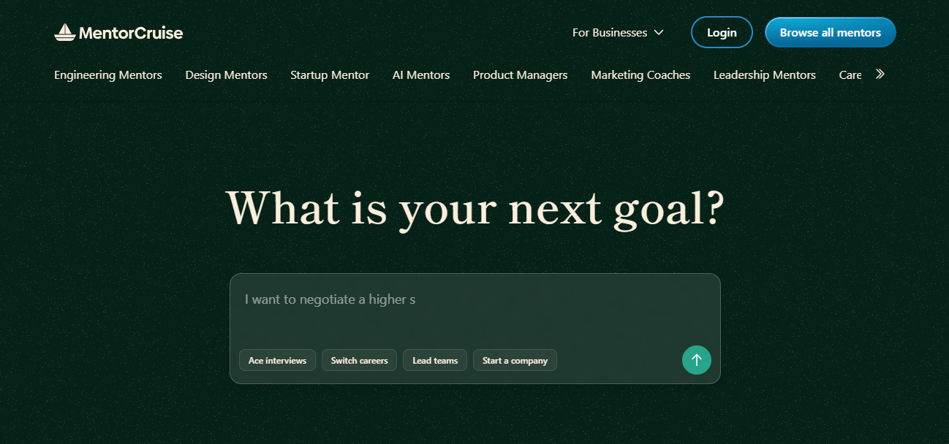

MentorCruise is a professional mentoring platform designed to provide long-term mentorship for individuals who want to improve their skills or advance their careers. Users can browse mentor profiles, review their experience, and choose mentors that match their learning goals. The platform offers paid mentorship plans, which include regular sessions, progress tracking, and direct communication between mentors and mentees. This structure allows learners to receive consistent support over time. For mentors, MentorCruise provides tools to manage their mentoring activities and earn income from their expertise, making the platform suitable for professional and organized mentoring relationships.
MentorCruise

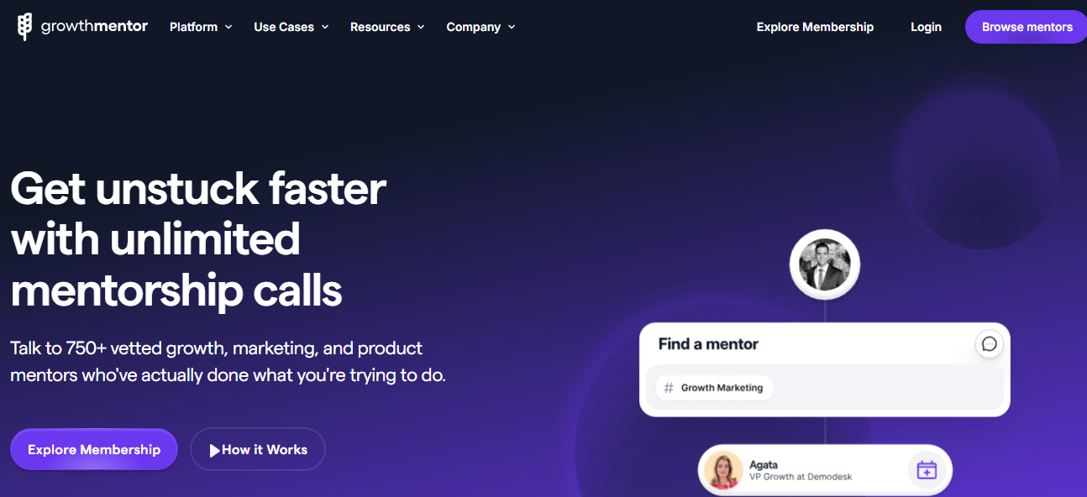

GrowthMentor is a mentoring platform focused on helping startups and professionals improve their business, marketing, and growth strategies. The platform connects users with experienced mentors who provide practical advice through short, focused video calls. Instead of long courses or theoretical content, GrowthMentor emphasizes real-world experience and actionable guidance. Users can ask specific questions and get direct feedback from experts who have worked in the industry. While the platform is effective for quick problem-solving, it may not always support long-term mentoring relationships.
GrowthMentor

COMPARISON & LIMITATIONS
    - STRENGTHS
- Easy access to experienced mentors from different professional fields.
- Global reach that allows learners to connect with mentors from various countries.
- One-on-one mentorship sessions that support direct interaction and personalized advice.
- Flexible session scheduling based on mentor availability.
- Real-world experience shared by mentors rather than purely theoretical content.
- Support for short-term and long-term mentorship models similar to professional mentoring platforms.
- Mentor profiles with background information and user reviews to support informed selection.
- Low entry barrier for learners in community-based mentoring platforms.
- Fast access to expert advice for specific problems or career guidance.
- Simple and user-friendly interfaces that are easy to navigate for most users.

2.2.2 WEAKNESSES:
- Lack of structured learning roadmaps or step-by-step learning plans.
- Limited progress tracking tools to measure learning improvement over time.
- Weak accountability mechanisms to ensure consistent engagement between mentors and learners.
- Learning paths often depend heavily on learner self-motivation.
- Communication is mostly limited to live calls or basic messaging without structured follow-up.
- Limited organization of questions, feedback, and learning tasks.
- Inconsistent mentor quality due to limited verification and standardization.
- Limited support for beginners who require guided learning.
- High subscription costs in some platforms, reducing accessibility for students.
- Short-term session focus that may not support continuous skill development.
- Lack of formal evaluation or feedback systems to assess learning outcomes.

JUSTIFICATION FOR THE PROPOSED SYSTEM
Our system will provide this:
- Personalized learning roadmaps with clear steps and milestones
- Long-term mentorship through structured learning plans
- Flexible subscription and pricing options
- Group and one-on-one mentoring support
- Built-in progress tracking using streaks and progress indicators
- Activity tracking to improve consistency and motivation
- Ticket-based communication for organized questions and replies
- Clear feedback and continuous mentor support
- Verified mentor profiles with reviews and ratings
- Tools to improve mentor quality and trust
- Advanced mentor search and matching options
- Reduced learning time through guided learning paths
- Better learner accountability using visible progress
- Support for beginner learners with clear guidance
- Shared calendar for session scheduling
- Mutual approval for schedule changes
- Motivation through simple engagement tools
- Balanced system combining structure, flexibility, and measurable progress

CHAPTER 3
SYSTEM REQUIREMENTS & TECHNIQUE

SYSTEM REQUIREMENTS

FUNCTIONAL REQUIREMENTS

User Management & Profiles
- FR1: The system must prompt the user to choose whether they’d like to start as a mentor or as a student.
- FR2: The system must allow users (mentors and students) to register and create profiles.
- FR3: The system must allow mentors to manage profiles with personal info, experience, certificates, and portfolio files.
- FR4: The system must allow students to manage profiles with interests, learning goals, and calendar integration.
- FR5: The system should allow students to rate and review mentors (after at least 1 session).

Matching & Discovery
- FR6: The system must provide a search and filter system for students to find mentors based on field, skill level, price, and availability.
- FR7: The system must allow students to book a free orientation session with a mentor.
- FR8: The system could have an AI-based recommendation system that helps match students and mentors.

Learning Management & Progress Tracking
- FR9: The system must allow mentors to create and manage personalized learning roadmaps for students, including steps with titles, objectives, deadlines, and materials.
- FR10: The system must allow mentors and to upload materials.
- FR11: The system must allow students to upload homework.
- FR12: The system should display student progress using visual aids: a streak system, progress bar, and heatmap.
- FR13: The system could have a "Study Mates" feature, allowing students under the same mentor to view each other's progress sheets.

Communication
- FR14: The system must provide a ticket-based messaging system for students to ask questions and mentors to respond within a pre-agreed timeline.
- FR15: The system must allow file attachments in tickets.
- FR16: The system won’t have public chat rooms or open communities.
- FR17: The system should integrate live video call functionality.
- FR18: The system should integrate a collaborative whiteboard for live sessions.
- FR19: The system should integrate screen-sharing capabilities.
- FR20: The system could have support tools for programming collaboration.

Scheduling & Payments
- FR21: The system must allow mentors to specify pricing for group or private sessions and set their availability specifications (like how many sessions per week for each subscription).
- FR22: The system could have reminders for scheduled sessions to reduce cancellations.
- FR23: The system should integrate the VISA API (via a payment processor like Stripe) to process payments securely.

NON-FUNCTIONAL REQUIREMENTS

User Management & Profiles
- NFR1: The profile creation and editing process shall be completed by a new user in under 5 minutes.
- NFR2: The system must authenticate users before granting access to protected features.
- NFR3: The system must authorize users so that they can only access data and functions pertinent to their role (student/mentor).
- NFR4: User passwords should be hashed and salted before storage.

Matching & Discovery
- NFR5: Search results should be returned in less than 10 seconds.
- NFR6: The matching system should ensure students can find mentors within the first 48-hour range of their registration.

Learning Management & Progress Tracking
- NFR7: The progress tracking dashboard (streaks, heatmap) should be intuitive and motivative and gets engagement rate up to 5% of users each day for the whole system and a minimum of 10% of the students heatmap to be “active”.
- NFR8: All student progress data must be consistently saved and backed up to prevent loss.

Communication
- NFR9: Ticket messages should be delivered and appear in the recipient's interface in real-time (under 1 second).
- NFR10: Communication within tickets must be private and accessible only to the student and mentor involved.
- NFR11: Live video should have low latency and reduced lagging to helps with natural interaction.

Scheduling & Payments
- NFR12: All payment transactions must be 100% secure (PCI DSS compliant).
- NFR13: The scheduling system must accurately reflect mentor availability and prevent double-booking.

TECHNIQUES AND TOOLS
Frontend:
- Framework: React.js. is ideal for building dynamic, single-page applications (SPAs) with complex UIs like interactive learning roadmaps, progress heatmaps, and live session interfaces.
- State Management: Redux (with React) This is crucial for managing complex application state, such as user profiles, progress data, and live session data.
- UI Library: Material-UI (MUI). This provides pre-built, responsive components to accelerate development and ensure a consistent, professional look and feel.
- Real-time Communication: Socket.IO. This library enables the real-time, bidirectional communication needed for the ticket-based messaging system, live chat within sessions, and collaborative whiteboard updates.
Backend (Server-Side):
- Framework: ASP.Net Excellent for building scalable RESTful APIs, with a strong ecosystem integrated with Entity Framework Core for data access, built-in support for logging, configuration, and authentication.
- Database:
  - Primary Database: SQL Server. A robust, relational database is perfect for structured data like user profiles, mentor portfolios, learning steps, payments, and reviews. It ensures data integrity and supports complex queries for the search and filter system.
  - In-Memory Database: Redis. Used for caching frequently accessed data (like mentor profiles) and for managing real-time features through Pub/Sub and storing live session states.
Third-Party Services & APIs:
- Payments: Stripe API. Industry standard for online payments. It securely handles VISA and other card payments, subscriptions, and complies with PCI DSS, fulfilling the secure transaction requirement.
- Live Video & Collaboration: Daily.co. Which provides SDKs to easily integrate high-quality video calls, screen sharing, and interactive whiteboards without building this complex infrastructure from scratch.
- File Storage: Amazon S3 or Google Cloud Storage. For securely storing and serving user-uploaded materials such as mentor portfolios, lesson materials, homework, and session recordings.
Techniques & Methodologies:
- Agile Methodology (Scrum): To manage development in iterative sprints, allowing for continuous feedback and adaptation based on the defined objectives.

Note that due to the incremental approach adopted the requirements, tools and technologies are all prone to change at any phase of the project development and all the previous information are initial.

CHAPTER 4
PROPOSED SYSTEM &

METHODOLOGY

SYSTEM USE CASE DIAGRAM

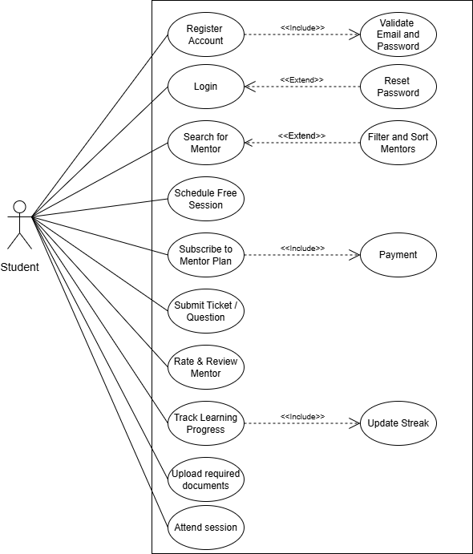

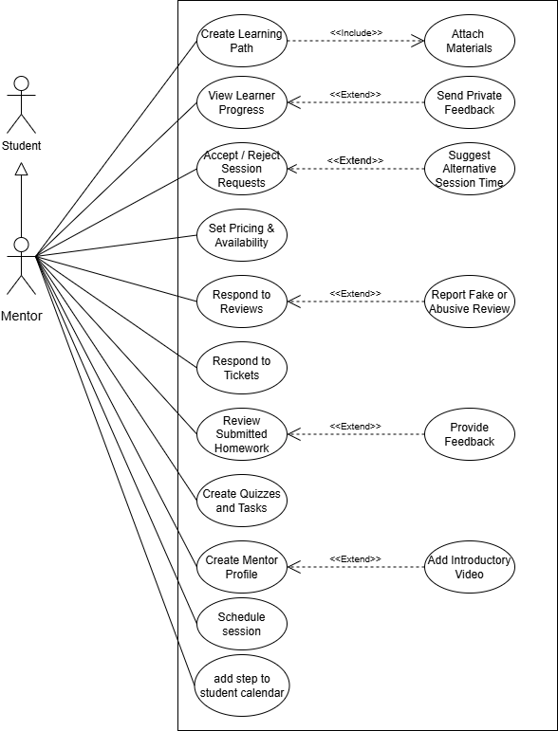

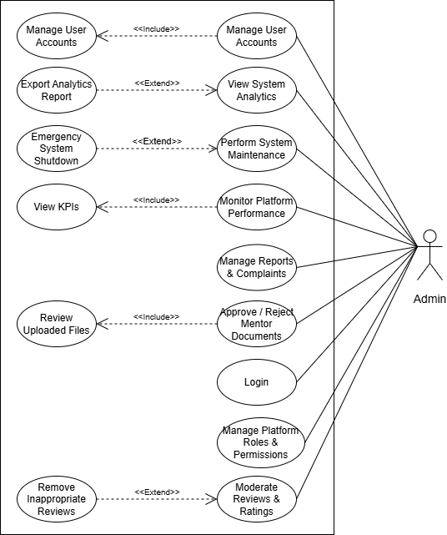

USE CASE DESCRIPTION (USE CASE SCENARIO)

- Register Account
Use case ID | UC-L01: Register Account
Actors | Students, Mentors
Preconditions | User is not logged in and has no existing account.
Main flow | - User opens the DisciplineX website.  - User clicks “Sign Up.”  - User enters email, password.  - User submits the registration form.  - System validates input and creates the account.  - System redirects the user to the login page.
Alternative flows | User enters optional profile details (name, avatar) during sign-up.
Exception flows | - If the password is weak:  System displays validation messages.  - If email already exists:  System shows “email already registered.”  - If verification email is not delivered:  System allows resend link.  - If server error during registration:  System displays “try again later.
Postconditions | User account is created and stored in the database.

- Login
Use case ID | UC-L02: Login
Actors | Students, Mentors
Preconditions | User already has an account.
Main flow | - User opens login page.  - User enters email + password.  - System validates credentials.  - User is logged in.
Alternative flows | - User chooses “remember me” option.  - User logs in from a new device and the system sends a security alert.
Exception flows | - If the password is wrong:  System shows error.  - If there are too many failed attempts:  Account temporarily locked.  - If Server timeout:  System fails to authenticate.
Postconditions | User is authenticated and redirected to dashboard.

- Search for a Mentor
Use case ID | UC-L03: Search for a Mentor
Actors | Students, Mentors
Preconditions | User is logged in.
Main flow | - User navigates to mentor search page.  - User displays a list of mentors.  - User views mentor profile.
Alternative flows | - User sorts mentors by price or rating.  - User saves mentor to favorites.  - User selects filters (skills, pricing, availability).
Exception flows | - No mentors match the filters:  System shows the message: “No mentors match your filters. Try adjusting your search criteria.”  - If server error displaying results:  System displays an error notification: “An unexpected error occurred. Please try again later.”  - If mentor profile data is missing:  System shows a warning: “This mentor’s profile is incomplete.”
Postconditions | Mentor list is displayed.

- Schedule free session
Use case ID | UC-L04: Schedule Free Session
Actors | Students, Mentors
Preconditions | Learner is logged in, mentor has available slots.
Main flow | - Learner opens mentor profile.  - Learner selects a 30-minute free session slot.  - System checks availability.  - Session is added to both calendars.
Alternative flows | - Learner chooses a different time zone.  - Learner edits the booking before confirmation.  - Learner adds session reminder notification.
Exception flows | - If slot becomes unavailable during booking:  - System cancels the booking process.  - System displays: “This slot is no longer available. Please choose another time.”  - System refreshes the available slots automatically.  - If learner’s internet disconnects before confirmation:  - System cancels the booking request.  - When the learner reconnects, the booking page shows a message:  “Your session was not confirmed due to connection issues. Please try again.”  - System fails to sync calendar:  - System rolls back the session creation.  - System displays: “We couldn’t save the session due to a system error. Please try again later.”
Postconditions | Session is confirmed.

- Track learning progress
Use case ID | UC-L05: Track Learning Progress
Actors | Students, Mentors
Preconditions | Learner is enrolled in a learning path.
Main flow | - Learner opens learning path page.  - Learner checks tasks and weekly activities.  - Learner marks tasks as completed.  - System updates streak and progress chart.
Alternative flows | - Learner adds custom notes.  - Learner sets a daily study timer.  - Learner skips a task and returns later.
Exception flows | - If streak fails to update:  - Display message: “Unable to update streak. Please try again later.”  - Activity is still marked as completed (optional based on your design).  - If task completion is not saved:  - Show warning: “Task status could not be saved.”  - Keep the task unchecked.  - If loading error for resources:  - Display message: “Failed to load content. Check your connection or try again.”  - Provide a retry button.
Postconditions | Learner progress is updated.

- Upload required documents
Use case ID | UC-M01: Upload Required Documents
Actors | Student
Preconditions | User is logged in, mentor mode is disabled.
Main flow | - User navigates to “Become a Mentor”.  - User uploads CV, certificates, skills documents.  - System validates document formats.  - Mentor option becomes available (enabled).
Alternative flows | - User uploads additional optional documents.  - User edits previously uploaded files.  - User uploads documents through drag-and-drop.
Exception flows | - If file format is invalid:  - Display error: “Invalid file format. Please upload a supported file type.”  - Do not accept or process the file.  - If file size is too large:  - Show message: “File size too large. Maximum allowed size is X MB.”  - Cancel upload process.  - If upload is interrupted:  - Show warning: “Upload interrupted. Please try again.”  - Keep partially uploaded data discarded.
Postconditions | Mentor mode is activated.

- Create mentor profile
Use case ID | UC-M02: Create Mentor Profile
Actors | Mentor
Preconditions | Mentor mode is active.
Main flow | - Mentor opens profile editor.  - Mentor fills skills, profile picture, pricing, roadmap.  - System saves data.
Alternative flows | - Mentor uploads a profile picture.  - Mentor copies details from uploaded CV.  - Mentor adds introductory video.
Exception flows | - If required fields is missing:  - Highlight missing fields.  - Display error message: “Please fill in all required fields.”  - Prevent form submission.  - If server fails to save data:  - Display message: “An error occurred while saving your data. Please try again later.”  - Log the error for admins.  - Keep user-entered data on the screen  - Image upload fails.
Postconditions | Mentor profile is visible to learners.

- Accept session request
Use case ID | UC-M03: Accept Session Request
Actors | Mentor
Preconditions | Mentor mode is active, student booked free session.
Main flow | - Mentor views new session request.  - Mentor confirms the session.  - System syncs session to mentor calendar.
Alternative flows | - Mentor suggests alternative time.  - Mentor enables automatic approval.  - Mentor adds session notes.
Exception flows | - If mentor tries to accept a past slot:  - Show error: “This time slot has already passed and cannot be accepted.”  - Prevent approval action.  - If calendar sync fails:  - Display warning: “Calendar sync failed. Session created locally only.”  - If system crashes during approval:  - Once system restarts or reconnects, show message:  “An error occurred while approving the session. Approval status could not be confirmed.”  - Roll back any partial changes to keep data consistent.
Postconditions | Session is confirmed.

- Create learning path
Use case ID | UC-M04: Create Learning Path
Actors | Mentor
Preconditions | Mentor mode is active.
Main flow | - Mentor creates a new learning path.  - Mentor adds weekly tasks and materials.  - System stores the learning path.
Alternative flows | - Mentor imports tasks from a previous path.  - Mentor adds video links or PDFs.
Exception flows | - File upload fails:  - Display error: “File upload failed. Please try again.”  - Clear any partially uploaded data.  - Keep user on the same page without losing other form information.  - Learning path name duplicated:  - Display message: “This learning path name already exists. Please choose a different name.”  - Highlight the name field.  - Prevent form submission.  - Auto-save fails:  - Display non-blocking warning: “Auto-save failed. Your recent changes may not be saved.”  - Keep the user on the page without interruption.  - Retry auto-save silently after a short delay
Postconditions | Learning path becomes available to student.

- View learner progress
Use case ID | UC-M05: View Learner Progress
Actors | Mentor
Preconditions | students enrolled in mentor’s learning paths.
Main flow | - Mentor opens the dashboard.  - System loads and displays an overview of all learner progress.  - Mentor selects a specific learning path or class to view details.  - System shows detailed progress charts, scores, and completion percentages.  - Mentor reviews individual learner performance summaries.
Alternative flows | - Mentor filters by student.  - Mentor exports progress report.  - Mentor sends private feedback.
Exception flows | - Data loading error:  - Show message: “Data failed to load. Please try again.”  - Display a retry button.  - Report export fails:  - Display error: “Export failed. Unable to generate the report.”  - Cancel the export attempt.  - Progress data incomplete:  - Show partial data only.  - Display a warning: “Some progress data could not be loaded.”  - Hide or disable features dependent on missing data.
Postconditions | Mentor receives updated progress insights.

- Approve mentor documents
Use case ID | UC-A01: Approve Mentor Documents
Actors | Admin
Preconditions | User submitted mentor documents.
Main flow | - Admin navigates to the Pending Mentor Requests page.  - Admin selects a mentor request to review.  - Admin opens and checks the submitted documents.  - Admin chooses to approve or reject the mentor request.  - System updates the mentor’s status accordingly.
Alternative flows | - Admin requests clarification.  - Admin asks for more documents.  - Admin assigns request to another admin.
Exception flows | - If documents is corrupted:  - Display: “This document appears to be corrupted and cannot be opened.”  - Prevent review from continuing.  - If a system error occurred during loading files:  - Display: “An error occurred while loading this file. Please try again.”  - Retry file access.  - If document format is incorrect:  - Display: “Unsupported document format. Please request a valid file type.”  - Request proper document from the user.
Postconditions | Mentor mode is fully approved or denied.

- Manage user accounts
Use case ID | UC-A02: Manage User Accounts
Actors | Admin
Preconditions | Admin logged in.
Main flow | - Admin navigates to the User Management page.  - Admin views the list of existing user accounts.  - Admin selects a user to manage.  - Admin edits the user’s role or status (e.g., learner, mentor, admin, active, suspended).  - System validates the changes.  - System updates the user account successfully.
Alternative flows | - Admin resets user password.  - Admin deactivates user temporarily.  - Admin updates profile fields.
Exception flows | - If account is not found:  - Display message: “User account not found.”  - Return Admin to the user list.  - Update fails:  - Display: “Failed to update account. Please try again later.”  - No changes are applied.  - Permission error:  - Display: “You do not have permission to perform this action.”  - Block the unauthorized action.
Postconditions | User account changes applied.

- Monitor platform performance
Use case ID | UC-A03: Monitor Platform Performance
Actors | Admin
Preconditions | System is online.
Main flow | - Admin navigates to the Analytics Dashboard.  - Admin views key performance indicators (KPIs):  - Server load  - Number of active users  - API response times  - Admin analyzes system performance.
Alternative flows | - Admin filters analytics by date.  - Admin exports performance report.  - Admin sets alert thresholds.
Exception flows | - If dashboard is not loading:  - Display: “Dashboard could not be loaded. Please try again.”  - Log the error for technical review.  - If data is outdated:  - Display warning: “Displayed data may be outdated.”  - Attempt auto-refresh.  - If analytics server is offline:  - Display warning: “Displayed data may be outdated.”  - Attempt auto-refresh.
Postconditions | Mentor receives updated progress insights.

- Manage reports & complaints
Use case ID | UC-A04: Manage Reports & Complaints
Actors | Admin
Preconditions | Student or mentor submits a report.
Main flow | - Admin navigates to the Reports & Complaints section.  - Admin views the list of submitted complaints.  - Admin selects a complaint to investigate.  - Admin reviews complaint details and any attached evidence.  - Admin takes the appropriate action (e.g., warning, suspension, case closure).  - System logs the action and marks the complaint as resolved.
Alternative flows | - Admin asks for more information.  - Admin temporarily suspends user.  - Admin escalates to higher authority.
Exception flows | - If report is missing data:  - Display: “Report is incomplete. Some required information is missing.”  - Mark the complaint as “Incomplete.”  - If evidence file is corrupted:  - Display: “Attached evidence is corrupted or unreadable.”  - Request the reporter to re-upload evidence.  - If action fails due to permissions:  - Display error: “You do not have permission to perform this action.”  - No changes are applied.
Postconditions | Complaint is resolved and stored.

- System maintenance
Use case ID | UC-A05: System Maintenance
Actors | Admin
Preconditions | Admin logged in.
Main flow | - Admin navigates to the System Maintenance panel.  - Admin initiates scheduled maintenance tasks (e.g., updates, backups, performance cleanup).  - System safely stops or limits specific services to avoid conflicts.  - System performs maintenance operations.  - System restarts all services and verifies their integrity.  - System logs maintenance results for record-keeping.
Alternative flows | - Admin postpones maintenance.  - Admin performs partial maintenance.  - Admin sends maintenance notice to users.
Exception flows | - If system fails to restart:  - Display: “System restart failed. Rolling back to previous state.”  - Attempt automatic rollback or safe mode.  - If maintenance logs corrupted:  - Display: “Maintenance logs corrupted. Logging failure detected.”  - Create a temporary error log entry.  - If unexpected outage occurs:  - Enter emergency recovery mode.  - Display: “Unexpected outage detected during maintenance.”  - Attempt service restoration.
Postconditions | System updated and stable.

SYSTEM ARCHITECTURE
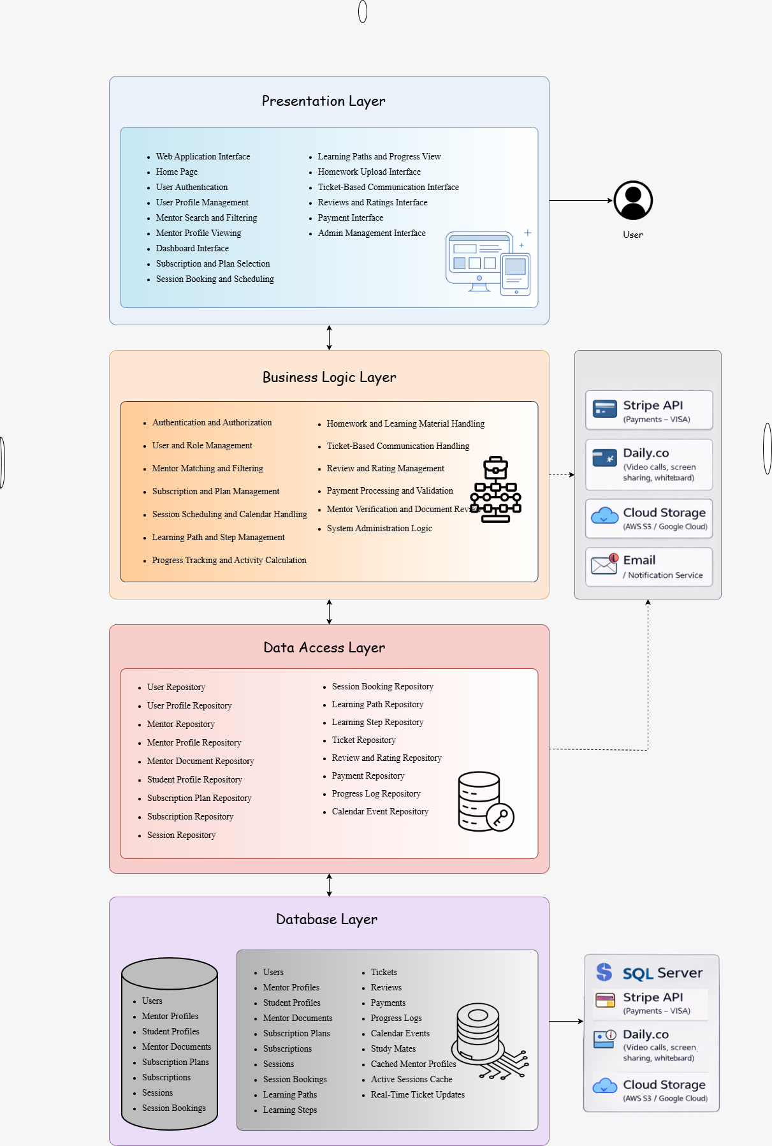

DATAFLOW DIAGRAMS

CONTEXT DIAGRAM (LEVEL 0)
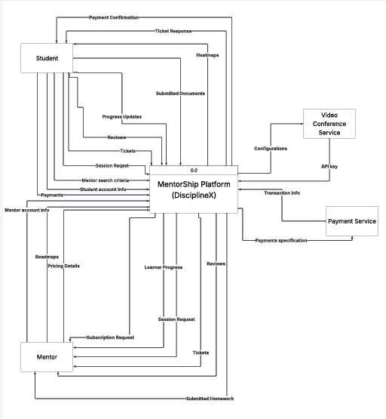

DATAFLOW DIAGRAM (LEVEL 1)

Logical
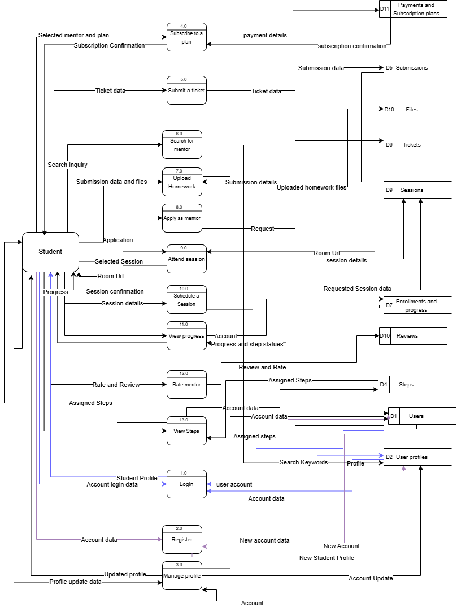
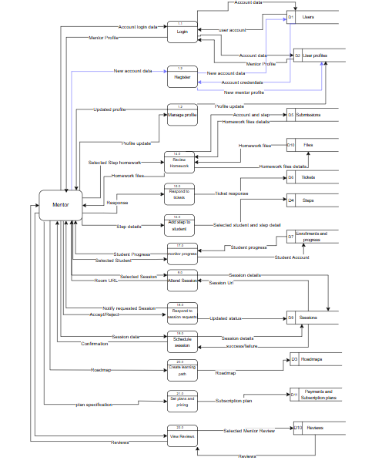
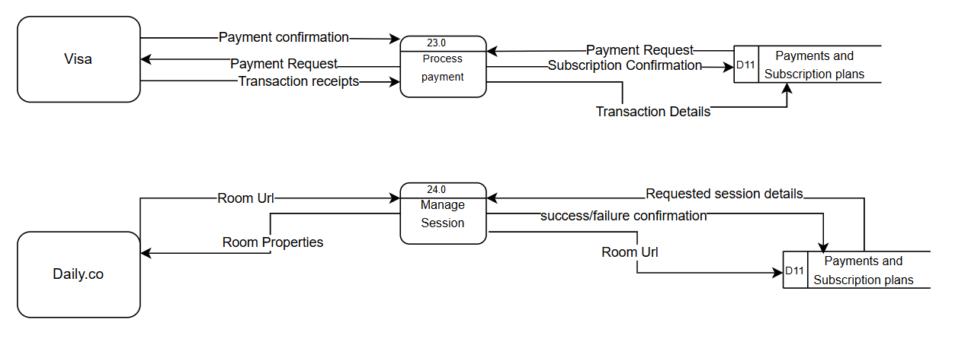

Physical
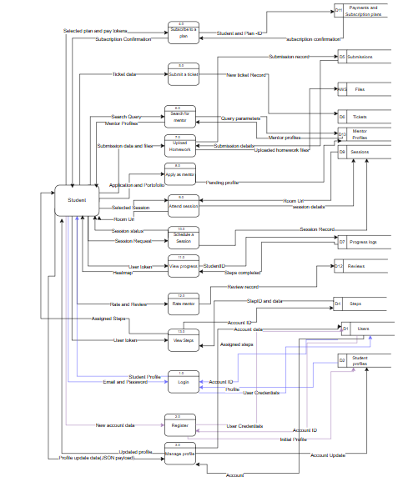

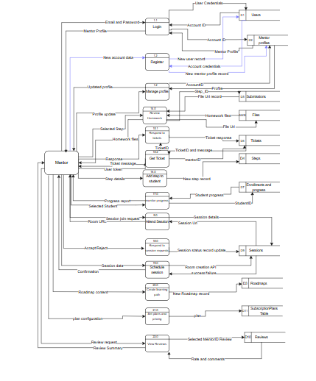

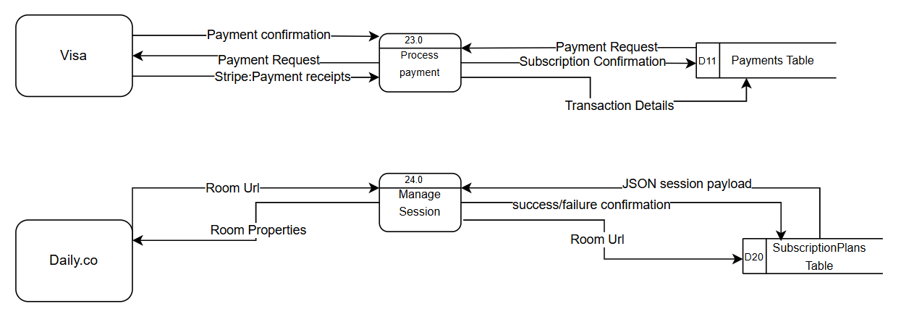

ACTIVITY DIAGRAM

4.5.1 Admin

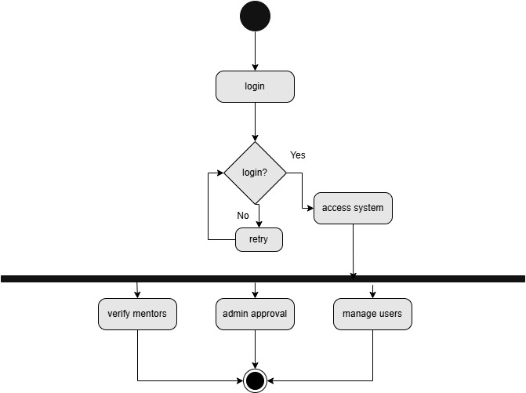

4.5.2 Student

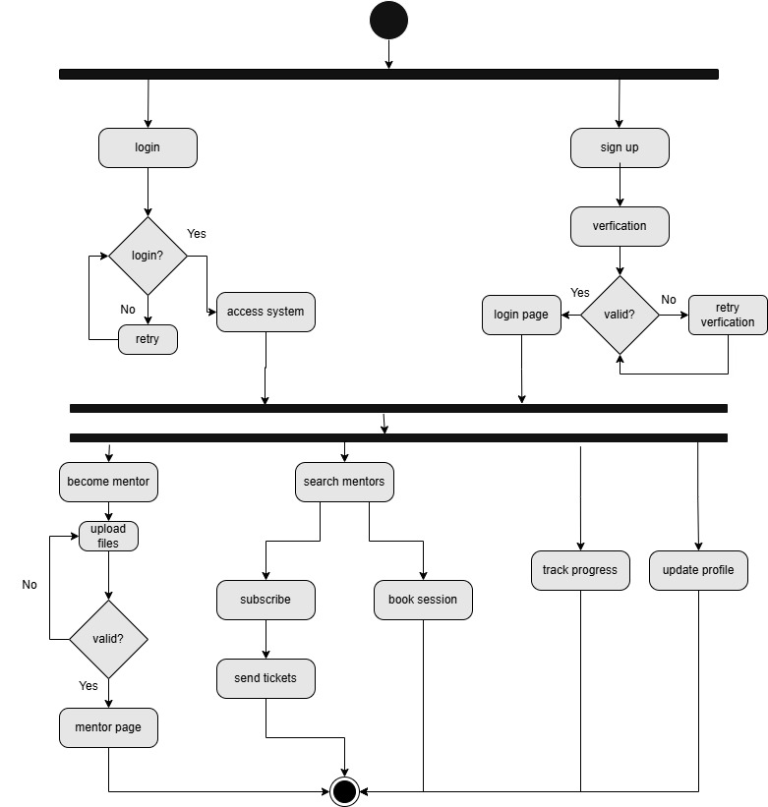

4.5.3 Mentor

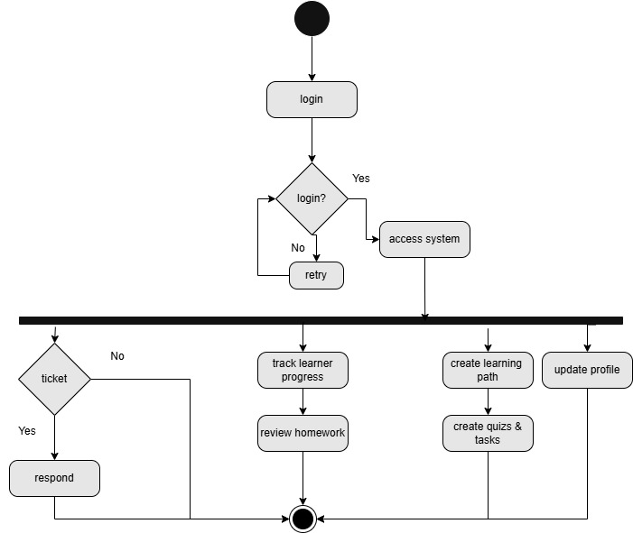

ER DIAGRAM
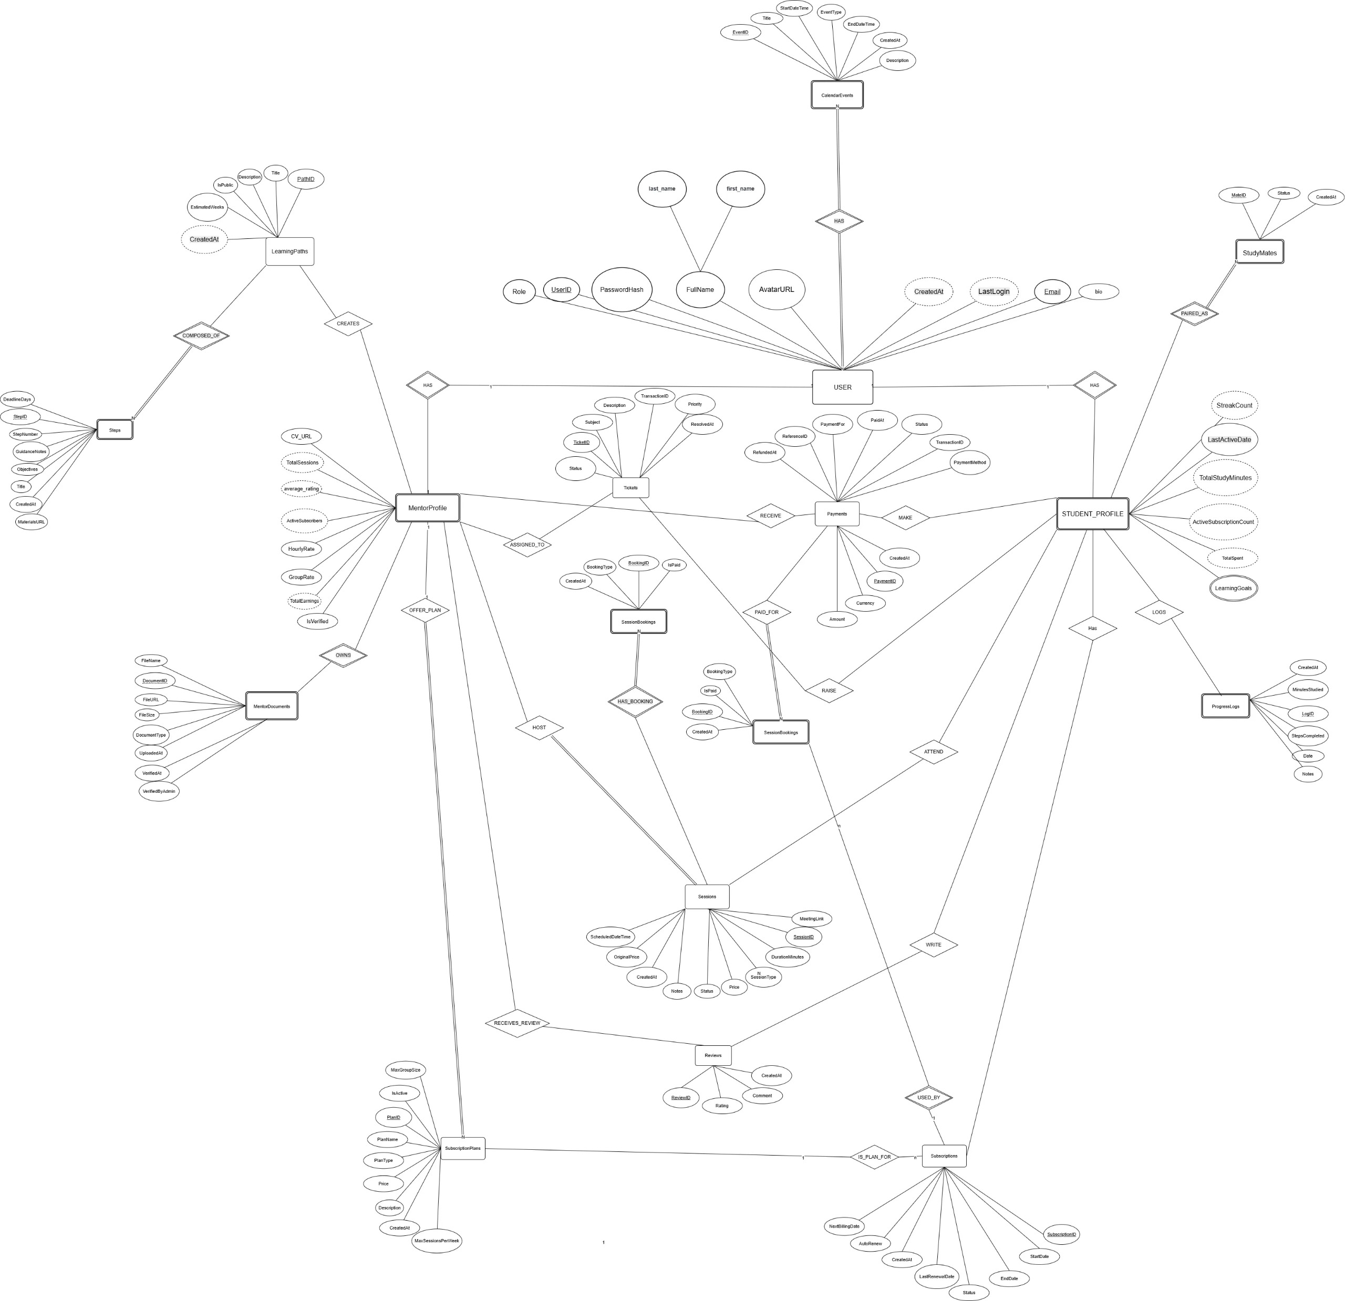

CHAPTER 5
CONCLUSIONS &
FUTURE WORK

CONCLUSIONS
DisciplineX was created to help students to study in a better way and to help mentors connect with students easily. The main goals of the project were to match students with mentors quickly, give students a clear learning plan, support communication, track progress, and make payments safe.
The project shows that all the important system requirements can be implemented and are suitable to achieve the goals. The requirements allow students and mentors to create accounts, search for mentors, book sessions, make learning plans, upload homework, send questions, track progress, and pay safely.
The system will offer main features such as:
- Personal learning plans (roadmaps) made by mentors
- Mentor profiles with experience, certificates, and pricing
- A ticket system for asking questions with file attachments
- Progress tools like streaks, progress bars, and heatmaps
- Safe payments using Stripe API
- Live session tools like whiteboard and screen sharing using Daily.co
and meets its goals by giving students clear direction, keeping them motivated, and helping them improve their skills step by step. The expected benefits for stakeholders are:
- Students will learn faster, stay motivated, and get feedback from experts
- Mentors can manage their mentoring work and earn money from teaching
- The community will have better skill sharing and more learning success
In short, DisciplineX is a good and realistic software solution that can solve the current learning problems.

FUTURE WORK
In the future, the platform can be improved by adding new features that were not included now. Some possible upgrades are:
- AI suggestions to help students find the best mentor
- A mobile app to make the system easier to use anywhere
- AI tools to help mentors check homework faster
- More tools for coding practice during live sessions
- Better dashboards to show mentor and student progress
The system can also use newer technology later, like:
- WebRTC for faster video calls inside the platform
- Microservices to make the system handle more users
- More study can also be done to improve things like:
- Making AI matching fair and more accurate
- Understanding how students stay active to improve streak and points systems
- Improving Redis caching for faster loading
These upgrades can help DisciplineX become smarter and stronger.

