# Palmora Group HR Analysis

By: Olabisi

Date: July 2025

## 1. Introduction

This report analyzes the Palmora Group employee dataset to uncover gender-related insights, pay structure, and compliance with the new minimum wage regulation.

## 2. Data Cleaning Summary

- Records removed with missing salary or department: 69

- Missing gender entries filled with "Not Disclosed"

## 3. Gender Distribution

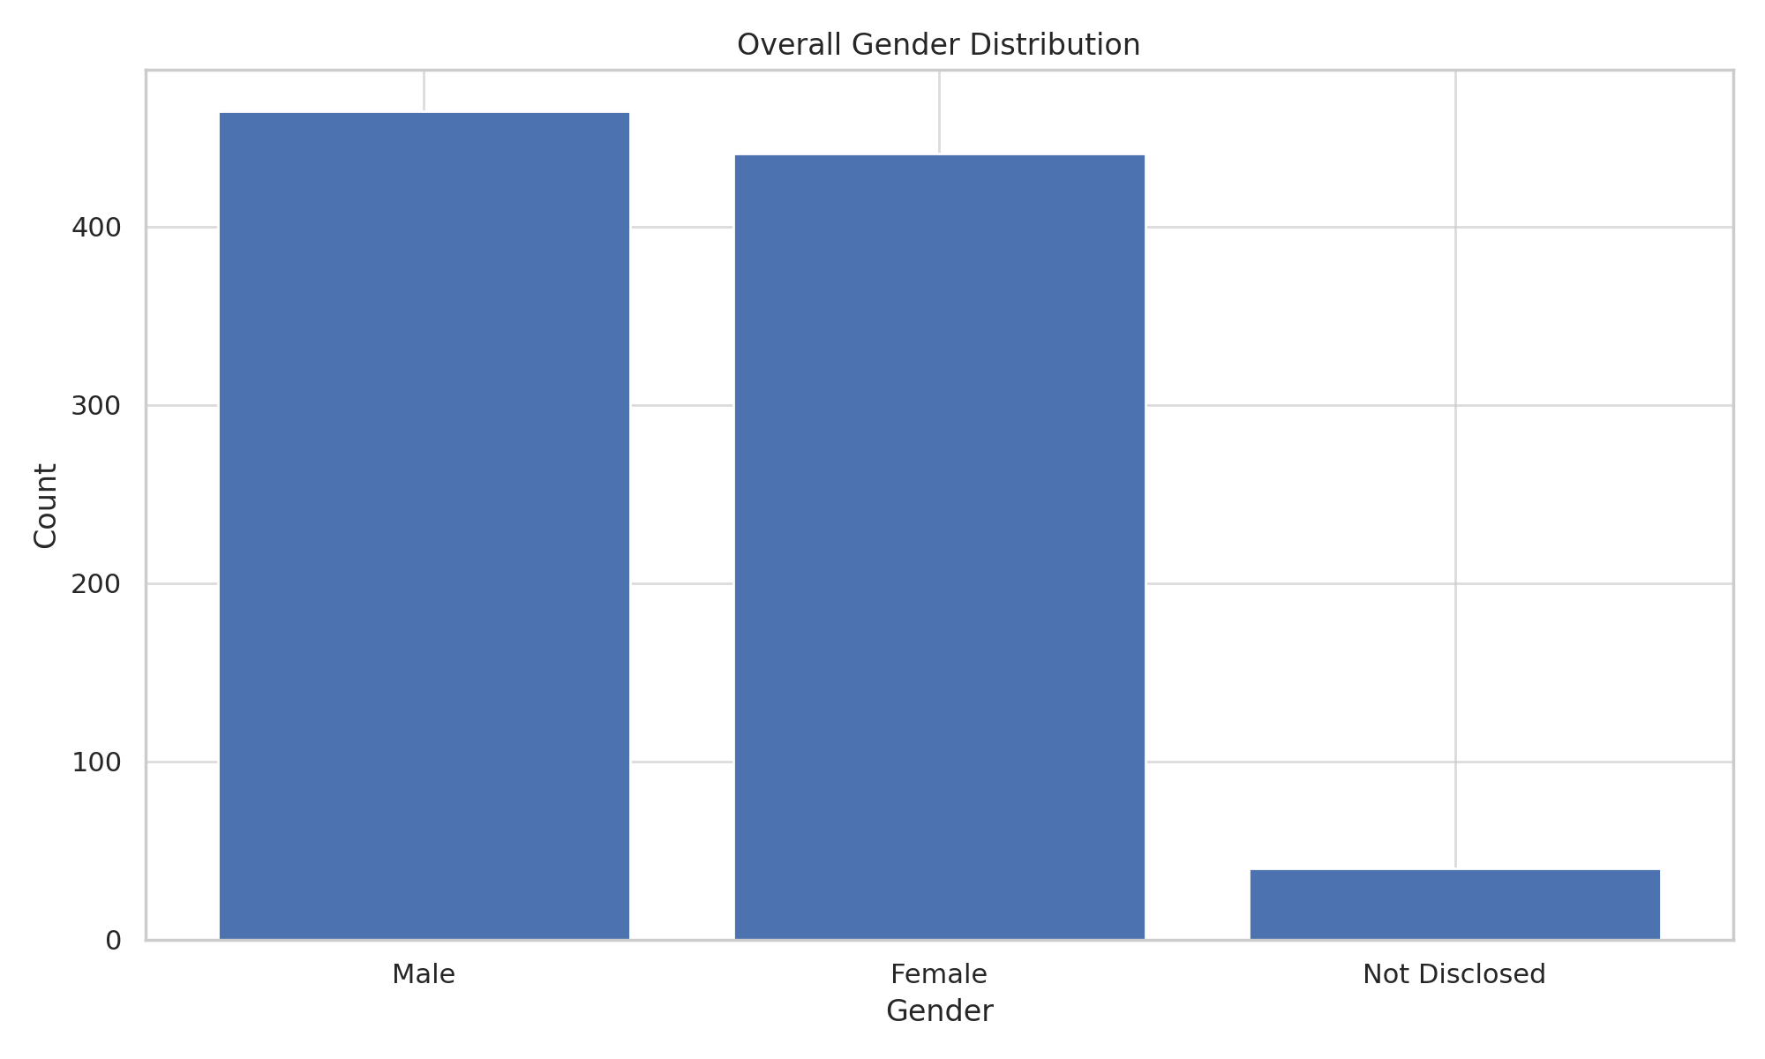

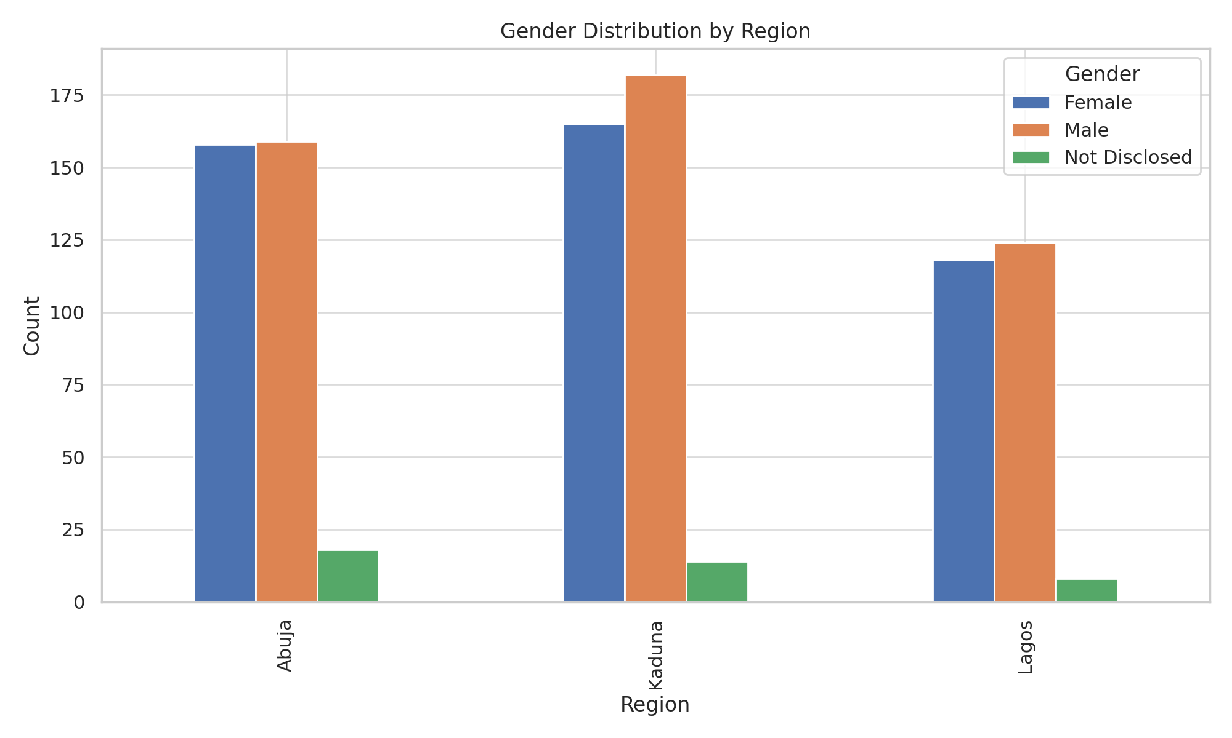

## 4. Salary & Pay Gap Analysis

- Average salary (Male): $74789.53

- Average salary (Female): $72135.69

- Pay gap: 3.68% (Male vs Female)

## 5. Minimum Wage Compliance ($90,000)

- Compliant: 292

- Non‑Compliant: 654

## 6. Conclusions & Recommendations

The organization shows a modest overall gender pay gap and regional imbalances in workforce gender. Focus departments with higher gaps (e.g., Human Resources, Business Development) should review pay structures. Kaduna has slightly fewer compliant salaries; management should prioritize salary adjustments for underpaid staff.