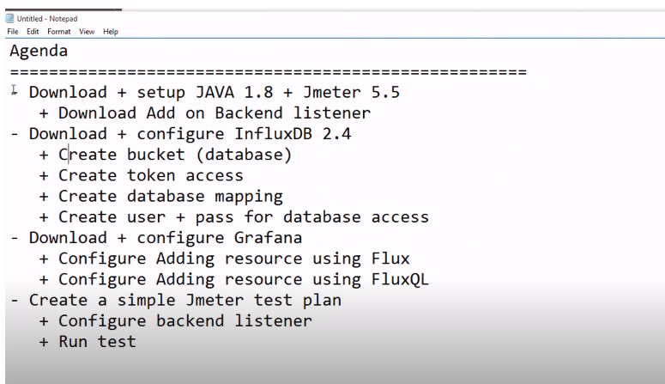

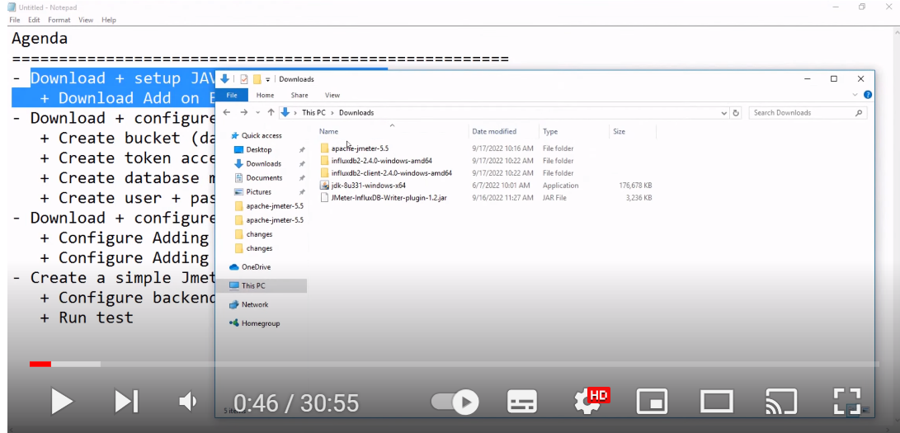

Download JMeter-influxDB-writer-plugin 1.2 jar and add it to JMeter > lib > ext path

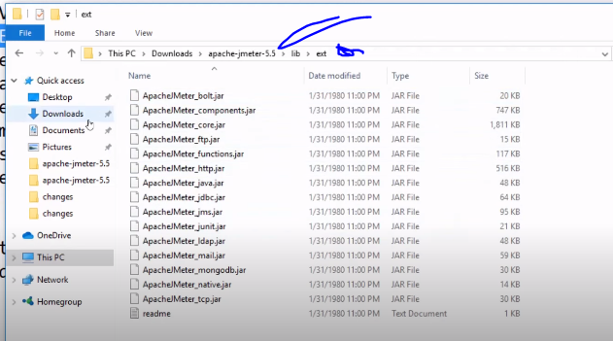

Do DB mapping by:

Donwload influxDB client and run influx.exe (powershell or cmd)

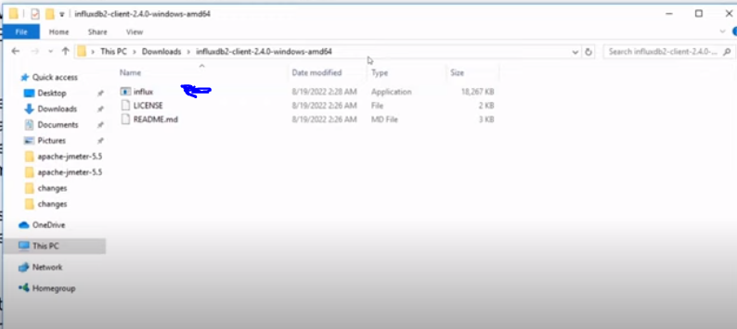

An erorr will be returned with the bucket creates, add influxDB user token with flag --token <token> and run command (see screen)

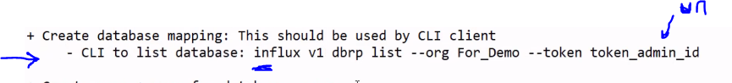

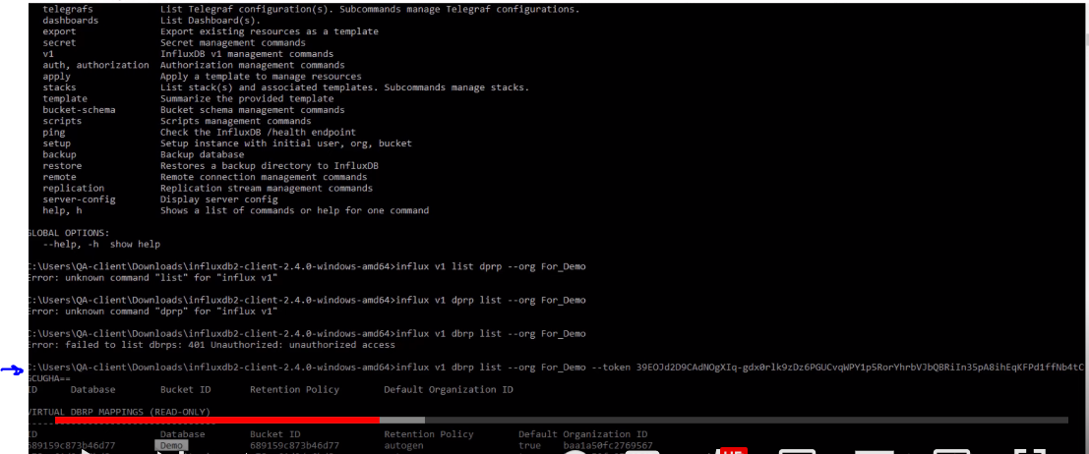

Continuation of database mapping:

Copy the influx create command generated and re-run command (see screen) - pls put --bucket



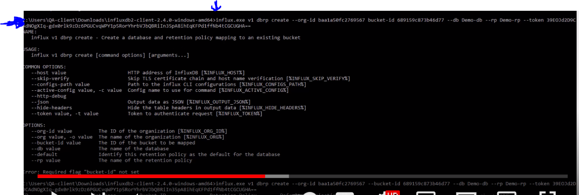

Create user + pwd for database access, run below command with input of ids:

Run > .\ influx.exe v1 auth create --read-bucket <bucketID> --write-bucket <bucketID> --username <demouser> --password <demopwd123> --token <yourtokenID> --org-id <orgID>



JMeter Apache Backend Listener for influxdb Setup:

