**Ladi’s Midi Fighter3D with FL Studios (20.7+)**

# Controls

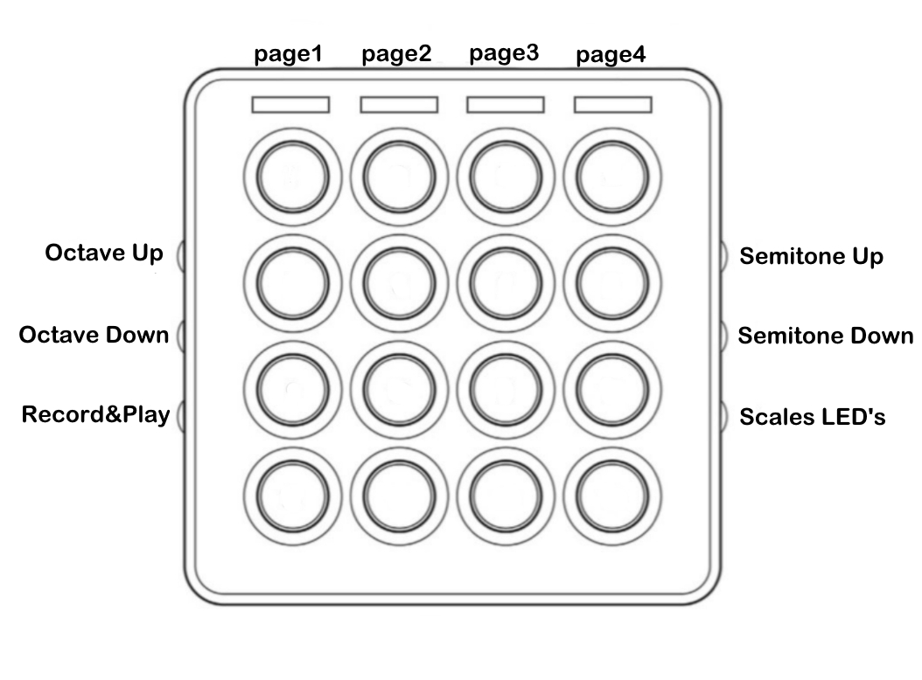

# How to Install

# 

Drop the **MidiFighter3D** Folder into the file at location C:\Users\oladi\Documents\Image-Line\FL Studio\Settings\Hardware

# How to edit scale color

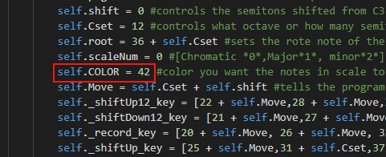

Change this line of code to equal on of the numbers attached to a color.

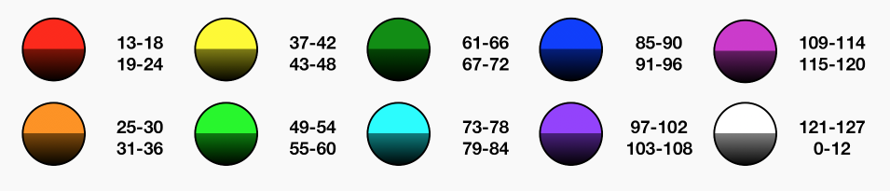

# Roots and Octaves

You can view the root that your on in the FL Studios helper window

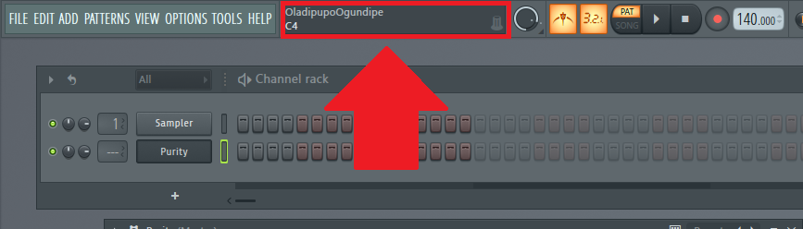

# Thank you

**Email me:** [Oladipupo.ogundipe@gmail.com](mailto:Oladipupo.ogundipe@gmail.com) if you find any bugs

Please **DONATE** if you can: <https://www.paypal.com/cgi-bin/webscr?cmd=_donations&business=5T62652PWUJF4&currency_code=USD>

# Triads Cheatsheet

