**AI** – Artificial intelligence can just be a predefined set of rules

**ML** – Machine learning is where it is fed data and answers and it figures out the rules for us through an algorithm. Not always accurate. You want to get the highest accuracy possible.

**DL/NN** – A layered representation of data. Multiple layers in the middle, compared to machine learning which only has two.

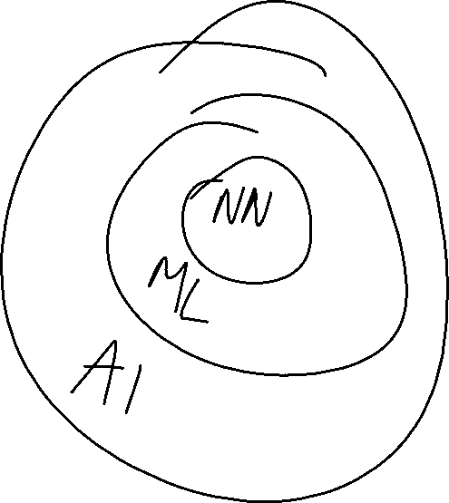

**Features** – Input information

**Label** – Output information

Data is the key thing used to create models. Varied data. A lot of data.

**Tensors**

* Must be in rectangular shape. Cannot have a tensor of size 2 and a size 3.
* When running tensor.shape() it describes the dimensions of the rectangle (array). Think of it as an excel table.
* A rank is the amount of “internal lists.”
* [[[“”]]] 3rd rank
* Types of tensors:
* Variables – Hardcode amounts
* Constant – Cannot change value during execution.
* Placeholder
* SparseTensor
* All except Variable cannot have a changed value during execution.

**Linear Regression**

* You try to have a linear correspondence between data points.
* Simplest machine learning.
* Used when data points have a direct correspondence.
* Line of best fit can predict things linearly.