

Wouter Lokhorst, BSc

Microbial ecology, Nioo-knaw, wageningen, The Netherlands

MSc Bioinformatics internship report

Linking tomato plant traits to the rhizosphere microbiome composition

Linking tomato plant traits to the rhizosphere microbiome composition

Wouter Lokhorst1, Ben Oyserman2 and Marnix Medema3

1. MSc student, Department of Bioinformatics, Wageningen UR, Wageningen, The Netherlands
2. Supervisor, Department of Microbial Ecology, Netherlands Institute of Ecology, Wageningen, The Netherlands
3. Supervisor, Department of Bioinformatics, Wageningen UR, Wageningen, The Netherlands

Keywords: bacteria, disease resistance, microbiome, qtl, recombinant inbred line, rhizosphere, stress, tomato

# Abstract

*Solanum lycopersicum* cultivars have lost pathogen resistance in favour of higher yields over time. This can be countered by crossing the plant with *Solanum pimpinellifolium*, which is more resilient. Through QTL analysis, genomic regions were mapped against genus abundance across 27 recombinant inbred lines. 17 region-genus pairs were significant and they represent various mechanisms involved with stress response and growth regulation. This analysis lays the basis for a larger scale study.

# Introduction

The highly cultivated modern tomato species *Solanum lycopersicum* is one of the most popular crops worldwide and its production is increased each year. The selection of specific traits during the domestication process and subsequent breeding often results in the loss of non-target traits [1]. In particular, recent attention has been given to the impact of domestication on the composition of the microbiome [2]. Microbiomes play an essential role in the development and health of plants [3][4]. For example, *S. lycopersicum* cultivars have lost pathogen resistance in favour of higher yields over time, which has led to increasing crop losses due to pathogens [5]. One such threat to increasing the yield is the early blight disease caused by the fungus *Alternaria solani*. Many studies have focused on using mycorrhizal inoculation to combat either the presence of *A. solani* or the symptoms it causes [6][7][8]. Others have focused on using bacteria to combat the same or other tomato diseases, including *Bacillus spp.* against bacteria, fungi and oomycetes [9] and using *Streptomyces spp.* against bacterial wilt, *Fusarium* wilt, *Verticillium* wilt, early blight and bacterial canker [10]. The range of diseases broadens further with tomato viruses. These include the Tomato Spotted Wilt Virus (TSWV), the Tomato Yellow Leaf Curl Virus (TYLCV) and many viruses that are also present on other Solanaceae [11]. What each of these approaches have in common is that they use an organism to compensate for the reduced disease resistance of the tomato plant.

However, it is also possible to increase disease resistance by making the plant itself more resilient.

A previous study crossed *S. lycopersicum* var. “Moneymaker” with the wild currant tomato *Solanum pimpinellifolium* G1.1554to potentially bring back lost or impaired traits that improved seed quality [12]. A second study created a linkage map of 715 unique genetic loci using 100 recombinant inbred lines (RILs) of these species, that were created through selfing until F8 [13].

Here, 16S sequencing of the rhizosphere of a subset of those 100 RILs has been added to the dataset, to discover which tomato plant genomic recombinations improve the plant its disease resistance, either through gain of resistance mechanisms or gain of mechanisms that attract bacterial species that strengthen the plant its disease resistance indirectly [3][4][14][15].

# Methods

The automated part of the analysis is performed by a single script written in R (Supplementary file 1). Its mechanisms are described below, as are the few manual steps at the end of the analysis.

## Dimension reduction

The analysis starts with removal of OTUs that have had their taxonomy annotated by the Silva database as “kingdom unclassified”, “family mitochondria” or “order chloroplast”, to remove sequences that are likely of non-bacterial origin. Samples that have less than 10000 reads after removal of these OTUs are discarded (Figure 1). Next, RILs with less than two replicates left are discarded. These two removal steps increase the reliability and reproducibility of the analysis. The remaining OTU read counts are normalised by sample totals and the average read count per OTU over all replicates of a RIL is taken.

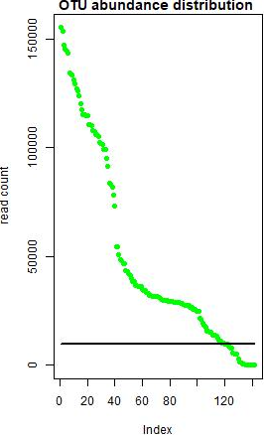

Figure 1. OTU abundance distribution. Each green dot is the total abundance of an OTU across all samples. The black line is the threshold of 10000 reads. The y-axis displays the read count per OUT, the x-axis displays the index of the OTUs (ordered by abundance).

The pipeline script then sums OTU read counts based on the given taxonomy level (kingdom, phylum, class, order, family, genus, species or OTU). Here, the taxonomy level of genus was chosen. Due to the limitation in the number of replicates, no statistical analysis could be conducted to determine differentially abundant genera. However, dimension reduction is an important step, as limiting the number of traits is important for statistical power of quantitative trait locus (QTL) analysis (i.e. multiple testing). Therefore, only the top 500 genera with the largest standard deviation (SD) over all RILs are were kept, and all other genera discarded. The reason for this is that if there is no variance within a genus among the RILs, the recombination events may not have an effect on the abundance of that genus and, in turn, will not have an effect on the plant. Therefore, the larger the variance of a genus between the different RILs, the larger of an effect it can have on the plant.

## QTL analysis

QTL analysis consists of mapping molecular markers (e.g. SNPs) against observed traits (e.g. 16S sequence abundance) in order to find correlation between marker-trait pairs [16]. These analyses scale up quickly, hence the need for multiple testing correction. Furthermore, it requires automated computer scripts to adequately process the information. Therefore, this study uses R (version (v.) 3.4.4) and makes heavy use of the R packages called R/QTL (v. 1.42.8) and R/QTL2 (v. 0.15.9), developed by Karl Broman *et al.* specifically for QTL analyses [17]. Other used packages are devtools (v. 1.13.5), parallel (v. 3.4.4), MASS (v. 7.3.49), base (v. 3.4.4), RColorBrewer (v. 1.1.2), plyr (v. 1.8.4) and RCy3 (v. 2.1.9).

The QTL analysis part of the script begins with calculating the probability of the genotype (maternal or paternal allele) at each of the 715 markers. To determine the significance threshold for the LOD scores, a genome scan using Haley-Knott regression is then performed 1000 times, where the genera abundances are shifted across the RILs. Of the resulting LOD scores, the maximum LOD score per genus-marker pair is retained and the threshold is set at the 95th percentile of these maxima (LOD score of 3.394). A separate genome scan using Haley-Knott regression is performed (with the read counts in their original places) to determine the actual LOD scores. All LOD score peaks above the threshold are regarded as significant QTLs.

## Genomic neighbourhood and genes

The genomic neighbourhood of the significant QTLs is defined here as all bases between the neighbouring markers of the marker that has the LOD score peak. Gene names are derived from a downloadable table that contains all coding genes of the *S. lycopersicum* reference genome of NCBI (Solanum lycopersicum SL3.0) [18]. The script then retrieves all genes that have either their start or stop position inside the genomic neighbourhood, lie entirely inside it, or span the entire genomic neighbourhood. The peak-gene combinations are then written to a file for manual annotation of gene function (i.e. searching articles about the gene its function). Lastly, the script generates a Cytoscape network of the peak-gene combinations.

# Results and discussion

With the current dataset, there were 17 significant peaks to be found on the genus level. Ten were on chromosome 2, one on chromosome 4, one on chromosome 7, four on chromosome 9 and one on chromosome 12 (Figure 2, Figure 3, Figure 4, Figure 5 and Figure 6). The ten peaks on chromosome 2 lie on roughly the same position on the genome, both can be split into two groups. The first group contains the genera *Ammoniphilus*, *Planifilum* and *Pelotomaculum*. The second group contains the genera *Afipia*, *Amycolatopsis*, *LD29*, *Litorilinea*, *Nitrospira*, *Blyi10* and *Ellin6067*. The groups share some of their genomic neighbourhood. The four peaks on chromosome 9 (*Pontibacter* has equal significant LOD scores on two consecutive positions, which are therefore counted as one peak) can also be divided into two groups that are in close physical distance from each other. The first contains the genera *Pajaroellobacter*, *Pir4_lineage* and *Sporichthya*. The second has the genus *Pontibacter*. This suggests that 1) there are numerous genomic regions that control different microbial populations and 2) there is some overlap between microbial groups under similar genetic control by the host.

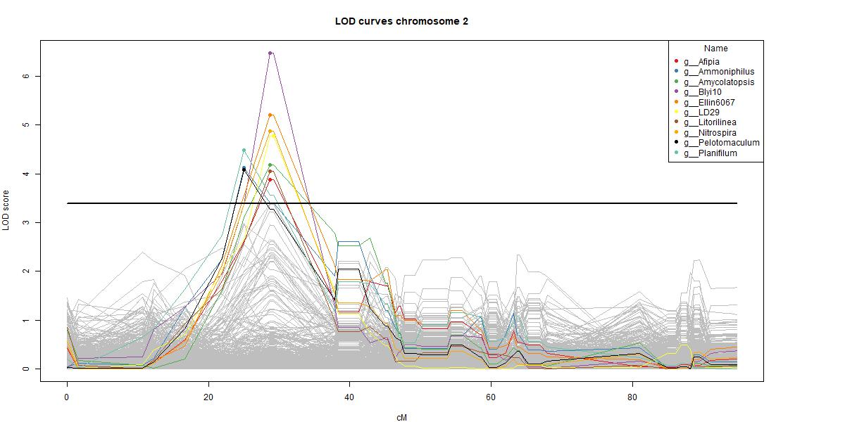

Figure 2. Significant QTLs (red lines) on chromosome 2. Grey lines are insignificant QTLs, black line is the genome-wide LOD threshold of 3.394 at α=0.05.

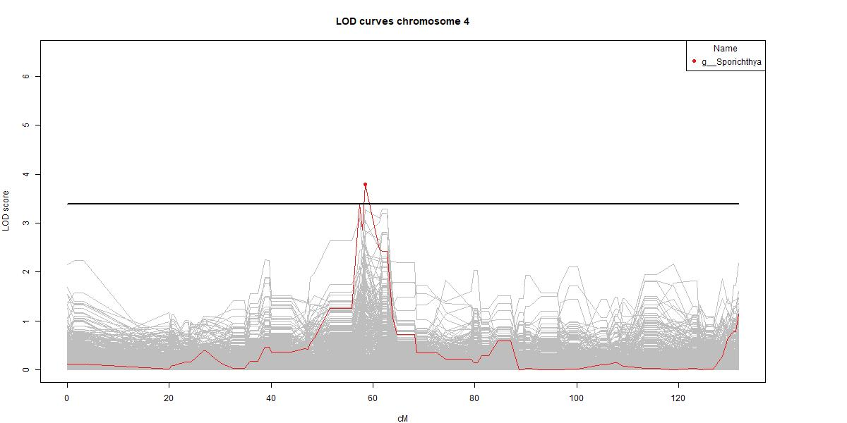

Figure 3. Significant QTL (red line) on chromosome 4. Grey lines are insignificant QTLs, black line is the genome-wide LOD threshold of 3.394 at α=0.05.

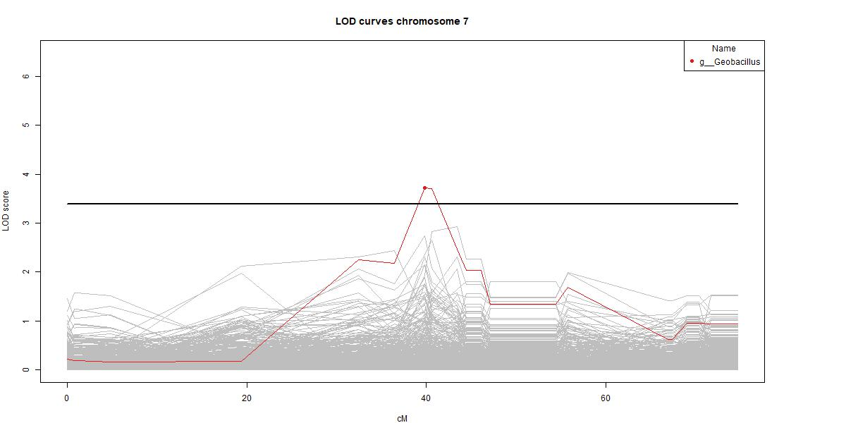

Figure 4. Significant QTL (red line) on chromosome 7. Grey lines are insignificant QTLs, black line is the genome-wide LOD threshold of 3.394 at α=0.05.

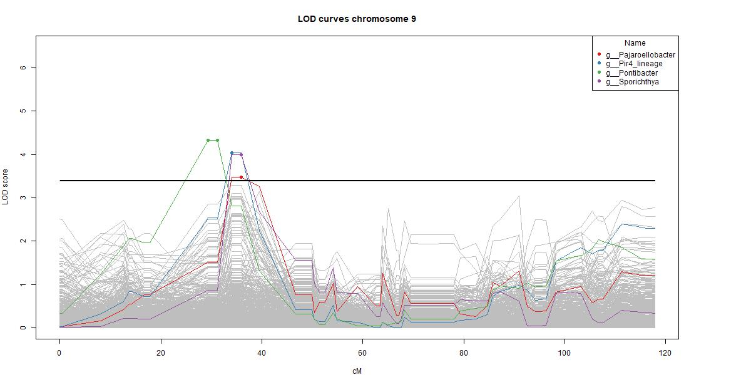

Figure 5. Significant QTLs (red lines) on chromosome 9. Grey lines are insignificant QTLs, black line is the genome-wide LOD threshold of 3.394 at α=0.05.

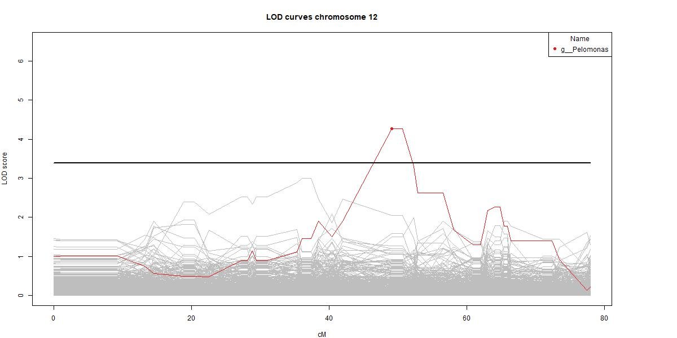

Figure 6. Significant QTL (red line) on chromosome 12. Grey lines are insignificant QTLs, black line is the genome-wide LOD threshold of 3.394 at α=0.05.

## QTLs dominated by stress and growth genes

The genes corresponding to the genomic regions can be viewed in Figure 7. Only laboratory-validated genes are shown (computer-predicted genes are not shown). Hence, there are five genera without genes visible. The laboratory-validated genes have had their functions annotated manually (Supplementary file 2) and were grouped by their function (Figure 8). There is an abundance of stress-related genes, which have been sub-divided in salt

stress (includes flooding stress), heat stress (includes chilling stress), biotic stress (stress caused by other organisms) and stress (undefined or general stress). The other groups are growth (plant growth and development), growth/stress (any combination of growth- and stress-related mechanisms), DNA/RNA (mechanisms involving DNA and/or RNA) and other (any mechanism that does not belong to the aforementioned categories).

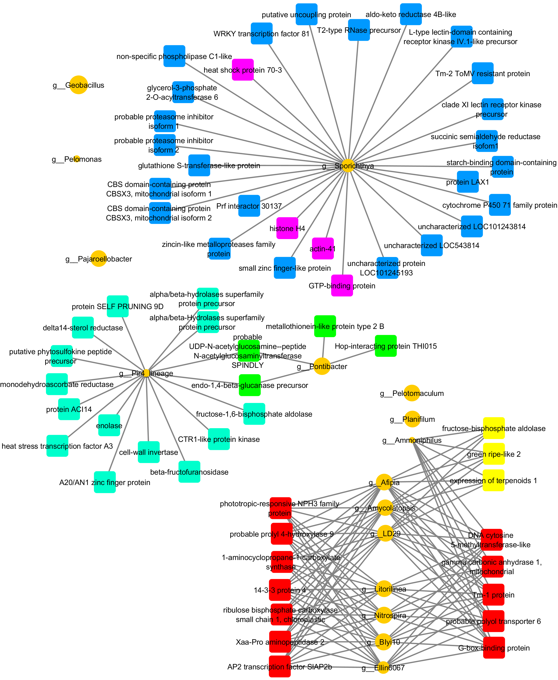

Figure 7. Genera-gene network. Orange circles are genera, with the size being the difference in number of read counts between S. lycopersicum and S. pimpinellifolium. Squares are genes, coloured by approximate genomic location: yellow = chr.2, 25cM, red = chr.2, 29cM, purple = chr.4, 58cM, green = chr.9, 31cM, light blue = chr.9, 34cM, dark blue = chr.9, 36cM. Only laboratory-validated genes are shown here (computer-predicted genes are not shown). Hence, there are five genera without genes visible here. Pajaroellobacter would be connected to some of the same predicted genes as Pir4_lineage and Sporichthya; and Pelotomaculum and Planifilum would be connected to some of the same predicted genes as Ammoniphilus.

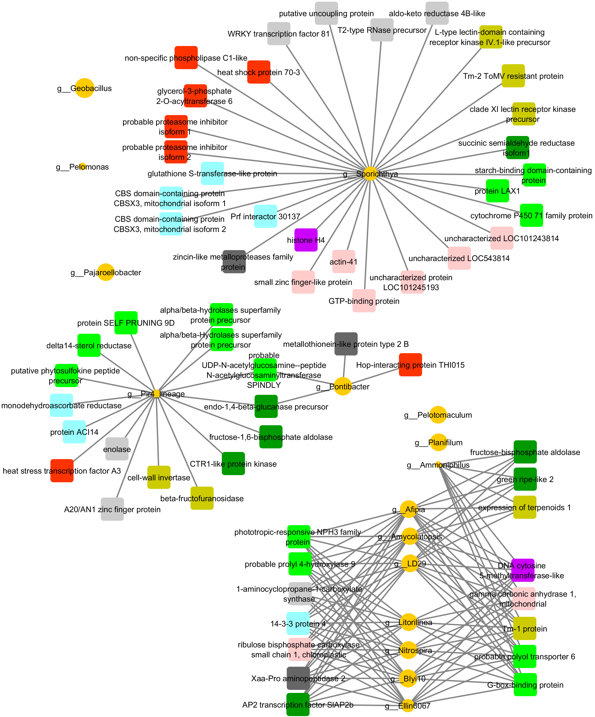

Figure 8. Genera-gene network. Orange circles are genera, with the size being the difference in number of read counts between S. lycopersicum and S. pimpinellifolium. Squares are genes and are coloured based on involved mechanism(s): Dark yellow = biotic stress, light blue = salt/flooding stress, red = heat/chilling stress, light grey = (unspecified or general) stress, light green = growth, dark green = growth/stress, dark grey = metals, purple = DNA/RNA, pink = other/not found. Only laboratory-validated genes are shown here (computer-predicted genes are not shown). Hence, there are five genera without genes visible here. Those genera form two groups when predicted genes are taken into account, though no other groups are formed or new linkages between existing groups are formed.

## Plant stress changes the microbiome

The QTL hotspot on chromosome 2 consists of the genera, *Afipia* [19], *Ammoniphilus* [20], *Amycolatopsis* [21], *Blyi10*, *Ellin6067*, *LD29*, *Litorilinea* [22], *Nitrospira* [23], *Pelotomaculum* [24] and *Planifilum* [25]. Most of these contain species that have found to be contributing to the degradation of organic material (e.g. wood-rotting). For a living plant, this causes wounding. Consequently, stress levels are elevated and stress-response pathways are activated. This stress response is greater in S. pimpinellifolium than in *S. lycopersicum* [26][27], which means that growth of such bacteria is limited in greater effect (Supplementary file 3). Further evidence is given by the fact that many of the genes present in the significant QTLs are part of the ethylene and/or auxin pathways. These pathways influence a range of mechanisms in the plant, mainly stress- and growth related. However, this is just one possible cause. Another is the ability of the plant to cope with changes in temperature. Heat and chilling stress activate the same pathways as wounding. Coincidentally, these genera also contain species that are thermotolerant. A third option is high soil ammonia. There is a proven link between high soil ammonia and root damage (i.e. stress) in tomato plants [28]. This could also be a (partial) cause of these results, because some of the genera contain ammonia-oxidizing species.

The genus *Geobacillus* includes thermophilic bacteria, favouring both hot environments as well as cold [29]. Even though it has no validated genes linked to it, it is likely influenced by at least some of the same mechanisms as the genera linked to chromosome 2.

There isn’t much known about the genus *Pir4_lineage* (*Pirellula*-like genus 4), but it contains species found in alpine cold desert steppe [30], as well as near deep-sea hydrothermal vents [33]. This suggests, as with *Geobacillus*, that there is a link to heat/chilling stress. Although the Pir4_lineage genus has a QTL in close proximity with *Pontibacter*, their genomic neighbourhoods barely overlap. The genus *Pontibacter* consists of many halotolerant species [34][35]. Since *S. lycopersicum* dehydrates the soil faster than *S. pimpinellifolium* because of their growth rate, it is easy to see why this genus has a higher abundance in *S. lycopersicum* samples. However, it also gives rise to another possible cause of why this and all previous genera have significant QTLs at these positions. Salt stress is higher in plants that grow in dehydrated soil and salt stress happens to be another trigger for activation of ethylene and auxin pathways. Of course, the opposite might also be happening here, meaning that *S. pimpinellifolium* has high stress levels due to flooding and that *S. lycopersicum* has normal levels.

The Pir4_lineage genus shares some predicted genes with the genus *Pajaroellobacter*, but due to a lack of publications on the latter, it is currently not known if there are similarities between the genera. The only described *Pajaroellobacter* is an etiologic agent of epizootic bovine abortion [36]. *Pajaroellobacter* is also connected to the genus *Sporichthya* through predicted genes. *Sporichthya* has a lot of heat and salt stress-related genes linked to it. *Sporichthya spp.* themselves are more motile when submerged, which allows them to find nutrients more easily and produce greater numbers of bacteria [37]. *Sporichthya* read counts are lower for *S. lycopersicum*. Therefore, the most probable cause for the shifts in both *Sporichthya* and *Pajaroellobacter* can be accounted to dehydration or flooding of the soil and, in turn, the QTLs are accounted to dehydration or flooding of the plants.

Although the *Pelomonas* genus does not have any validated genes linked to it through the QTL, it is worth a mention solely because of its close relation to the genus *Mitsuaria*, which is known to suppress soilborne diseases for plants [38]. It is therefore likely that they possess some of the same mechanisms which could be regulated by the various stress-response pathways of tomato plants mentioned earlier in this study.

## It is all subject to change

The current analysis was done at the genus level. However, there are seven more taxonomic levels to be investigated (kingdom, phylum, class, order, family, species and OTU). Due to time constraints, these were not investigated during this study. Nonetheless, a quick scan of the results on OTU level (Supplementary file 4) shows that most of the genes and therefore genomic locations stay the same, though it remains to be seen if the changes that do happen, bring any functional changes as well. The bacteria themselves obviously show a greater diversity, though there are many reoccurring genera among them. What the implications are, is currently not known. Diversity within a genus may cause noise (e.g. different OTUs may respond differently and have a signal but are then clumped together). Conversely, other OTUs may have more general responses and act as a coherent unit, and their signal may only be picked up if the OTUs are clumped by genus.

# Conclusions & future research

Many, if not most, of the genes are part of the ethylene and/or auxin pathways. These pathways influence a range of mechanisms in the plant, mainly stress- and growth related. In this study, the microbiome changes can be ascribed to flooding/drought, chilling/heat and salt stress. The exact reason remains elusive due to the absence of gene expression data, and the lack of phenotypic characterization of the plants under the conditions grown. Nonetheless, increased stress impedes growth and vice versa. Future research can focus on discovering the exact pathways and decouple these mechanisms to provide farmers with fast-growing, yet resilient plants.

The evidence presented here suggests that the current pipeline produces reliable results and is ready for being used with a larger dataset. This will also increase the consistency when repeating the analysis. More accurate conclusions can also be drawn when expression data of the plant genes is available and by comparing the results of the different taxonomic levels.

# References

1. Genomic analyses provide insights into the history of tomato breeding. Lin *et al.*, Nature Genetics, volume 46, pages 1220-1226 (2014). <http://www.nature.com/articles/ng.3117>
2. Impact of plant domestication on rhizosphere microbiome assembly and functions. Pérez-Jaramillo *et al.*, Plant Molecular Biology, volume 90, issue 6, pages 635-644 (2015). <https://link.springer.com/article/10.1007%2Fs11103-015-0337-7>
3. The rhizosphere microbiome and plant health. Berendsen *et al.*, Trends in Plant Science, volume 17, issue 8, pages 478-486 (2012). <https://www.sciencedirect.com/science/article/pii/S1360138512000799>
4. Manipulating the soil microbiome to increase soil health and plant fertility. Chaparro *et al.*, Biology and Fertility of Soils, volume 48, issue 5, pages 489-499 (2012). <https://link.springer.com/article/10.1007/s00374-012-0691-4>
5. Functional genomics of tomato for the study of plant immunity. Rosli *et al.*, Briefings in Functional Genomics, volume 14, issue 4, pages 291-301 (2015). <https://academic.oup.com/bfg/article/14/4/291/202514>
6. Enhanced tomato disease resistance primed by arbuscular mycorrhizal fungus. Song *et al.*, Frontiers in Plant Science (2015). <https://www.frontiersin.org/articles/10.3389/fpls.2015.00786/full>
7. Influence of plant genotype on the cultivable fungi associated to tomato rhizosphere and roots in different soils. Poli *et al.*, Fungal Biology, volume 120, issues 6-7, pages 862-872 (2016). <https://doi.org/10.1016/j.funbio.2016.03.008>
8. Improvement of growth, fruit weight and early blight disease protection of tomato plants by rhizosphere bacteria is correlated with their beneficial traits and induced biosynthesis of antioxidant peroxidase and polyphenol oxidase. Babu *et al.*, Plant Science, volume 231, pages 62-73 (2015). <https://doi.org/10.1016/j.plantsci.2014.11.006>
9. *Bacillus* lipopeptides: versatile weapons for plant disease biocontrol. Ongena *et al.*, Trends in Microbiology, volume 16, issue 3, pages 115-125 (2008). <https://doi.org/10.1016/j.tim.2007.12.009>
10. Towards the biological control of fungal and bacterial diseases of tomato using antagonistic *Streptomyces spp.* El-Abyad *et al.*, Plant and Soil, volume 149, issue 2, pages 185-195 (1993). <https://link.springer.com/article/10.1007/BF00016608>
11. Oligonucleotide microarray-based detection and identification of 10 major tomato viruses. Tiberini *et al.*, Journal of Virological Methods, volume 168, issues 1-2, pages 133-140 (2010). <https://doi.org/10.1016/j.jviromet.2010.05.003>
12. Complex genetics controls natural variation among seed quality phenotypes in a recombinant inbred population of an interspecific cross between *Solanum lycopersicum × Solanum pimpinellifolium*. Kazmi *et al.*, Plant, Cell & Environment, volume 35, issue 5 (2011). <https://doi.org/10.1111/j.1365-3040.2011.02463.x>
13. Mapping in the era of sequencing: high density genotyping and its application for mapping TYLCV resistance in *Solanum pimpinellifolium*. Víquez-Zamora *et al.*, BMC Genomics, volume 15:1152 (2014). <https://doi.org/10.1186/1471-2164-15-1152>
14. An Underground Revolution: Biodiversity and Soil Ecological Engineering for Agricultural Sustainability. Bender *et al.*, Trends in Ecology & Evolution, volume 31, issue 6, pages 440-452 (2016). <https://doi.org/10.1016/j.tree.2016.02.016>
15. Plant root-microbe communication in shaping root microbiomes. Lareen *et al.*, Plant Molecular Biology, volume 90, issue 6, pages 575-587 (2016). <https://link.springer.com/article/10.1007/s11103-015-0417-8>
16. Quantitative trait locus (QTL) analysis. Miles *et al.*, Nature Education, volume 1, issue 1, page 208 (2008). <https://www.nature.com/scitable/topicpage/quantitative-trait-locus-qtl-analysis-53904>
17. R/qtl2. Broman *et al.* <http://kbroman.org/qtl2/>
18. NCBI *S. lycopersicum* reference genome. <https://www.ncbi.nlm.nih.gov/genome/proteins/7?genome_assembly_id=393272>
19. Isolation and characterization of haloacetic acid-degrading *Afipia spp.* from drinking water. Zhang *et al.*, FEMS Microbiology Letters, volume 297, issue 2, pages 203-208 (2009). <https://doi.org/10.1111/j.1574-6968.2009.01687.x>
20. New aerobic ammonium-dependent obligately oxalotrophic bacteria: description of *Ammoniphilus oxalaticus* gen. nov., sp. nov. *and Ammoniphilus oxalivorans* gen. nov., sp. nov. Zaitsev *et al.*, International Journal of Systematic and Evolutionary Microbiology, volume 48, pages 151-163 (1998). <https://doi.org/10.1099/00207713-48-1-151>
21. Genome Sequence of *Amycolatopsis sp.* Strain ATCC 39116, a Plant Biomass-Degrading Actinomycete. Davis *et al.*, Journal of Bacteriology (2012). <https://doi.org/10.1128/JB.00186-12>
22. *Litorilinea aerophila* gen. nov., sp. nov., an aerobic member of the class Caldilineae , phylum *Chloroflexi* , isolated from an intertidal hot spring. Kale *et al.*, International Journal of Systematic and Evolutionary Microbiology, volume 63, pages 1149-1154 (2013). <https://dx.doi.org/10.1099/ijs.0.044115-0>
23. Complete nitrification by *Nitrospira* bacteria. Daims *et al.*, Nature, volume 528, pages 504-509 (2015). <https://www.nature.com/articles/nature16461>
24. The genome of *Pelotomaculum thermopropionicum* reveals niche-associated evolution in anaerobic microbiota. Kosaka *et al.*, Genome Research, volume 18, issue 3, pages 442-448 (2008). <https://dx.doi.org/10.1101%2Fgr.7136508>
25. *Planifilum fimeticola* gen. nov., sp. nov. and *Planifilum fulgidum* sp. nov., novel members of the family 'Thermoactinomycetaceae' isolated from compost. Hatayama *et al.*, International Journal of Systematic and Evolutionary Microbiology, volume 55, pages 2101-2104 (2005). <https://dx.doi.org/10.1099/ijs.0.63367-0>
26. SpWRKY1 mediates resistance to *Phytophthora infestans* and tolerance to salt and drought stress by modulating reactive oxygen species homeostasis and expression of defense-related genes in tomato. Li *et al.*, Plant Cell, Tissue and Organ Culture, volume 123, issue 1, pages 67-81 (2015). <https://link.springer.com/article/10.1007/s11240-015-0815-2>
27. Salt tolerance in *Lycopersicon* species. I. Character definition and changes in gene expression. Asins *et al.*, Theoretical and Applied Genetics, volume 86, issue 6, pages 737-743 (1993). <https://link.springer.com/article/10.1007/BF00222664>
28. Ammonium nitrogen accumulation and root injury to tomato plants. Uljee, New Zealand Journal of Agricultural Research, volume 7, issue 3, pages 343-356 (1964). <https://doi.org/10.1080/00288233.1964.10416415>
29. Some (bacilli) like it hot: genomics of *Geobacillus* species. Studholme, Microbial Biotechnology, volume 8, issue 1 (2014). <https://doi.org/10.1111/1751-7915.12161>
30. Soil microbial communities of three grassland ecosystems in the Bayinbuluke, China. Shao *et al.*, Canadian Journal of Microbiology, volume 64, issue 3, pages 209-213 (2018). <https://doi.org/10.1139/cjm-2017-0585>
31. Diversity of Planctomycetes in iron-hydroxide deposits from the Arctic Mid Ocean Ridge (AMOR) and description of *Bythopirellula goksoyri* gen. nov., sp. nov., a novel Planctomycete from deep sea iron-hydroxide deposits. Storesund *et al.*, Antonie van Leeuwenhoek, volume 104, issue 4, pages 569-584 (2013). <https://dx.doi.org/10.1007/s10482-013-0019-x>
32. *Pontibacter yuliensis* sp. nov., isolated from soil. Cao *et al.*, International Journal of Systematic and Evolutionary Microbiology, volume 64, pages 968-972 (2014). <https://dx.doi.org/10.1099/ijs.0.055004-0>
33. *Pontibacter locisalis* Sy30T sp. nov. isolated from soil collected from an abandoned saltern. Zhou *et al.*, Antonie van Leeuwenhoek, volume 109, issue 3, pages 415-420 (2016). <https://link.springer.com/article/10.1007%2Fs10482-016-0646-0>
34. Characterization of *Pajaroellobacter abortibovis*, the etiologic agent of epizootic bovine abortion. Brooks *et al.*, Veterinary Microbiology, volume 192, pages 73-80 (2016). <https://doi.org/10.1016/j.vetmic.2016.07.001>
35. Selective Isolation and Distribution of *Sporichthya* Strains in Soil. Suzuki *et al.*, Applied Environmental Microbiology, volume 65, issue 5, pages 1930-1935 (1999). <https://aem.asm.org/content/65/5/1930>
36. Linking Sequence to Function in Soil Bacteria: Sequence-Directed Isolation of Novel Bacteria Contributing to Soilborne Plant Disease Suppression. Benítez *et al.*, Applied Environmental Microbiology, volume 75, issue 4, pages 915-924 (2009). <https://dx.doi.org/10.1128%2FAEM.01296-08>