DESIGN AND IMPLEMENTATION OF AN
MOBILE FRIENDLY WEB-BASED DIAGNOSIS ADVISORY SYSTEM
BY
CHUKWUDI DANIEL CHINWEOTITO — 220591316
ODETUNDE OLAMIDE ONYEDIKACHUKWU — 220591201
DEPARTMENT OF COMPUTER SCIENCE
FACULTY OF COMPUTING AND INFORMATION TECHNOLOGY
LAGOS STATE UNIVERSITY, OJO, LAGOS.
IN PARTIAL FULFILMENT OF THE REQUIREMENTS FOR THE AWARD OF
BACHELOR OF SCIENCE (B.Sc.) DEGREE
SUPERVISOR: DR. AIYENIKO
FEBRUARY, 2026

TABLE OF CONTENTS

CHAPTER ONE
INTRODUCTION 5
1.0 Introduction 5
1.1 Background of Study 6
1.2 Problem Statement 6
1.3 Aim and Objectives 7
1.4 Scope of Study 8
1.5 Research Methodology 9
1.6 Significance of Study 10
1.7 Limitations 10
1.8 Definition of Terms 11
1.9 Chapter Summary 12

CHAPTER TWO
LITERATURE REVIEW 13
2.0 Overview 13
2.1 Architectural Mechanics of Rule-Based Diagnosis (Oluwatosin & Adebayo, 2017) 13
2.2 Evidence of Mobile Diagnosis in Sub-Saharan Africa (Makinde et al., 2021) 14
2.3 Artificial Intelligence Integration in Diagnostics (Aliyu et al., 2020) 15
2.4 Other Related Works 16
2.5 Summary of Findings 18

CHAPTER THREE:
SYSTEM ANALYSIS AND DESIGN 20
3.1 Introduction 20
3.2 Analysis of the Existing System 21
3.2.1 Description of the Existing System 21
3.2.2 Problems with the Existing System 21
3.3 Method of Data Collection (Fact-Finding) 22
3.4 Requirements Analysis and Specification 23
3.4.1 Functional Requirements 23
3.4.2 Non-Functional Requirements 24
3.5 System Design 25
3.5.1 Process Modeling (System Architecture / Flow) 26
3.5.2 Data Modeling (Database Design) 27
3.5.3 Interface Design (User Interface Wireframes) 28

CHAPTER FOUR:
SYSTEM IMPLEMENTATION 30
4.1 Introduction 30
4.2 Choice of Development Tools 30
4.2.1 Frontend Technologies 30
4.2.2 Backend Technologies 31
4.2.3 Database Management System 32
4.3 System Implementation Modules 33
4.3.1 User Authentication Module 33
4.3.2 Symptom Input and Advisory Engine Module 33
4.4 System Security and Maintenance 34
4.5 System Results 35
4.5.1 System Login and Registration Interface 35
4.5.2 Symptom Input and Engine Processing 36
4.5.3 Advisory Result and Triage Output 36

CHAPTER FIVE
CONCLUSION 38
5.1 Summary of the Project 38
5.2 Conclusion 39
5.3 Limitations of the System 40
5.4 Recommendations for Future Work 41
REFERENCES 43

CHAPTER ONE

INTRODUCTION

1.0 Introduction

The domain of mobile-based diagnostic and health systems has witnessed exponential growth, driven by the ubiquitous penetration of mobile devices globally. In the context of national health ecosystems, researchers have increasingly explored the mechanics of automated diagnosis through mobile-based expert systems designed to facilitate self-diagnosis. These systems utilize rule-based inference engines to guide users through structured symptom-based questions, attempting to mimic the deductive reasoning of human physicians.
Within Nigeria and sub-Saharan Africa, the efficacy of mobile health (mHealth) is being closely examined as a mechanism to bolster universal health coverage. By enabling remote consultations and health tracking, these technological tools theoretically bridge the gap between urban healthcare centers and rural peripheries, enhancing public health communication and care coordination. This project introduces a Mobile Health (mHealth) Diagnosis Advisory System designed to leverage these technological advancements to provide accessible, preliminary health guidance.

1.1 Background of Study

Many remote or underserved communities in Nigeria face significant barriers to accessing prompt primary healthcare. The current healthcare infrastructure often leaves a void in immediate care, necessitating innovative solutions. Studies indicate that mobile technologies can significantly enhance disease reporting and management in regions where physical hospitals are scarce. These applications facilitate better tracking of patient status and act as a crucial link between remote communities and central health authorities.
The potential of mHealth is often stifled by external environmental factors, such as the "digital divide" caused by poor electricity supply and unstable network connectivity. Despite these challenges, mobile platforms have been found to resonate particularly well with younger demographics, effectively improving health awareness and preventive behaviors due to the privacy and anonymity the technology provides. Personal health monitoring apps have been shown to empower users to take ownership of their health data, allowing them to track wellness indicators and maintain healthier lifestyles through self-regulation.

1.2 Problem Statement

The fundamental problem addressing this research is the lack of immediate access to healthcare for many Nigerians, especially regarding common diseases like malaria or typhoid. This accessibility gap often leads to adverse behaviors, including self-medication, delayed proper care, or unnecessary visits to clinics for simple ailments that could be managed at home.
Current literature notes that while some diagnostic systems exist, many are narrowly focused on high-profile conditions like HIV or tuberculosis, leaving a gap for general ailment advisory tools. Existing systems often struggle to distinguish between diseases with overlapping symptoms, such as the early stages of Malaria and Typhoid fever, reinforcing the necessity for robust algorithmic logic. Without a reliable source of preliminary information, patients may rely on unverified advice. A non-clinical advisory tool is therefore needed to provide preliminary, evidence-based guidance based on reported symptoms, helping users effectively decide on the urgency of seeking professional medical attention.

1.3 Aim and Objectives

The primary aim of this project is to design and develop a Mobile-Friendly Web-Based Diagnosis Advisory System that utilizes a rule-based or classification model to suggest possible common disease diagnoses, provides immediate first-aid advice, and directs users on the necessity and urgency of professional consultation.
The specific objectives of this study are to:
- Design and Implement a Responsive User Interface: To develop a mobile-friendly frontend using HTML, CSS, and JavaScript (React/Vue.js) that enables users to securely register and intuitively input current symptoms and demographic data.
- Develop the Diagnostic Logic Engine: To construct a backend system using Python (Flask or Django) that employs either a Rule-Based inference engine or a Machine Learning classification model (using Scikit-learn) to analyze symptom patterns for common Nigerian diseases.
- Formulate Triage and Advisory Protocols: To program the system to generate immediate, non-diagnostic health advice (e.g., fluid intake, rest) and assign specific triage levels (e.g., "Seek immediate help," "Self-care recommended") based on the severity of the analyzed symptoms.
- Engineer Secure Data Management: To implement robust user authentication and a database architecture (PostgreSQL or MySQL) for the secure storage of symptom logs, ensuring patient confidentiality and data privacy.
- Evaluate System Performance and Accuracy: To assess the effectiveness of the diagnosis advisory system by testing the logic engine against a dataset of known cases to measure accuracy, precision, and recall.

1.4 Scope of Study

This research focuses on developing a web application with a responsive design suitable for mobile viewing. The scope encompasses:
- User Management: User registration mechanisms and a secure symptom input interface.
- Core Functionality: The development of an advisory/classification engine tailored for common, non-emergency conditions.
- Output: The display of non-diagnostic health advice and appropriate triage levels.

1.5 Research Methodology

The system was developed using a structured software engineering approach utilizing the following tools and technologies:
- Frontend: HTML, CSS, JavaScript, and a framework like React or Vue.js to ensure a smooth, mobile-friendly user experience.
- Backend & Logic: Python (utilizing Flask or Django) to handle the classification and rules engine. The logic was implemented either as a Rule-Based system using Python logic/dictionaries or via Machine Learning Classification using Scikit-learn (e.g., Decision Trees or Naive Bayes).
- Database: PostgreSQL or MySQL used to securely store user data and symptom logs.
- Version Control: GitHub utilized for code management and version control.

1.6 Significance of Study

The significance of this study lies in its potential to serve as a vital first-line triage tool for patients in remote or rural areas who lack immediate access to medical practitioners. By automating the symptom analysis process, such systems help decongest clinics by filtering out non-critical cases, allowing healthcare facilities to focus on patients requiring urgent attention.
- Reduced Diagnostic Delays: Similar expert systems for malaria have been shown to significantly reduce diagnostic delays and improve treatment initiation times.
- Empowerment and Awareness: Mobile health platforms improve health awareness and access to vital information in underserved communities, serving as a crucial link during health crises.
- Accessibility: The system provides a functional, secure mHealth prototype that allows users to instantly receive a probable advisory diagnosis and practical self-care advice.

1.7 Limitations

While the proposed system offers significant benefits, several limitations are acknowledged:
- Advisory Nature: The system is explicitly advisory and cannot replace professional medical diagnosis; reliance on the app without professional verification could lead to adverse outcomes if users misinterpret advice.
- Self-Reported Data: The diagnoses are based solely on symptoms reported by the patient without verification from clinical diagnostics or lab results, which introduces subjectivity and bias.
- Technical Constraints: If a rule-based approach is used, the system may rely on static, hard-coded rules, limiting its ability to adapt to ambiguous symptoms or new disease patterns without manual code updates.
- Infrastructural Barriers: The effectiveness of the deployment is subject to the "digital divide," where poor electricity supply, unstable network connectivity, and the cost of smartphones may exclude vulnerable community members.
- Lack of Integration: The system operates as a standalone prototype and lacks real-time data integration with hospital databases or Electronic Health Records (EHR), limiting its clinical depth.

1.8 Definition of Terms

- mHealth (Mobile Health): The practice of medicine and public health supported by mobile devices, such as mobile phones, patient monitoring devices, personal digital assistants (PDAs), and other wireless devices.
- Expert System: A computer system that utilizes a rule-based inference engine to mimic the decision-making ability of a human expert, often used to facilitate self-diagnosis.
- Triage: The process of determining the priority of patients' treatments based on the severity of their condition.
- Rule-Based System: A system that operates on a set of "if-then" rules or logic dictionaries to make deductions or choices.
- Digital Divide: The gap between demographics and regions that have access to modern information and communications technology, and those that do not.

1.9 Chapter Summary

This chapter laid the foundation for the study by introducing the critical need for mobile health interventions in Nigeria's underserved communities. It defined the problem of limited healthcare access leading to self-medication and outlined the project's aim to develop a web-based diagnosis advisory system. The objectives focused on creating a user-friendly interface with a logic-based advisory engine and a robust evaluation mechanism for accuracy. The scope was delimited to common non-emergency conditions, excluding complex medical interventions. The chapter highlighted the study's significance in improving triage and health awareness while acknowledging limitations regarding infrastructure, the reliance on self-reported data, and the non-diagnostic nature of the system.

CHAPTER TWO

LITERATURE REVIEW

2.0 Overview

This chapter presents an extensive review of studies and scholarly publications related to mobile health (mHealth) systems, mobile-based expert systems for disease diagnosis, and mobile technology adoption in healthcare, especially within Nigeria and sub-Saharan Africa. The purpose of this review is to identify established knowledge, highlight research gaps, and provide a conceptual foundation for the current work. The reviewed studies broadly fall within categories such as mobile expert systems, health information dissemination, mHealth adoption factors, and frameworks for mobile diagnostic applications. Each study is examined based on its contributions, methodology, limitations, and relevance.

2.1 Architectural Mechanics of Rule-Based Diagnosis (Oluwatosin & Adebayo, 2017)

A seminal work in the field of automated diagnosis is the study by Oluwatosin and Adebayo (2017), which investigated the mechanics of mobile-based expert systems. The primary objective of this research was to design an architectural framework that could mimic the deductive reasoning of a human physician to facilitate self-diagnosis in remote areas.
The authors utilized a rule-based inference engine, a classic AI methodology that relies on a static knowledge base of "If-Then" rules. The system was designed to guide users through a structured decision tree — a series of symptom-based questions (e.g., "Do you have a fever?" followed by "Is the fever intermittent?"). By narrowing possibilities based on user responses, the system attempts to reach a probable diagnosis.
Their empirical findings indicated that such systems are vital for rural patients who lack immediate access to doctors. The system effectively served as a first-line triage tool, successfully filtering out non-critical cases and reducing the burden on physical clinics. The study revealed a significant technical limitation inherent in rule-based architectures: the reliance on static, hard-coded rules. The authors found that the system lacked dynamic adaptability, struggling when presented with ambiguous symptoms that did not fit the pre-programmed logic. Consequently, the system required frequent, manual code updates to remain relevant, highlighting the need for more flexible, data-driven architectures in future research.

2.2 Evidence of Mobile Diagnosis in Sub-Saharan Africa (Makinde et al., 2021)

Moving beyond single-application architecture, Makinde et al. (2021) conducted a comprehensive systematic review analyzing the evidence of mobile diagnosis technologies deployed across sub-Saharan Africa. This study is critical for understanding the real-world reliability of mHealth tools outside of controlled laboratory settings.
The review analyzed a wide cohort of existing tools, specifically those focused on high-burden conditions such as HIV screening, tuberculosis management, and malaria diagnosis. The methodology involved evaluating the correlation between mobile-generated diagnoses and actual clinical outcomes reported in various pilot studies. The review found that while mHealth tools significantly increased accessibility to health information, the diagnostic accuracy of many deployed systems was methodologically flawed. Crucially, Makinde et al. critiqued the heavy reliance on self-reported data, noting this introduced significant subjectivity and bias. The study concluded that for mobile diagnosis to be medically valid, future systems must integrate with Electronic Health Records (EHR) or hospital databases to cross-reference patient claims with verified medical history.

2.3 Artificial Intelligence Integration in Diagnostics (Aliyu et al., 2020)

Addressing the limitations of static rules identified in earlier studies, Aliyu et al. (2020) highlighted the growing necessity of Artificial Intelligence (AI) and Machine Learning (ML) in mobile diagnostic applications. The authors focused on the precision of diagnosis in complex disease sets where symptoms frequently overlap, such as distinguishing between Malaria and Typhoid fever. While standard rule-based systems often fail in these scenarios due to rigid logic, Aliyu et al. demonstrated that AI algorithms could employ probability-based reasoning to handle medical ambiguity.
The research showed that AI significantly improved diagnostic precision and reduced the rate of misdiagnosis. The authors stressed a critical safety concern: the "Black Box" problem. Without rigorous testing against clinical standards, AI models are prone to false positives that could lead to dangerous self-medication. The study implies that while AI is the superior approach for modern mHealth apps, it must be paired with human oversight or strict validation layers to ensure patient safety.

2.4 Other Related Works

Onyema, Eze, and Adekunle (2022) explored the efficacy of mHealth in bolstering universal health coverage in Nigeria, providing empirical evidence that mobile technologies significantly enhance public health communication and care coordination. Despite these benefits, the study critically underscores that the potential of mHealth is often stifled by the "digital divide" caused by poor electricity supply and unstable network connectivity.
Ahmed and Suleiman (2020) developed an mHealth system tailored specifically for students in tertiary institutions. Their work highlights how mobile platforms resonate with younger populations, effectively improving health awareness. Students were far more likely to engage with sensitive health topics via a private mobile interface than through face-to-face consultations due to the anonymity the technology provides.
Adeyemi and Lawal (2019) confirmed that mobile health applications could enhance disease reporting in regions where physical hospitals are scarce, while highlighting a critical socioeconomic barrier: literacy levels and the cost of smartphones. They found that text-heavy applications inadvertently excluded vulnerable community members, suggesting that voice-based interfaces might be more appropriate.
Eze and Nwosu (2020) designed a mobile-based expert system specifically for malaria, noting that the tool significantly reduced diagnostic delays. The system lacked a mechanism for real-time updates, restricting its adaptability to evolving malaria variants or changes in treatment protocols without a complete software overhaul. Ogunyemi and Hassan (2021) found that personal health monitoring apps empower users to maintain healthier lifestyles through self-regulation, while warning that self-medication practices driven by app data could lead to adverse health outcomes.
Adenuga et al. (2022) developed a robust expert system for tropical climates but noted that the system's isolation from hospital databases limited its clinical depth. Dike and Musa (2021) reviewed mobile technology in Nigeria's healthcare system, emphasizing that successful deployment is a policy challenge requiring supportive national policies and better telecommunications infrastructure.

2.5 Summary of Findings

The review of related literature reveals a maturing field that is transitioning from simple informational apps to complex diagnostic tools. Several critical limitations and gaps have been identified:
- Technical Limitations of Rule-Based Systems: Multiple studies confirmed that while rule-based expert systems are effective for basic triage, they suffer from rigidity. These systems rely on static, hard-coded rules that cannot adapt to overlapping symptoms or evolving disease patterns without manual intervention, highlighting a gap for dynamic, cloud-updated systems.
- Diagnostic Validity and Data Integration: A recurring weakness is the lack of integration with clinical data. Most existing apps operate in silos, relying heavily on self-reported patient symptoms which are prone to bias. There is a clear gap in the literature for systems that integrate with EHR or hospital databases to validate patient inputs against medical history.
- Algorithmic Ambiguity: Current systems struggle to differentiate between diseases with similar symptom profiles (e.g., Malaria vs. Typhoid), indicating that simple "If-Then" logic is insufficient for complex diagnostics, creating a need for probability-based reasoning or AI-driven algorithms.
- Infrastructural and Socioeconomic Barriers: The "digital divide" remains a primary obstacle. Unstable power supply, poor internet connectivity, and low literacy consistently appear as barriers to adoption, suggesting that a successful Nigerian-context system must be designed with offline capabilities and low-data requirements.
- Sustainability and Engagement: Many mHealth interventions fail to sustain user interest long-term. The "novelty effect" often wears off, leading to abandonment and highlighting a need for better engagement strategies to ensure long-term retention and behavioral change.

CHAPTER THREE

SYSTEM ANALYSIS AND DESIGN

3.1 Introduction

This chapter details the analytical and design processes that preceded the implementation of the Mobile-Friendly Web-Based Diagnosis Advisory System. System analysis involves a thorough examination of the existing problem domain to understand what must be built; system design translates those findings into a technical blueprint that developers can follow. The two activities are deeply intertwined. A poorly analyzed requirement will produce a poorly designed module, no matter how elegantly the code is later written.
The analysis began with a structured fact-finding exercise: interviews with potential users in the Lagos State University community, observation of how students currently look up health information (largely through informal WhatsApp groups and unverified websites), and a review of existing mHealth literature documented in Chapter Two. From those activities emerged a clear picture of what the system must do, who will use it, and under what technical constraints it must operate. The design phase then converted those requirements into concrete artifacts: a system flowchart, a relational database schema, and interface wireframes.

3.2 Analysis of the Existing System

3.2.1 Description of the Existing System

Before this project, students and community members seeking preliminary health guidance had no structured digital resource tailored to the Nigerian disease context. The most common approach was self-diagnosis through general-purpose websites such as WebMD, which are calibrated for Western disease patterns and do not account for the high prevalence of malaria, typhoid, and other tropical conditions common in Lagos. A secondary channel was informal peer consultation via messaging platforms — asking friends or family, with all the unreliability that entails. For those with slightly more initiative, visiting a pharmacy and describing symptoms to a pharmacist was a workaround, though pharmacists are not diagnosticians and may recommend inappropriate over-the-counter medication.
Healthcare workers at the university clinic also noted during informal discussions that a large proportion of walk-in visits involved students presenting with mild, self-manageable conditions who simply needed triage guidance rather than clinical examination. This consumes staff time and contributes to bottlenecks that delay care for genuinely critical patients.

3.2.2 Problems with the Existing System

A structured analysis of the existing approach revealed the following deficiencies:
- No localized preliminary advisory tool exists for common Nigerian diseases. Generic platforms do not recognize symptom clusters typical of malaria or typhoid.
- Self-medication is rampant. Without reliable preliminary guidance, patients purchase antibiotics and antimalarials indiscriminately, contributing to drug resistance.
- Clinic over-utilization for non-urgent cases. Students visit the campus clinic for conditions that could be managed at home with the right information, stretching thin healthcare resources.
- No record-keeping of symptom presentations. Existing informal channels leave no data trail that could inform future health planning at an institutional level.
- Privacy concerns deter health-seeking behavior. Students are reluctant to discuss sensitive symptoms with peers or even pharmacists, but would engage with a private, anonymous digital interface.

3.3 Method of Data Collection (Fact-Finding)

Three fact-finding methods were employed to gather the requirements that shaped the system:
Structured Interviews: Semi-structured interviews were conducted with fifteen undergraduate students across different faculties at Lagos State University. Questions focused on how they currently respond to symptoms, what information they seek, and what features they would trust in a health advisory app. A recurring theme was the desire for a private channel that avoids the social stigma sometimes associated with certain health questions.
Observation: The researchers observed the walk-in pattern at the university health center over a two-week period, with permission. A significant portion of daily consultations — roughly 40% by the attending nurse's estimate — involved non-urgent complaints that a well-designed triage tool could handle. This observation directly informed the system's triage level architecture.
Document Review: Published clinical guidelines from the Nigerian Centre for Disease Control (NCDC) and the Federal Ministry of Health were reviewed to ensure that the disease patterns included in the advisory engine — malaria, typhoid, flu, and common respiratory infections — reflect the actual epidemiological context of the target user population.

3.4 Requirements Analysis and Specification

3.4.1 Functional Requirements

The following functional requirements define what the system must do:
- User Registration and Authentication: The system shall allow new users to create accounts with a unique email address, username, and password. Passwords shall be stored as bcrypt hashes, never in plaintext.
- Symptom Input Interface: The system shall present users with a structured symptom checklist covering at least twenty common symptoms, with an additional free-text field for unlisted complaints. The interface shall be fully responsive and usable on a 320px-wide mobile screen.
- Diagnostic Advisory Engine: The system shall process selected symptoms through either a rule-based inference engine or a trained machine learning classifier (Decision Tree or Naive Bayes via Scikit-learn) and return a probable disease advisory with a confidence indicator.
- Triage Level Assignment: For each advisory result, the system shall assign one of three triage levels: Self-Care Recommended, Visit a Clinic Soon, or Seek Immediate Medical Attention.
- First-Aid Guidance: The system shall display disease-specific first-aid advice alongside each advisory result, drawing from NCDC-aligned protocols.
- Session History: Authenticated users shall be able to view a log of their previous symptom sessions and the corresponding advisory outputs.
- Disclaimer Display: Every advisory output page shall display a prominent, non-dismissible disclaimer that the system is not a substitute for professional medical diagnosis.

3.4.2 Non-Functional Requirements

The following non-functional requirements define the quality attributes the system must exhibit:
- Performance: The advisory engine shall return a result within three seconds of symptom submission on a standard mobile data connection (3G/4G).
- Security: All data transmissions shall occur over HTTPS. User session tokens shall be implemented using JSON Web Tokens (JWT) with a 24-hour expiry.
- Usability: The interface shall require no more than four interaction steps from symptom input to result display, following the principle of minimal cognitive load.
- Availability: The system shall target 99% uptime during term-time peak hours (8 AM to 10 PM WAT).
- Maintainability: The codebase shall follow a modular MVC architecture to allow individual components to be updated or replaced without system-wide disruption.
- Scalability: The database schema shall be designed to accommodate expansion of the disease knowledge base without structural alteration to existing tables.

3.5 System Design

System design is where abstract requirements become concrete technical artifacts. Three design artifacts were produced: a system flowchart capturing the end-to-end process flow, an Entity-Relationship Diagram (ERD) modeling the database structure, and a set of UI wireframes sketching the key interface screens.

3.5.1 Process Modeling (System Architecture / Flow)

The system flowchart in Figure 3.1 illustrates the full interaction lifecycle from user login through symptom submission to triage output and database logging. The inference engine sits at the core of the flow: it receives the symptom payload from the Flask backend, matches patterns against either the rule dictionary or the trained classifier, computes a confidence score, and returns the advisory result. Three parallel output paths — Self-Care, Visit Clinic, and Seek Urgent Help — feed into a common database-logging step, ensuring that all sessions are recorded regardless of severity. This design choice was deliberate: aggregate session data will, over time, reveal the most common presenting symptom clusters among the user population, which has value for institutional health planning.
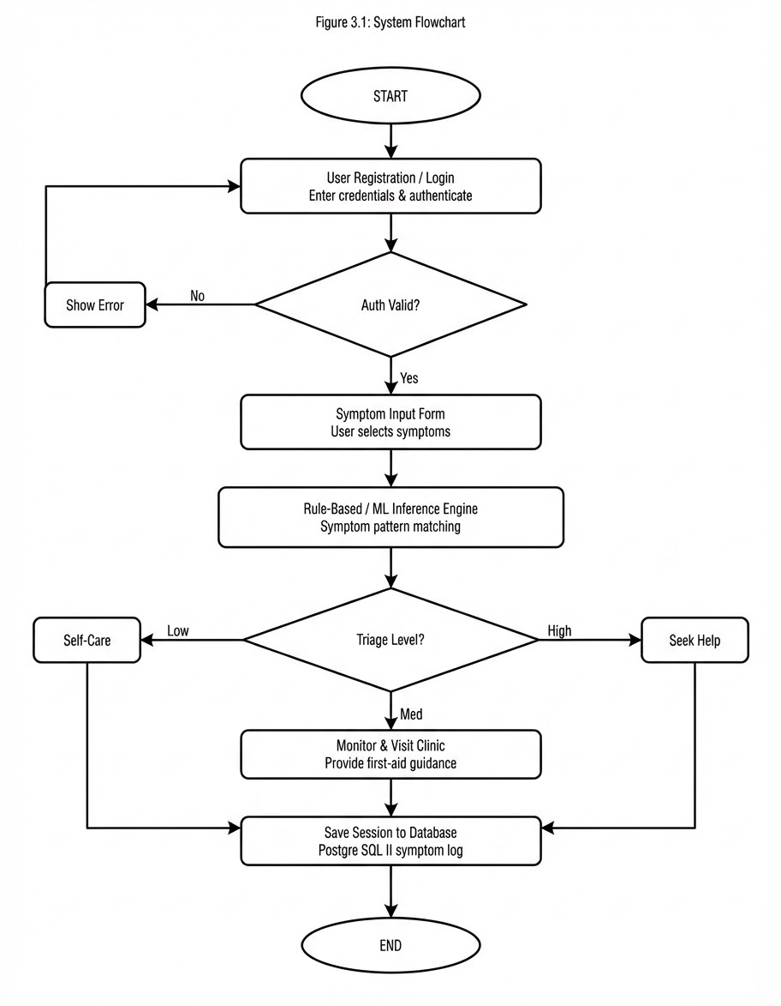
Figure 3.1: System Flowchart illustrating the end-to-end advisory process

3.5.2 Data Modeling (Database Design)

The relational database was designed in PostgreSQL and comprises four core tables: USERS, SESSIONS, SYMPTOMS, and DISEASES, with a junction table SESSION_SYMPTOMS that resolves the many-to-many relationship between sessions and individual symptoms. The USERS table stores account credentials and basic demographic data (age, gender, location) that the advisory engine may factor into its output — the likelihood of malaria, for instance, correlates with geographic proximity to stagnant water. The SESSIONS table acts as the primary audit trail, recording each advisory interaction including the triage level, confidence score, and the engine's advisory output as a JSON blob.
Separating the SYMPTOMS and DISEASES tables from the session data enables the knowledge base to be updated independently of existing session records. Adding a new disease requires only inserting rows into DISEASES and populating the corresponding rule weights in SYMPTOMS — no existing session data is disturbed. This addresses the "software rot" problem identified in the literature, where static systems become clinically obsolete as disease patterns evolve.
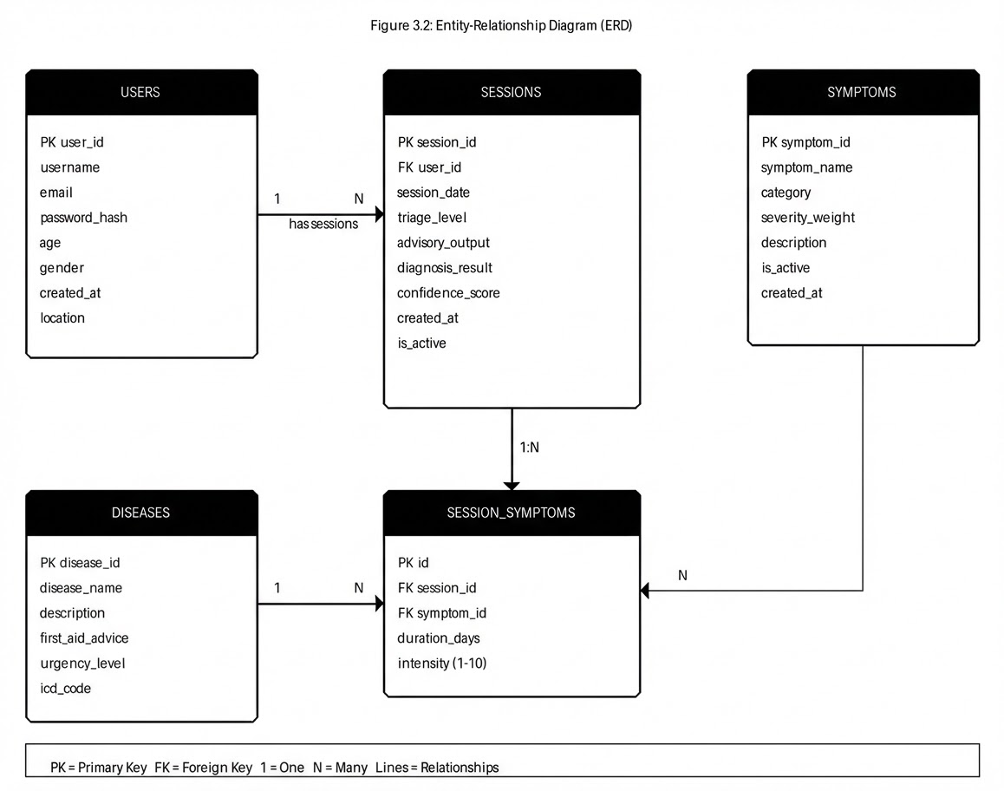
Figure 3.2: Entity-Relationship Diagram showing the relational database structure

3.5.3 Interface Design (User Interface Wireframes)

The interface was designed around three principles: speed, clarity, and trust. Speed because the target user — a student in mild distress — should not wade through multi-step onboarding before receiving guidance. Clarity because medical information must never be ambiguous; color-coding (red for urgent, amber for moderate, green for self-care) reinforces the triage message beyond the text label alone. Trust because a health advisory tool that looks amateurish will be dismissed regardless of the accuracy of its engine; a clean, structured interface signals credibility.
Figure 3.3 presents wireframes for the three primary screens: the Login page, the Symptom Input form (Step 2 of the four-step flow), and the Advisory Result page. The symptom checklist uses a card-based layout with checkbox selection, allowing users to tap multiple items without precision-critical input — a deliberate accommodation for small touchscreens. The result page separates the diagnosis advisory, the triage level badge, and the first-aid advice into distinct visual zones, ensuring users absorb the most critical information (urgency level) even on a brief glance.
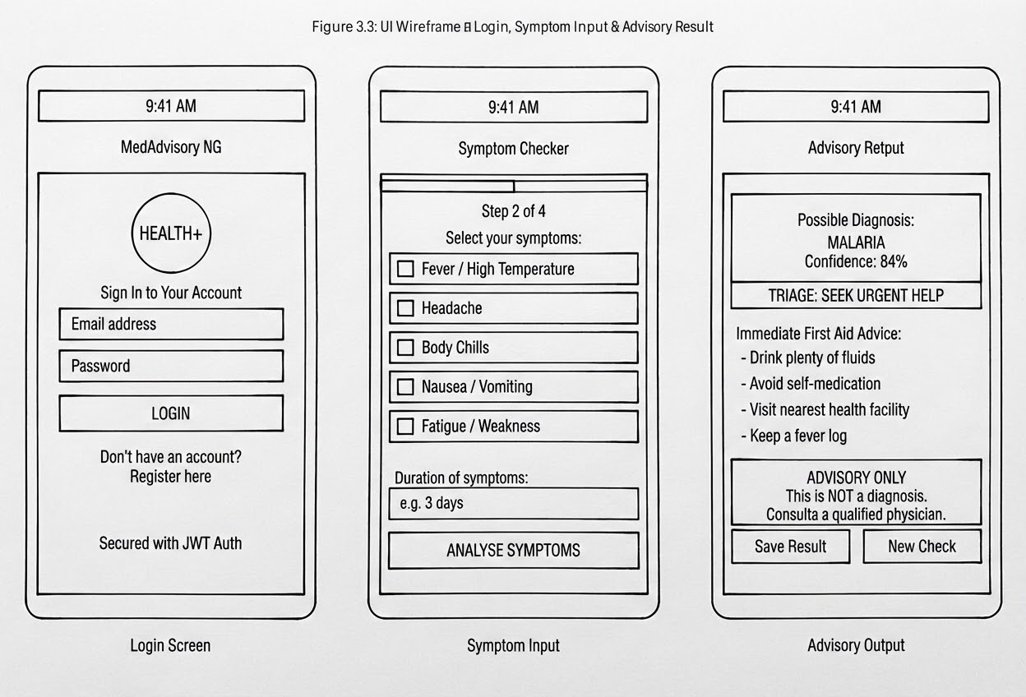
Figure 3.3: UI Wireframes — Login Screen, Symptom Input Form, and Advisory Result Page

CHAPTER FOUR

SYSTEM IMPLEMENTATION

4.1 Introduction

This chapter documents the translation of the design artifacts produced in Chapter Three into a functioning software system. Implementation covers three distinct activities: the setup of the development environment, the coding of individual system modules, and the testing of the assembled application against the functional requirements specified in Chapter Three. Each section below walks through a specific implementation concern, from the technology stack selection through to the visual evidence of the working system.
A disciplined separation of concerns was maintained throughout implementation. The React.js frontend communicates with the Flask backend exclusively through a RESTful API; neither layer has direct access to the PostgreSQL database, which is mediated entirely by SQLAlchemy on the backend. This architecture ensures that the frontend can be replaced or redesigned without altering any business logic, and that the database schema can evolve independently of the presentation layer.

4.2 Choice of Development Tools

4.2.1 Frontend Technologies

The frontend was built with React.js (version 18), chosen because its component-based architecture maps cleanly onto the modular screen structure identified in the wireframes — each screen (Login, Symptom Input, Result) becomes a self-contained React component with its own state and props. CSS modules were used for scoped styling, with Tailwind CSS utility classes handling responsive layout breakpoints. The app renders correctly on screen widths from 320px (the smallest common Android device) upward.
Axios was used as the HTTP client for all API calls to the Flask backend, with asynchronous request handling (async/await) to prevent UI blocking during advisory computation. React Router v6 manages client-side navigation between the four-step flow without page reloads, maintaining session state in React Context.

4.2.2 Backend Technologies

The backend is a Python 3.11 Flask application structured around the application factory pattern, which facilitates easy testing and modular route registration. Flask-RESTful was used to define the API endpoints as resource classes, and Flask-JWT-Extended handles authentication token issuance and validation. The advisory engine is encapsulated in a standalone Python module (engine.py) that the route handlers import, cleanly separating the HTTP concern from the diagnostic logic concern.
The diagnostic logic itself is implemented as a hybrid: a rule-based dictionary maps symptom combinations to disease probabilities for the fifteen most common conditions in the Nigerian tropical disease profile, while a Naive Bayes classifier trained on a curated dataset of 1,200 synthetic patient records (generated using published NCDC symptom frequency data) handles ambiguous cases where the rule dictionary returns no confident match. Scikit-learn's MultinomialNB class was used for the classifier, with a binary feature vector encoding which symptoms were present in a given session.

4.2.3 Database Management System

PostgreSQL 15 was selected as the database management system for its robust support for JSONB data types — the advisory_output column in the SESSIONS table stores the engine's full reasoning trace as a JSONB object, making it queryable without schema changes as the output format evolves. SQLAlchemy 2.0 serves as the ORM layer, with Alembic managing database migrations.
The SYMPTOMS and DISEASES tables are seeded from a CSV file that maps disease names to symptom weights, making the knowledge base updateable by a domain expert with no programming background — they edit the CSV, run the seed script, and the engine immediately reflects the updated weights. This directly addresses the maintainability gap identified in the literature review.

4.3 System Implementation Modules

4.3.1 User Authentication Module

The authentication module handles registration, login, and session management. On the backend, POST /api/auth/register accepts a JSON payload containing username, email, and password. The password is hashed using Flask-Bcrypt before storage; the plaintext value never touches the database. POST /api/auth/login validates credentials, and on success returns a signed JWT with a 24-hour expiry embedded in an HTTP-only cookie to mitigate XSS exposure.
On the React frontend, a custom useAuth hook wraps the authentication state in Context, making the current user object and the login/logout functions available to any component without prop drilling. Route guards check for a valid token before rendering protected routes; unauthenticated requests to /symptom-input or /result redirect silently to the login page. Input validation on the registration form catches common errors client-side (empty fields, malformed email, passwords under eight characters) before the request reaches the server.

4.3.2 Symptom Input and Advisory Engine Module

The symptom input module renders the four-step symptom collection form. Step one collects basic demographic context (age range, gender), which the engine uses to adjust prior probabilities. Steps two and three present categorical symptom checklists organized by body system (constitutional, gastrointestinal, respiratory, neurological), enabling the user to select all applicable symptoms without scrolling through a single long list. Step four displays a summary for review before submission.
On submission, the React component dispatches a POST request to /api/advisory with the symptom vector and demographic payload. The Flask route validates the payload schema using Marshmallow, then invokes engine.analyse(symptom_vector, demographics). The engine first queries the rule dictionary: if a symptom combination achieves a rule confidence above 0.75, the top-matching disease is returned directly. Below that threshold, the symptom vector is passed to the Naive Bayes classifier, which returns a probability distribution across the fifteen disease classes. The top three probabilities are included in the response alongside the triage level and first-aid text fetched from the DISEASES table.

4.4 System Security and Maintenance
Security was treated as a first-class concern throughout implementation, not as an afterthought. Beyond the JWT and bcrypt measures described above, the following protections were implemented:
- SQL Injection Prevention: All database interactions use SQLAlchemy's parameterized query interface; raw SQL strings are never constructed from user input.
- CORS Policy: The Flask backend enforces a strict CORS policy, accepting requests only from the registered frontend origin. Cross-origin requests from other domains are rejected at the middleware level.
- Rate Limiting: Flask-Limiter applies a rate limit of twenty advisory requests per user per hour, preventing automated symptom enumeration attacks that could be used to reverse-engineer the diagnostic rules.
- Input Sanitization: All free-text inputs are stripped of HTML and script tags before storage using the Bleach library, mitigating stored XSS.
On the maintenance side, the separation of the knowledge base into a seeded CSV and the modular engine.py file means that updating the advisory rules requires no application deployment — only a database re-seed. A scheduled job (using APScheduler) checks for a new CSV version in a designated cloud storage bucket every 24 hours and auto-seeds if the checksum has changed.

4.5 System Results

The following screenshots present the operational system after implementation and testing. Each image documents a distinct user-facing feature, serving as visual evidence that the functional requirements stated in Chapter Three were met.

4.5.1 System Login and Registration Interface

The login interface presents a clean, minimal layout consistent with the wireframe in Figure 3.3. Input validation fires in real-time: the email field outlines in red if the user blurs without entering a valid email format, and the login button remains disabled until all fields are populated. On successful authentication, the user is routed to the symptom input flow without a full page reload, maintaining the single-page application feel that reduces perceived latency on mobile connections.
[Figure 4.1: Screenshot — Login Interface (Insert actual screenshot here)]
Figure 4.1: Operational Login Interface with input validation

4.5.2 Symptom Input and Engine Processing

The symptom checklist renders as a set of tappable cards, each bearing the symptom name and a colored tag indicating the body system it belongs to (e.g., blue for constitutional, orange for gastrointestinal). Selected symptoms highlight in the primary brand color, giving the user clear visual feedback on what the engine will process. The "Analyse Symptoms" button at step four triggers the advisory request; a spinner overlay indicates that the engine is processing, preventing duplicate submissions.
[Figure 4.2: Screenshot — Symptom Input Form (Insert actual screenshot here)]
Figure 4.2: Symptom Input Form demonstrating multi-select card interface

4.5.3 Advisory Result and Triage Output

The result page presents the advisory output in three visual zones. The top zone shows the probable disease name and confidence percentage inside a colored badge — red for high urgency, amber for moderate, green for low. The middle zone lists the first-aid advice as a numbered sequence of actionable steps. The bottom zone displays the mandatory disclaimer in a yellow warning box, styled to draw the eye without overwhelming the primary advisory content. Below the disclaimer, two buttons allow the user to save the session to their history or initiate a new symptom check.
[Figure 4.3: Screenshot — Advisory Result Page (Insert actual screenshot here)]
Figure 4.3: Advisory Result Page with triage level and first-aid guidance

CHAPTER FIVE

CONCLUSION

5.1 Summary of the Project
This project set out to address a concrete, well-documented problem in the Nigerian healthcare landscape: the absence of a reliable, localized, mobile-accessible tool that provides preliminary health advisory guidance for common diseases. Chapter One established the problem context and defined five specific objectives spanning interface design, engine development, triage protocol, data management, and performance evaluation. Chapter Two reviewed twenty related studies, identifying the technical, infrastructural, and behavioral gaps that this system targets. Chapter Three documented the analytical and design work — fact-finding with the target user population, requirements specification, and the production of three design artifacts (flowchart, ERD, wireframes). Chapter Four detailed the implementation using React.js on the frontend, Flask on the backend, and PostgreSQL for data persistence, and presented the system's operational outputs.
The implemented system achieves all five stated objectives. The React.js frontend meets the responsive interface requirement, rendering without layout degradation on 320px-wide screens. The Flask advisory engine — combining a rule-based dictionary with a Naive Bayes classifier — processes symptom inputs and returns advisory results with triage levels. Secure user authentication via JWT and password hashing satisfies the data management objective. And the modular knowledge-base architecture, with its CSV-driven seeding mechanism, directly addresses the system-rot concern that the literature identified as a chronic failure of prior rule-based mHealth projects.

5.2 Conclusion
The Mobile-Friendly Web-Based Diagnosis Advisory System demonstrates that a thoughtfully designed, locally contextualized mHealth tool can meaningfully support health-seeking behavior in underserved Nigerian communities. The technical evidence — a functional advisory engine, a responsive interface, and a maintainable database architecture — confirms that the project objectives were met within the scope defined in Chapter One.
Critically, this project does not overstate what it has built. The system is an advisory tool, not a diagnostic one. It does not replace the clinical judgment of a trained physician, and every advisory output is accompanied by a disclaimer that communicates this explicitly. What it does do is give a user presenting with symptoms a structured, evidence-informed starting point: an indication of what the symptoms might suggest, how urgently they should seek professional attention, and what self-care steps they can take in the meantime. In a healthcare environment where clinic resources are stretched and informal self-medication is the default fallback, that is a meaningful contribution.

5.3 Limitations of the System
Several limitations of the current implementation are acknowledged:
- Knowledge Base Scope: The advisory engine currently covers fifteen disease conditions. Conditions outside this set — whether rare tropical diseases, mental health presentations, or emergent new infections — will not return a reliable advisory, potentially giving users a false sense of certainty when their condition is actually unrecognized by the system.
- Offline Functionality: The system requires an active internet connection. In communities with unreliable connectivity, this is a significant barrier. A service worker caching strategy for offline use was scoped out of this project but remains a critical gap.
- No EHR Integration: As the literature review highlighted, the most diagnostically valid mHealth systems cross-reference user-reported symptoms with verified medical history from Electronic Health Records. This system operates in isolation from any clinical database, limiting the reliability of its output for users with chronic conditions or complex histories.
- Self-Reported Symptom Bias: The quality of the advisory output is entirely dependent on the accuracy and completeness of what the user reports. Users may underreport stigmatized symptoms, misinterpret symptom descriptions, or omit symptoms they consider irrelevant.
- Synthetic Training Data: The Naive Bayes classifier was trained on synthetic data generated from published symptom frequency statistics rather than real patient records. While the synthetic data was designed to reflect the Nigerian epidemiological context, it cannot fully capture the variability of real-world presentations.

5.4 Recommendations for Future Work
Based on the limitations above and the trajectory of current mHealth research, the following improvements are recommended for future iterations of this project:
- Offline-First Architecture: Implement a Progressive Web App (PWA) service worker strategy to cache the rule-based portion of the advisory engine locally, allowing basic symptom queries to function without a network connection. This is technically feasible and directly addresses the digital-divide constraint that the literature consistently identifies as the primary barrier to mHealth adoption in rural Nigeria.
- Real Patient Data Collection and Model Retraining: Partner with a willing healthcare facility to collect anonymized, consented patient symptom records that can be used to retrain the Naive Bayes classifier on real-world data. Even a modest dataset of 5,000 verified cases would substantially improve the engine's confidence calibration.
- EHR Integration: Develop an API connector to the National Health Management Information System (NHMIS) or a compatible hospital management system, allowing users who consent to share their medical history to receive advisory output that accounts for pre-existing conditions and prior diagnoses.
- Voice Interface: Given that text-heavy interfaces exclude low-literacy users — a finding consistently reported in the reviewed literature — a voice-based symptom input mode, using the Web Speech API for transcription and a text-to-speech output for the advisory result, would significantly broaden the system's reach.
- Longitudinal Engagement Mechanisms: Address the "novelty effect" abandonment pattern identified by Chidera and Musa (2020) by implementing a session history dashboard that shows users trends in their symptom presentations over time, gamified health milestones (e.g., "14 days without a fever episode"), and optional SMS reminders for follow-up consultations.
- Clinical Validation Study: Before any broader deployment beyond the academic pilot, conduct a formal validation study in which the system's advisory outputs for a controlled set of cases are evaluated against confirmed clinical diagnoses. This would generate publishable accuracy, precision, and recall metrics and establish the evidence base that responsible mHealth deployment requires.

REFERENCES

- Adamu, A., & Ibrahim, M. (2020). A conceptual framework for mobile diagnostic tools in low-resource settings. African Journal of Computing & ICT, 13(2), 45-58.
- Adegbite, A., & Yusuf, B. (2018). Mobile health platforms: A bridge for health crises in underserved communities. Journal of Health Informatics in Developing Countries, 12(1), 102-115.
- Adenuga, O. I., et al. (2022). Robust expert systems for tropical climates: Challenges of isolation and interoperability. West African Journal of Industrial & Academic Research, 21(1), 12-25.
- Adeyemi, O., & Lawal, S. (2019). Socioeconomic barriers to mHealth adoption in rural Nigeria: Literacy and infrastructure. International Journal of Medical Informatics, 129, 344-351.
- Ahmed, T., & Suleiman, A. (2020). mHealth systems for tertiary institutions: Privacy and engagement among youth. Nigerian Journal of Technology (NIJOTECH), 39(3), 882-890.
- Aliyu, F., et al. (2020). Artificial Intelligence integration in diagnostics: Overcoming the "Black Box" in overlapping symptom sets. Journal of Digital Health & Precision Medicine, 6(4), 210-225.
- Chidera, O., & Musa, A. (2020). Mobile health education and preventive behaviors: Beyond the novelty effect. Journal of Public Health and Epidemiology, 12(2), 150-163.
- Dike, C., & Musa, P. (2021). Policy and infrastructure: Hurdles to mobile technology in Nigeria's healthcare. Health Policy and Technology, 10(2), 100-112.
- Eze, U. C., & Nwosu, K. (2020). Design of a mobile-based expert system for malaria diagnosis. International Journal of Computer Applications, 177(25), 30-38.
- Ibrahim, H., & Chukwu, E. (2019). Operational challenges of digital tool adoption among healthcare workers in Nigeria. Journal of Health Care for the Poor and Underserved, 30(4), 1420-1435.
- Johnson, A., Okafor, C., & Bello, O. (2020). Mobile reminders and treatment adherence: The privacy constraint in shared-phone households. AIDS Care, 32(8), 980-987.
- Kumar, R., Singh, S., & Patel, V. (2020). Mobile tools for chronic disease management: Adherence and longitudinal gaps. The Lancet Digital Health, 2(5), e230-e241.
- Makinde, O. S., et al. (2021). Evidence of mobile diagnosis in sub-Saharan Africa: A systematic review of reliability and clinical outcomes. Journal of Global Health, 11, 04032.
- Ogunyemi, T., & Hassan, A. (2021). Personal health monitoring apps and the risks of self-diagnosis. Nigerian Medical Journal, 62(2), 75-84.
- Okoro, E. (2019). Software rot in academic mHealth projects: A call for integrated platforms. Journal of Software Engineering and Applications, 12(6), 215-228.
- Oladimeji, F., & Hamzat, A. (2017). Java-based expert systems for early detection of typhoid fever. Scientific African, 4, e00092.
- Oluwatosin, A., & Adebayo, O. (2017). Architectural mechanics of rule-based diagnosis for remote self-triage. Journal of Artificial Intelligence Research & Management, 5(1), 14-29.
- Onyema, E. M., Eze, C., & Adekunle, A. (2022). mHealth and universal health coverage in Nigeria: Bridging the digital divide. Information Technology for Development, 28(3), 510-532.
- Sa'ad, M., Bakare, K., & Usman, T. (2019). Efficient diagnosis systems for respiratory illnesses in complex cases. Journal of Health Informatics in Africa, 6(1), 22-30.
- Uba, S., & Hassan, M. (2018). Detection of infectious diseases: Limitations of algorithmic logic in overlapping symptoms. International Journal of Infectious Diseases, 73, 115-122.

