OPTIX
Face Recognition-Based Attendance Management System

A Software Engineering Research and Implementation Report
Course: CPE 302, C++ Programming
Built with C++20, Qt 6, OpenCV 4.x and SQLite3
Author: ____________________________
Supervisor: Engr. Akinlabi
July 2026

Abstract
Optix is a modular desktop application that automates classroom attendance using facial recognition. The system replaces manual roll calls and paper registers with a biometric workflow in which an administrator registers each student once, captures a small dataset of face images, trains a recognition model, and thereafter records attendance by simply presenting the student to a webcam. The application is written in modern C++ (C++20) with a Qt 6 Widgets interface, performs face detection and recognition through OpenCV using the Haar Cascade detector and the Local Binary Patterns Histograms (LBPH) recognizer, and persists all records in a local SQLite3 database. The software is engineered with a clean layered architecture that separates the user interface, business services, data repositories, and domain models, which keeps the codebase testable and maintainable. This report documents the motivation for the system, the concepts and technologies behind it, the system design and workflow, the user interaction flow, the implementation approach, and the current state of development.
Keywords:
Face recognition, attendance management, LBPH, Haar Cascade, OpenCV, Qt 6, C++20, SQLite3.

1. Introduction

1.1 Background
Attendance tracking is a routine but important activity in academic institutions. Traditional methods, such as calling names or passing a signed sheet around a lecture hall, are slow, easy to falsify through proxy signing, and difficult to summarize into useful reports. As biometric techniques have matured and ordinary webcams have become widely available, facial recognition has emerged as a practical way to confirm a person's identity without physical contact or additional hardware. Optix applies this idea to the classroom, providing a single application that an administrator can use to enroll students, capture their faces, and mark attendance automatically.

1.2 Problem Statement
Manual attendance systems suffer from three recurring problems. First, they consume class time that could be spent teaching. Second, they are vulnerable to impersonation, since one student can answer or sign for another. Third, the resulting records are stored on paper and are tedious to search, filter, or export for administrative use. A system is needed that verifies identity reliably, prevents duplicate or fraudulent entries, and stores attendance in a structured form that can be queried and exported on demand.

1.3 Aim and Objectives
The aim of this work is to design and implement a reliable, user-friendly desktop application that records student attendance through facial recognition. The specific objectives are:
- To provide secure, password-protected administrative access to the system.
- To support full management of student records, including creation, editing, and searching.
- To capture a consistent dataset of face images for each student using a live webcam feed.
- To train a face recognition model from the captured datasets and store it for reuse.
- To verify students in real time and record attendance while preventing duplicate check-ins on the same day.
- To generate, filter, and export attendance reports for administrative use.

1.4 Scope
Optix is a single-machine desktop application intended for use by an authorized administrator, for example a lecturer or a departmental officer. It targets a standard webcam and stores its data locally in a SQLite3 file rather than a networked server. The recognition approach is the LBPH algorithm, which is lightweight and well suited to the modest dataset sizes and hardware typical of a classroom setting. Network deployment, cloud storage, and mobile clients are outside the scope of the present work.

2. Review of Concepts and Technologies

2.1 Face Detection with Haar Cascades
Before a face can be recognized it must first be located within the camera frame. Optix uses the Haar Cascade classifier, a detector that scans an image at multiple scales and identifies regions whose intensity patterns match those learned from many example faces. The detected region of interest is then cropped and converted to grayscale, which reduces the influence of lighting and colour and prepares the image for recognition.

2.2 Face Recognition with LBPH
For identity matching, Optix uses the Local Binary Patterns Histograms recognizer provided by the OpenCV contrib modules. LBPH describes a face by comparing each pixel with its neighbours to build a texture pattern, then summarizes these patterns as histograms over small regions of the image. Recognition is performed by comparing the histogram of a new face against those of the enrolled students and returning the closest match together with a confidence value. LBPH is robust to changes in lighting, is inexpensive to compute, and can be updated with new students without retraining from scratch, which makes it a sound choice for this application.

2.3 Supporting Technologies
The user interface is built with Qt 6 Widgets, a mature cross-platform framework that provides the windows, controls, and event handling used throughout the application. All records are stored in SQLite3, a self-contained file-based database accessed through prepared statements for efficiency and safety. The entire system is written in C++20 and assembled with CMake, using smart pointers and the standard library filesystem for safe resource and file management.

3. System Design and Methodology

3.1 Architectural Overview
Optix follows a layered architecture that separates concerns into independent, replaceable parts. The user interface layer contains the views the administrator interacts with. Beneath it, a services layer holds the application logic, such as authentication, student validation, and camera coordination. The services rely on a repository layer that hides the details of database access behind clearly defined interfaces, and the repositories in turn read from and write to the data layer, which comprises the SQLite database, the raw image datasets, and the trained model file. The layers are wired together through a dependency injection container, and a theme manager compiles the visual styling so that the interface can switch between light and dark modes at runtime. Because each layer depends only on the interface of the layer below it, individual parts can be tested or replaced in isolation; the project even includes a mock backend that stands in for the camera and vision library so the application can be built and run without the full computer vision stack installed.

3.2 Data Model
The database is organized around three tables. The Users table holds administrator accounts and their password hashes. The Students table holds each student's profile, including matriculation number, email, phone number, department, level, and whether a face has been registered. The Attendance table holds one row for every recorded check-in, linking a student to a date and time. Passwords are never stored in plain text; they are hashed with SHA-256 before being saved and compared.

3.3 System Workflow
The end-to-end operation of the system is summarized in Figure 1. The administrator logs in and, on first use, is guided to register students. Each student is enrolled by capturing sixty face images from the webcam, which are stored as grayscale samples. These datasets are used to train the LBPH model, which is saved to a single model file. During an attendance session the camera recognizes each face, checks that the student has not already been recorded that day, and writes the entry to the database. Finally, the recorded attendance can be filtered and exported as a report.

Figure 1. End-to-end system pipeline and layered architecture of Optix.

3.4 Development Methodology
The system was developed incrementally across a series of sprints, each delivering a working slice of functionality. Early sprints established the project structure, the theming engine, the database, and the administrative screens. Later sprints introduced the camera pipeline, model training, live recognition, and reporting. This incremental approach allowed each layer to be verified before the next was built on top of it.

4. User Interaction Flow
Figure 2 presents the application from the administrator's point of view, mapping the screens and actions available in each part of the interface. From the root, the application branches into its main sections: authentication, the dashboard, student management, face registration, attendance, reports, and settings. The vision pipeline steps, namely camera capture, model training, and live recognition, are highlighted, and the successful outcomes, such as a saved model and a recorded entry, are marked as completion states. This view complements the system pipeline in Figure 1 by showing how a user actually navigates the product.
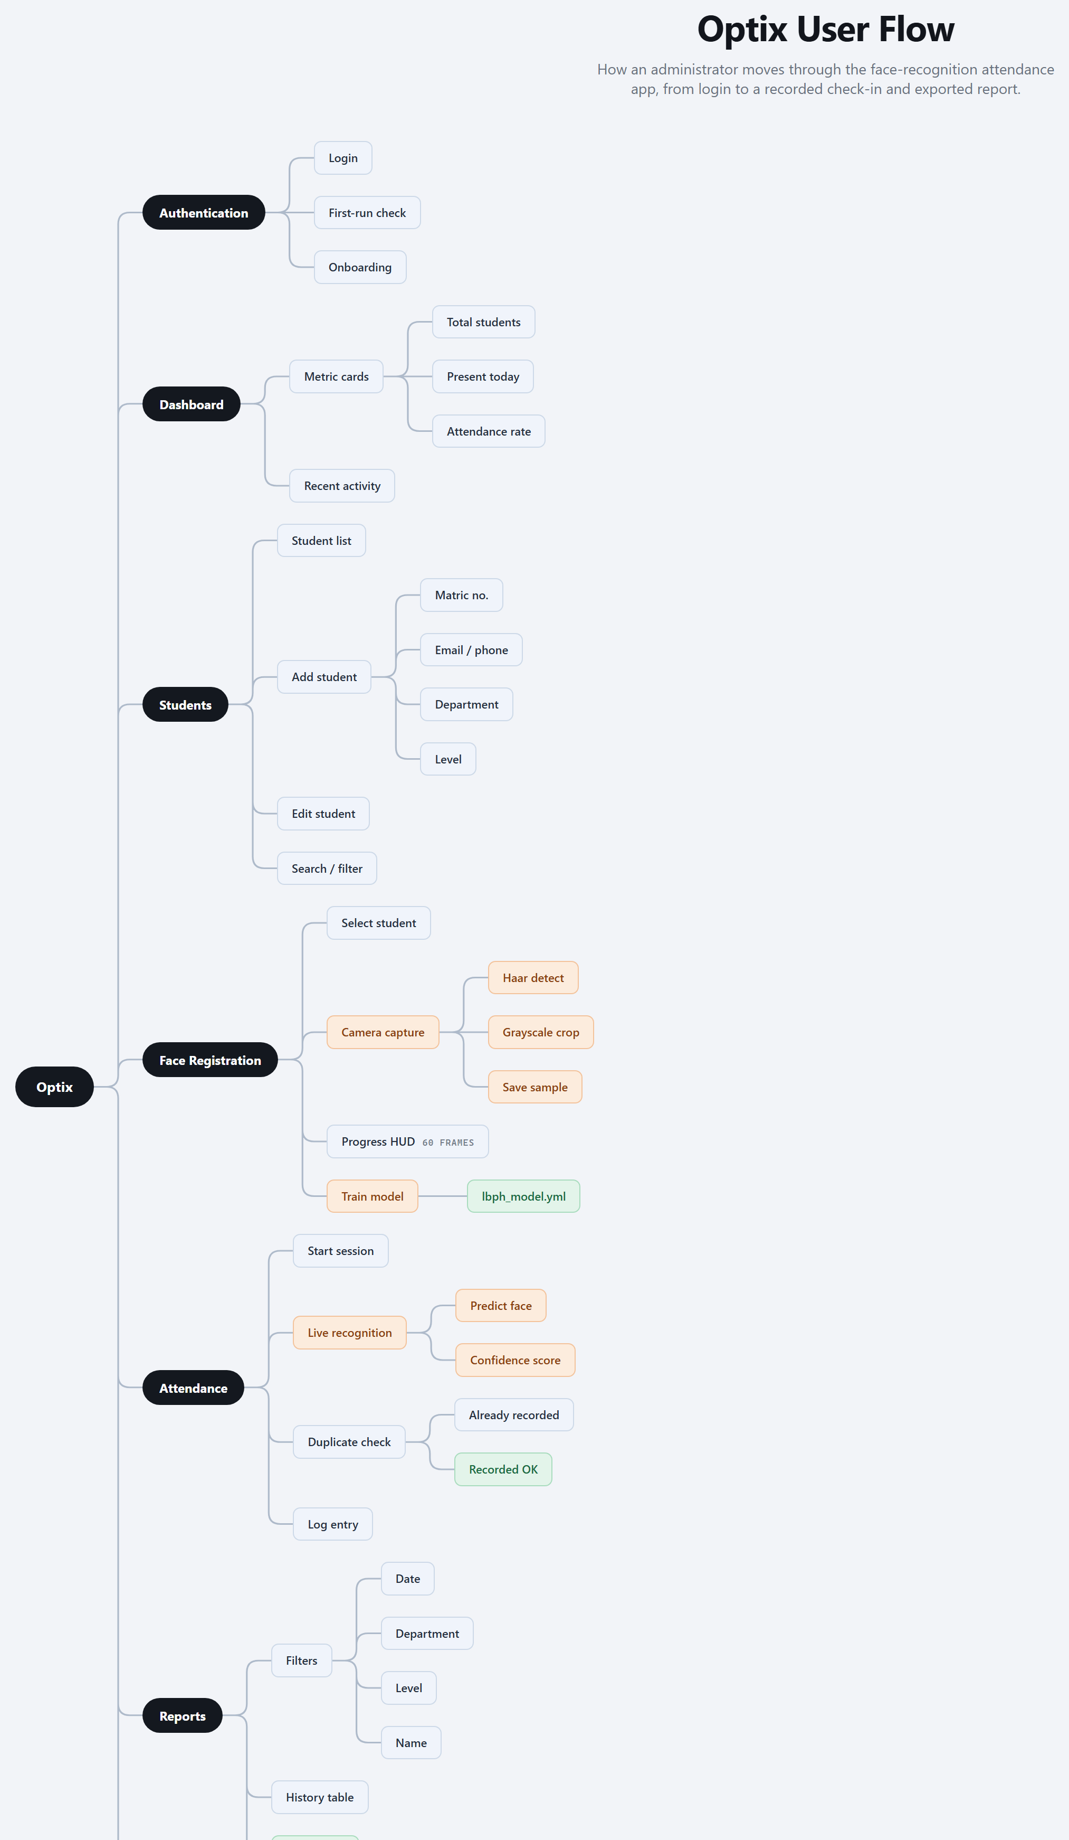
Figure 2. Optix user interaction flow across the application's sections.

5. Implementation

5.1 Technology Stack
The main technologies used in the implementation are summarized in Table 1.
Component | Technology and Role
Language | C++20, using smart pointers, RAII, and the standard filesystem library.
Interface | Qt 6 Widgets, with dynamic QSS styling and a light or dark theme switcher.
Computer Vision | OpenCV 4.x, Haar Cascade detection and the LBPH face recognizer.
Database | SQLite3, a local file-based store accessed through prepared statements.
Security | SHA-256 password hashing for administrator credentials.
Build System | CMake 3.16 or newer, with dependencies managed through vcpkg.
Table 1. Technology stack of the Optix application.

5.2 Key Modules
The administrative login is handled by an authentication service that verifies the entered password against the SHA-256 hash stored in the database. Student records are managed through a validation service that checks email and phone formats before saving. Face capture is performed by an asynchronous camera worker running on its own thread, so that reading and processing webcam frames never freezes the interface. A face service coordinates the loading of datasets and the recognizer, while the recognizer itself wraps the OpenCV LBPH implementation behind a simple interface so that the underlying algorithm could later be replaced without affecting the rest of the system.

5.3 Interface and Theming
The interface uses a clean split layout with a sidebar for navigation and a main content area that switches between the dashboard, student management, registration, attendance, reports, and settings views. A theme manager compiles a style template by substituting colour variables, allowing the whole interface to redraw instantly in either a light or a dark palette.

6. Development Progress
The state of the project across its planned sprints is summarized in Table 2. The foundational sprints are complete and working, the camera capture pipeline is under active development, and the remaining sprints are scaffolded and ready to be filled in.
Sprint | Focus | Status
1 | Project scaffolding, build system, and theme engine | Completed
2 | Database, repositories, authentication, and student management | Completed
3 | Asynchronous camera worker, face detection, and dataset capture | In progress
4 | LBPH model training and validation | Planned
5 | Live recognition, duplicate prevention, and check-in | Planned
6 | Report filters, CSV export, settings, and quality polish | Planned
Table 2. Sprint milestones and current status.

7. Conclusion and Future Work
Optix demonstrates that a practical, contactless attendance system can be built on ordinary hardware using established computer vision techniques and disciplined software engineering. The layered design keeps the codebase organized and testable, the LBPH recognizer offers a good balance of accuracy and speed for classroom use, and the local database keeps the system self-contained and easy to deploy. The core administrative and data-management features are complete, and the recognition pipeline is well underway.
Future work will complete the model training and live recognition sprints, add richer reporting and export options, and refine the settings panel for camera selection and confidence tuning. Longer-term improvements could include support for larger datasets, more advanced recognition models, and optional synchronization of records to a central server for multi-room deployments.

References
[1] Viola, P., and Jones, M. (2001). Rapid Object Detection using a Boosted Cascade of Simple Features. Proceedings of the IEEE Conference on Computer Vision and Pattern Recognition.
[2] Ahonen, T., Hadid, A., and Pietikainen, M. (2006). Face Description with Local Binary Patterns: Application to Face Recognition. IEEE Transactions on Pattern Analysis and Machine Intelligence.
[3] OpenCV Team. OpenCV 4.x Documentation, Face Recognition and Objdetect modules. Available at opencv.org.
[4] The Qt Company. Qt 6 Documentation, Qt Widgets Module. Available at doc.qt.io.
[5] SQLite Consortium. SQLite Documentation. Available at sqlite.org.

