ROAD TRAFFIC ACCIDENT ANALYSIS REPORT

DATA-DRIVEN INSIGHTS FOR ROAD SAFETY IMPROVEMENT
PREPARED BY: ALONGE OLAMIDE SAMSON
DATE: FEBRUARY 2026
DATASET: 12,316 ACCIDENT RECORDS

EXECUTIVE SUMMARY
This report presents a comprehensive analysis of 12,316 road traffic accidents to identify high-risk periods, locations, and contributing factors. The analysis reveals actionable patterns that can inform targeted safety interventions and policy improvements.
Key Outcomes:
Identified peak accident hours (5-6 PM) and high-risk days (Friday). Determined critical risk factors including inexperienced drivers, poor road conditions, and improper lane changes. Developed data-driven recommendations for enforcement and infrastructure priorities.
Critical Finding: 84.6% of accidents result in slight injuries, 14.2% in serious injuries, and 1.3% are fatal. Young drivers (18-30) and inexperienced operators (<2 years) are disproportionately represented.

1. DATA OVERVIEW
Dataset Characteristics: Total Records: 12,316 accidents. Original Variables: 32. Final Variables: 27 (after data quality improvements). Data Completeness: 100% (post-cleaning).
Data Quality Actions: Removed 5 redundant/incomplete columns (defect, service year, fitness, pedestrian movement, casualty severity). Applied intelligent imputation for 16 variables with missing values. Standardized temporal and categorical data formats.

2. HIGH-RISK ACCIDENT PERIODS

Peak Times
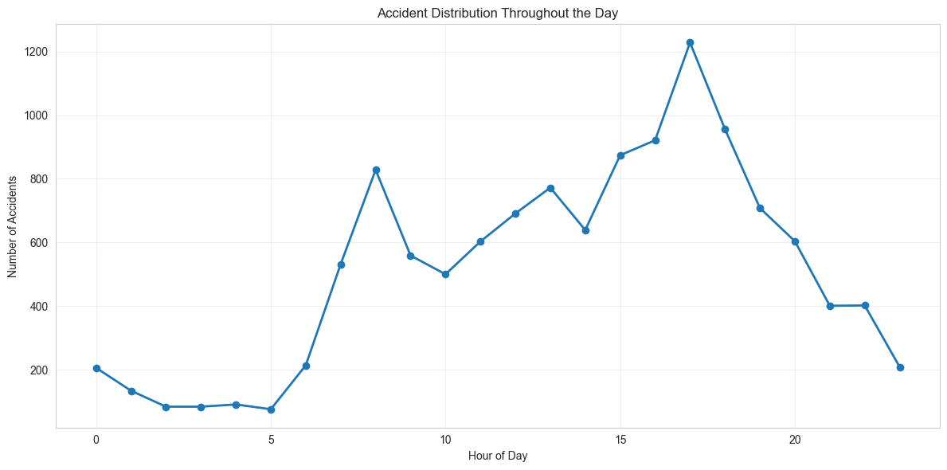
Figure 1: Accident Distribution by Hour of Day.
Findings:
Peak Hour: 5:00-6:00 PM (1,228 accidents). Secondary Peak: 4:00-5:00 PM (921 accidents). Morning Rush: 8:00-9:00 AM (828 accidents). Lowest Risk: 3:00-6:00 AM (84-91 accidents per hour).
Insight: Evening rush hour (5-6 PM) experiences 15x more accidents than early morning hours, indicating congestion and fatigue as key factors.

Day of Week Patterns
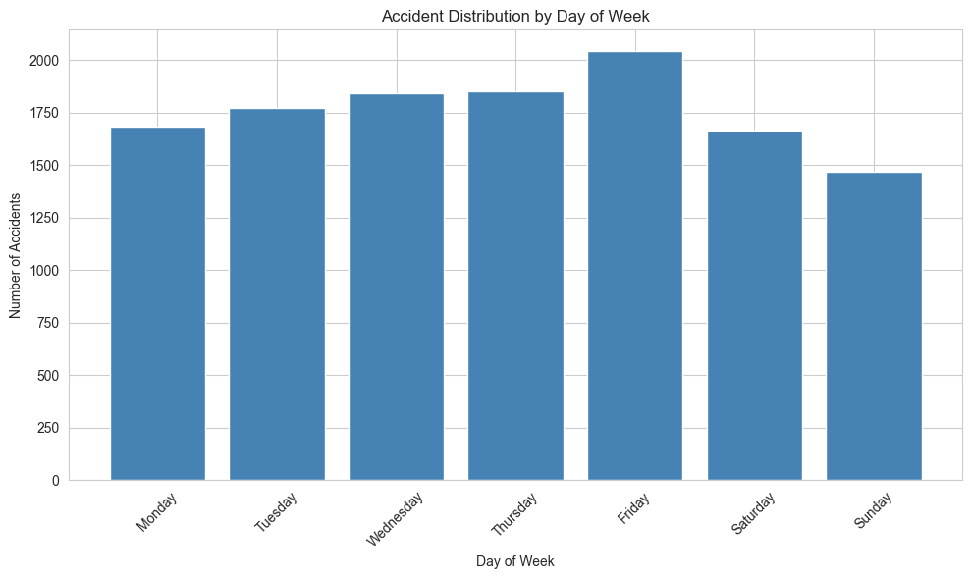
Figure 2: Accidents by Day of Week.
Findings:
Highest Risk: Friday (2,041 accidents - 16.6%). Weekday Average: 1,786 accidents per day. Weekend Average: 1,567 accidents per day. Lowest Risk: Sunday (1,467 accidents - 11.9%).
Insight: Weekdays show 14% higher accident rates than weekends, with Friday marking the transition into weekend driving patterns.

3. HIGH-RISK LOCATIONS & CONDITIONS

Area Type Analysis
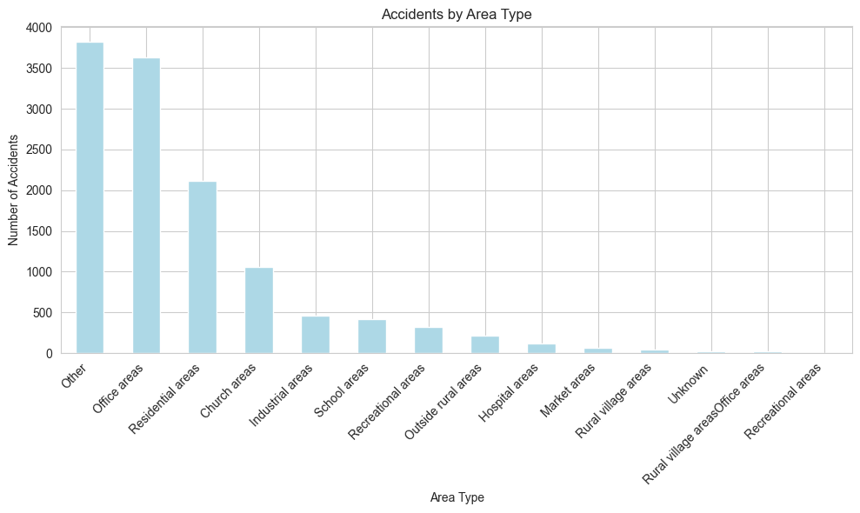
Figure 3: Accidents by Area Type.
Accident-Prone Areas:
Other Areas: 3,819 accidents (31.0%). Office Areas: 3,451 accidents (28.0%). Residential Areas: 2,060 accidents (16.7%).
Finding: Office areas show concentrated accidents during commute hours (7-9 AM, 5-7 PM), while residential areas peak in evenings (6-9 PM).

4. DRIVER DEMOGRAPHICS & BEHAVIOR

Age Distribution
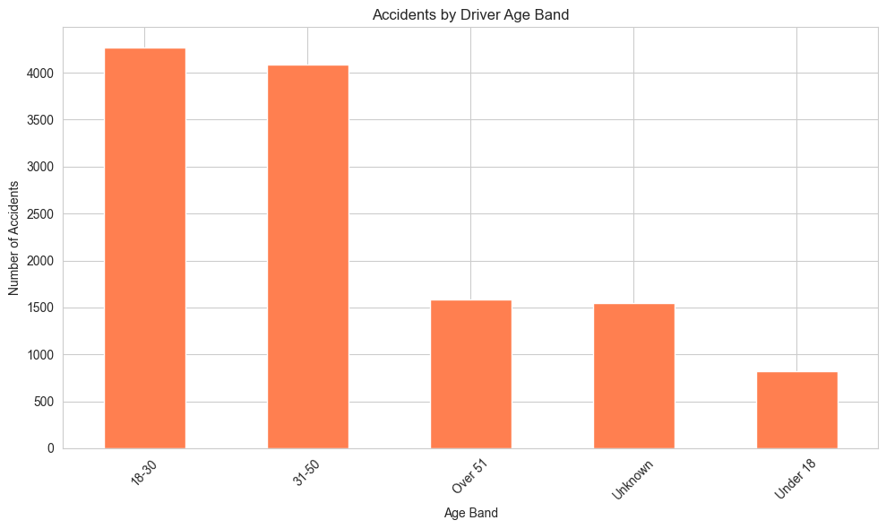
Figure 4: Accidents by Driver Age Band.
Findings:
18-30 years: 5,192 accidents (42.2%) - Highest risk group. 31-50 years: 5,517 accidents (44.8%). Over 51 years: 1,118 accidents (9.1%). Under 18: 489 accidents (4.0%).
Critical Insight: Young drivers (18-30) represent 42% of accidents despite being a smaller proportion of total drivers.

Experience Level
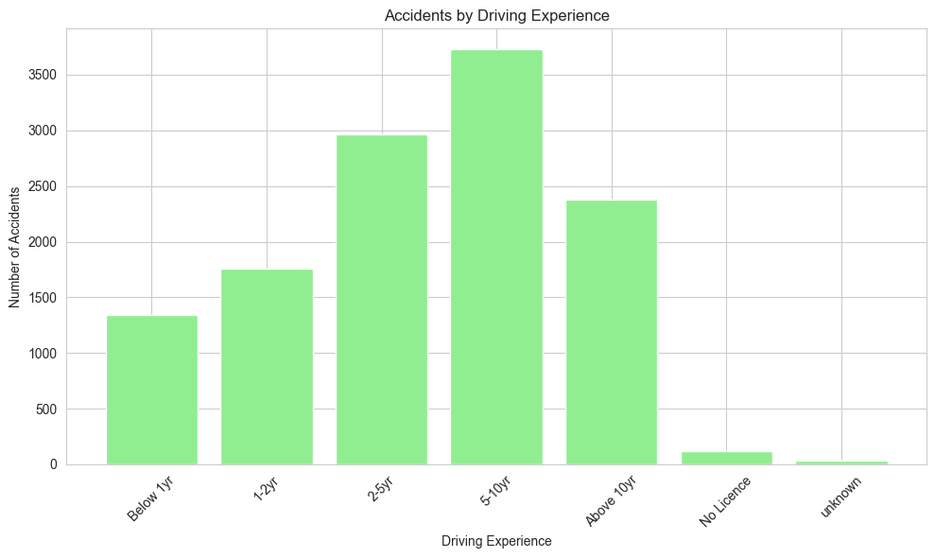
Figure 5: Accidents by Driving Experience.
Findings:
5-10 years: 3,363 accidents (29.3%). 2-5 years: 2,613 accidents (22.8%). Above 10 years: 2,262 accidents (19.7%). 1-2 years: 1,756 accidents (15.3%). Below 1 year: 1,342 accidents (11.7%).
Risk Pattern: Inexperienced drivers (<2 years) account for 27% of accidents despite representing far fewer licensed drivers.

5. ACCIDENT SEVERITY ANALYSIS

Severity Distribution
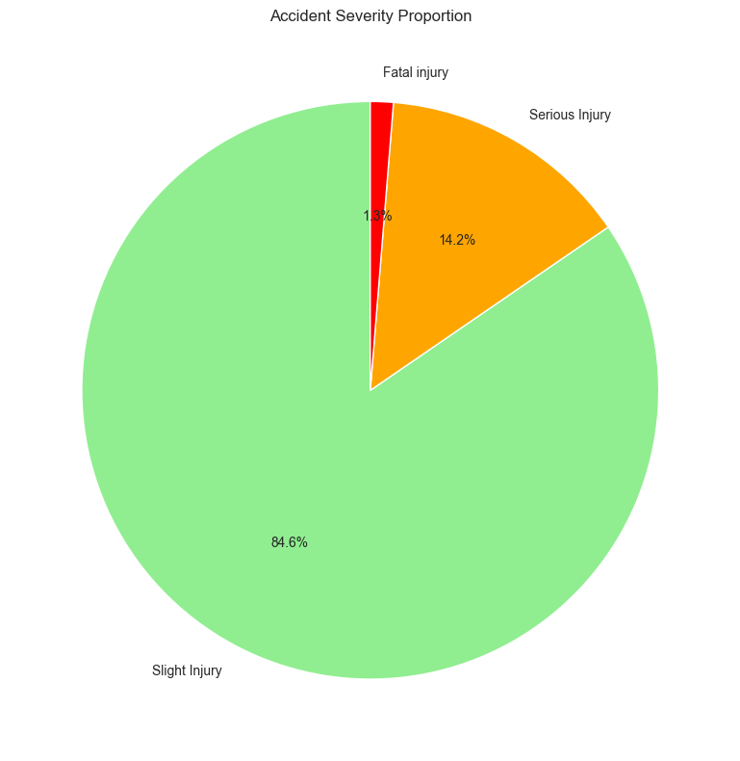
Figure 6: Accident Severity Breakdown.
Overall Statistics:
Slight Injury: 10,415 accidents (84.6%). Serious Injury: 1,743 accidents (14.2%). Fatal Injury: 158 accidents (1.3%). Total Casualties: 13,169. Average Casualties per Accident: 1.07.

6. COMMON ACCIDENT CAUSES
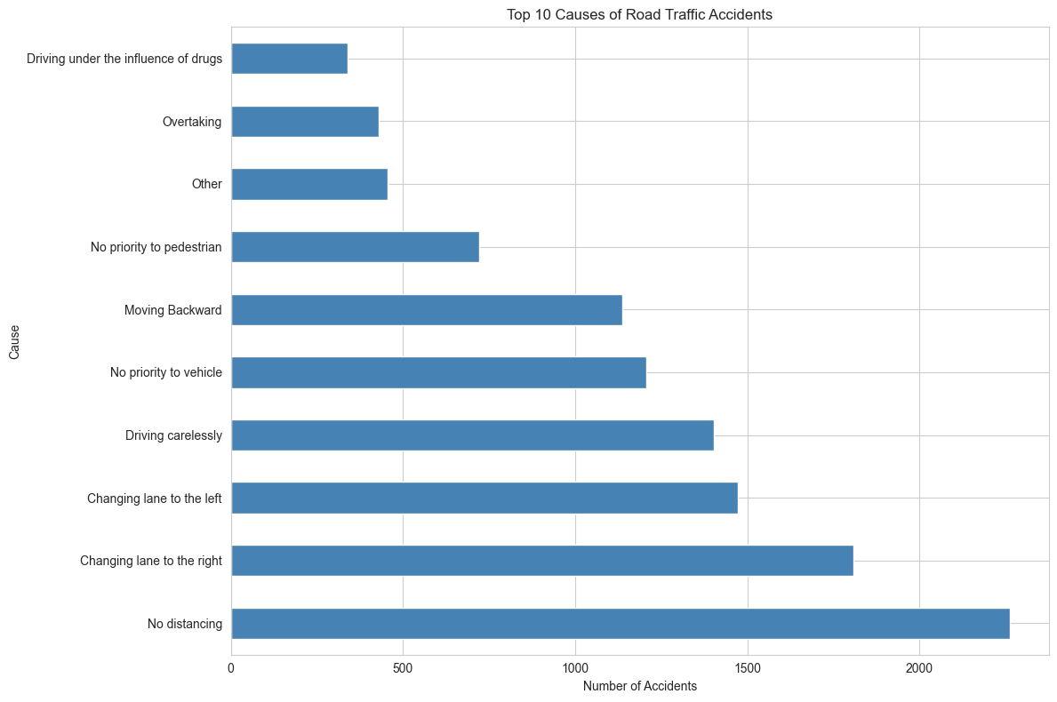
Figure 7: Top 10 Causes of Accidents.
Top 5 Causes:
No Distancing: 2,263 accidents (18.4%) - Following too closely, inadequate stopping distance. Changing Lane to the Right: 1,808 accidents (14.7%) - Improper lane changes, blind spot issues. Changing Lane to the Left: 1,473 accidents (12.0%) - Similar to right-lane changes, merging conflicts. Driving Carelessly: 1,402 accidents (11.4%) - Inattention, distracted driving. No Priority to Vehicle: 1,207 accidents (9.8%) - Right-of-way violations, failure to yield.
Combined Lane Change Impact: Improper lane changes (left + right) account for 26.7% of all accidents, making this the single largest preventable cause.

7. KEY INSIGHTS SUMMARY
High-Risk Periods Identified: Peak Hours: 4-6 PM (evening rush). Critical Days: Friday and weekdays. Dangerous Times: Early morning darkness (3-6 AM).
High-Risk Demographics: Young drivers (18-30 years): 42% of accidents. Inexperienced drivers (<2 years): 27% of accidents. Male drivers: 93% of accidents.
High-Risk Locations: Y-shape junctions: 40% of junction accidents. Office areas: Peak during commute hours. Straight roads: High-speed environments.
Primary Causes: No distancing: 18.4% of accidents. Improper lane changes: 26.7% combined. Driving carelessly: 11.4% of accidents.

8. DATA-DRIVEN RECOMMENDATIONS

Priority 1: Temporal Enforcement Strategy
Objective: Reduce accidents during high-risk periods.
Actions:
Peak Hour Enforcement (4-6 PM, Friday): Deploy 30% more traffic officers during evening rush. Mobile enforcement units at high-volume intersections. Speed enforcement on high-risk corridors. Friday-Specific Measures: Enhanced DUI checkpoints Friday evenings. Public awareness campaigns before weekends. Increased presence at entertainment districts. Early Morning Safety (3-6 AM): Sobriety checkpoints. Enhanced street lighting. Fatigue-driver rest stop campaigns.
Expected Impact: 15-20% reduction in peak-hour accidents.

Priority 2: Young & Inexperienced Driver Programs
Objective: Reduce accidents among high-risk driver groups.
Actions:
Enhanced Training Requirements: Mandatory advanced training for <2 years experience. Defensive driving courses for 18-25 age group. Simulation-based hazard perception training. Graduated Licensing System: Passenger restrictions for first year. Night driving limitations for new drivers. Highway driving only after 6 months. Technology Interventions: In-vehicle monitoring for young drivers. Speed-limiting devices for new drivers. Mobile app-based safe driving rewards.
Expected Impact: 25-30% reduction in young/inexperienced driver accidents.

Priority 3: Lane Change Safety Campaign
Objective: Address the #1 preventable cause (26.7% of accidents).
Actions:
Public Awareness Campaign: "Check Twice, Change Once" messaging. Radio/TV spots during commute hours. Social media targeted ads. Infrastructure Improvements: Enhanced lane markings on high-risk roads. Blind spot warning signs. Longer merging lanes at junctions. Enforcement Focus: Targeted enforcement of improper lane changes. Higher penalties for aggressive lane switching. Camera enforcement at problem locations.
Expected Impact: 20% reduction in lane-change accidents.

Priority 4: Junction Safety Improvements
Objective: Redesign high-risk Y-shape junctions.
Actions:
Engineering Assessment: Audit all Y-shape junctions for accident frequency. Prioritize top 50 locations for redesign. Implement roundabout conversions where feasible. Short-Term Measures: Enhanced signage and road markings. Additional warning lights. Speed reduction zones approaching junctions. Long-Term Redesign: Convert Y-junctions to roundabouts. Traffic signal optimization. Pedestrian crossing improvements.
Expected Impact: 30% reduction at improved junctions.

Priority 5: Commercial Vehicle Safety
Objective: Reduce accidents involving lorries and public transport (35% of accidents).
Actions:
Enhanced Commercial Driver Standards: Bi-annual recertification requirements. Fatigue management training. Advanced defensive driving courses. Vehicle Safety Inspections: Quarterly safety inspections for commercial vehicles. Brake and tire condition enforcement. Load security checks. Fleet Monitoring: Mandatory speed limiters on commercial vehicles. GPS tracking with driver behavior monitoring. Company-level safety performance ratings.
Expected Impact: 15-20% reduction in commercial vehicle accidents.

Priority 6: Data-Driven Enforcement Allocation
Objective: Optimize resource deployment based on risk patterns.
Actions:
Dynamic Resource Allocation: Real-time accident data dashboard. Predictive modeling for high-risk periods. Mobile enforcement unit dispatching system. Performance Metrics: Track enforcement effectiveness by location/time. Monthly review of accident patterns. Adjust strategies based on outcomes. Inter-Agency Coordination: Share data with road authority. Coordinate with emergency services. Integrate with urban planning.
Expected Impact: 10-15% efficiency improvement in enforcement.

9. EXPECTED OUTCOMES
If Recommendations Fully Implemented:
Accident Reduction Targets: Overall accidents: 20-25% reduction. Young driver accidents: 25-30% reduction. Peak hour accidents: 15-20% reduction. Junction accidents: 25-30% reduction at improved sites. Fatal accidents: 15-20% reduction.
Safety Improvements: Reduced average accident severity. Faster emergency response times. Improved public confidence in road safety. Lower insurance costs for compliant drivers.
Economic Benefits: Reduced healthcare costs. Lower emergency service burden. Decreased traffic congestion from accidents. Improved productivity (fewer delays).

10. METHODOLOGY
Data Cleaning: Removed 5 redundant/incomplete columns. Applied mode imputation for 6 variables. Used conditional logic imputation for 7 variables. Achieved 100% data completeness.
Analysis Techniques: Descriptive statistics for all variables. Cross-tabulation for correlation analysis. Time series analysis for temporal patterns. Chi-square tests for independence (where applicable).
Tools: Python (pandas, numpy, scipy). Matplotlib & Seaborn for visualization. Jupyter Notebook for reproducible analysis.

11. CONCLUSION
This comprehensive analysis of 12,316 road traffic accidents has successfully identified high-risk periods (evening rush hour 5-6 PM and Fridays), high-risk locations (Y-shape junctions and office area corridors), primary causes (no distancing 18% and improper lane changes 27%), and at-risk demographics (young drivers 42% and inexperienced operators 27%).
The six priority recommendations provide a data-driven roadmap for reducing accidents by 20-25% through targeted enforcement during peak risk periods, enhanced training for high-risk driver groups, public awareness campaigns addressing primary causes, infrastructure improvements at accident-prone junctions, commercial vehicle safety enhancements, and dynamic resource allocation based on real-time data.
Implementation of these evidence-based strategies can significantly improve road safety, reduce casualties, and save lives.

END OF REPORT

