Bank Marketing Campaign - Business Analytics Case Study Report
Introduction
This report analyses the Bank Marketing Dataset from a Portuguese bank. The dataset contains information on 11,162 customers contacted during telemarketing campaigns and the goal was to identify which customer segments are most likely to subscribe to a term deposit. This analysis aims to help the bank improve its marketing campaign strategy.
Business Problem Statement
The bank runs telemarketing campaigns to sell term deposits but not all customers subscribe and every unsuccessful call costs the bank time and money The two key questions are:
- Why do some customers subscribe while others don't?
- Which customer groups are most likely to respond positively to the campaign?
Dataset Overview
The dataset was obtained from Kaggle and contains 11,162 rows and 17 columns. The key columns are described below:
- age — the age of the customer
- job — the customer's occupation
- marital — marital status
- education — level of education
- default — whether the customer has credit in default
- balance — customer's average yearly bank account balance
- housing — whether the customer has a housing loan
- loan — whether the customer has a personal loan
- contact — form of contact used
- day/month — the day and month the customer was last contacted
- duration — how long the call lasted in seconds
- campaign — how many times the customer was contacted during this campaign
- pdays — number of days since the customer was last contacted in a previous campaign
- previous — number of times contacted before this campaign
- poutcome — outcome of the previous marketing campaign
- deposit — whether the customer subscribed to a term deposit (yes/no) — this is our target variable
Data Analysis Process
The analysis was conducted using Python in Jupyter Notebook. The following steps were taken:
First, the dataset was loaded and inspected to understand its structure, including the number of rows and columns, data types, and missing values. No missing values were found, and all data types were confirmed to be correct, meaning no data cleaning was required.
The following visualizations were then created to explore patterns and trends in the data:
- Distribution of deposit subscriptions
- Age distribution of customers
- Subscription rate by job type
- Subscription rate by education level
- Subscription rate by contact method
- Previous campaign outcome vs subscription
- Subscription rate by housing loan status
- Call duration vs subscription outcome
- Correlation heatmap of numeric variables
Key Findings
Some of the key findings include;
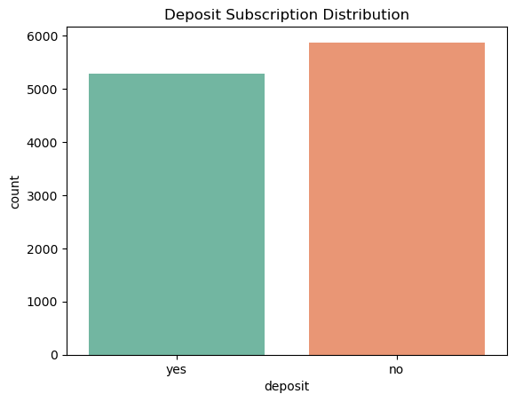
The chart shows the distribution of deposit subscriptions among the 11,162 customers in the dataset. Approximately 5,289 customers (47%) subscribed to a term deposit while 5,873 customers (53%) did not, indicating a fairly balanced dataset.

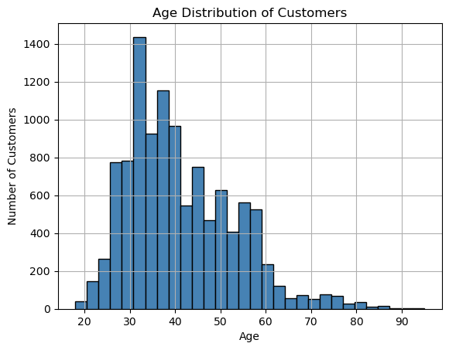

The age distribution shows that the majority of customers are between 30 and 40 years old, with the highest concentration around age 33. Customer numbers drop off significantly after the age of 50, indicating that the bank's customer base is predominantly working-age adults.
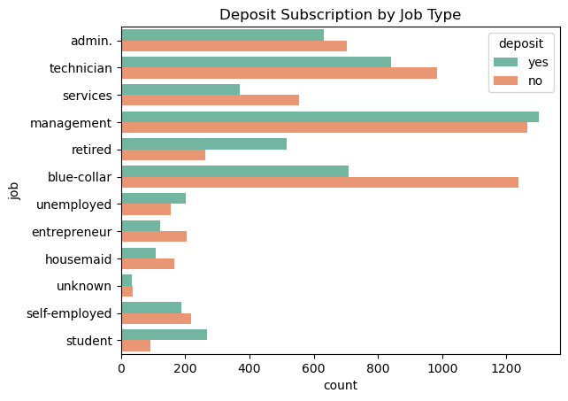
The deposit subscription by job type shows that people with stable or surplus money are more likely to lock it in a term deposit.

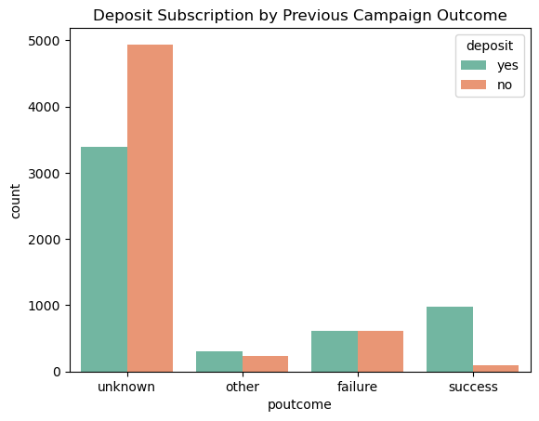
This chart tells us that if a customer said yes to the bank in a previous campaign, they are very likely to say yes again. Past behavior predicts future behavior.
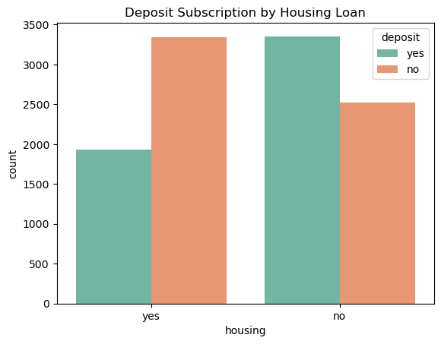
Customers without a housing loan have more disposable income. They're not tied down by monthly mortgage payments, so they can afford to lock money away in a term deposit.

Business Insights
  - Students and retired customers, who tend to have more stable or unencumbered income, such as parental financial support and pension payments, are more likely to subscribe to a term deposit. The bank should therefore prioritize targeting these groups in future campaigns to improve conversion rates.
  - Customers who engaged in longer calls were significantly more likely to subscribe. This means the bank should train agents to keep customers engaged on the call rather than rushing to close, as call duration is a strong indicator of genuine interest.
  - Customers without a housing loan have more disposable income and fewer financial commitments, making them more receptive to locking money in a term deposit. The bank should focus its outreach on this segment for higher subscription success.
  - Customers who subscribed in a previous campaign are highly likely to subscribe again, suggesting they already understand and value the product. The bank should treat these customers as a priority segment and re-engage them first before approaching new prospects.
Recommendations
- The bank should prioritize targeting students, retired, and tertiary-educated customers in future campaigns, as these groups demonstrated the highest subscription rates and are therefore more likely to convert.
- The bank should use cellular phones as the primary contact method, as data shows it significantly outperforms telephone and unknown contact methods in terms of subscription conversion.
- The bank should train agents to keep customers engaged for longer on calls, as the analysis shows that customers with longer call durations are significantly more likely to subscribe to a term deposit.
- The bank should re-engage customers who subscribed in previous campaigns as a first priority, since these customers have already demonstrated they understand and value the product and are highly likely to subscribe again.
- The bank should use financial profiling to identify and prioritize customers without housing loans, as these customers carry fewer financial commitments and therefore have more disposable income available for a term deposit.
Conclusion
The goal of this analysis was to identify which customer segments are most likely to subscribe to a term deposit and to understand the key factors that influence subscription decisions. The most important findings revealed that job type, contact method, call duration, and previous campaign outcomes are the strongest drivers of subscription behavior. By implementing the recommendations outlined in this report, the bank can significantly improve its campaign conversion rates, reduce wasted calls, and allocate its marketing resources more effectively.

