CHAPTER FOUR
RESULTS AND DISCUSSION

4.1 Introduction
This chapter presents and discusses the results obtained from implementing the methodology described in Chapter Three. It reports the outcomes of data preparation and exploratory data analysis, the results of building and tuning the three machine learning models, and their comparative evaluation on the held-out test set using the metrics defined earlier. The chapter then examines the association between maize yield and the weather, soil and management factors, presents the interactive dashboard developed to deliver the model, and discusses the findings in relation to the objectives of the study and the literature reviewed in Chapter Two.

4.2 Data Preparation Results
The raw dataset contained 10,000 records across four crops. In line with the scope of the study, the data was restricted to maize, yielding 2,477 maize records for analysis. A key data-handling issue was identified and resolved at this stage: the value “None” in the Irrigation and Previous_Crop columns is a genuine category (denoting rainfed plots and fallow land respectively), but the data-loading library treats “None” as a missing value by default. Correcting this prevented approximately 1,100 maize entries from being wrongly flagged as missing and imputed over.
After this correction, the maize dataset contained no genuine missing values, no duplicate records, and no out-of-range or outlier values. The four categorical variables were converted to numerical form using one-hot encoding, producing 19 input features. The data was divided into an 80% training set (1,981 records) and a 20% test set (496 records), stratified by region, and the numeric features were standardised using parameters learned from the training set only.

4.3 Exploratory Data Analysis Results
Exploratory analysis examined the distribution of each variable and its relationship with maize yield. The numeric variables were well-behaved, with no extreme values. The correlation analysis produced the clearest single finding of the study: maize yield is very strongly associated with the quantity of fertiliser applied, and moderately associated with rainfall, while the remaining variables show weak individual correlations with yield.
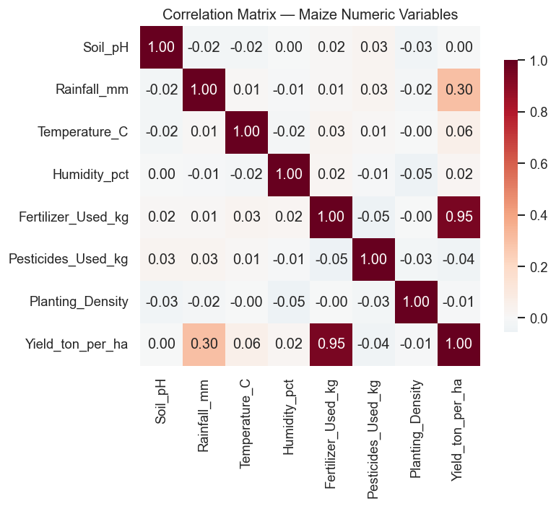
Figure 4.1: Correlation matrix of the maize numeric variables. Fertiliser (r = 0.95) and rainfall (r = 0.30) are the dominant correlates of yield.
Specifically, fertiliser used showed a correlation of 0.95 with yield and rainfall a correlation of 0.30, while temperature, humidity, soil pH, pesticides and planting density each correlated below 0.07 in absolute terms. This indicated, before any modelling, that a large share of the variation in maize yield could be explained by a small number of inputs, and that the relationship might be close to linear.

4.4 Model Building and Hyperparameter Tuning Results
Three models were built on the same training data: Linear Regression as the baseline, and Random Forest and XGBoost as the two main models. The two ensemble models were tuned using grid search with five-fold cross-validation, searching over the number of trees, tree depth, and (for XGBoost) the learning rate and sampling rates.
The best Random Forest configuration used 200 trees, a maximum depth of 15, and a minimum of 2 samples per leaf. The best XGBoost configuration used 300 trees, a maximum depth of 3, a learning rate of 0.03, and 0.8 row and column sampling. The shallow trees and low learning rate selected for XGBoost are consistent with a dataset whose underlying signal is relatively simple.

4.5 Model Evaluation and Comparison
Each trained model was evaluated on the held-out test set using Root Mean Square Error (RMSE), Mean Absolute Error (MAE), the R-squared score, and accuracy (the percentage of predictions within ±10% of the mean yield). Table 4.1 summarises the results, ordered from best to worst by RMSE.
Model | RMSE (↓) | MAE (↓) | R² (↑) | Accuracy % (↑) | CV R² (↑)
Linear Regression | 5.325 | 4.243 | 0.981 | 95.77 | 0.983
XGBoost | 5.558 | 4.429 | 0.979 | 96.37 | 0.981
Random Forest | 5.732 | 4.537 | 0.977 | 95.16 | 0.979
Table 4.1: Comparative performance of the three models on the maize test set (496 records).
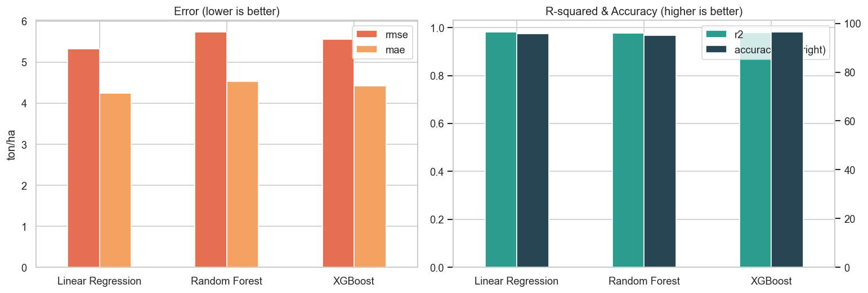
Figure 4.2: Model comparison. Left: error metrics (lower is better). Right: R² and accuracy (higher is better).
All three models performed strongly, each explaining approximately 98% of the variation in maize yield. The Linear Regression baseline achieved the lowest error (RMSE = 5.325, MAE = 4.243) and the highest R² (0.981), narrowly ahead of XGBoost (RMSE = 5.558, R² = 0.979) and Random Forest (RMSE = 5.732, R² = 0.977). XGBoost recorded the highest accuracy within the ±10% margin (96.37%). The differences between the models are small — less than 0.5 ton/ha in RMSE on a mean yield of about 118 ton/ha.
The five-fold cross-validated R² scores confirmed that these results are stable rather than an artefact of one lucky split: Linear Regression 0.983 ± 0.002, XGBoost 0.981 ± 0.002, and Random Forest 0.979 ± 0.003. The very small standard deviations indicate consistent performance across different subsets of the data.

4.6 Error Analysis
Error analysis was carried out on the best-performing model to understand where and why it makes mistakes. Figure 4.3 plots predicted against actual yields: the points lie very close to the diagonal line of perfect prediction, confirming the model tracks the true yield closely across the full range.
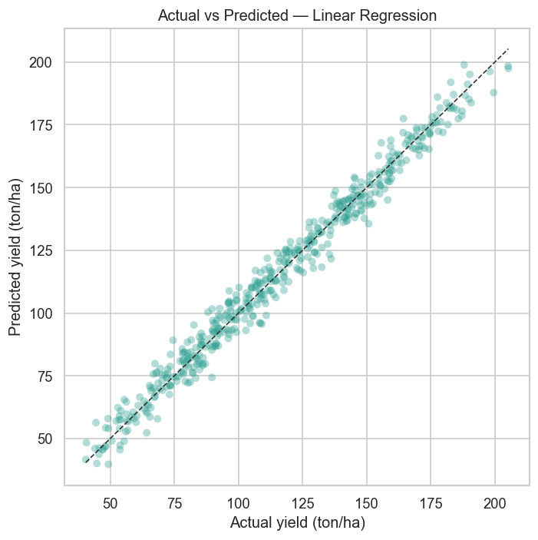
Figure 4.3: Actual versus predicted maize yield for the best model. Points close to the dashed line indicate accurate predictions.
Figure 4.4 examines the residuals (actual minus predicted yield). The residuals scatter randomly around zero with no visible pattern against the predicted value, and their distribution is approximately symmetric and centred on zero. This is the expected signature of a well-specified model: it is not systematically over- or under-predicting in any part of the range.
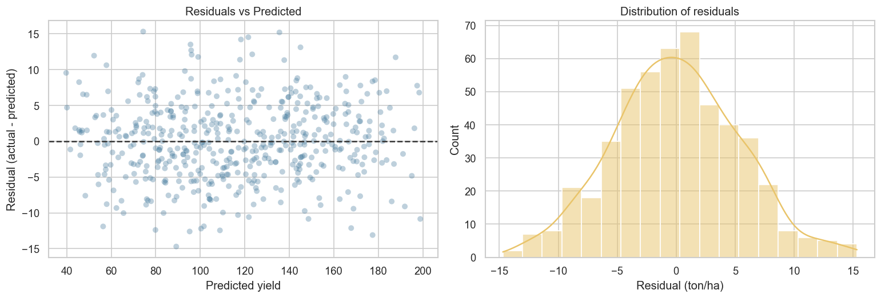
Figure 4.4: Residual analysis. Left: residuals versus predicted yield. Right: distribution of residuals.
The average prediction error was also broken down by region (Figure 4.5). The mean absolute error is similar across all four regions, showing that the stratified train/test split succeeded in producing a model that performs evenly rather than favouring any single region.
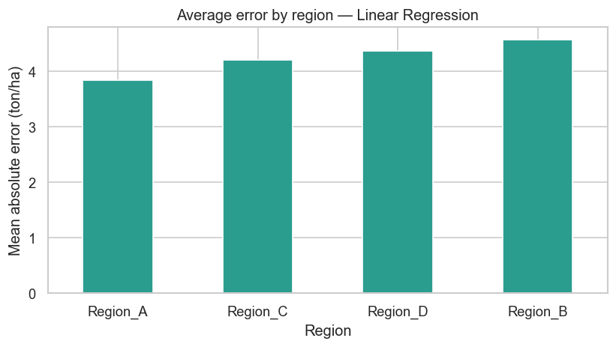
Figure 4.5: Mean absolute error by region for the best model. Error is broadly even across regions.

4.7 Association Between Maize Yield and Input Factors
The second objective of the study was to determine the association between maize yield and the weather, soil and management factors. This was assessed through both the correlation analysis (Section 4.3) and the feature-importance ranking produced by the XGBoost model (Figure 4.6).
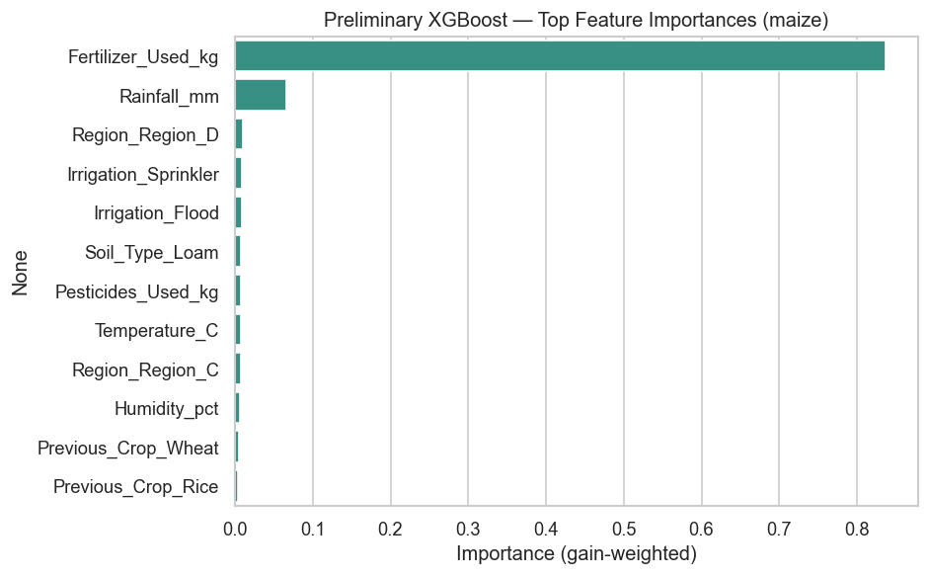
Figure 4.6: Feature importance from the XGBoost model. Fertiliser dominates, followed by rainfall.
Both methods agree. Fertiliser applied is overwhelmingly the most influential factor in determining maize yield, followed by rainfall. The soil, temperature, humidity and other management variables contribute comparatively little in this dataset. This aligns with agronomic understanding — nitrogen supply through fertilisation and water availability through rainfall are two of the best-established drivers of maize yield — and it is consistent with the literature reviewed in Chapter Two, where rainfall and soil fertility were repeatedly identified as leading predictors (Shuaibu et al., 2024; Lontsi Saadio et al., 2022).

4.8 The Interactive Dashboard
The fourth objective was to deliver the model through an interactive dashboard that non-technical users can operate. This was achieved with a web-based dashboard built in Streamlit, which loads the trained models and applies exactly the same preprocessing used during training, so its predictions match the models precisely. The dashboard has three sections.
- Predict Yield: the user enters the plot’s weather, soil and management values, selects a model, and receives the predicted yield with an expected-error range and a chart of the factors that most influenced that prediction.
- Model Performance: compares the three models on all four metrics, so users can see how the models relate.
- Prediction History: every prediction is stored in a database and can be reviewed as a table and a trend chart, implementing the PredictionRecord store described in the system design.
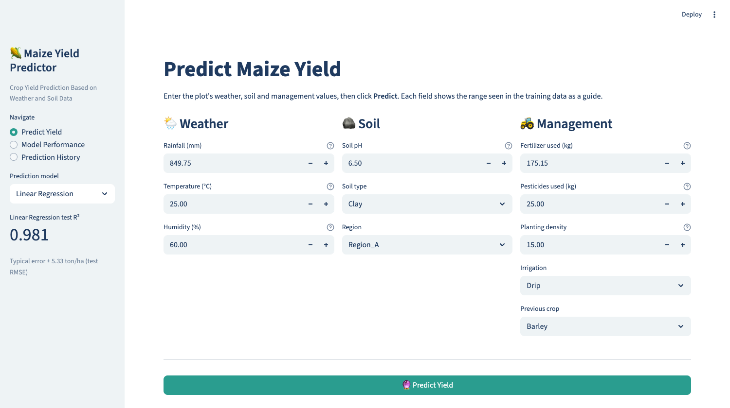
Figure 4.7: The prediction page of the interactive dashboard, showing the grouped input form and model selector.
The dashboard also validates user input before predicting: physically impossible values (for example a soil pH above 14) are rejected with a clear message, and values outside the range seen in the training data trigger an extrapolation warning. After each prediction, the user can download a one-page PDF report recording the inputs, the predicted yield, and the main influencing factors. This directly addresses the gap identified in Chapter Two, where almost no published maize prediction system provided a usable interface.

4.9 Discussion
The results show that all four objectives of the study were met: a maize yield prediction model was built (Objective 1), the association between yield and the input factors was determined (Objective 2), the model was evaluated against alternatives (Objective 3), and it was delivered through an interactive dashboard (Objective 4).
The most notable analytical finding is that the simple Linear Regression baseline matched, and slightly outperformed, the more complex Random Forest and XGBoost models. This is explained by the structure of the data: maize yield in this dataset is very close to a linear function of a few inputs, dominated by fertiliser and rainfall. When the true relationship is near-linear, a linear model captures it fully, and the flexibility of ensemble methods provides no advantage. Far from being a weakness, this result demonstrates the value of including a baseline — it shows that the ensembles are not overfitting and are not missing any hidden non-linear structure. The high accuracy achieved (R² ≈ 0.98) is in the same range as recent maize prediction studies such as Samaila and Wycliffe (2025), who reported R² values between 0.93 and 0.98.
These results should be read alongside an important limitation. The dataset used contains weather, soil and management variables (rainfall, temperature, humidity, soil pH, soil type, fertiliser, pesticides, irrigation, planting density and previous crop) rather than the full ERA5, SoilGrids and FAOSTAT variable set described in the original methodology. The strong performance therefore reflects this particular dataset, in which fertiliser is the dominant driver. On real, noisier field data with more weather and soil detail, the relationships would likely be more complex, and the ensemble models might then show a clearer advantage over the linear baseline. This is a natural direction for future work.
From a practical standpoint, the findings are directly useful to the intended stakeholders. The dominance of fertiliser and rainfall gives farmers and extension officers a clear, evidence-based message about which factors most affect maize yield, and the dashboard makes the model itself usable without any programming knowledge, closing the research-to-practice gap highlighted in the literature.

4.10 Summary
This chapter presented the results of the maize yield prediction study. The data was cleaned and prepared with careful handling of the “None” category, leaving a complete dataset of 2,477 maize records. Three models were trained and compared; all achieved approximately 98% R², with the Linear Regression baseline marginally best on error and XGBoost best on within-margin accuracy. Error analysis confirmed the models predict evenly and without systematic bias. Fertiliser and rainfall were identified as the dominant drivers of yield, and the model was delivered through an interactive, input-validating dashboard with downloadable reports. The following chapter presents the conclusions of the study and recommendations for future work.

