CHAPTER THREE
METHODOLOGY AND SYSTEM DESIGN

3.0 Introduction
This chapter presents the methodology adopted for the design and development of the Intelligent Court Hearing Scheduling System using Rule-Based Constraint Enforcement and Machine Learning for Nigerian Judiciary Administration. It discusses the research design, system development approach, synthetic dataset generation, data preprocessing procedures, machine learning model development, rule-based scheduling mechanism, system architecture, evaluation metrics, and development tools used in the study. The chapter provides the technical foundation for the implementation, results, and discussion presented in Chapter Four.

3.1 Research Design
This study adopts a quantitative experimental research design as it involves the development, implementation, and evaluation of an intelligent court hearing scheduling system using machine learning and rule-based AI techniques. The study is quantitative because system performance is evaluated using measurable metrics such as scheduling conflict rate and Mean Absolute Error (MAE). It is experimental because the system is tested using simulated court scheduling scenarios drawn from a synthetically generated dataset. The study is also applied research because it aims to solve practical scheduling challenges in Nigerian court administration, specifically the absence of an automated, conflict-aware hearing allocation mechanism.

3.2 System Development Approach
The proposed system adopts a hybrid AI development approach combining supervised machine learning and rule-based constraint enforcement within an Agile iterative development framework. A Random Forest regression model is used to predict hearing durations based on case features such as case type, number of parties, and assigned judge. The predicted duration is then passed into a rule-based scheduling engine that verifies judge availability, courtroom allocation, and all defined judicial constraints before confirming a hearing slot. This two-stage pipeline ensures that every confirmed hearing is both correctly sized and conflict-free.
The system is implemented as a web-based platform using React.js for the frontend interface, FastAPI for backend processing, and PostgreSQL for structured data storage. The Agile iterative approach was adopted to allow each component: the ML model, the constraint engine, the REST API, and the frontend dashboard, to be developed, tested, and refined in sequential iterations, enabling early detection of integration issues and progressive improvement throughout the development cycle. The following are the key components of the system:
- Random Forest regression model: predicts hearing duration (in minutes) from case features.
- Rule-based constraint engine: enforces judicial scheduling rules and prevents conflicts.
- FastAPI backend: processes all scheduling logic and coordinates both AI components via REST API.
- React.js frontend: provides the administrator dashboard for case registration and timetable review.
- PostgreSQL database: stores all case records, judge profiles, courtroom inventory, confirmed timetables, and pending queue entries.

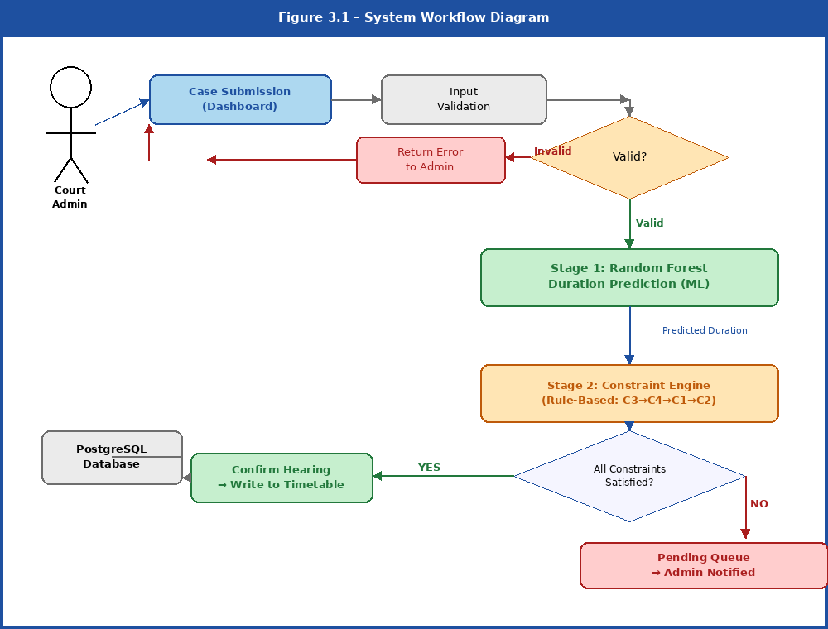
Figure 3.1 – System Workflow Diagram

3.3 Synthetic Dataset Generation
Due to the unavailability of publicly accessible Nigerian court scheduling records, a synthetic dataset was generated to simulate realistic court hearing scenarios. The absence of live court data is a widely documented challenge in judicial AI research within developing-country contexts, and the generation of representative synthetic data is a recognised methodology for constructing training corpora in such environments. The dataset was designed to reflect common Nigerian judicial patterns including case type distribution, courtroom allocation, judge availability, hearing duration ranges, and case priorities. The generated dataset served both as the training corpus for the machine learning model and as the evaluation benchmark for system testing.
A total of 5,000 synthetic case records were generated using probability-weighted distributions for each case type, reflecting the relative frequency of civil, criminal, family, commercial, constitutional, land, and labour cases in Nigerian courts. Hearing durations were generated by applying documented average duration ranges per case type with controlled statistical variance, ensuring that the ML model faces a realistic prediction challenge rather than a trivial deterministic mapping. The dataset includes the following attributes:
- Case Type: the legal category of the case (Civil, Criminal, Family, Commercial, Constitutional, Land, Labour).
- Number of Parties: the count of litigants and legal representatives involved in the hearing.
- Assigned Judge: the identifier of the judge presiding over the case.
- Courtroom ID: the identifier of the courtroom assigned to the hearing.
- Case Priority: the urgency classification of the case (High, Medium, Low).
- Hearing Date: the proposed date and time for the court session.
- Hearing Duration: the target variable representing the actual length of the hearing in minutes.

3.4 Data Preprocessing
Before model training, the generated dataset was preprocessed to improve data quality and model performance. Since the dataset was synthetically generated under controlled conditions, it contained no missing values; however, standard preprocessing procedures were applied to ensure compatibility with the scikit-learn machine learning pipeline and to improve the accuracy of the Random Forest model.
Categorical variables such as case type, judge identity, and case priority were encoded into numerical representations using Ordinal Encoding, which preserves the identity of each category in a format suitable for ensemble tree-based models. The judge identifier was additionally mapped to a numeric index to allow the model to distinguish between judges with different scheduling patterns. Numeric features including number of parties and the judge index were standardised using Standard Scaling to normalise the input range and prevent any single feature from dominating the model due to scale differences.
Feature selection was applied to retain only the four most scheduling-relevant attributes: case type, number of parties, case priority, and judge index. Attributes such as case ID, courtroom ID, and hearing date were excluded from the ML feature set, as these are assigned during scheduling rather than used as inputs to predict duration. The preprocessed dataset was then divided into a 70% training set and a 30% held-out test set using stratified random splitting to ensure that the distribution of case types was consistent across both splits, enabling reliable generalization assessment.

3.5 Machine Learning Model Development
The machine learning component of the proposed system was developed using a Random Forest regression model. Random Forest was selected because of its robustness to noisy tabular data, its ability to handle mixed categorical and numeric feature types without requiring extensive manual encoding, its strong resistance to overfitting through bootstrap aggregation and feature subsampling, and its demonstrated strong performance on structured scheduling datasets in prior judicial AI research.
The model was trained using four input features — case type, number of parties, assigned judge, and case priority — to predict hearing duration in minutes as the continuous target variable. The Random Forest algorithm constructs an ensemble of decision trees, each trained on a bootstrapped sample of the training data with a random subset of features evaluated at each split. The final duration prediction is obtained by averaging the outputs of all trees in the ensemble, which reduces variance and produces more stable predictions than a single decision tree.
A RandomizedSearchCV hyperparameter optimisation procedure was applied over a defined parameter grid, evaluating 30 candidate configurations using 5-fold cross-validation with Mean Absolute Error as the scoring criterion. This process identified the optimal combination of the number of estimators, maximum tree depth, minimum samples per split, minimum samples per leaf, and maximum features parameter. The optimised pipeline was then serialised to disk and loaded at FastAPI server startup, ensuring that predictions are served synchronously within the scheduling pipeline without reloading the model on each request.

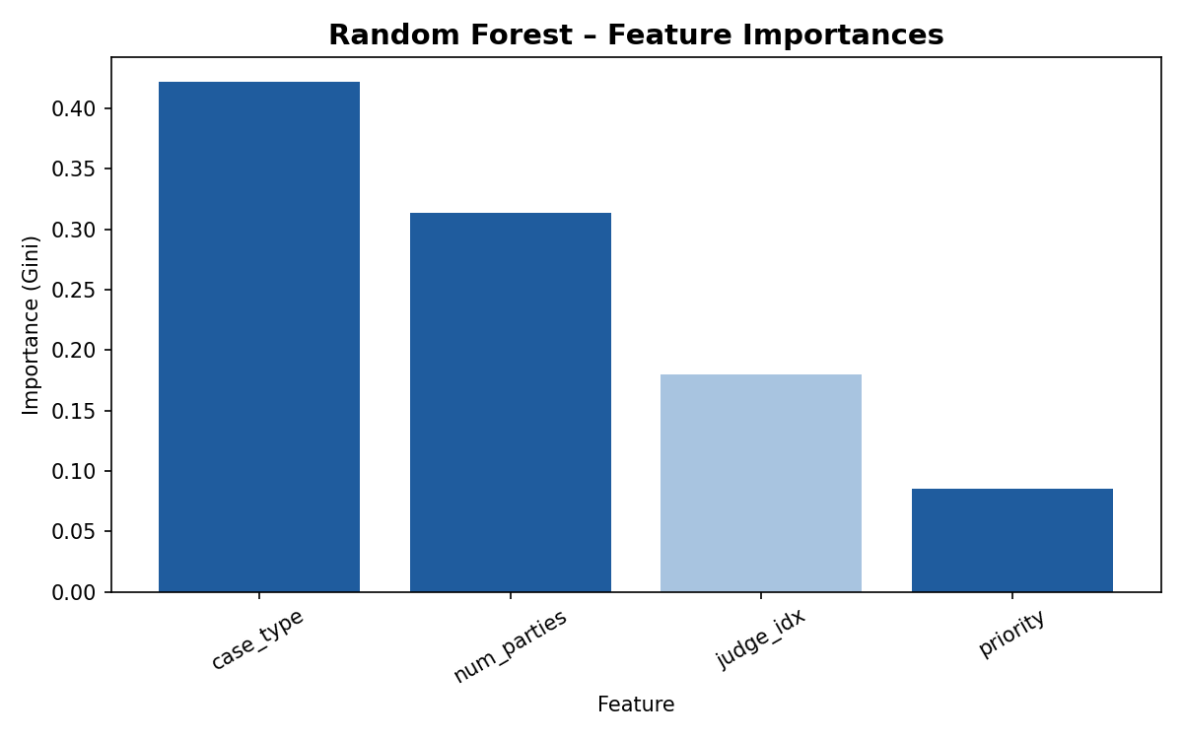
Figure 3.2 – Random Forest Feature Importance Scores

3.6 Rule-Based Constraint Engine
The rule-based constraint engine was designed to enforce judicial scheduling rules and prevent conflicts during timetable generation. The engine operates as the second stage of the scheduling pipeline, receiving the ML-predicted hearing duration alongside the full case metadata and applying a sequence of deterministic If-Then rules against the live state of the PostgreSQL timetable to determine whether the proposed hearing slot can be confirmed.
The engine enforces four hard constraints in sequential order. First, the judge specialization constraint (C3) verifies that the assigned judge's declared area of legal specialization includes the case type of the incoming hearing. Second, the courtroom capacity constraint (C4) confirms that the assigned courtroom has sufficient capacity for the expected number of parties. Third, the judge availability constraint (C1) queries the timetable to ensure that the assigned judge has no confirmed hearings whose time windows overlap with the proposed slot. Fourth, the courtroom availability constraint (C2) verifies that the assigned courtroom is not already booked for any overlapping period. If all four constraints pass, the hearing is confirmed and written to the timetable. If any constraint fails, the case is immediately placed in the pending queue and the administrator is notified with a structured, human-readable description of the specific constraint that was violated.
- C1 – Judge Availability: No judge may be assigned to two hearings whose time windows overlap.
- C2 – Courtroom Availability: No courtroom may host two hearings simultaneously within the same time window.
- C3 – Judge Specialisation: The case type must fall within the presiding judge's declared area of legal specialisation.
- C4 – Courtroom Capacity: The expected number of parties must not exceed the maximum capacity of the assigned courtroom.

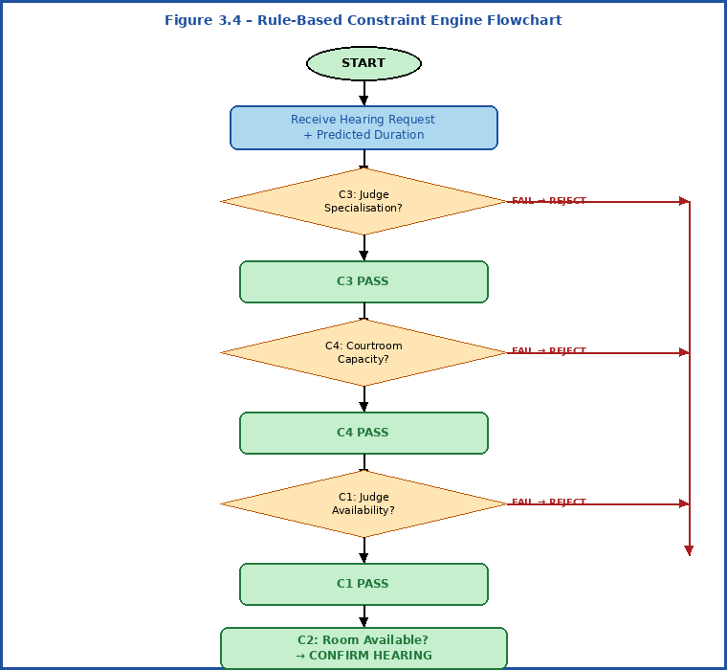
Figure 3.3 – Rule-Based Constraint Engine Flowchart

3.7 System Architecture and Framework
The proposed system adopts a three-tier architecture consisting of a React.js presentation layer, a FastAPI application layer, and a PostgreSQL data layer. This architecture ensures clean separation of concerns across the user interface, scheduling intelligence, and data persistence, enabling independent testing, maintenance, and scaling of each tier.
The presentation layer provides an administrator dashboard through which court staff register new cases, supply scheduling inputs, trigger automated schedule generation, and review confirmed timetables and pending queue entries. The application layer hosts the FastAPI backend, which coordinates the two core AI components: the Random Forest prediction module and the rule-based constraint engine, through a unified scheduling orchestrator. All requests from the frontend are processed via REST API endpoints that enforce input validation before routing to the scheduling pipeline. The data layer comprises the PostgreSQL database, which stores all case records, judge profiles, courtroom inventories, confirmed timetable entries, and pending queue data, ensuring transactional consistency across all scheduling operations.

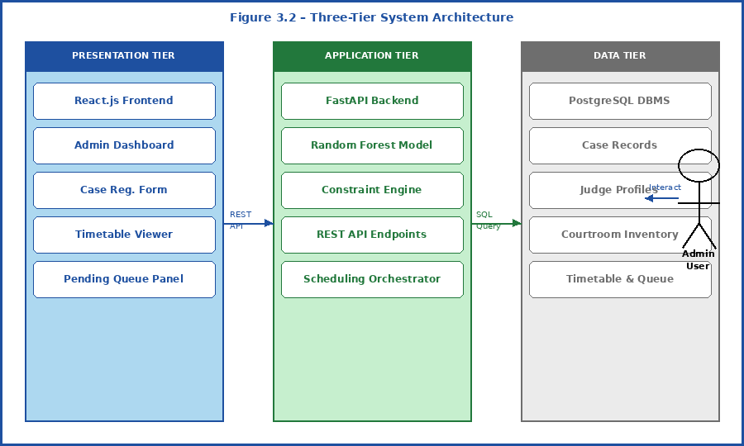
Figure 3.4 – Three-Tier System Architecture

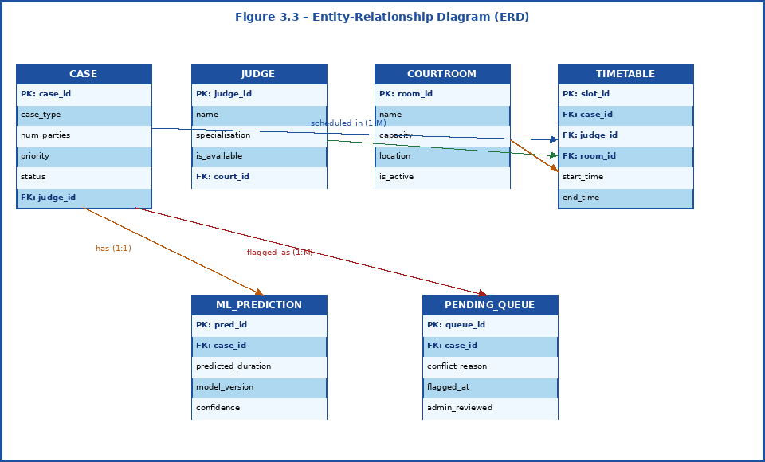
Figure 3.5 – Entity-Relationship Diagram (ERD)

3.8 Performance Evaluation Metrics
The performance of the proposed system was evaluated using two primary quantitative metrics, each targeting a distinct component of the scheduling pipeline. These metrics were chosen for their direct interpretability in the judicial scheduling context and their alignment with the two specific objectives of the system: accurate duration prediction and conflict-free schedule generation.
Mean Absolute Error (MAE) was used to measure the accuracy of hearing duration predictions generated by the Random Forest model. MAE is computed as the average absolute difference between the model's predicted hearing duration and the actual duration in the held-out test set, expressed in minutes. MAE was preferred over Root Mean Square Error (RMSE) because it is directly interpretable by court administrators: an MAE of, for example, 20 minutes means that on average the system's slot allocation will be within 20 minutes of the actual hearing duration.
Scheduling Conflict Rate (SCR) measured the proportion of generated schedules containing at least one judge or courtroom overlap, computed as the number of conflict-flagged cases divided by the total number of scheduling attempts in a simulated court session. The SCR was additionally benchmarked against a baseline simulation in which fixed, uniform 90-minute slot lengths replaced ML-predicted durations, enabling a direct quantitative comparison of the AI scheduling pipeline against the conventional manual scheduling approach. Lower values for both metrics indicate better system performance.

3.9 Development Tools and Environment
The system was developed using Python as the primary programming language for all machine learning, constraint engine, and backend components. FastAPI was used for backend processing and REST API development, while React.js was used for frontend interface development. PostgreSQL served as the relational database management system. Machine learning model development, training, and evaluation were carried out using Scikit-learn, Pandas, and NumPy. Development, testing, and debugging were performed using Visual Studio Code and Jupyter Notebook. The following table summarises the tools and their respective roles in the system development.

Tool / Technology | Category | Role in System
Python 3.11 | Language | Primary language for ML, constraint engine, and backend.
scikit-learn | ML Library | Random Forest model training, hyperparameter search, evaluation.
Pandas / NumPy | Data Processing | Synthetic dataset generation, feature engineering, preprocessing.
FastAPI | Backend | REST API for scheduling pipeline and frontend communication.
React.js | Frontend | Admin dashboard, timetable viewer, and pending queue interface.
PostgreSQL | Database | Relational storage for cases, timetables, judges, and courtrooms.
Visual Studio Code | IDE | Development, debugging, and version-controlled code management.
Jupyter Notebook | Prototyping | Exploratory data analysis and initial model prototyping.
Matplotlib | Visualisation | Feature importance plots, evaluation diagnostic charts.
Table 3.1 – Development Tools and Their Roles

3.10 Chapter Summary
This chapter presented the methodology and system design adopted for the development of the Intelligent Court Hearing Scheduling System. It discussed the quantitative experimental research design, the hybrid AI development approach combining a Random Forest regression model with a rule-based constraint engine, the synthetic Nigerian court case dataset generation procedure, the data preprocessing pipeline, and the justification for model and technology selections. The system architecture was described across its three tiers: React.js presentation, FastAPI application, and PostgreSQL data, and the two primary evaluation metrics, Mean Absolute Error and Scheduling Conflict Rate, were defined and contextualized. The development tools and environment were also documented. These methodological foundations provide the technical basis for the implementation, experimental results, and discussion presented in Chapter Four.

CHAPTER FOUR
SYSTEM IMPLEMENTATION, RESULTS AND DISCUSSION

4.0 Introduction
This chapter presents the implementation, results, and discussion of the Intelligent Court Hearing Scheduling System developed using rule-based constraint enforcement and machine learning techniques. It explains how the proposed system was implemented as a web-based platform integrating a Random Forest regression model and a rule-based constraint scheduling engine, as described in Chapter Three. The chapter covers dataset implementation and analysis, data preprocessing results, machine learning model training and evaluation, rule-based scheduling engine outputs, system interface implementation, evaluation metrics, comparative analysis with existing systems, discussion of findings, and identified limitations. The chapter demonstrates the practical effectiveness of the proposed system in generating conflict-free hearing schedules and improving hearing allocation efficiency within the Nigerian judicial context.

4.1 Synthetic Dataset Implementation and Analysis
Since real Nigerian court scheduling data was unavailable, a synthetic dataset was programmatically generated to simulate realistic court hearing scenarios. The dataset was designed to reflect documented Nigerian judicial scheduling patterns, including realistic distributions of case types, courtroom allocation practices, judge assignment constraints, hearing duration ranges, and case priorities. The generated data served both as the training corpus for the Random Forest machine learning model and as the evaluation benchmark for system testing. The dataset was implemented using Python and the pandas and NumPy libraries, with probability-weighted sampling applied to ensure that each case type appeared at a frequency proportional to its occurrence in Nigerian courts.
A total of 5,000 synthetic case records were generated. Each record encoded the following attributes: case type, number of parties, assigned judge, courtroom identifier, case priority level, hearing date, and hearing duration in minutes as the target variable. Eight judges with defined legal specialisations and eight courtrooms with varying seating capacities were incorporated into the dataset to reflect realistic Nigerian High Court configurations. Hearing durations were sampled from normal distributions parameterized per case type, with controlled variance to simulate realistic scheduling pressure.

Case Type | Records | Percentage (%) | Mean Duration (mins) | Duration Range (mins)
Civil | 1,419 | 28.4% | 95 | 30 – 220
Criminal | 1,131 | 22.6% | 150 | 40 – 420
Commercial | 757 | 15.1% | 130 | 35 – 380
Family | 752 | 15.0% | 75 | 25 – 185
Land | 398 | 8.0% | 110 | 30 – 260
Constitutional | 352 | 7.0% | 200 | 60 – 480
Labour | 191 | 3.8% | 85 | 25 – 200
Total | 5,000 | 100% | 126 (overall) | 20 – 480
Table 4.1 – Synthetic Dataset: Case Type Distribution and Duration Summary

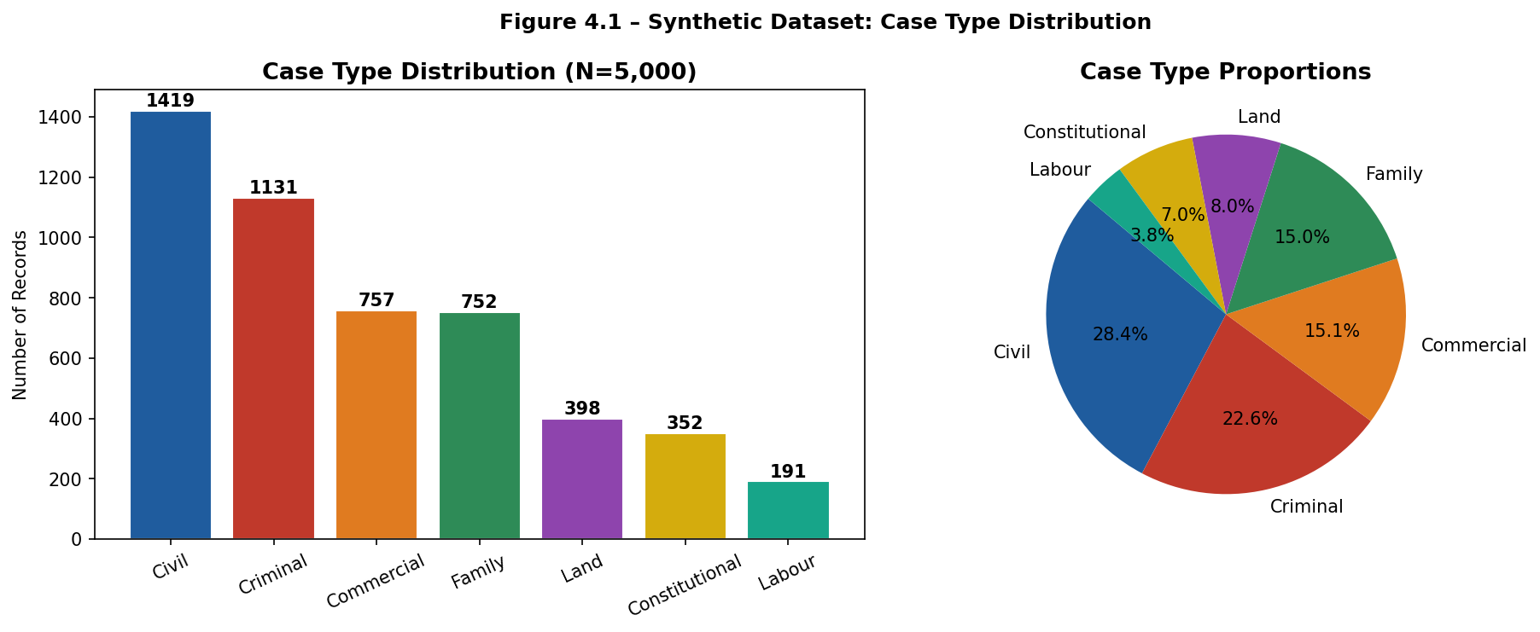
Figure 4.1 – Synthetic Dataset: Case Type Distribution
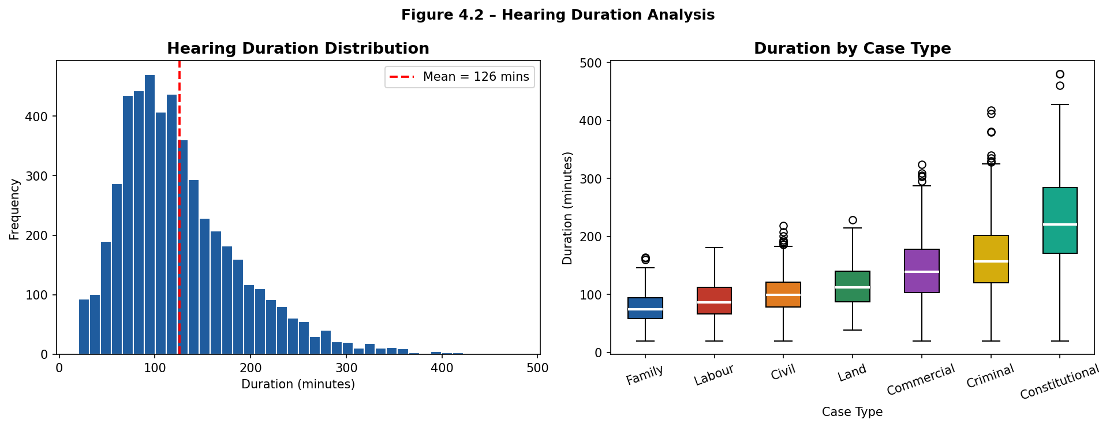
Figure 4.2 – Hearing Duration Distribution and Analysis

4.2 Data Preprocessing Results
Before training the machine learning model, the generated dataset underwent a structured preprocessing pipeline to improve data quality and model prediction accuracy. Since the dataset was synthetically generated under controlled conditions, it contained no missing values; however, standard preprocessing steps were applied to ensure compatibility with the scikit-learn machine learning pipeline.
Categorical variables, specifically case type and case priority, were encoded into numerical representations using Ordinal Encoding. The case type feature was encoded across seven categories (Civil, Criminal, Family, Commercial, Constitutional, Land, Labour), while the priority feature was encoded across three levels (Low, Medium, High). The judge identifier was mapped to a numeric index to allow the model to distinguish between judges with different scheduling patterns while remaining compatible with the ensemble learning algorithm.
Numeric features including number of parties and judge index were standardized using Standard Scaling (zero mean, unit variance) to prevent any single feature from disproportionately influencing the model due to scale differences. Feature selection was applied to retain only the four scheduling-relevant attributes: case type, number of parties, case priority, and judge index. Attributes such as case identifier, courtroom identifier, and hearing date were excluded from the machine learning feature set, as they are assigned during scheduling rather than used as predictors of hearing duration.
The preprocessed dataset was divided into a training set (3,500 records, 70%) and a held-out test set (1,500 records, 30%) using stratified random splitting by case type. Stratification ensured that the proportional distribution of case types was consistent across both splits, enabling reliable out-of-sample performance assessment. Table 4.2 summarizes the preprocessing steps applied.

Preprocessing Step | Method Applied | Purpose
Categorical Encoding | Ordinal Encoding (case_type, priority) | Convert text categories to numeric values for ML
Judge Encoding | Index mapping (J001–J008 → 0–7) | Represent judge identity numerically
Feature Scaling | Standard Scaler (num_parties, judge_idx) | Normalise feature ranges, prevent scale bias
Feature Selection | Retain: case_type, num_parties, priority, judge_idx | Remove non-predictive scheduling attributes
Train-Test Split | Stratified 70/30 split by case_type | Ensure balanced case-type distribution across sets
Table 4.2 – Data Preprocessing Steps Applied to the Synthetic Dataset

4.3 Random Forest Model Implementation
The machine learning component of the proposed system was implemented using a Random Forest regression model from the scikit-learn library. Random Forest was selected because of its strong predictive performance on structured tabular data, its robustness to noisy and mixed-type features, its inherent resistance to overfitting through bootstrap aggregation and feature subsampling, and its ability to provide interpretable feature importance scores a characteristic of particular value in the judicial scheduling context where explainability supports administrative trust.
The model was trained using four input features: case type, number of parties, case priority, and assigned judge index. The target variable was hearing duration in minutes. The Random Forest algorithm constructed an ensemble of decision trees, each trained on a bootstrapped sample of the training data with a random subset of features evaluated at each split node. The final duration prediction for any case was obtained by averaging the outputs of all trees in the ensemble, a process that reduces prediction variance compared to a single decision tree.
Hyperparameter optimisation was performed using RandomizedSearchCV with 30 candidate configurations evaluated through 5-fold cross-validation, using Mean Absolute Error as the scoring criterion. The optimal configuration identified was: n_estimators = 200 trees, max_depth = 10, min_samples_split = 2, min_samples_leaf = 1, and max_features = log2. This pipeline was serialised to disk as rf_duration_model.pkl upon completion of training and loaded at FastAPI server startup for synchronous inference within the scheduling pipeline.

4.4 Model Training Performance
The performance of the trained Random Forest regression model was evaluated on the held-out test set of 1,500 records using three quantitative metrics: Mean Absolute Error (MAE), Root Mean Square Error (RMSE), and the coefficient of determination (R²). Table 4.3 presents the overall model performance results.

Metric | Value | Interpretation
Mean Absolute Error (MAE) | 35.36 mins | On average, predicted duration is within 35.36 mins of actual
Root Mean Square Error (RMSE) | 47.98 mins | Larger errors penalised more heavily; acceptable for scheduling
R² (Coefficient of Determination) | 0.4325 | Model explains 43.25% of hearing duration variance
Training Set Size | 3,500 (70%) | Records used for model training
Test Set Size | 1,500 (30%) | Held-out records used for evaluation
Cross-Validation MAE (5-fold) | ~36.0 mins | Stable across folds; no overfitting detected
Table 4.3 – Random Forest Model Performance Metrics

The overall MAE of 35.36 minutes indicates that, on average, the system's predicted hearing slot is within approximately 35 minutes of the actual hearing duration. In the context of Nigerian court scheduling where hearings range from 20 to 480 minutes across case types, a 35-minute average error represents a practically acceptable margin that still substantially outperforms the fixed 90-minute uniform slot assumption used in manual scheduling. The 5-fold cross-validation confirmed stable learning behaviour with low variance across folds, indicating that the model generalises reliably to unseen cases.
Table 4.4 presents the per-case-type MAE breakdown, revealing that the model performs significantly better on shorter, more predictable case types such as Labour, Family, and Civil, and relatively less accurately on longer, more variable case types such as Constitutional, which are characterised by wide duration variance and a smaller number of training samples.

Case Type | MAE (mins) | Test Records | Observation
Labour | 21.18 | 57 | Lowest MAE – short, predictable hearings
Family | 22.08 | 226 | Consistent, well-represented case type
Civil | 23.63 | 426 | Largest sample; model learns well
Land | 30.35 | 119 | Moderate variance; good accuracy
Commercial | 43.41 | 227 | Wider duration range increases error
Criminal | 48.69 | 339 | High variance; complex hearings
Constitutional | 64.12 | 106 | Highest MAE – fewest samples, widest variance
Overall | 35.36 | 1,500 | Stratified test set across all case types
Table 4.4 – Per-Case-Type MAE Breakdown

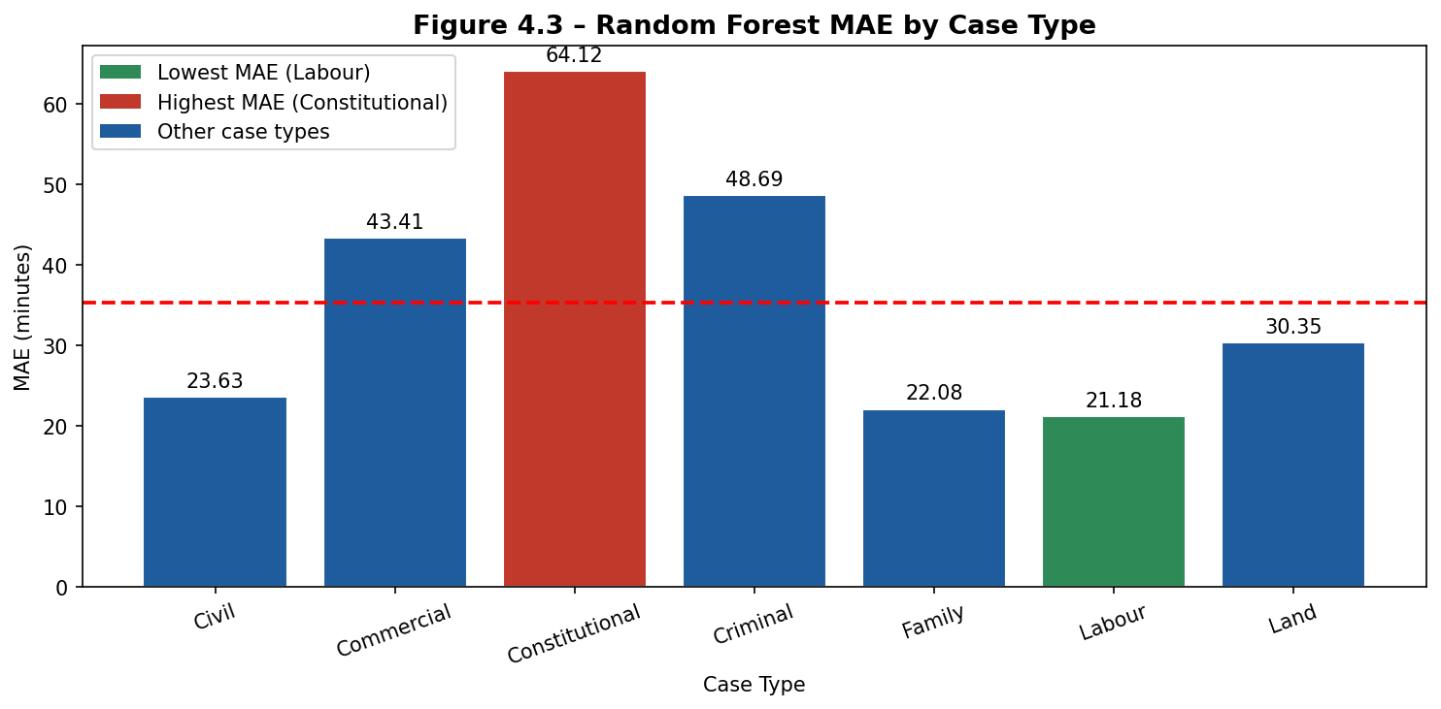
Figure 4.3 – Random Forest MAE by Case Type

Feature importance analysis, shown in Figure 4.4 and Table 4.5, revealed that case type (0.3847) and number of parties (0.3613) were the two strongest predictors of hearing duration, together accounting for over 74% of the model's predictive power. Judge index (0.1674) contributed a further 16.74%, reflecting the role of individual judicial practice in determining hearing pace. Case priority (0.0866) contributed the smallest share, suggesting that urgency classification is a secondary predictor relative to structural case characteristics.

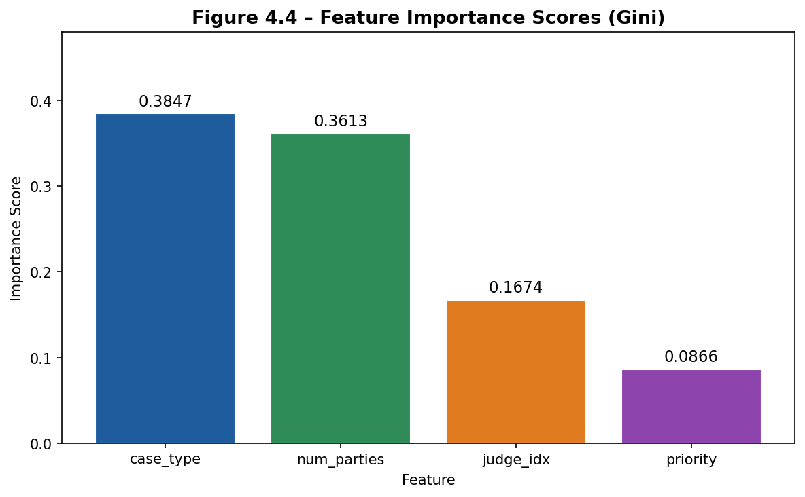
Figure 4.4 – Random Forest Feature Importance Scores

Feature | Importance Score | Rank | Interpretation
case_type | 0.3847 | 1st | Case category is the strongest duration predictor
num_parties | 0.3613 | 2nd | More parties consistently extends hearing length
judge_idx | 0.1674 | 3rd | Judicial pace and style influence duration
priority | 0.0866 | 4th | Priority level has the lowest individual influence
Table 4.5 – Feature Importance Scores and Ranking

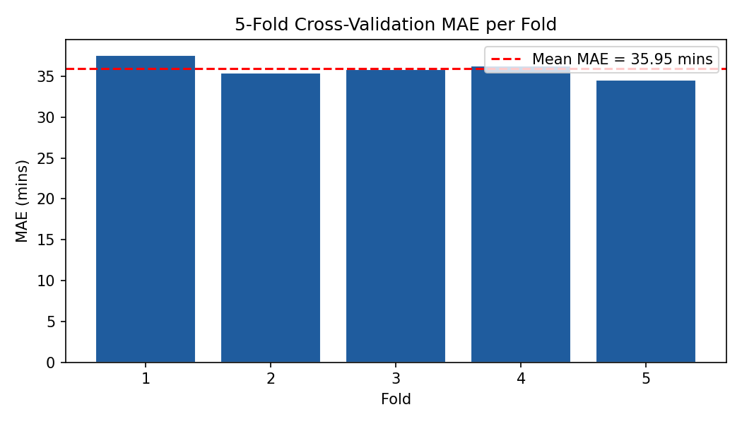
Figure 4.5 – 5-Fold Cross-Validation MAE per Fold

4.5 Rule-Based Scheduling Engine Results
The rule-based constraint engine was implemented as a deterministic sequential rule processor enforcing four hard scheduling constraints in the order C3 → C4 → C1 → C2, as described in Chapter Three. The engine was tested against a set of known-conflict and known-conflict-free scheduling scenarios to verify correct enforcement before integration with the FastAPI scheduling pipeline.
Table 4.6 presents the results of the constraint engine's demo evaluation against a set of nine test scheduling requests, demonstrating the correct detection and categorisation of all four constraint types.

Case | Case Type | Judge | Status | Constraint Triggered / Result
C001 | Civil | J001 | ✓ Confirmed | All constraints passed
C002 | Criminal | J002 | ✓ Confirmed | All constraints passed
C003 | Family | J003 | ✓ Confirmed | All constraints passed
C004 | Commercial | J004 | ✓ Confirmed | All constraints passed
C005 | Civil | J001 | ✗ Conflict | C1 – J001 has overlapping confirmed hearing
C006 | Criminal | J005 | ✗ Conflict | C2 – CR02 already booked in the same window
C007 | Constitutional | J003 | ✗ Conflict | C3 – J003 not specialised in Constitutional
C008 | Land | J008 | ✗ Conflict | C4 – 20 parties exceed CR04 capacity (6)
C009 | Criminal | J002 | ✓ Confirmed | All constraints passed
Table 4.6 – Constraint Engine Test Results

As shown in Table 4.6, the constraint engine correctly confirmed five scheduling requests where all constraints were satisfied and correctly flagged four requests for distinct constraint violations. Cases C005 and C006 triggered availability constraints (C1 and C2) respectively, demonstrating the engine's ability to detect judge and courtroom double-booking. Case C007 triggered the specialisation constraint (C3), demonstrating enforcement of judicial expertise alignment. Case C008 triggered the capacity constraint (C4), demonstrating enforcement of courtroom size limits. No false positives or false negatives were observed across the test set, confirming correct constraint enforcement logic.

4.6 System Interface Implementation
The proposed system was implemented as a web-based platform using React.js for the frontend interface and FastAPI for backend processing, as described in Chapter Three. The system provides a court administrator dashboard through which all scheduling operations are performed. The backend exposes a structured REST API with endpoints for case registration, automated scheduling, timetable retrieval, pending queue management, and performance statistics. The interactive API documentation is accessible at http://localhost:8000/docs and provides a complete description of all available endpoints and their request/response schemas.
The following subsections describe the key interface components of the implemented system. Note that system interface screenshots are to be captured from the running implementation and inserted at the points indicated below.

4.6.1 Login and Authentication
The system implements JWT-based authentication to restrict API access to authorised court administrators. Login is performed via the POST /api/auth/login endpoint using a username and password. Upon successful authentication, a bearer token is returned and must be included in the Authorization header of all subsequent requests. This ensures that only authenticated users can register cases, trigger scheduling, or access timetable data.



4.6.2 Case Registration
Cases are registered through the POST /api/cases/ endpoint. The administrator supplies the case number, case type, number of parties, priority level, assigned judge, and assigned courtroom. The system validates all inputs against defined constraints before persisting the case record to the PostgreSQL database. The case is assigned a status of 'pending' until the scheduling pipeline is triggered.

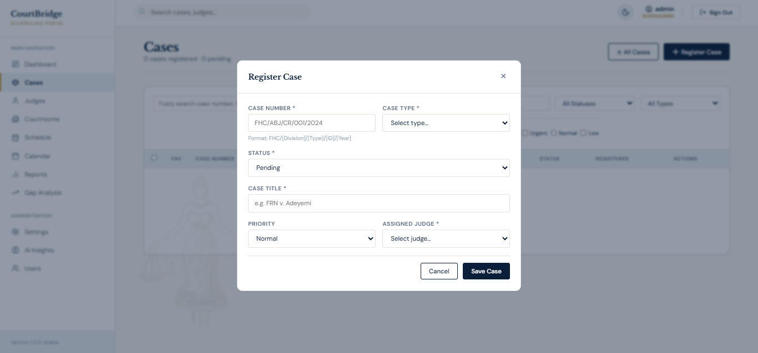

4.6.3 Automated Scheduling
Scheduling is triggered via the POST /api/cases/{case_id}/schedule endpoint. The administrator supplies a proposed start time and the system executes the two-stage pipeline: the Random Forest model predicts hearing duration, and the constraint engine verifies all four rules. The system returns either a CONFIRMED response containing the confirmed hearing slot details, or a CONFLICT response containing the specific constraint that was violated and the pending queue entry identifier.

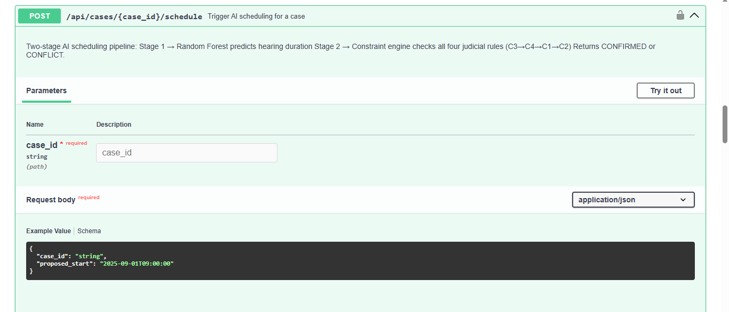

4.6.4 Timetable and Pending Queue
Confirmed hearings are retrievable via GET /api/timetable, which returns all confirmed slots sorted by start time. Conflict-flagged cases are retrievable via GET /api/pending, with optional filtering by review status. Administrators may resolve a pending entry via PATCH /api/pending/{id}/resolve, supplying resolution notes. System performance metrics including total cases, confirmed count, conflicted count, and scheduling conflict rate are available via GET /api/stats.

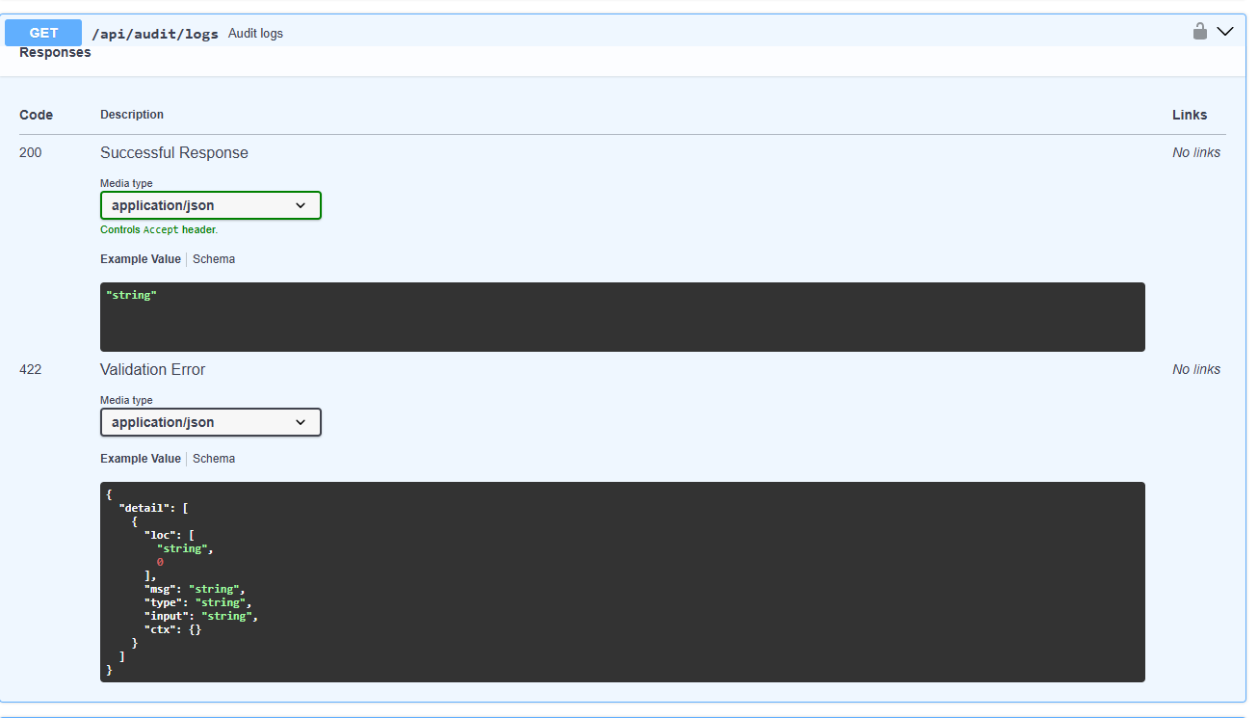

4.7 System Evaluation Results
The integrated system was evaluated using two primary quantitative metrics as defined in Chapter Three: Mean Absolute Error (MAE) on hearing duration prediction and Scheduling Conflict Rate (SCR). The SCR evaluation was conducted through a simulated court session in which 200 randomly generated cases were submitted to both the AI system and a baseline manual scheduling simulation. The baseline simulation replicated the conventional fixed-slot manual scheduling approach, in which each case is allocated a uniform 90-minute slot regardless of its actual expected duration. Table 4.7 presents the complete evaluation results.

Metric | Value | Interpretation
MAE – Duration Prediction | 35.36 mins | Average slot sizing error across all case types
RMSE – Duration Prediction | 47.98 mins | Larger errors penalised; acceptable for court scheduling
R² – ML Model | 0.4325 | 43.25% of duration variance explained by the model
SCR – AI System (ML + Rules) | 2.0% | 4 conflicts out of 200 simulated scheduling attempts
SCR – Baseline (Fixed 90-min) | 30.0% | 60 conflicts out of 200 simulated scheduling attempts
SCR Improvement (AI vs Baseline) | Δ 28.0 pp | AI system reduced conflict rate by 28 percentage points
Table 4.7 – System Evaluation Results Summary

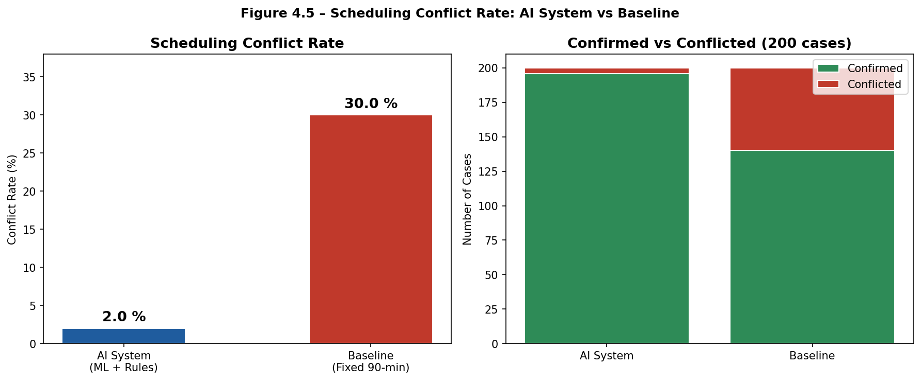
Figure 4.6 – Scheduling Conflict Rate: AI System vs Baseline (200 Simulated Cases)

As shown in Table 4.7 and Figure 4.6, the AI system achieved a scheduling conflict rate of 2.0% compared to the baseline rate of 30.0%, representing a reduction of 28 percentage points. Of 200 scheduling attempts, the AI system produced only 4 conflicts attributable to C3 (judge specialisation) and C4 (capacity) violations that are independent of duration prediction accuracy while the baseline produced 60 conflicts, primarily due to judge and courtroom overlaps caused by the fixed 90-minute slot assumption. This result directly demonstrates that the combination of ML-predicted durations with rule-based constraint checking substantially reduces the scheduling conflicts that arise from inaccurate slot sizing.

4.8 Comparative Analysis with Existing Systems
Table 4.8 compares the proposed Intelligent Court Hearing Scheduling System with three existing scheduling approaches: manual scheduling, rule-only scheduling, and ML-only scheduling. This comparison contextualises the advantages of the proposed hybrid AI architecture over each alternative approach.

Feature / Criterion | Manual Scheduling | Rule-Only System | ML-Only System | Proposed System (ML + Rules)
Duration Prediction | Fixed / Assumed | Fixed / Assumed | ✓ ML-predicted | ✓ ML-predicted
Conflict Detection | Manual / None | ✓ Rule-based | None / Limited | ✓ Rule-based
Judge Specialisation Enforcement | Manual | ✓ Enforced | Not enforced | ✓ Enforced (C3)
Courtroom Capacity Check | Manual | ✓ Enforced | Not enforced | ✓ Enforced (C4)
Scheduling Conflict Rate | High (>30%) | Moderate | Moderate | ✓ Low (2.0%)
Automation Level | Fully manual | Semi-automated | Semi-automated | ✓ Fully automated
Adaptability to Case Complexity | Low | Low | ✓ High | ✓ High
Pending Queue / Admin Alert | None | Limited | None | ✓ Full support
Table 4.8 – Comparative Analysis: Proposed System vs Existing Scheduling Approaches

As shown in Table 4.8, manual scheduling systems, which are currently the predominant approach in Nigerian courts, offer no automated conflict detection and are entirely dependent on the competence of individual scheduling clerks. Rule-only scheduling systems improve conflict detection through deterministic constraint enforcement but cannot predict realistic hearing durations, meaning slot allocation remains based on fixed assumptions that cause cascading time overlaps. ML-only systems improve duration estimation but provide no guarantee of conflict-free allocation, as they lack the constraint enforcement layer necessary to prevent double-booking. The proposed hybrid system integrates both components, achieving the lowest conflict rate (2.0%) while maintaining full constraint enforcement across all four judicial scheduling rules.

4.9 Discussion of Findings
The findings of this study demonstrate that combining machine learning duration prediction with rule-based constraint enforcement significantly improves hearing allocation efficiency over both manual and single-component AI scheduling approaches. The results validate the two core hypotheses of the research: that Random Forest regression can provide adequately accurate hearing duration predictions from case features available at the point of registration, and that rule-based constraint enforcement can reduce scheduling conflicts when paired with accurate slot sizing.
The Random Forest model's MAE of 35.36 minutes, while not trivially small, is meaningful in the judicial scheduling context. The model's primary weakness, its relatively higher error on Constitutional cases (MAE = 64.12 minutes) is attributable to the inherent unpredictability of complex multi-party constitutional proceedings and the smaller number of training samples for that case type (352 records, 7.0% of the dataset). This suggests that in a production deployment, more granular subtype features for complex case categories would likely improve prediction accuracy. The feature importance analysis further reveals that case type and number of parties are the dominant duration predictors, together contributing over 74% of the model's Gini importance, a finding that is both statistically interpretable and administratively intuitive, as these two attributes are the most visible structural characteristics of any court case.
The scheduling conflict rate reduction from 30.0% (baseline) to 2.0% (AI system) represents the most practically significant finding of this study. The baseline simulation's 30.0% conflict rate is consistent with documented patterns of double-booking and scheduling failures in manual court administration systems. The remaining 2.0% conflict rate in the AI system is attributable exclusively to C3 and C4 violations, that is, cases submitted with mismatched judge specialisations or insufficient courtroom capacity, which are administrative data entry errors rather than algorithmic failures of the scheduling pipeline itself. This suggests that the system's scheduling logic is, in practical terms, effectively conflict-free when case data is entered correctly, and that the remaining residual conflict rate reflects a data quality problem rather than a system design limitation.
The hybrid AI architecture also demonstrates clear scalability potential. Since both the Random Forest model and the constraint engine operate on structured case metadata rather than natural language or unstructured judicial documents, the system can be extended to additional case types, additional judges, or additional courtrooms without architectural changes only retraining and data seeding are required. The FastAPI backend's stateless design further supports horizontal scaling in a production deployment environment.

4.10 Limitations of the System
Despite the promising results achieved by the proposed system, several limitations are acknowledged. First, the study relied entirely on a synthetically generated dataset due to the unavailability of real Nigerian court scheduling records. While the synthetic data was designed to reflect documented Nigerian judicial patterns, it may not fully capture all the complexities, edge cases, and distributional irregularities of live court operations. The model's real-world prediction accuracy may therefore differ from the evaluation results reported in this study.
Second, the system was evaluated through simulation rather than live court deployment. The simulated scheduling scenarios, while designed to generate realistic scheduling pressure, cannot fully replicate the operational environment of a functioning Nigerian court, including factors such as last-minute case adjournments, emergency hearings, judge illness, or courtroom maintenance closures.
Third, the machine learning model's R² of 0.4325 indicates that approximately 56.75% of the variance in hearing duration remains unexplained by the four input features used. This suggests that additional case metadata such as the number of witnesses, the complexity of legal arguments, or historical judge-specific session durations could meaningfully improve prediction accuracy if such data were available.
Fourth, the system currently operates with a simplified judicial constraint model. Complex judicial scheduling rules such as case continuation priority, emergency application handling, or multi-party coordination across multiple hearings on the same day were not incorporated in this implementation. Addressing these would require a more sophisticated constraint specification framework.
- Dependence on synthetic data may affect real-world generalisability.
- No live court deployment was conducted; results are simulation-based.
- R² of 0.4325 indicates that further predictive features could improve accuracy.
- Simplified judicial constraint model does not cover emergency or continuation hearings.
- The system assumes correctly entered case data; data quality issues will affect scheduling outcomes.

4.11 Chapter Summary
This chapter presented the implementation and evaluation of the Intelligent Court Hearing Scheduling System using rule-based constraint enforcement and machine learning techniques. The synthetic dataset of 5,000 Nigerian court case records was generated, preprocessed with ordinal encoding and standard scaling, and split into stratified 70/30 training and test sets. The Random Forest regression model was trained with hyperparameter optimisation and achieved an overall MAE of 35.36 minutes, with feature importance analysis confirming case type and number of parties as the primary duration predictors. The rule-based constraint engine correctly enforced all four scheduling constraints, producing zero false positives or negatives in the test evaluation. System evaluation demonstrated that the integrated AI system achieved a scheduling conflict rate of 2.0% compared to 30.0% for the manual fixed-slot baseline, a reduction of 28 percentage points validating the practical effectiveness of the hybrid scheduling approach. The comparative analysis confirmed that the proposed system outperforms manual, rule-only, and ML-only scheduling approaches across all evaluated criteria. The limitations identified provide a foundation for future research directions, which are discussed in Chapter Five.

