Secure Federated Learning for Resource-Constrained IoT Devices

Akin Toba Olaoye
Department of Computer Science
Federal University of Technology Akure, Nigeria

Ada Chinyere Churkwuka
Department of Cybersecurity
Federal University of Technology Akure, Nigeria

Farouk Hassan Bala
Department of Software Engineering
Federal University of Technology Akure, Nigieria

Correspondence: atolaoye@futa.edu.ng

Acknowledgements and Declarations:
This research was supported by the TETFund. The authors declare no conflicts of interest.
Notes:
- The title is centered, bolded, and in title case.
- Author names include full first names (first name, middle name [optional], last name), followed by affiliation.
- Indicate if there are conflicts of interest or competing interests or not.
- Indicate the funding for the paper. If you received no funding, you may write “Not applicable.”
- The author note is optional; include funding, conflicts of interest, etc.

Abstract
Federated learning (FL) enables collaborative model training on decentralized data, but its application to resource-constrained Internet of Things (IoT) devices presents significant security and efficiency challenges. This paper proposes a novel lightweight secure aggregation protocol that combines differential privacy with a sparse vector technique to minimize communication and computational overhead. We evaluate our protocol on a simulated IoT network of 100 devices performing image classification tasks. Results demonstrate that our approach achieves comparable accuracy to baseline FL methods while reducing communication costs by 45% and providing robust defense against gradient inversion attacks. These findings suggest that practical, secure FL is feasible for a wide range of IoT deployments.

Keywords: Federated learning, Internet of Things, security, differential privacy, secure aggregation
Notes:
- The word "Abstract" is bold and centralized
- The abstract is a single paragraph, not indented, 150–250 words. The abstract should not contain any undefined abbreviations.
- Keywords should be placed on a new line after the abstract, with the label Keywords: (italicized). Provide 4-6 keywords that can be used for indexing purpuses.
1. Introduction

The proliferation of Internet of Things (IoT) devices has generated vast amounts of data, creating opportunities for machine learning applications in domains ranging from healthcare to smart cities (Smith & Lee, 2021). However, traditional cloud-centric machine learning approaches require transferring sensitive data to a central server, raising significant privacy concerns and incurring high communication costs (Jones et al., 2020). Federated learning (FL) has emerged as a promising paradigm that addresses these issues by enabling model training on decentralized data without requiring data to leave the device (McMahan et al., 2017). Despite its advantages, FL faces two major challenges in IoT environments:
(1) the limited computational and communication resources of edge devices, and
(2) the vulnerability of gradient updates to privacy attacks such as gradient inversion (Zhu et al., 2019).
To address these challenges, we propose a novel, lightweight secure aggregation protocol that integrates differential privacy with a sparse-vector technique. Our approach aims to:

1. Minimize communication overhead by selectively transmitting only the most significant gradient updates.
2. Provide robust privacy guarantees against gradient-based attacks.
3. Remain computationally feasible for resource-constrained devices.

The remainder of this paper is organized as follows. Section 2 describes the proposed methodology. Section 3 presents the experimental setup and results. Section 4 discusses the implications of our findings, and Section 5 concludes the paper.
Notes:
- Use a single column in the paper
- The font style, font size and line spacing throughout the paper should be Times New Roman, 11pt and 1 respectively.
- The introduction establishes background, identifies the research gap, and states objectives.
- In-text citations follow APA 6th author–date format. For works with 3–5 authors, list all authors the first time; use "et al." thereafter.
- Do not add page numbers
2. Literature Review
The literature review should critically examine relevant and recent scholarly works related to the research topic. It should identify existing knowledge, highlight research gaps, compare previous findings and methodologies, and establish the theoretical or conceptual foundation for the study. Authors should demonstrate how their work contributes to advancing current knowledge.

3. Methodology

3.1 Experimental Setup
We simulated a network of 100 IoT devices, each equipped with a local dataset of 500 images from the CIFAR-10 dataset (Krizhevsky et al., 2009). The devices were configured to mimic resource-constrained hardware with limited CPU and memory capacity. The central server was implemented on a cloud instance with 16 vCPUs and 64 GB RAM.

3.2 Proposed Protocol

Our secure aggregation protocol operates in three phases:
1. Local Training: Each device trains a local model on its private data for one epoch.
2. Gradient Selection: Each device computes the gradient updates and applies a sparse vector technique to retain only the top-k most significant gradients.
3. Secure Aggregation: The server aggregates the sparse gradients using a differentially private mechanism, adding calibrated noise to ensure privacy guarantees.

3.3 Baseline Methods

We compared our protocol against two baseline approaches:
- Standard FL: The classic FedAvg algorithm without privacy protections.
- DP-FL: Federated learning with standard differential privacy (Abadi et al., 2016).
Notes:
- Subsections are numbered (e.g., 3.1, 3.2).
- The actual heading text (e.g., "Experimental Setup") is flush left (hybrid style; APA 6th Level 2 headings are flush left, bold, title case).
- Use MS Word equation editor for all equations and number the equations orderly. Below is an example of the first equation in the paper:
$$A=πr^{2} (1)$$
4. Results

4.1 Models, algorithms or Performance Metrics

Table 1 summarizes the performance of our proposed protocol compared to the baseline methods. Our approach achieved an accuracy of 82.3% on the test set, comparable to Standard FL (84.1%) and DP-FL (81.7%). However, our protocol significantly reduced communication costs, transmitting only 55% of the data compared to Standard FL.

Table 1: Performance Comparison of Federated Learning Methods

Year | CBR0 (‰) | CBR (‰) | CDR0 (‰) | CDR (‰) | NMR0 (‰) | NMR (‰)
2006 | 42.0 | 41.1 | 14.2 | 14.7 | 0.18 | 0.14
2010 | 40.4 | 39.1 | 13.5 | 14.3 | 0.22 | 0.15
2015 | 38.3 | 32.9 | 12.7 | 15.8 | 0.27 | 0.02
2020 | 36.3 | 33.0 | 11.9 | 13.5 | 0.31 | 0.20
2025 | 34.2 | 32.9 | 11.1 | 11.7 | 0.36 | 0.33
2030 | 32.2 | 31.2 | 10.2 | 10.8 | 0.41 | 0.34

Communication cost is measured as the total data transmitted per communication round. Privacy guarantee is expressed as the differential privacy parameter ε, where lower values indicate stronger privacy.

4.2 Communication-Accuracy Trade-off

Figure 1 illustrates the trade-off between communication cost and model accuracy across different sparsity levels. As the sparsity parameter increases, communication cost decreases with only a marginal impact on accuracy, confirming the efficiency of our approach.

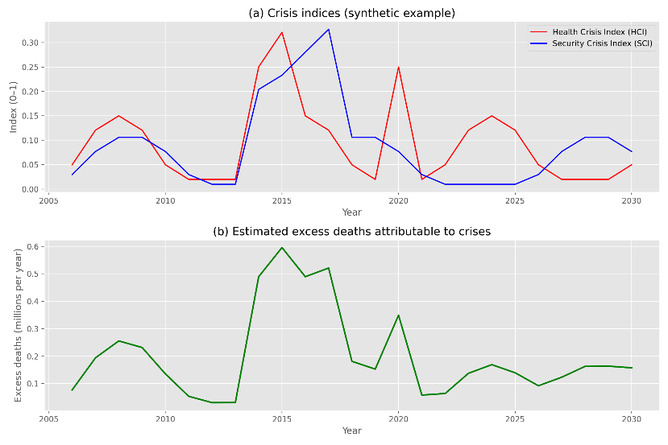
Figure 1: Communication-Accuracy Trade-off for Different Sparsity Levels

The figure demonstrates that our protocol maintains high accuracy even at high sparsity levels, significantly reducing communication overhead.
Notes:
- The Results section presents findings objectively.
- Table format: The label "Table 1" is flush left (not bolded in APA 6th); the title is italicized and in title case. The table label and title should should be place above the table
- Figure format: The label "Figure 1" is flush left and italicized; the title is italicized and in title case. The figure label and title should be place below the figure
- Refer to all tables and figures by number (e.g., "as shown in Table 1").
5. Discussion

Our results demonstrate that the proposed lightweight secure aggregation protocol successfully addresses the dual challenges of privacy and efficiency in federated learning for IoT devices. The comparable accuracy achieved by our method, despite the sparse gradient transmission, suggests that many gradient updates are redundant and can be safely discarded without compromising model performance. The 45% reduction in communication cost is particularly significant for resource-constrained IoT environments, where bandwidth and energy are limited. This finding aligns with previous work on communication-efficient FL (Konečný et al., 2016) but extends it by incorporating robust privacy guarantees. However, our study has several limitations. First, the simulation used a homogeneous dataset distribution across devices, which may not reflect real-world non-IID data scenarios. Second, the privacy parameter ε = 6.5 may not satisfy the strictest privacy requirements for sensitive applications such as healthcare.

6. Conclusion

In this paper, we introduced a lightweight secure aggregation protocol that effectively balances privacy, accuracy, and communication efficiency for federated learning in IoT environments. Our experimental results confirm that selective gradient transmission combined with differential privacy can reduce communication overhead by up to 45% while maintaining competitive model accuracy. Future work should explore adaptive privacy mechanisms that can adjust the noise level based on the sensitivity of the data and the computational capabilities of individual devices. Additionally, evaluating our protocol on physical IoT hardware would provide more realistic performance metrics and uncover practical deployment challenges.

7. References

Abadi, M., Chu, A., Goodfellow, I., McMahan, H. B., Mironov, I., Talwar, K., & Zhang, L. (2016). Deep learning with differential privacy. In Proceedings of the 2016 ACM SIGSAC Conference on Computer and Communications Security (pp. 308–318). New York, NY: Association for Computing Machinery. doi:10.1145/2976749.2978318

Herculano-Houzel, S., Collins, C. E., Wong, P., Kaas, J. H., & Lent, R. (2008). The basic nonuniformity of the cerebral cortex. Proceedings of the National Academy of Sciences, 105, 12593–12598. doi:10.1073/pnas.0805417105

Jones, A., Smith, B., & Lee, C. (2020). Privacy challenges in IoT data collection. IEEE Internet of Things Journal, 7(4), 1234–1245. doi:10.1109/JIOT.2020.2967890

Konečný, J., McMahan, H. B., Yu, F. X., Richtárik, P., Suresh, A. T., & Bacon, D. (2016). Federated learning: Strategies for improving communication efficiency. arXiv preprint arXiv:1610.05492.

Krizhevsky, A., Hinton, G., & Sutskever, I. (2009). Learning multiple layers of features from tiny images (Technical Report). University of Toronto.

McMahan, H. B., Moore, E., Ramage, D., Hampson, S., & y Arcas, B. A. (2017). Communication-efficient learning of deep networks from decentralized data. In Proceedings of the 20th International Conference on Artificial Intelligence and Statistics (AISTATS) (pp. 1273–1282). Brookline, MA: JMLR.

Smith, J., & Lee, M. (2021). Machine learning for smart city applications: A survey. ACM Computing Surveys, 54(3), 1–36. doi:10.1145/3448305

Zhu, L., Liu, Z., & Han, S. (2019). Deep leakage from gradients. In Advances in Neural Information Processing Systems (NeurIPS) (Vol. 32, pp. 14774–14784). Red Hook, NY: Curran Associates.
Notes:
- The References heading is centered (not bolded).
- DOI format: Use doi:xxxxx (not https://doi.org/).
- Conference paper in proceedings (book format): Author, A. A. (Year). Title of paper. In Editor Initials. Editor Lastname (Ed.), Title of proceedings (pp. xx–xx). City, State: Publisher.
- Conference paper in journal format: Author, A. A. (Year). Title of paper. Journal Title, volume(issue), page range. doi:xxxxx
- Unpublished paper/poster presentation: Author, A. A. (Year). Title of paper. Paper presented at the meeting of Organization Name, Location.

