Structural Optimization 2025

Project #1 Report

**Student: Alexandru Olareanu**

**ID Number: 21-953-294**

For visualization + cool graphs (with convergence) please run each main.mat for each Task.

* Task 1:

Objective function at x0 = -200, -200 : f(x) = 1.077170620659947e+03

* Task 2:

x_optimal: 1.10550e+02, 1.43699e+02; f_optimal: 8.37526e+02 (11 iterations)

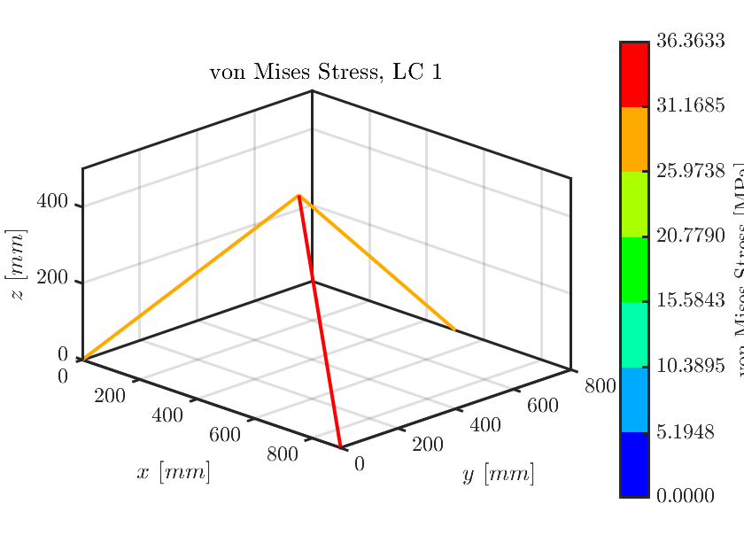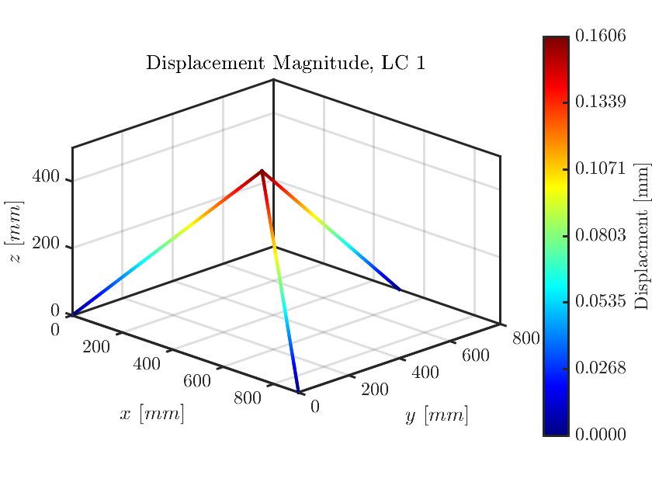

* Task 3:

Gradient at x0 = [200, 100]: 6.97902e-02 1.09867e-02

* Task 4:

x_optimal: 1.10550e+02 1.43699e+02; f_optimal: 8.37526e+02 (16 iterations)

* Task Bonus:

x_optimal: 1.10550e+02 1.43699e+02; f_optimal: 8.37526e+02 (8 iterations)

And a nice Convergence history plot from the Bonus Task below. Note that most tasks have plots like this.

