Structural Optimization 2025

Project #3 Report

**Student: Olareanu Alexandru**

**ID Number: 21-953-294**

**Task 1:**

Number of nodes: 27, Number of bars: 62, Total bar volume: 3.2056

**Task 2:**

Displacement at loaded node: 0.1

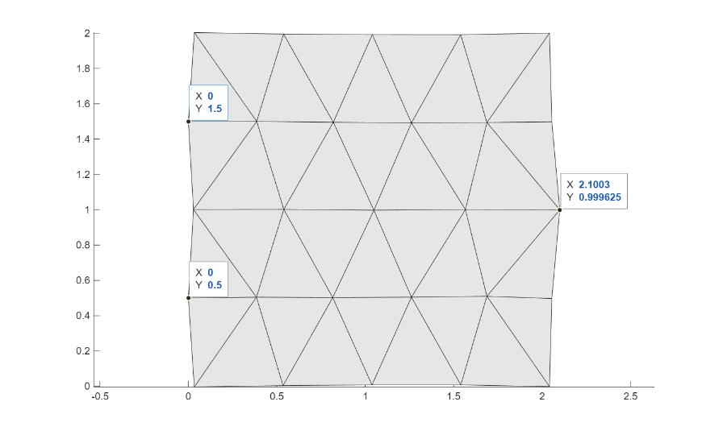

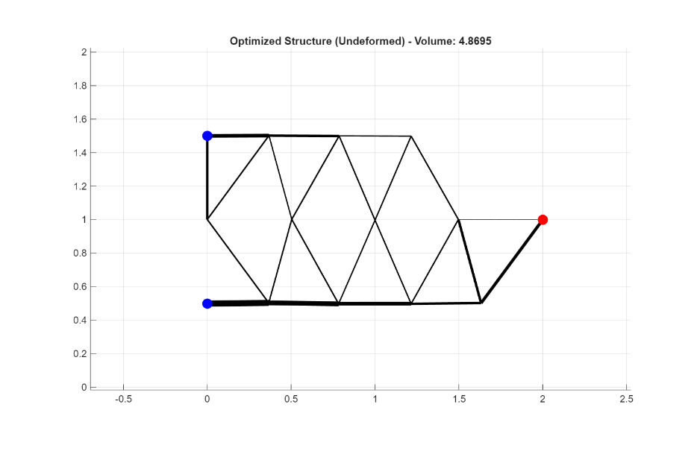**Task 3:**

Fmincon optimised minimum volume: 4.869527 (Fully Stressed Design used for cross-validation)

**Task 4:**

Best solution: h0=0.691139, yf=0.996184; Best Objective function value (min Volume): 8.452985

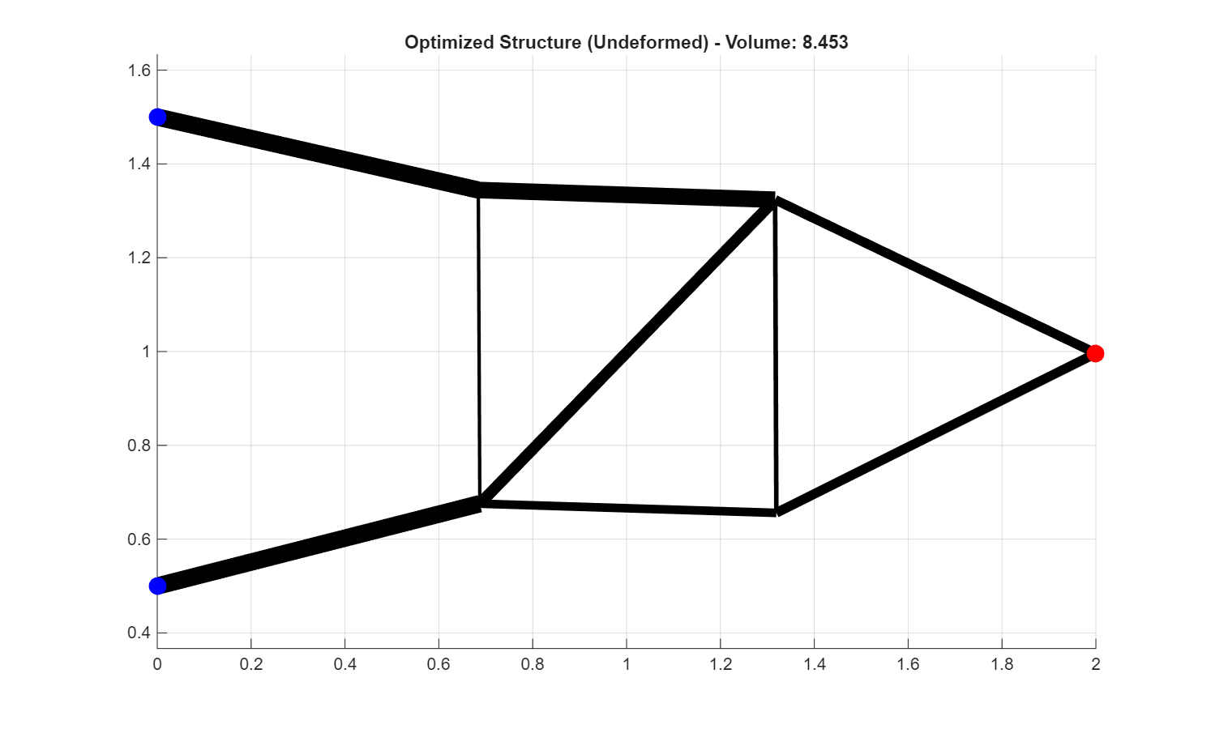

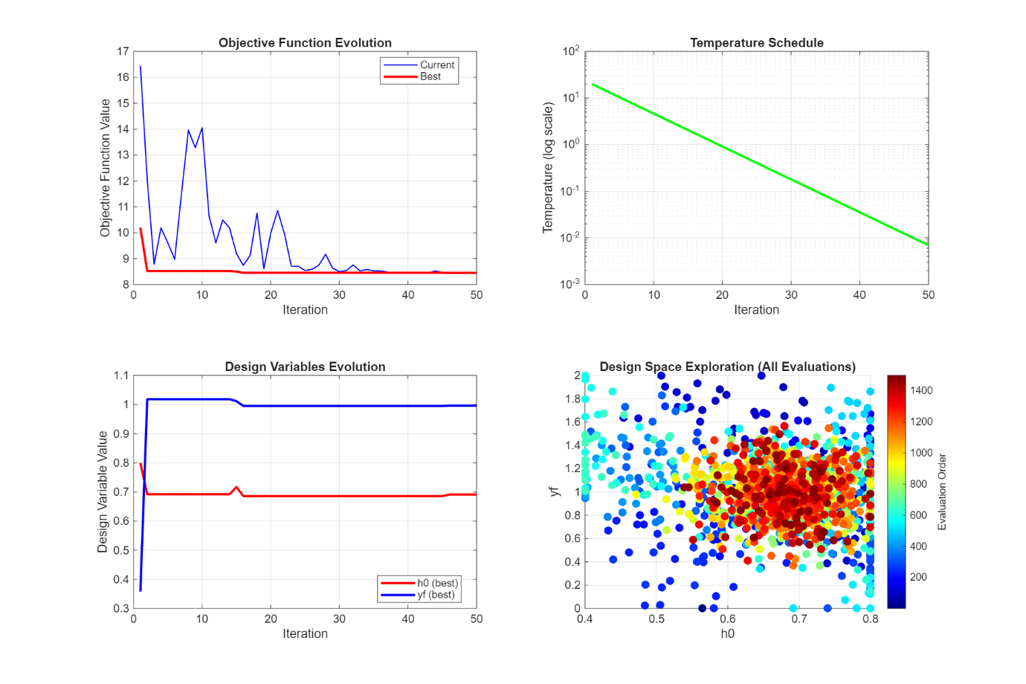

(Plots from an optimisation run with 0.4 as a lower h0 bound, as when using 0.2, it takes hours to solve. Still had 30 min solve time with 04 as lower bound. Final best solution was found using 0.2 as bounds, as per the assignment.)

See Bonus Task folder for Bonus Task