**Proposed Azure Deployment Architecture for GenAI-Powered Data/AI Governance Compliance System**

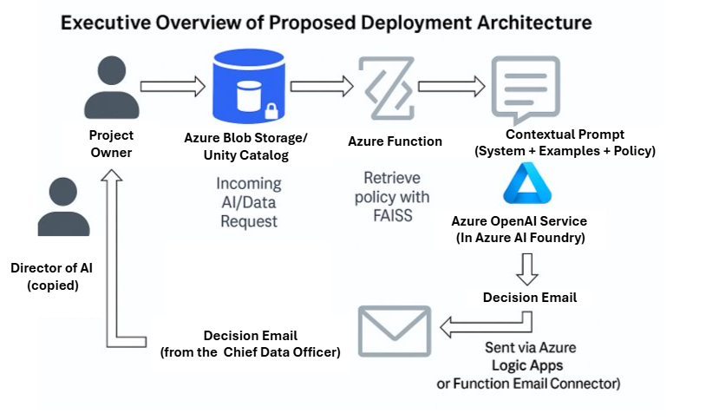

**🔷 1. Data & Model Assets**

* **Azure Blob Storage**
  + Stores uploaded **AI Project Requests (JSON/.txt)**
  + Stores **AI/Data Governance Policy Document (PDF)**
  + Stores **Decision Emails (txt/pdf)**
* **Azure Cosmos DB / Azure SQL DB**
  + Structured storage for logged project evaluations, compliance metadata, versioned policy documents

**🔷 2. Preprocessing Layer (Text Chunking + Embedding)**

* **Azure Functions (Serverless)**
  + Automatically chunks and embeds policy PDFs when updated
  + Saves FAISS vector index in Blob Storage or Azure Files
* **Azure Container Apps (Optional)**
  + Hosts the FAISS vector search service behind a secure API

**🔷 3. Backend Processing & Compliance Engine**

* **Azure Machine Learning Workspace**
  + Hosts notebook or scheduled compute jobs for:
    - Loading requests
    - Calling OpenAI API (via Azure OpenAI or external endpoint)
    - Constructing prompts (system + few-shot + user context)
    - Evaluating compliance
* **Azure OpenAI Service**
  + Hosts the **GPT-4 model** in a secure, Azure-native way
  + Enables compliant, auditable, low-latency GenAI inference

**🔷 4. Frontend / User Interface**

* **PowerApps / Azure Static Web Apps**
  + Lightweight request submission portal for Project Owners
  + Optional dashboard for the CDO, Director of AI, etc.

**🔷 5. Identity & Security**

* **Azure Active Directory (AAD)**
  + Secures user access to frontend, API, and ML assets
  + Tracks ownership and history of each project request
* **Azure Key Vault**
  + Stores secrets such as OPENAI_API_KEY and connection strings
  + Referenced by both notebooks and Azure Functions securely

**🔷 6. Orchestration + Monitoring**

* **Azure Logic Apps / Data Factory**
  + Orchestrates:
    - New request submission
    - FAISS search
    - Prompt creation
    - LLM inference
    - Email delivery
* **Azure Monitor & App Insights**
  + Track latency, success/failure, and usage metrics
  + Useful for auditing PHI-safe AI evaluations

**🔁 Workflow Recap**

1. **Project Owner submits request** → stored in **Blob Storage**
2. **Azure Function** triggers FAISS search on policy index
3. **Prompt constructed** with system + example + request context
4. **GPT-4 evaluates policy compliance**
5. **Decision email generated** → saved + optionally sent via **Logic Apps**
6. **CDO/AI Director dashboard** reflects decision and logs