4.
.MODEL MEDIUM
.STACK 100H
.DATA

X DB 100 dup (?)
Y DB100 dup (?)

.CODE
.STARTUP
MAIN PROC FAR

MOV CX, 100
LEA SI, X
LEA DI, Y
START:
MOV AL, [SI]
CMP AL, 0
JG L1
TEST AL, 80H
JZ L1
NEG AL
L1:
MOV [DI], AL
INC SI
INC DI
LOOP START

.EXIT

MAIN ENDP
END

5.
.MODEL MEDIUM
.STACK 100H
.DATA
k dw ?
p dw 500 dup (?)
.code
;to do
.STARTUP

MAIN PROC FAR
mov k, 0
mov cx, 500
mov si, 0
start: mov ax, k
cmp k, 300
jg minus

plus:
add p[si], ax
jmp next

minus:
sub p[si], ax

next:
inc k ; k++
inc si
inc si
loop start

.EXIT
MAIN ENDP
END
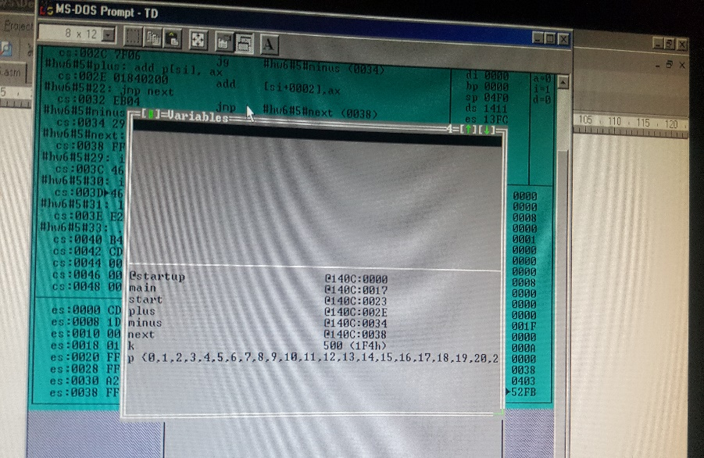

7.

.MODEL MEDIUM
.STACK 100H
.DATA
MYARRAY DW -45, 1000, -34, 1500, 20, 60
COUNT EQU 6 ; SIX ELEMENTS IN THE ARRAY
RESULT DW 0
.CODE
.STARTUP
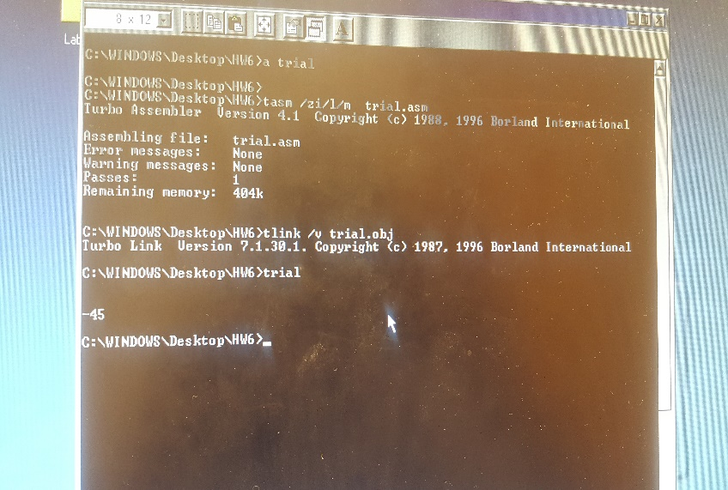
MAIN PROC FAR
MOV AX,@DATA
MOV DS,AX
MOV CX, COUNT
LEA SI, MYARRAY
CALL FINDMIN
;to do
NEG RESULT
MOV RESULT, ax
.EXIT
MAIN ENDP
FINDMIN PROC NEAR
MOV AX, [SI]
DEC CX
BEGIN: INC SI
INC SI
CMP AX, [SI]
JL L1
MOV AX, [SI]
L1: LOOP BEGIN
RET
FINDMIN ENDP
END

