Introduction
Antimicrobial resistance (ARM) in the 21st century is still among one of the most noteworthy threats to global threats. It is notable for its extensive effects on healthcare systems, clinical outcomes and global economies. According to previous estimates, AMR is responsible for about 700,000 deaths worldwide (Review on Antimicrobial Resistance, 2014). However, recent studies according to estimates from the World Health Organization (WHO), bacterial (AMR) causes around five million deaths a year, of which 1.27 million are directly linked to resistant illnesses (Murray et al., 2022; WHO, 2022). AMR also presents significant financial challenges, such as increased healthcare expenses brought on by lengthier hospital stays and more costly treatments (Dadgostar, 2019). Two different estimations of the economic impact of AMR in Europe show that it costs more than €9 billion a year, according to one survey (Llor & Bjerrum, 2014; Prestinaci et al., 2015), however, the WHO calculates that the combined healthcare and productivity losses in the EU and European Economic Area amount to about €11.7 billion annually (World, Health Organization, 2023). Because they can quickly acquire and spread multidrug-resistant determinants through horizontal gene transfer and mobile genetic elements, gram-negative infections are especially dangerous (Jee et al., 2018; Navon-Venezia et al., 2017). Among these, carbapenem-resistant Enterobacterales (CRE) represent a significant clinical problem that jeopardizes the effectiveness of carbapenems, which are frequently thought of as the last line of treatment for serious bacterial infections (Logan & Weinstein, 2017). The demand for quicker, more precise, and genomics-driven diagnostic methods has increased due to the rapid increase in CRE cases worldwide (Robert F Potter, et al., 2016).
Klebsiella pneumoniae (K. pneumoniae), which causes a variety of diseases such as pneumonia, bloodstream infections, urinary tract infections, and newborn sepsis, is the most clinically relevant species in this group (Podschun & Ullmann, 1998; Martin & Bachman, 2018). The remarkable capacity of K. pneumoniae to acquire plasmids, incorporate external genetic material, and create hypervirulent lineages that can cause invasive illness even in healthy hosts is well known (Wyres & Holt, 2018; Lam et al., 2019). As a result, carbapenem-resistant K. pneumoniae (CRKP) has been classified as a Critical Priority 1 pathogen by the WHO and CDC, highlighting the critical need for creative countermeasures to stop its spread (World Health Organization, 2017; CDC, 2019). Clinically, CRKP infections are associated with death rates that often exceed 40–50%, particularly in hospitalized or immunocompromised groups (Tzouvelekis et al., 2012; Daikos et al., 2014). This emphasizes how crucial CRKP infections are to the treatment of modern infectious diseases.
Phenotypic prediction is difficult because carbapenem resistance in K. pneumoniae arises from a complex interplay of processes. Carbapenemase enzymes, particularly those from the KPC, NDM, VIM, and OXA-48-like families, are the main contributors (Nordmann et al., 2012; Dortet et al., 2014). However, extended-spectrum β-lactamases (ESBLs) in conjunction with porin mutations (such as OmpK35 and OmpK36 disruptions), efflux pump overexpression, and modifications in membrane permeability can also result in resistance (Wong et al., 2019; Li et al., 2018). These many processes can differ among strains, lineages, and geographical areas and frequently take place concurrently. The ensuing polygenic character of carbapenem resistance restricts the efficacy of existing gene-based detection approaches and complicates clinical decision-making.
Traditional diagnostic procedures rely mostly on phenotypic antimicrobial susceptibility testing (AST), which, although crucial, generally needs 24–72 hours for culture, growth, and interpretation. This time delay can be significant in severe illnesses requiring rapid treatment selection (Peker et al., 2019, Wenzler et al., 2023). Furthermore, isolates with dual resistance mechanisms or borderline carbapenem MIC values may produce unclear results from phenotypic assays (Jung et al., 2019). Although molecular diagnostics like PCR and lateral flow immunoassays have reduced detection times, they are still only able to identify known carbapenemase genes; they are unable to identify novel variations, regulatory alterations, or non-carbapenemase resistance mechanisms (Osei Sekyere, 2019; Dortet et al., 2017). These constraints underscore the urgent need for more thorough, scalable diagnostic instruments that can identify both established and novel genetic determinants as resistance continues to change quickly.
Whole-genome sequencing (WGS) has become the gold standard for bacterial genomic investigation in recent years (Parcell et al, 2021). Within a single procedure, WGS allows the simultaneous detection of resistance genes, virulence factors, plasmid replicons, mutations, sequence types, and genome structural variation (Ruppé et al., 2020; Didelot et al., 2012). Unmatched insights into pathogen evolution, transmission, and outbreak dynamics are provided by its great resolution (David et al., 2019). WGS is now more widely available for routine investigation and clinical research because to its increased speed and affordability (Ellington et al., 2017). However, WGS produces massive datasets, and sophisticated computational techniques that can integrate tens of thousands of genetic characteristics are needed to extract therapeutically useful information (Brlek et al., 2024).
Macesic and associates used machine-learning techniques to analyze whole-genome data from a sizable, clinically significant K clone (CG258). pneumoniae to forecast polymyxin resistance phenotype (Macesic et al., 2020). They trained tree-based models using a combination of gene content, SNPs, and other genome-derived features. The study showed that machine learning (ML) can identify polygenic signals linked to resistance, but it also highlighted issues with clonal population structure and limited generalizability outside of the training lineage. This work emphasizes the need for greater strain diversity and model interpretability, but it is also significant as a proof-of-concept that machine learning may identify intricate resistance pathways beyond single genes.
Nguyen et al. created eMIC-AntiKP, a framework that predicts Minimum Inhibitory Concentrations (MICs) for several antibiotics in K. pneumoniae using convolutional neural networks and k-mer based representations (Nguyen et al., 2022). Their method demonstrated that k-mer deep models may catch minor signals throughout the genome by using thousands of genomes to predict MIC values or MIC-adjacent "tiers" for a panel of antibiotics. Large sample sizes and MIC-level prediction (rather than just binary R/S) are strengths; interpretability (k-mers are difficult to link to biological pathways) and susceptibility to population structure are drawbacks.
Tan et al. used XGBoost and neural nets to compare SNP characteristics and k-mer counts for meropenem MIC prediction in K. pneumoniae (Tan et al., 2021). They showed that combining SNP-level data with k-mer characteristics increased carbapenem prediction accuracy, but they also noted that generalizability was hampered by small sample sizes and inconsistent MIC testing across datasets. When predicting MIC or resistance from genomes, their work emphasizes the significance of meticulous phenotypic curation and harmonization.
This study examined the best ways to model MICs and binary resistance from large Klebsiella collections (thousands of genomes) and highlighted crucial methodological decisions, such as managing MIC censoring, accounting for population structure, and favoring interpretable models when clinical actionability is necessary (Biffignandi et al., 2024). Their benchmarking revealed that population diversity and phenotype encoding have a significant impact on model performance. To prevent overly optimistic estimations, they suggested layered validation and external test sets. This work serves as a methodological benchmark for research projects that seek to provide clinically reliable predictors.
Condorelli et al. presented a pipeline that predicts AMR phenotypes in K. pneumoniae by combining genome composition and gene content features (Condorelli et al., 2024). The authors reported decent accuracies for a number of antibiotic classes using feature selection with Random Forests and cross-validation; nonetheless, they pointed up limits due to dataset variability and the necessity for more explicit inclusion of plasmid and mobile element context. Although this study is noteworthy for packing an end-to-end analysis, a completely automated, containerized approach with explicit explainability outputs is still lacking.
In order to model CRKP risk and outcomes, Lapp and colleagues combined pathogen genetic characteristics with patient clinical data (Lapp et al., 2021). Their analysis demonstrates that integrating host and microbial data enhances clinical outcome prediction and implies ML models can be useful for both clinical risk assessment and binary resistance decisions. The main takeaway is that while multi-modal data might help with phenotypic prediction, many genome-only machine learning research leave out patient metadata that could increase clinical relevance.
Predicting carbapenem-resistant infections from clinical and microbiological data using tree-based techniques is the topic of several clinical machine learning applications (Alparslan et al., 2021; related clinical ML studies). These underline the practical limitations of data quality, missingness, and interpretability that face real-world implementation while highlighting the therapeutic viability of ML prediction. These findings highlight the translational gap between prediction models and clinical decision assistance, even though they are not WGS-only.
In conclusion, recent studies have demonstrated that machine learning can accurately predict complex resistance phenotypes from genomic data; however, significant practical challenges still exist, particularly with regard to interpretability, phenotype harmonization, reproducibility, and generalizability. By combining comprehensive genomic feature capture, stringent QC and coverage checks, repeatable execution, and interpretable ML with SHAP explanation, our end-to-end, containerized Snakemake process directly tackles these problems. As a result, our research closes specific technical and translational gaps documented in the literature and offers a clear route toward WGS-based resistance prediction that is therapeutically helpful.
Methods
Implementation

In order to guarantee a completely repeatable, scalable, and transparent examination of whole-genome sequencing (WGS) data for the prediction of carbapenem resistance in Klebsiella pneumoniae, the methodological framework for this study was created. Snakemake (Köster & Rahmann, 2012) was used to coordinate all computational processes, allowing for smooth parallelization across compute environments, tight dependency monitoring, and automated workflow management. According to Budiš et al. (2023), Snakemake enables the pipeline to be represented as a collection of modular "rules" connected by a directed acyclic graph (DAG). Each rule represents a computing step with specified inputs, outputs, resources, and dependencies. To maintain lightweight and portable execution, the entire workflow uses conda for software version control, avoiding Docker due to large image sizes and long build times. Figure 1 presents the overall architecture of the pipeline, beginning with automated data retrieval, followed by quality control, genome assembly, annotation, resistome profiling, phenotype curation, and machine-learning-ready dataset preparation.

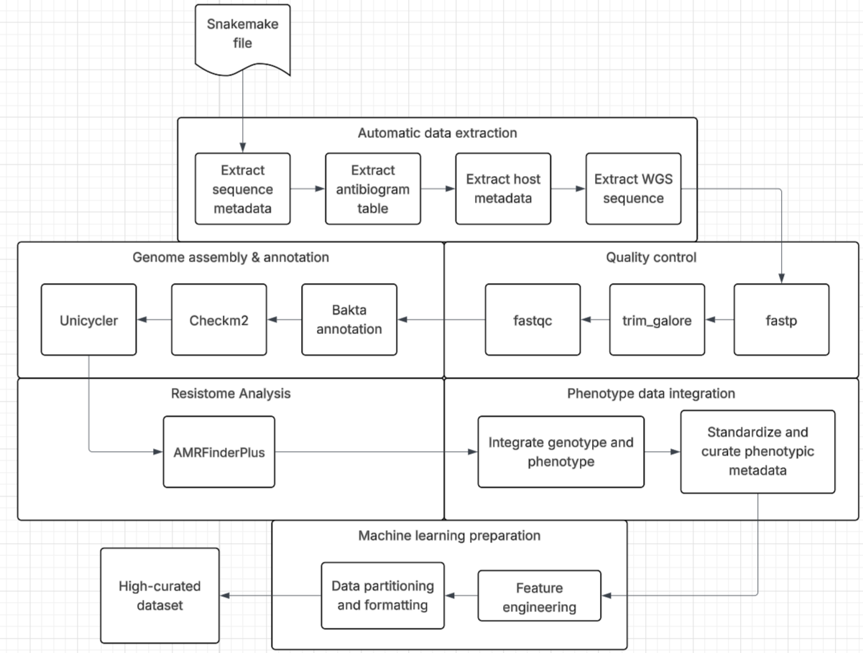
Figure 1. Work flow for curating WGS data

Data Acquisition and Metadata Curation
Raw sequencing reads and associated metadata were retrieved from the NCBI Sequence Read Archive (SRA) using the SRA Toolkit (Leinonen et al., 2011). Metadata tables were automatically parsed to extract relevant attributes, including BioSample identifiers, isolation source, collection location, sequencing platform, and antimicrobial susceptibility phenotypes when available. All metadata fields underwent normalization and consistency checks to reduce redundancy and resolve formatting inconsistencies, following established best practices in bacterial genomics metadata curation (Kodama et al., 2012; Federhen, 2015). These curated metadata were incorporated directly into the Snakemake workflow, ensuring complete traceability of each isolate throughout downstream analyses (Figure 2). As illustrated in Figure 2, the workflow employed a structured and fully automated filtering strategy to ensure that only biologically relevant and analytically compatible Klebsiella pneumoniae isolates were selected. Each candidate BioSample retrieved from SRA was first examined to verify its organism annotation. Only records corresponding to K. pneumoniae were retained. For these verified entries, the workflow next assessed the availability of antimicrobial susceptibility testing (AST) data, an essential requirement for linking genomic variation with phenotypic resistance profiles. Samples lacking AST information were excluded from consideration. Following phenotype verification, the sequencing metadata for each candidate isolate were examined to ensure that complete paired-end whole-genome sequencing reads were available. Because paired-end libraries are critical for accurate genome assembly and structural reconstruction, isolates associated with single-end or incomplete read sets were removed from the eligible pool.This filtering logic was applied iteratively across the SRA metadata registry until a predefined sample threshold was achieved—representing the minimum number of isolates meeting all three criteria: correct organism identity, available AST phenotypes, and paired-end WGS data. Only once this threshold was met did the workflow initiate the download of raw sequencing reads for the selected isolates. At this stage, the corresponding sample-level and host-level metadata were retrieved simultaneously to maintain complete biological context and ensure reproducibility. Through this multi-stage curation framework, the pipeline produced a high-confidence, phenotypically annotated, and assembly-ready dataset optimized for downstream genome analysis and machine-learning–based resistance prediction.
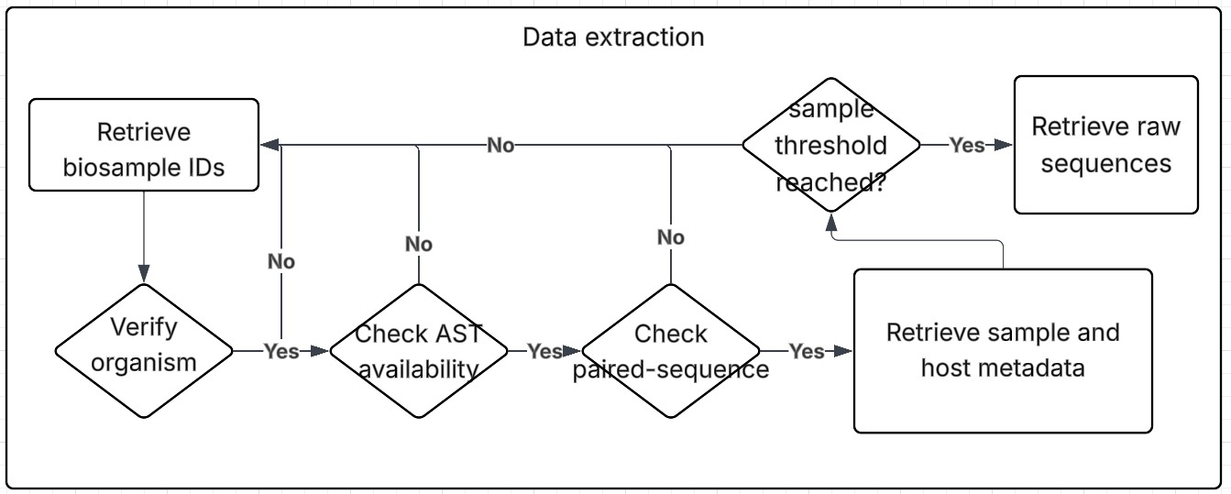
Figure 2. Automatic data retravel workflow

Quality Control and Preprocessing of Raw Reads
Sequencing reads were then subjected to an initial quality assessment using FastQC, which assesses duplication levels, adaptor contamination, GC distribution anomalies, and per-base quality scores (Andrews, 2010). This revealed systematic problems that needed to be fixed before further analysis and gave a baseline profile of raw read quality.
Fastp, an effective all-in-one tool for adapter removal, quality trimming, polyG tail correction, and low-complexity region filtering, was used for read preprocessing (Chen et al., 2018). Fastp was chosen due to its speed, integrated error-correction procedures, and automatic report production, all of which have led to its widespread use in contemporary microbial genomics workflows (Chen et al., 2018; Ewels et al., 2016).
Trim Galore, a wrapper around Cutadapt, was used to provide more severe adapter clipping in situations where extra adapter cutting was needed, especially for Illumina-specific overhang contamination (Krueger, 2015). When used in tandem, these tools improved downstream assembly and variant finding accuracy while guaranteeing the elimination of sequencing artifacts.
In accordance with suggested QC procedures for high-throughput bacterial WGS datasets, all FastQC and fastp HTML reports were automatically combined into a single multi-sample summary to preserve an open overview of data quality across all isolates (Quainoo et al., 2017).

Genome Assembly and Assembly Quality Assessment

Unicycler, a hybrid-capable genome assembler tailored for bacterial genomes, was used to assemble filtered high-quality reads from scratch (Wick et al., 2017). Unicycler uses an SPAdes-based assembly graph framework and additional bridging heuristics and conservative graph cleaning steps to reduce fragmentation artifacts common in Enterobacteriaceae assemblies, which helps it perform exceptionally well in short-read-only mode even though it was initially intended to integrate both short- and long-read data (Wick et al., 2017; Bankevich et al., 2012). This method has been frequently used in clinical and epidemiological K. pneumoniae genomics and yields more contiguous assemblies than traditional short-read assemblers.
We used CheckM2, the deep learning-enhanced replacement for CheckM, to assess genomic completeness, contamination, strain heterogeneity, and overall assembly integrity (Parks et al., 2015; Chklovski et al., 2022). CheckM2 predicts contamination and completeness on Klebsiella and other Enterobacteriaceae species with significantly higher accuracy using machine-learning models and lineage-specific marker sets. In order to ensure that only physiologically reliable genomes entered the analytical workflow, assemblies with low completeness or high contamination were rejected from downstream annotation and machine learning feature engineering.
Bakta, an effective and standardized prokaryotic genome annotation tool that offers high-quality gene predictions, antimicrobial resistance gene detection, replicon typing, and curated functional labels using its integrated PLSDB and RefSeq was used to perform functional genome annotation (Schwengers et al., 2021). Bakta was chosen because it produces consistent identifiers (such as baktags) and FAIR-compliant, repeatable annotations that enable downstream feature extraction for machine learning, such as resistome profiling, virulence factor identification, and accessory genome characterisation
.
Functional Annotation and Resistome / Virulome Profiling
Using AMRFinderPlus (Feldgarden et al., 2019), the NCBI-maintained toolkit for antimicrobial resistance (AMR) gene discovery, resistome characterisation was carried out directly on the high-quality, Bakta-annotated genome assemblies. AMRFinderPlus uses its carefully selected protein and hidden Markov model (HMM) databases to find acquired AMR genes, point mutations, and stress/virulence-associated loci. To ensure consistent detection across all isolates, each assembly was screened using default parameters. The hierarchical gene family structure of AMRFinderPlus was used to assign sequence variations, allowing for uniform naming and reducing false-positive annotations.
In order to facilitate downstream comparative genomics and phenotype-genotype interpretation, gene calls and mutation reports were processed into a structured output table that was integrated into the Snakemake workflow. For resistome profiling, only AMRFinderPlus was utilized, guaranteeing methodologic clarity and preventing database redundancy.
The resistome dataset utilized in further analyses was created using this simplified method, which produced an accurate and repeatable catalog of AMR determinants pertinent to carbapenem resistance.

