Introduction
Antimicrobial resistance (ARM) in the 21st century is still among one of the most noteworthy threats to global threats. It is notable for its extensive effects on healthcare systems, clinical outcomes and global economies. According to previous estimates, AMR is responsible for about 700,000 deaths worldwide (Review on Antimicrobial Resistance, 2014). However, recent studies according to estimates from the World Health Organization (WHO), bacterial (AMR) causes around five million deaths a year, of which 1.27 million are directly linked to resistant illnesses (Murray et al., 2022; WHO, 2022). AMR also presents significant financial challenges, such as increased healthcare expenses brought on by lengthier hospital stays and more costly treatments (Dadgostar, 2019). Two different estimations of the economic impact of AMR in Europe show that it costs more than €9 billion a year, according to one survey (Llor & Bjerrum, 2014; Prestinaci et al., 2015), however, the WHO calculates that the combined healthcare and productivity losses in the EU and European Economic Area amount to about €11.7 billion annually (World, Health Organization, 2023). Because they can quickly acquire and spread multidrug-resistant determinants through horizontal gene transfer and mobile genetic elements, gram-negative infections are especially dangerous (Jee et al., 2018; Navon-Venezia et al., 2017). Among these, carbapenem-resistant Enterobacterales (CRE) represent a significant clinical problem that jeopardizes the effectiveness of carbapenems, which are frequently thought of as the last line of treatment for serious bacterial infections (Logan & Weinstein, 2017). The demand for quicker, more precise, and genomics-driven diagnostic methods has increased due to the rapid increase in CRE cases worldwide (Robert F Potter, et al., 2016).
Klebsiella pneumoniae (K. pneumoniae), which causes a variety of diseases such as pneumonia, bloodstream infections, urinary tract infections, and newborn sepsis, is the most clinically relevant species in this group (Podschun & Ullmann, 1998; Martin & Bachman, 2018). The remarkable capacity of K. pneumoniae to acquire plasmids, incorporate external genetic material, and create hypervirulent lineages that can cause invasive illness even in healthy hosts is well known (Wyres & Holt, 2018; Lam et al., 2019). As a result, carbapenem-resistant K. pneumoniae (CRKP) has been classified as a Critical Priority 1 pathogen by the WHO and CDC, highlighting the critical need for creative countermeasures to stop its spread (World Health Organization, 2017; CDC, 2019). Clinically, CRKP infections are associated with death rates that often exceed 40–50%, particularly in hospitalized or immunocompromised groups (Tzouvelekis et al., 2012; Daikos et al., 2014). This emphasizes how crucial CRKP infections are to the treatment of modern infectious diseases.
Phenotypic prediction is difficult because carbapenem resistance in K. pneumoniae arises from a complex interplay of processes. Carbapenemase enzymes, particularly those from the KPC, NDM, VIM, and OXA-48-like families, are the main contributors (Nordmann et al., 2012; Dortet et al., 2014). However, extended-spectrum β-lactamases (ESBLs) in conjunction with porin mutations (such as OmpK35 and OmpK36 disruptions), efflux pump overexpression, and modifications in membrane permeability can also result in resistance (Wong et al., 2019; Li et al., 2018). These many processes can differ among strains, lineages, and geographical areas and frequently take place concurrently. The ensuing polygenic character of carbapenem resistance restricts the efficacy of existing gene-based detection approaches and complicates clinical decision-making.
Traditional diagnostic procedures rely mostly on phenotypic antimicrobial susceptibility testing (AST), which, although crucial, generally needs 24–72 hours for culture, growth, and interpretation. This time delay can be significant in severe illnesses requiring rapid treatment selection (Peker et al., 2019, Wenzler et al., 2023). Furthermore, isolates with dual resistance mechanisms or borderline carbapenem MIC values may produce unclear results from phenotypic assays (Jung et al., 2019). Although molecular diagnostics like PCR and lateral flow immunoassays have reduced detection times, they are still only able to identify known carbapenemase genes; they are unable to identify novel variations, regulatory alterations, or non-carbapenemase resistance mechanisms (Osei Sekyere, 2019; Dortet et al., 2017). These constraints underscore the urgent need for more thorough, scalable diagnostic instruments that can identify both established and novel genetic determinants as resistance continues to change quickly.
Whole-genome sequencing (WGS) has become the gold standard for bacterial genomic investigation in recent years (Parcell et al, 2021). Within a single procedure, WGS allows the simultaneous detection of resistance genes, virulence factors, plasmid replicons, mutations, sequence types, and genome structural variation (Ruppé et al., 2020; Didelot et al., 2012). Unmatched insights into pathogen evolution, transmission, and outbreak dynamics are provided by its great resolution (David et al., 2019). WGS is now more widely available for routine investigation and clinical research because to its increased speed and affordability (Ellington et al., 2017). However, WGS produces massive datasets, and sophisticated computational techniques that can integrate tens of thousands of genetic characteristics are needed to extract therapeutically useful information (Brlek et al., 2024).
Macesic and associates used machine-learning techniques to analyze whole-genome data from a sizable, clinically significant K clone (CG258). pneumoniae to forecast polymyxin resistance phenotype (Macesic et al., 2020). They trained tree-based models using a combination of gene content, SNPs, and other genome-derived features. The study showed that machine learning (ML) can identify polygenic signals linked to resistance, but it also highlighted issues with clonal population structure and limited generalizability outside of the training lineage. This work emphasizes the need for greater strain diversity and model interpretability, but it is also significant as a proof-of-concept that machine learning may identify intricate resistance pathways beyond single genes.
Nguyen et al. created eMIC-AntiKP, a framework that predicts Minimum Inhibitory Concentrations (MICs) for several antibiotics in K. pneumoniae using convolutional neural networks and k-mer based representations (Nguyen et al., 2022). Their method demonstrated that k-mer deep models may catch minor signals throughout the genome by using thousands of genomes to predict MIC values or MIC-adjacent "tiers" for a panel of antibiotics. Large sample sizes and MIC-level prediction (rather than just binary R/S) are strengths; interpretability (k-mers are difficult to link to biological pathways) and susceptibility to population structure are drawbacks.
Tan et al. used XGBoost and neural nets to compare SNP characteristics and k-mer counts for meropenem MIC prediction in K. pneumoniae (Tan et al., 2021). They showed that combining SNP-level data with k-mer characteristics increased carbapenem prediction accuracy, but they also noted that generalizability was hampered by small sample sizes and inconsistent MIC testing across datasets. When predicting MIC or resistance from genomes, their work emphasizes the significance of meticulous phenotypic curation and harmonization.
This study examined the best ways to model MICs and binary resistance from large Klebsiella collections (thousands of genomes) and highlighted crucial methodological decisions, such as managing MIC censoring, accounting for population structure, and favoring interpretable models when clinical actionability is necessary (Biffignandi et al., 2024). Their benchmarking revealed that population diversity and phenotype encoding have a significant impact on model performance. To prevent overly optimistic estimations, they suggested layered validation and external test sets. This work serves as a methodological benchmark for research projects that seek to provide clinically reliable predictors.
Condorelli et al. presented a pipeline that predicts AMR phenotypes in K. pneumoniae by combining genome composition and gene content features (Condorelli et al., 2024). The authors reported decent accuracies for a number of antibiotic classes using feature selection with Random Forests and cross-validation; nonetheless, they pointed up limits due to dataset variability and the necessity for more explicit inclusion of plasmid and mobile element context. Although this study is noteworthy for packing an end-to-end analysis, a completely automated, containerized approach with explicit explainability outputs is still lacking.
In order to model CRKP risk and outcomes, Lapp and colleagues combined pathogen genetic characteristics with patient clinical data (Lapp et al., 2021). Their analysis demonstrates that integrating host and microbial data enhances clinical outcome prediction and implies ML models can be useful for both clinical risk assessment and binary resistance decisions. The main takeaway is that while multi-modal data might help with phenotypic prediction, many genome-only machine learning researches leave out patient metadata that could increase clinical relevance.
Predicting carbapenem-resistant infections from clinical and microbiological data using tree-based techniques is the topic of several clinical machine learning applications (Alparslan et al., 2021; related clinical ML studies). These underline the practical limitations of data quality, missingness, and interpretability that face real-world implementation while highlighting the therapeutic viability of ML prediction. These findings highlight the translational gap between prediction models and clinical decision assistance, even though they are not WGS-only.
In conclusion, recent studies have demonstrated that machine learning can accurately predict complex resistance phenotypes from genomic data; however, significant practical challenges still exist, particularly with regard to interpretability, phenotype harmonization, reproducibility, and generalizability. By combining comprehensive genomic feature capture, stringent QC and coverage checks, repeatable execution, and interpretable ML with SHAP explanation, our end-to-end, containerized Snakemake process directly tackles these problems. As a result, our research closes specific technical and translational gaps documented in the literature and offers a clear route toward WGS-based resistance prediction that is therapeutically helpful.
Methods
Implementation

In order to guarantee a completely repeatable, scalable, and transparent examination of whole-genome sequencing (WGS) data for the prediction of carbapenem resistance in Klebsiella pneumoniae, the methodological framework for this study was created. Snakemake (Köster & Rahmann, 2012) was used to coordinate all computational processes, allowing for smooth parallelization across compute environments, tight dependency monitoring, and automated workflow management. According to Budiš et al. (2023), Snakemake enables the pipeline to be represented as a collection of modular "rules" connected by a directed acyclic graph (DAG). Each rule represents a computing step with specified inputs, outputs, resources, and dependencies. To maintain lightweight and portable execution, the entire workflow uses conda for software version control, avoiding Docker due to large image sizes and long build times. Figure 1 presents the overall architecture of the pipeline, beginning with automated data retrieval, followed by quality control, genome assembly, annotation, resistome profiling, phenotype curation, and machine-learning-ready dataset preparation.

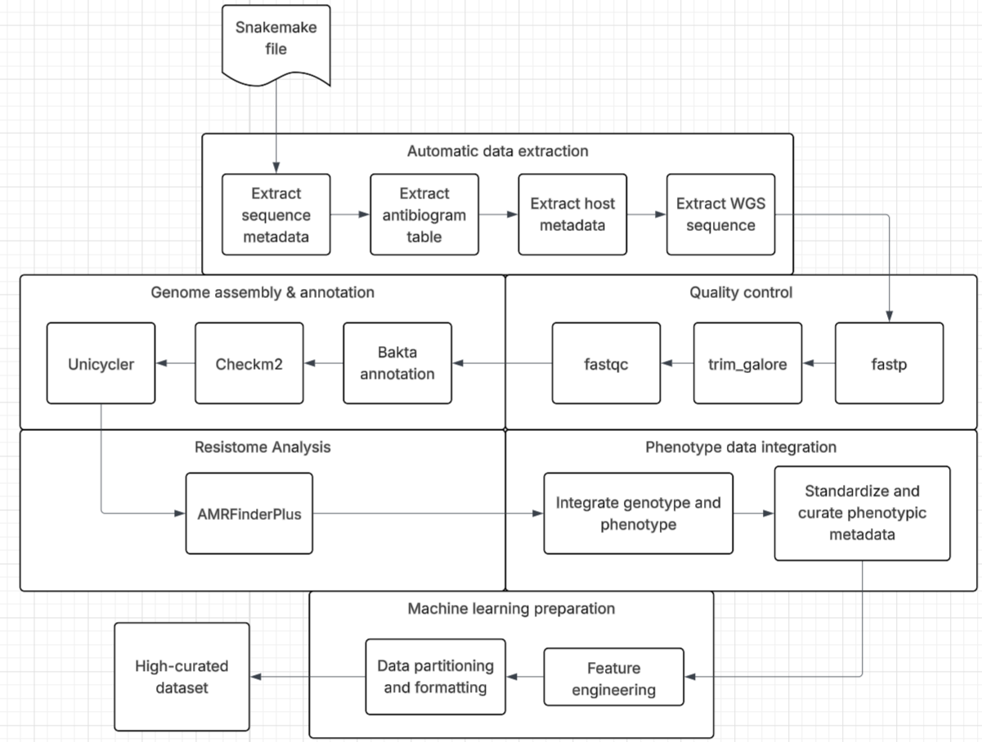
Figure 1. Work flow for curating WGS data

Data Acquisition and Metadata Curation
Raw sequencing reads and associated metadata were retrieved from the NCBI Sequence Read Archive (SRA) using the SRA Toolkit (Leinonen et al., 2011). Metadata tables were automatically parsed to extract relevant attributes, including BioSample identifiers, isolation source, collection location, sequencing platform, and antimicrobial susceptibility phenotypes when available. All metadata fields underwent normalization and consistency checks to reduce redundancy and resolve formatting inconsistencies, following established best practices in bacterial genomics metadata curation (Kodama et al., 2012; Federhen, 2015). These curated metadata were incorporated directly into the Snakemake workflow, ensuring complete traceability of each isolate throughout downstream analyses (Figure 2). As illustrated in Figure 2, the workflow employed a structured and fully automated filtering strategy to ensure that only biologically relevant and analytically compatible Klebsiella pneumoniae isolates were selected. Each candidate BioSample retrieved from SRA was first examined to verify its organism annotation. Only records corresponding to K. pneumoniae were retained. For these verified entries, the workflow next assessed the availability of antimicrobial susceptibility testing (AST) data, an essential requirement for linking genomic variation with phenotypic resistance profiles. Samples lacking AST information were excluded from consideration. Following phenotype verification, the sequencing metadata for each candidate isolate were examined to ensure that complete paired-end whole-genome sequencing reads were available. Because paired-end libraries are critical for accurate genome assembly and structural reconstruction, isolates associated with single-end or incomplete read sets were removed from the eligible pool.This filtering logic was applied iteratively across the SRA metadata registry until a predefined sample threshold was achieved—representing the minimum number of isolates meeting all three criteria: correct organism identity, available AST phenotypes, and paired-end WGS data. Only once this threshold was met did the workflow initiate the download of raw sequencing reads for the selected isolates. At this stage, the corresponding sample-level and host-level metadata were retrieved simultaneously to maintain complete biological context and ensure reproducibility. Through this multi-stage curation framework, the pipeline produced a high-confidence, phenotypically annotated, and assembly-ready dataset optimized for downstream genome analysis and machine-learning–based resistance prediction.
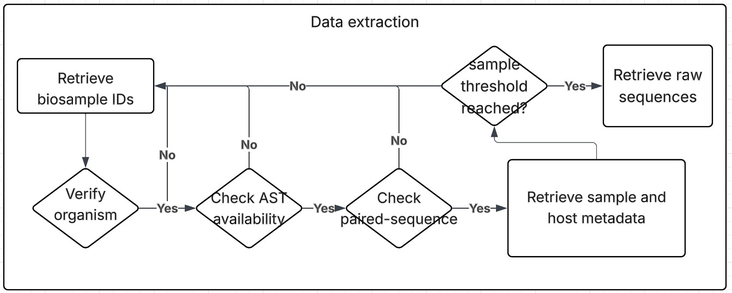
Figure 2. Automatic data retravel workflow

Quality Control and Preprocessing of Raw Reads
Sequencing reads were then subjected to an initial quality assessment using FastQC, which assesses duplication levels, adaptor contamination, GC distribution anomalies, and per-base quality scores (Andrews, 2010). This revealed systematic problems that needed to be fixed before further analysis and gave a baseline profile of raw read quality.
Fastp, an effective all-in-one tool for adapter removal, quality trimming, polyG tail correction, and low-complexity region filtering, was used for read preprocessing (Chen et al., 2018). Fastp was chosen due to its speed, integrated error-correction procedures, and automatic report production, all of which have led to its widespread use in contemporary microbial genomics workflows (Chen et al., 2018; Ewels et al., 2016).
Trim Galore, a wrapper around Cutadapt, was used to provide more severe adapter clipping in situations where extra adapter cutting was needed, especially for Illumina-specific overhang contamination (Krueger, 2015). When used in tandem, these tools improved downstream assembly and variant finding accuracy while guaranteeing the elimination of sequencing artifacts.
In accordance with suggested QC procedures for high-throughput bacterial WGS datasets, all FastQC and fastp HTML reports were automatically combined into a single multi-sample summary to preserve an open overview of data quality across all isolates (Quainoo et al., 2017).

Genome Assembly and Assembly Quality Assessment

Unicycler, a hybrid-capable genome assembler tailored for bacterial genomes, was used to assemble filtered high-quality reads from scratch (Wick et al., 2017). Unicycler uses an SPAdes-based assembly graph framework and additional bridging heuristics and conservative graph cleaning steps to reduce fragmentation artifacts common in Enterobacteriaceae assemblies, which helps it perform exceptionally well in short-read-only mode even though it was initially intended to integrate both short- and long-read data (Wick et al., 2017; Bankevich et al., 2012). This method has been frequently used in clinical and epidemiological K. pneumoniae genomics and yields more contiguous assemblies than traditional short-read assemblers.
We used CheckM2, the deep learning-enhanced replacement for CheckM, to assess genomic completeness, contamination, strain heterogeneity, and overall assembly integrity (Parks et al., 2015; Chklovski et al., 2022). CheckM2 predicts contamination and completeness on Klebsiella and other Enterobacteriaceae species with significantly higher accuracy using machine-learning models and lineage-specific marker sets. In order to ensure that only physiologically reliable genomes entered the analytical workflow, assemblies with low completeness or high contamination were rejected from downstream annotation and machine learning feature engineering.
Bakta, an effective and standardized prokaryotic genome annotation tool that offers high-quality gene predictions, antimicrobial resistance gene detection, replicon typing, and curated functional labels using its integrated PLSDB and RefSeq was used to perform functional genome annotation (Schwengers et al., 2021). Bakta was chosen because it produces consistent identifiers (such as baktags) and FAIR-compliant, repeatable annotations that enable downstream feature extraction for machine learning, such as resistome profiling, virulence factor identification, and accessory genome characterisation
.
Functional Annotation and Resistome / Virulome Profiling
Using AMRFinderPlus (Feldgarden et al., 2019), the NCBI-maintained toolkit for antimicrobial resistance (AMR) gene discovery, resistome characterisation was carried out directly on the high-quality, Bakta-annotated genome assemblies. AMRFinderPlus uses its carefully selected protein and hidden Markov model (HMM) databases to find acquired AMR genes, point mutations, and stress/virulence-associated loci. To ensure consistent detection across all isolates, each assembly was screened using default parameters. The hierarchical gene family structure of AMRFinderPlus was used to assign sequence variations, allowing for uniform naming and reducing false-positive annotations.
In order to facilitate downstream comparative genomics and phenotype-genotype interpretation, gene calls and mutation reports were processed into a structured output table that was integrated into the Snakemake workflow. For resistome profiling, only AMRFinderPlus was utilized, guaranteeing methodologic clarity and preventing database redundancy.
The resistome dataset utilized in further analyses was created using this simplified method, which produced an accurate and repeatable catalog of AMR determinants pertinent to carbapenem resistance.

Results
Sequencing Quality Control and Read Filtering
Raw paired-end Illumina sequencing reads from two Klebsiella pneumoniae isolates (SRR338169184 and SRR33816926) were subjected to quality control and preprocessing using fastp (v0.23.4). Initial sequencing depth was high for both isolates, with 11.35 million and 10.68 million paired reads generated prior to filtering, respectively. Before quality control, base-level quality metrics already indicated high sequencing accuracy, with Q30 base proportions of 88.3% for SRR338169184 and 89.5% for SRR33816926, and GC contents consistent with K. pneumoniae genomes (54–55%).
Following adapter trimming, quality filtering, and low-complexity read removal, 98.4% of reads were retained for SRR338169184 and 98.9% for SRR33816926, demonstrating minimal data loss during preprocessing. Post-filtering quality metrics improved further, with Q30 base proportions increasing to 91.8% and 93.2%, respectively. Mean read lengths were reduced from 151 bp to 128 bp (SRR338169184) and 123 bp (SRR33816926), reflecting the removal of low-quality terminal bases while preserving the majority of high-confidence sequence information.
GC content remained stable after filtering (55.1% and 54.1%), and duplication rates were low (<2%) for both isolates, indicating limited library bias and high sequencing complexity. Collectively, these results confirm that the sequencing data were of high quality and suitable for reliable downstream genome assembly, annotation, and resistome analysis.

Genome Assembly Quality and Completeness
Genome assembly quality and completeness were evaluated using CheckM2, a lineage-aware framework that estimates genome completeness and contamination based on conserved single-copy marker genes using a neural network–based model (Parks et al., 2023). Both Klebsiella pneumoniae assemblies demonstrated exceptional quality, meeting accepted thresholds for high-confidence downstream comparative and functional analyses.
The assembled genome for isolate SRR338169184 achieved an estimated completeness of 100.0% with a contamination level of 0.09%, indicating a highly complete and uncontaminated reconstruction. Similarly, isolate SRR33816926 also exhibited 100.0% completeness with minimal contamination (0.22%). These values fall well within, and surpass, commonly accepted standards for high-quality bacterial draft genomes, where completeness above 90–95% and contamination below 5% are considered acceptable.
Genome sizes were consistent with known K. pneumoniae reference genomes, measuring approximately 5.29 Mb for SRR338169184 and 5.58 Mb for SRR33816926, with GC contents of 57% in both cases. These metrics further support accurate species identification and the absence of substantial contamination or assembly artifacts. Coding densities were high (≈88%), reflecting efficient gene recovery and structurally coherent assemblies.
Assembly contiguity metrics indicated moderate fragmentation, with both genomes comprising 105 contigs. However, this level of fragmentation is typical for short-read–only assemblies of Enterobacteriaceae and does not compromise functional annotation or resistome profiling. Notably, contig N50 values were substantial, reaching 215,893 bp for SRR338169184 and 280,628 bp for SRR33816926, indicating that a large proportion of each genome is represented in long contiguous sequences.
Together, these results confirm that both genome assemblies represent high-quality draft genomes suitable for downstream annotation, antimicrobial resistance gene detection, and integrative genotype–phenotype analyses.

Comparative Genome Assembly of SRR33816918 and SRR33816926
De novo assembly of isolate SRR33816926 was performed using the same Unicycler short-read pipeline as applied to SRR33816918, enabling direct comparison of assembly quality metrics. Unicycler evaluated a wide k-mer range (27–127) and selected a k-mer size of 119 as optimal, yielding the highest graph score with reduced fragmentation and minimal dead ends. Following read-depth filtering, which removed approximately 19 kb of low-coverage contigs, the final assembly achieved a total length of 5,581,865 bp distributed across 173 contigs.
Compared to SRR33816918, SRR33816926 exhibited improved assembly contiguity, reflected by a higher N50 value (280,628 bp vs 215,893 bp) and a substantially longer maximum contig of 901,128 bp. The bridged assembly graph consisted of three components, including a dominant chromosomal component (5.55 Mb) that remained incomplete, a secondary 31.7 kb fragment, and a fully resolved circular contig of 3.1 kb. The circular element did not contain a detectable replication initiation gene (dnaA or repA), suggesting it may represent a small cryptic plasmid or extrachromosomal element.
Overall, both isolates produced high-quality draft genomes consistent with known Klebsiella pneumoniae genome sizes. However, SRR33816926 demonstrated superior long-range contiguity, indicating more favorable sequencing depth and/or genomic complexity for short-read assembly. These assemblies provide a robust foundation for downstream functional annotation, resistome profiling, and comparative genomic analyses.

Genome Annotation and Functional Features
Genome annotation of the two Klebsiella pneumoniae isolates (SRR33816918 and SRR33816926) was performed using Bakta v1.11.4 with the light v6.0 database, a rapid and standardized bacterial genome annotation framework.
General genome features
Both assemblies exhibited genome sizes and GC contents consistent with K. pneumoniae, which typically possesses genomes of approximately 5.3–5.7 Mb with GC contents around 57% .
SRR33816918 had a genome length of 5,291,366 bp, while SRR33816926 was slightly larger at 5,579,775 bp. The GC content was highly similar between isolates (57.5% and 57.1%, respectively), supporting organismal consistency.
Assembly continuity metrics reflected the draft nature of both genomes. Each assembly consisted of 105 contigs, with SRR33816926 showing improved contiguity (N50 = 280,628 bp) compared to SRR33816918 (N50 = 215,893 bp), indicating a more contiguous assembly for SRR33816926.
Both genomes showed zero ambiguous bases (N ratio = 0.0) and no assembly gaps, suggesting high-quality base calling and effective post-assembly filtering.
Coding potential and gene content
Both Klebsiella pneumoniae genomes exhibited high coding densities, with 88.4% for SRR33816918 and 88.2% for SRR33816926, consistent with the compact gene organization typical of bacterial chromosomes. Automated annotation predicted 4,919 protein-coding sequences in SRR33816918 and 5,170 in SRR33816926, reflecting a modest expansion in gene content in the latter isolate that corresponds with its larger genome size and improved assembly contiguity. The observed difference in predicted coding sequences is therefore more likely attributable to assembly continuity rather than substantive biological divergence between isolates, a common effect in draft bacterial genome assemblies.
Both genomes encoded a complete complement of essential RNA genes, including multiple transfer RNAs and ribosomal RNAs, supporting the functional completeness of the assemblies. SRR33816926 contained a slightly higher number of RNA features overall, including additional tRNA and rRNA genes, which again aligns with its increased genome length and higher N50 value. Non-coding RNAs were also consistently represented across both isolates, further indicating intact transcriptional and regulatory potential.
A subset of predicted proteins lacked functional annotation and were classified as hypothetical proteins, representing approximately 6% of the total coding sequences in both genomes. This proportion is well within the expected range for Enterobacteriaceae and reflects current limitations in functional databases rather than deficiencies in annotation quality. Notably, no pseudogenes were detected in either genome, suggesting minimal gene disruption and supporting the structural integrity of the predicted coding regions.
Functional completeness and genome architecture
No pseudogenes or assembly gaps were detected in either genome, suggesting intact gene prediction and minimal assembly artefacts. Both isolates lacked CRISPR arrays, a feature variably present in K. pneumoniae and frequently absent in clinical lineages.
Multiple predicted origins of replication (oriCs) were detected in both genomes (n = 2), while SRR33816918 additionally contained a predicted origin of transfer (oriV). Such predictions are commonly observed in fragmented assemblies, where contig breaks can lead to duplicated origin signals.

Annotation confidence and limitations
A moderate number of hypothetical proteins were identified in both isolates (5.9% in SRR33816918; 6.2% in SRR33816926). These proportions are typical for Enterobacteriaceae genomes and reflect current limitations in functional databases rather than annotation failure.
The use of the Bakta light database prioritizes speed and consistency but may under-annotate strain-specific or novel genes. Consequently, some hypothetical proteins may represent uncharacterized virulence or resistance-associated factors that warrant further investigation using expanded databases or manual curation.

Antimicrobial Resistance Gene Profile
Whole-genome–based antimicrobial resistance profiling identified a limited but consistent set of resistance determinants in both Klebsiella pneumoniae isolates. Each genome harbored five acquired AMR genes, representing resistance to β-lactams, fosfomycin, quinolones/phenicols, and multiple drug classes via efflux mechanisms. A broad-spectrum class A β-lactamase of the SHV family was detected in both isolates, with allelic variation observed between strains (bla<sub>SHV-187</sub> in SRR33816918 and bla<sub>SHV-1</sub> in SRR33816926), consistent with the intrinsic and plasmid-associated β-lactam resistance repertoire of K. pneumoniae.
Both isolates carried the oqxAB operon, encoding a resistance-nodulation-division (RND) family multidrug efflux pump associated with reduced susceptibility to quinolones and phenicols, alongside emrD, a major facilitator superfamily efflux transporter contributing to low-level multidrug resistance. Resistance to fosfomycin was mediated by glutathione transferase genes of the fosA family, with distinct alleles identified between isolates (fosA10 in SRR33816918 and fosA in SRR33816926), indicating allelic diversification without expansion of resistance mechanisms.
Importantly, no carbapenemase-encoding genes were detected in either genome, including bla<sub>KPC</sub>, bla<sub>NDM</sub>, bla<sub>OXA-48-like</sub>, bla<sub>VIM</sub>, or bla<sub>IMP</sub>, suggesting an absence of acquired carbapenem resistance determinants in both isolates. All AMR gene hits exhibited near-complete reference coverage and high sequence identity (≥99%), supporting confident functional assignment. Overall, the two isolates displayed highly similar resistance profiles, differing only at the allelic level, with no evidence of expanded resistance gene content.

