**Easy-to-Build Textile Pressure Sensor**

Dr. Francisco Pizarro - ([francisco.pizarro.t@pucv.cl](mailto:francisco.pizarro.t@pucv.cl))



**A Smart Chair to Monitor Sitting Posture by Capacitive Textile Sensors**

Marc Martinez Estrada ([marc.martinez.estrada@upc.edu](mailto:marc.martinez.estrada@upc.edu))

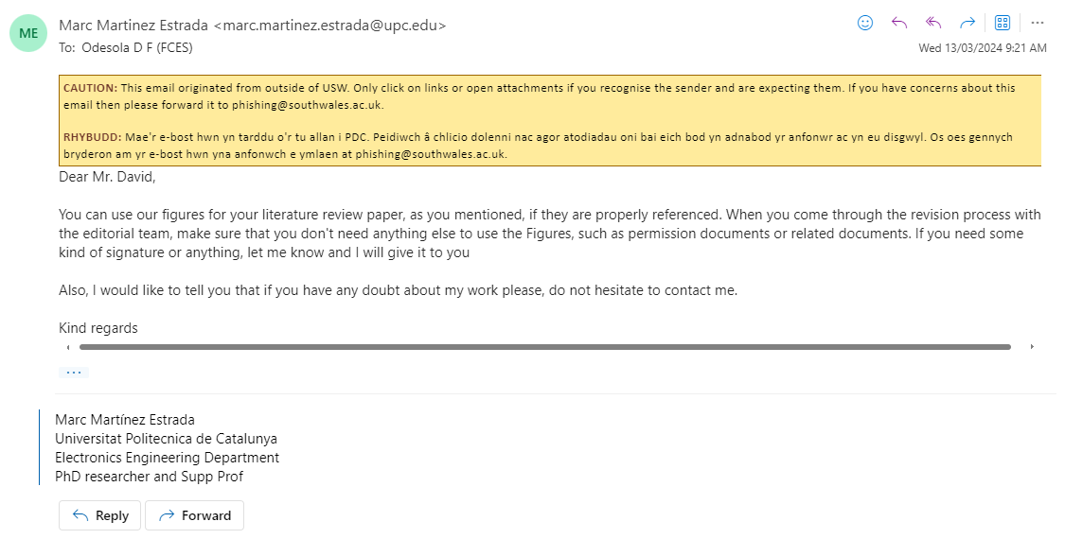

**Development of a Smart Chair Sensors System and Classification of Sitting Postures with Deep Learning Algorithms**

Taraneh Aminosharieh Najafi ([taraneh.aminoshariehnajafi@epfl.ch](mailto:taraneh.aminoshariehnajafi@epfl.ch))

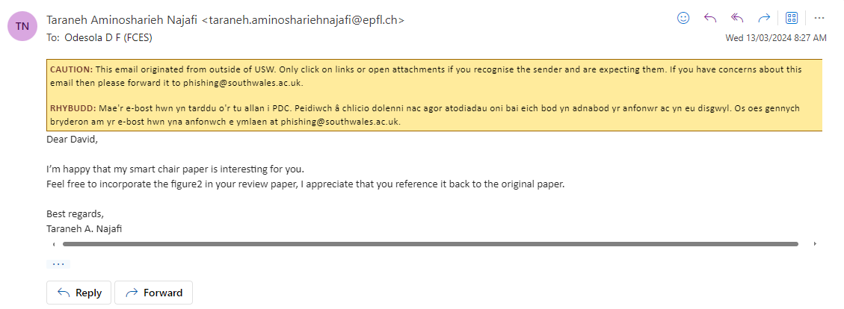

A Smart Chair to Monitor Sitting Posture by Capacitive Textile Sensors

Tiina Vuohijoki ([tiina.vuohijoki@tuni.fi](mailto:tiina.vuohijoki@tuni.fi))



**Sitting Posture Recognition Using a Spiking Neural Network**

Dr. Abdulmotaleb El Saddik ([elsaddik@uottawa.ca](mailto:elsaddik@uottawa.ca))



Basim Hafidh ([bhafidh@uottawa.ca](mailto:bhafidh@uottawa.ca))

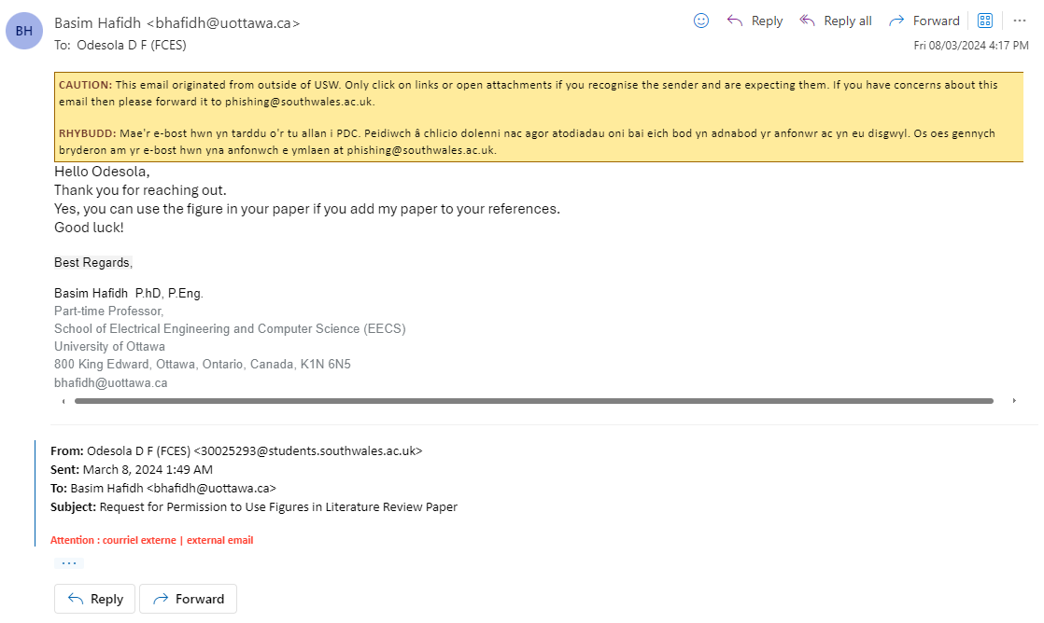

**Robust, Low-cost, Non-intrusive Sensing and Recognition of Seated Postures**

Dr. Bilge Mutlu (bilge@cs.wisc.edu)



A portable sitting posture monitoring system based on a pressure sensor array and machine learning

Bin Chen ([chenbin121@swu.edu.cn](mailto:chenbin121@swu.edu.cn))

