Task 1

Initial Benchmark:
time ./gpurender
real 0m2.509s
user 0m2.422s
sys 0m0.020s

time ./gpurender -g
real 0m7.073s
user 0m6.998s
sys 0m0.008s

a)

time ./gpurender -v=4320 -w=8192 -d=3
real 0m21.405s
user 0m20.860s
sys 0m0.120s

Timing workQueue:
time ./gpurender -v=4320 -w=8192 -d=3
Runs:
1: 11.2017s
2: 11.1944s
3: 11.2167s

b)

Here I simply added #pragma omp parallel for to the loop iterating over the workQueue.
time ./gpurender -v=4320 -w=8192 -d=3

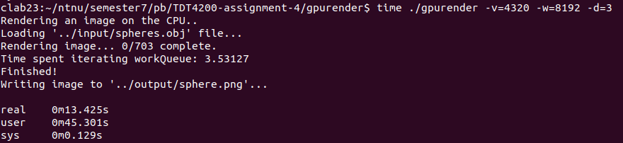

c)

I can not see any change in the image when using OpenMP, however using MD5 I can see that the hash of the image is different every time when rendering the image, which means there is some race condition, even though I am unable to see this in the image.

Without OpenMP
md5sum ../output/sphere.png
4018d55f742c7e7d5ad692d0124b83e5 ../output/sphere.png

With OpenMP
md5sum ../output/sphere.png
<Different every time you run the renderer> ../output/sphere.png

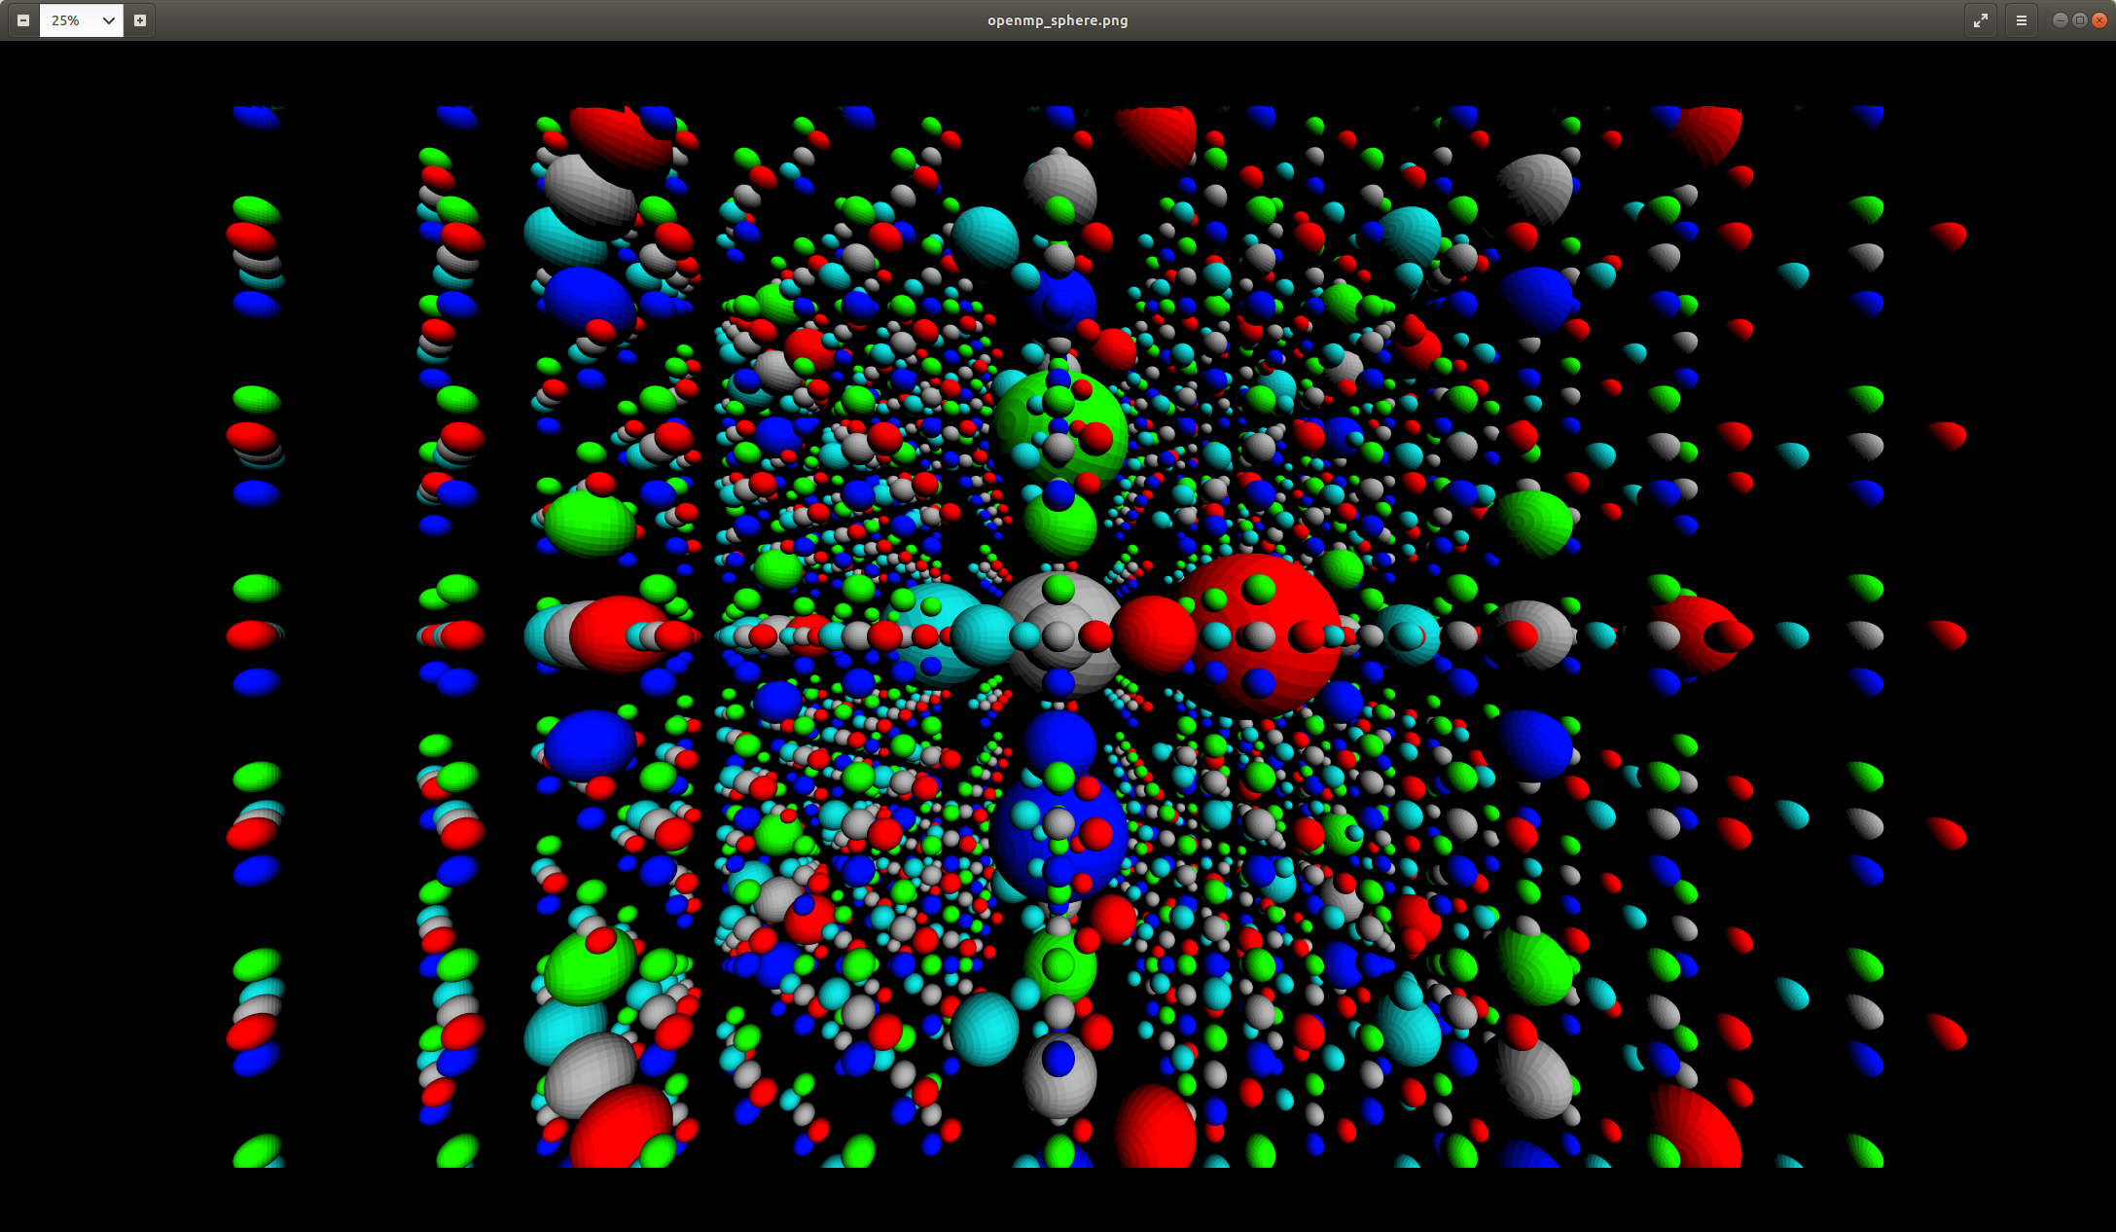
Using a mutex and md5sum, I managed to narrow down the race condition to the rasteriseTriangles method, and inside this method I managed to narrow it down to the float pixelDepth = face.getDepth(u,v,w); call. Surrounding this with a mutex solved the race condition (md5 is the same as original), however the speed was lowered significantly compared to not having this mutex.

d)
time ./gpurender -v=4320 -w=8192 -d=3

Static (standard):
real 0m17.818s
user 1m6.945s
sys 0m11.200s
Time spent iterating workQueue: 7.75986

Dynamic:
real 0m17.830s
user 1m8.603s
sys 0m10.562s
Time spent iterating workQueue: 7.88126

Guided:
real 0m17.599s
user 1m7.275s
sys 0m10.373s
Time spent iterating workQueue: 7.65621

Changing the scheduling strategy did not seem to impact performance much, guided might be slightly faster.

e)

Without OpenMP: ~11.2s, comparing workQueue times.

Static: 30.8% faster.
Dynamic: 29.6% faster.
Guided: 31.7% faster.

f)

Since the pixels have a similar amount of computation associated with each, I would not expect a specific schedule to be faster than another. You can expect some strategies to be faster than others if part of the work further along in the queue is slower than previous entries, however in this case this is not the case.

Task 2

