
richfield.ac.za

FACULTY OF INFORMATION TECHNOLOGY

2026

ASSIGNMENT MOBILE APP DEVELOPMENT 700

Name and Surname: Olerato Mphogo
Qualification:

Year of Study:

Semester:

Assignment due date:

Date submitted:

QUESTION

EXAMINER MARKS

MODERATOR MARKS

REMARKS

Student ITS No: 402107321
2
3
23/10/2026
23/10/2026
BSc IT

ASSIGNMENT INSTRUCTIONS

Please tick each box to confirm completion. (10 Marks)

Use Times New Roman font, size 12, with 1.5 line spacing throughout the document. Apply Harvard Referencing Style for all citations and references.

For essay -style assignments, please include the following sections:
Table of Contents
Introduction
Main Body (with relevant subheadings)
Conclusion
References
Submit the assignment in PDF format on Moodle.
Use the specified cover page provided. Include a signed declaration of originality.

DECLARATION OF ORIGINALITY:
I hereby declare that this assignment is my own work and has not been copied from any other source except where due acknowledgment is made. I affirm that all sources used have been properly cited and that this submission complies with the institution’s policies on academic integrity and plagiarism.

Student Signature: OT MPHOGO Date: 23 October 2026

Richfield Graduate Institute of Technology (Pty) Ltd is register under the Higher Education Act, 1997, Registration Certificate No. 2000/HE07/008.ed with the Department of Higher Education & Training as a Private Higher Education Institution

Table of Contents
1. Introduction
2. System Design
3. Implementation
4. Key Code Snippets
5. Challenges and Solutions
6. References
1. Introduction
Smart Pantry Manager is a Java-based Android application designed to help users reduce household food waste. Users record the ingredients available at home and the app displays recipes only when every ingredient required by a recipe is available in the pantry. The intended users are people who want to plan simple meals around ingredients they already own, without needing to shop for missing items.
The application implements pantry create, read, update and delete (CRUD) operations, a seeded recipe collection, strict recipe matching, recipe details and a settings/information screen. SQLite stores data locally so pantry entries remain available after the application is closed and reopened.
2. System Design
Screen-flow diagram
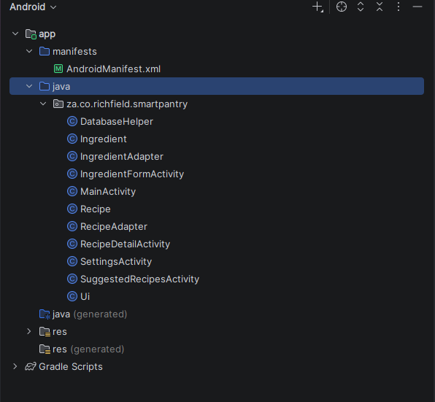
Database model
The database contains two tables. The pantry table stores user-entered ingredients. The recipes table stores the recipe name, comma-separated required ingredient names and preparation instructions. The current implementation uses recipe ingredient names rather than a separate relational recipe-ingredient table.
ER-style model:
PANTRY(id PK, name, quantity, unit, expiry)
RECIPES(id PK, name, ingredients, steps)
The two tables are independently stored. Recipe matching compares the ingredient names in RECIPES.ingredients against pantry names.
Technology choices
The application is written in Java and uses standard Android Activities, Intents, ListView and custom BaseAdapter classes. SQLiteOpenHelper creates the database and tables and inserts 20 starter recipes on first database creation. SQLite was chosen because it supports offline, on-device persistence without requiring a cloud account or external backend.

3. Implementation
Pantry management
Users can create an ingredient by entering the name, quantity and unit. An expiry date will be recorded optionally. Selecting an ingredient opens the edit form, while long-pressing an item opens a delete confirmation dialog. The form rejects blank required fields and quantities that are not positive numbers. This is also available on the screen while using the app
Recipe collection and details
The database takes 20 simple recipes on first run. Each recipe includes a name, required ingredient names and preparation steps. Selecting a suggested recipe opens a detail screen that displays its ingredient list and method.
Strict-matching algorithm
For each recipe, the application checks each required ingredient against the current pantry. A recipe is added to the suggested list only if every required ingredient is found with a stored quantity of at least 1. If any ingredient is missing, the recipe is excluded. When there are no matches, the app displays an explanatory message instead of an empty screen.
Screenshots
Pantry List:
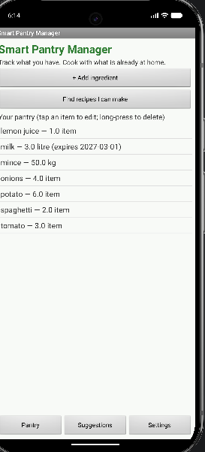
Add Ingredient:
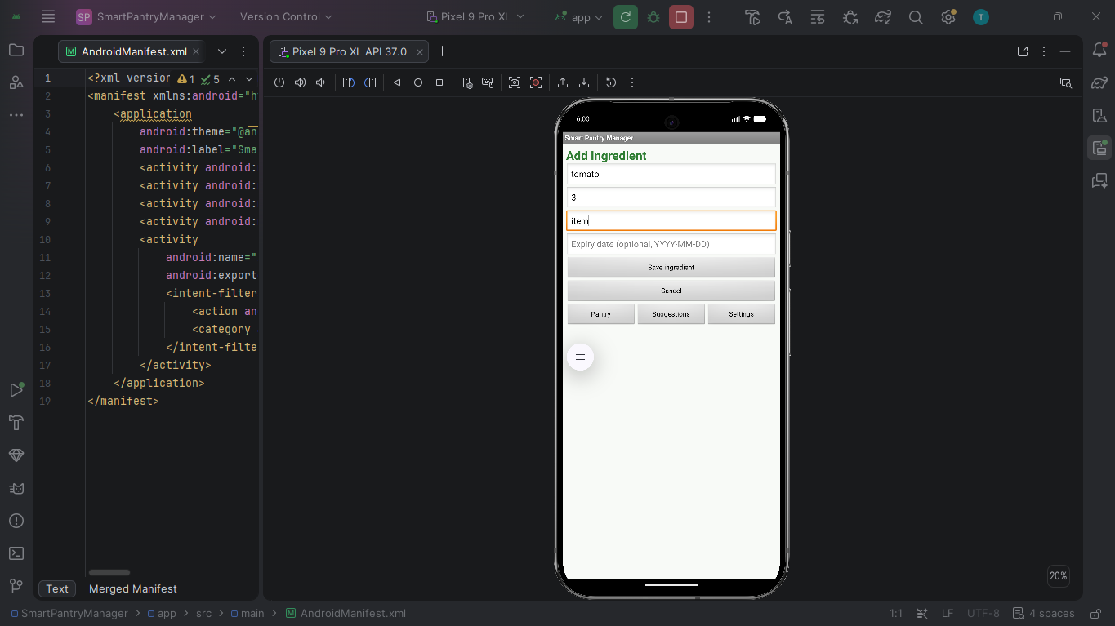
Edit Ingredient:
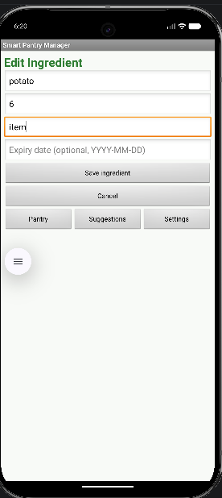
Delete confirmation/result:
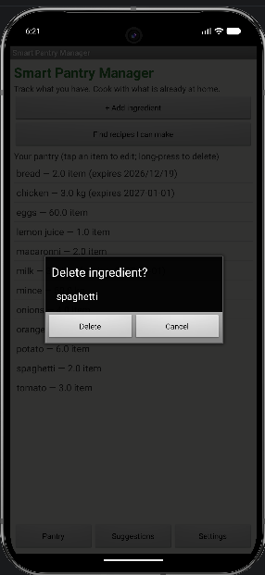

4. Key Code Snippets
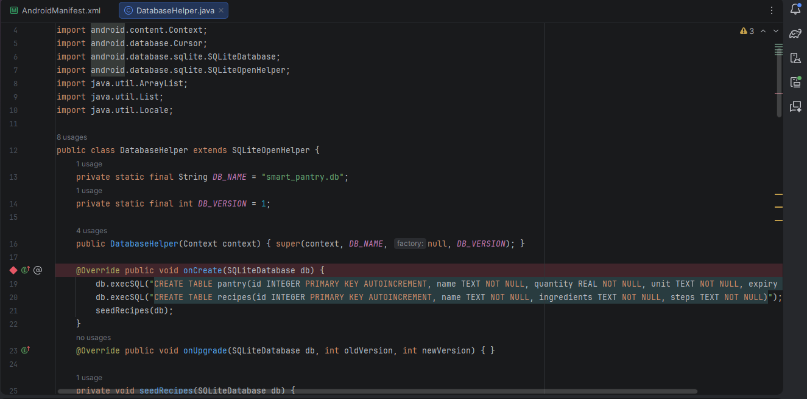
DatabaseHelper.onCreate() creates the pantry table with an integer primary key and required name, quantity and unit fields. It also creates a recipes table and seeds the recipe collection. This makes the database setup repeatable on first launch.
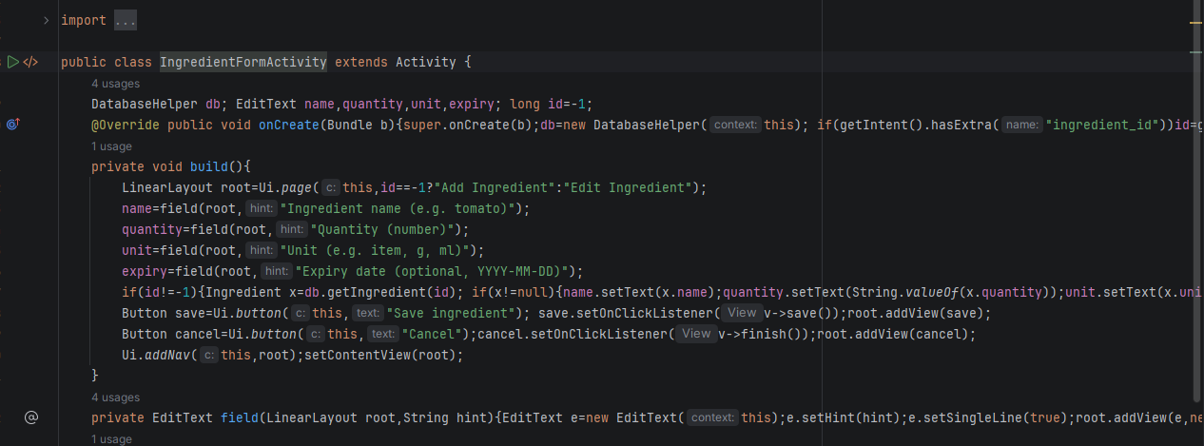
IngredientFormActivity checks that the name, quantity and unit are present and that quantity parses to a number greater than zero before writing to SQLite. This prevents common invalid entries.

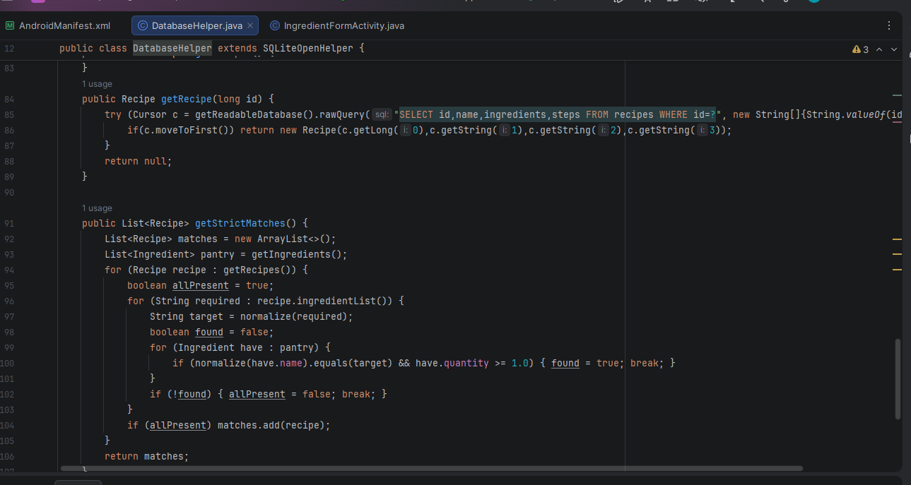
.getStrictMatches() iterates through every recipe and every required ingredient. It marks a recipe as ineligible immediately when one required ingredient is absent. Only recipes for which all required
5. Challenges and Solutions
The following are example discussion prompts. Replace them with the actual challenges you encounter while testing and developing the app.
1.Could’t get the app to run: Had to sync the project with gradle files
2. Struggled with creating a GitHub repository: Watched a YouTube video
6. References
Christina Warren. @GitHub on youtube. Accessed -22 October 2026
YouTube. @SkillsBuild Security. Accessed 20 October 2026.
Claude
Richfield Graduate Institute of Technology (2026) Mobile App Development 700

