# Ayodele Olayinka

**SUMMARY**

I am an ambitious website developer that will bring problem-solving approach and powerful technology skills to the web development process. I can communicate well with colleagues to ascertain web marketing needs and design interfaces to accommodate specifications. I'm a software engineer with a strong passion for building responsive and effective web applications with great user interfaces that positively impacts the world**.**

**EXPERIENCE**

**None. Education**

* **Introduction to Computer Science by CS50**
* **Web development by CS50**
* **Python Programming by CS50**

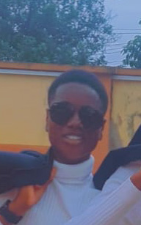

**+2347081122907**

theolayinkayodele@gmail.com

**Skills**

* **HTML**
* **CSS**
* **Javascript**
* **Python**
* **C#**
* **Git**

**Education**

* **Introduction to Computer Science by CS50**
* **Web development by CS50**
* **Python Programming by CS50**