Taverner asset tracking user handbook

# 1. Register and Login form

To register, please use a taverner email address. Personal email addresses will not be processed.

Your password must be at least 10 characters long and contain at least one special character.

If you forget your password, simply click the 'Reset Password' button located at the bottom of the login page.

After entering your email address and clicking 'Reset', an email will be sent to you with further instructions. You can set a new password by typing it in and clicking the 'Reset Password' button. After resetting your password, you will be able to log in with your new credentials.

# 2. Navigation bar



After logging in, you will see a navigation bar at the top of the home page.

Clicking on a label will take you to the corresponding page. If you click on 'TAB ALLOC', a dropdown menu will be displayed, allowing you to select additional labels.

# 3. Home page

The home page displays a summary of the four different types of assets owned by the company, each shown in a separate block. The summary includes the total number of assets stored in the database. For PCs and laptops, the location of the device is displayed. For other devices, up to five types of devices are listed in descending order based on the number of devices. For tablets, the number of issued and available tablets is shown. For SIM cards, the number of issued and available SIMs, as well as the total expenditure on SIMs, are displayed.

# 4. Table

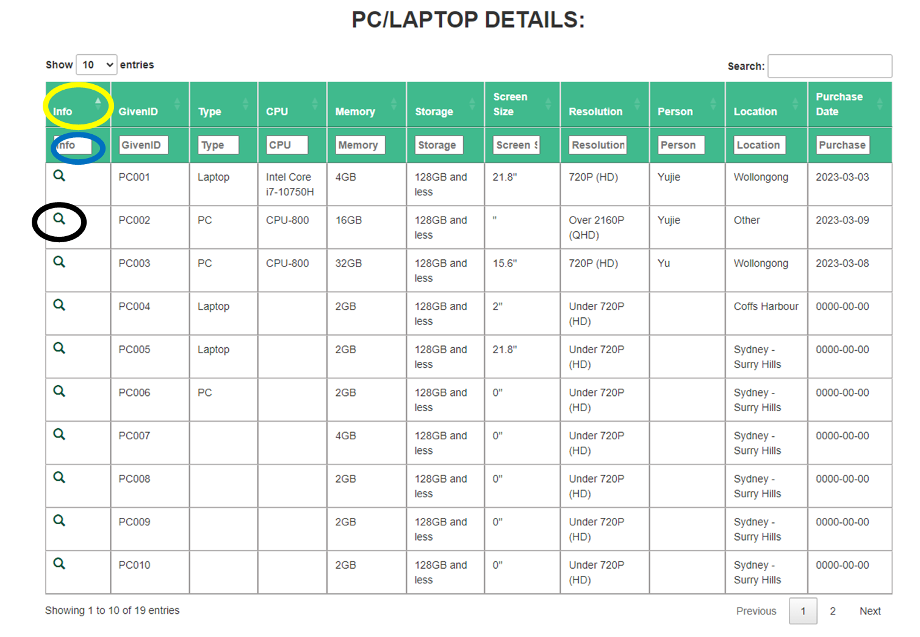

Clicking on the PC/LAPTOP, TABLET, SIM, OTHER section in the navigation bar leads you to a page displaying a table with detailed information about the devices. You can adjust the number of devices displayed in the table by using the dropdown menu in the top-left corner. Additionally, you can use the search box in the top-right corner to filter the results by entering relevant keywords.

To change the order (ascending or descending) of the table rows, click on the column header labelled with a yellow circle. Clicking on the field labelled with a blue circle allows you to filter the table by a specific column based on the entered keyword. Only rows containing the keyword will be displayed.

By clicking the search icon labelled with a black circle, you can view the detailed information page of the selected device. At the bottom of the page, you can view the total number of pages and select the page you wish to visit.

# 5. Review and change detail

On the detail page, users can review and modify all the information related to a particular device, including details that may not be displayed on the table page. The page provides a comprehensive overview of the device's information.

At the bottom of the page, users can post comments and view comments made by other users. This feature encourages collaboration and allows users to share their thoughts and feedback about the device.

# 6. Sim card allocation detail

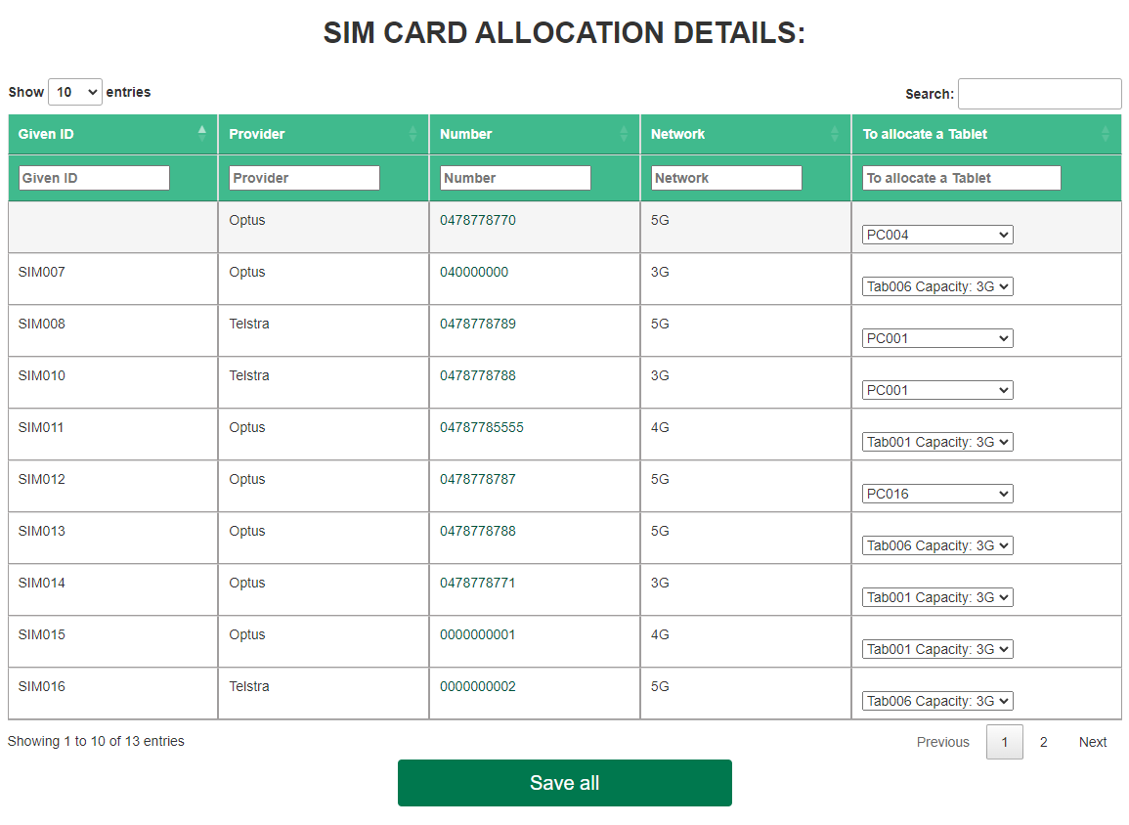

The SIM card detail, including the SIM given ID, provider, number, and network, are displayed on this page. On the right side of the table, devices (such as tablets and laptops) that have the capacity to use a SIM card are listed.

Users can modify the available tablets and laptops by using the dropdown list on the right. To allocate a selected tablet or laptop with a corresponding SIM card, users need to select the matching pair and click the 'Save All' button. Only the information displayed on this page will be saved.

# 7. Tablet allocation detail

When the user clicks on the 'Allocate a Tablet' button on the navigation bar, they can begin the process of assigning a tablet to a specific person, project, and date. Only tablet that has not been issued will be available on this page. To allocate multiple tablets at once, the user can click the 'Add' button and fill in all the required information. If necessary, the user can also delete any unwanted rows by clicking the 'Delete' button.

# 8. Return an allocated tablet.

When the user clicks on the 'Return a Tablet' button on the navigation bar, they can begin the process of returning an assigned tablet. On this page, all issued tablets with their respective issue information will be displayed. To return a tablet, the user needs to select a date for the return, click on the checkbox for the tablet they want to return, and write any necessary comments. Once the user clicks 'Save', the selected tablet will be returned and removed from this page.

Before return:

After return:

# 9. Allocation history

User can view the tablet allocation history by clicking on the allocation history button on navigation bar.

# 10. Upload a new device

By clicking on the ‘Upload New’ button on the navigation bar, the user can choose the type of device to upload.

After selecting a device type, the user can upload a new device. It's important to note that all fields are required. The given ID is suggested based on the largest given ID of an existing device, but the user can alter it based on their preference (although it's not recommended).