|  |  |
| --- | --- |
| 学号 | 姓名 |
| 16301073 | 龙淇伟 |
| 16301150 | 傅睿萱 |

# Report

**The technology used in the project**

**Android Navigation View**

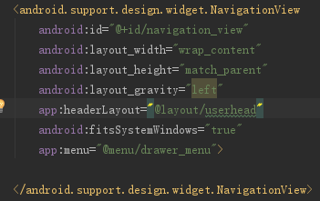

**Android Menu**

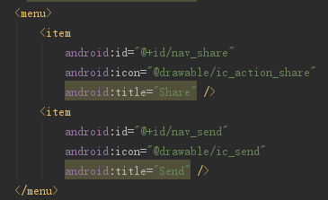

**Android Intent**

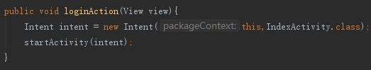

**Android Constrain Layout**

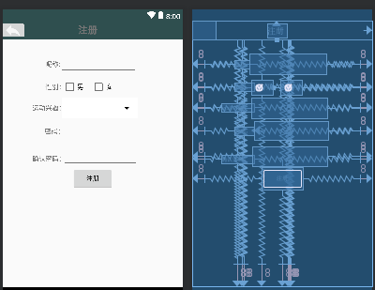

**Android Drawer layout**

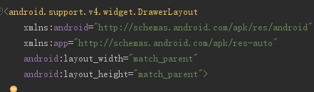

**Android Banner**

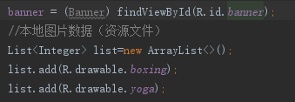

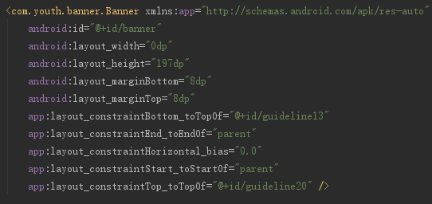

**Android Scroll View**

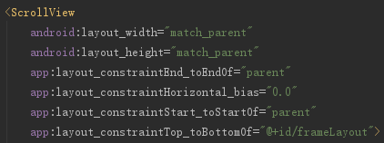

**Android Image Loader**

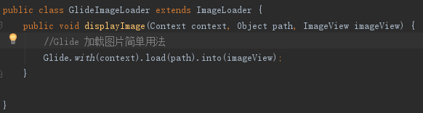

**Android Card View**

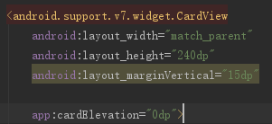

**Android Image Button**

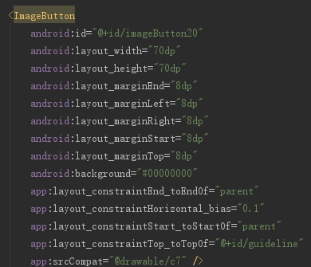

**Android Circle Image View**

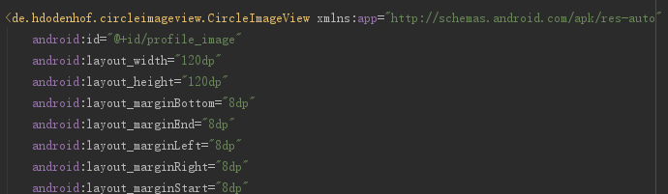

**Android Relative Layout**

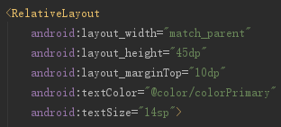

**Android Guideline**

