|  |  |
| --- | --- |
| 学号 | 姓名 |
| 16301073 | 龙淇伟 |
| 16301150 | 傅睿萱 |

# Report

**The technology used after project1**

**Okhttp3**

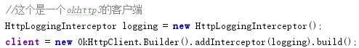

**Retrofit2**

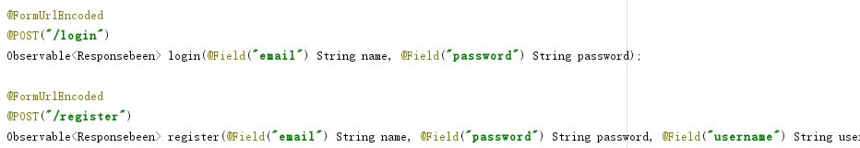

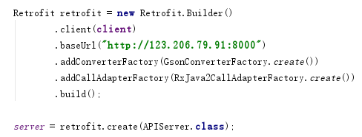

**Rxjava2**

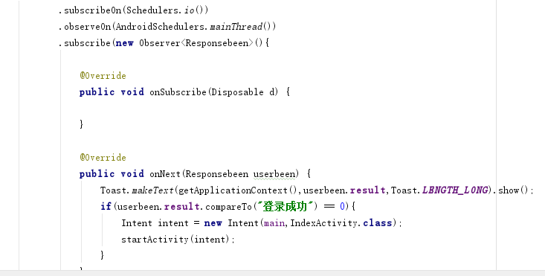

**RecycleView**

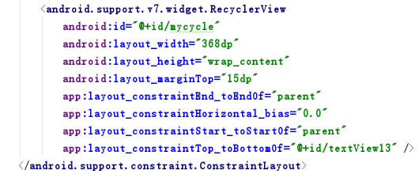

**Butterknife**

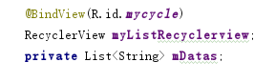

**Picasso**

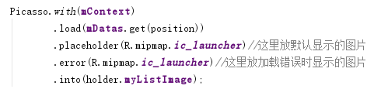

**GsonConverterFactory**

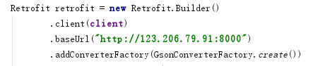

**Django**

