Databases exercise 1a

Part a
- Create a Canonical System of Record for your question and submit app.
Canonical means the official, authoritative version that everything else must follow
A system of record is the authoritative source for a specific piece of business data — the place where the organisation agrees the “official” version of that data lives.
We will be using this term when discussing future architecture
i.e. a database for your questions using a MySQL or Postgres database
Rather than reading or writing questions and answers to and from a file, write them to a database table.
The database should persist using a Docker named volume.
- Provide a question and answer bulk upload
You should be able to submit questions and answers from your submit app as before but also, submit should be capable of bulk uploading questions and answers from a file.
To bulk upload, a submitter should be able to write the questions and answers in a comma delimited file. E.g.,
What colour is grass?, red, green, blue, yellow, 1
What is 3 squared? 3, 6, 9, 12, 2
So each data item is separated from the next with a comma but terminated with a new line
The 1 and 2 are correct answers if you choose not to set the correct answer to always the first one in which case you don’t need an answer column – that’s up to you.
- Create a new endpoint in submit to enable the file to be read, transformed into json then sent to the question application which will then load the questions and answers into the database table. You should be able to use the same endpoint in the question application to accept a single question as you do now, or multiple questions as submitted from upload – they are both just json.

Part b – SQL exercises
Using a mysql or postgres container:
- Create a database called sales
- Create 5 tables in the database from the provided SQL
- Populate all the tables using the provided SQL
Note: you can copy and paste the whole lot in one go at the command line
- Now write the SQL statements for the following requirements. You will be asked to demonstrate them next week

- Find all products that cost more than £100
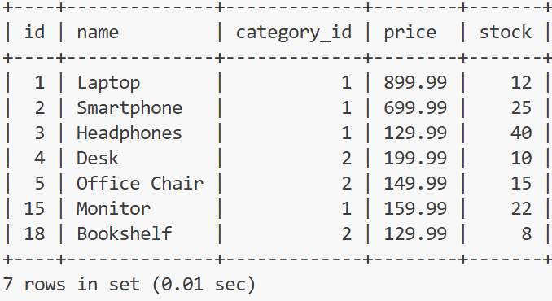

- Show the total stock value (price × stock) for each product.
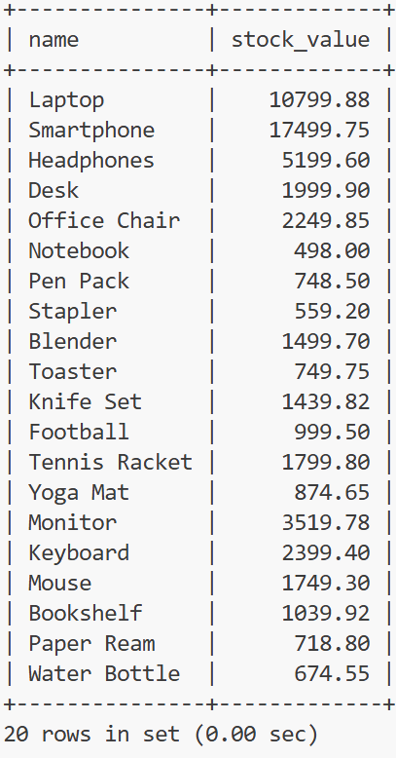

- Find the top 3 most expensive products.
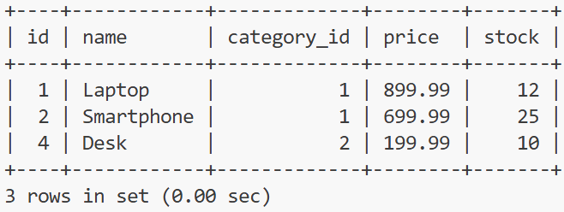

- Display the average price of each product in descending order of average price to 2 decimal places.
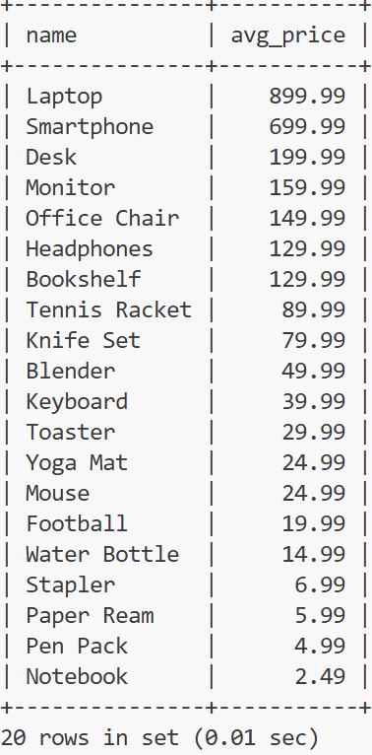

- Item stock is low if there are less than 20 products. High value products are those worth more than £150. Show the number of high value items that are low in stock.
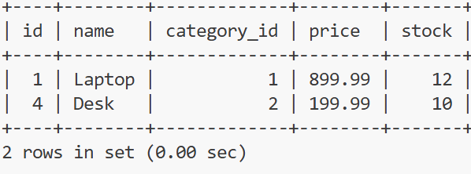

- Bob Jones and George King have mistakenly been added as .com email addresses instead of .co.uk so, assuming there will only ever be one Bob Jones and one George King, correct their email addresses.
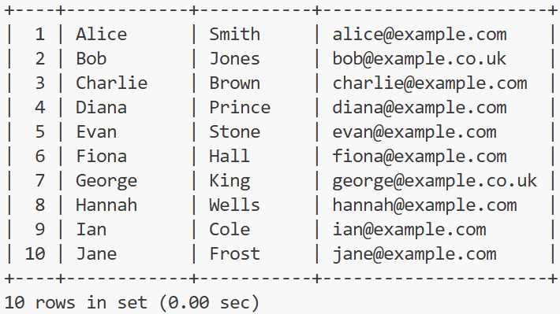

Select all email addresses that end in .co.uk
