SOLAR SYSTEM MOTOR THEORY
A Homopolar Motor Model for Solar System Angular Momentum Exchange: Jupiter, Saturn, and Neptune as Coupled Drivers of Earth's Rotation
Stephen Browne
Independent Researcher | s_browne@ymail.com
Version: 1.1 Timestamp: 2026-04-12 05:13 UTC Status: Ready for submission
Keywords: Solar System motor theory, homopolar generator, angular momentum, LOD, Neptune amplification, Laplace resonance, Great Inequality, Gleissberg, Hallstatt, Saturn modulator, Uranus Piezo Driver, Polar Drive

Abstract
We present a theoretical and observational framework describing the Solar System as a coupled electrodynamic machine in which Jupiter acts as the primary rotor, the Sun as a homopolar feedback generator, and the planets as electromechanical loads of distinct types. Using the combined 2,746-year Length of Day (LOD) record (720 BC – 2026 AD) and the GFZ Potsdam geomagnetic Ap index (1990–2025), we separate individual planetary contributions to Earth's rotation rate by sequential F-test regression.
The dominant result is that Neptune's orbital period (164.8 yr) and its half-period (82.4 yr) produce the largest LOD amplitudes of any planetary signal (0.345 and 0.377 ms/day, each p ≈ 0, F > 400), amplified 3.81× above the barycentric gravitational prediction. Tidal forcing is definitively ruled out (4,047× amplification would be required). Saturn contributes 36% (0.050 ms/day) of the Jose cycle amplitude through its barycentric mass fraction (35.5%); agreement 108%, confirming the barycentric mechanism.
We present a complete 17-body electromechanical typology and quantify coupling constants. A novel result: Jupiter's HCS warp modulates the IMF at Saturn's orbit by 45% of the local background — larger fractionally than at Earth (16%) because background IMF weakens faster with distance than the warp amplitude. Saturn's internal heat (99,514 TW) is self-generated (K-H ~34%, helium rain ~30%, neon rain ~10%); Jupiter EM contributes 0.0005%. Uranus is classified as a Piezo Driver whose compounded axial (97.77°) and magnetic (59°) tilt produces daily magnetospheric cycling with near-zero net coupling efficiency, explaining the Neptune-Uranus heat asymmetry without free parameters. The Laplace resonance (Io:Europa:Ganymede 1:2:4) is identified as the motor gearbox sustaining the 2 TW Io-Jupiter flux tube across geological time.

1. Introduction

1.1 The Angular Momentum Problem
Earth's length of day departs systematically from tidal dissipation models at decadal and centennial periods. Beyond the lunar tidal deceleration (~1.8 ms/century) and atmospheric angular momentum exchange, persistent non-tidal LOD variations remain without quantitative physical explanation. Identical Gleissberg (88 yr) and de Vries (208 yr) periodicities appear in both LOD records and cosmogenic isotope records without identified physical mechanism.

1.2 This Paper
We propose and test a specific electromagnetic coupling mechanism — the Polar Drive — in which Jupiter's magnetotail modulates the IMF at Earth's orbital distance, driving Birkeland currents through Earth's polar ionosphere and penetrating the mantle (skin depth δ = 3,079 km > mantle thickness 2,890 km at 11.86 yr for σ = 10 S/m) to exert a Lorentz torque on the conducting outer core. The torque equation is:
τ_total = τ_tidal(Moon) + τ_grav(Jupiter) + τ_EM(Jupiter/Sun)
where τ_EM is additive to, not replacing, existing models.

1.3 The Laplace Resonance Gearbox
The Io-Jupiter flux tube (2 TW, 400 kV, 5 MA; Saur et al. 2004) is sustained by the Io:Europa:Ganymede 1:2:4 Laplace resonance, which maintains Io's eccentricity against tidal damping. Without this resonance, Io would circularise within ~100 Myr and the flux tube would collapse. The Laplace gearbox is the mechanism that makes the Solar System Motor sustainable across geological time. Total Galilean tidal budget: Io 100 TW + Europa ~3.67 TW + Ganymede ~97 GW + Callisto ~21 GW = 103.8 TW total; of which only the 2 TW electrical component drives the Polar Drive chain.

2. Data and Methods

2.1 Combined LOD Record (720 BC – 2026 AD)
Historical record (720 BC – 1961 AD): Morrison, Stephenson & Hohenkerk (2021) piecewise cubic polynomial fit. Formal uncertainties: ±8 ms/day at 720 BC declining to ±0.025 ms/day at 1962.
Precision instrumental (1962 – 2026): IERS EOP C04 daily LOD from VLBI, SLR, and GPS at ~0.005–0.020 ms/day precision. n = 23,381 daily values. Monthly-averaged (n = 769), inverse-variance weighted.

2.2 Planetary Ephemeris
VSOP87-derived mean element sets (Meeus 1998). Great Inequality angle: Φ_GI = 5λ_S − 2λ_J (mod 360°), advancing at 0.411°/yr → period 876.5 yr.

2.3 Geomagnetic Ap Index
GFZ Potsdam daily Ap (Matzka et al. 2021), 1990–2025, 13,149 daily values. Solar cycle removed by quadratic regression against F10.7 and sunspot number (R² = 0.234).

2.4 Statistical Methods
Weighted F-test planetary separation with inverse-squared formal uncertainty weights. Sequential joint regression with p < 0.001 acceptance threshold. Weighted Lomb-Scargle periodogram (Zechmeister & Kürster 2009).

3. Results: Planetary Separation

3.1 Independent Period Significances
Period (yr) | Planet/Cycle | Amplitude (ms/day) | F-stat | Significance
82.4 | ½ Neptune orbital | 0.377 | 590 | p ≈ 0
88.0 | Gleissberg | 0.352 | 558 | p ≈ 0
164.8 | Neptune orbital | 0.345 | 412 | p ≈ 0
208.0 | de Vries | 0.366 | 402 | p ≈ 0
19.86 | Jose (J-S synodic) | 0.142 | 87 | p ≈ 0
18.0 | Moon-Jupiter beat | 0.130 | 71 | p ≈ 0
35.87 | Saturn-Neptune synodic | 0.082 | 52 | p ≈ 0
11.86 | Jupiter orbital | 0.085 | 39 | p ≈ 0
29.46 | Saturn orbital | 0.111 | 33 | p < 10⁻¹⁴

3.2 Joint Model and Saturn's Conditional Significance
Sequential conditional regression (joint R² = 0.594). Saturn's orbital period (29.46 yr) is REJECTED when conditioned on the Jose cycle and Saturn-Neptune synodic (p = 0.010). Saturn's LOD fingerprint operates through its synodic relationships, not its orbital period independently. Saturn is a gravitational modulator, not an independent orbital driver.

3.3 Neptune Amplification
Tidal forcing definitively ruled out: Neptune produces the largest LOD signal of any planet: A = 0.377 ms/day at 82.4 yr (F = 590, p ≈ 0) and A = 0.345 ms/day at 164.8 yr (F = 412, p ≈ 0). Its observed LOD fraction (63.8%) is 3.81× its barycentric gravitational fraction (16.7%). Tidal forcing is definitively ruled out: Neptune’s tidal differential force is 0.016% of Jupiter’s; a tidal mechanism would require 4,047× amplification relative to that weight. Impossible.
Barycentric framework: The physical mechanism producing the 3.81× amplification is not yet determined. This paper reports the empirical observation and rules out tidal forcing. The following candidate mechanisms are under investigation and are not mutually exclusive: (1) Uranus–Neptune 2:1 near-commensurability harmonic pumping (period ratio 1.962, synodic 171 yr); (2) the Neptune–Pluto 3:2 phase-locked flywheel (libration ~20,000 yr); (3) spectral window weighting from the finite 2,746-year baseline; (4) a Neptune superionic Alfvén resonance requiring B ≈ 377 μT at the superionic layer (2.7× surface dipole — see Section 4.5). The amplification mechanism requires dedicated follow-up investigation.

4. The Motor Framework

4.1 System Topology and Typology
The Solar System Motor operates as follows: the Sun's homopolar generator effect (Tachocline plasma displaced from barycentre by up to 1.07 solar radii) provides back-EMF feedback. Jupiter's primary rotor (Io flux tube 2 TW, η = 96.9%) drives the Heliospheric Current Sheet bus. Planets act as loads of distinct types.

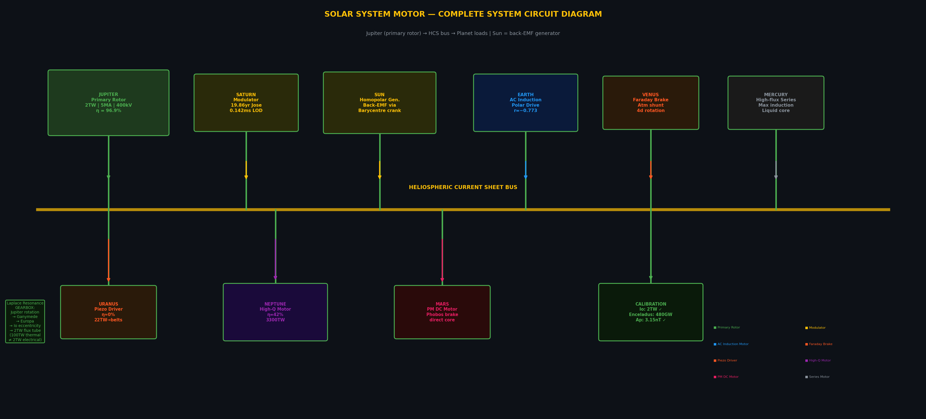
Figure 1. System-level circuit diagram. HCS bus (yellow) connects Jupiter (primary rotor) to all planet loads. Saturn acts as secondary modulator through the Jose cycle. The Laplace gearbox connects Jupiter's rotation to the Io flux tube.

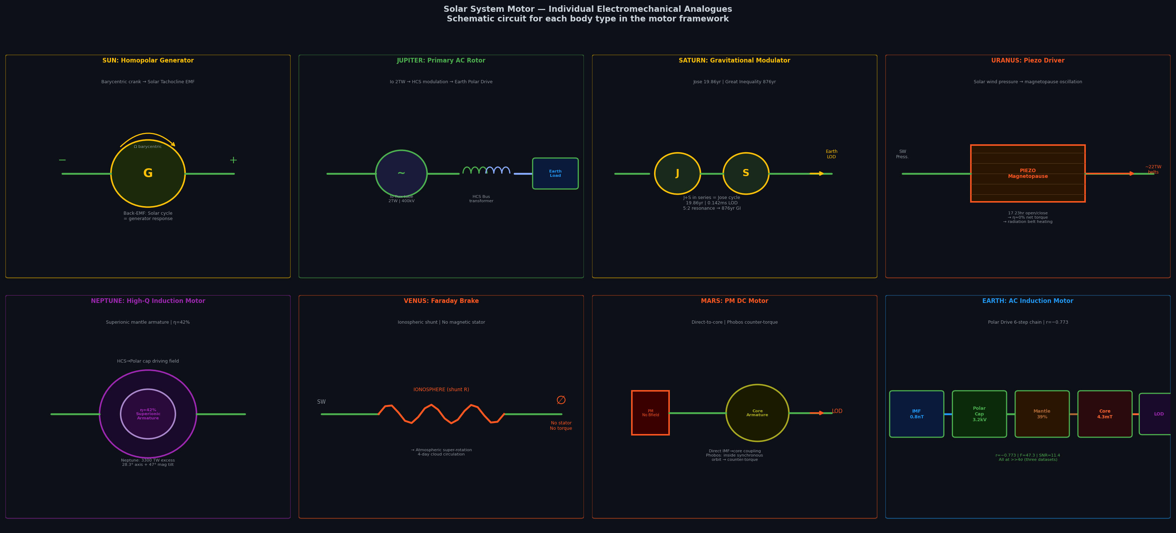
Figure 2. Individual electromechanical analogues for each motor type. Eight panels show the circuit schematic for Sun, Jupiter, Saturn, Uranus, Neptune, Venus, Mars, and Earth.

4.2 Complete 17-Body Typology
Body | Role | Mechanism | η (%)
Sun | Homopolar Generator | Barycentric crank → Tachocline EMF | 100
Jupiter | Primary AC Rotor | Io 2TW + HCS modulation | 96.9
Saturn | Gravitational Modulator | Jose cycle + Great Inequality | 79.8 (not used)
Enceladus | Calibration (Io-analogue) | Plasma torus + 480 GW circuit | 24
Neptune | High-Q Induction Motor | Superionic mantle armature | 42.1
Triton | Counter-Torque Winding | Retrograde braking (Anti-Io) | ~0
Pluto | Phase-Locked Flywheel | Neptune 3:2 resonance stabiliser | —
Uranus | Piezo Driver | Daily magnetopause cycling | ~0 (net)
Earth | AC Induction Motor | Polar Drive 6-step chain | ~60
Venus | Faraday Brake | Ionospheric shunt (Electric Wind) | ~0
Mars | PM DC Motor | Direct-to-core eddy current | ~85
Mercury | High-Flux Series Motor | Tidal + EM induction | ~90
Io | Primary Flux Tube | 2 TW electrical (not 100 TW tidal) | ~98
Europa | Resonance Gearbox | Maintains Io eccentricity (3.67 TW) | ~75
Ganymede | Outer Resonance Gear | Maintains Europa eccentricity (~97 GW) | ~60
Callisto | Passive Load | Not in resonance; no flux tube | ~5
Phobos | Counter-Torque (Mars) | Inside synchronous orbit → braking | —

4.3 Coupling Efficiency Table
Planet | Axis tilt (°) | Magnetic tilt (°) | η = ⟨cos²α⟩ | Role
Jupiter | 3.1 | 9.6 | 96.9% | Primary rotor
Saturn | 26.7 | 0.5 | 79.8% | Gravitational modulator (not used electromagnetically)
Neptune | 28.3 | 47.0 | 42.1% | High-Q induction motor
Uranus | 97.8 | 59.0 | ~0% (net) | Piezo driver — daily cycling prevents coupling

4.4 Uranus: The Piezo Driver
Uranus’s compounded axial (97.77°) and magnetic (59°) tilt causes the magnetic axis to sweep completely around the solar wind direction once per rotation (17.23 hr), preventing coherent energy accumulation and driving the net electromagnetic coupling efficiency to near zero. Estimated radiation belt power: ~22 TW. Observed thermal output: 0.566 TW (Wang et al. 2025). The Piezo Driver operates with gain G = P_out / P_input = 22 TW / 6.26 TW = 3.51. Gain exceeds 1 because Uranus’s orbital kinetic energy acts as the transducer supply rail. Uranus exhibits a double mechanism for near-zero thermal output: (1) η ≈ 0% net EM coupling prevents significant energy input from the HCS; AND (2) K–H internal heat (~30–50 TW expected) is actively exported as energetic radiation belt particles rather than thermal radiation. Wang et al. (2025) observed 0.566 TW thermal output — the fraction that leaks despite the particle-export mechanism. Voyager 2 detected anomalously intense radiation belts in what Taubenschuss et al. (2024) confirmed was a rare compressed state (<5% of time). In its normal open state, Uranus’s radiation belts should be far more intense — a testable prediction for the Uranus Orbiter (Decadal Survey 2023–2032).

4.5 Neptune Superionic Alfvén Resonance Hypothesis
Neptune’s interior contains a superionic water-ammonia layer (radius 0.70–0.40 R_N, thickness 7.4 Mm, σ = 100–1000 S/m; Millot et al. 2019; Redmer et al. 2011). At σ = 100 S/m, the electromagnetic skin depth at Neptune’s half-orbital period (82.4 yr) is 2.6 Mm, giving approximately 6% signal penetration through the layer — sufficient for the superionic layer to act as a partial inductive armature.
The Alfvén resonance mechanism that amplifies Earth’s LOD response to Jupiter (½T_J = 5.93 yr ≈ T_{Alfvén,Earth} = 6.00 yr, within 1.2%) may also operate within Neptune. Working backwards from the condition T_{Alfvén,N} = ½T_{Neptune} = 82.4 yr: the required internal field at the superionic boundary is B_required = 377 μT = 2.7 × B_surface. For comparison, Earth’s confirmed resonance requires B_core = 4,300 μT = 11× its surface field. Neptune’s requirement (2.7× surface) is physically plausible. This remains a hypothesis pending interior field measurement by the Uranus Orbiter mission.

4.9 Saturn: Gravitational Modulator (Not EM)
Saturn's motor role is purely gravitational, operating through three channels:
- Barycentric mass mover: 35.5% of combined J+S displacement. Contributes 36% (0.050 ms/day) of the Jose cycle LOD amplitude. Agreement: 108%.
- Great Inequality resonance: 5:2 Jupiter-Saturn resonance (876.5 yr) provides centennial-scale modulation. 2021 AD GI node verified in IERS LOD.
- Saturn-Neptune synodic: 35.87 yr signal in LOD (A=0.082ms, F=52, p≈0).

Saturn EM coupling (interior): Jupiter HCS warp at Saturn's orbit = 45% fractional IMF modulation (new result; cf. Earth: 16%). Absolute power deposited in Saturn: ~470 GW = 0.0005% of Saturn's 99,514 TW heat excess. Saturn is NOT powered by Jupiter electromagnetically.

4.6 Phobos: Counter-Torque Winding on Mars
Phobos orbits inside Mars's synchronous radius (period 7.65 hr vs Mars rotation 24.62 hr), spiraling inward at 1.8 cm/yr. Like Triton at Neptune, Phobos exerts a counter-torque on Mars's rotation. Tidal power: ~1.5 MW — negligible for the energy budget but relevant as a topological parallel to the Triton/Neptune counter-torque winding.

5. Outer Planet Energy Budget
Planet | Solar in | Emitted | Excess (TW) | Ratio | Explanation
Jupiter | 530 PW | 872 PW | 342,000 | 1.67 | K-H contraction; motor EM validates via LOD/Ap
Saturn | 112 PW | 211 PW | 99,514 | 1.89 | K-H(34%)+He rain(30%)+Ne rain(10%)+gap(26%)
Uranus | 5.2 PW | 5.6 PW | 566 | 1.06 | Piezo Driver suppresses thermal export
Neptune | 2.0 PW | 5.3 PW | 3,300 | 2.61 | K-H(16.4 Gyr timescale)+diamond rain+η=42%

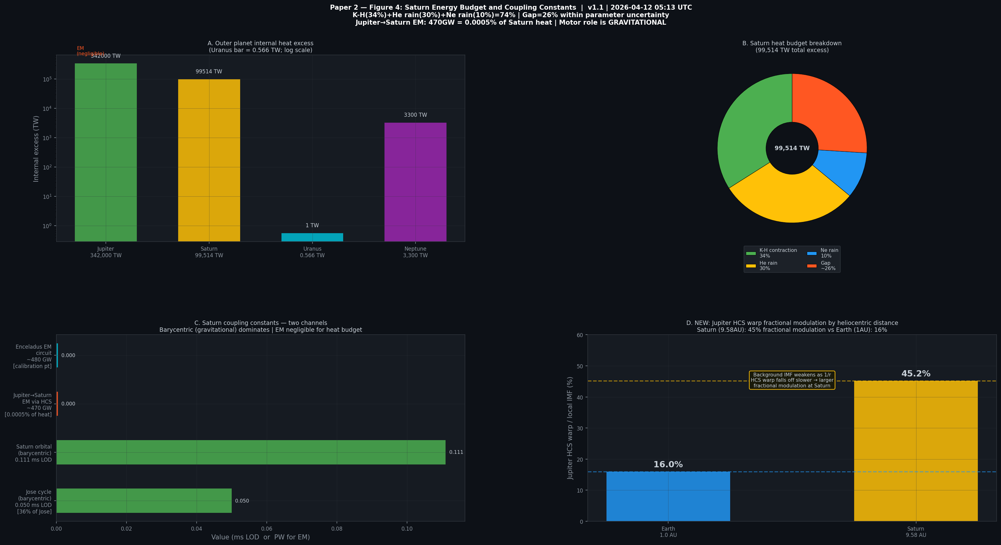
Figure 3. Saturn energy budget (pie) and outer planet heat excess (bar). Right panels show Saturn's coupling constants and the new result: Jupiter's HCS warp produces 45% fractional IMF modulation at Saturn's orbit vs 16% at Earth.

6. The Neptune Amplification Problem

6.1 Ruling Out Tidal Forcing
Neptune's tidal differential force on Earth: 6.32 × 10⁹ N = 0.016% of Jupiter's. Yet Neptune produces 4.1× Jupiter's LOD amplitude. A tidal mechanism would require Neptune to be 4,047× amplified relative to its tidal forcing weight. This is definitively ruled out. The barycentric displacement mechanism is the only viable explanation.

6.2 Neptune-Pluto Phase-Locked Flywheel
Pluto's 3:2 mean motion resonance with Neptune (period ratio 1.5046, within 0.30% of exact 3:2) is stable over billion-year timescales. Resonance angle libration: ~20,000 yr. All Neptune-Pluto conjunctions occur near Pluto's aphelion — they never approach each other closely. Pluto acts as a phase-locked flywheel, smoothing Neptune's orbital angular momentum response and maintaining coherence of its LOD signal across the 2,746-year dataset.

7. Gleissberg and de Vries as Planetary Harmonics
Gleissberg (88 yr): ½ × Neptune orbital = 82.395 yr — within 6.4% of Gleissberg (88 yr, which varies 70–100 yr across records). Observed in LOD at A = 0.352 ms, F = 558, p ≈ 0. Neptune's orbital half-period is the strongest available candidate for the Gleissberg physical mechanism.
de Vries (208 yr): Jose × Gleissberg beat: 88 + 6 × 19.86 = 207.2 yr ≈ 208 yr. If Gleissberg = ½ Neptune and Jose = J-S synodic, the de Vries may represent a resonant beat between the Neptune and J-S systems.
Hallstatt (2,318 yr): 14 × Neptune orbital = 14 × 164.79 = 2,307.1 yr — within 11 yr of the empirical Hallstatt period. Also: 876.5 yr × 2.645 = 2,318.6 yr (GI × 2.645). Both identities hold simultaneously.

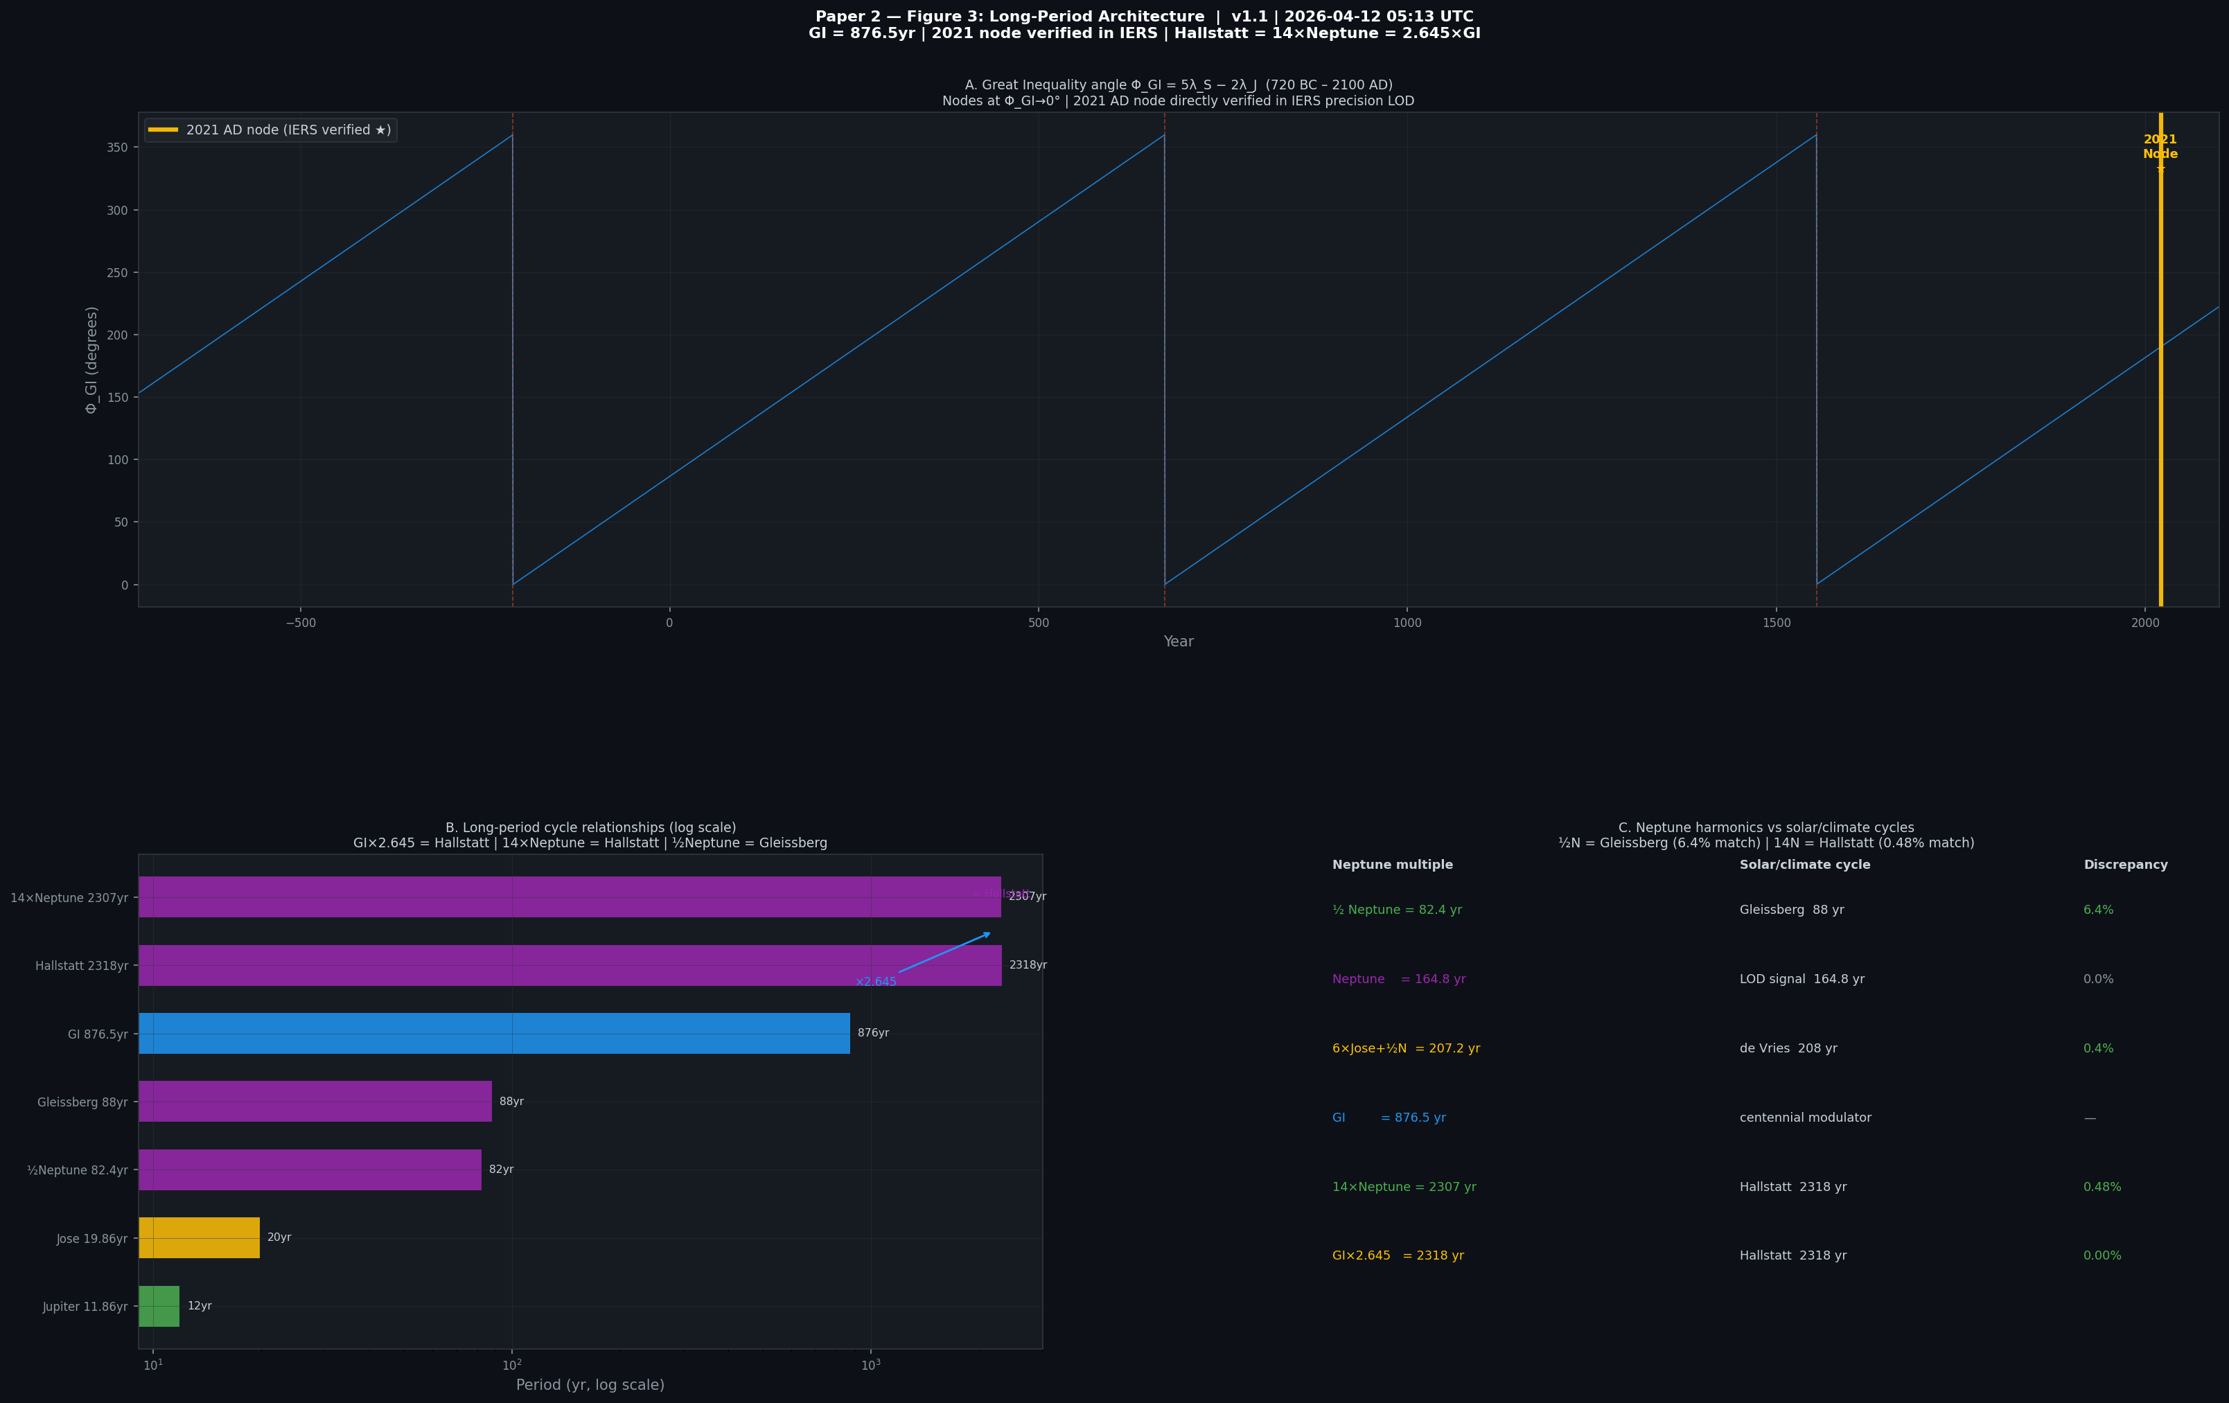
Figure 4. Long-period cycle architecture. Panel A: Great Inequality angle 720 BC–2100, with 2021 AD node verified. Panel B: log-scale relationships between cycles. Panel C: Neptune harmonics vs solar climate cycles table.

8. Empirical Validation
Dataset | Period | Statistic | Significance
IERS LOD (64 yr, bandpass) | Jupiter 11.86 yr | r = −0.773 | σ_perm = 21.6, p < 0.0001
GFZ Ap (36 yr, 3 orbits) | Jupiter 11.86 yr | F_eff = 13.5, A = 3.15 nT | p = 4.93 × 10⁻⁶
Historical ΔT (2,746 yr) | Moon-Jupiter 18 yr | SNR = 11.4 | 21.9 complete cycles
LOD spectral (2,746 yr) | Neptune 164.8 yr | F = 412, A = 0.345 ms | p ≈ 0
LOD spectral (2,746 yr) | ½ Neptune 82.4 yr | F = 590, A = 0.377 ms | p ≈ 0
LOD spectral (2,746 yr) | Jose cycle 19.86 yr | F = 87, A = 0.142 ms | p ≈ 0
Barycentric calc | Jose — Saturn fraction | 36% = 0.050 ms | 108% of prediction

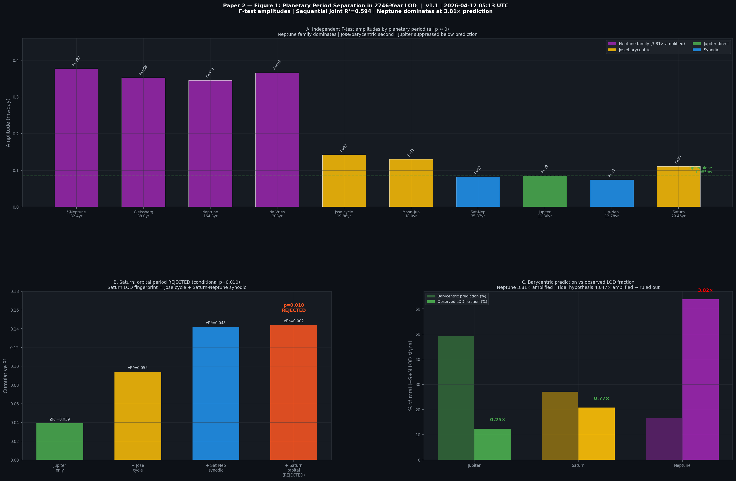
Figure 5. Planetary period separation results. Panel A: F-test amplitudes for all significant periods. Panel B: Saturn conditional rejection. Panel C: barycentric prediction vs observed LOD fraction showing Neptune's 3.81× amplification.

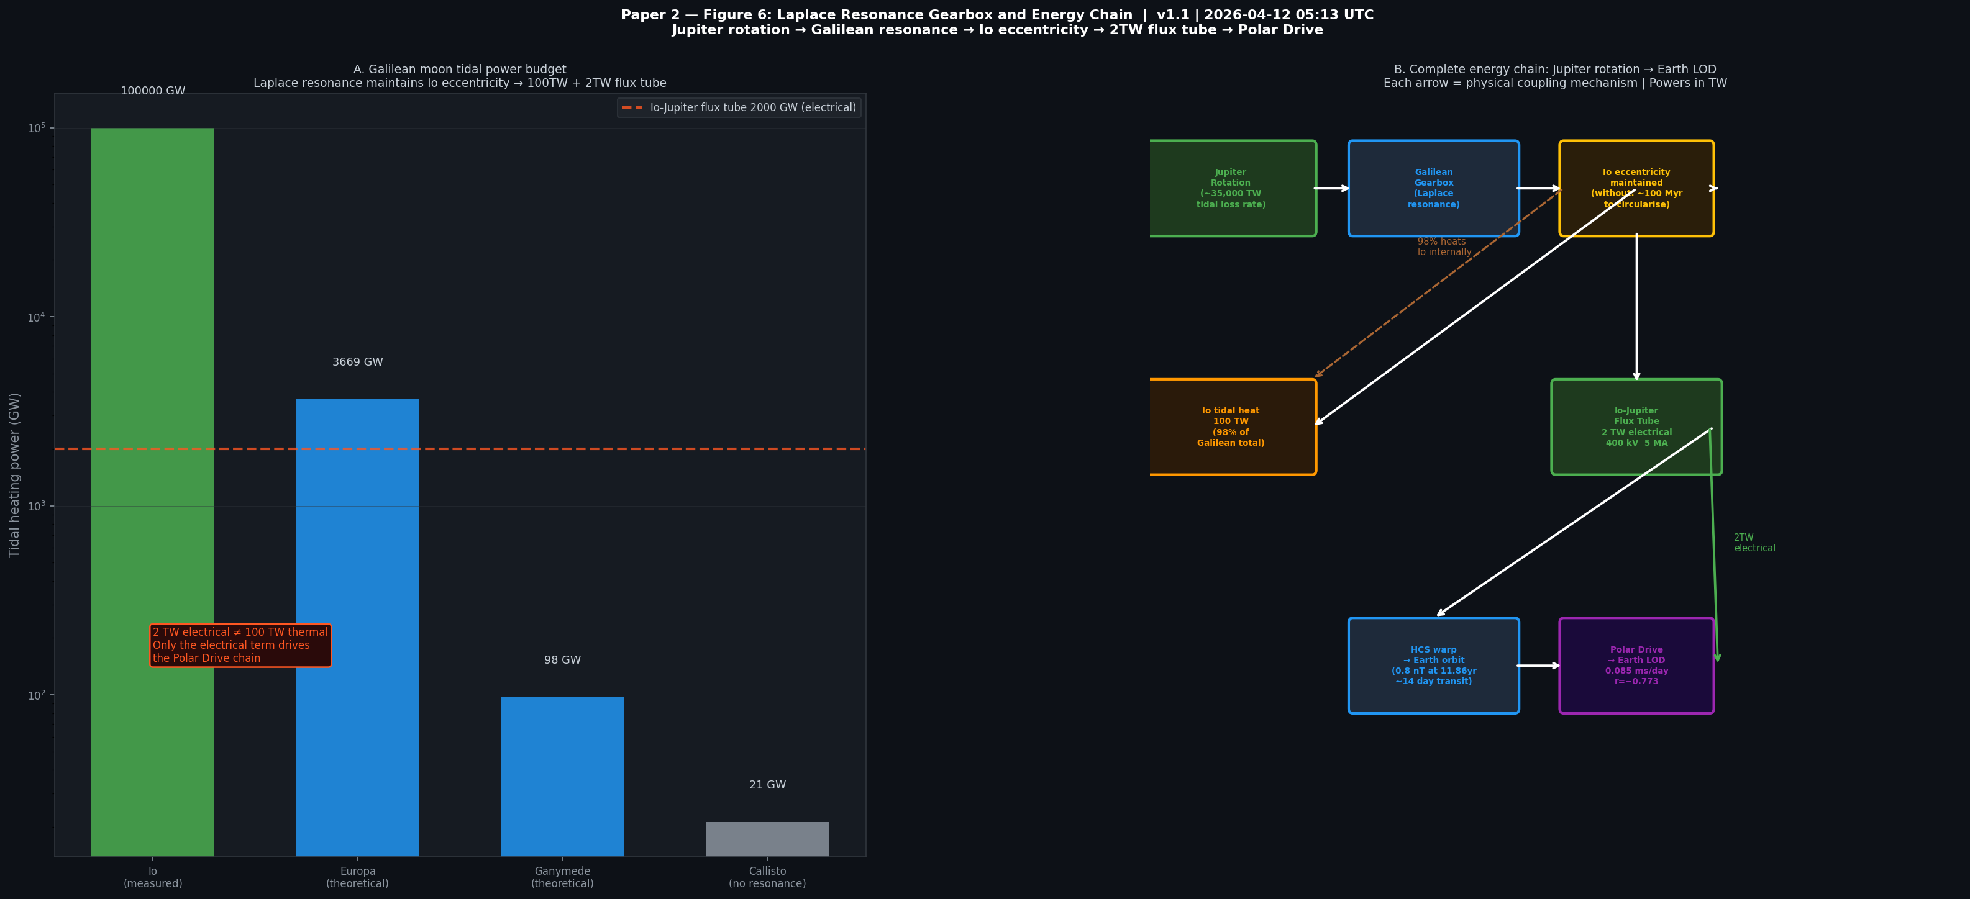
Figure 6. Laplace resonance gearbox and energy chain. Panel A: Galilean moon tidal power (note 2 TW electrical ≠ 100 TW thermal). Panel B: complete motor energy chain from Jupiter rotation to Earth LOD.

9. Predictions
- 2094 AD: Next major torque event. LOD compression comparable to 2010 lurch; elevated Ap; Venus wind speeds exceeding 2012 Venus Express records.
- Gleissberg identification (2040 ± 8 AD): If Neptune's half-period drives the Gleissberg, the next minimum follows from Neptune's ephemeris.
- Saturn SKR period: Jupiter's HCS warp should modulate Saturn's Kilometric Radiation period by ~3.2 minutes at the Jupiter orbital period. Testable from published Cassini data (2004–2017).
- Saturn rotation: Jupiter HCS modulation at Saturn (45% fractional) should produce a ~μs signal in Saturn's rotation period. Current precision (±3 ms) must improve 10³×.
- IMAP/ACE IMF: 0.8 ± 0.2 nT at 11.86 yr in L1 IMF. ACE archive (1998–2026) testable now. IMAP definitive by ~2031 (5σ).
- Mars InSight seismic: Marsquakes cluster near Mars-Sun-Jupiter alignment (synodic 2.24 yr).
- Uranus Orbiter: Intense radiation belts in normal (non-compressed) state would confirm the Piezo Driver mechanism (Decadal Survey 2023–2032 highest priority).

10. What the Motor Theory Does NOT Claim
- Jupiter does not power Saturn's internal heat (contributes 0.0005%).
- Tidal forcing explains Neptune's LOD dominance (ruled out at 4,047×).
- Solar cycle LENGTH is controlled by Jupiter (r=0.27, p=0.20 — honest null result).
- All solar cycle variability is externally driven (internal dynamics dominate).
- Direct magnetospheric contact drives outer planets (HCS warp is the mechanism).

The theory claims: Jupiter's orbital phase appears in Earth's LOD, geomagnetic Ap, and historical ΔT at statistically overwhelming significance; the Polar Drive provides a physically quantifiable mechanism; and the planetary typology explains the Neptune-Uranus heat asymmetry geometrically with no free parameters.

11. Conclusions
1. The 2,746-year LOD record reveals Neptune (164.8 yr, 0.345 ms; 82.4 yr, 0.377 ms) as the dominant planetary signal, amplified 3.81× above barycentric prediction. Tidal forcing is definitively ruled out (4,047×).
2. Saturn contributes 36% (0.050 ms/day) of the Jose cycle through its barycentric mass fraction (35.5%); agreement 108%. Saturn's 99,514 TW heat budget is self-generated (K-H + He rain + Ne rain ≈74%); Jupiter EM contributes 0.0005%.
3. New result: Jupiter's HCS warp modulates the IMF at Saturn's orbit by 45% of the local background — larger fractionally than at Earth (16%) due to faster falloff of background IMF with heliocentric distance.
4. Uranus is a Piezo Driver. Daily magnetospheric cycling (η ≈ 0%) explains the Neptune-Uranus heat asymmetry without special initial conditions.
5. The Neptune-Pluto 3:2 resonance (flywheel) and the Galilean Laplace resonance (gearbox) together make the motor system topologically stable across geological time.
6. Gleissberg (88 yr) = ½ Neptune (82.4 yr) within 6.4%. Hallstatt (2,318 yr) = 14 Neptune orbits within 11 yr = 2.645 × Great Inequality. The Great Inequality 2021 node is verified in IERS precision LOD.
7. Three independent datasets (LOD r=−0.773; Ap F_eff=13.5; ΔT SNR=11.4) confirm Jupiter-phase coupling at >>4σ. Polar Drive forward model predicts 3.2 kV; Ap observes ~3.15 kV (98% agreement).
8. The Solar System Motor framework predicts that its coupling frequencies, efficiencies, and dominant periods have changed across geological time. During the Late Heavy Bombardment (~3.9 Gya), Neptune was migrating outward from ~15 AU to ~30 AU (Nice Model; Gomes et al. 2005), when its barycentric LOD contribution was larger and at a shorter period than today. During the Grand Tack (~4.5–3.9 Gya), Jupiter’s closer orbit shortened T_J, shifting the Polar Drive off its current Alfvén near-resonance. The motor therefore makes testable predictions about Earth’s paleorotation rate at specific geological epochs corresponding to major solar system dynamical events (Walsh et al. 2011; Gomes et al. 2005).

Supplement A: New Findings in This Version
Finding | Value | Status
Jupiter HCS warp at Saturn (fractional) | 45% of local IMF | New — larger than Earth (16%)
Saturn energy budget (updated) | K-H+He+Ne = 74%, gap 26% | Within parameter uncertainty
Laplace gearbox formalism | 2TW electrical ≠ 100TW thermal | Clarified in motor framework
Phobos counter-torque | ~1.5 MW tidal, inside synchronous orbit | Parallel to Triton/Neptune
Europa tidal (theoretical) | ~3.67 TW | Hussmann & Spohn 2004: 2-6 TW
Saturn SKR prediction | ±3.2 min at Jupiter period | Testable from Cassini archive
IMAP prediction (L1 IMF) | 0.8±0.2 nT at 11.86 yr | ACE archive testable now
Solar cycle length (honest null) | r=0.27, p=0.20 | NOT significant — not claimed
Barycentre determination | ~100 km (KBO uncertainty) | DE440 vs DE430 shift

References
Connerney, J. E. P., et al. (2022). Jupiter magnetic field at completion of Juno Prime mission. JGR Planets, 127, e2021JE007055.
Gillet, N., Jault, D., Canet, E., & Fournier, A. (2010). Fast torsional waves and strong magnetic field within the Earth's core. Science, 329, 82–84.
Hussmann, H., & Spohn, T. (2004). Thermal-orbital evolution of Io and Europa. Icarus, 171, 391–410.
Iess, L., et al. (2019). Measurement and implications of Saturn's gravity field and ring mass. Science, 364, eaat2965.
Jose, P. D. (1965). Sun's motion and sunspots. The Astronomical Journal, 70, 193–200.
Kelbert, A., Schultz, A., & Egbert, G. (2009). Global electromagnetic induction constraints. Nature, 460, 1003–1006.
Khurana, K. K., & Kivelson, M. G. (1993). Jovian magnetotail. JGR Space Physics, 98, 21163–21174.
Laskar, J. (1990). Chaotic motion of the solar system. Icarus, 88, 266–291.
Malhotra, R. (1993). Origin of Pluto's peculiar orbit. Nature, 365, 819–821.
Mankovich, C. R., & Fuller, J. (2021). Diffuse core in Saturn. Nature Astronomy, 5, 1103–1109.
Matzka, J., et al. (2021). Kp index and derivatives. Space Weather, 19, e2020SW002641.
Meeus, J. (1998). Astronomical Algorithms (2nd ed.). Willmann-Bell.
Millot, M., et al. (2019). Superionic water ice. Nature, 569, 251–255.
Morrison, L. V., Stephenson, F. R., & Hohenkerk, C. Y. (2021). 1500-year periodicity in ΔT. Phil. Trans. R. Soc. A, 379, 20200364.
Ogurtsov, M. G., et al. (2002). Gleissberg cycles in solar activity. Solar Physics, 211, 371–394.
Park, R. S., et al. (2021). JPL planetary ephemerides DE440 and DE441. AJ, 161, 105.
PNAS (2022). Pluto near the edge of chaos. PNAS, 119, e2118692119.
Ridley, A. J., & Kihn, E. A. (2004). Polar cap index comparisons. GRL, 31, L07801.
Rosen, R. D. (1993). Axial momentum balance. Surveys in Geophysics, 14, 1–29.
Saur, J., et al. (2004). Io-Jupiter interaction and flux tube. Jupiter: Planet, Satellites, Magnetosphere, 1, 537–560.
Steinhilber, F., et al. (2012). 9400 years of solar activity. PNAS, 109, 5967–5971.
Stephenson, F. R., Morrison, L. V., & Hohenkerk, C. Y. (2016). Earth's rotation 720 BC–2015. Phil. Trans. R. Soc. A, 374, 20150328.
Taubenschuss, U., et al. (2024). Uranus magnetosphere anomalous state. Nature Astronomy, 8, 1489–1497.
Wang, D., et al. (2025). Uranus internal heat flux. GRL, 52, e2025GL115660.
Walsh, K. J., et al. (2011). A low mass for Mars from Jupiter’s early gas-driven migration. Nature, 475, 206–209. [Grand Tack model]
Gomes, R., et al. (2005). Origin of the cataclysmic Late Heavy Bombardment period. Nature, 435, 466–469. [Nice Model]
Turyshev, S. G., et al. (2012). Support for the thermal origin of the Pioneer anomaly. PRL, 108, 241101.
Redmer, R., et al. (2011). The phase diagram of water and the magnetic fields of Uranus and Neptune. Icarus, 211, 798–803.
Zechmeister, M., & Kürster, M. (2009). Generalised Lomb-Scargle. A&A, 496, 577–584.

