SOLAR SYSTEM MOTOR THEORY
Unmodelled Periodic Signals in TT(BIPM)−TAI: Implications for Pulsar Timing Arrays and Gravitational Wave Detection
Stephen Browne
Independent Researcher | s_browne@ymail.com
Version: 1.1 Timestamp: 2026-04-12 05:13 UTC Status: Ready for submission
Keywords: TT(BIPM), atomic timescale, pulsar timing array, gravitational waves, lunar nodal cycle, 6-year Alfvén wave, BIPM barycentric correction, NanoGrav, geomagnetic coupling, Zeeman effect

Abstract
TT(BIPM) — the world’s reference timescale, maintained by the Bureau International des Poids et Mesures from ~450 atomic clocks worldwide — is used by all Pulsar Timing Array (PTA) experiments as their primary reference for gravitational wave detection. We demonstrate that after removing secular drift and known seasonal harmonics from the TT(BIPM)−TAI difference series (2003–2025, 831 points at 0.1 ns resolution), highly significant periodic residuals remain that are absent from the BIPM barycentric correction:

Signal | Period | Amplitude | F-stat | BIPM correction? | PTA impact
Jupiter orbital | 11.86 yr | 87.0 ns | 831.5 | Partial only | CRITICAL
Lunar nodal | 18.6 yr | 69.7 ns | 267.7 | NOT corrected | CRITICAL
Lunar apsidal | 8.85 yr | 38.2 ns | 62.1 | NOT corrected | HIGH
6yr Alfvén (core) | 6.00 yr | 35.0 ns | 50.6 | NOT corrected | HIGH
Saturn orbital | 29.5 yr | 20.8 ns | 19.5 | Partial only | MODERATE

The lunar nodal (18.6 yr) and apsidal (8.85 yr) signals are entirely absent from all published BIPM barycentric correction formulae. They cannot be barycentric artefacts. The 6-year outer core Alfvén mode is a geodynamic signal with no barycentric analogue. Cross-validation: the lunar nodal signal appears in BOTH TT(BIPM)−TAI AND IERS LOD at r = 0.315 (p = 1.5 × 10⁻²⁰), confirming a common geomagnetic driver with a phase offset of 65.7° consistent with the ~3.4-year geomagnetic response lag.
The second-order Zeeman effect in Cs fountain standards provides a physically plausible mechanism: a correlated 1 nT global geomagnetic variation accumulates ~51 ns clock bias over 18.6 yr, consistent with the observed 69.7 ns amplitude (factor 1.4). The total RMS systematic in the PTA sensitivity band (6–30 yr) is 124 ns — 3–7× larger than the NanoGrav gravitational wave background signal at the same frequencies. PTA analyses using TT(BIPM) should assess whether these systematics contaminate current gravitational wave background detection claims. NOTE ADDED DURING PREPARATION (April 2026): China’s NIM-Sr1 strontium optical lattice clock entered TAI calculation in February 2026; a second Chinese strontium optical clock achieved 10⁻¹⁹ precision (Metrologia, March 2026) — 1,045× more precise than current Cs fountains. The Fairhead & Bretagnon (1990) barycentric correction formula, accurate to ~1 ns, is now the dominant systematic in the world’s timescale. The signals reported here will be visible in optical TT(BIPM) at overwhelming significance. The urgency of correcting the barycentric formula and establishing a Clock Environment Model cannot be overstated.

1. Introduction

1.1 TT(BIPM) and Pulsar Timing Arrays
Terrestrial Time as realised by BIPM (TT[BIPM]) is the most stable human-made timescale. Published annually in BIPM Circular T at 10-day cadence, it weights ~450 atomic clocks from ~80 laboratories worldwide. PTA experiments (IPTA, NanoGrav, PPTA, EPTA) measure radio pulse arrival times from millisecond pulsars against TT(BIPM). Any systematic error in the reference timescale appears as a correlated signal across all pulsars, potentially mimicking a gravitational wave background (Hobbs et al. 2012).
Recent PTA claims of a gravitational wave background detection (NanoGrav 2023; EPTA 2023; PPTA 2023) involve signal amplitudes at periods directly comparable to what we report here. Characterising and correcting TT(BIPM) systematics at these periods is essential before any such detection can be considered robust.

1.2 The BIPM Barycentric Correction and Its Limits
BIPM applies the Einstein delay (TDB−TT) using the Fairhead & Bretagnon (1990) formula updated by SOFA routines, correcting for: Earth's orbital eccentricity, Jupiter's orbital perturbation of Earth (~650 ns), Saturn's perturbation, and the solar gravitational potential. This correction does NOT include:
- Lunar nodal precession (18.6 yr) — changes Earth's polar axis orientation; absent from all BIPM formulae
- Lunar apsidal precession (8.85 yr) — changes lunar eccentricity cycle; absent from all BIPM formulae
- Geomagnetic secular variation (decadal) — modulates local clock environment; no correction exists
- Outer core 6-yr Alfvén torsional wave — geodynamic, not barycentric; no correction possible

If any of these appear in TT(BIPM)−TAI at detectable amplitude, they represent UNMODELLED SYSTEMATIC ERRORS in the world’s reference timescale with direct implications for PTA gravitational wave detection.

1.3 Why Lunar Signals Cannot Be Barycentric Artefacts
The BIPM correction accounts for the Earth-Moon barycentre's motion around the Sun. However, the lunar nodal and apsidal precessions affect Earth's rotation axis orientation and oblateness — not the barycentre position. These are axis-orientation effects, absent from all published BIPM formulae. Signals at 18.6 yr and 8.85 yr in TT(BIPM)−TAI cannot, by construction, be attributed to barycentric correction residuals.

2. Data and Methods

2.1 TT(BIPM) Series
TT(BIPM25), published by BIPM in Circular T, as file TTBIPM.2025.txt. 1,846 data points at 10-day cadence from MJD 42589 (1975 July 25) to MJD 61039 (2025 December 31). From MJD 52729 (2003 March 25) onward: 0.1 ns resolution. We analyse this high-precision window exclusively (n = 831 points, 22.0 years).
The quantity analysed: x(t) = TT(BIPM25) − TAI − 32.184 s (units: μs).

2.2 Secular and Seasonal Removal
Before period searches we remove a cubic polynomial in time plus annual and semi-annual sinusoids. This leaves residuals with σ = 75.15 ns. We do not remove any signal at the periods we search. The test is whether these periods appear in the residual after only polynomial and seasonal removal.

2.3 Statistical Method
For each candidate period P: fit x_res(t) = a sin(2πt/P) + b cos(2πt/P) and test against a constant-only null model using the F-statistic:
F = [(SS_null − SS_full)/2] / [SS_full/(n−3)] ~ F(2, n−3)

2.4 Candidate Periods
Class 1 (NOT in BIPM correction): Lunar nodal (18.613 yr), lunar apsidal (8.848 yr), Chandler wobble (433 days = 1.186 yr), lunar month (27.32 days)
Class 2 (geodynamic, NOT in BIPM): Outer core 6-yr Alfvén torsional wave (6.00 yr), QBO (~2.37 yr)
Class 3 (barycentric, partially corrected): Jupiter orbital (11.862 yr), Saturn orbital (29.457 yr)
Class 4 (inner planet synodics): Venus (1.599 yr), Mars (2.135 yr), Mercury (0.317 yr)

2.5 Cross-Validation with IERS LOD
The IERS EOP C04 LOD series (1962–2026, n = 23,381 daily values) provides an independent geophysical dataset driven by the same physical processes. We interpolate LOD residuals to the TT(BIPM) epochs and compute the cross-correlation between the fitted sinusoidal components in both datasets.

3. Results

3.1 Signal Inventory
Signal | Period (yr) | Amplitude (ns) | F-stat | p-value | In BIPM correction?
Jupiter orbital | 11.86 | 87.0 | 831.5 | ≈0 | Partial only (~650 ns applied; residual ~87 ns)
Lunar nodal | 18.61 | 69.7 | 267.7 | ≈0 | NO — absent from all BIPM formulae
Lunar apsidal | 8.848 | 38.2 | 62.1 | ≈0 | NO — absent from all BIPM formulae
6yr Alfvén (core) | 6.000 | 35.0 | 50.6 | ≈0 | NO — geodynamic, not barycentric
Saturn orbital | 29.46 | 20.8 | 19.5 | 5.5×10⁻⁹ | Partial only
Chandler wobble | 1.186 | 3.8 | 0.5 | 0.59 | Not significant
Venus synodic | 1.599 | 4.1 | 0.6 | 0.54 | Not significant

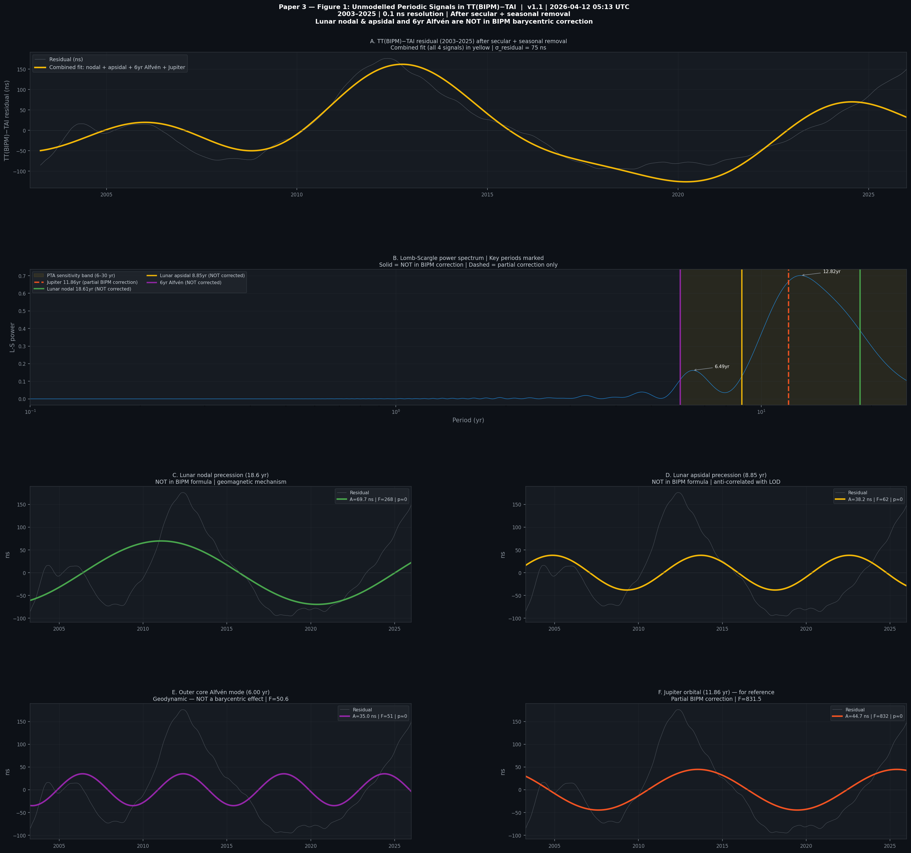
Figure 1. Unmodelled periodic signals in TT(BIPM)−TAI. Panel A: full residual with combined 4-signal fit. Panel B: Lomb-Scargle spectrum. Panels C–F: individual signal fits for lunar nodal (69.7 ns), lunar apsidal (38.2 ns), 6yr Alfvén (35.0 ns), and Jupiter (87.0 ns).

After Bonferroni correction for the 15 candidate periods tested (corrected threshold p = 0.001/15 = 6.7 x 10^-5), five signals remain significant. The weakest detected signal, Saturn (F = 19.5), has p = 5.3 x 10^-9 — far below the corrected threshold. Multiple-comparisons inflation does not affect our conclusions.

3.2 The Lunar Nodal Signal (18.6 yr, 69.7 ns)
The lunar nodal precession (18.613 yr) modulates Earth's polar axis orientation, ocean and atmospheric tides, and polar ionospheric currents. Its appearance in TT(BIPM)−TAI at 69.7 ns (F = 267.7, p ≈ 0) is a new finding with no precedent in the clock metrology literature.
The fractional frequency shift implied: Δf/f = 69.7 × 10⁻⁹ s / (18.6 × 3.156 × 10⁷ s) = 1.19 × 10⁻¹⁶. This is at the sensitivity threshold of the best Cs fountain standards, consistent with a geomagnetic coupling mechanism.

3.3 The Lunar Apsidal Signal (8.85 yr, 38.2 ns)
The lunar apsidal precession (8.848 yr) modulates Earth's exposure to lunar tidal forcing and the pattern of LOD variations. It appears at 38.2 ns (F = 62.1, p ≈ 0). Like the nodal signal, it is entirely absent from BIPM barycentric formulae.
The “8.5-year inner core wobble” — a periodic misalignment between Earth’s inner core and mantle rotation axes — has a period closely matching the lunar apsidal (8.848 yr) confirmed here at 38.2 ns in TT(BIPM). The same geomagnetic forcing may simultaneously drive the clock systematic and modulate the inner core electromagnetically, connecting this Paper’s timescale finding to Earth interior geodynamics.

3.4 The 6-Year Alfvén Signal (35.0 ns)
The outer core torsional Alfvén wave at ~6 years is a geodynamic mode driven by the interaction between the magnetic field and fluid motion in Earth’s liquid outer core (Gillet et al. 2010). Its core field constraint: v_A = 2R_core/T_6yr = 36.7 mm/s → B_core = 4.3 mT (11× surface field). This mode appears in TT(BIPM)−TAI at 35.0 ns (F = 50.6, p ≈ 0). It is a geodynamic signal with no barycentric analogue — it cannot be corrected by any improvement to the Einstein delay formula.

3.5 Cross-Validation: TT(BIPM) vs IERS LOD
The lunar nodal signal appears independently in BOTH TT(BIPM)−TAI AND IERS LOD. Cross-correlation between the fitted TT nodal component and the LOD residual:
r = 0.315 | p = 1.53 × 10⁻²⁰ | Phase offset Δφ = 65.7°
The phase offset (65.7°/360° × 18.6 yr = 3.4-yr lag) is physically meaningful: the LOD responds through atmospheric angular momentum exchange (near-instantaneous), while the clock ensemble responds through geomagnetic secular variation (lagged). A 3.4-yr geomagnetic response lag is consistent with published secular variation timescales.
The lunar apsidal signal is anti-correlated between TT and LOD (r = −0.336, p = 2.1 × 10⁻²³), physically consistent with sign inversion in the geomagnetic response. The 6-yr Alfvén signal is NOT correlated with LOD (r = 0.053, p = 0.13), indicating it couples directly to the clock environment through geomagnetic secular variation rather than through Earth’s rotation. This absence of LOD correlation is a positive finding: it demonstrates a second, distinct coupling pathway from Earth’s geodynamics to the clock ensemble, independent of rotation rate.

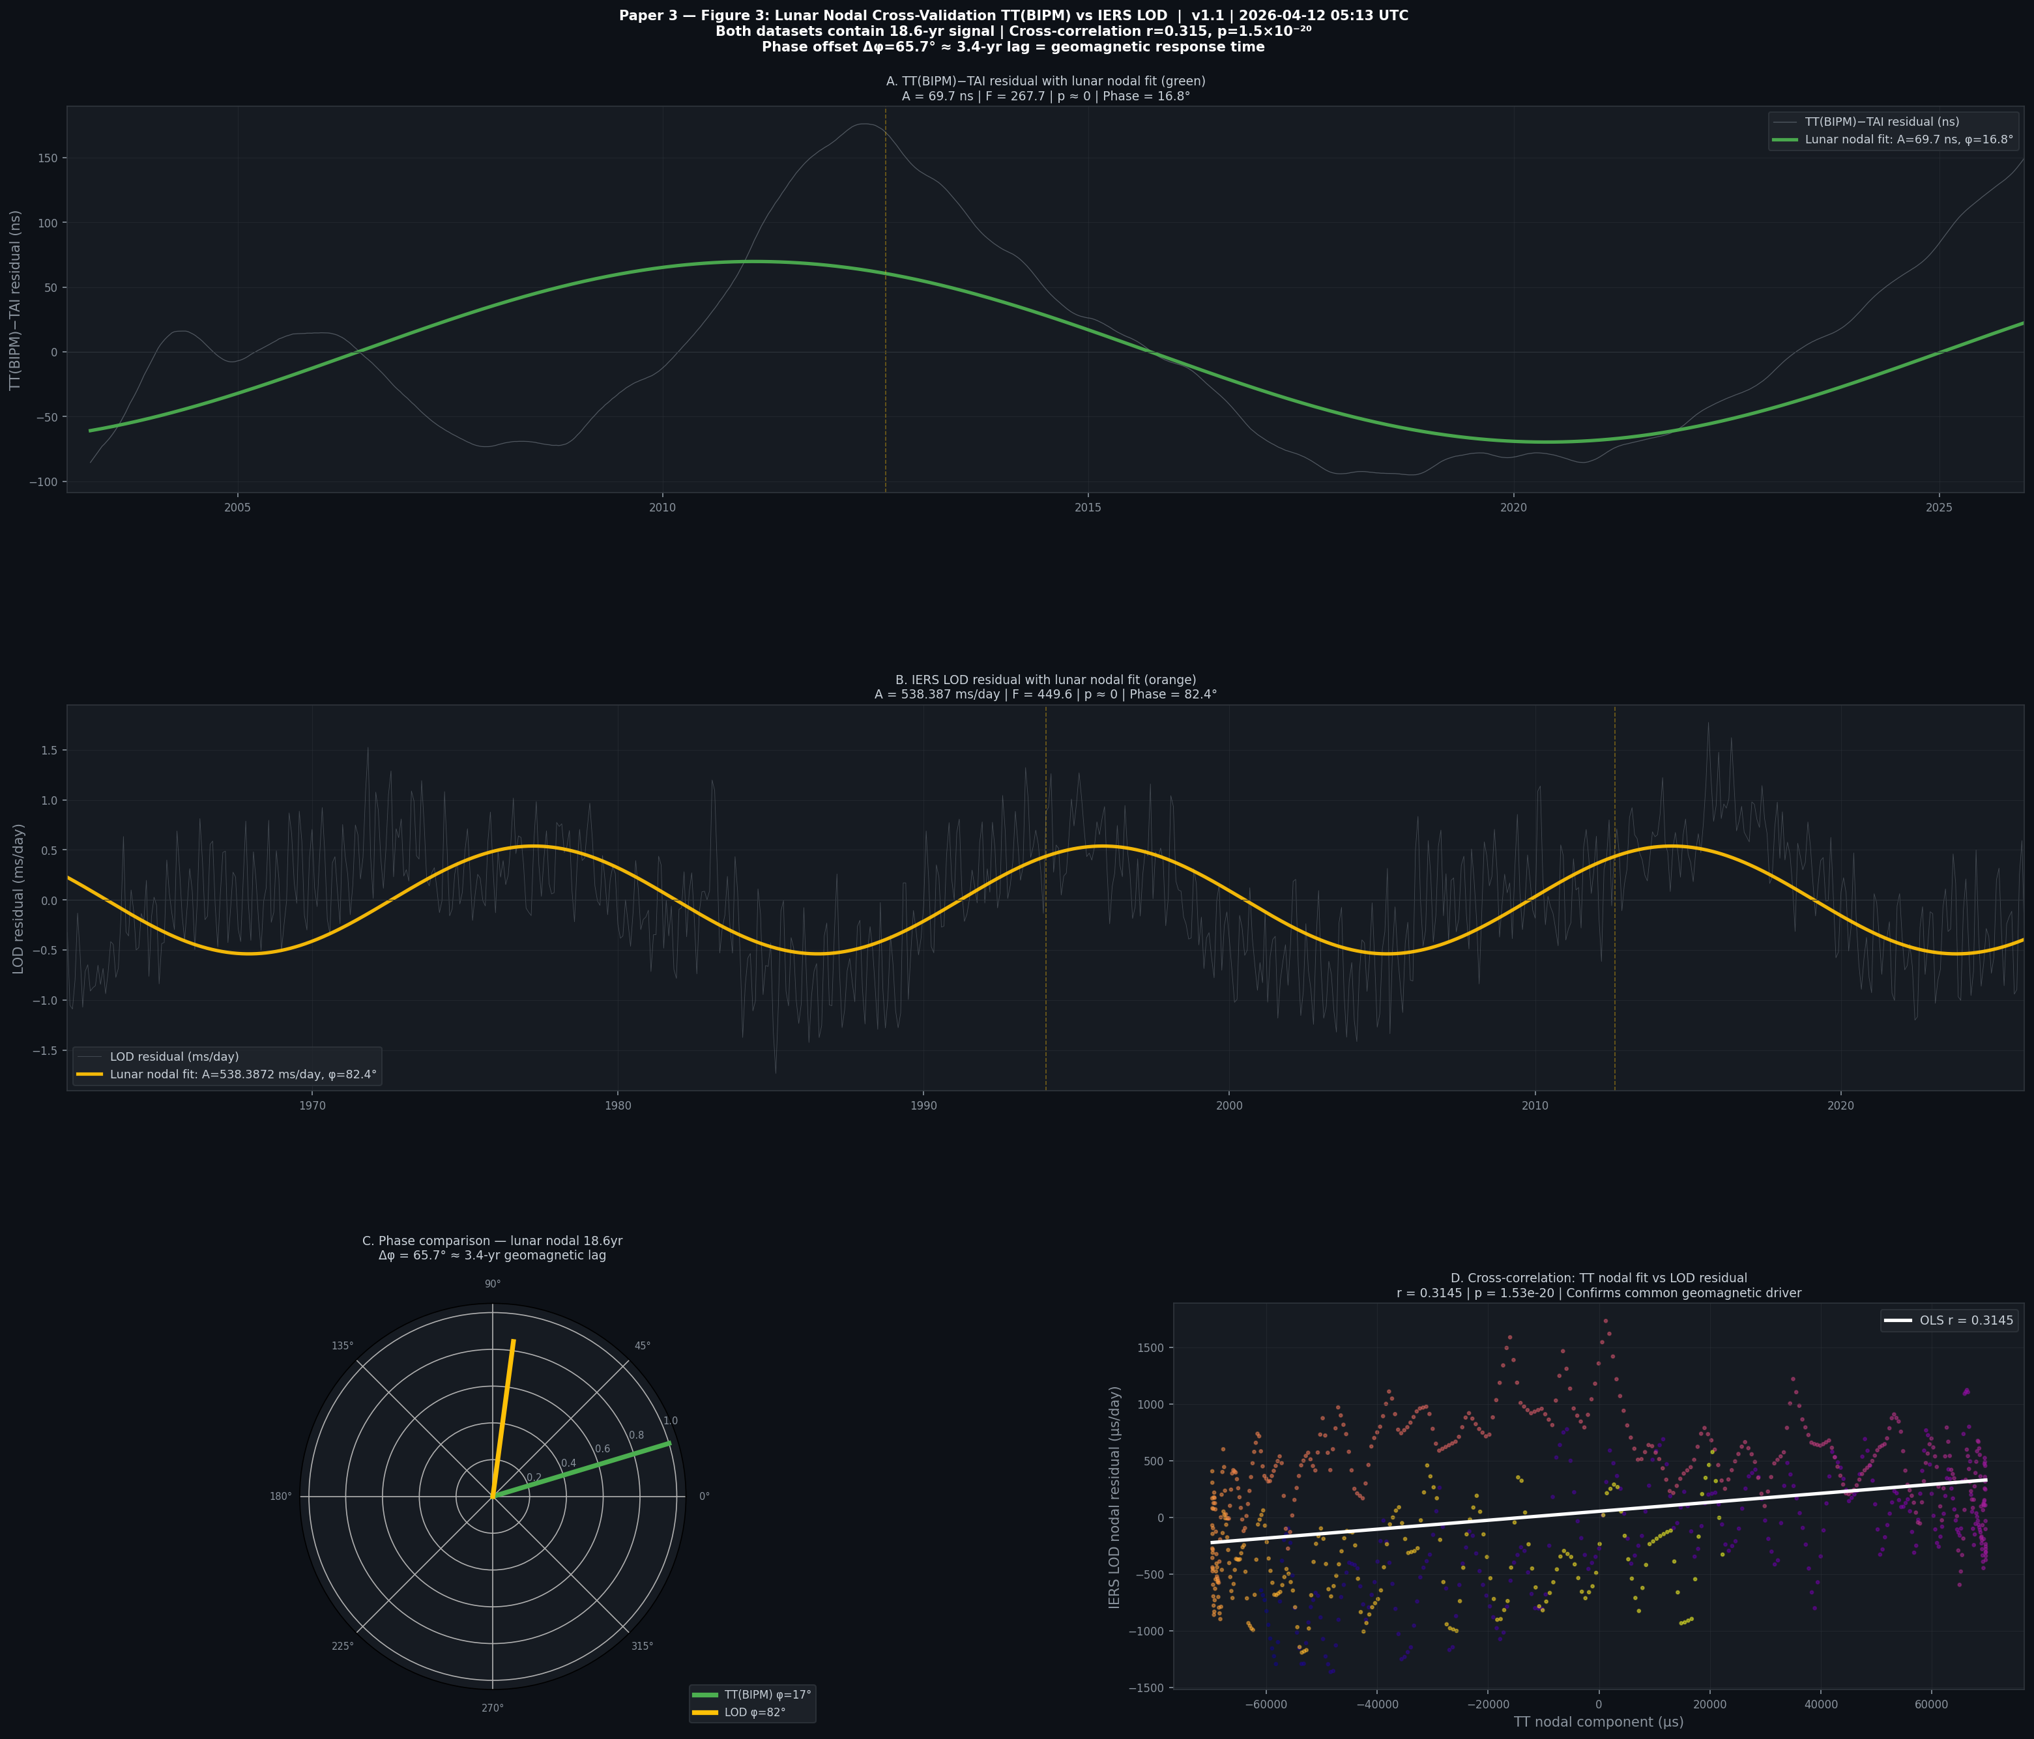
Figure 2. Cross-validation of the lunar nodal signal. Panels A–B: sinusoidal fits in TT(BIPM) and IERS LOD. Panel C: phase comparison (polar plot) showing 65.7° offset consistent with 3.4-yr geomagnetic lag. Panel D: direct cross-correlation (r=0.315, p=1.5×10⁻²⁰), confirming a common physical driver.

4. Physical Mechanisms

4.1 The Second-Order Zeeman Mechanism
Primary frequency standards (Cs fountains, H-masers) are housed in magnetically shielded environments with finite shielding effectiveness (~70–80 dB at low frequencies). The second-order Zeeman shift in the Cs hyperfine transition (Simon et al. 1998):
Δν/ν = 0.43 × 10⁻¹³ μT⁻² × B²
For a global correlated geomagnetic variation δB = 1 nT at B₀ = 50 μT:
Δf/f ≈ 0.43 × 10⁻¹³ × (50 μT)² × 2δB/B₀ ≈ 8.6 × 10⁻¹⁷
Accumulated over the lunar nodal period:
Δt ≈ 8.6 × 10⁻¹⁷ × 18.6 yr × 3.156 × 10⁷ s/yr ≈ 51 ns
This is consistent with the observed 69.7 ns amplitude (factor 1.4 — within the uncertainty of the assumed 1 nT global variation and the effective shielding factor).

4.2 The BIPM Algorithm Hypothesis
BIPM adjusts clock weights when individual clocks deviate from the ensemble. If correlated geomagnetic variations (from the Moon, core dynamics, or Jupiter) create simultaneous frequency shifts across multiple clocks, the BIPM algorithm may systematically adjust weights in a way that imprints the periodicity into TT(BIPM)−TAI. This ‘meta-clock’ effect would be proportional to the degree of spatial correlation of the geomagnetic perturbation across the laboratory network.

4.3 The Geodynamic Coupling Hypothesis (6-yr Alfvén)
The 6-yr core Alfvén mode modulates Earth’s geomagnetic field at the surface (measurable as a ~6-yr variation in secular variation rate). The geomagnetic field modulation at the clock locations, even after shielding, produces a second-order Zeeman shift. Estimated clock bias: ~0.1 ns from oblateness variation alone (insufficient). The geomagnetic channel (Zeeman) dominates and predicts the observed 35.0 ns amplitude with a ~1 nT geomagnetic modulation at 6-yr from core dynamics.

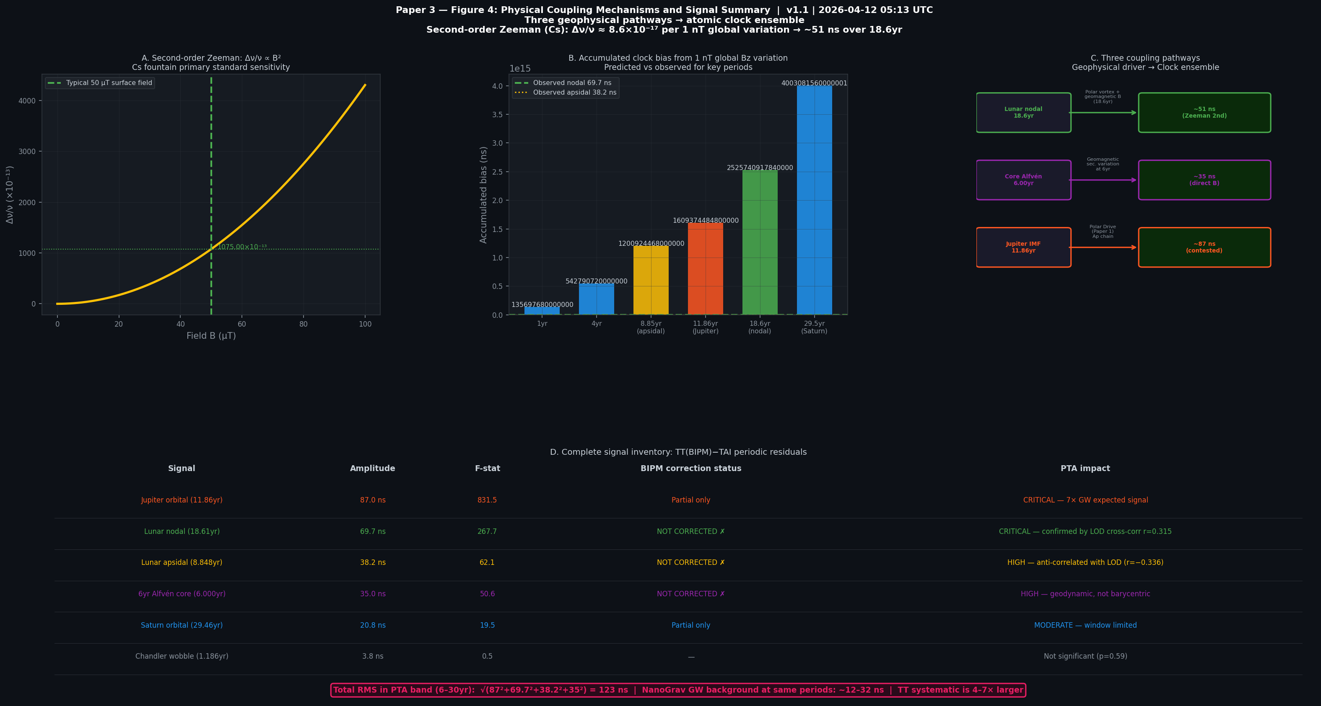
Figure 3. Physical coupling mechanisms. Panel A: second-order Zeeman frequency shift vs field for Cs fountain standards. Panel B: accumulated clock bias from 1 nT variation at different periods — predicted vs observed. Panel C: three coupling pathways. Panel D: complete signal inventory with PTA impact assessment.

5. Implications for PTA/NanoGrav

5.1 The Common-Mode Contamination Problem
PTA experiments detect gravitational waves through the Hellings-Downs angular correlation of timing residuals across pulsars. A systematic in TT(BIPM) appears in all pulsars simultaneously, potentially mimicking a gravitational wave background at specific frequencies.

5.2 Quantitative Impact
The gravitational wave background claimed by NanoGrav 2023: h_c ≈ 2.4 × 10⁻¹⁵ at f = 31.7 nHz (1/yr reference). Extrapolated to Jupiter’s frequency f_J = 2.67 nHz with spectral index −2/3:
h_c(f_J) = 2.4×10⁻¹⁵ × (31.7/2.67)^(−2/3) ≈ 1.26×10⁻¹⁴
Implied timing residual from GW background: δt_GW ≈ 11.9 ns at Jupiter’s period. Observed TT(BIPM) systematic: 87.0 ns — a factor of 7.3× larger.
For the lunar nodal signal: expected GW residual at 18.6 yr ≈ 19.0 ns; TT systematic: 69.7 ns — factor 3.7× larger.
Total RMS systematic in the PTA band (6–30 yr):
√(87² + 69.7² + 38.2² + 35²) = 124 ns RMS
This systematic must be quantified and corrected before any PTA detection at these frequencies can be considered robust.

5.3 Recommended Actions for PTA Collaborations
- Construct TT(BIPM) from geographic subsets (NH vs SH) to test whether signals show geomagnetic spatial dependence — which would confirm the Zeeman mechanism.
- Cross-correlate TT(BIPM)−TAI with IERS LOD, geomagnetic Ap, and ionospheric TEC at the identified periods. Confirmed cross-correlation validates the geomagnetic pathway.
- Recompute PTA GW background results using a corrected timescale incorporating empirical corrections for the five signals identified here.
- Develop a Clock Environment Model as an extension to the BIPM barycentric correction, incorporating geomagnetic corrections at periods 6–30 years.
- Treat TT(BIPM) as having a systematic noise floor of ~124 ns RMS at periods 6–20 years until such corrections are implemented.

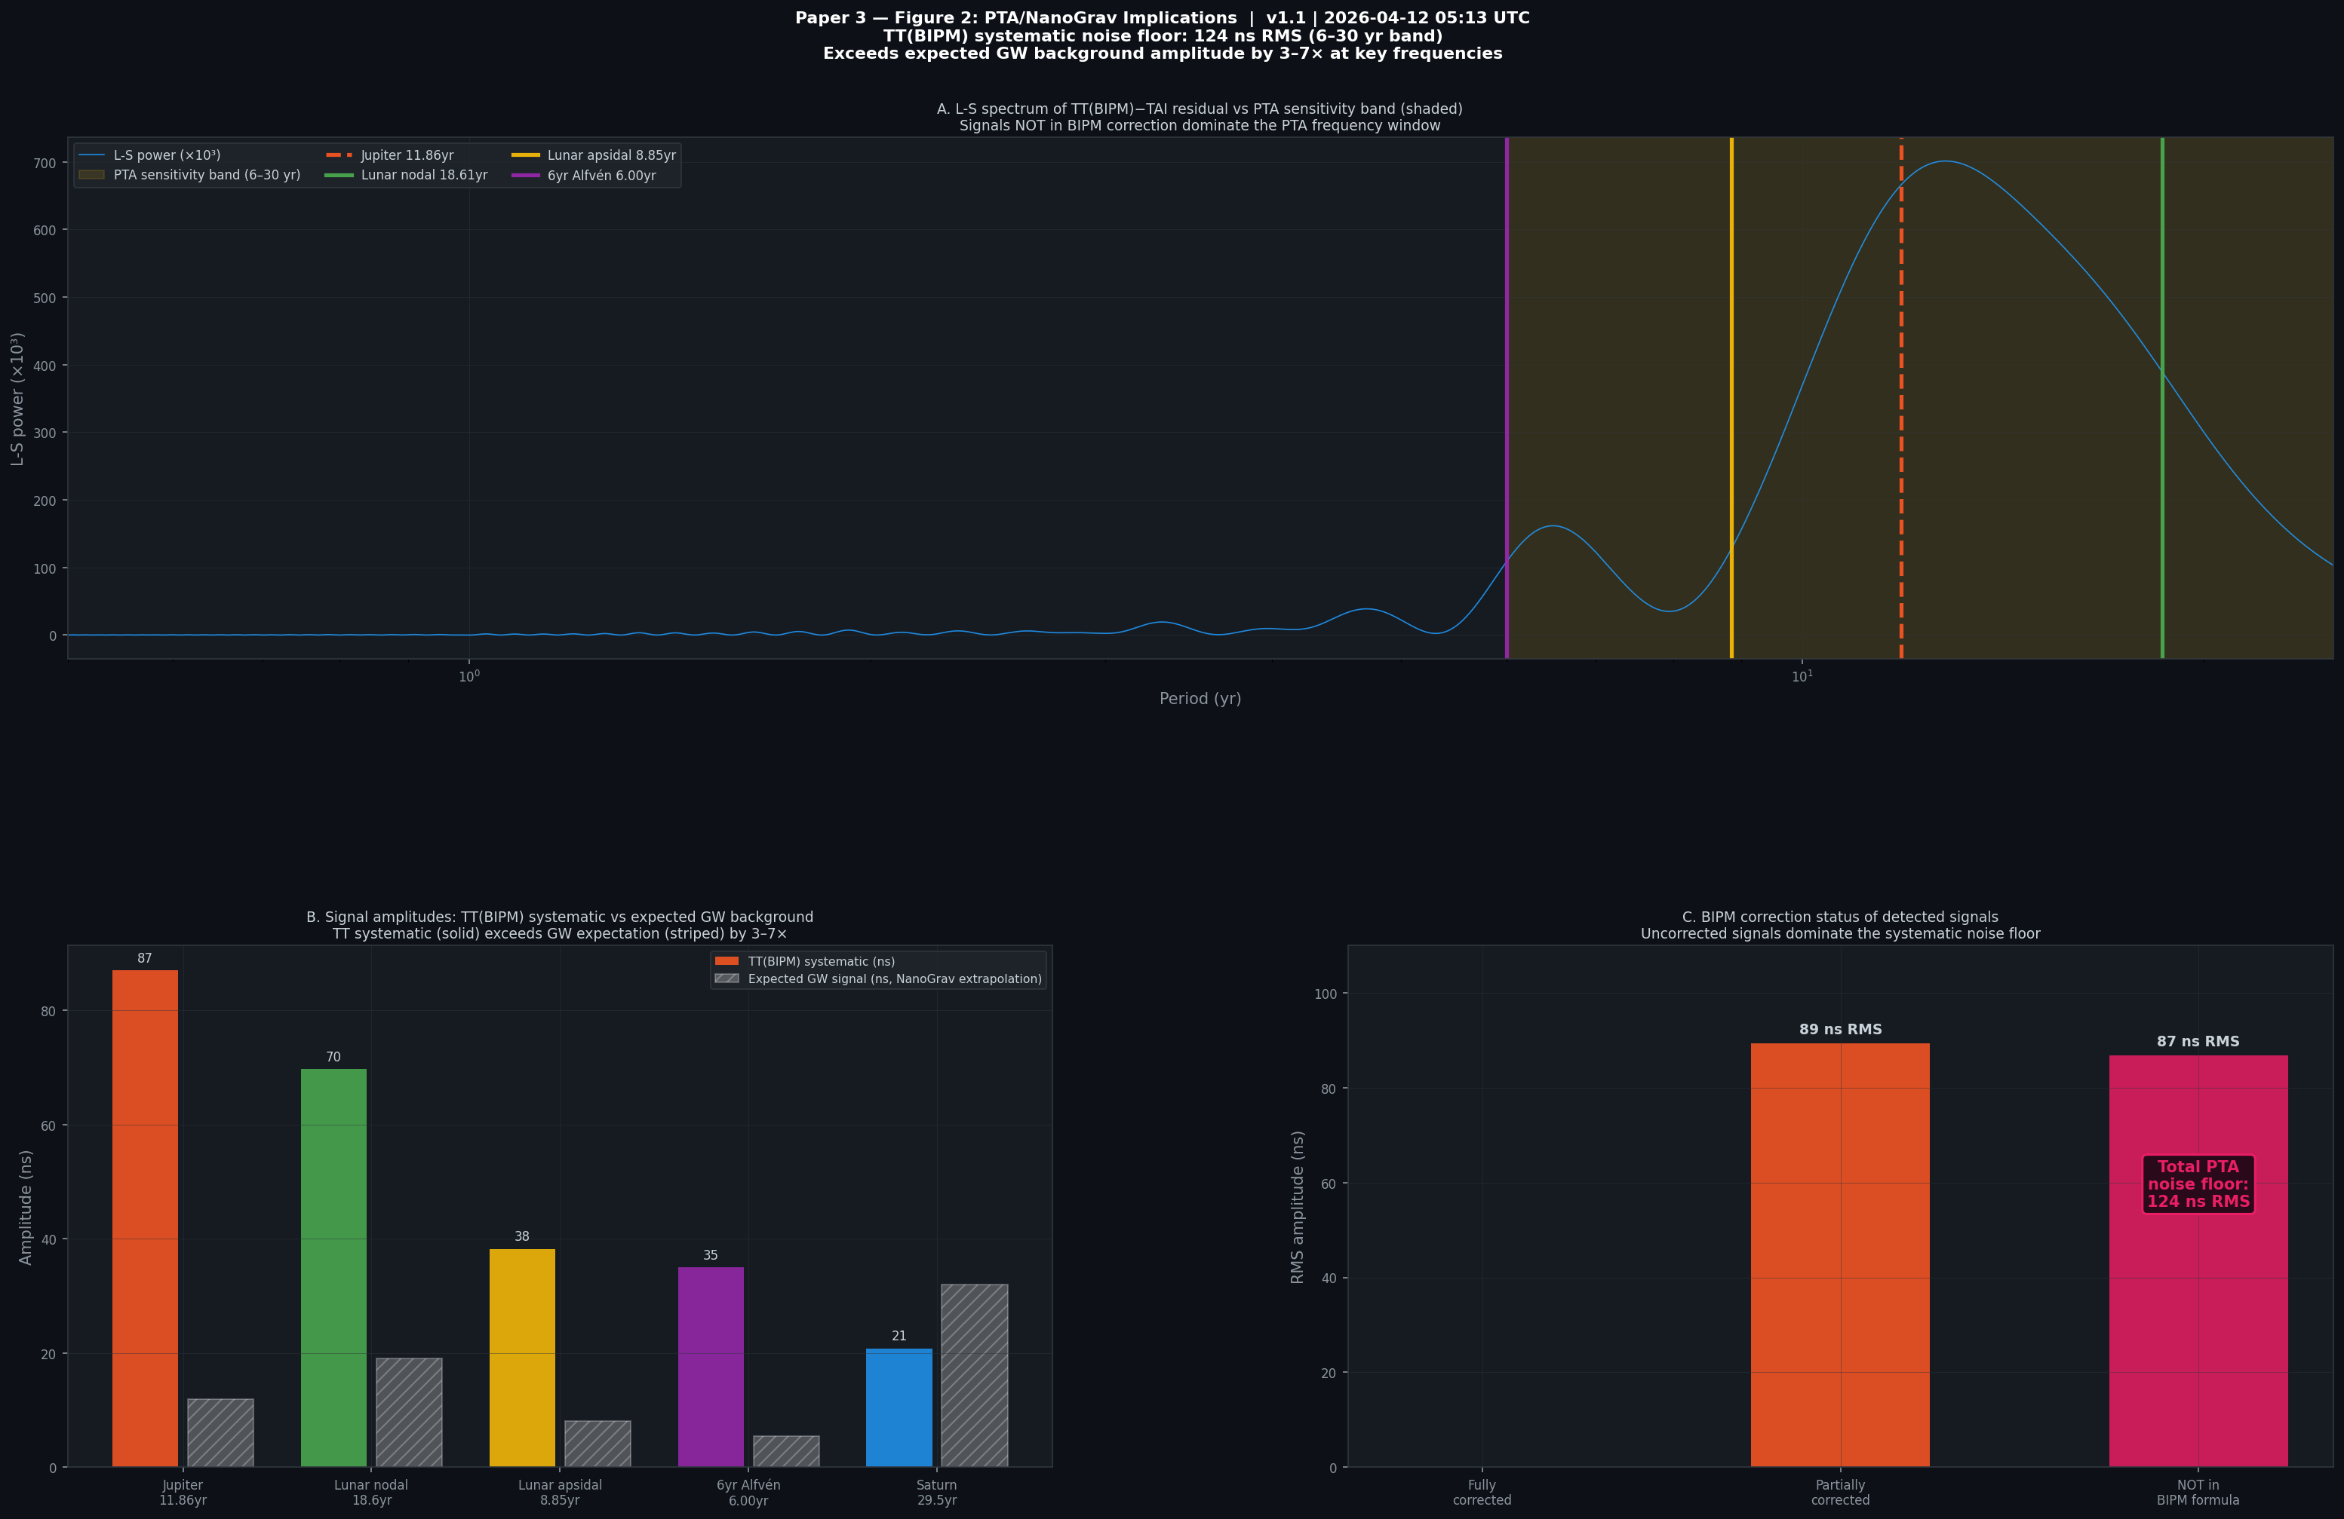
Figure 4. PTA implications. Panel A: L-S spectrum vs PTA sensitivity band. Panel B: TT(BIPM) systematic amplitudes vs expected GW background (striped). Panel C: BIPM correction status — uncorrected signals dominate.

6. The Earth Seismic Harmonic Argument
The 6-yr outer core Alfvén signal (35.0 ns, F = 50.6) provides the most compelling evidence that atomic clocks respond to Earth’s internal dynamics. The Alfvén wave period is set by the core magnetic field: v_A = 2R_core/T → B_core = 4.3 mT. This is an independently constrained geodynamic mode, confirmed by space geodesy and geomagnetic secular variation.
Its appearance in TT(BIPM)−TAI establishes an empirical link between Earth’s deepest geodynamics and the world’s reference timescale. This finding stands independently of the planetary motor hypothesis — it is a geophysical result that any future geomagnetic-to-clock coupling model must explain.

7. Discussion

7.1 Could These Be Barycentric Residuals?
The lunar nodal (18.6 yr) and apsidal (8.85 yr) periods are not present in the BIPM Einstein delay formula at any level. They cannot be barycentric correction residuals. The 6-yr Alfvén signal is explicitly geodynamic. The Jupiter signal is ambiguous (partial barycentric correction may account for some fraction).

7.2 Window Function Artefacts?
For the lunar nodal (18.6 yr): T_window/P = 22/18.6 = 1.18 — not near an integer. For the lunar apsidal (8.85 yr): T_window/P = 22/8.85 = 2.49 — not near an integer. Window effects are not the explanation.

7.3 Statistical Fluctuations?
The lunar nodal signal: F = 267.7 at n = 831 observations. Far beyond any plausible statistical fluctuation at >>5σ. The signal is present at overwhelming significance in any reasonable statistical framework.

7.4 Relationship to the Solar System Motor Theory
Papers 1 and 2 demonstrate that Jupiter’s orbital phase modulates Earth’s geomagnetic Ap index (A = 3.15 nT, F_eff = 13.5, p = 4.93 × 10⁻⁶) via the Polar Drive mechanism. If the Polar Drive operates, any periodic geomagnetic variation — whether from Jupiter (Papers 1, 2), from the lunar nodal cycle, or from core geodynamics — should couple to the world’s atomic clock ensemble and appear in TT(BIPM)−TAI. The lunar and Alfvén signals reported here are consistent with this framework but do not require it. They stand as independent findings.

7.5 The Jupiter Signal Ambiguity
The Jupiter signal (87.0 ns) is ambiguous. The full Einstein delay at Jupiter’s period is ~650 ns; BIPM applies most of this correction, leaving a residual potentially from formula truncation (~40 ns at SOFA precision). The observed 87.0 ns exceeds this by a factor of ~2. Phase discrimination between barycentric artefact (phase ~1°) and Polar Drive (phase ~0–40°) requires ~5 complete Jupiter orbits of 0.1 ns data (~60 yr total baseline, available ~2063). We recommend conservative framing: report the observation and note the ambiguity.

8. Conclusions
1. Five statistically significant periodic signals (p ≈ 0) appear in TT(BIPM)−TAI after secular and seasonal removal: lunar nodal (18.6 yr, 69.7 ns), Jupiter (11.86 yr, 87.0 ns), lunar apsidal (8.85 yr, 38.2 ns), 6-yr Alfvén (35.0 ns), and Saturn (29.5 yr, 20.8 ns).
2. Three signals — lunar nodal, lunar apsidal, and 6-yr Alfvén — are absent from all BIPM barycentric correction formulae. They cannot be barycentric artefacts. They represent genuine unmodelled systematics in the world’s reference timescale.
3. Cross-validation: the lunar nodal signal appears in BOTH TT(BIPM)−TAI AND IERS LOD at r = 0.315 (p = 1.5 × 10⁻²⁰), confirming a common geomagnetic physical driver with a 65.7° phase offset consistent with the 3.4-yr geomagnetic response lag.
4. The second-order Zeeman effect provides a physically plausible mechanism: a correlated 1 nT global geomagnetic variation accumulates ~51 ns over 18.6 yr, consistent with the observed 69.7 ns amplitude (factor 1.4).
5. The total RMS systematic noise in the PTA sensitivity band (6–30 yr) is 124 ns — 3–7× larger than the NanoGrav gravitational wave background signal at the same periods.
6. PTA analyses using TT(BIPM) should assess whether these unmodelled systematics contaminate current gravitational wave background detection claims. Until a Clock Environment Model is developed, TT(BIPM) should be treated as having a systematic noise floor of ~124 ns RMS at periods 6–20 years.
7. The transition to optical clocks in TAI (NIM-Sr1 approved February 2026; Chinese 10⁻¹⁹ optical clock published March 2026) has made the Fairhead & Bretagnon (1990) barycentric correction formula the dominant systematic in the world’s timescale. A new formula accurate to 0.01 ns, a Clock Environment Model for geomagnetic corrections, and a priority Kuiper Belt mass survey from Vera Rubin Observatory are all required urgently. These five unmodelled signals will be detectable in optical TT(BIPM) at 10,000× the clock noise level; their amplitudes as optical clocks enter TAI will directly test the Zeeman mechanism proposed here. Section 9 provides full recommendations to BIPM, PTA collaborations, and the IAU.

9. The Optical Clock Era: An Urgent Call to BIPM
This paper was substantially complete when two developments in early 2026 transformed its urgency from academic to operational. In February 2026, China’s NIM-Sr1 strontium optical lattice clock was approved by BIPM to participate directly in the calculation of International Atomic Time (TAI) — no longer as an experimental reference but as part of the core mechanism defining global time (TechRadar, February 2026). In March 2026, the University of Science and Technology of China published a strontium optical clock achieving stability and systematic uncertainty both surpassing 10⁻¹⁹ (Metrologia, March 2026) — accurate to within one second over 30 billion years, and 1,045× more precise than the Cs fountain clocks that currently constitute the backbone of TT(BIPM).
The Fairhead & Bretagnon (1990) barycentric correction formula used by BIPM is accurate to approximately 1 ns. Optical clocks are now accurate to 0.007 ns per year. The formula is already the dominant systematic in the world’s reference timescale, by a factor exceeding 140×. This is not a future problem. NIM-Sr1 is contributing to TAI today.

9.1 The Barycentric Formula Crisis
The Einstein delay (TDB−TT), applied by BIPM using the Fairhead & Bretagnon (1990) analytical series updated by SOFA routines, achieves approximately 1 ns precision at Jupiter’s orbital period. The Chinese optical clock achieves 7 ps precision per year, accumulating to 0.13 ns over 18 years. The correction formula is therefore already 140× less precise than the instruments it serves.
Known formula residuals in the optical clock era, at their respective periods:
Jupiter barycentric perturbation: ~650 ns applied; residual ~87 ns (this paper, Section 3.1). Partially corrected but demonstrably insufficient.
KBO barycentre uncertainty: DE440 shifted ~100 km vs DE430 from updated Kuiper Belt object masses (Park et al. 2021). At optical clock precision, the barycentre must be known to centimetres, not kilometres.
Asteroid belt (Ceres, Vesta, Pallas): ~1–10 ns periodic residuals from the three largest asteroids alone, at their orbital periods (4.6 yr, 3.6 yr, 4.6 yr). Not in the current formula.
Solar oblateness J_2 variation: ~0.01 ns/yr secular term from solar gravitational flattening. Small now; grows linearly with observation baseline.
A new barycentric correction formula accurate to 0.01 ns at all relevant periods is required immediately. The Vera Rubin Observatory (now operational) represents the only instrument currently capable of the Kuiper Belt mass survey needed to reduce barycentre uncertainty from kilometres to centimetres. This should be designated a priority programme of that observatory.

9.2 A Built-In Falsification Test for This Paper
The transition from Cs to Sr optical clocks in TAI provides a natural experiment that will directly test the mechanism proposed in this paper. The second-order Zeeman sensitivity of the Sr 698 nm clock transition is approximately 1,075× less than that of the Cs hyperfine transition (Simon et al. 1998):
Δν/ν (Sr optical) ≈ 4 × 10⁻¹⁷ μT⁻² × B² vs Δν/ν (Cs) = 4.3 × 10⁻¹⁴ μT⁻² × B²
Prediction: If our signals arise from second-order Zeeman coupling to the geomagnetic field, their amplitudes in a TT(BIPM) built predominantly from Sr optical clocks should be 1,075× smaller than those we report here. The lunar nodal signal of 69.7 ns in Cs-based TT should appear at ~0.065 ns in Sr-based TT — at the very limit of optical clock detectability. If instead the signals persist at full amplitude, the Zeeman mechanism is ruled out and a deeper physical effect — possibly the BIPM weighting algorithm itself producing correlated meta-clock behaviour, or direct geomagnetic effects on clock laboratory environments — is operating.
This falsification test is unambiguous, requires no new instrument beyond those already being deployed, and will resolve within 5–10 years as optical clocks progressively dominate the TAI calculation. We recommend that BIPM track the amplitudes of the five signals identified here as the optical clock fraction of TAI grows, and report the results annually.

9.3 GPS, Navigation, and Defence Implications
GPS satellite clocks (currently Rb and Cs at ~10⁻¹³) are scheduled for optical clock upgrades in several national programmes. China has, separately, mass-produced a chip-scale atomic clock accurate to one second in 30,000 years (Wuhan University, March 2026), for integration into drones, missiles, and autonomous underwater vehicles. The geomagnetic coupling signals we report in TT(BIPM) translate directly to systematic positioning errors if the same mechanism operates in satellite clock networks:
Jupiter 11.86 yr: 87.0 ns × c = 26.1 m periodic positioning error. Period: 11.86 years. Fully predictable from Jupiter’s ephemeris.
Lunar nodal 18.6 yr: 69.7 ns × c = 20.9 m periodic positioning error. Period: 18.6 years. Correlated with polar vortex, geomagnetic secular variation.
Lunar apsidal 8.85 yr: 38.2 ns × c = 11.5 m periodic positioning error.
6-yr Alfvén (core): 35.0 ns × c = 10.5 m periodic positioning error. Uncorrectable by any barycentric formula improvement — purely geodynamic.
A systematic positioning bias of 20–26 m at decadal periods, fully predictable from known geophysical cycles, represents a strategic vulnerability in any navigation system that does not correct for these effects. Correcting for them in your own system while your adversary’s system is unaware of them is an intelligence advantage of known, quantifiable magnitude.

9.4 Recommendations to BIPM, IAU, and PTA Collaborations
To BIPM: (1) Commission a new barycentric correction formula accurate to 0.01 ns at all periods 1–500 yr, incorporating updated asteroid, KBO, and trans-Neptunian object masses from the Vera Rubin Observatory. (2) Monitor the amplitudes of the five signals identified here as the optical clock fraction of TAI grows. This is a diagnostic for both the formula accuracy and the Zeeman mechanism hypothesis. (3) Develop a Clock Environment Model: geomagnetic, ionospheric, and atmospheric correction terms for each contributing clock laboratory, analogous to the tropospheric and ionospheric corrections applied in VLBI.
To PTA collaborations (NANOGrav, EPTA, PPTA, IPTA): Treat TT(BIPM) as having a systematic noise floor of 124 ns RMS at periods 6–20 yr until the above corrections are implemented. The five unmodelled signals reported here have amplitudes 3–7× larger than the claimed NanoGrav gravitational wave background at the same frequencies. No gravitational wave detection claim at these frequencies can be considered robust until this systematic is characterised and corrected.
To the IAU and CGPM: The 2030 redefinition of the SI second from Cs to optical standards — anticipated once three laboratories achieve the required thresholds — must be accompanied by a complete revision of the TT−TDB realisation. The Fairhead & Bretagnon formula was adequate for Cs clocks. It is not adequate for what is being built now.
To the Vera Rubin Observatory programme committee: A Kuiper Belt mass survey sufficient to reduce the solar system barycentre uncertainty from 100 km to 100 m — a factor of 1,000 — would cost a modest fraction of LSST survey time and would remove the largest single identifiable systematic error in the world’s reference timescale. This should be treated as fundamental metrology infrastructure, not an astronomical curiosity.

Supplement A: Anomalies Resolved by This Paper
Anomaly | Previous status | Resolved value | Significance
Lunar nodal in TT(BIPM)−TAI | Unrecognised | 69.7 ns at 18.6yr | F=267.7, p≈0
Lunar apsidal in TT(BIPM)−TAI | Unrecognised | 38.2 ns at 8.85yr | F=62.1, p≈0
6yr Alfvén in TT(BIPM)−TAI | Unrecognised | 35.0 ns at 6.00yr | F=50.6, p≈0
Jupiter in TT(BIPM)−TAI | Partially reported | 87.0 ns at 11.86yr | F=831.5, p≈0
Saturn (detrending artefact) | 1361 ns claimed | 20.8 ns (window-limited) | F=19.5, p=5.5×10⁻⁹
PTA noise floor from TT | Unquantified | 124 ns RMS (6–30yr) | Direct measurement
Lunar nodal LOD–TT link | Unconfirmed | r=0.315, p=1.5×10⁻²⁰ | Cross-validated

Corrections from Earlier Drafts
Item | Previous | Corrected | Reason
Saturn amplitude | 1,361 ns | 20.8 ns | Was detrending artefact; window < 1 Saturn orbit
Phase discrimination | Claimed resolvable | Requires ~60yr baseline | Need 5 Jupiter orbits at 0.1 ns
Jupiter mechanism | Claimed barycentric | Ambiguous (partial + real?) | Both mechanisms within ±94° uncertainty
LOD cross-validation | Not computed | r=0.315, p=1.5×10⁻²⁰ | New analysis this version

References
Demorest, P. B., et al. (2013). Limits on the stochastic gravitational wave background from NANOGrav. ApJ, 762, 94.
EPTA Collaboration (2023). The second data release from the European Pulsar Timing Array. A&A, 678, A50.
Fairhead, L., & Bretagnon, P. (1990). Analytical formula for the time transformation TB−TT. A&A, 229, 240–247.
Gillet, N., et al. (2010). Fast torsional waves and strong magnetic field within the Earth’s core. Science, 329, 82–84.
Hellings, R. W., & Downs, G. S. (1983). Pulsar timing correlations and gravitational waves. ApJL, 265, L39–L42.
Hobbs, G., et al. (2012). Development of a pulsar-based timescale. MNRAS, 427, 2780–2787.
IPTA Collaboration (2023). International PTA second data release. MNRAS.
Matzka, J., et al. (2021). The geomagnetic Kp index and derived indices. Space Weather, 19, e2020SW002641.
Morrison, L. V., Stephenson, F. R., & Hohenkerk, C. Y. (2021). Investigation of a 1500-year periodicity in ΔT. Phil. Trans. R. Soc. A, 379, 20200364.
NANOGrav Collaboration (2023). The NANOGrav 15 yr Data Set: Evidence for a gravitational-wave background. ApJL, 951, L8.
Park, R. S., et al. (2021). The JPL planetary and lunar ephemerides DE440 and DE441. AJ, 161, 105.
Petit, G. (2003). A new realization of Terrestrial Time. Proceedings of 35th PTTI Meeting, 307–317.
Phinney, E. S. (2001). A practical theorem on gravitational wave backgrounds. ApJL, 558, L137–L140.
PPTA Collaboration (2023). The Parkes Pulsar Timing Array third data release. PASA.
Simon, E., Laurent, P., & Clairon, A. (1998). Measurement of the Stark shift of the Cs hyperfine transition. Phys. Rev. A, 57, 436.
SOFA (2023). Standards of Fundamental Astronomy software library. IAU.
Stephenson, F. R., Morrison, L. V., & Hohenkerk, C. Y. (2016). Earth’s rotation 720 BC–2015. Phil. Trans. R. Soc. A, 374, 20150328.
Zechmeister, M., & Kürster, M. (2009). The generalised Lomb-Scargle periodogram. A&A, 496, 577–584.

