 |  | INTERNATIONAL TELECOMMUNICATION UNION
 |  | ITU-T | G.984.3  Implementers’ Guide
 |  | TELECOMMUNICATION  STANDARDIZATION SECTOR  OF ITU |  | (17 February 2006)
 | SERIES G: TRANSMISSION SYSTEMS AND MEDIA, DIGITAL SYSTEMS AND NETWORKS
Implementers’ Guide for ITU-T Rec. G.984.3 (02/2004)
Gigabit-capable Passive Optical Networks
(G-PON): Transmission convergence layer specification

Summary
This document is an Implementers' Guide for ITU-T Recommendation of G.984.3 (02/2004).
Source
This document was agreed by ITU-T Study Group 15 on 17 February 2006.

© ITU 2005
All rights reserved. No part of this publication may be reproduced, by any means whatsoever, without the prior written permission of ITU.

Table of Contents

1. Introduction 1
2. AES mechanism and golden vectors 1
2.1 Key Switching Time Message Structure 1
2.2 AES Encryption golden vector 1
2.3 AES with DS FEC golden vector 3
3. FEC Encoding golden vector 5
4. Scrambler diagram 8
5. A Downstream Frame Example 8
6. ONU Activation Process 9
6.1 Assumptions 11
6.2 State O1 11
6.3 State O2 11
6.4 State O3 12
6.5 State O4 14
7. PLOAM Messages 16
7.1 Acknowledge PLOAM Message 16
8. Transmitter Block Diagram 17

Implementers’ Guide 1 for Recommendation G.984.3
Gigabit-capable Passive Optical Networks (G-PON): Transmission convergence layer specification

Summary
This document is an informative section for the 984.3 standard, aimed to clarify GPON GTC related aspects and enable easier interoperability. The document includes examples for some of the main data processing in the GPON GTC level.
Sections 2-5 of the document provide example golden vectors for some of the GTC functionality, including AES, FEC and scrambling.
Section 6 shows an example of ONU activation process.
Section 7 contains examples for PLOAM messages
Section 8 illustrate the order of processes in a GTC transmit flow
Keywords
G-PON, Implementers’ Guide

Introduction
This Implementers’ guide describes basic functions for interoperability between OLT and ONU on GPON GTC. This guide aims to clarify descriptions on ITU-T Recommendations G.984.3. The Implementers’ guide does not request any modifications for the recommendation, but provides comments and clarifications on the recommendation to enhance readability for implementers.

AES mechanism and golden vectors

Key Switching Time Message Structure
Section 9.2.3.19 of G.984.3 specifies the structure of the downstream Key_Switching_Time PLOAM message. The following clarification applies to the FrameCounter1 field of that message.
The 6 LSB bits of the FrameCounter1 field contains the 6 MSB bits of the 30-bit super frame counter.
For example: when the super frame counter is 0x2A123456, the FrameCounter1 field would be 0x2A.

AES Encryption golden vector
The AES encryption / decryption procedure depends on the encryption key used, on the current super-frame counter and on the byte in frame location of the GEM fragments. The following example includes 3 consecutive GEM fragments for the same ONU, i.e. all use the same encryption key. The sequence parameters are the following:
- The key in use is: 0x112233445566778899AABBCCDDEEFF00
(In ‘Encryption Key’ message - Key byte 0 is ‘11’, Key byte 15 is ‘00’)
- The super-frame counter value is: 0x3DCAE120
- The first byte of the first fragment is the 158th byte in the GTC frame.
The example consists of the plain-text vector and the cipher-text vector, and a diagram which demonstrates the parameters used for the AES procedure (e.g. byte number, crypto counter value).The numbers in the example are given in hexadecimal representation. The bold numbers represent GEM header bytes.

The plain-text:
B4 9A 12 D0 73 00 01 02 03 04 05 06 07 08 09 0A
0B 0C 0D 0E 0F 10 11 12 13 14 15 16 17 18 19 1A
1B 1C 1D 1E 1F 20 21 22 B6 CA 12 C0 4A AA BB CC
DD EE FF B6 5A 12 C1 BB 11 22 33 44 55 66 77 88
99 AA BB CC DD EE FF

The cipher-text:
B4 9A 12 D0 73 3A FB 97 EE FC BC C1 6B 6C 57 1A
A4 FF 7A C3 AD 6C 85 28 5A 57 F8 9E 7A 36 07 CA
8A CE 45 0A 97 A9 74 5A B6 CA 12 C0 4A 8B 5F 94
E4 8F 34 B6 5A 12 C1 BB 9D F4 F4 15 F6 A4 3C D0
30 0F F6 92 88 EE 54
The following figure demonstrates the relation between the data and the crypto-counter:
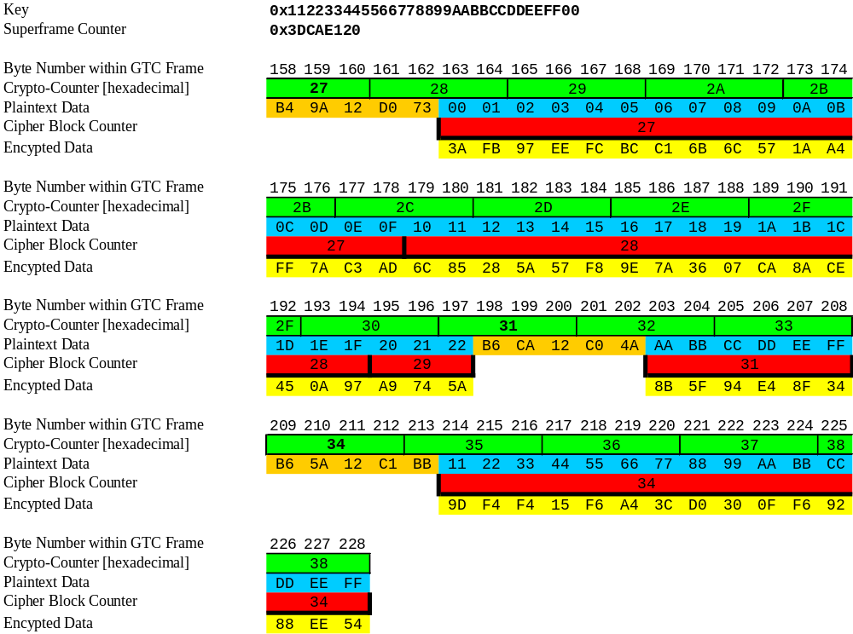

AES with DS FEC golden vector
The following example demonstrates encryption of 2 GEM fragments, when FEC is enabled on the downstream. Both GEM fragments are for the same ONU, i.e. use the same encryption key.
The sequence parameters are:
- The key in use is: 0x112233445566778899AABBCCDDEEFF00
(In ‘Encryption Key’ message - Key byte 0 is ‘11’, Key byte 15 is ‘00’)
- The super-frame counter value is: 0x3DCAE120
- The first byte of the first fragment is the 220th byte in the GTC frame.
The example consists of the plain-text vector and the cipher-text vector and a diagram which demonstrates the parameters used for the AES procedure (e.g. byte number, crypto counter value). The numbers in the example are given in hexadecimal representation. The bold numbers represent GEM header bytes. Parity bytes are marked as PP and their value is not given since only a part of the codeword is shown in the example.

The plain-text:
B7 4A 12 D0 21 00 01 02 03 04 05 06 07 08 09 0A 0B
0C 0D 0E PP PP PP PP PP PP PP PP PP PP PP PP PP PP
PP PP 0F 10 11 12 13 14 15 16 17 18 19 1A 1B 1C 1D
B6 5A 12 C1 BB 11 22 33 44 55 66 77 88 99 AA BB CC
DD EE FF

The cipher-text:
B7 4A 12 D0 21 0F DA 75 62 82 60 A4 8E A0 53 1B 6D
CA 53 9B PP PP PP PP PP PP PP PP PP PP PP PP PP PP
PP PP B6 0C 48 B2 74 5A 7E 95 C1 F3 63 BD 63 5C DF
B6 5A 12 C1 BB 58 F1 4C 22 75 38 D0 32 C8 90 28 6E
71 84 ED

It is important to note that the parity bytes are not encrypted.

The following figure demonstrates the relation between the data and the crypto-counter:
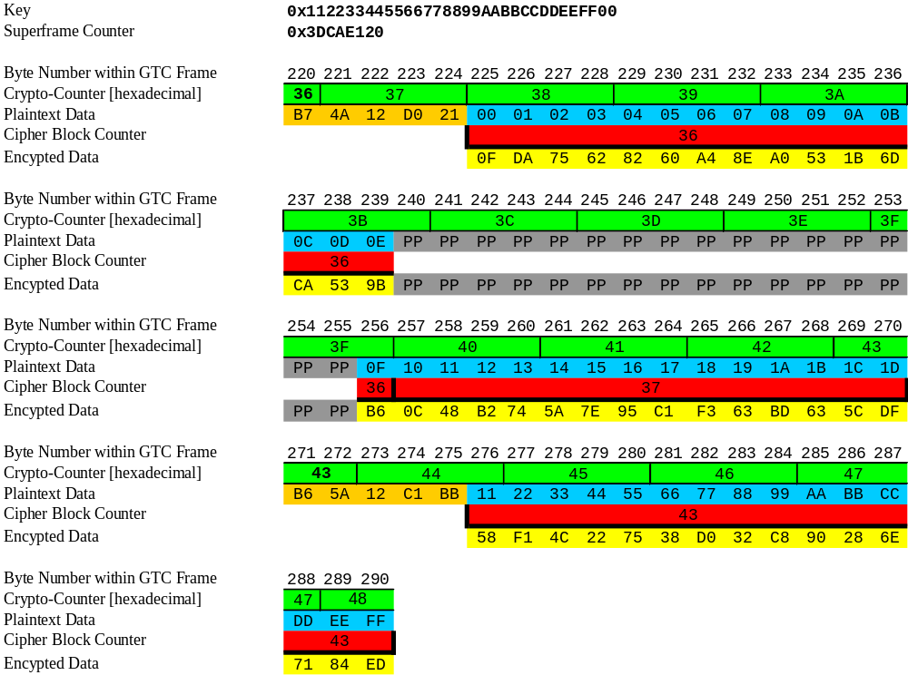

FEC Encoding golden vector
The GPON FEC is based on the RS(255,239) as used in ITU-T Recommendations G.975 and G.709.
The implementation of the FEC encoder should be the functional equivalent of the IIR model depicted below. In this IIR model, all the multipliers and adders are operations in GF(256) and the primitive polynomial is: X⁸+X⁴+X³+X²+1.

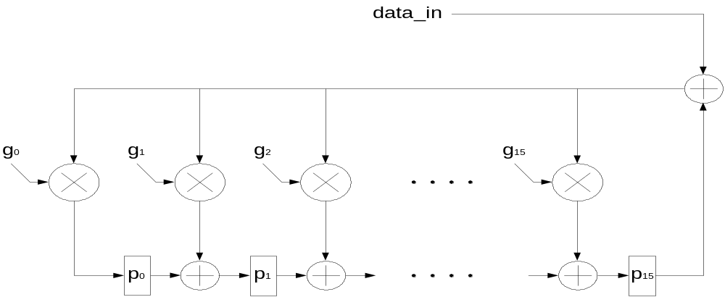

Figure 1 – IIR Model for FEC Encoder
The ‘data_in’ are the payload symbols (bytes). Initial value for p₀ ₋p₁₅ is 0x00.
While ‘data_in’ is transmitted to the line it is pushed into the encoder as well. After the last data byte is transmitted the parity bytes results are ready in the p₀ - p₁₅ registers. Then the parity bytes are transmitted (p₁₅ first).
The values of the generator polynomial coefficients in hexadecimal representation are (g₀ - g₁₅, respectively):
3B, 24, 32, 62, E5, 29, 41, A3, 08, 1E, D1, 44, BD, 68, 0D, 3B
The following provides two examples: a full 255 byte code word and a shorter last code word with 122 bytes. Each example includes the payload bytes followed by the 16 bytes FEC parity, marked in bold. The numbers in the example are given in hexadecimal representation.
1. A full code word example:
00 65 f2 50 51 52 53 54 55 56 57 58 59 5a 5b 5c
a2 ec 40 21 f7 00 01 02 03 04 05 06 07 08 09 0a
0b 0c 0d 0e 0f 10 11 12 13 14 15 16 17 18 19 1a
1b 1c 1d 1e 1f 20 21 22 23 24 25 26 27 28 29 2a
2b 2c 2d 2e 2f 30 31 32 33 34 35 36 37 38 39 3a
3b 3c 3d 3e 3f 40 41 42 43 44 45 46 47 48 49 4a
4b 4c 4d 4e 4f 50 51 52 53 54 55 56 57 58 59 5a
5b 5c 5d 5e 5f 60 61 62 63 64 65 66 67 68 69 6a
6b 6c 6d 6e 6f 70 71 72 73 74 75 76 77 78 79 7a
7b 7c 7d 7e 7f 80 81 82 83 84 85 86 87 88 89 8a
8b 8c 8d 8e 8f 90 91 92 93 94 95 96 97 98 99 9a
9b 9c 9d 9e 9f a0 a1 a2 a3 a4 a5 a6 a7 a8 a9 aa
ab ac ad ae af b0 b1 b2 b3 b4 b5 b6 b7 b8 b9 ba
bb bc bd be bf c0 c1 c2 c3 c4 c5 c6 c7 c8 c9 ca
cb cc cd ce cf d0 d1 d2 d3 d4 d5 d6 d7 d8 d9 d1
ee 8b 7e 8e 33 b7 89 cb e4 c4 64 cb 12 d4 d9

2. A shorter last codeword example:
da db dc dd de df e0 e1 e2 e3 e4 e5 e6 e7 e8 e9
ea eb ec ed ee ef f0 f1 f2 f3 f4 f5 f6 f7 f8 f9
fa fb fc fd fe 00 01 02 03 04 05 06 07 08 09 0a
0b 0c 0d 0e 0f 10 11 12 13 14 15 16 17 18 19 1a
1b 1c 1d 1e 1f 20 21 22 23 24 25 26 27 28 29 2a
2b 2c 2d 2e 2f 30 31 32 33 34 35 36 37 38 39 3a
3b 3c 3d 3e 3f 40 41 42 43 44 72 d1 ba 17 30 b5
03 71 70 49 54 35 1c 40 1e 59

Scrambler diagram
X^0 X^7
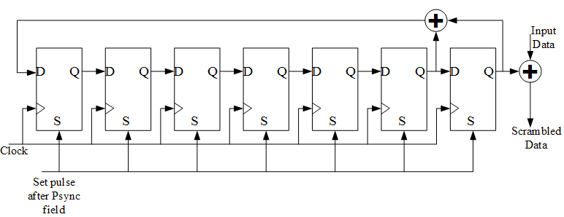

Figure 2 – Scrambler Block Diagram
Initial condition: Every downstream frame, after the Psync field, the scrambler is initialized to all ones.
The 127-bit scrambler sequence is given below in binary and hexadecimal representation (last 3 binary bits are without a hexadecimal representation):

1111 | 1110 | 0000 | 0100 | 0001 | 1000 | 0101 | 0001 | 1110 | 0100 | 0101 | 1001
F | E | 0 | 4 | 1 | 8 | 5 | 1 | E | 4 | 5 | 9
1101 | 0100 | 1111 | 1010 | 0001 | 1100 | 0100 | 1001 | 1011 | 0101 | 1011 | 1101
D | 4 | F | A | 1 | C | 4 | 9 | B | 5 | B | D
1000 | 1101 | 0010 | 1110 | 1110 | 0110 | 0101 | 010
8 | D | 2 | E | E | 6 | 5

A Downstream Frame Example
The purpose of the downstream frame test vectors is to provide:
- Examples for CRC on PLOAM, Plend and US BW map accesses
- Example of traffic payload mapping into GEM fragments
- Example of frame scrambling

The example includes the first 138 bytes of a GTC downstream frame. This includes the PCBd and two GEM fragments (zero ATM portion). The PCBd includes a ‘Key Switching Time’ PLOAM message and two US BW map accesses.

The detailed parameters for the different fields are:
- Ident field: Super-frame counter is 0x00051276 and FEC ind is 0
- PLOAM Message: ‘Key Switching Time’ (type 0x13) message addressed to ONU-ID 0x12
- US BW map:
 | Alloc-ID | Flags | SStart | SStop
Access 1 | 0x10 | 0x000 | 0x1000 | 0x1500
Access 2 | 0x150 | 0x400 | 0x1600 | 0x1700
- GEM fragments:
1. First Fragment: 64 byte Ethernet packet where:
DA=FF-FF-FF-FF-FF-FF, SA=00-0E-7F-5F-F1-DF
2. Second Fragment: unstructured data
Note:
- AES is not applied to GEM fragments.
- BIP field is NA in the example.

Frame before scrambling:
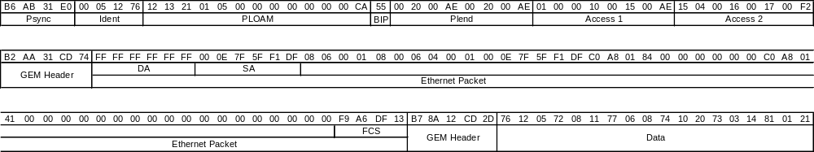
Frame after scrambling:

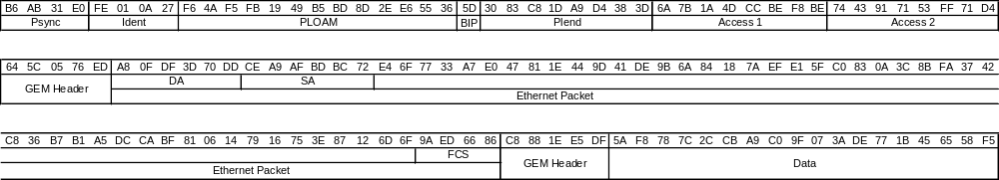

ONU Activation Process
The purpose of this section is to clarify issues in the OLT-ONU interaction during the activation process.
The section describes the activities in the OLT and ONU during the activation process, their timing relations and the messages exchanged between them.
The chapter is divided according to the activation states (O1-O5). Each section describes the processes during that state.
See Figure 3 below for a visual example of the flow. The numbers refer to the Notes below the diagram.
Note that in the cases where the ONU state changes are triggered by the reception of a PLOAM message, the ONU changes its status after the first valid message it receives (out of the 3 repetition sent by the OLT). Since the OLT is not aware which messages were received correctly by the ONU, its wait period of 750uSec starts from the third PLOAM. In Figure 3, the ONU changes its states after a processing time which is demonstrated to be less than the 750uSec.

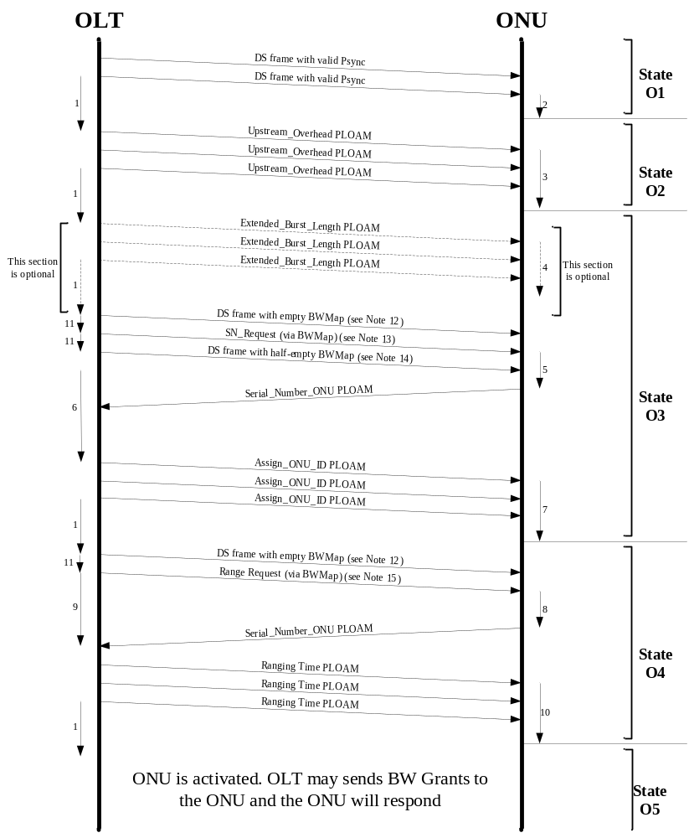
Figure 3 – Activation Process Flow
Note 1 OLT waits at least 750us for the ONU to process the message
Note 2 ONU clears LOS/LOF error
Note 3 ONU constructs the preamble and delimiter and sets pre-assigned equalization delay
Note 4 ONU constructs extended preamble
Note 5 ONU randomizes a response time and constructs Serial_Number_ONU PLOAM message
Note 6 OLT analyzes incoming PLOAMs and associates ONU_IDs with Serial Numbers
Note 7 ONU stores assigned ONU_ID
Note 8 ONU prepares response PLOAM
Note 9 OLT measures time until response is received and calculates the adjustment to the ONU’s Equalization Delay
Note 10 ONU updates its Equalization Delay
Note 11 Transmissions are in consecutive frames
Note 12 Downstream frame with empty BWMap (creates 125us of “quiet window”)
Note 13 BWMap should be constructed according to section 6.4.2
Note 14 To complete the SN Request window (per section 6.4.2) the first Sstart in this frame should follow the margins described in section 6.4.2 (approximately 2us)
Note 15 BWMap should be constructed according to section 6.5.1

Assumptions
The following assumptions apply to the described flow:
- The farthest ONU is 20Km from the OLT
- Pre-assigned equalization delay is 0
- The OLT is not aware of the Serial Numbers of ONUs on the PON (Discovered SN Method)
- The PLO length is 127 bytes (maximum) during ranging and 11 bytes (minimum recommended) during normal operation

State O1
During this state the OLT is transmitting valid downstream frames, and the ONU attempts to attain frame synchronization.
The ONU searches for the PSync value bit-by-bit (example of downstream frame structure is shown in section 5). Once two consecutive frames with a valid PSync value are found, the ONU clears the LOS/LOF error and transitions to State O2.

State O2
After transmitting at least two valid downstream frames, the OLT transmits the Upstream_Overhead PLOAM message 3 times.
The following table shows the structure of the message, with ranges and typical values for the different fields.
Upstream_Overhead message
Octet | Content | Description | Example Value
1 | 11111111 | Broadcast message to all ONUs
2 | 00000001 | Message identification “Upstream_Overhead”
3 | gggggggg | Number of guard bits | 32 (G) (see Note 1)
4 | xxxxxxxx | Length of Type 1 Preamble bits | 8 (P1) (see Note 1)
5 | yyyyyyyy | Length of Type 2 Preamble bits | 8 (P2) (see Note 1)
6 | cccccccc | Pattern of Type 3 preamble pattern. | AA
7 | bbbbbbbb | Pattern of byte 1 of delimiter. | 0xAB
8 | bbbbbbbb | Pattern of byte 2 of delimiter | 0x59
9 | bbbbbbbb | Pattern of byte 3 of delimiter | 0x83
10 | xxemsspp | xx – Reserved  e – Status of pre-Equalization mechanism  m – Status of SN_Mask mechanism  ss – Max number of extra SN-transmissions | 0 (See Note 2)
11 | dddddddd | MSB of pre-assigned equalization delay | 0 (See Note 2)
12 | dddddddd | LSB of pre-assigned equalization delay | 0 (See Note 2)
General Note - The values in this message, except for P1 and P2, are selected according to OLT parameters and preferences
Note 1 – Given that the total length of the burst overhead is L (L maximum value is 128 bytes), the values for G,P1, P2, P3 (number of Type 3 preamble bytes) and D (delimiter length) must satisfy G+P1+P2+P3+D=L. The Extended_Overhead_Burst message may pre-empt the value of L by modifying the value of P3 (for both pre ranged and ranged states). It is the responsibility of the OLT to ensure that the total length of the burst overhead is an integer number of bytes.
Note 2 – It is assumed that the pre-assigned equalization delay is not used and that the SN value is transmitted once by the ONUs
The message is transmitted 3 times by the OLT. Upon receiving at least one of the messages, the ONU stores the received values and constructs the preamble and delimiter using the values received. The ONU then transitions to state O3.

State O3
In this state there are four messages that flow between the OLT and ONU:

Extended_Burst_Length PLOAM message
This part of the process is optional at the discretion of the OLT.
The following table shows the structure of the message, with ranges and typical values for the different fields.
Extended_Burst_Length message
Octet | Content | Description | Example Value
1 | 11111111 | Broadcast message to all ONUs
2 | 00010100 | Message identification “Extended_Burst_Length”
3 | xxxxxxxx | Number of Type 3 preamble bytes used when the ONU is in the ‘pre-ranged’ states (O3-O4) | 119
4 | yyyyyyyy | Number of Type 3 preamble bytes used when the ONU is in the ‘ranged’ states (O5-O6) | 3
5-12 | 00000000
The OLT transmits this message 3 times. If the ONU supports this mode of operation, upon receiving at least one of the messages it stores the values received and constructs a new preamble. Otherwise, these messages are ignored.

Serial_Number_Request message
The Serial_Number_Request is a BWMap entry, addressed to Alloc-ID 0xFE, which contains a PLOAM transmission request in a 13 byte access.
The OLT sends the SN_request message with a quiet window to insure no transmission collision in the upstream. The quiet window should take into account the following parameters:
- ONU minimum and maximum distances
- 48us random delay
- 2us caused by ±1us variation in ONU response time
- margin for ONUs which transmit ONU Additional Data (up to 120 bytes)
- margin for PLO of next transmission (up to 131 bytes)
The following present one possible way of implementation:
Prior to sending the SN_Request message, the OLT opens a “pre-SN quiet window” where no BW grants are given for 200us (less if the farthest ONU is less than 20Km away). To create the “pre-SN quiet window” the OLT send a frame with no BWMap section , followed by a frame with only the Serial_Number_Request with an SStart equal to 75us+PLO from the frame beginning (0x2E14 for 1.25Gbps US or 0x174C for 622Mbps US).
Following the Serial_Number_Request, a “post-SN quiet window” of 50us+Margin should be provided. This window ensures no collisions between ONUs responding to the Serial_Number_Request and ranged ONUs responding to regular BWMap grants following the Serial_Number_Request.
The following diagram shows the structure of the “quiet windows” and the SN request, which follows the above example:
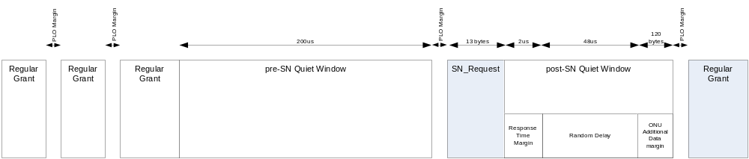
Figure 4 – Serial Number Request Example

Serial_Number_ONU message
Upon receiving the S/N grant, the ONU responds by sending an S/N response message after waiting a random delay of 0-48us. The following table shows the ONU’s response transmission (the preamble, delimiter, Vendor-ID and Serial Number values are for example only):

preamble | Delimiter | BIP | ONU-ID | IND | Serial_Number_ONU Message (response to Serial_Number_Request) |  |  |  |  |  | Optional ONU Additional Data
 |  |  |  |  | ONU-ID | MSG-ID | Vendor-ID | Serial Number | Abilities advertisement and Random Delay | CRC | Optional ONU Additional Data
0xAA..AA | 0xAB5983 | 0xXX | 0xFF | 0x00 | 0xFF | 0x01 | 0x12345678 | 0x9ABCDEF0 | 0xRRRX | 0xYY | 0xXX..XX
If the ONU supports Extended Burst Length, and the Extended_Burst_Length message was received, the ONU should use the Extended PLO in this transmission.
The ONU may transmit ONU Additional Data of up to 120 bytes following this transmission.
The OLT waits for transmissions following the Serial_Number_Request grant and collects incoming Serial_Number_ONU PLOAM messages.

Assign_ONU-ID message
After collecting the incoming Serial_Number_ONU PLOAM messages, the OLT associates available ONU-ID values with the received Serial Numbers, and assigns them to ONUs using the Assign_ONU-ID message. The following table shows an example message (referring to the example message in section 6.4.3 above):

Assign_ONU-ID Message
Octet | Content | Description | Example value
1 | 11111111 | Broadcast message to all ONUs
2 | 00000011 | Message identification “Assign_ONU-ID”
3 | pppppppp | ONU-ID | 0x01
4 | xxxxxxxx | Serial Number byte 1 | 0x12
5 | xxxxxxxx | Serial Number byte 2 | 0x34
6 | xxxxxxxx | Serial Number byte 3 | 0x56
7 | xxxxxxxx | Serial Number byte 4 | 0x78
8 | xxxxxxxx | Serial Number byte 5 | 0x9A
9 | xxxxxxxx | Serial Number byte 6 | 0xBC
10 | xxxxxxxx | Serial Number byte 7 | 0xDE
11 | xxxxxxxx | Serial Number byte 8 | 0xF0
12 | 00000000 | Unspecified
The OLT transmits this message 3 times. Upon receiving at least one of the messages, the ONU stores the ONU-ID and transitions to state O4.

State O4
In this state there are three messages that flow between the OLT and ONU:

Range_Request message
The Range_Request is a BWMap entry, to a specific ONU, which contains a PLOAM transmission request in a 13 byte access. The Alloc-ID of the request is equal to the ONU-ID.
The OLT sends the Range_Request message with a quiet window to insure no transmission collision in the upstream.
The following present one possible implementation:
Prior to sending this message, the OLT opens a “pre-Ranging quiet window” where no BW grants are given for 200us (less if the farthest ONU is less than 20Km away). To create the “pre-Ranging quiet window” the OLT sends a frame with no BWMap section, followed by a frame that includes Range_Request with an SStart equal to 75us+PLO from the frame beginning (0x2E14 for 1.25Gbps US or 0x174C for 622Mbps US).
Following the Range_Request, the OLT should provide a margin for ONU Additional Data (up to 120 bytes) which the ONU may transmit. After that, the OLT may resume providing regular BW grants.
The following diagram shows the structure of the “quiet window” and the Range_Request, which follows the above example:
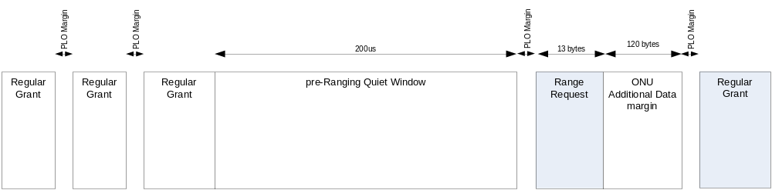
Figure 5 - Ranging Request Example

Range_Response message
The ONU responds to the Range_Request access with a Range_Response message. The response is the Serial_Number_ONU PLOAM described in section 6.4.3 above. The example burst transmission in section 6.4.3 applies here, but the random delay field in this state is set to 0x000.
If the ONU supports Extended Burst Length, and the Extended_Burst_Length message was received, the ONU should use the Extended PLO in this transmission.
The ONU may transmit ONU Additional Data of up to 120 bytes following this transmission at its own discretion.

Ranging_Time PLOAM message
After sending the Range_Request, the OLT looks for the ONU transmission. Upon receiving the transmission, the OLT calculates the distance to the ONU and sends a Ranging_Time PLOAM message to indicate to the ONU the new Equalization Delay to use in future transmissions.
The following table shows an example Ranging_Time message, where the assigned delay is 0x11223344. The example message is addressed to ONU-ID 0x1.

Ranging_Time Message
Octet | Content | Description | Example value
1 | ONU-ID | Directed message to one ONU | 0x1
2 | 00000100 | Message identification “Ranging_Time” | 0x04
3 | 0000000b | Main path EqD/Protection path EqD | 0x00
4 | xxxxxxxx | MSB of delay | 0x11
5 | xxxxxxxx |  | 0x22
6 | xxxxxxxx |  | 0x33
7 | xxxxxxxx | LSB of delay | 0x44
8-12 | Unspecified |  | 0x00
The OLT sends this message 3 times. Upon receiving at least one of the messages, the ONU updates its Equalization Delay value and transitions to state O5.

PLOAM Messages

Acknowledge PLOAM Message
The following seeks to clarify the structure of the upstream ‘Acknowledge’ PLOAM message via the following example:
In response to the following downstream PLOAM message:
01 08 03 00 10 00 00 00 00 00 00 00 2A
The ONU should respond with the following Acknowledge message:
01 09 08 01 08 03 00 10 00 00 00 00 46

Transmitter Block Diagram
The following block diagrams present the order of operations in downstream and upstream framing:
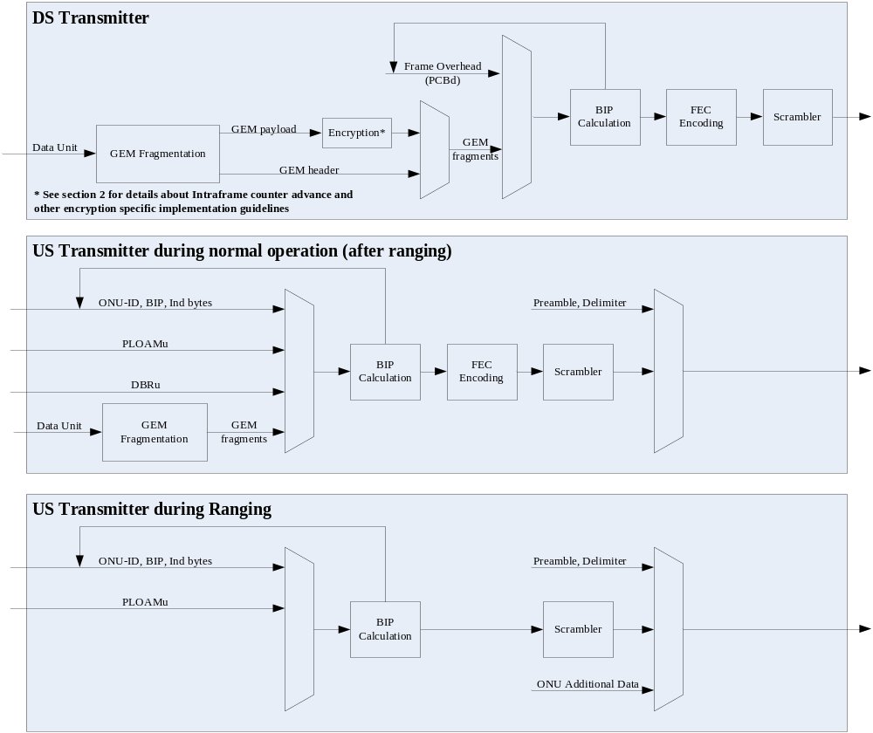
Figure 6 – Transmitter Block Diagram

_______________

