G.984.4 Implementer’s Guide
Second Revision

Summary
This document is an informative section for the 984.4 standard, aimed to clarify GPON provisioning and management related aspects and enable easier interoperability. The document includes suggested best practices for implementing the ONT management and control interface.
Source
Keywords
G-PON, Implementers’ Guide, OMCI

Introduction
This Implementers’ Guide describes best practices for interoperability between the GPON OLT and ONT in the management plane. As such, it attempts to provide a foundation that promotes interoperability between equipment from all GPON vendors.

Scope
The purpose of this document is to clarify descriptions on ITU-T Recommendation G.984.4. The Implementers’ guide does not request any modifications for the recommendation, but provides comments and clarifications on the recommendation to enhance readability for implementers.

In the course of describing the establishment of the ONT Management and Control Channel (OMCC), this document touches on some aspects of PLOAM usage described in G.984.3. However, the remainder of the document confines itself to aspects of G.984.4.

References

Definitions

GPON Access Node – A full GPON implementation of the TR-156 Access Node including the ONT/ONU, OLT and ODN.

Abbreviations and acronyms

L2-OCM – Layer 2 OMCI Common Model

Conventions

Basis for Document
This guide uses the requirements presented in G.984.4 Amendment 2 as the basis for the MIB assumed for an ONT. In addition, it uses the requirements contained in Broadband Forum TR-156 as the basis for the data service capabilities that are provided by an ONT.

Best Practices
This section describes best practices in the implementation of G.984.4 that are not directly associated with a specific ONT function.

OMCI MIB
This section contains a description of the best practices associated with the ONT Management and Control Interface (OMCI) MIB.

Managed Entity Identifiers
In some cases, G.984.4 specifies the identifier of a managed entity (ME ID). The ME ID may be specified as 0 when the ME is instantiated automatically and there is only one. The ONT-G ME is a good example of this class. In other cases, the definition of an ME specifies a rule for the assignment of ME ID, such as a slot-port model.

When an ME is created by the OLT, and its ME ID is unconstrained by the G.984.4 definition, it is preferred to avoid ME IDs 0 and 0xFFFF, which create ambiguity in pointers that may need to refer to the ME.

Likewise, when an ME is created by the ONT, and its ME ID is free for the ONT to choose, the ONT should avoid ME IDs 0 and 0xFFFF.

Interdependent Attribute Handling
Some attributes within an ME are interdependent. For example, attribute B may be used to enable/disable the use of attribute A. In these cases, it is recommended that the OLT provision the dependent attribute (A) first or in the same Set message. If the attributes are provisioned in an order that causes the use of an unprovisioned attribute, the OLT cannot expect an error indication from the ONT and the correct operation of the ONT cannot be guaranteed.

  - OMCC
This section contains a description of the best practices associated with the ONT Management and Control Channel (OMCC).

OMCC Establishment

A newly active ONT autonomously creates a T-CONT ME instance for each T-CONT that is supported by the ONT. Upon creation, all T-CONT ME instances are unassigned (Alloc-ID = 0x0FFF). The ONT also creates the internal OMCC structure that contains an OMCI queue, a placeholder for an Alloc-ID attribute, and a placeholder for an OMCI Port-ID attribute. The OMCC structure (a virtual "OMCI T-CONT") is not represented in the MIB.

The establishment of the OMCC should follow the process as shown in Figure ‎7.1 OMCC Best Practices. During the activation, theUONT receives a PLOAM message from the OLT indicating the assignment of the ONU-ID. TheUONT should then populate the Alloc-ID attribute of its OMCC structure with the ONU-ID. This makes the Alloc-ID for OMCI used by theUONT the same as the assigned ONU-ID. Upon completion ofUONT ranging, the OLT should assign to theUONT the GEM Port ID for carrying the OMCI messages. This is accomplished by a Configure_Port-ID PLOAM message. TheUONT populates the OMCI Port-ID attribute of the OMCC structure based on that message, and responds back to the OLT with an acknowledgment. At this point, the OMCI path has been successfully established.

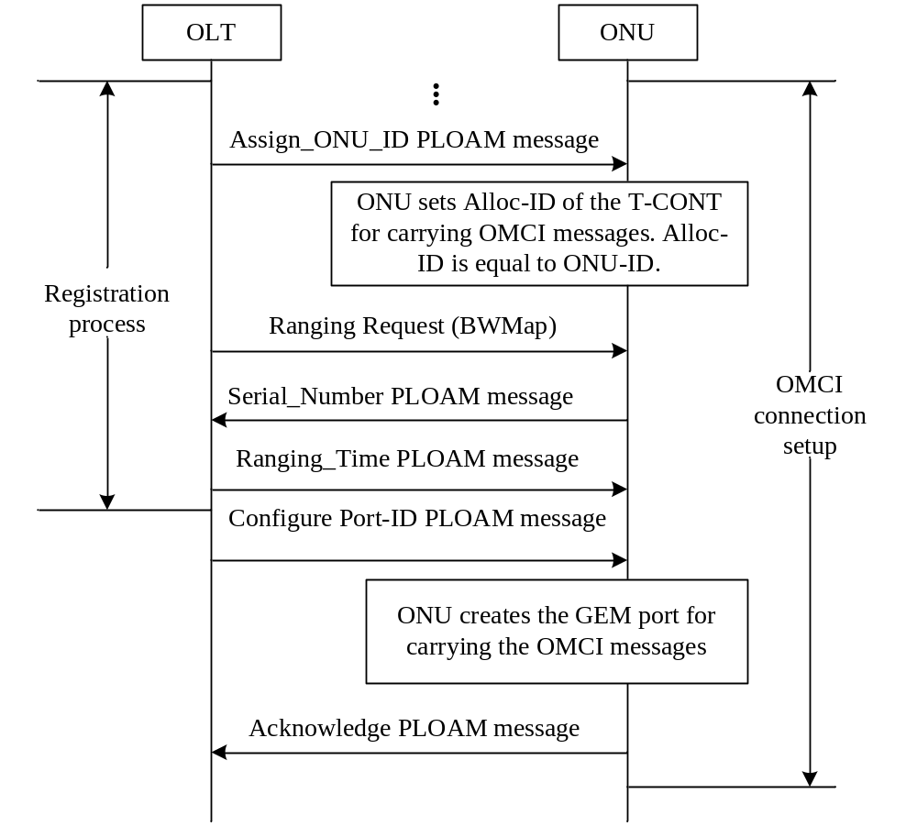
Figure ‎7.1 OMCC Best Practices

Since the Assign_ONU-ID PLOAM message also assigns a numerically identical Alloc-ID by default, it is not necessary for the OLT to use an Assign_Alloc-ID message in order to assign the default Alloc-ID to the ONT (i.e., the Alloc-ID equal to the ONU-ID). If the OLT nevertheless chooses to send an Assign_Alloc-ID PLOAM with the default Alloc-ID, the ONT acknowledges this message without taking any specific further action. The latter is true regardless of the Alloc-ID Type value in the Assign_Alloc-ID message: it should not be possible to de-allocate the default Alloc-ID with an Assign_Alloc-ID Type 255 message.

While it is possible for the default allocation to carry subscriber traffic, it is not commonly implemented. Therefore, it is recommended that the default allocation not be used to carry subscriber traffic.

Encryption
After the OMCC has been established, it is possible for the OLT to enable encryption on the OMCC GEM port. This is accomplished by the OLT sending the ONT an Encrypted Port ID PLOAM identifying the GEM port for OMCC that was previously provisioned in the ONT by the OLT.

Equipment management

ONT Bring-up
ONT Bring-up is separated into two distinct processes: New ONT Bring-up and Old ONT Bring-up. The definition of new ONT vs. old ONT is based on the status of the ONT as viewed by the OLT:

New ONT: The ONT has never completed the OLT’s MIB synchronization. For instance:

- The ONT has never been connected to the OLT and the OLT never “saw” its serial number.
- The ONT has been connected to the OLT but OLT did not assign an ONU-ID to it.
- The ONT has been provisioned but later de-provisioned by OpS.
- The ONT has failed MIB synchronization due to MIB corruption.

Old ONT: The ONT has been connected to the OLT, assigned the ONU-ID, and completed MIB synchronization at least once.

New ONT Bring-up
The bring-up process for new ONTs should be followed as shown in Figure ‎8.3 New ONT Bring-up. After the ONT powers up, and begins execution of a valid software version, the ONT automatically creates its MIB. Refer to G.984.3 for a more detailed explanation of state transitions during the activation process. Once the ONT transitions to Operation-state (O5), the OLT creates the OMCC as described in section 7 OMCC Best Practices. Initially, the OLT sets the ONT MIB to its default state by sending a MIB reset to the ONT. Once the ONT receives this message, it re-initializes its MIB to default values, and resets the MIB data sync counter to zero. Next, the OLT sends a MIB synchronization command, uploads the ONT MIB, and retrieves all ONT instances and capabilities. The OLT then downloads MIB updates to the ONT to bring the ONT MIB in synch with the OLT MIB.

In general, the use of Attribute Value Change (AVC) messages should be viewed as a partial method of ONT discovery. The OLT cannot solely rely on the receipt of AVCs to learn all ONT information since not all managed entities or attributes issue AVCs, and AVCs can be lost in transmission without an error being detected. Therefore, the OLT should audit any ONT immediately after a reset is completed.

When an ONT changes an attribute value autonomously, it sends an AVC message to OLT. The ONT can send AVC messages during MIB synchronization or MIB download processes.
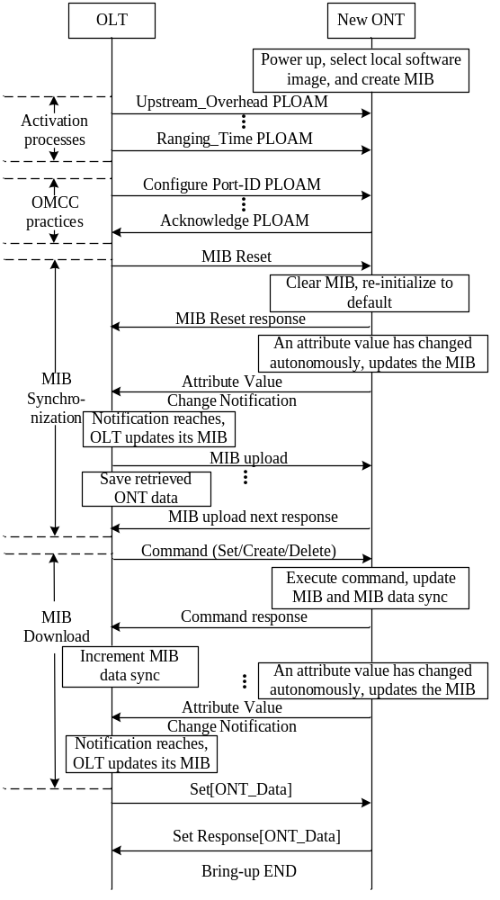

Figure ‎8.3 New ONT Bring-up

Old ONT Bring-up
The old ONT bring-up process should be followed as shown in figures Figure ‎8.5 Old ONT Bring-up case 1 – ONT MIB data sync matched and Figure ‎8.7 Old ONT Bring-up case 3 – ONT MIB data sync mismatched.

Once the ONT transitions to Operation-state (O5), the OLT creates the OMCC as described in section 7 OMCC Best Practices. The OLT then retrieves the ONT data sync by sending a Get[ONT_Data] message to ONT, and the ONT responds with a Get_response[ONT_Data] message. After receipt of the ONT’s data sync value, the OLT compares the received value to the OLT’s data sync value for that ONTs MIB.

The result of the comparison will lead to three possible ONT bring-up scenarios:

If the ONT MIB data sync value matches with OLT’s but is not equal to zero, the OLT assumes that their MIBs are in alignment. The MIB data on both sides of OLT and ONT are identical. The ONT bring-up process is completed.

If the ONT MIB data sync value equals zero (possibly the result of an ONT software upgrade or the ONT considering its MIB to be invalid), the OLT follows the same Bring-up sequence as described for a New ONT (above).

If the ONT MIB data sync value did not match, the OLT executes the MIB synchronization process. The sending of a MIB reset message is optional. Refer to section 8.2 for more details. To align MIB data sync, the OLT sends a Set[ONT_Data] command to complete the bring-up process. If the ONT failed MIB synchronization due to MIB corruption during ONT bring-up, the OLT may re-synchronize the ONT as shown in Figure ‎8.3 New ONT Bring-up or use the MIB re-synchronization method as shown inFigure ‎8.7.

Note: It should be recognized that the OLT ultimately makes the choice between using the New ONT bring up method and the Old ONT bring up method. Therefore, the implementation of the ONT should not cause the New ONT bring up method to function incorrectly for an ONT that has previously been provisioned.
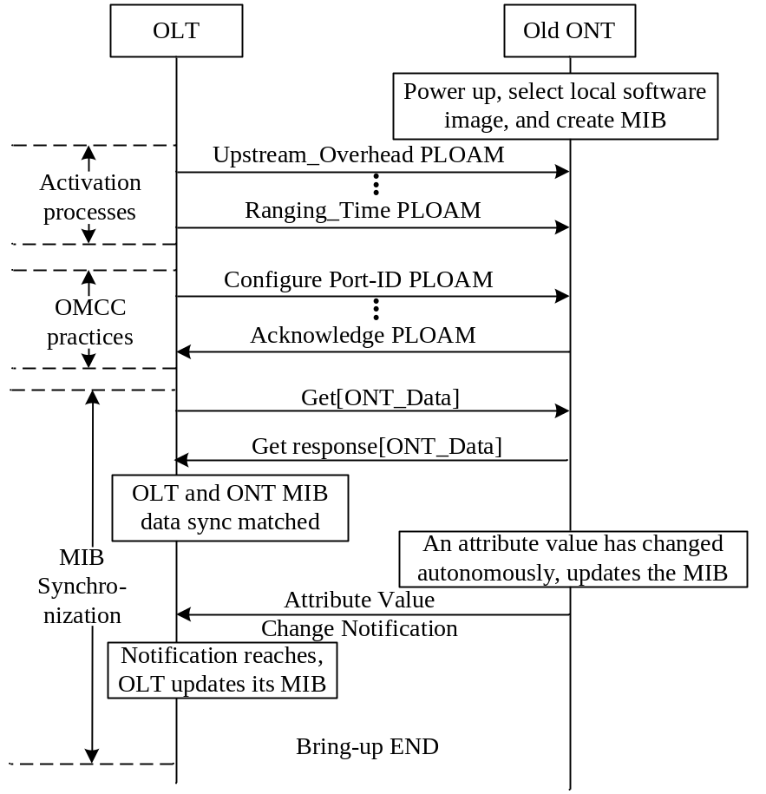

Figure ‎8.5 Old ONT Bring-up case 1 – ONT MIB data sync matched

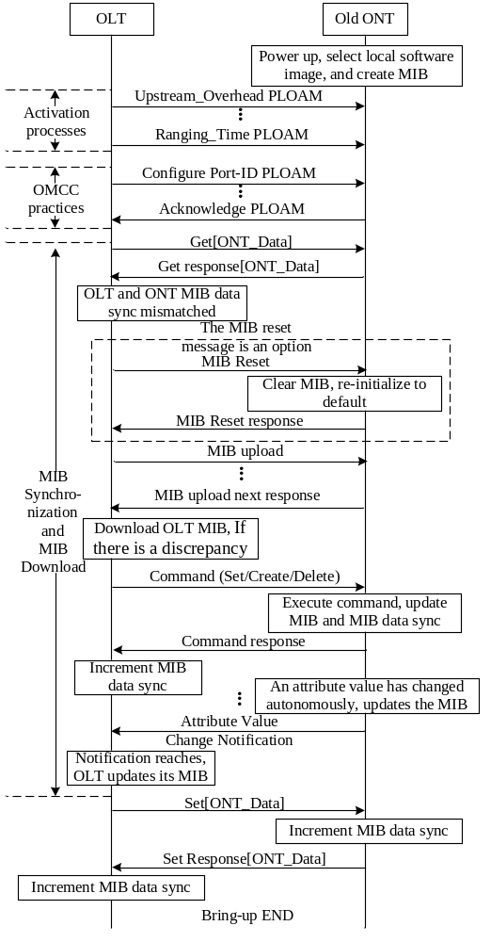
Figure ‎8.7 Old ONT Bring-up case 3 – ONT MIB data sync mismatched

MIB and Alarm Synchronization

MIB Synchronization

MIB data sync attribute
It’s essential to the correct operation of the GPON system to keep the MIB synchronized between the OLT and ONT at all times. As defined in G.984.4, the generic "tool" used for achieving this is the MIB data sync attribute of the ONT Data managed entity. The MIB data sync attribute is a global 8-bit sequence number. When auditing the MIB in the ONT, the OLT requests this sequence number. If this number is equal to the sequence number in the OLT, no further action is needed, as the copy of the MIB, in ONT and the copy of the MIB in the OLT, are considered to be identical. However, the MIB data sync attribute does not reflect the state of the entire MIB so it is important to understand the operation of the MIB data sync attribute.

MIB data sync operations
The MIB data sync attribute is incremented for the creation and deletion of managed entity instances that are the consequence of a command by the OLT. The MIB data sync counter is also incremented for attribute value changes which are the consequence of a command by the OLT. The MIB data sync counter is incremented once per executed command not once per attribute impacted by a command (Figure ‎8.9 Increment of MIB data sync at ONT and OLT under OLT command). This includes the modification of the MIB data sync counter attribute via a Set command from the OLT. Therefore, a Set of the MIB data sync counter value to N will result in a MIB data sync counter value of N+1 after completion of the Set command.
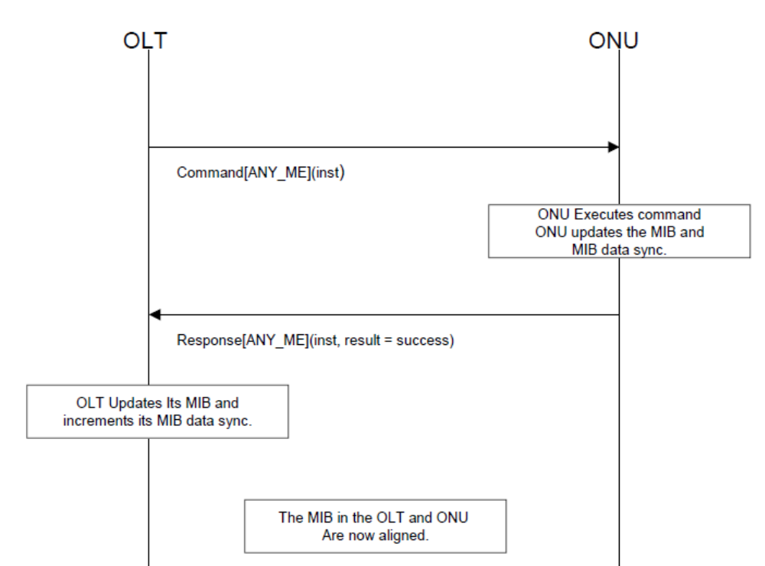
Figure ‎8.9 Increment of MIB data sync at ONT and OLT under OLT command

In contrast, the MIB data sync counter is not incremented for autonomous creation and deletion of managed entity instances by the ONT itself. Neither is the MIB data sync counter incremented for autonomous changes to attributes of managed entities within the ONT (Figure ‎8.11 No increment of MIB data sync at ONT and OLT).

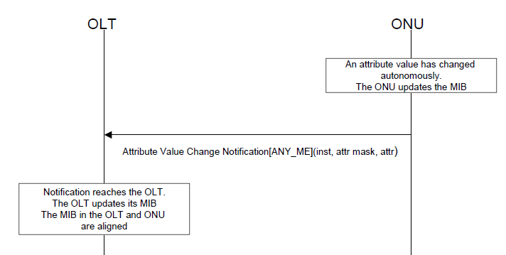
Figure ‎8.11 No increment of MIB data sync at ONT and OLT

For the off-lined ONT case, the OpS sends a command (create/delete/set) to ONT, the OLT saves these MIBs only on the OLT side and increments the MIB data sync, but does not send the command to ONT. In other words, the OLT should only locally update the MIB and increment the MIB data sync so that it guarantees that when the ONT comes on-line, the MIBs audit will fail.

The order in which the OLT and the ONT update their MIBs and increment the MIB data sync attribute is not imposed by G.984.4. Regardless of the order chosen, both the OLT and the ONT must locally update the MIB and increment the MIB data sync as one atomic action. However, it is considered good practice for the OLT to not increment its data sync counter until it has received a positive acknowledgement to the command that it sent to the ONT.

When incremented, the sequence number that follows 255 is 1. Zero is reserved for the following cases:

- Default MIB with which the ONT left the factory.
- An ONT which after (re-) initialization cannot restore its MIB.

In other words, a sequence number of 0 indicates that the ONT’s MIB is not well defined, and therefore requires audit / reconfiguration.

Note that no mechanisms exist to detect that an autonomous attribute value change notification has been lost. Therefore, the OLT must regularly read the values of the attributes that can change their values autonomously.

Loss of MIB synchronization
In the process of an OLT modifying the MIB in an ONT, the MIB at the OLT side could fall out of synchronization with the MIB at ONT side. Figure ‎8.13 The mismatch of MIBs at ONT and OLT under OLT command, shows one possible scenario for this occurring.
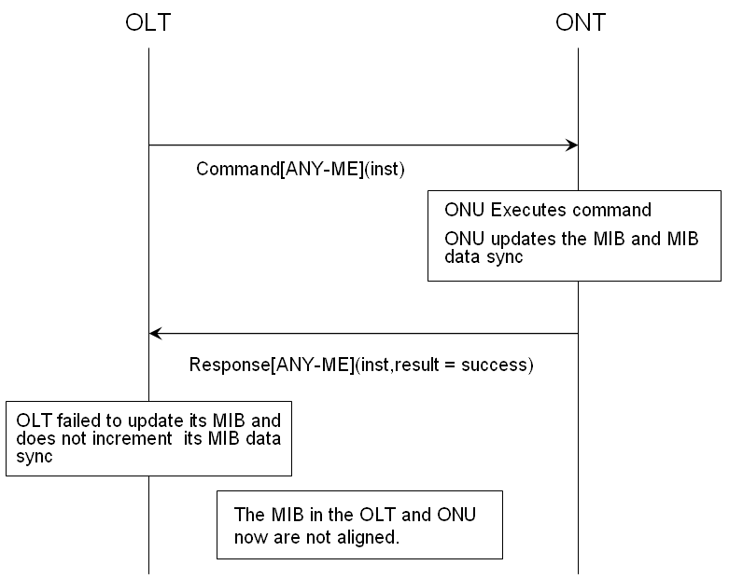
Figure ‎8.13 The mismatch of MIBs at ONT and OLT under OLT command
A failure in sending an AVC from the ONT to OLT will lead to a MIB mismatch. In this case, the discrepancy between OLT and ONT MIBs may not be detected by the MIB audit mentioned below. Under these circumstances, the MIB data syncs are still the same for both sides but the MIB content is no longer identical between the OLT and ONT. (Figure ‎8.15 The mismatch of MIBs due to lost AVC) .
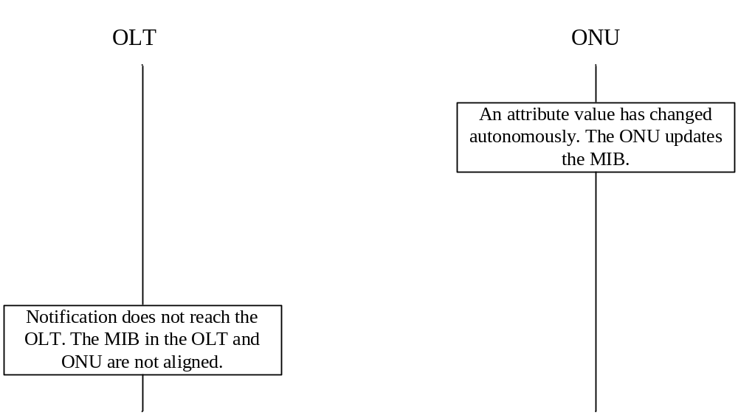
Figure ‎8.15 The mismatch of MIBs due to lost AVC

MIB Audit
The ONT is audited with respect to its MIB in three cases:

- On loss and re-establishment of the OMCC.
- Periodically, based on the operator's requirements.
- On demand of the OpS.

On detecting a newly installed ONT, regardless of the sequence number of its MIB, the OLT will directly perform a MIB reset and ONT bring up procedure (see section 2.1 in this guide). Figure ‎8.17 MIB Audit shows the scenario diagram of a MIB audit.
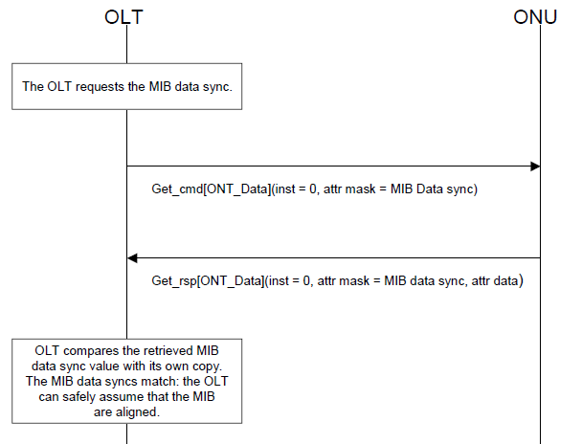
Figure ‎8.17 MIB Audit

MIB resynchronization
Figure ‎8.19 MIB resynchronization shows the scenario diagram of the MIB resynchronization process. In this case, the MIB resynchronization is the result of a MIB audit failure. Since the MIB data sync attribute does not reflect the status of the entire MIB, it is considered good practice for the OLT to periodically perform a MIB resynchronization regardless of the out come of a MIB audit.
OLT
ONU
The OLT request the MIB data sync
Get_cmd[ONT_Data]( inst = 0, attr mask = MIB data sync)
Get_cmd[ONT_Data]( inst = 0, attr mask = MIB data sync)
OLT compares the retrieved MIB data sync value with its own copy. The MIB data syncs do not match: the OLT can align the MIBs incrementally. For this, the OLT first uploads the MIB of the ONT. At this point, the OLT makes a copy of its MIB. Then the OLT will have an active MIB (A_{OLT}) and a copy (C_{OLT})
MIBupload_cmd[ONT_Data]( inst = 0 )
The ONU makes a copy of the MIB; thus the ONU will have an active MIB (AONU) and a copy (CONU). The ONU response with the indication of the number of commands (N) to be uploaded
MIBUpload_rsp[ONT_Data]( inst = 0, number of subsequent commands = N)
The OLT request the information of all instances in the MIB of the ONU. The ONU can still send AVCs and the OLT can still send configuration requests during the upload
MIBUploadNext_cmd[ONT_Data]( inst = 0, command sequence = 0 )
MIBUploadNext_rsp[ONT_Data]( inst = 0, ME class, ME inst, attr mask, attr data )
……
MIBUploadNext_cmd[ONT_Data]( inst = 0, command sequence = N-1 )
MIBUploadNext_rsp[ONT_Data]( inst = 0, ME class, ME inst, attr mask, attr data )
The OLT compares the information of received C_{ONU} to its C_{OLT} and updates the A_{OLT} or A_{ONU}.
Figure ‎8.19 MIB resynchronization
The OLT must issue as many MIBUploadNext requests as the number of commands given in the MIBUpload response. The maximum time between two MIBUploadNext requests is 1 minute. If the OLT does not send a MIBUploadNext request within this time after the previous MIBUploadNext request or after the MIBUpload start request, the ONT assumes the MIB upload to be terminated. The ONT can drop the copy of the MIB, and consider any MIBUploadNext requests to be out of range, as described in G.984.4.

It should be noted, that certain MEs are excluded from the MIB upload. In particular, instances of some general purpose MEs, such as the Managed Entity ME and the Attribute ME, are not included in the MIB upload. All table attributes are not included in the MIB upload. If the OLT requires this information, it obtains it on a per table basis through the use of the Get/GetNext mechanism.

Alarm synchronization

Alarm sequence number increase
The ONT informs the OLT of alarm status changes by sending alarm status change notifications. Note that these notifications are sent in unacknowledged messages that carry an eight-bit alarm sequence number for the benefit of the OLT to detect loss of alarm notifications (Figure ‎8.21 Increment of alarm sequence number at ONT and OLT thru Figure ‎8.25 No increment of alarm sequence number at ONT and OLT under ARC).

After a restart of the ONT, the alarm sequence number is reset so that the first alarm notification sent by the ONT has an alarm sequence number equal to 1. The alarm message sequence number is incremented for each alarm notification and wraps around from 255 to 1. Consequently, an alarm notification with sequence number 0x00 is never sent.

In the case of alarms under ARC, an alarm message is not sent. Therefore, the alarm sequence number is not incremented.
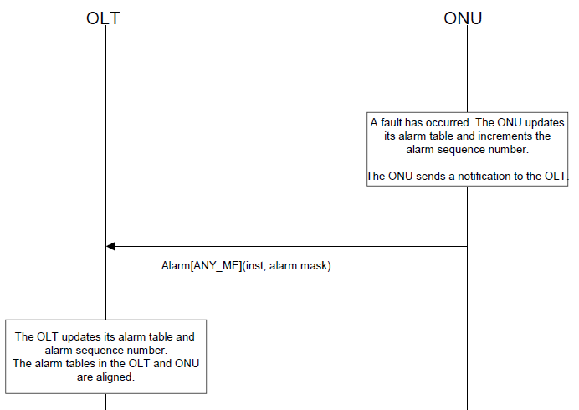
Figure ‎8.21 Increment of alarm sequence number at ONT and OLT
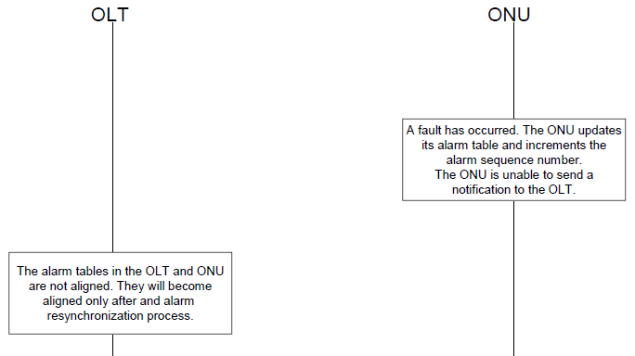
Figure ‎8.23 Alarm Sequence Number Fails to Stay in Sync
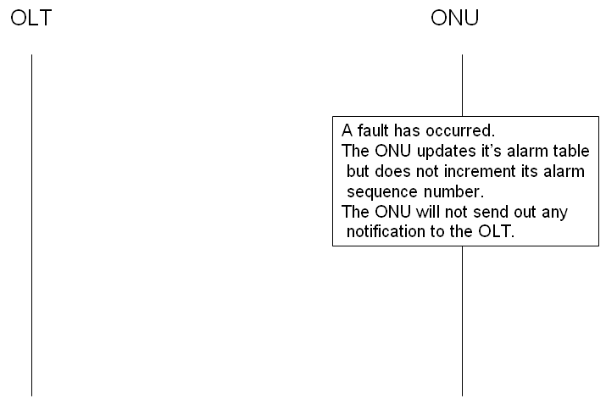
Figure ‎8.25 No increment of alarm sequence number at ONT and OLT under ARC

Alarm audit and resynchronization
When the OLT detects a gap in the alarm sequence number, it asks the ONT for an alarm status report by sending a "Get All Alarms" command targeted at the “ONT data” ME, as shown in . This command is acknowledged by a response that contains the number of managed entity instances that have outstanding alarms. The OLT then requests the alarm status of all these managed entity’s instances via the "Get All Alarms Next" command targeted at the ONT data ME. The OLT then compares the received alarm statuses with its own alarm table entries for that ONT and notifies the network manager of any changes. The alarm sequence number is reset to zero by the ONT when it receives the "Get All Active Alarms" request.

The OLT detects a missing alarm notification.
GetAllAlarms_cmd[ONT-Data](inst=0)
The ONU makes a copy of the current alarm status table of all managed entity instances, thus the ONU will have an active (A_{ONU}) and a copy (C_{ONU}) of the alarm table
GetAllAlarmsNxt_cmd[ONT-Data](inst=0,cmd seq num = 0.)
GetAllAlarmsNxt_rsp [ONT-Data](inst=0,Me class, inst, alarms.)
GetAllAlarmsNxt_cmd[ONT-Data](inst=0,cmd seq num = N.)
GetAllAlarmsNxt_rsp [ONT-Data](inst=0,Me class, inst, alarms.)
The OLT copies the (C_{OLT}) populated from the GetAllAlarm sequence
The OLT processes the buffered alarms and updates its alarm table.
ONU
OLT

The ONU resets the alarm sequence number to 1 and responds to the request with an indication of the number of instances (N+1) that are required to retrieve the active alarms.

GetAllAlarms_rsp[ONT-Data](inst=0, number of commands(N))

The OLT makes a blank alarm status table, thus the OLT will have an active alarm table (A_{OLT}) and a blank version (C_{OLT}). The OLT requests the alarm status using the number of commands indicated in the response.

During the Alarm Resynchronization, the ONU can still send alarm notifications. For alarms that are newly issued at this period, the OLT will buffer them temporarily and take actions after the completion of reconciliation.

Figure ‎8.27 Alarm Resynchronization

The OLT must issues as many GetAllAlarmsNext requests as the number of instances given in the GetAllAlarms response. The maximum time between two GetAllAlarmsNext requests is 1 minute. If the OLT does not send a GetAllAlarmsNext request within this time after the previous GetAllAlarmsNext request or after the GetAllAlarms request, the ONT assumes the alarm upload to be terminated. The ONT can drop the copy of the alarm table, and consider any GetAllAlarmsNext requests to be out of range, as described in G.984.4. If there’s any new alarm issued during the process of alarm upload, it is queued at the OLT side. Then after the reconciliation, OLT processes this new alarm immediately and updates its alarm table accordingly. If the OLT sets the alarm retrieval mode indicator in the GetAllAlarms command to 1, then the ONT only returns the alarms which are currently not under ARC. Otherwise, the ONT returns all alarms regardless of the ARC status.

Discovery

Discovery of ONT physical capabilities – MIB UPLOAD
When an ONT initializes, it populates its MIB with information about its equipment configuration. This should occur prior to ranging of the ONT so that the MIB provided in response to a MIB upload request reflects the current hardware configuration of the ONT. This permits the OLT to discover the hardware configuration of the ONT by analysis of the uploaded MIB.

Discovery of ONT software capabilities -- OMCI Capability Report
The GPON system should support ONT software capability reporting through the discovery of the managed entity types and message types supported by the ONT. This is accomplished through the reading of two table attributes contained within the OMCI ME and the contents of the Managed Entity ME instances.

The OLT obtains the managed entity types supported by the ONT through the managed entity type table attribute of the OMCI ME. This operation follows the procedure in Figure ‎8.29 ONT ME types report.
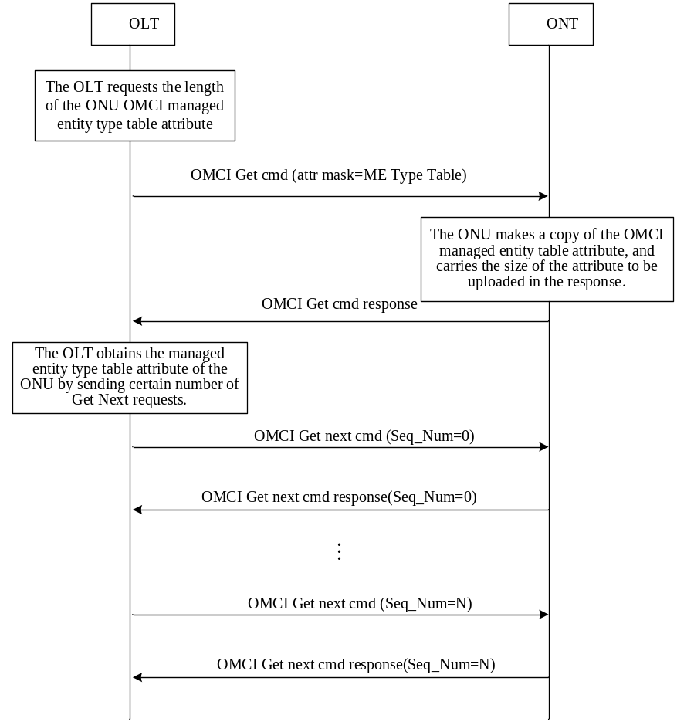
Figure ‎8.29 ONT ME types report

The OLT obtains the message types supported by the ONT through the “message type attribute” of the OMCI ME. This operation follows the procedure in Figure ‎8.31 ONT message types report.
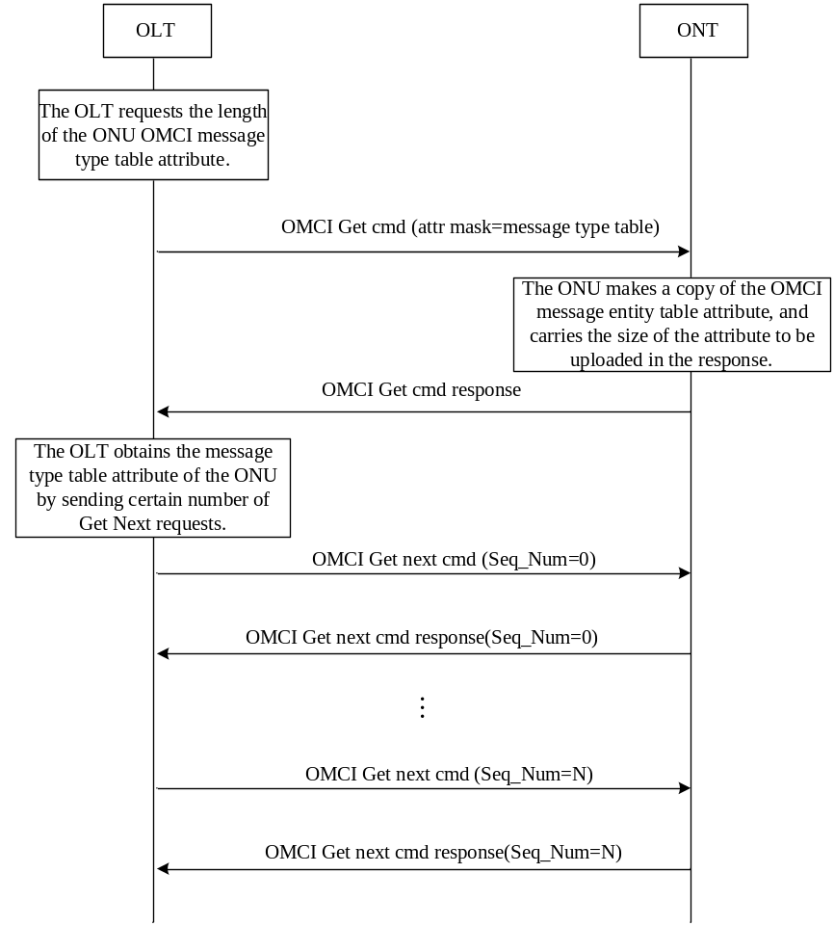
Figure ‎8.31 ONT message types report

The OLT obtains further details about the ONT’s support for a given OMCI ME by reading the Managed Entity ME for that ME. This includes the following:

Name: ME Type name for the represented ME.
Attributes table: A table containing pointers to the attribute MEs that describe each of this ME’s attributes. Note: the managed entity ID attribute is not included in the list.
Access: Represents who creates this ME. The following code points are defined:
1 Created by the ONT
2 Created by the OLT
3 Created by both ONT and OLT
Alarms table: Lists the alarm codes that are supported for the represented ME.
AVCs table: Lists the AVCs that are supported for the represented ME.
Actions: Lists the action codes supported on this object, formatted as a bit map. The action codes are the message types from table 11-1/G.984.4. The least significant bit represents action 0, and so on.
Instances table: A list of pointers to all instances of this ME that have been created.
Support: Represents support capability of this ME in the ONT’s implementation. This attribute does not declare if the OMCI implementation complies with the recommendations, but if it complies with the OMCI declaration itself. The following code points are defined:
1 Supported (supported as defined in this object)
2 Unsupported (OMCI returns error code if accessed)
3 Partially supported (some aspects of ME supported)
4 Ignored (OMCI supported, but underlying function is not)

Software Image Download
The ME for software download is given in clause 9.1.4 of G.984.4. For each ME which contains independently manageable software (either ONT or circuit pack), the ONT creates two software images (known as image 0 and image 1). Each image has three attributes: committed, active, and valid. An image is valid if the contents have been verified to be an executable code image. An image is committed if it will be loaded and executed upon reboot of the ONT and/or circuit pack. An image is active if it is currently loaded and executing in the ONT and/or circuit pack. At any given time, at most one image may be active and at most one image may be committed.

An ONT will go through a series of states to download and activate a software image as shown in G.984.4. Each state is determined by the status of both software images. For example, S3 is the state where both images are valid but only image 0 is committed and active. The OLT controls the state of the ONT through a series of commands also shown in G.984.4. For example, an ONT in state S3 will traverse to state S4 upon receipt of the activate(1) command. The defined commands are Start download, Download section, End download, Activate image, and Commit image.

The detailed scenario diagrams for software image download, activate, and commit are described in Figure ‎8.35 - Software Download thru Figure ‎8.39 - Software Activate and Software Commit. The message layouts for the commands are described in G.984.4.

Composition of Software Image
A software image is divided into sections of 31 bytes, with one section per OMCC message, and each section covered by the OMCC CRC. A set of sections is known as a window, and a set of windows comprises the image. The relationship between sections, windows, and the software image is shown in Figure ‎8.33 - Relationship between Image, Windows, and Sections.

Download
The detailed scenario diagrams for software image download are described in Figure ‎8.35and Figure ‎8.37. The first step in the download process is to determine the number of sections in a window, which is known as the window size. The window size is negotiated between the OLT and the ONT. The OLT proposes a window size value in the Start software download command and the ONT selects the final value in the Start software download response. The value selected by the ONT must be less than or equal to the proposed OLT value. Each section is then downloaded using the Download section command. Subsequent sections increment the “download section number” field. The first section of a window should be numbered zero. The OLT requests that the ONT send an acknowledgment for a window by setting the AR bit in the final section command of that window. If all sections of the window have been successfully received by the ONT, a positive acknowledgement is sent in a Download section response. A negative acknowledgment is sent if a section is not successfully received (caused by an OMCC CRC failure or a missed section). Upon receipt of a negative acknowledgment, the OLT may either retransmit the window or terminate the download process by sending an End software download command. The OLT may effectively reduce the window size at any time by setting the AR bit in a section command at a point in the section sequence that is less than the previously agreed upon window size.

Dependant on the size of the software image being downloaded, there may not be enough image remaining to fill the last download window. In this case, the OLT may either fill the remaining sections of the window with padding or set the AR bit in the final Download section command that contains actual software image.

After all windows have been downloaded, the OLT will send an End software download command containing a CRC-32 covering the entire software image excluding any padding. This CRC is calculated in accordance with I.363.5. The ONT sends an End software download response when the validity of the CRC-32 is verified and the downloaded image is prepared for the receipt of an Activate or Commit command (i.e. written to flash).

If the ONT detects an error during a section download, it should wait until the OLT sends a section command with the AR bit set to send a negative acknowledgement as shown in Figure ‎8.35.

A common behavior in many ONTs is to respond to an End software download command with an End software download response containing the response code “device busy.” This is because some ONTs utilize a persistent memory device which requires a longer image storage interval than a typical OMCC timeout interval. The OLT should send the End software download command at some frequency until the response is not “device busy.” (ref: Figure ‎8.37) The OLT should include a timeout to detect an ONT that never leaves this state.
As well as the download of an image to the ONT as a whole, the download messages allow an option to download an image to each of several circuit packs in parallel. The starting assumption is that the OLT knows the set of circuit packs that require the same download file, so that it can specify this set in the download command sequence.

Commit and Activate
The detailed scenario diagram for software image activate and commit is described in Figure ‎8.39 - Software Activate and Software Commit. Once the ONT has downloaded and validated the image, that image is initially not committed and not activated. The OLT may then send the Activate image command. After a positive acknowledgement is sent (Activate image response) by the ONT, the valid software image will be loaded and executed by the ONT without changing the committed state. The OLT may then send the Commit image command, causing the ONT to set its commit state to a one and to send a Commit image response. Note that the most recent “commit” is always the commit that is followed. The time between the phases of download, activate, and commit are not prescribed by the standard.

If after downloading, verifying and activating there is still a problem with the image that causes the ONT to fail (e.g. watchdog timers detects activation failure), then the ONT should do a soft restart to the committed image. In this way, activating prior to committing may allow for automatic failure recovery by the ONT.

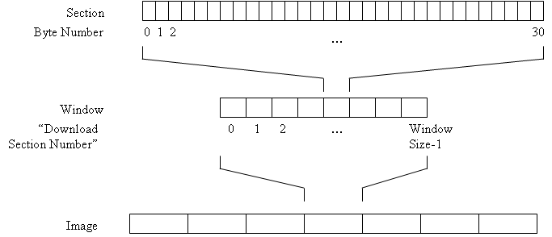

Figure ‎8.33 - Relationship between Image, Windows, and Sections

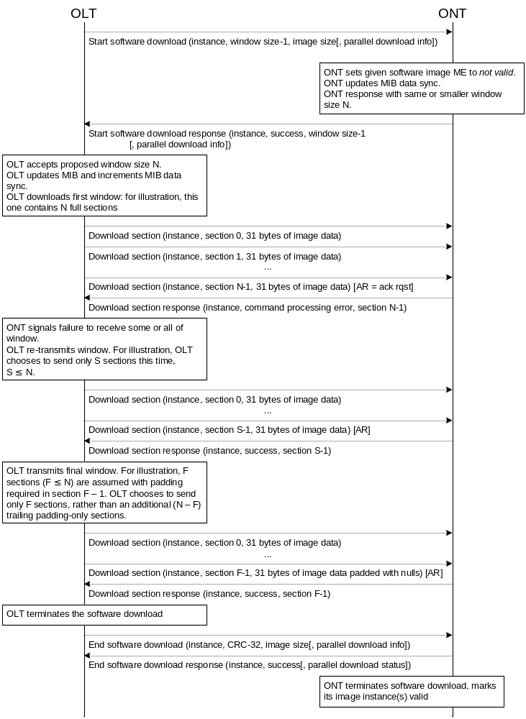

Figure ‎8.35 - Software Download
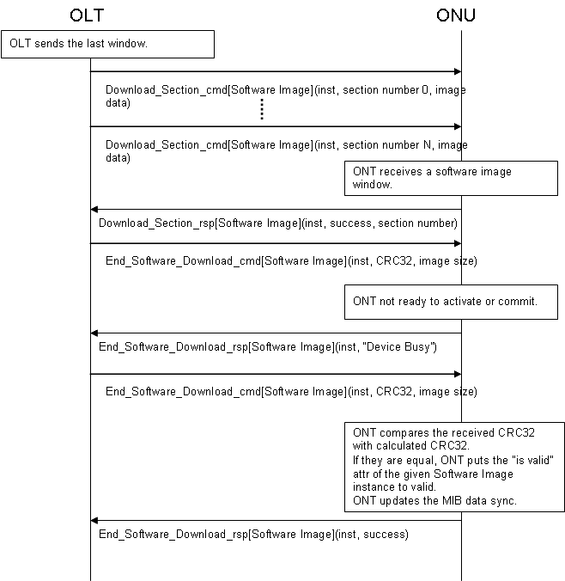

Figure ‎8.37 – Busy Response Handling
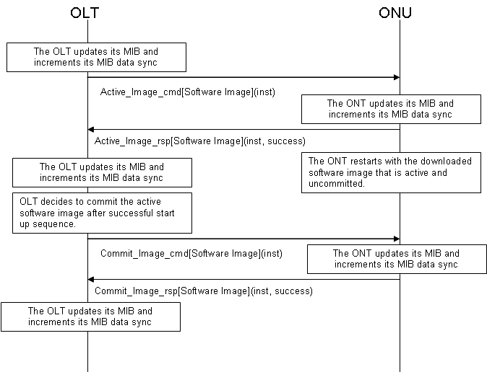

Figure ‎8.39 - Software Activate and Software Commit

Circuit Packs
G.984.4 appendix I.2 contains a number of clauses dealing with circuit pack provisioning. The GPON implementers’ guide replaces appendix I.2 in its entirety.

The slot-port model
ONT equipment management is modeled on a three-level hierarchy: the chassis (the ONT itself), cardholders (also known as slots), which may contain circuit packs of varying types over the course of time, and ports, which present external interfaces either to the subscriber, to the PON or to a local management tool. Many OMCI managed entities are addressed in accordance with the slot-port model. Ports – the physical termination point group of MEs – would be expected to follow this model, of course, but the T-CONT, MAC bridge service profile, IP router service profile, ARP service profile and traffic scheduler are also modelled by slot, if not by port.
All ONTs must therefore adhere to at least a minimal slot-port model. An integrated ONT is represented as a virtual chassis containing virtual cardholders. There are three ways in which this may be done.

- Several virtual cardholders may be defined, one for each interface type. This was the original model and is the most common. The more significant byte of the ME ID of a virtual cardholder has the value 1; a real cardholder has the value 0. In both cases, the slot number (actual or virtual) is the value of the less significant byte.

- A single virtual cardholder may be defined as slot 0 (LS byte), and all interfaces may be represented through the port mapping package ME, which maps ports of arbitrary types in arbitrary combinations. The port mapping package has the merit that it is universally applicable to integrated and chassis-based ONTs equipped with any type of real or virtual circuit pack, but for historical reasons, it is commonly used only when it is the only choice: a chassis-based ONU that contains circuit packs with mixed port types.

- The port mapping package may be contained by the ONT directly, rather than by a virtual cardholder. This approach has the merit that it avoids a virtual cardholder that serves no real purpose, and the disadvantage that it applies only to integrated ONTs. It is unlikely to appear in actual practice.

In the original model, real or virtual slot numbering was segregated by PON-side (128 up) vs subscriber-side (127 down). Although this constraint is no longer specified – it was unsatisfactory for real chassis with real slots, as well as mixed-function circuit packs – many existing virtual-slot implementations continue to follow this convention for historic reasons.

In addition, the two most significant bits of the slot address are available to designate xDSL bearer channels when desired. While this violates orthogonality, it poses fewer problems in practice than in theory, since a space of 64 slots more than suffices for real or virtual cardholders. Best practice would indicate that slot numbers be unique within their 6 LSBs, particularly if there is any possibility that xDSL bearer channels may need to be modeled.

As to port addressing, the original model specified ports numbered in increasing order, left to right, bottom to top, but this was inappropriate both for three-dimensional ONT packages with mixed ports of all types on several surfaces or edges and for chassis-based ONUs with service connections through the backplane rather than on circuit pack faceplates. Today, port addresses are expected only to start with 1 and to be unique. Small numbers in a contiguous sequence are preferred.

Finally, it is worth mentioning that nothing actually prohibits mixing port types on any card type, without benefit of the port mapping package. The combined video UNI and PON type (code point 44) even explicitly allows for differing port types. No convention exists for the numbering of such ports, configuration discovery is likely to be a problem, and best practice would avoid this option.

The chassis-based ONU
The original slot-port model was, and is, arguably adequate for integrated ONTs, where it is easy to create as many virtual cardholders as may be desirable. For chassis-based ONUs, however, a number of difficulties arise:

- The model does not readily accommodate the richness of possible service interfaces. G.984.4 defines circuit pack types, with an eye to listing all possibilities, but it doesn’t scale well. As an example, the long list of VF specials is not presently represented. See the next two bullet points as well.

- The model does not adequately represent common equipment, circuit packs with no external ports at all, for example power supply packs. G.984.4 includes a single code point for common equipment; it does not distinguish different types of common equipment.

- It has no way to flexibly model equipment with a combination of interfaces, for example, a single circuit pack with a PON interface, a craft port and an RF video port (code point 44 includes PON and RF video, but not craft). Code point 45 is defined for multi-function packs; it does not distinguish different types of multi-function packs. As mentioned above, port numbering conventions are undefined, except by way of the port mapping package.

- There were ambiguities in G.984.4, specifically between the possible mixes of 10/100/1000 Mb/s Ethernet and its physical media. The ambiguity has been resolved with a compromise, but existing implementations must be regarded with caution.

- The original model could not distinguish between two Ethernet packs, for example, with four ports on one and eight on the other. Port count attributes were added as a patch, but they do not address the reality that both operators and vendors are likely to manage real equipment inventory by a code (CLEI, for example, or vendor product name/number), rather than simply by generic type.

The integrated ONT was first to be developed, so the issues mentioned above were not immediately apparent. Various extensions have been added to the equipment model to address these concerns, as discussed below.

While the generic circuit pack types of G.984.4 arguably suffice for the integrated ONT, it is recommended that the chassis based ONU use the equipment ID attributes as its primary means to identify equipment options. Equipment ID is also the preferred way to identify an integrated ONT for inventory purposes.

In G.984.4, a small range of equipment types was reserved for vendor-specific assignment. Vendor-specific code points would seem to introduce interoperability issues, but they are in principle no worse than equipment ID as an identifier: the OLT and EMS must have a priori knowledge of the meaning and characteristics of whatever identifiers are used, presumably through business agreements and information exchange between the vendors concerned.

Dynamic behaviour

ONU initialization

The ONU’s view
When an ONU initializes, it populates its MIB with information about its equipment configuration. The recommendations are written as if it discovers this information for itself when it comes to life. This may be the case, but it is also possible that an ONU, especially an integrated ONT, may be equipped with a basic MIB at the factory, in which case initialization may comprise merely copying the MIB into working store and discovering only options that may have changed after the last shutdown and prior to the current initialization.

If it exists, the non-volatile MIB image used as the initialization reference for a chassis-based ONU may be populated with circuit pack types or equipment IDs, either by factory predetermination or from prior operation of the ONU. This equipment may or may not be present during the current initialization. Whether there is a non-volatile MIB or not, the ONU must actually perform some level of self-discovery to determine what, if anything, exists in its cardholders.

The ONU is specified to issue AVCs or alarms when it discovers circuit packs, or when it discovers that a circuit pack that was recorded in its non-volatile MIB (if there is one) is no longer present or no longer has the same type or equipment ID. However, ONU initialization typically occurs while the ONU is not ranged on the PON, so successful transmission of AVCs and alarms is not necessarily possible. Queuing of notifications for future delivery is not specified, so the OLT must audit the connected equipment when the ONU re-ranges.

It is recommended that an initializing ONU complete MIB update through whatever process of self-discovery is appropriate before it responds to ranging grants from the OLT. This allows the OLT to begin a MIB audit immediately without concern for races with the ONU’s continuing initialization process.

No initialization issues arise if there are no mismatches between an ONU’s actual equipage and its (possible) non-volatile MIB. If there are mismatches, however, the ONU should declare alarms as appropriate and should not attempt to bring the mismatched circuit packs into service.

ONU initialization: the OLT view
When the OLT ranges an ONU, the OLT either has a MIB that corresponds to that ONU or it does not.

If the OLT does not have a MIB for that particular ONU already, it uploads the ONU’s MIB as a starting point. Subsequent operation and provisioning is recorded both in the ONU’s MIB and in the OLT’s functional duplicate. AVCs from the ONU alert the OLT to changes that could occur from external causes such as craft removal or installation of circuit packs. An AVC triggers the OLT to update its view of the ONU. The details of such an update are beyond the scope of this document.

When it ranges the ONU, the OLT may already have a MIB (or database functional equivalent) for a particular ONU, either because the ONU has been pre-provisioned or because the ONU has previously been active on the PON. The initialization requirements are the same in either case.

Assuming that the OLT has a MIB for this particular ONU, an audit is necessary once ranging is complete as part of service (re-)activation. The ONU is responsible to know its current equipment configuration, which must be reconciled by the OLT. The OLT, on the other hand, is responsible to know all provisioned information, and to ensure that, once initialization is complete, the ONU is provisioned accordingly. The OLT should declare alarms or events toward an EMS if the configuration has changed unexpectedly or provisioning reconciliation fails.

Circuit pack provisioning
The previous section discusses ONU initialization. This section discusses the dynamics of circuit pack provisioning, installation and removal for an ONU that is ranged on the PON. It assumes a chassis-based ONU: changes to (virtual) circuit packs should not occur on integrated ONTs. An integrated ONT should deny attempts to provision cardholder and circuit pack attributes that are in fact immutable, even if their OMCI definitions indicate that they have write or set-by-create semantics.

The ONU is sensitive to four events in this context, each of which has a number of use cases. Each event is discussed in its own section below.

- A circuit pack is provisioned into a cardholder.
- A cardholder is de-provisioned.
- A circuit pack is physically inserted into a cardholder.
- A circuit pack is physically extracted from a cardholder.

A circuit pack is provisioned into a cardholder
This event comprises the change of any of the writeable attributes of the cardholder, except setting the expected plug-in unit type to 0, which is covered under the de-provisioning clause below. If the expected plug-in unit type is 0, all of the other attributes of the cardholder may be freely altered without generating a provisioning event or affecting the ONU’s state or its alarms. That is, the ONU’s expectation of the presence or absence of a circuit pack is based entirely on the non-zero value of the expected plug-in unit type attribute.

If the cardholder is empty at the time of provisioning, the ONU can, and should, confirm that all attributes are consistent within the scope of its knowledge. That is, if either or both of expected port count and expected equipment ID are also provisioned, either in the same set command or separately, the combination of attributes must be consistent with the expected plug-in unit type. An Ethernet pack CLEI, for example, should be denied in the expected equipment ID attribute if the expected plug-in unit type is xDSL. Likewise, if the only Ethernet packs supported by the ONU have four ports, the ONU should deny an attempt to pre-provision an Ethernet slot with eight ports. Expected plug-in unit type code-point 255 (plug and play) is a don’t care case in terms of consistency checking, but the remaining attributes must still be mutually consistent and known to the ONU.

Assuming the provisioning event succeeds, the cardholder immediately declares the plug-in LIM missing alarm. (Note that the cardholder has neither administrative state nor ARC attributes, so its alarms cannot be suppressed.)

At this point, the ONU should instantiate a circuit pack ME, though it may be only an empty husk if insufficient information is provided (plug and play case).
It is possible that the provisioning command does not unambiguously define the equipment. For example, an ONU may support both a four-port and an eight-port Ethernet pack. If pre-provisioning merely calls out an Ethernet pack in such an example, best practice suggests that the ONU create an empty husk circuit pack ME. It is also acceptable for the ONU to deny the provisioning command, but creating four ports now and possibly four more ports later is discouraged.

Given enough information about type, port count and equipment ID, the ONU now creates a fully populated circuit pack ME, along with a suitable number of physical path termination point or ANI-G MEs, and any other MEs known to be appropriate to the configuration, for example a port mapping package ME, an equipment extension package or a protection data ME, software images, traffic shapers, T-CONTs, etc. From this enhanced MIB, the ONU is prepared to accept pre-provisioning of services. Service pre-provisioning should be denied if an empty husk circuit pack ME was created.

If the cardholder is occupied at the time of provisioning, the provisioning action may either create a mismatch with the existing circuit pack or resolve a mismatch.
Provisioning creates a mismatch if it sets the expected plug-in unit type to any value other than 0, to 255 (plug and play) or to the actual type. Provisioning creates a mismatch if it sets the expected equipment ID to any value other than all spaces, or to the actual equipment ID. Provisioning creates a mismatch if it sets the expected port count to any value other than 0 or to the actual port count. The ONU declares an alarm for a type or equipment ID mismatch. No alarm is defined for expected port count mismatch; rather the ONU should deny a provisioning command that attempts to create such a mismatch. The ONU should take no additional action upon mismatch creation. For example, if service is in fact running on existing hardware, it should be left in place. (But service would not be restored to a mismatch after ONU initialization because the ONU would have no independent record of the prior configuration.)

If the cardholder was in mismatch before the provisioning action, the mismatch is resolved if all of the following are true:

- The expected plug-in unit type is provisioned to the actual plug-in unit type. If the ONU supports plug and play, codepoint 255 also resolves a mismatch.
- The expected port count is provisioned either to 0 or to the actual port count.
- The expected equipment ID is provisioned either to the actual equipment ID or to a string of all spaces.

The ONU should clear any alarms that may have been declared as a consequence of the mismatch state. It should also initialize (or complete the initialization of) the physical circuit pack, up to and including bringing up any services that may be provisioned onto it.

A cardholder is de-provisioned
This event occurs when the cardholder’s expected type is set to 0. If it was already 0, this is a no-op. The ONU should delete all associated managed entities (see list and examples above), and clear any alarms associated with the equipment. It is an error for the OLT to de-provision equipment without first de-provisioning all services that depend on the equipment, and while ONU robustness is encouraged, the ONU’s behavior is undefined, up to and including the possibility that orphan or conflicting MEs may be left behind in the MIB, and nothing less than a MIB reset can recover.

If the cardholder is populated with a circuit pack at the time of de-provisioning, the ONU should place it in an inactive holding pattern, awaiting extraction or re-provisioning. The holding pattern state implies no user services; provisioning and test commands should be denied, alarms should be cleared and no new ones generated, and ports and preferably the entire circuit pack should be powered down. ONU initialization from this state should initiate the sequence that occurs when a circuit pack is inserted into an unprovisioned slot.

A circuit pack is physically inserted into a cardholder
The two cases to consider in this event are distinguished by whether the circuit pack managed entity already exists or not. The common cases are the installation of new packs and the replacement of defective packs. In the normal course of events, a circuit pack ME exists before either of these events.

If the cardholder is provisioned with an expected plug-in unit type, then a circuit pack ME exists, either of the specified type or of type 255, signifying unknown. When the actual circuit pack appears, the ONU updates the circuit pack ME with actual values from the equipment. (Note: OMCI does not presently define AVCs for changes to normally immutable attributes that may in fact change during this process, such as the circuit pack type.) If the appearance of the circuit pack resolves ambiguous provisioning, For example, as a plug-and-play circuit pack, this is the point at which the ONU creates the subordinate MEs mentioned above: PPTPs, software images, etc.

The appearance of a circuit pack either triggers a mismatch, in accordance with the mismatch discussion above, or it does not. If there is no mismatch, the ONU continues initialization and bring-up of the circuit pack and services. If there is a mismatch, the ONU declares a mismatch alarm through the cardholder ME. No alarm is defined for mismatch of port count; if this is deemed significant, a port count mismatch alarm should be proposed as an extension to the cardholder ME.

Most, if not all, physical path termination points (ports) include an optional operational state ME. Among other circumstances, this attribute should have the value disabled when the pack is not present. Operational state should change to enabled, and be reported via AVC, when the port successfully enters service. Within the scope of current OMCI, the failure to receive an AVC on the port is the only notification the OLT has of port mismatch.

If the circuit pack ME does not already exist, the ONU should instantiate it upon pack insertion. The ONU should populate the attributes of the circuit pack from the equipment itself, and report them to the OLT via AVCs from the cardholder.

The ONU should instantiate the complete set of PPTP/ANI MEs, port mapping packages, etc, as described above. If the pack and ports pass self-test, each should report an AVC when its operational state becomes enabled.

The absence of the circuit pack ME a priori guarantees that no additional pre-provisioned information exists in the MIB, except possibly in the de-provisioned corner case discussed above in which the ONU’s behavior is undefined.

A circuit pack is physically extracted from a cardholder
The most common cause of this event is the replacement of a defective circuit pack. When the old circuit pack is extracted, the event may trigger additional alarms – the circuit pack and some or all of the services are likely already in alarm – such as cardholder improper removal. No managed entities are deleted as the consequence of this event; only de-provisioning destroys MEs.

Replacing the defective pack with a like pack follows the normal sequence of events: the pack is initialized, no MIB changes are necessary, and services are restored. Replacing the pack with an incompatible pack triggers mismatch behavior as described in the previous section. Replacing the pack with a functionally similar pack (eg different CLEI, same capabilities) may or may not be accepted by the ONU, depending on its built-in knowledge of equipment compatibilities.

Less common is the removal of a circuit pack, either to leave the slot unpopulated or to re-use it for other purposes. It is recommended that services first be de-provisioned and then the cardholder be de-provisioned before the circuit pack is extracted, but if the pack is extracted first, it is treated exactly as if it were simply being replaced with another pack of the same type.

MIB sanity
Regardless of the flows described above, it is always allowed and encouraged for an ONU to deny provisioning actions that create MIB inconsistencies.

Protection
Two kinds of protection can be supported within the OMCI model, ANI (PON) protection and equipment protection. Vendor-interoperable protection has not been widely deployed as yet; in the absence of real-world experience, some aspects of its operation doubtless remain for further study.

The model for PON protection assumes two ANI MEs, which would presumably reside on separate circuit packs. The protection data ME coordinates the two ANIs and specifies various attributes of the protection group. PON protection handshaking is based on SDH K bytes. If more than LOS-based single-ended protection were to be supported, further work would likely be needed to rationalize the details of K byte protection with GPON.

The model for equipment protection is exemplified by a chassis-based ONU with DS1 circuit packs, in which one or two circuit packs protect up to eight working packs. Protection of this nature is likely to be built into the backplane or cabling of the ONU; protection packs may or may not be the same as the working packs. This function is supported by the equipment protection profile ME. Equipment protection can be manually invoked through an attribute of the working cardholder ME.

Subscriber facility protection, for example on 1+1 OC3 drops, is not supported by the current OMCI model.

Environmental inputs and outputs
OMCI provides an equipment extension package that may be associated either with an ONU or a cardholder to provide external sense or control points. The conceptual model is of equipment able to detect external contact closures, and report either a closed or an open contact as an off-normal event. Rectifier plant alarms may be reported with this mechanism, for example. The semantics of these alarms are undefined to OMCI and the ONU, and must be interpreted at the OLT or EMS level.

Where the ONU structure is hard-wired for particular alarms that are already defined in OMCI, the hard-wired alarms should be reported in preference to the general-purpose capabilities of the equipment extension package. For example, a physical intrusion alarm can be declared by the ONT-G, and is preferred, as long as no ONU provisioning is needed to associate the alarm with a specific input point. Likewise, existing battery alarms, declared by the ONT-G ME, are preferred where they convey the correct semantics and require no provisioning.

The equipment extension package managed entity also allows for external control points to be activated or released.

Managed entity analysis
This section discusses managed entities and attributes of interest. It is not a complete list of all concerned MEs or their characteristics; it represents those for which commentary is appropriate.

ONT-G, ONT2-G
These MEs define attributes, actions and notifications that conceptually pertain to the ONU as a whole equipment unit. When the ONU is implemented as integrated equipment, no issues arise. This section describes the common attributes, actions and notifications for the chassis-based ONU.

Attributes
Vendor id, version, serial number, vendor product code (RO) –
These attributes are not expected to exist for the chassis, per se. Their values should be taken from the controller pack (primary controller pack if there are two). Replacement of the controller pack may require reprovisioning of the ONU’s serial number at the OLT.
Traffic management option (RO) – Report the value from the pack that implements traffic management. In most cases, this would be the controller pack.
Battery backup (RW) – The integrated ONU should proxy this value on behalf of the pack that implements battery monitoring unless explicit provisioning is required, in which case the external sense points of the equipment extension ME should be used instead. If the ONT/ONU has no capability to monitor battery-related states, it should deny an attempt to enable battery monitoring.
Admin state (RW) – Administrative lock at the ONT level should disable all subscriber services on all ports of all circuit packs.
Operational state (RO) – Operational state indicates whether the ONT in its entirety is capable of performing some (vs none) of its functions. In accordance with the state model of X.731, the ONT should report its operational state as disabled only if all of its ports are out of service for autonomous reasons (eg failure or circuit pack extraction). At the ONT level, this information is not very useful; because operational state is an optional attribute, it may be omitted.
Equipment id (RO) – The equipment ID string is 20 characters, typically long enough for two informative fields. It is recommended that the primary information field be left justified in the equipment ID attribute, for example CLEI code in markets that use this identifier. If a second identifier (for example, vendor product designator) is desired, it is recommended that it be right-justified in the equipment ID attribute, with spaces padding the gap in the center. Although this information may be provided by the controller pack rather than the backplane, it is quite likely to differ from the corresponding equipment id attribute of the controller circuit pack, since it represents the ONU, rather than the circuit pack.
OMCC version (RO) – This attribute indicates the OMCI version supported by the ONU as an entirety, and should be reported as the most primitive version, considering all software residing on all circuit packs. Note: for historic reasons, an implementation may report 0x80, even though it actually supports a more recent version of OMCI.
Total priority queue number, total traffic scheduler number (RO) –
These attributes are defined to be the count of queues (schedulers) not associated with a specific circuit pack. The chassis-based ONU should report these on behalf of the controller (or traffic management) circuit pack, if a single (or duplicated) pack provides these functions. It is also acceptable to report these values as 0, and to report values for individual packs instead.
Total GEM port-ID number (RO) – This attribute should be reported for the ONU as an entirety on behalf of the ANI or traffic management circuit pack, typically the (primary) controller.
Actions
Reboot – This action should cause the ONU as an entirety to re-boot. It would be expected that the controller pack (or both controller packs) would re-boot, and any other circuit packs would be re-booted or reinitialized as applicable. Re-boot is not expected to be hitless to subscriber services. POTS calls are allowed to be dropped, and layer 2, 3 and 4 data associations are allowed to be lost.
Test – The test action on a chassis-based ONU may not be meaningful. In the case that the test action is not meaningful, it is the vendor’s choice whether to reject an ONU-directed test action, or whether to proxy the action to the (primary) controller pack.
Synchronize time – This action should resynchronize all circuit packs that maintain PM-related interval timers and counters.
Notifications – AVCs
Vendor ID, version, serial number –
These AVCs are of little use. These attributes should never change on an integrated ONT, and when the controller pack is replaced on a chassis-based ONU, it is questionable whether the new pack is in a position to declare the AVCs. The OLT should query this information from the ONU when the ONU re-boots.
Op state – As noted above, the operational state attribute is optional, and conveys little information at best. When the ONU is really incapable of performing any of its functions, it is likely also incapable of conveying a state indication over the PON.
Notifications – alarms
Equipment alarm, ONT self test fail – This alarm would be expected to be declared against an individual circuit pack, rather than against a chassis-based ONU as an entirety. If one of these alarms is declared by a chassis-based ONU, the alarm should really indicate a chassis problem, not a circuit pack problem.
Powering alarm, battery missing, battery failure, battery low, physical intrusion, voltage yellow, voltage red – These alarms are meaningfully declared by the ONU an an entity in its own right.
Dying gasp – The purpose of this alarm is to help the OLT distinguish, when possible, between fiber cuts and equipment faults. Dying gasp should therefore be declared by the ONU on behalf of the circuit pack that supports the ANI. That is, other parts of the ONU may remain up and running; the alarm indicates only the state of the PON optics. If the ONU has two PON interface circuit packs, dying gasp should not be declared on one to indicate imminent shutdown of the other. In that sense, the alarm is really declared by the PON circuit pack, but using the ONT-G as a reporting entity. Dying gasp is not an irrevocable commitment to drop off the PON: the OLT should accept the possibility that the ONU remains active on the PON and clears the alarm after a last-second recovery.
Temperature yellow, temperature red – While it is possible that a chassis could contain global temperature sensors, it is expected that, in the case of a chassis-based ONU, temperature alarms would be declared by individual circuit packs instead. In any event, the alarms should be declared by the ME that best represents the scope of the problem.

Cardholder
The cardholder ME is needed even by integrated ONTs, because it contains information pertinent to the virtual slot model.

Attributes
Actual plug-in unit type (RO) – This attribute takes a value from table 9.1.5-1. Choices from the table are expected to suffice for the integrated ONT, and the equipment ID attributes are not expected to be used.
Expected plug-in unit type (RW) – This attribute permits some level of pre-provisioning. Although the equipment ID is preferred to indicate a precise circuit pack type, this attribute should be selected from table 9.1.5-1 to be as meaningful as possible. Although this attribute is marked read-write, the integrated ONT should deny attempts to change its value.
Expected port count (RW) – This attribute permits pre-provisioning of generic circuit pack types when the equipment ID is not specified. Since equipment ID is preferred, this attribute should not be used. If it is used, it must be set to a value that does not conflict with other attributes, such as equipment ID, that may exist already or that may be part of the same set operation. As with the expected plug-in type, which is also read-write, an integrated ONT should deny an attempt to change the value of this attribute.
Expected equipment id (RW) – The OMCI definition states that this attribute pertains only to real (not virtual) cardholders. An integrated ONU should deny an attempt to write its value. As noted earlier, vendors may choose to encode two informative fields into this attribute, for example a CLEI and a vendor product code name. No substring matching behaviour is expected: the provisioned value of this attribute must match exactly the value found in the equipment itself.
Actual equipment id (RO) – The OMCI definition states that this attribute pertains only to real (not virtual) cardholders.
Notifications – AVCs
Actual type, actual equipment id – These AVCs are not meaningful for integrated ONUs.
Notifications – alarms
Plug in LIM missing, plug in type mismatch, improper card removal, plug in eqpt id mismatch, protection switch – These alarms are not meaningful for integrated ONUs.

Circuit pack
Virtual circuit packs exist for an integrated ONU. The type and number of ports attributes are meaningful from an equipment management point of view.

Attributes
Type (RWSC) – This attribute takes a value from table 9.1.5-1. While the attribute value should align as closely as possible with an appropriate equipment type (table 9.1.5-1), a chassis-based ONU should rely on the equipment ID attribute to convey precise information about circuit pack type.
Number of ports (RO) – Because a circuit pack can have only one type, all of its ports must be the same, and this attribute is just a scalar port count. More complex configurations are managed either by defining additional virtual cardholders and virtual circuit packs (integrated ONU) or with the port mapping package managed entity.
Serial number, version, vendor id, equipment id (RO) – These attributes are reported from the circuit pack hardware. For the (primary) controller pack, they would have the same value as reported in the ONT-G ME pair.
Administrative state (RWSC) – When this attribute has the value locked, all subscriber (and craft) services depending on this circuit pack are blocked. It may not be meaningful to lock circuit packs without subscriber (or craft) interfaces, or circuit packs with mixed interfaces such as ANI, LCT and video UNI; the behaviour in such a case depends on the vendor. It would be reasonable for the ONT to deny the lock operation, or for the operation to have no effect.
Operational state (RO) – This attribute has the value disabled if none of the circuit pack’s functions is operational for autonomous reasons.
Power shed override (RW) – This attribute permits ports to be declared essential and thereby to be excluded from power shedding timeout. It assumes a simple scalar numbering of ports; for circuit packs with several types of ports, the meaning of this attribute is undefined.
Actions
Reboot – This action is intended to permit an individual (real) circuit pack to be re-booted. If the circuit pack is the (primary) controller, however, it may have the same effect as an ONU reboot action.
Notifications – alarms
Powering alarm – This alarm is intended to indicate a more specific failure of the equipment. The failed equipment could be either a power supply circuit pack or a client circuit pack with a failed input fuse or converter. Battery and AC alarms are declared at the ONU level if they are hard-wired.

Remote Debug
The remote debug managed entity is used for free form information exchange with an ONT for the purpose of debugging ONTs from OLTs due to the lack of any other ability to debug using RJ45 or RS232 (primarily due to security concerns of the operator) or due to the unit being in a remote location (or not otherwise easily accessible).

The remote debug entity has the ability to send 25 bytes of information to an ONT and then collect up to 0xFFFFFFFE bytes worth of information from an ONT. The information exchange may be defined as ASCII coded or in raw data format which would imply vendor specific encoding and decoding of the command SET and reply information.

While it is assumed the majority of the OLT/ONTs which implement the ASCII format of this for interoperability where by OLTs can inject basic ASCII commands to an ONT and receive ASCII formatted reports back to the ONT, the raw data format offers the ability to collect information in a coupled environment (same vendors OLT and ONT) for advanced debugging purposes. Note it is not the purpose of this object to offer any other management abilities which should done using conventional OMCI or other vendor specific managed entities, and it was for this reason the command attribute was limited to 25 bytes.

The managed entity id of this object is always zero. Since the object is created by the ONT, no other managed entity ids should be possible. Ability of the remote debug capability of an ONT can be detected by using the OMCI object to see if the remote debug managed entity is supported, or by an error response from the ONT indicating that the object does not exists.

This object contains three attributes for the purpose of exchanging information with an ONT. These are:

- Command format – defines if the information is to be ASCII coded (value zero) or in free format (value one). This value is read only by the OLT and will indicate which form of command is expected, and is fetched from the ONT using the GET message.
- Command – if the command format is ASCII (value zero), then the command attribute is 25 ASCII characters (string) of information. This information is expected to be NULL (0x0) terminated if the string is less than 25 bytes long to indicate the end of the string. This attribute is write only and is sent to the ONT using the SET message.
- Reply table – This attribute is used to fetch the information from the ONT. This is typically done after a command has been sent to the ONT but may also be done outside of the scope of a previous set command. On the GET message, the reply table attribute is 4 bytes long and returns the byte size of information to be returned by using the GET-NEXT operation. If no information is to be replied, then the value zero will indicate this. The OLT may then use the GETNEXT message to serially obtain the information one GETNEXT message at a time. If the ONT receives a GETNEXT message and has no more information to be sent back, then a parameter error message should be returned to indicate the overrun condition. Once the total number of bytes has been collected from the ONT using the GETNEXT operation that was indicated by the ONT on the GET operation, then the information can be used by the OLT as defined by the Command format parameter (ASCII or raw format).

Command syntax (in either mode) is vendor specific, as is the reply information. However, some general guidelines for the ASCII mode are suggested as a best practice. The ASCII command of “help” should be supported by the ONT, such that the ONT would then reply back with the available commands that may be supported by the remote debug process. In addition, if a command is not recognized or can not be parsed by the ONT, a reply to that nature should be returned in the command format specified. The use of OMCI error codes to indicate an error in the ASCII command (not the OMCI command) is not advised.

Message flow

Success Example
Figure ‎8.41 - success example, shows a potential remote debug exchange.
OLT
ONT
Remote debug – get – command format
Remote debug – get reply – command format – value 0 (ASCII)
Remote debug – set – command – “dump status” = (0x64 75 6D 70 20 73 74 61 74 75 73 00 .. 00)

Remote debug – set reply – command – set success
Remote debug – get – reply table
Remote debug – get reply – reply table – value 0x00000023 (dec 35)
Remote debug – getnext – reply table – sequence 0x0
Remote debug – getnext reply – reply table – value 0x53 74 61 74 75 73 20 69 73 20 6F 6B 2E 20 20 45 76 65 72 79 74 68 69 6E 67 20 69 73 20
Remote debug – getnext – reply table – sequence 0x1
Remote debug – getnext reply – reply table – value 0x66 69 6E 65 2E 00 00 00 00 00 00 00 00 00 00 00 00 00 00 00 00 00 00 00 00 00 00 00 00
Figure ‎8.41 - success example

In this example, the OLT sends an ASCII text string command of “dump status” to the ONT, and the ONT replies with the ASCII text “Status is ok. Everything is fine.”

Failure Examples
The following figures depict potential failure scenarios with the remote debug object. Figure ‎8.43 - Failure - ONT does not support remote debug object, shows a remote debug request to an ONT which does not support the remote debug object.

OLT
ONT
Remote debug – get – command format
Remote debug – get reply – result 0100 – unknown managed entity

Figure ‎8.43 - Failure - ONT does not support remote debug object

t When the OLT performs a get on the reply table with no data available and receives zeroF, no further GETNEXT operations should be performed.

OLT
ONT
Remote debug – get – reply table
Remote debug – get reply – reply table – value 0x0FFFFFFFF
Figure ‎8.45 - Failure - GET on reply table performed with no data available.

If an OLT performs a GETNEXT request for a sequence that is beyond the size that was available to collect, then a parameter error message will be sent in the reply, as is seen in Figure ‎8.47 - Failure - OLT performs an overrun in the GETNEXT sequence.

OLT
ONT
Remote debug – get – command format
Remote debug – get reply – command format – value 0 (ASCII)
Remote debug – set – command – “dump status” = (0x64 75 6D 70 20 73 74 61 74 75 73 00 .. 00)

Remote debug – set reply – command – set success
Remote debug – get – reply table
Remote debug – get reply – reply table – value 0x00000023 (dec 35)
Remote debug – getnext – reply table – sequence 0x0
Remote debug – getnext reply – reply table – value 0x53 74 61 74 75 73 20 69 73 20 6F 6B 2E 20 20 45 76 65 72 79 74 68 69 6E 67 20 69 73 20
Remote debug – getnext – reply table – sequence 0x1
Remote debug – getnext reply – reply table – value 0x66 69 6E 65 2E 00 00 00 00 00 00 00 00 00 00 00 00 00 00 00 00 00 00 00 00 00 00 00 00
Remote debug – getnext – reply table – sequence 0x2
Remote debug – getnext reply – result – 0011 (parameter error)

Figure ‎8.47 - Failure - OLT performs an overrun in the GETNEXT sequence

Power Shedding
Power shedding is the ability of an ONT to reduce power consumption during AC power outages. It is predicated on the assumption that the ONT is attached to a power source that contains a battery back-up and the ability to notify the ONT of AC power loss and restoration. When the ONT is notified by the power source that AC power has been lost, the ONT may reduce power consumption by shutting down selected ONT interfaces. For the purposes of provisioning, these interfaces are divided into classes which may be individually provisioned to shed power after AC power loss is reported to the ONT.

Provisioning of ONT Power Shedding is accomplished through the use of two OMCI MEs. These are the ONT Power Shedding ME and the Circuit Pack ME. The ONT Power Shedding ME contains most of the attributes associated with power shedding. The Circuit Pack ME contains a single attribute, Power Shed Override, that allows for the override of power shedding on a per port basis.

The Power Shedding ME is auto-created by an ONT if that ONT supports power shedding. It contains the following attributes:

- Restore power timer reset interval – The time delay, in seconds, before resetting shedding timers after power restoration. Upon instantiation, this attribute is set to 0. The OLT uses a Set command to provision this attribute to the desired value.
- Shedding Timer Attributes – For each class of service, defined in G.984.4 an interval attribute is defined below. The value 0 disables power shedding, while the value 1 enables immediate power shed, that is, as soon as AC power fails. Other values specify the time, in seconds, to keep the service active after AC failure. The OLT uses a Set command to provision these attributes to the desired value. Upon ME instantiation, the ONT sets each of the interval attributes to 0.
  - Data class shedding interval
  - Voice class shedding interval: Note that this attribute only pertains to voice services that terminate on the ONT, not to voice services that may reside in the customer premises served by a data type port.
  - Video overlay class shedding interval
  - Video return class shedding interval
  - DSL class shedding interval
  - ATM class shedding interval
  - CES class shedding interval
  - Frame class shedding interval
  - Sonet class shedding interval
- Shedding Status – Boolean indication of power shedding status for each shedding class. A change in this attribute results in an AVC being sent by the ONT. This is an optional attribute but it is recommended that ONTs implement this attribute.

The Power Shed Override attribute within the Circuit Packs ME is a bitmap that can be used on a per port basis to override the settings contained within the Power Shedding ME. This attribute is defined as a 4 byte bitmap with port 1 being the MSB of the bitmap. When a bit within this attribute is set to 1, the corresponding port within that circuit pack is exempt from the provisioning contained within the Power Shedding ME.

If the hardware associated with that circuit pack does not support individually powering off the ports, then the entire attribute is taken as a single Boolean value. In this case, any bit in the bitmap being set to 1 will result in all ports on that circuit pack being exempt from the provisioning contained in the Power Shedding ME.

State Diagram
Of particular interest in the management of ONT power shedding is the expected behavior of the ONT during various power shedding scenarios. This is especially true for the relationship between the two timers represented by the attributes Restore power reset interval (Tr) and Shedding interval (Ts). This behavior is depicted in Figure ‎8.49 – Power Shedding State Diagram. The following terms are used in the diagram:
- Start Timer – The specified timer is started from the existing value. A Start Timer does not imply a reset of the timer.
- Stop Timer – The specified timer is stopped and not reset.
- Reset Timer – Stops and resets a timer. The timer is not started.

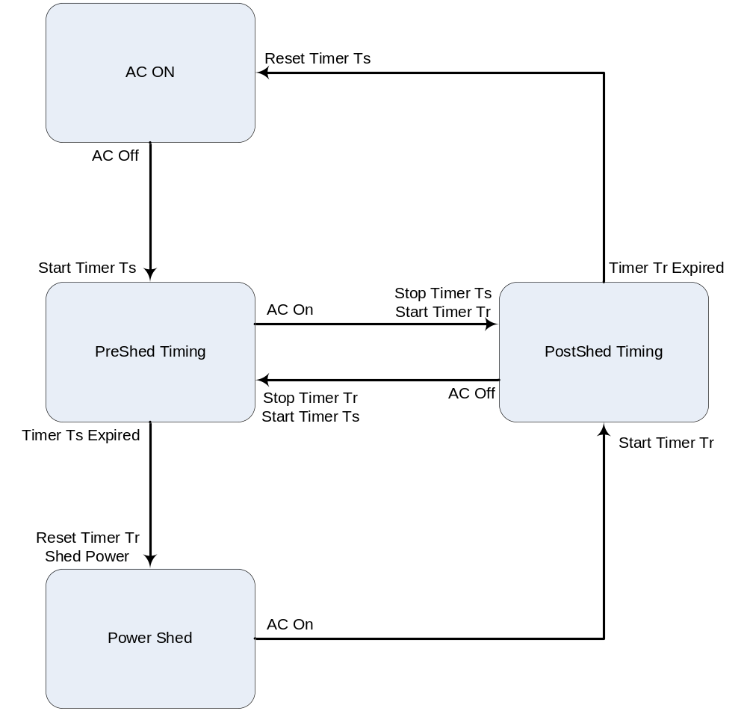

Figure ‎8.49 – Power Shedding State Diagram

Layer 2 Data Service
This section uses several relationship diagrams to illustrate provisioning models. To improve readability these diagrams use a slightly different notation from what is found in G.984.4. Figure ‎9.51 gives the legend of symbols used in these diagrams.

Managed Entity A
Managed Entity B
Entity created by the ONT
Entity created by the OLT
Entity A has explicit pointer to Entity B
Entity A has implicit ID relationship to Entity B
(M.E. IDs are equal, or use structured numbering)
Entity A has an explicit indirect reference to
Entity B (i.e. port number to UNI.)
Managed Entity B
Managed Entity B
Managed Entity B
Managed Entity A
Managed Entity A
Managed Entity A

Figure ‎9.51 Relationship Diagram Symbols

Requirements Base
TR-156 provides the core set of requirements for Layer 2 data service functionality within a GPON Access Node. There are 3 network service architectures addressed in TR-156. These are defined as follows:

- 1:1 VLANs - Indicates a one-to-one mapping between user port and VLAN. The uniqueness of the mapping is maintained in the GPON Access Node and across the Aggregation Network

- N:1 VLANs - Many-to-one mapping between user ports and VLAN. The user ports may be located in the same or different GPON Access Nodes.

- VLANs for Business Ethernet Services (VBES) (aka TLS) – Transparent transport of incoming frames as they arrive at the UNIs regardless of whether they are tagged, priority tagged or untagged.

For details of the requirements contained within TR-156, the reader should refer directly to TR-156. As an aid to matching functionality described within this document with the requirements defined in TR-156, a cross reference table is provided in appendix I of this document.

OLT and ONT Relationship
Section 9 describes recommended provisioning models and message sequences that are intended to support the functionality described in TR-156. However, it is important to recognize that the OLT and ONT have a master slave relationship with the OLT being the master. Therefore, the OLT may choose to provision a subset of the models described in this text or a subset of the functionality defined in TR-156 and the ONT should act as commanded by the OLT. Only if the OLT requests ONT actions that are beyond the capabilities represented here, is the OLT considered to be performing outside of the scope of this text.

Layer 2 Unicast Data Services
It is desirable for vendors to implement their GPON systems with a common OMCI model that provides support for the requirements specified in TR-156. This does not limit a vendor from using additional OMCI layer 2 models or providing optional extensions to the common model. However, every vendor that wishes to provide G.984.4 compliant OLT – ONT interoperability in their systems should support the model described within this section.

Single UNI OMCI Provisioning Model
The Layer 2 OMCI Common Model (L2-OCM) that should be supported by all G.984.4 compliant vendor systems is based on the 1:MP model identified in section 8.2 of G.984.4. This model is comprised of MAC bridging and 802.1p mapping functionality for a single UNI. Figure ‎9.53 depicts a diagram of L2-OCM when applied to a single UNI ONT.

ONT-G
Cardholder
ONT Data
Software Image
ONT2-G
Software Image
Circuit
Pack
MAC Bridge Service Profile
MAC Bridge Port Config Data
PPTP Ethernet UNI
UNI-G
GEM Interworking TP
GEM Interworking TP
Ext VLAN tag oper. config. data
MAC Bridge Port Config Data
802.1p Mapper Service Profile
T-CONT
Priority Queue A1 (Downstream)
Priority Queue 1 (upstream)
Priority Queue 2 (upstream)
Priority Queue 3 (upstream)
Priority Queue A2 (Downstream)
Priority Queue A3 (Downstream)
Priority Queue A4 (Downstream)
VLAN Tagging Filter
T-CONT
T-CONT
T-CONT
GEM Port
Network CTP
GEM Port
Network CTP
Priority Queue 4 (upstream)
Traffic Descriptor
(Downstream)
Traffic Descriptor
(upstream)
Traffic Descriptor
(Downstream)
Traffic Descriptor
(upstream)
PQ A1
PQ 1
PQ A2
PQ 2
GEM Port
Network CTP
GEM Interworking TP
GEM Interworking TP
GEM Port
Network CTP
Traffic Descriptor
(Downstream)
Traffic Descriptor
(upstream)
Traffic Descriptor
(Downstream)
Traffic Descriptor
(upstream)
PQ A3
PQ 3
PQ A4
PQ 4
ANI-G
Cardholder
Circuit
Pack
GEM Port
Network CTP
MAC Bridge Port Config Data
802.1p Mapper Service Profile
GEM Interworking TP
GEM Interworking TP
VLAN Tagging Filter
GEM Port
Network CTP
Traffic Descriptor
(Downstream)
Traffic Descriptor
(upstream)
Traffic Descriptor
(Downstream)
Traffic Descriptor
(upstream)
PQ A1
PQ 1
PQ A2
PQ 2
MAC bridge port filter table data
MAC bridge port filter preassign table
MAC bridge port filter table data
MAC bridge port filter preassign table

Figure ‎9.53 Single UNI L2-OCM With Overlapping Priorities

The diagram in Figure ‎9.53 depicts the provisioning that would be used to provide the upstream mapping of two VIDs and the 802.1p priorities within those VIDs. One VID is provisioned for the mapping of 802.1p priorities to two GEM ports each going to a single Priority Queue. The other VID is provisioned for the mapping of 802.1p priorities to four GEM Ports each going to a single Priority Queue.

Note that all GEM ports send frames through one of four Priority Queues because this diagram only depicts support for 4 classes of traffic which is the minimum requirement of TR-156. It can easily be extended to the 6 classes of traffic that is a goal requirement of TR-156. This is accomplished by adding GEM Port Network CPT MEs, GEM Interworking TP MEs, Priority Queue MEs and T-CONTs.

The diagram assumes an Ethernet UNI but the same provisioning model could be used for other UNI types.

The diagram in Figure ‎9.53 includes equipment management MEs to illustrate the position within the OMCI MIB of the L2-OCM.

The diagram in Figure ‎9.55 depicts another possible provisioning using the L2-OCM. This provisioning has no overlap in priorities but treats VLANs has having an implied priority that is outside the scope of the 802.1p priority bits. In this case, there are two VLANs and identical p-bits between those two VLANs. One VLAN has priority over the other VLAN and the p-bits are mapped within the scope of these VLAN priorities. For example, VLAN 1 (VID 1) with p-bits 2 and 3 are mapped to one bridge port and 802.1p mapper and VLAN 2 (VID 2) with p-bits 2 and 3 are mapped to another bridge port and 802.1p mapper. Each 802.1p mapper maps p-bits 2 and 3 to separate priority queues, resulting in 4 distinct priority flows.

ONT-G
Cardholder
ONT Data
Software Image
ONT2-G
Software Image
Circuit
Pack
MAC Bridge Port Config Data
MAC Bridge Service Profile
MAC Bridge Port Config Data
PPTP Ethernet UNI
UNI-G
GEM Interworking TP
GEM Interworking TP
802.1p Mapper Service Profile
Ext VLAN tag oper. config. data
MAC Bridge Port Config Data
802.1p Mapper Service Profile
GEM Interworking TP
GEM Interworking TP
T-CONT
Priority Queue A1 (Downstream)
Priority Queue 1 (upstream)
Priority Queue 2 (upstream)
Priority Queue 3 (upstream)
Priority Queue A2 (Downstream)
Priority Queue A3 (Downstream)
Priority Queue A4 (Downstream)
VLAN Tagging Filter
VLAN Tagging Filter
T-CONT
T-CONT
T-CONT
GEM Port
Network CTP
GEM Port
Network CTP
GEM Port
Network CTP
GEM Port
Network CTP
Priority Queue 4 (upstream)
Traffic Descriptor
(Downstream)
Traffic Descriptor
(upstream)
Traffic Descriptor
(Downstream)
Traffic Descriptor
(upstream)
Traffic Descriptor
(Downstream)
Traffic Descriptor
(upstream)
Traffic Descriptor
(Downstream)
Traffic Descriptor
(upstream)
PQ A1
PQ 1
PQ A2
PQ 2
PQ A3
PQ 3
PQ A4
PQ 4
Multicast Subscriber Config info
Multicast Operations
Profile
ANI-G
Cardholder
Circuit
Pack

Figure ‎9.55 Single UNI VID Based Priority Treatment

T-CONT and GEM Port Usage
The common OMCI model uses 4 T-CONT MEs, each representing a single logical connection group associated with a PLOAM layer alloc-id. To meet TR-156 requirements, each connection group transports a single traffic class. Therefore, each T-CONT ME is instantiated with the policy attribute set to the policy used for that T-CONT by that ONT. Since there is only a single Priority Queue associated with each T-CONT, this attribute should be treated as a “don’t care” by the OLT.

Each T-CONT is associated with a 1 to N GEM Ports by way of the upstream Priority Queue. Each GEM Port is represented in the model by a GEM Port Network CTP ME and a GEM Interworking TP ME. These MEs should support the following provisioning considerations:

- GEM Port Network CTP ME – The Direction attribute is set to 3 to indicate a bidirectional GEM Port as required by TR-156. The Priority queue pointer attribute for downstream should be used to provide a reference point for the downstream Traffic Descriptor ME that is also associated with the GEM Port Network CTP ME. However, downstream frames arriving at the GEM Port should not be directly transferred to the Priority Queue but should be routed through the 802.1p mapper and MAC Bridge. Therefore it is important for the provisioning of the MAC Bridge and the Priority queue pointer attribute to agree upon the destination queue for the downstream frames. The Traffic management pointer for upstream, Traffic descriptor profile pointer for upstream, and Traffic descriptor profile pointer for downstream, attributes should be supported. For detailed information on the usage of the Traffic attributes refer to section 10.
- GEM Interworking TP ME- The GEM port network CTP connectivity pointer attribute is set to point to the partner GEM Port Network CTP ME. The Interworking option, Service profile pointer, and GAL profile pointer attributes should all be set according to 802.1p mapper service. The Interworking termination point pointer attribute should be set to 0 and not used because the common model contains a MAC bridge.

Classification and Marking
The Extended Tagging Operation Data ME provides classification and marking of ingress frames at the UNI. This includes adding tags based on Ether Type and setting 802.1p p-bit values based on DSCP.

MAC Address Filtering
Figure ‎9.53 depicts a MAC bridge port filter preassign table ME and a MAC bridge port filter table data ME associated with the ANI side MAC Bridge Port Configuration Data MEs. While these MEs are auto-created by theUONT upon creation of a MAC Bridge Port Configuration Data ME, only the ANI side MEs are depicted. TR-156 requires only upstream MAC address filtering support on theUONT and this function is performed by the ANI side Bridge port filter MEs. These MEs are used in the following manner (filtering applies to frames exiting the MAC bridge port):

- MAC bridge port filter preassign table ME – Used to filter frames based on predefined addresses or Ethertype. The list of filter options is pre-defined in G.984.4.
- MAC bridge port filter table data ME – Used to filter frames based on specific MAC addresses. MAC address learning should be disabled prior to the setting of table entries.

Note: MAC address filtering is supported in all ONT models (Single UNI, Multiple UNI, Single and Multiple UNI with Multicast) but is only depicted in Figure ‎9.53 to minimize the complexity of the figures depicting the more complex models.

Flow Routing
Flow routing within the GPON System is provisioned using a combination of the MAC bridge ME group and the 802.1p Mapper Service Profile ME.

The MAC bridge ME group provides support for flow routing based on VID. This group should support the following provisioning considerations:

- The L2-OCM diagram in Figure ‎9.53 shows only OLT created MAC bridge MEs. There are several ONT created MEs that are automatically instantiated when a MAC Bridge Service Profile ME or MAC Bridge Port Config Data ME is created by the OLT. TheUONT should provide support for these MEs for completeness of overall MAC bridge functionality.
- A VLAN Tagging Filter Data ME should be provisioned to implement VID based flow mapping. If VID flow mapping is not a requirement for a specific deployment, this ME does not need to be created by the OLT.
- Only a single ANI side MAC Bridge Port Config Data ME should be created for deployments that do not require VID flow mapping. In addition, only a single 802.1p mapper is needed for these deployments.
- The MAC bridge should not be used to map subscriber data flows based on p-bits. This functionality is reserved for the 802.1p Mapper ME.

The 802.1p Mapper Service Profile ME provides support for upstream flow routing based on 802.1p priority bits. This ME should support the following provisioning considerations:

- The TP Pointer attribute should be set to Null (0xFFFF) as required for a bridging-mapping model
- The TP Type attribute should be set to 0 to indicate that a bridging-mapping model is being used.

Message Flows
Figure ‎9.57 through Figure ‎9.65 depict the core message flow that is used to create the L2-OCM. Each figure represents a step within the flow. Each step may be performed multiple times to produce multiple ME instances. It is recommended to follow the depicted ordering of steps and the ordering of messages within those steps to ensure that no ME pointer attribute is populated prior to creation of the ME that it references. This increases the likelihood of successful interoperation with legacy ONTs that are sensitive to the ordering of ME creation. Since the GEM Interworking TP ME and the 802.1p Mapper Service Profile ME point to each other, it is particularly important to create the 802.1p Mapper Service Profile ME with Null Interwork TP pointer for P-bit priority attributes. Only in the final step, after the GEM Interworking TP MEs have been created, are these attributes populated with pointers to the MEs.

OLT
ONT
GEM port Network CTP Create cmd
GEM port Network CTP Create response
Once per T-CONT

Figure ‎9.57 L2-OCM Message Flow - Step 1

OLT
ONT
GAL Ethernet Profile Create cmd
GAL Ethernet Profile Create response
MAC bridge Service Profile Create cmd
MAC bridge Service Profile Create response
Once per UNI
At least 1 per ONT

Figure ‎9.59 L2-OCM Message Flow - Step 2

OLT
ONT
MAC bridge Port Config Data Create cmd
The ONT automatically create an instance of MAC bridge Port Designation Data
The ONT automatically create an instance of MAC bridge Port filter Table Data
The ONT automatically create an instance of MAC bridge Port Bridge Table Data
MAC bridge Port Config Data Create cmd response
802.1p Mapper Service Profile Create cmd
802.1p Mapper Service Profile Create cmd response
VLAN tagging filter Data Create cmd
VLAN tagging filter Data Create cmd response
MAC bridge Port Config Data Create cmd response
Once per ANI side MAC Bridge Port

Figure ‎9.61 L2-OCM Message Flow - Step 3
OLT
ONT
Once per GEM Port
GEM Interworkinginterwokring TP Create cmd
GEM Interworkinginterwokring TP Create response

Figure ‎9.63 L2-OCM Message Flow - Step 4

OLT
ONT
Once per 802.1p Mapper
802.1p Mapper Service Profile set cmd
802.1p Mapper Service Profile set cmd response

Figure ‎9.65 L2-OCM Message Flow - Step 5

Multiple UNI OMCI Provisioning Model
The multiple UNI L2-OCM is an extension to the single UNI model presented in Figure ‎9.53. As shown in Figure ‎9.67, the extension is accomplished by adding another instance of the single UNI L2-OCM for each UNI. It is important to note that there are still the same number of T-CONTs as in the single-UNI diagram.

For the clarity of presentation, the diagram in Figure ‎9.67 does not include as many GEM Ports per UNI as the diagram in Figure ‎9.53. However, the underlying functionality associated with each UNI is still the same.

ONT-G
ONT Data
Software Image
ONT2-G
Software Image
MAC Bridge Port Config Data
MAC Bridge Service Profile
MAC Bridge Port Config Data
PPTP Ethernet UNI
UNI-G
GEM Interworking TP
GEM Interworking TP
802.1p Mapper Service Profile
Ext VLAN tag oper. config. data
MAC Bridge Port Config Data
802.1p Mapper Service Profile
GEM Interworking TP
GEM Interworking TP
T-CONT
Priority Queue A1 (Downstream)
Priority Queue 1 (upstream)
Priority Queue 2 (upstream)
Priority Queue 3 (upstream)
Priority Queue A2 (Downstream)
Priority Queue A3 (Downstream)
Priority Queue A4 (Downstream)
VLAN Tagging Filter
VLAN Tagging Filter
T-CONT
T-CONT
T-CONT
PPTP Ethernet UNI
UNI-G
Ext VLAN tag oper. config. data
Priority Queue B1 (Downstream)
Priority Queue B2 (Downstream)
Priority Queue B3 (Downstream)
Priority Queue B4 (Downstream)
MAC Bridge Port Config Data
MAC Bridge Service Profile
MAC Bridge Port Config Data
GEM Interworking TP
GEM Interworking TP
802.1p Mapper Service Profile
MAC Bridge Port Config Data
802.1p Mapper Service Profile
GEM Interworking TP
GEM Interworking TP
VLAN Tagging Filter
GEM Port
Network CTP
GEM Port
Network CTP
GEM Port
Network CTP
GEM Port
Network CTP
GEM Port
Network CTP
GEM Port
Network CTP
GEM Port
Network CTP
GEM Port
Network CTP
Priority Queue 4 (upstream)
Traffic Descriptor
(Downstream)
Traffic Descriptor
(upstream)
Traffic Descriptor
(Downstream)
Traffic Descriptor
(upstream)
Traffic Descriptor
(Downstream)
Traffic Descriptor
(upstream)
Traffic Descriptor
(Downstream)
Traffic Descriptor
(upstream)
Traffic Descriptor
(Downstream)
Traffic Descriptor
(upstream)
Traffic Descriptor
(Downstream)
Traffic Descriptor
(upstream)
Traffic Descriptor
(Downstream)
Traffic Descriptor
(upstream)
Traffic Descriptor
(Downstream)
Traffic Descriptor
(upstream)
PQ A1
PQ 1
PQ A2
PQ 2
PQ A3
PQ 3
PQ A4
PQ 4
PQ B1
PQ 1
PQ B2
PQ 2
PQ 3
PQ B4
PQ 4
PQ B3
VLAN Tagging Filter
Multicast Subscriber Config info
Multicast Operations
Profile
Cardholder
Circuit
Pack
ANI-G
Cardholder
Circuit
Pack

Figure ‎9.67 Multi-UNI L2-OCM

T-CONT and GEM Port Usage
Multiple UNI L2-OCM adds support for additional UNIs without increasing the number of T-CONTs used by single UNI L2-OCM. However, an additional set of GEM ports is added to provide a per UNI Service Level Agreement (SLA) capability. GEM ports are provisioned in the same manner as described in 9.3.1.1.

Classification and Marking
Classification and marking are provisioned on a per UNI basis in the same manner as described in 9.3.1.2

Flow Routing
Flow routing is provisioned for each UNI through the use of a unique MAC bridge ME group and set of 802.1p Mapper ME set as described in 9.3.1.4.

Message Flows
Provisioning of multiple UNI ONUs is accomplished with additional iterations of the message flow described in 9.3.1.5.

Layer 2 Multicast Data Services
Within a GPON Access Node, multicast and broadcast capabilities have two applications. The first application is traditional IGMP controlled downstream multicast traffic. The second is the transport of infrequent downstream broadcast frames arriving at the network facing interface of the OLT. This is sometimes referred to as incidental broadcast.

Both applications require provisioning of data plane functionality. In addition, traditional multicast requires provisioning of control plane functionality. This section describes provisioning of both the data and control plane.

Data Plane
A GPON Access Node can support both upstream and downstream broadcast or multicast frames. However, no special consideration has been made within OMCI to support the upstream broadcast/multicast data plane. This is because the point to multipoint nature of GPON only exists in the downstream direction. In the upstream direction all frames are transported based on the unicast provisioning described in 9.3.1.

In the downstream direction, special accommodation has been made for multicast and broadcast frames. This accommodation takes into account the point to multi-point nature of GPON and uses a shared GEM port for multicast and a shared GEM port for broadcast frames. The sharing of these GEM ports increases the downstream efficiency of this traffic on the PON by not replicating frames.

Traffic sent over both of these GEM ports may also be contained in a VLAN and more than one VLAN may appear within these GEM ports. To ensure that only subscribers intended to receive the multicast or broadcast frames actually receive them, VLAN filtering is performed at the ANI side MAC bridge port.

Single UNI OMCI Provisioning Model
Figure ‎9.69 depicts the relationship diagram for L2-OCM with the addition of the MEs required for multicast/broadcast provisioning. As indicated by this diagram, multicast/broadcast support is built upon the model for unicast provisioning through the addition of two specialized GEM ports. One GEM port is used for multicast traffic and the other is used for incidental broadcast traffic. These are both unidirectional GEM ports provisioned in the ANI to UNI direction.

Within the OMCI provisioning model, the multicast GEM port is represented by a GEM network CTP ME and a Multicast GEM interworking TP ME. The Multicast GEM interworking TP is then connected into the unicast model through a MAC Bridge Config Data ME. Since there is no upstream traffic supported by the GEM port there is no requirement to use an 802.1p mapper ME between the MAC Bridge Port Config Data ME and the Multicast GEM interworking TP ME.

Within the OMCI model, the incidental broadcast GEM port is represented by a GEM network CTP ME and a GEM interworking TP ME. The GEM interworking TP is then connected into the unicast model through a MAC Bridge Config Data ME. Since there is no upstream traffic supported by the GEM port there is no requirement to use an 802.1p mapper ME between the MAC bridge port config data ME and the GEM interworking TP ME.

Associated with the MAC bridge port config data MEs connected to each GEM port is a VLAN tagging filter ME. This ME is used to provision filtering of downstream broadcast frames so that only the frames destined for the affected UNI are allowed into the bridge. Since there are no upstream frames delivered over the Multicast GEM port, MAC address filtering is not required on the MAC bridge port associated with the Multicast GEM IW TP.

ONT-G
Cardholder
ONT Data
Software Image
ONT2-G
Software Image
Circuit
Pack
MAC Bridge Port Config Data
MAC Bridge Service Profile
MAC Bridge Port Config Data
PPTP Ethernet UNI
UNI-G
GEM Interworking TP
GEM Interworking TP
802.1p Mapper Service Profile
Ext VLAN tag oper. config. data
MAC Bridge Port Config Data
802.1p Mapper Service Profile
GEM Interworking TP
GEM Interworking TP
T-CONT
Priority Queue A1 (Downstream)
Priority Queue 1 (upstream)
Priority Queue 2 (upstream)
Priority Queue 3 (upstream)
Priority Queue A2 (Downstream)
Priority Queue A3 (Downstream)
Priority Queue A4 (Downstream)
VLAN Tagging Filter
VLAN Tagging Filter
T-CONT
T-CONT
T-CONT
GEM Port
Network CTP
GEM Port
Network CTP
GEM Port
Network CTP
GEM Port
Network CTP
Priority Queue 4 (upstream)
Traffic Descriptor
(Downstream)
Traffic Descriptor
(upstream)
Traffic Descriptor
(Downstream)
Traffic Descriptor
(upstream)
Traffic Descriptor
(Downstream)
Traffic Descriptor
(upstream)
Traffic Descriptor
(Downstream)
Traffic Descriptor
(upstream)
PQ A1
PQ 1
PQ A2
PQ 2
PQ A3
PQ 3
PQ A4
PQ 4
GEM IW TP
(incidental mcast)
GEM Port
Network CTP*1
PQ Ay
null
Multicast GEM IW TP
MAC Bridge Port Config Data
GEM Port
Network CTP*1
null
VLAN Tagging Filter
MAC Bridge Port Config Data
PQ Ax
Traffic Descriptor
(Downstream)
Traffic Descriptor
(Downstream)
Multicast Subscriber Config info
Multicast Operations
Profile
ANI-G
Cardholder
Circuit
Pack
VLAN Tagging Filter
Figure ‎9.69 L2-OCM with Multicast

Provisioning Considerations
Both GEM Network CTP MEs are provisioned with the following considerations:

- The T-CONT pointer attribute is not meaningful since the GEM ports are unidirectional in the ANI to UNI direction.
- The Direction attribute should be set to 2 indicating that the associated GEM port is unidirectional in the ANI to UNI direction.
- The Traffic Management pointer for upstream attribute is not meaningful since the GEM ports are unidirectional in the ANI to UNI direction.
- The Traffic Descriptor profile pointer for upstream attribute is not meaningful since the GEM ports are unidirectional in the ANI to UNI direction.
- The Priority Queue pointer for downstream attribute is used as a “template queue pointer” for all UNIs affected by this GEM port. Specifically, if this attribute points to Priority Queue 1 for UNI 1, then it is inferred to reference Priority Queue 1 for all affected UNIs.

The Multicast GEM interworking TP ME is provisioned with the following considerations:

- The Interworking option attribute should be set to zero indicating a don’t care,
- The Service Profile pointer attribute is set to zero and not used.
- The Interworking termination point pointer attribute is set to zero and not used.
- The PPTP counter attribute is set to 0xFF and not used.
- The GAL profile pointer and GAL loopback configuration attributes are set to zero and not used.
- A single OMCC Set command should be used for each entry in the Multicast Address Table attribute.

The GEM interworking TP ME that is used for incidental broadcast is provisioned with the following considerations:

- The Interworking option attribute should be set to six to indicate broadcast.
- The Service profile pointer attribute should be set to zero.
- The Interworking termination point pointer attribute should be set to zero.
- The GAL profile pointer attribute should be set to zero.
- The GAL loopback configuration attribute should be ignored.

Message Flows

Figure ‎9.71 shows the message flow that is used to add multicast or incidental broadcast to the L2-OCM.
OLT
ONT
GEM port Network CTP Create cmd
GEM port Network CTP Create response
MAC bridge Port Config Data Create cmd
MAC bridge Port Config Data Create cmd response
VLAN tagging filter Data Create cmd
VLAN tagging filter Data Create cmd response
GEM interwokring TP Create cmd
GEM interwokring TP Create cmd response
Or Multicast GEM Interworking TP
Once per bridge

Figure ‎9.71 Data Plane Provisioning

Multiple UNI OMCI Provisioning Model
Figure ‎9.73 contains the relationship diagram for multicast and incidental broadcast in an ONU with multiple UNIs. The only notable difference between the model depicted in Figure ‎9.69 is that the multicast GEM port and the incidental broadcast GEM port are associated with multiple bridges. This takes advantage of the downstream broadcast nature of GPON by sharing a single multicast or broadcast flow across multiple UNIs.

The operation of the model is functionally identical to the operation of the model described in 9.4.1.1.
ONT-G
ONT Data
Software Image
ONT2-G
Software Image
MAC Bridge Port Config Data
MAC Bridge Service Profile
MAC Bridge Port Config Data
PPTP Ethernet UNI
UNI-G
GEM Interworking TP
GEM Interworking TP
802.1p Mapper Service Profile
Ext VLAN tag oper. config. data
MAC Bridge Port Config Data
802.1p Mapper Service Profile
GEM Interworking TP
GEM Interworking TP
T-CONT
Priority Queue A1 (Downstream)
Priority Queue 1 (upstream)
Priority Queue 2 (upstream)
Priority Queue 3 (upstream)
Priority Queue A2 (Downstream)
Priority Queue A3 (Downstream)
Priority Queue A4 (Downstream)
VLAN Tagging Filter
VLAN Tagging Filter
T-CONT
T-CONT
T-CONT
PPTP Ethernet UNI
UNI-G
Ext VLAN tag oper. config. data
Priority Queue B1 (Downstream)
Priority Queue B2 (Downstream)
Priority Queue B3 (Downstream)
Priority Queue B4 (Downstream)
MAC Bridge Port Config Data
MAC Bridge Service Profile
MAC Bridge Port Config Data
GEM Interworking TP
GEM Interworking TP
802.1p Mapper Service Profile
MAC Bridge Port Config Data
802.1p Mapper Service Profile
GEM Interworking TP
GEM Interworking TP
VLAN Tagging Filter
GEM Port
Network CTP
GEM Port
Network CTP
GEM Port
Network CTP
GEM Port
Network CTP
GEM Port
Network CTP
GEM Port
Network CTP
GEM Port
Network CTP
GEM Port
Network CTP
Priority Queue 4 (upstream)
Traffic Descriptor
(Downstream)
Traffic Descriptor
(upstream)
Traffic Descriptor
(Downstream)
Traffic Descriptor
(upstream)
Traffic Descriptor
(Downstream)
Traffic Descriptor
(upstream)
Traffic Descriptor
(Downstream)
Traffic Descriptor
(upstream)
Traffic Descriptor
(Downstream)
Traffic Descriptor
(upstream)
Traffic Descriptor
(Downstream)
Traffic Descriptor
(upstream)
Traffic Descriptor
(Downstream)
Traffic Descriptor
(upstream)
Traffic Descriptor
(Downstream)
Traffic Descriptor
(upstream)
PQ A1
PQ 1
PQ A2
PQ 2
PQ A3
PQ 3
PQ A4
PQ 4
PQ B1
PQ 1
PQ B2
PQ 2
PQ 3
PQ B4
PQ 4
PQ B3
MAC Bridge Port Config Data
VLAN Tagging Filter
MAC Bridge Port Config Data
GEM IW TP
(incidental mcast)
GEM Port
Network CTP*1
PQ Ay
null
Multicast GEM IW TP
GEM Port
Network CTP*1
null
VLAN Tagging Filter
PQ Ax
Traffic Descriptor
(Downstream)
Traffic Descriptor
(Downstream)
MAC Bridge Port Config Data
MAC Bridge Port Config Data
VLAN Tagging Filter
Multicast Subscriber Config info
Multicast Operations
Profile
Multicast Subscriber Config info
Multicast Operations
Profile
Cardholder
Circuit
Pack
ANI-G
Cardholder
Circuit
Pack
VLAN Tagging Filter
VLAN Tagging Filter

Figure ‎9.73 Multi-UNI L2-OCM with Multicast

Control Plane
Implementation of traditional multicast services also requires support for the IGMP control plane protocol. The Multicast subscriber config info ME and the Multicast operations profile ME are used to provision this support. As shown in Figure ‎9.73, these MEs are associated with the MAC Bridge port config data ME on the UNI side of the OMCI model. The following considerations should be used when provisioning these MEs:

- Permitting multicast on a subscriber UNI is not predicated on the creation of the Multicast subscriber config info ME. The default action for a bridge port and associated UNI is to allow the forwarding of frames in the multicast address range. Blocking of frames in the multicast address range is achieved through the use of the MAC bridge port filter table data ME or MAC bridge port filter preassign table ME.
- The ME Type attribute of the Multicast subscriber config info ME should be set to zero to indicate an association with a MAC Bridge port config data ME.
- The IGMP version attribute of the Multicast operations profile ME should be set to 3 to indicate that the ONU will be using IGMP v3 as required by TR-156.
- A bandwidth based multicast Service Level Agreement (SLA) can be implemented using the Max multicast bandwidth and Bandwidth enforcement attributes in the Multicast subscriber config info ME in conjunction with the Imputed group bandwidth field of the Dynamic access control list table in the Multicast operations profile ME. However, to make this capability useful, entries in the Dynamic access control list table need to be made based on a shared bandwidth allocation so that a join/no join decision can be made in the ONT.

Traffic Management
This section gives a high level mapping from the traffic management requirements in TR-156 to the G.984.4 recommendation. In this document, numbers in brackets (e.g. [R-x]) indicate the corresponding requirement number in TR-156.

Note: To clarify the mapping of requirements found in TR-156 to the G.984.4 recommendation, paraphrasing of TR-156 requirements is used in this text. This does not imply that all TR-156 requirements are mandatory to comply with recommendation G.984.4 or the G.984.4 Implementer’s Guide. In case of inconsistencies between this section and TR-156, the TR-156 requirements take precedence over this section.

Traffic management is defined in this section to be composed of the following components: 1) traffic classification, 2) rate limiting, 3) queuing, 4) scheduling, and 5) T-CONTs. The primary source of traffic management specification for this section is TR-156. TR-156 assumes that there will always be a Broadband Network Gateway (BNG) and possibly an Ethernet Aggregation node on the network side of an OLT and a Residential Gateway (RG) on the user side of an ONT/ONU. G-PON-fed DSLAMs are not considered in this section.

The high level architectural view considered in this section is given in Figure ‎10.75 (from TR-156). The OLT and ONT/ONU are considered together as the Access Node (AN). It is possible for the ONT/ONU and RG to be integrated.

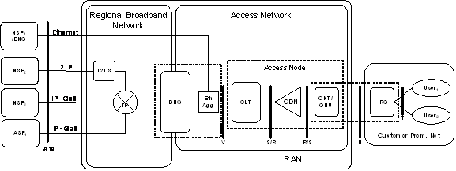

Figure ‎10.75 High Level Architecture

Traffic Classification
GEM ports are used to differentiate between traffic classes, for a particular user port. Each GEM Port identifies a specific traffic class going to a specific UNI on a specific ONT. Therefore, a given GEM port will carry no more than one traffic class [R-6, 7].

In the upstream direction ,the ONT must support deriving VLAN priority (p-bits) markings based on user port, VID, received P-bit markings, and EtherType [R-48], and the ONT should support deriving the P-bit markings based on user port, VID and received DSCP value [R-49]. The ONT must support mapping traffic flows into GEM Ports based on user port, VLAN ID, or VLAN priority [R-51].

The OLT and ONT must support at least 4 traffic classes [R-46], and should support at least 6 traffic classes [R-47].

Rate Limiting
The ONT and OLT must support rate limiting of IGMP messages received from user-facing ports on a multicast VLAN [R-87]. The ONT and OLT must support rate limiting of CFM (Connectivity Fault Management) Ethernet OAM messages arriving on a user port; the rate must be configurable per port [TR-101 R-268]. This text interprets CFM message rate limiting as a requirement for defensive actions by the ONT host processor to prevent being overloaded by a CFM message based denial of service attacks. Since this is addressed by ONU implementation and does not require provisioning, it is not addressed by the OMCI MIB or this document.

Queuing
The ONT and OLT must be capable, during periods of queue congestion, of dropping (i.e. not putting into the queue) packets marked as drop eligible with higher probability compared to packets not marked as drop eligible. Drop eligibility (drop precedence) can be indicated either by VLAN priority bits (802.1ad PCP encoder) [R-54], or by the DEI bit (802.1ad) [R-55]. These packets may have drop eligibility marked externally (e.g. by the BNG or RG).

The OLT must support at least 4 downstream queues per PON [R-58], 1 per traffic class, and at least 4 upstream queues per network facing port [R-66], 1 per traffic class. The OLT should support at least 6 downstream queues per PON [R-62], 1 per traffic class, and at least 6 upstream queues per network facing port [R-68], 1 per traffic class.

The ONT must support at least 4 downstream queues per user facing port [R-56], 1 per traffic class, and at least 4 upstream queues [R-57], 1 per traffic class. The ONT should support at least 6 downstream queues per user facing port [R-60], 1 per traffic class, and at least 6 upstream queues per user facing port [R-61], 1 per traffic class.

The OLT must and the ONT should support setting the maximum size/depth of all queues [R-73].

Scheduling
Strict priority scheduling among queues must be supported. In the downstream direction, the OLT must support strict priority scheduling among at least 4 queues for each PON [R-63], and the ONT must support strict priority scheduling among at least 4 queues for each user facing port [R-63]. In the upstream direction, the OLT must support strict priority scheduling among at least 4 queues for each network facing port [R-70].

Weighted scheduling among queues should be supported. The OLT and ONT should support scheduling of queues according to their assigned priority and weight, with the following conditions: 1) multiple queues may be assigned to the same priority, 2) queues assigned to the same priority must be scheduled according to a weighted algorithm, and 3) weights must be assigned through provisioning [R-65, 72].

The OLT must support the extended traffic descriptor parameters P_{i} and ω_{i} as specified in G.984.3 [R-45], which are used to implement the strict priority and weighted scheduling of T-CONTs. The OLT must support the basic traffic descriptor parameters R_{F}, R_{A}, R_{M}, and χ_{AB} as specified in G.984.3 [R-44]. These parameters must be configurable [R-44, 45]. The OLT must support T-CONT types 1, 2, 3 and 4 [R-59].

In the ONT-G ME, Traffic management option 0 (priority controlled) must be supported.

T-CONT Support
The ONT must support at least 4 T-CONTs [R-67], one per traffic class, and should support at least 6 T-CONTs [R-69], one per traffic class.

OMCI Model
The following 984.4 MEs and attributes must be supported to support the functionality in this section:

- Priority queue-G
  - Related port: For upstream, the first two bytes point to the associated T-CONT, and the last two bytes are “don’t care” (for TR-156 there is only one priority queue for each T-CONT and therefore no scheduling is performed by the T-CONT). For downstream, the first two bytes point to the slot and port of the specific downstream port, and the last two bytes indicate the strict priority associated with this priority queue.
  - Traffic scheduler-G pointer: Set to default value null (0).
  - Weight: For upstream, this attribute should remain at the default value of 1 (for TR-156 there is only one priority queue for each T-CONT and therefore no scheduling is performed by the T-CONT). For downstream, this attribute should be set to the weight associated with this priority queue (or set to 1 if weighted scheduling is not used).
  - Packet drop queue thresholds: These are used to implement the TR-156 drop eligibility (drop precedence) requirements.
  - Packet drop max_p
  - Queue_drop_w_q
  - Drop precedence color marking: Must be set to either one of the PCP modes or DEI
- ONT-G
  - Traffic management option: Set to 0, indicating priority controlled mode.
- T-CONT
  - Policy: This value is a “don’t care” (for TR-156 there is only one priority queue for each T-CONT and therefore no scheduling is performed by the T-CONT)

Figure ‎10.77 and Figure ‎10.79 give examples of the downstream and upstream traffic management functionality.
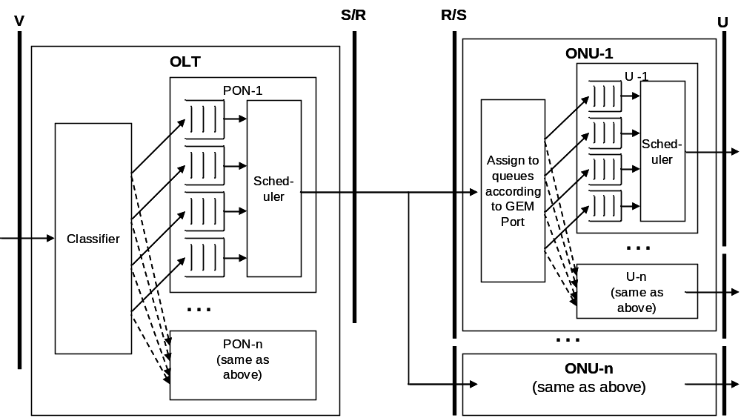

Figure ‎10.77 Downstream Functionality Example

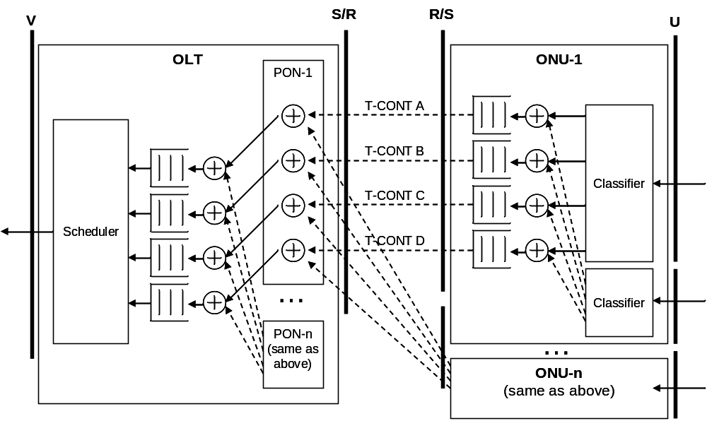

Figure ‎10.79 Upstream Functionality Example

Upstream Traffic Scheduling and T-CONTs
There are non-TR-156 applications where it is desirable to have multiple queues per T-CONT and to have scheduling between those queues. One example would be the MDU (Multiple Dwelling Unit) ONT, where there are multiple UNIs, each of which is connected to a different user. The service provider may want to configure the ONT such that no single UNI within the ONT consumes more than its fair share of the bandwidth assigned to a given traffic class. This could be done for a given traffic class by giving each UNI a separate queue, then using some form of weighted scheduling (like WRR, or Weighted Round Robin) to schedule traffic from the queues into the T-CONT for that traffic class.

Another example would be where the service provider assigns a VLAN to a T-CONT, but wants to give different priority to different flows within that T-CONT. This could be done by mapping specific p-bit values within that VLAN to different queues, then using strict priority to schedule traffic from the queues into the T-CONT for that VLAN. As a specific example, p-bit 1 could be mapped to one queue, p-bit 3 could be mapped to another queue, and strict priority could be used to schedule between the two queues.

This section describes the best practice for implementing scheduling among multiple queues associated with a given T-CONT. Only a single level of scheduling is considered; hierarchical scheduling is not considered. The section considers only two scheduling disciplines for each multi-queue T-CONT:

- Strict priority scheduling. The queues are serviced in the specified priority order. This corresponds to the HOL value of the scheduling Policy attribute.
- Weighted scheduling. Back-logged (non-empty) queues are serviced in proportion to their specified weight. This corresponds to the WRR value of the scheduling Policy attribute.

In early versions of G.984.4 (prior to 2009), there was a fixed set of Priority Queue-G MEs and Traffic Scheduler-G MEs associated with each T-CONT ME. In 2009, a flexible means of mapping between queues, schedulers, and T-CONTs was added, allowing a pool of queues to be attached to any scheduler and T-CONT in the same slot. The fixed aspect is retained for backwards compatibility, and the flexible aspect is controlled via the “QoS configuration flexibility” attribute in the ONT2-G ME. In the first part of this section, the default practice for using the fixed method is described. In the second part of this section, an alternative using the flexible method is described.

The fixed method is considered to be the default method – the ONT must have a factory default configuration of queues/schedulers/T-CONTs that would be usable by an OLT that only supports the fixed method, and the OLT must work with ONTs that only support the fixed method. The flexible method is considered an extension of the fixed method, and may be used when supported by both the ONT (as indicated by the “QoS configuration flexibility” attribute in the ONT2-G ME) and the OLT.

Default Practice – Fixed Queue/Scheduler/T-CONT Method

In early versions of G.984.4 (prior to 2009), there is a fixed set of Priority Queue-G MEs and Traffic Scheduler-G MEs associated with each T-CONT ME. The pointers between Traffic Scheduler-G MEs and T-CONT MEs are fixed, but the Priority Queue-G MEs can be provisioned to either point to the associated T-CONT ME or one of the associated Traffic Scheduler-G MEs. The scheduling policy of each T-CONT ME and each Traffic Scheduler-G ME is fixed. In this section it is not assumed that all T-CONTs have the same number of Priority Queue-G MEs and Traffic Scheduler-G MEs. The OLT must determine the ONT queue configuration and connect the GEM Port Network CTP MEs accordingly.

Not all T-CONTs in an ONT must support these scheduling capabilities. However, in order to be interoperable, any T-CONT that supports the scheduling capabilities of this section must have at least two Priority Queue-G MEs and one of the two following configurations:

- Traffic Scheduler-G not present. Only a single scheduling discipline is supported as determined by the T-CONT Policy attribute. The Priority Queue-G MEs are connected directly to the T-CONT ME.
- Traffic Scheduler-G present. The Traffic Scheduler-G ME and T-CONT ME must have “opposite” Policy attributes, meaning that one has HOL policy and the other has WRR. Both scheduling disciplines are therefore supported. The Priority Queue-G MEs can be connected to either the Traffic Scheduler-G ME or directly to the T-CONT ME to determine the scheduling discipline.

Further, the read-only parameter values described in the following sections are required in order to be interoperable.

Provisioning Considerations
The MEs used in this section for traffic scheduling are the Priority Queue-G ME, Traffic Scheduler-G ME and the T-CONT ME.

Figure ‎10.81 shows an example of a T-CONT with three queues and no Traffic Scheduler-G ME. Each queue is directly connected to the T-CONT ME. The scheduling discipline is determined from the policy attribute of the T-CONT ME, in this case weighted (Policy=WRR).

Figure ‎10.82 shows an example of a T-CONT with four queues and a Traffic Scheduler-G ME. Because each queue is connected to the Traffic Scheduler-G ME, the scheduling discipline is determined from the policy attribute of the Traffic Scheduler-G ME, in this case weighted (Policy=WRR).

Figure ‎10.83 shows an example of a T-CONT with four queues and a Traffic Scheduler-G ME. Because each queue is directly connected to the T-CONT ME, the scheduling discipline is determined from the policy attribute of the T-CONT ME, in this case strict (Policy=HOL).

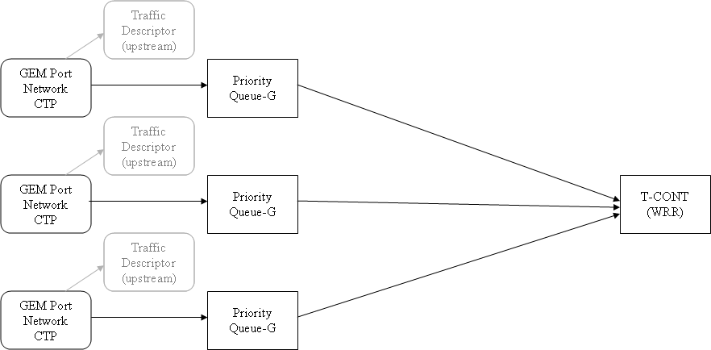

Figure ‎10.81 Example System of Weighted Scheduling with Three Queues per T-CONT and No Traffic Scheduler-G, Connected Directly to T-CONT

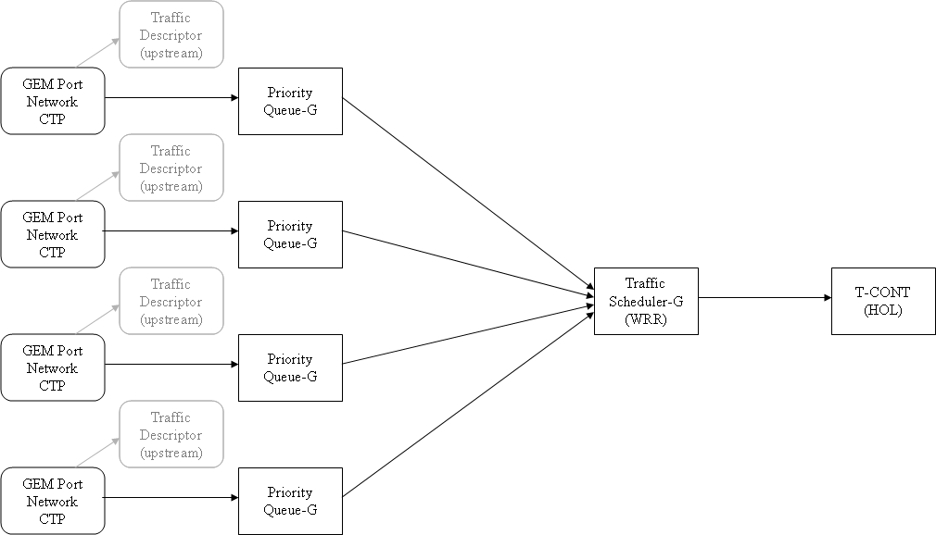

Figure ‎10.82 Example System of Weighted Scheduling with Four Queues per T-CONT and Traffic Scheduler-G, Connected to Traffic Scheduler-G

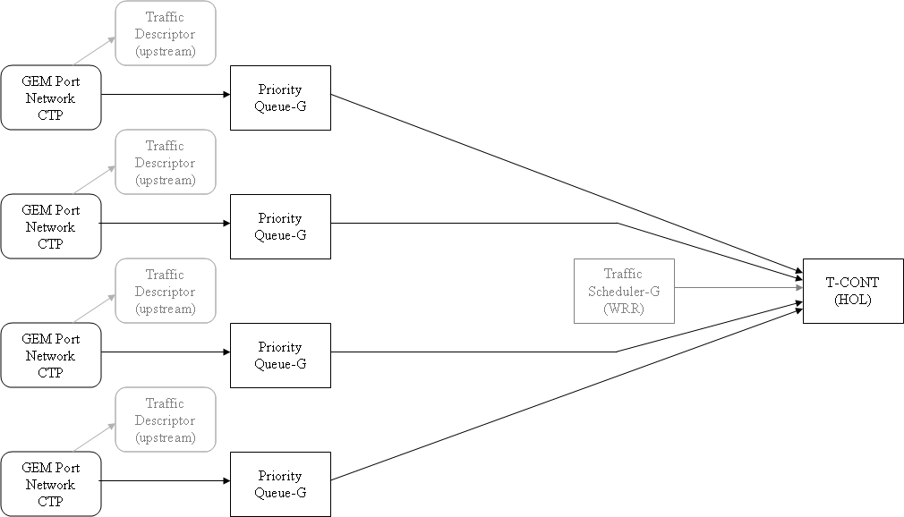

Figure ‎10.83 Example System of Strict Priority Scheduling with Four Queues per T-CONT and Traffic Scheduler-G, Connected Directly to T-CONT

Priority Queue-G ME
Each Priority Queue-G ME has a fixed priority and a configurable weight. The OLT can configure each Priority Queue-G ME to either point to the associated Traffic Scheduler-G ME or to point directly to the associated T-CONT ME.

For an upstream queue, the Related Port attribute is read-only and is divided into two parts for upstream traffic: 1) the ME ID of the associated T-CONT, and 2) the priority of the queue. To support strict priority scheduling between multiple queues associated with a T-CONT, each queue must have a different priority.

The Weight attribute is R/W, and is used to provide weighted scheduling between the queues associated with a T-CONT.

The Traffic scheduler-G pointer attribute is R/W and is provisioned to either point to the associated Traffic Scheduler-G ME (if present) or to the associated T-CONT ME (null pointer value). The value of this attribute as a function of desired scheduling discipline is shown in Table ‎10.1. During normal operation, either all Priority-Queues associated with a T-CONT should be mapped to the Traffic Scheduler-G ME (if present) or all should be mapped to the T-CONT ME. During provisioning, there may be a temporary period where some of the Priority-Queues associated with a T-CONT are mapped to the Traffic Scheduler-G ME (if present) and some are mapped to the T-CONT ME, in which case the ONT’s behavior is undefined. The Traffic Scheduler-G pointer attribute value is a “don’t care” for Priority-Queues that are not in use, i.e. that are not connected to a GEM port network CTP ME.

Desired  Scheduling  Disicpline | T-CONT  Policy | Traffic  Scheduler-G  Present? | Traffic  Scheduler-G  Policy | Priority  Queue-G  “Traffic Scheduler-G pointer” attribute
Strict | HOL | Don’t Care | Don’t Care | T-CONT (null)
Strict | WRR | Yes | HOL | Traffic Sheduler-G
Weighted | WRR | Don’t Care | Don’t Care | T-CONT (null)
Weighted | HOL | Yes | WRR | Traffic Sheduler-G

Table ‎10.2 Value of Priority Queue-G “Traffic Scheduler-G pointer” attribute to achieve desired scheduling discipline

Traffic Scheduler-G ME
The Traffic Schedulers-G ME has a fixed scheduling policy and fixed pointers and a configurable priority/weight. If the Traffic Scheduler-G is present, the following are the attribute settings.

The T-CONT pointer attribute is read-only and always points to the associated T-CONT.

The Traffic scheduler pointer attribute is read-only and within the scope of this section is always null, because hierarchical scheduling is out of scope.

The Policy attribute is read-only and within the scope of this section is always the “opposite” of the T-CONT ME, i.e. one must be WRR and the other must be HOL.

The Priority/Weight attribute is R/W and within the scope of this section its value is a “don’t care”, with a suggested value of zero.

T-CONT ME
The Policy attribute is read-only and is always either WRR or HOL.

OLT Considerations
The OLT must learn the priority of each queue and the association between each queue and a T-CONT– the priorities and associations cannot be provisioned. If it wishes to support the policy option opposite to that built into the T-CONT itself, the OLT must determine whether a Traffic Scheduler-G ME is associated with this T-CONT. The OLT must provision the ONT such that the Priority Queue-G / Traffic Scheduler-G (if present) / T-CONT ME group is properly connected (via a GEM interworking TP and GEM port network CTP) to the appropriate 802.1p Mapper Service Profile and MAC Bridge Port Config Data MEs, and that the queues are connected to the scheduler providing the desired policy.

Strict Priority Scheduling
If the service requires strict priority scheduling between queues, then the OLT must discover a T-CONT ME that has a sufficient number of associated Priority Queue-G MEs and either supports the HOL scheduling policy itself or has a Traffic Scheduler-G ME that supports such a policy. For this discovered T-CONT ME, each required Priority Queue-G ME is connected, according to its read-only priority attribute, to the GEM Port Network CTP associated with that priority. Each required Priority Queue-G MEs is also connected to the associated T-CONT ME or Traffic Scheduler-G ME with HOL policy as shown in Table ‎10.3. Any unused queues are left unconnected.

Weighted Scheduling
If the service requires weighted scheduling between queues, then the OLT must discover a T-CONT ME that has a sufficient number of associated Priority Queue-G MEs and either supports the WRR scheduling policy itself or has a Traffic Scheduler-G ME that supports such a policy. For this discovered T-CONT ME, the OLT provisions the weight of each required Priority Queue-G ME. Each required Priority Queue-G ME is connected from the GEM Port Network CTP associated with that weight. Each required Priority Queue-G ME is connected to the associated T-CONT ME or Traffic Scheduler-G ME with WRR policy as shown in Table ‎10.4. Any unused queues are left unconnected.

Alternative Practice – Flexible Queue/Scheduler/T-CONT Method

In this alternate method, the “QoS configuration flexibility” attribute in the ONT2-G ME allows simplification of the provisioning of single-level scheduling. The queues are no longer fixed to a particular T-CONT and set of Traffic Scheduler-G MEs, but rather can be flexibly associated with any T-CONT or Traffic Scheduler-G ME in the same slot. Further, the scheduling policy for the T-CONT and Traffic Scheduler-G MEs is no longer fixed but can be modified during provisioning.

Provisioning Considerations
The MEs used in this section for traffic scheduling are the ONT2-G, Priority Queue-G ME and the T-CONT ME. The Traffic Scheduler-G ME is not used.

Figure ‎10.84 shows an example of a T-CONT with four “flexible” queues, each directly connected to the T-CONT ME. As a function of the “QoS configuration flexibility” attribute in the ONT2-G ME, these queues are assumed to be taken from a pool of queues with flexible pointers, meaning they can point to any Traffic Scheduler-G or T-CONT ME in the same slot. The scheduling discipline is selected via from the policy attribute of the T-CONT ME, in this example weighted (Policy=WRR).

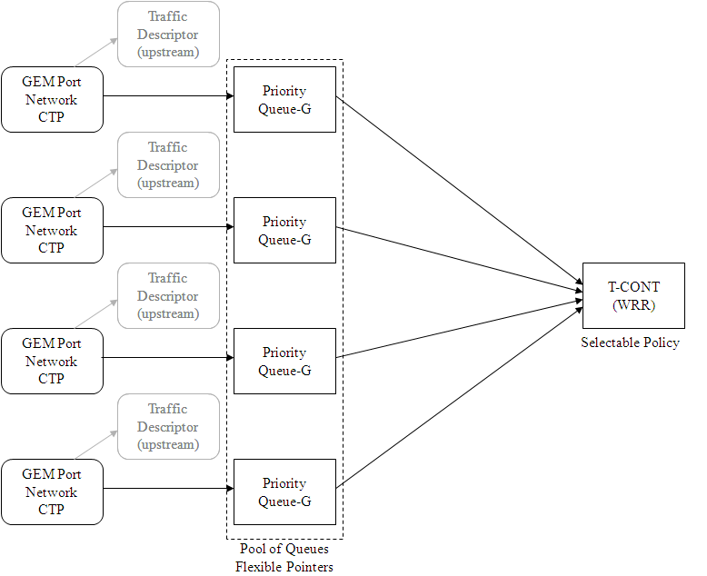

Figure ‎10.84 Example System of Weighted Scheduling with Four “Flexible” Queues

ONT2-G ME
The “QoS configuration flexibility” attribute of the ONT2-G ME indicates whether the ONT supports flexible Priority Queue-G and Traffic Scheduler-G pointers, and flexible Traffic Scheduler-G and T-CONT scheduling policies. Specifically, 1) if bit 1 is set, the Priority Queue-G ME may point to any T-CONT ME in the same slot, 2) if bit 2 is set, the Priority Queue-G ME may point to any Traffic Scheduler-G ME in the same slot,3) if bit 3 is set, the Traffic Scheduler-G ME can point to any T-CONT in the same slot, 4) if bit 4 is set, the Traffic scheduler-G ME Policy attribute is read-write, and 5) if bit 5 is set, the T-CONT ME Policy attribute is read-write. For the single-level scheduling in the rest of this section, it is assumed that bits 1 and 5 are set, and bits 2, 3 and 4 are “don’t care.”

Priority Queue-G ME
Each Priority Queue-G ME has a fixed priority and a configurable weight. The OLT can configure each Priority Queue-G ME to point to any Traffic Scheduler-G ME or any T-CONT ME in the same slot.

The Related Port attribute is divided into two parts for upstream traffic: 1) the ME ID of the associated T-CONT, which should be set to the desired T-CONT in a given slot and 2) the priority of the queue. To support strict priority scheduling between multiple queues, each queue must have a different priority.

The Weight attribute is R/W, and is used to provide weighted scheduling between the queues associated with a T-CONT.

The Traffic scheduler-G pointer attribute is R/W and is provisioned to either point to the associated Traffic Scheduler-G ME or to the associated T-CONT ME (null pointer value). The value of this attribute should be set to zero (null), indicating that that this queue is mapped to the T-CONT indicated by the Related Port attribute. During provisioning, there may be a temporary period where some of the Priority-Queues associated with a T-CONT are mapped to a Traffic Scheduler-G ME and some are mapped to the T-CONT ME, in which case the ONT’s behavior is undefined. The Traffic Scheduler-G pointer attribute value is a “don’t care” for Priority-Queues that are not in use, i.e. that are not connected to a GEM port network CTP ME.

T-CONT ME
The Policy attribute is read/write and must be either WRR or HOL according to the required service.

OLT Considerations
The OLT must select the desired Priority Queue-G MEs from the pool, and connect them to the desired T-CONT. It must also set the policy of this T-CONT to conform scheduling policy required by the service. The OLT must provision the ONT such that the Priority Queue-G / T-CONT ME group is properly connected (via a GEM interworking TP and GEM port network CTP) to the appropriate 802.1p Mapper Service Profile and MAC Bridge Port Config Data MEs.

Strict Priority Scheduling
If the service requires strict priority scheduling between queues, then the OLT must select a T-CONT ME and set its Policy attribute to HOL. The OLT must also select the required number of Priority Queue-G MEs from the pool, each with a different read-only priority. Each required Priority Queue-G ME is connected, according to its read-only priority attribute, to the GEM Port Network CTP associated with that priority. Each required Priority Queue-G MEs is also connected to the associated T-CONT ME. Any unused queues are left unconnected.

Weighted Scheduling
If the service requires weighted scheduling between queues, then the OLT must select a T-CONT ME and set its Policy attribute to WRR. The OLT must also select the required number of Priority Queue-G MEs from the pool, and provisions the weight of each required Priority Queue-G ME. Each required Priority Queue-G ME is connected from the GEM Port Network CTP associated with that weight. Each required Priority Queue-G ME is also connected to the associated T-CONT ME. Any unused queues are left unconnected.

Voice Services
Provisioning of voice services on an ONT is accomplished through the use of a common set of MEs along with MEs specific to a VoIP signalling protocol. These MEs are grouped as follows:

- Common VoIP MEs
  - IP Host Config data
  - TCP/UDP Config data
  - VoIP Config data
  - VoIP Voice CTP
  - VoIP Media profile
  - RTP Profile data
  - Voice Service Profile AAL
  - PPTP POTS UNI

- SIP specific MEs
  - SIP User Data
  - SIP Agent Data
  - Network Dial Plan Table
  - VoIP Feature Access Codes
  - VoIP App Service Profile
- H.248 specific MEs
  - MGC Config Data

The OMCI VoIP MIB allows for single subscriber per SIP User Agent (UA) or multiple subscribers per UA. It is also possible to provision multiple UAs per IP address or a single UA per IP address.

The Extended VLAN Tagging Operation Configuration Data ME is used to provision layer 2 tag operations for a MAC Bridge Port Config Data ME. Therefore, if multiple UAs using the same IP address are provisioned, all UAs must share the same VLAN because there is a one to one relationship between a MAC Bridge Port Config Data ME and an IP Host Config Data ME.

VoIP Capability Discovery
The OLT discovers support of VoIP capabilities by interrogating the MIB of the ONT. When this discovery is performed is up to the discretion of the OLT but it is considered best practice for the OLT to discover VoIP capabilities prior to the attempted creation of any VoIP related MEs.

Support of VoIP in general is indicated by both the existence of an VoIP Config data ME and a non-zero value in the Available Signalling Protocols attribute. Further interrogation of attributes contained in the VoIP Config data ME is performed to discover the specific signalling protocols and provisioning methods supported by the ONT.

The number of voice ports available on an ONT is indicated in three ways:

- By the number of PPTP POTS UNIs that exist on an ONT.
- The Port Count attribute of the Circuit Pack ME.
- The Port Mapping Package-G ME if mixed port types are present on a single circuit pack.

VoIP Common Provisioning
The following considerations should be made when provisioning the common VoIP MEs.

- IP Host Config data – The ONT creates one IP Host Config data ME for each IP stack instance. A single IP address is supported with each instance. The IP Host Config data ME contains a group of IP parameter attributes (IP Address, Mask, etc.) that are settable by the OLT. The OLT sets these attributes if OMCI is being used to provision the IP Parameters. The IP Host Config data ME also contains a group of Current IP parameter attributes. Each Current attribute corresponds to one of the previously mentioned IP parameter attributes. The OLT may only perform a get on these attributes. The current attributes are used display the IP parameters that will be used by the IP stack.

The IP Options attribute is used to control behaviour of the IP stack and IP parameter provisioning. When the Enable DHCP option is set to enable, DHCP is used to retrieve the IP parameters which are reflected in the Current attributes. The OLT may set the IP Address, Mask, Gateway, Primary DNS, or Secondary DNS attributes only when the Enable DHCP option is set to disable. If the OLT sets one of these attributes when DHCP is enabled, the ONT accepts and stores the attribute value but the IP stack does not use those values unless the DHCP option is set to disable. Likewise the value is not reflected in the associated Current attribute unless the DHCP option is set to disable. The OLT should never perform a get command on the writable IP parameter attributes to determine the parameter values being used by the IP stack. This information should only be obtained from the Current IP parameter attributes.

The Disable IP Stack option is used to disable the operation of the IP stack. The values reflected in the Current attributes are used by the IP stack if the Disable IP Stack option is set to enabled. While it is not required by G.984.4, it is considered best practice to disable the IP stack prior to modifying the IP parameters with OMCI. In this manner the IP stack will have a complete coherent set of IP parameters when it is re-enabled.

- TCP/UDP Config data – The OLT creates a TCP/UDP Config data ME for each TCP or UDP port associated with an IP Host Config data ME. The OLT may choose to use the port number as the ME ID but the OLT should ensure that no conflict exists because of overlapping TCP and UDP port number assignments. The TOS/Diffserv Field attribute is used in conjunction with an Extended VLAN Tagging Operation Configuration data ME to mark the VoIP frames with the desired VID and P-bits. The Extended VLAN Tagging Operation Configuration data ME is associated with the MAC Bridge Port Config data ME that points to the IP Host Config data ME. Since the Extended VLAN Tagging Operation Configuration data ME only supports mapping DSCP to P-bits, only a single VID can be used for VoIP frames. This means signalling frames and bearer frames must share a VLAN but can have different P-bits. The IP Host Pointer must be set to point to the IP Host Config data ME that is associated with this TCP/UDP port.

- VoIP Config data – The VoIP Config data ME is automatically created by the ONT. The OLT reads the Available Signaling Protocols attribute to determine the VoIP signalling protocols supported by the ONT. The OLT performs a set on the Signaling Protocol Used attribute to select one of the available signalling protocols for the ONT to use. The Available VoIP Configuration Methods attribute is read by the OLT to determine the provisioning methods that are supported by the ONT. The OLT performs a set on the VoIP Configuration Method Used attribute to select which of the available configuration methods the ONT will use. If TR-069 or IETF sipping are selected, the OLT is not required to perform any further actions to provision voice services. If the configuration file retrieval method is selected, the OLT must set the VoIP Configuration Address Pointer to reference a Network Address ME that provides a retrieval address for the configuration file. Actions required when a proprietary provisioning method is selected are not within the scope of this document.

- VoIP Voice CTP – The OLT creates the VoIP Voice CTP as the last step in basic voice services provisioning. The VoIP Voice CTP uses three ME pointer attributes to tie a POTS port (PPTP POTS UNI) to a signalling protocol (SIP User data ME or MGC Config data ME) and bearer channel (VoIP Media Profile ME). In addition, the OLT may set the Signaling Code attribute to select the POTS line type to use for the POTS port.

- VoIP Media profile – The OLT creates the VoIP Media profile ME to provision the parameters used for voice encoding. The Voice Service Profile AAL Pointer and RTP Profile Pointer attributes must point to those MEs associated with this set of encoding parameters. If an attribute is set to a value that is not supported by the ONT, it will return a parameter error in the command response.

- RTP Profile data – The OLT creates the RTP profile data ME to provision parameters defining the RTP streams used to carry encoded voice. Since RTP ports are assigned dynamically, there is no TCP/UDP Port Config data ME associated with the RTP streams. The MAC Bridge Port Config Data ME associated with the IP Host Config data referenced by the signalling stack is used as the L2-L3 interworking point for the RTP streams. Any L2 marking of the RTP frames must be provisioned using the Extend VLAN Tagging Operation Configuration Data ME associated with this MAC Bridge Port Config Data ME. The DSCP Mark attribute of the RTP Profile Data ME is used in conjunction with the tagging ME to arrive at unique tags for the RTP frames. The DTMF Events attribute is only meaningful if the OOB DTMF attribute of the VoIP Media Profile ME is enabled.

- Voice Service Profile – Created by the OLT to define the parameters associated with the carrying of voice over a packet network.

- PPTP POTS UNI – This ME is created by the ONT for each POTS port. The Interworking TP Pointer attribute is not meaningful in the context of VoIP and may be left as a NULL pointer.

SIP Provisioning
The following considerations should be made when provisioning the SIP MEs.

- SIP User Data – The SIP User Data ME is created by the OLT to define the parameters associated with a single subscriber. The Username/Password attribute references the data used for subscriber authentication not SIP agent authentication. The release timer attribute has a default value of 10 seconds. If the release timer attribute is set to zero, the ONT uses it’s internal default release timer value. This may or may not be the same as the attribute default of 10 seconds and is not discoverable by the OLT.

- SIP Agent Config Data – The SIP Agent Config Data ME is created to define the parameters associated with a SIP user agent. The Proxy Server Address Pointer attribute references a Large String ME so there is no authentication associated with this address. Proxy Server authentication is performed through the use of the SIP registrar attribute which may or may not reference the same address as the Proxy Server Address Pointer attribute. The TCP/UDP Pointer attribute references the TCP/UDP Config data ME that defines the port to be used by the SIP signalling protocol.

- Network Dial Plan Table – The Network Dial Plan Table ME is optionally created by the OLT if a dial plan other than the default used by the ONT is required. Upon the creation of this ME, the ONT returns an unknown managed entity indication if the ONT does not support dial plans beyond the default. There is no standard way for the OLT to discover the default dial plan of an ONT.

- VoIP Feature Access Codes – The VoIP Feature Access Code ME is optionally created by the OLT if feature access codes other than the default used by the ONT are required. Upon the creation of this ME, the ONT returns an unknown managed entity indication if the ONT does not support feature access codes beyond the default. There is no standard way for the OLT to discover the default feature access codes of an ONT.

- VoIP Application Service Profile - The VoIP Application Service Profile ME is optionally created by the OLT if the provisioning of VoIP features is required. Upon the creation of this ME, the ONT returns an unknown managed entity indication if the ONT does not support VoIP feature provisioning. There is no standard way for the OLT to discover the default VoIP features of an ONT.

H.248 Provisioning
The following considerations should be made when provisioning the H.248 MEs

- MGC Config Data – The MGC Config Data ME is created by the OLT to provision the parameters associated with an H.248 media gateway. The Primary MGC and Secondary MGC attributes reference addresses that may contain port numbers for the media gateway controller. These port numbers are not necessarily the same as the media gateway port number defined in the TCP/UDP Port Config data ME. The default port used for the media gateway controller is dependant on the value contained in the Message Format attribute.

Message Flows

SIP Provisioning Flow
Figure ‎11.85 depicts the provisioning flow for basic SIP service. To assist in overall clarity the provisioning of optional MEs is not included nor is the explicit provisioning of the various ME pointers included in the OMCI VoIP MIB.

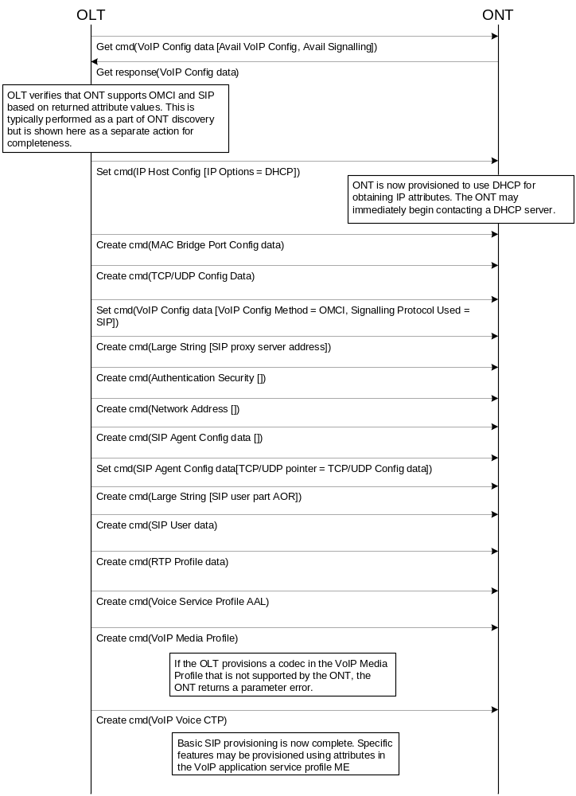

Figure ‎11.85 SIP Provisioning Flow

H.248 Message Flow
Figure ‎11.88 depicts the provisioning flow for H.248 service. To assist in overall clarity, the explicit provisioning of the various ME pointers included in the OMCI VoIP MIB is not included.

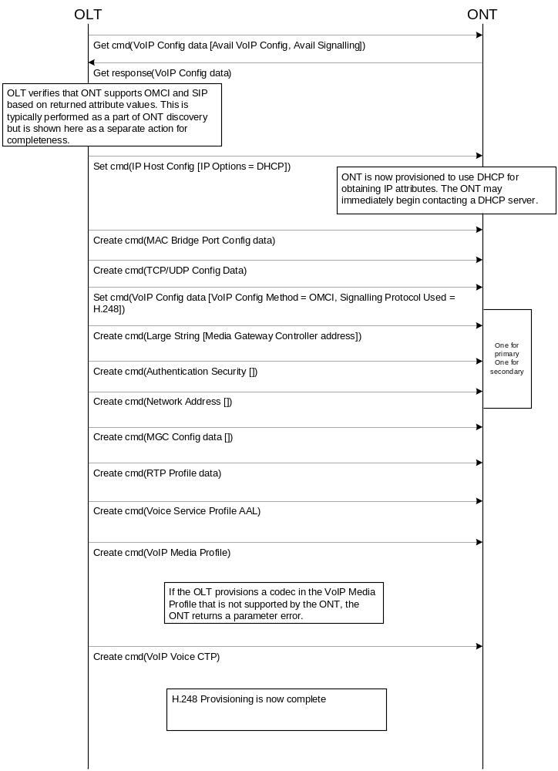

Figure ‎11.88 H.248 Provisioning Flow

Voice Service in a Dual Managed ONT
In addition to supporting full voice service provisioning, OMCI also supports ONTs that use a method other than OMCI to manage voice services. This section describes the techniques that are used for supporting non-OMCI managed voice service.

Common Provisioning
The following considerations should be made when provisioning the common VoIP MEs for non-OMCI managed voice service.

- IP Host Config data – The ONT creates the IP Host Config Data ME for each IP stack instance. Attributes in this ME provide the IP parameters used for the non-OMCI management interface. All considerations from section 12.2 of this document apply.

- TCP/UDP Config data – The OLT creates a TCP/UDP Config data ME for the port used by the non-OMCI management interface. All considerations from section 12.2 of this document apply.

- VoIP Config data – The VoIP Config Data ME is automatically created by the ONT when it supports voice service. The OLT reads the Available VoIP configuration methods attribute to discover the voice service management methods supported by this ONT. The OLT performs a set on the VoIP Configuration method used attribute to select the non-OMCI method to be used by the ONT. The OLT may optionally set the VoIP Configuration address pointer attribute to a network location from which the ONT will receive its voice provisioning parameters. The OLT also optionally sets the Retrieve Profile attribute to indicate to the ONT that it must go retrieve the provisioning parameters for voice service. The ONT uses the VoIP Configuration state attribute to indicate the state of voice service provisioning. The ONT uses the Profile Version attribute to indicate the version of the voice service parameter set that it is currently using.

- VoIP Voice CTP – Not used

- VoIP Media profile – Not used

- RTP Profile data – Not used

- Voice Service Profile – Not used

- PPTP POTS UNI – Used in the same manner as described in section 12.2 of this document.

SIP Provisioning
When an ONT supports non-OMCI provisioning of SIP, it automatically creates a SIP Config Portal ME. This ME contains a single table attribute, Configuration text table. The OLT reads this table to obtain a textual representation of the SIP configuration in use on the ONT. Whenever the text in this table changes, the ONT issues an AVC to the OLT. The format of the text contained with the table is not defined but should be human readable.

H.248 Provisioning
When an ONT supports non-OMCI provisioning of H.248, it automatically creates an H.248 Config Portal ME. This ME contains a single table attribute, Configuration text table. The OLT reads this table to obtain a textual representation of the H.248 configuration in use on the ONT. Whenever the text in this table changes, the ONT issues an AVC to the OLT. The format of the text contained with the table is not defined but should be human readable.

Performance Monitoring

Performance management
As defined in G.984.4, the "tools" used for performance monitoring are:
- The Performance Monitoring History Data managed entities. These MEs exist for most ONT functions including GEM adaptation, Circuit emulation service, Ethernet service and Voice service.
- The Threshold Data 1/2 ME pair. These MEs are used to provide thresholds in support of the Threshold Crossing Alert (TCA) function.
- The Synchronize time action on the ONT-G ME. This action is used to synchronize all existing PM History Data MEs to a common 15 minute collection interval starting point.
- The TCA OMCI alarm. Used to alert the OLT to the crossing of a threshold previously defined by the OLT for a specific PM History Data collection attribute.

Performance Monitoring History Data ME Considerations
For every PM managed entity, its ME ID is set to be identical to that of its parent managed entity..
It is the responsibility of the OLT to create the Performance Monitoring History Data MEs as needed. It is also the responsibility of the OLT to delete these MEs when they are not in use. Since the collection of data only terminates upon deletion, existence of a Performance Monitoring ME may result in an extra processing load on the ONT host processor.
Performance Monitoring data is collected into bins defined by the Performance Monitoring History Data ME collection attributes at 15 minute intervals.
Collection attributes defined as counters do not roll over upon reaching their size limit. Instead, they remain at their maximum value until the end of the current 15 minute interval.
In a few special cases, such as traffic loss ratio, the attribute acquires a value only at the close of a 15-minute interval.
Each Performance Monitoring History data collection attribute provides two storage bins; the accumulator bin and the history bin. The accumulator bin is used to store data collected for the current 15 minute interval. The history bin is used to store data for the previous 15 minute interval. At the end of the current 15 minute interval, they switch roles: the previous accumulator bin becomes the new history bin, while the content of the history bin is discarded and the bin itself is initialized as the new accumulator.The ONT performs no calculations upon the collected data nor does it keep an archive of collected data beyond the previous 15 minute interval. All calculations based on collected data and archiving of past intervals is performed by a higher order network element such as the OLT or EMS.
Each PM History Data ME has an interval count attribute, which is used to identify the most recently monitored interval. This attribute is a single byte, which rolls over from 255 back to 0.
If the OLT wishes to receive TCA alarms, it must set the Threshold data 1/2 ID attribute to reference a previously defined Threshold data 1/2 ID pair.
The OLT may perform two actions on a PM collection attribute; Get data and Get current data. A Get data action returns the value of the collection bin for the previous 15 minute interval. For collection attributes that store intermediate values in the attribute, a Get current data action returns a snap shot of the collection bin for the current 15 minute interval. For other collection attribute types, a Get current data action returns an undefined value.

Threshold Data 1/2 ME Considerations
Each PM History Data ME may contain 14 data collection attributes. To support these 14 attributes and still permit a Set By Create initialization of the threshold attributes, the threshold data attributes are split between two Threshold Data MEs; Threshold Data 1 and Threshold Data 2. These MEs are associated with one another by the sharing of an ME ID. Each Threshold Data 1/2 ME pair may be associated with one or more PM History Data MEs. Not all PM attributes need to be thresholded; thresholding is part of the definition of each PM managed entity. Even when thresholding is defined on a managed entity, it is the option of the OLT whether to provision it (see next section regarding optional pointers). If fewer than seven thresholded counters appear in an ME’s definition, the threshold data 2 ME is not needed.
The threshold for a counter attribute may be disabled by setting it either to zero, to 0xFF (in each byte). A threshold may also be effectively disabled by setting it to a value greater than the maximum possible accumulation, for example a value greater than 900 in an errored seconds attribute.

Synchronizing Collection Intervals
The 15 minute interval for all performance monitoring history MEs is synchronized to a common start point by the issuance of the Synchronize time action by the OLT against the ONT-G ME. Only the Synchronize time action is guaranteed to correctly reset the 15 minute interval. A MIB reset, ONT restart, or protection switch produces no defined action on the 15 minute interval.
Note: The extended synchronize time message contains the OLT’s current time of day within the message itself, so that the ONT can reset its PM timer to a current value (in the range 0..900 seconds) at any time, rather than just at a 15-minute time of day boundary. Use of the use of the extended synchronize time message for GPON is optional based on the criteria defined in G.984.4 Amd 2.
At the moment of synchronization, all PM History Data collection attributes are cleared to 0 and collection is restarted. Also, the value of the interval end time attribute of the PM History Data MEs is set to 0 and restarted.
Additionally, the OLT uses the Synchronize time action as a reference point for archiving PM history.

Threshold Crossing Alerts
During the PM timing interval, a PM History Data collection attribute collects performance data in accordance with its definition. If the collection attribute is a counter, the current value is compared with the provisioned threshold whenever the collection attribute value is incremented. When a current value becomes greater than or equal to the threshold, the ONT originates a TCA.
If the collection attribute is of a type that does not store a value until the end of a 15 minute interval, the issuance of a TCA only occurs at the end of a 15 minute interval. Since existing TCAs are cleared at the beginning of each 15 minute interval, the TCA is then immediately cleared.
TCAs are reported in OMCI alarm messages. It’s guaranteed that the TCA codepoints and alarm codepoints of the same ME will not overlap due to the fact that MEs typically declare either alarms or TCAs, but not both.
At the end of a 15 minute interval, a second OMCI alarm message clearing the alarm is issued for each TCA reported during that interval.

Counter Overflow
Each of the standard PM managed entity contains several counters with a limited size. In order to avoid the unspecified follow up operation after a counter fills up during one single PM interval, the counters are required to remain at its maximum possible value, rather than rolling over.
In a few special cases, such as traffic loss ratio, the attribute acquires a value only at the close of a 15-minute interval. The value returned by a get current data operation is undefined. If a threshold is defined on such an attribute, the TCA is declared at the end of the 15-minute interval and then immediately cleared as the registers are re-initialized.

PM managed entities and the MIB uploading
Both PM History Data MEs and Threshold Data MEs are uploaded as part of a MIB upload. However, the only attribute uploaded for a PM History Data ME is the Threshold Data 1/2 ID attribute.

Threshold Data Change
The OLT may choose to modify the value of a Threshold Data ME attribute at any time. If the modification of an attribute lowers the threshold such that it has already been passed, the TCA will be reported on the next current value to threshold value compare. If the modification of an attribute results in a threshold being disabled or raised beyond the level of an already reported threshold crossing the existing TCA is cleared at the start of the next 15 minute interval.

Creation of PM History MEs in a Running System
The OLT may choose to create a new PM History Data ME in an ONT that is already performing data collection at synchronized intervals. In this case, the OLT may issue a new Synchronize time action to align all PM History MEs to the same 15 minute interval or simply recognize the first interval for the newly created ME as a partial interval.

Dual Managed ONTs
In many cases, the ONT is physically separated from the equipment connected at its UNI, and the ONT is managed via OMCI while the UNI equipment is managed by some other means. For example, the ONT may be connected to an RG via an Ethernet interface, with the ONT managed by OMCI and the RG managed by TR-69. As another example, in the PON-fed DSLAM case, the ONT may be connected to the DSLAM via an Ethernet interface, with the ONT managed by OMCI and the DSLAM managed by SNMP. In these examples, the demarcation point between the two management domains is clear: it is the Ethernet interface.

However, there are cases where the ONT and the UNI equipment are physically integrated into the same device (e.g., an integrated ONT / RG or an integrated ONT / DSLAM) and there may not be a physical interface connecting the two. Since in this case there may be two management domains operating in the same device, this is commonly known as a “dual-managed ONT.” The Virtual Ethernet Interface Point (VEIP) ME is the data plane demarcation point between these two management domains, with OMCI managing from the Virtual Ethernet Interface Point to the ANI.

ONT-G
ONT Data
Software Image
ONT2-G
Software Image
MAC Bridge Port Config Data
MAC Bridge Service Profile
MAC Bridge Port Config Data
Virtual Ethernet Interface Point
UNI-G
GEM Interworking TP
GEM Interworking TP
802.1p Mapper Service Profile
Ext VLAN tag oper. config. data
MAC Bridge Port Config Data
802.1p Mapper Service Profile
GEM Interworking TP
GEM Interworking TP
T-CONT
Priority Queue A1 (Downstream)
Priority Queue 1 (upstream)
Priority Queue 2 (upstream)
Priority Queue 3 (upstream)
Priority Queue A2 (Downstream)
Priority Queue A3 (Downstream)
Priority Queue A4 (Downstream)
VLAN Tagging Filter
VLAN Tagging Filter
T-CONT
T-CONT
T-CONT
IP Host Config Data
Ext VLAN tag oper. config. data
MAC Bridge Port Config Data
MAC Bridge Service Profile
MAC Bridge Port Config Data
GEM Interworking TP
GEM Interworking TP
802.1p Mapper Service Profile
MAC Bridge Port Config Data
802.1p Mapper Service Profile
GEM Interworking TP
GEM Interworking TP
VLAN Tagging Filter
GEM Port
Network CTP
GEM Port
Network CTP
GEM Port
Network CTP
GEM Port
Network CTP
GEM Port
Network CTP
GEM Port
Network CTP
GEM Port
Network CTP
GEM Port
Network CTP
Priority Queue 4 (upstream)
Traffic Descriptor
(Downstream)
Traffic Descriptor
(upstream)
Traffic Descriptor
(Downstream)
Traffic Descriptor
(upstream)
Traffic Descriptor
(Downstream)
Traffic Descriptor
(upstream)
Traffic Descriptor
(Downstream)
Traffic Descriptor
(upstream)
Traffic Descriptor
(Downstream)
Traffic Descriptor
(upstream)
Traffic Descriptor
(Downstream)
Traffic Descriptor
(upstream)
Traffic Descriptor
(Downstream)
Traffic Descriptor
(upstream)
Traffic Descriptor
(Downstream)
Traffic Descriptor
(upstream)
PQ A1
PQ 1
PQ A2
PQ 2
PQ A3
PQ 3
PQ A4
PQ 4
PQ B1
PQ 1
PQ B2
PQ 2
PQ 3
PQ B4
PQ 4
PQ B3
MAC Bridge Port Config Data
VLAN Tagging Filter
GEM IW TP
(incidental mcast)
GEM Port
Network CTP*1
PQ Ay
null
Multicast GEM IW TP
GEM Port
Network CTP*1
null
VLAN Tagging Filter
PQ Ax
Traffic Descriptor
(Downstream)
Traffic Descriptor
(Downstream)
MAC Bridge Port Config Data
Multicast Subscriber Config info
Multicast Operations
Profile
Cardholder
Circuit
Pack
ANI-G
Cardholder
Circuit
Pack
VLAN Tagging Filter
TCP/UDP Config Data
Any PPTP Type
Generic Status Portal

Figure 14.1 Dual-Managed ONT OMCI Model

The OMCI model for dual-managed ONT/RG is given in Figure 14.1. There are several important features of this model:

- Just like a physical Ethernet, multiple traffic classes can flow across the virtual Ethernet interface, and the traffic classes have associated priority queues. One implication of this is that extra work may be involved to multiplex / de-multiplex data on both sides of the VEIP. For example, in the upstream direction, the RG will typically separate (map) traffic by class for queuing and scheduling, then merge all classes to a single stream to pass through the VEIP; the ONT will again separate (map) traffic by class to direct to the appropriate upstream queue.

- The same number of virtual Ethernet interfaces are used as there would be physical Ethernet interfaces between the OMCI domain and the non-OMCI domain if the domains existed on separate devices. For example, there will typically be only one virtual Ethernet interface per RG.

- The virtual Ethernet interface represents the termination of the ONT data plane, whereas the associated IP Host Config data ME (IPHCD) represents the termination of the ONT management plane. The IPHCD is the container for the IP address, mask, gateway and DNS information in the OMCI domain, and is used by the OLT to determine the current IP address, mask, gateway and DNS information in the OMCI domain. For a detailed discussion of IPHCD provisioning, refer to section 12.2 of this document.

- The IPHCD is conditionally required for the dual-managed ONT, depending on the IP stack configuration in the integrated device. There are three stack configurations to consider: a) dual-stack, where each management domain contains a unique IP stack, b) single-stack, where there is only a single stack that is shared between the two domains and c) a single stack that is only used by the non-OMCI domain. In the case of a and b, the IPHCD is required. In the case of c, the IPHCD is optional.

- The presence of virtual Ethernet interface ME provides an unambiguous way for the ONT to represent its true nature to the OLT during the OMCI MIB discovery process.

- One or more VEIP may exist on an ONT, but exactly one Generic Status Portal (GSP) may be created by the OLT per VEIP.

- As an option, the ONT may auto-create UNI-Gs and their associated PPTPs that are assigned to a management domain in one of the following manners:
- Dedicated to the OMCI domain.
- Dedicated to a non-OMCI domain.
- Assignable to a specific domain by the OLT.
The capability of the UNI-G/PPTP is advertised by the ONT in the Management capability attribute of the UNI-G ME. If a UNI-G/PPTP is assignable to a specific domain, the OLT can set the UNI-G non-OMCI management identifier to assign the PPTP/UNI-G to a non-OMCI domain.

The dual-managed ONT OMCI data plane model is provisioned in the same way as in section 9.2.1 of this document, Single UNI OMCI Provisioning Model.

The Generic Status Portal provides a way for the OLT to discover the status and configuration information of a non-OMCI management domain within an ONT. This ME contains two table attributes, Status document table and Configuration document table. The OLT reads these tables to obtain an XML representation of the non-OMCI management domain status and configuration information. Whenever the text in this table changes, the ONT issues an AVC to the OLT. The rate at which AVCs are issued is controlled by the AVC Rate Control attribute.

TR-156 Requirements Table

The following table provides a cross reference between the requirements contained in TR-156 and the sections within this document that address those requirements.

TR-156 Requirement No. | TR-156 Requirement Text | Implementer’s Guide Section
R1 | For the Ethernet physical layer options at the U reference point, The RG MUST support TR-101 Section 2.1 requirements. | N/A
R-2 | The Business RG MUST support sending and receiving the following frame types: untagged frames, priority-tagged frames, VLAN-tagged and double tagged (802.1ad) Ethernet frames in upstream and downstream directions for the interfaces at U. | N/A
R-3 | The OLT MUST support user isolation as defined in TR-101 . | N/A
R-4 | The ONT and OLT MUST support frame sizes of 2000 bytes as per IEEE 802.3as. | N/A
R-5 | GEM Port IDs MUST be assigned automatically by the OLT. | N/A
R-6 | Within the GPON, a bidirectional GEM Port MUST carry one or more traffic flows associated with the same traffic class going to a specific U interface on a specific ONU | 9.2.1.1
R-7 | The OLT and the ONU MUST support one bi-directional GEM Port for each traffic class configured for a specific U interface on a specific ONU. | 9.2.1.1
R-8 | The ONU and OLT MUST support all VID values from the range: 1-4094 as specified in IEEE 802.1Q, on all ports | N/A
R-9 | R-9 The ONU MUST support setting VID for untagged and priority tagged frames in the upstream direction based on EtherType, except VLANs for Business Ethernet Services.  See R-26/TR-101 and R-27/TR-101. | 9.2.1.2
R-10 | The ONU MUST support adding an S-TAG to upstream untagged traffic received from the U interface | 9.3.1.2
R-11 | The ONU MUST support removing an S-TAG from downstream traffic received from the OLT | 9.3.1.2
R-12 | The ONU MUST support unique, symmetric translation of Q-TAG VIDs received from the U interface into S-TAG VIDs | 9.2.1.2
R-13 | The ONU MUST support unique, symmetric translation of the S-TAG VIDs used in the downstream-tagged traffic into the Q-TAG VIDs sent to the U interface | 9.2.1.2
R-14 | The unique symmetric translation among tag VIDs MUST be done by means of a single provisioned table per U interface | 9.2.1.2
R-15 | The OLT MUST support passing an S-TAG in the upstream direction | N/A
R-16 | The OLT MUST support passing an S-TAG in the downstream direction | N/A
R-17 | The OLT MUST support forwarding traffic received at the V interface (i.e. downstream direction) to GEM Ports on the PON based on S-TAG, including P-bits if needed, and destination MAC address | N/A
R-18 | The OLT MUST be able to prevent forwarding traffic between user ports (user isolation). This behavior MUST be configurable per S-VID | N/A
R-19 | The ONU MUST support mapping traffic from one or more GEM Ports to a U interface in the downstream direction | 9.2.1.3
R-20 | The ONU MUST support adding a C-TAG or S-TAG to upstream untagged traffic | 9.2.1.2
R-21 | The ONU MUST support removing the tag from downstream traffic | 9.2.1.2
R-22 | The ONU MUST support VID translation of the Q-TAG received from the U interface into the C-TAG or S-TAG for upstream-tagged traffic | 9.2,1,2
R-23 | The ONU MUST support VID translation of the tag used in the downstream tagged traffic into the Q-TAG sent to the U interface | 9.2.1.2
R-24 | The OLT MUST support adding an S-TAG in the upstream direction for C-tagged traffic | N/A
R-25 | The OLT MUST support passing an S-TAG in the upstream direction | N/A
R-26 | The OLT MUST support passing an S-TAG in the downstream direction | N/A
R-27 | The OLT MUST support forwarding traffic to the V interface (i.e. upstream direction) based on S-VID | N/A
R-28 | The OLT SHOULD support forwarding traffic to the V interface (i.e. upstream direction) based on S-VID and C-VID | N/A
R-29 | The OLT MUST support forwarding traffic received at the V interface (i.e. downstream direction) to GEM Ports on the PON based on S-VID or (S-VID & C-VID), including P-bits, where needed, in the S-TAG | N/A
R-30 | The OLT MUST support removal of an S-TAG in the downstream direction when traffic is double-tagged | N/A
R-31 | The ONU MUST support mapping traffic from one or more GEM Ports to a U interface in the downstream direction | 9.2.1.3
R-32 | The OLT MUST support deactivating MAC learning, for 1:1 VLANs | N/A
R-33 | The Access Node MUST configure 1:1 VLANs so that the C-TAGs are assigned to be unique across the U interfaces and across the entries in the 1:1 VLAN membership list | N/A
R-34 | The ONU MUST support adding an S-TAG in the upstream direction for Q-tagged, untagged, and priority-tagged frames | 9.2.1.2
R-35 | The ONU MUST support validating and translating an S-TAG in the upstream direction for S-tagged frames | 9.2.1.2
R-36 | The ONU MUST support removing an S-TAG in the downstream direction | 9.2.1.2
R-37 | The OLT MUST support forwarding traffic to the V interface (i.e. upstream direction) based on S-TAG | N/A
R-38 | The OLT MUST support passing an S-TAG in the upstream direction | N/A
R-39 | The OLT MUST support forwarding traffic in the downstream direction to GEM Ports based on the S-TAG, including P-bits, when needed, and destination MAC address | N/A
R-40 | The OLT MUST support passing an S-TAG in the downstream direction | N/A
R-41 | The ONU MUST support mapping traffic from one or more GEM Ports to a U interface in the downstream direction | 9.2.1.3
R-42 | The ONU MUST support VID translation of the S-TAG received from the U interface into a new S-TAG for upstream double-tagged traffic | 9.2.1.2
R-43 | The ONU MUST support VID translation of the S-TAG received from the GPON interface into a new S-TAG for downstream double-tagged traffic sent to the U interface | 9.2.1.2
R-44 | The OLT MUST support the basic traffic descriptor parameters as specified in G.984.3 (7.4.4.3 Fixed, Assured, Max BW and type NA or BE). These parameters MUST be configurable | N/A
R-45 | The OLT MUST support the extended traffic descriptor parameters Pi and i as specified in G.984.3. These parameters MUST be configurable | N/A
R-46 | The OLT and ONU MUST support at least 4 traffic classes for Ethernet frames | 10.3
R-47 | The OLT and ONU SHOULD support at least 6 traffic classes for Ethernet frames | 10.3
R-48 | The ONU MUST support deriving P-bit markings in the upstream direction based on an arbitrary combination of: user port, VID, received P-bit markings, and EtherType | 9.2.1.2, 10.1
R-49 | The ONU SHOULD support deriving the P-bit markings in the upstream direction based on an arbitrary combination of: user port, VID and received DSCP value | 9.2.1.2, 10.1
R-50 | The ONU MUST perform any necessary VID and P-bit manipulations before performing the mapping into GEM ports | 9.2.1.2
R-51 | The ONU MUST support mapping traffic into GEM Ports based on arbitrary combination of user port, VID and P-bit values in the upstream direction | 9.2.1.3
R-52 | The ONU MUST NOT prevent multiple P-bit values being used in the same VLAN | 9.2.1.2, 9.2.1.3
R-53 | The ONU MUST NOT prevent multiple VLANs from using the same P-bits | 9.2.1.2, 9.2.1.3
R-54 | The OLT and ONU MUST support drop precedence within at least 2 traffic classes and MUST support configurable mapping to these classes and drop precedence from the 8 possible values of the Ethernet P-bits | 10.3
R-55 | The OLT and ONU MUST support drop precedence within all supported traffic classes based on the DEI bit value of the 802.1ad header | 10.3
R-56 | In the downstream direction, the ONU MUST support at least 4 queues per user port, one per traffic class | 10.3
R-57 | In the upstream direction, the ONU MUST support at least 4 queues, one per traffic class | 10.3
R-58 | In the downstream direction, the OLT MUST support at least 4 queues per PON, one per traffic class | N/A
R-59 | OLT MUST support T-CONT types 1, 2, 3 and 4. Each T-CONT type MUST be able to use the full bandwidth available on the GPON | N/A
R-60 | In the downstream direction, the ONU SHOULD support at least 6 queues per user port, one per traffic class | 10.3
R-61 | In the upstream direction, the ONU SHOULD support at least 6 queues, one per traffic class | 10.3
R-62 | In the downstream direction, the OLT SHOULD support at least 6 queues per PON, one per traffic class | N/A
R-63 | The OLT and ONU MUST support scheduling of downstream queues according to strict priority among at least 4 TCs | 10.4
R-64 | The OLT and ONU MUST support assigning an individual TC to a downstream queue | 9.2.1.3
R-65 | The OLT and ONU SHOULD support assigning multiple downstream queues to the same priority. If multiple downstream queues are assigned to the same priority, queues assigned to the same priority MUST be scheduled according to a weighted algorithm (like WFQ) with weights assigned through provisioning | 9.2.1.3, 10.4
R-66 | In the upstream direction, the OLT MUST support at least 4 queues per network facing port, one per traffic class | N/A
R-67 | In the upstream direction, the ONU MUST support at least 4 T-CONTs, one per traffic class | 9.2.1.1, 10.5
R-68 | In the upstream direction, the OLT SHOULD support at least 6 queues per network facing port, one per traffic class | N/A
R-69 | In the upstream direction, the ONU SHOULD support at least 6 T-CONTs, one per traffic class | 9.2.1.1, 10.5
R-70 | The OLT MUST support scheduling of upstream queues according to strict priority among at least 4 priorities | N/A
R-71 | The OLT MUST support assigning a TC to an upstream queue | N/A
R-72 | The OLT SHOULD support assigning multiple upstream queues to the same priority. If multiple upstream queues are assigned to the same priority, queues assigned to the same priority MUST be scheduled according to a weighted algorithm (like WFQ) with weights assigned through provisioning | N/A
R-73 | The OLT MUST and ONU SHOULD support setting the maximum depth of all queues | 10.3
R-74 | The GPON network MUST be able to forward all multicast-VLAN traffic using a single downstream multicast GEM port | 9.3.1.1
R-75 | The OLT SHOULD be able to forward all multicast-VLAN traffic and act on IGMP on an N:1 VLAN using only bidirectional unicast GEM ports | N/A
R-76 | The ONU MUST allow the configuration of the IP multicast groups that are acceptable per user port based on:  • Source address matching  • Group address matching  • VLAN membership | 9.3.2
R-77 | The OLT MUST allow the configuration of the IP multicast groups that are associated with a multicast-VLAN based on:  • Source address matching  • Group address matching | N/A
R-78 | The OLT MUST allow the configuration of IP multicast groups described in R-76 and R-77 using ranges based on:  • Source address matching  • Group address matching | N/A
R-79 | The GPON network MUST use a bi-directional GEM port for upstream IGMP messages. This GEM Port can be shared by other VLANs from the same U interface that share the same TC | 9.3.1.1
R-80 | The OLT SHOULD send downstream multicast IGMP messages (e.g. Global Query messages) using the same GEM port that is used to carry the multicast content | N/A
R-81 | The ONU MUST support receiving downstream multicast IGMP messages (e.g. Global Query messages) on either a unicast GEM port, or the multicast GEM port that is used to carry the multicast content | 9.3.1.1
R-82 | The ONU and OLT MUST support the identification and processing of upstream IGMP messages. When this function is disabled on a port and/or VLAN, these messages are transparently forwarded | 9.3.2
R-83 | The OLT MUST support configurable silent discard of all IGMP messages received on an ONU user port and/or VLAN | N/A
R-84 | The OLT and ONU MUST support matching groups conveyed by IGMP messages on a user port to the list of groups (R-76) associated with this port. When there is no match, the copy of IGMP message directed toward the multicast-VLAN MUST be silently discarded. When there is a match, the IGMP message SHOULD be forwarded within a multicast-VLAN, and enter the IGMP snooping function | 9.3.2
R-85 | The OLT MUST support mechanisms to stop user ports injecting multicast traffic to the aggregation network. This behaviour MUST be configurable per ONU user port and/or VLAN | N/A
R-86 | The OLT MUST be able to discard IGMP messages received from user-facing ports on a multicast-VLAN | N/A
R-87 | The ONU and OLT MUST be able to rate-limit IGMP messages received from user-facing ports on a multicast-VLAN | 9.3.2
R-88 | The ONU and OLT MUST support an IGMP v3 (as per RFC 3376) transparent snooping function. This MUST be configurable on a per VLAN basis | 9.3.2
R-89 | The ONU and OLT IGMP v3 transparent snooping function MUST support the capability to snoop the multicast source IP address and destination IP group address in IGMP messages and to set the corresponding MAC group address filters as specified in R-90 | 9.3.2
R-90 | The ONU and OLT IGMP v3 transparent snooping function MUST be able to dynamically create and delete MAC-level Group Filter entries, enabling in turn, selective multicast forwarding from network-facing VLANs to user-facing ports | 9.3.2
R-91 | The ONU MUST support IGMP immediate leave as part of the IGMP transparent snooping function | 9.3.2
R-92 | Upon detecting topology changes (e.g. VLAN membership change, port being disabled by STP and network port changing state) the OLT MUST be able to issue an IGMP proxy query solicitation, i.e. an IGMP Group Leave with group address ‘0.0.0.0’. This will indicate to the BNG to immediately send Group Specific queries, which will populate the L2 multicast filters in the Access Node, in order to speed up network convergence. For reference see RFC 4541, chapter 2.1.1 section 4 | N/A
R-93 | For security purposes, the ONU SHOULD and OLT MUST silently discard any user-initiated IGMP Leave messages for group ‘0.0.0.0’ | 9.3.2
R-94 | The ONU MUST support marking, in the upstream direction, user-initiated IGMP messages with Ethernet P-bits | 9.3.2
R-95 | The OLT SHOULD provide the following statistics.  Per VLAN, per multicast group:  1. Total number of currently active hosts  Per U interface, per multicast-VLAN:  1. Total number of successful joins  2. Total number of unsuccessful joins  3. Total number of leave messages  4. Total number of general queries sent to users  5. Total number of specific queries sent to users  6. Total number of invalid IGMP messages received  Per multicast-VLAN:  1. Current number of active groups  2. Total number of sent joins  3. Total number of joins received from users  4. Total number of successful joins from users  5. Total number of unsuccessful joins from users  6. Total number of leave messages  7. Total number of leave messages received from users  8. Total number of general queries sent  9. Total number of general queries received from network  10. Total number of specific queries sent to users  11. Total number of specific queries received from network  12. Total number of invalid IGMP messages received | N/A
R-96 | The ONU MUST support configuring which user ports are members of a given multicast-VLAN | 9.3.1.1
R-97 | The ONU and OLT MUST be able to configure per U interface the maximum number of simultaneous multicast groups allowed | 9.3.2
R-98 | The ONU MUST silently discard IGMP v1 messages | 9.3.2
R-99 | The ONU SHOULD support an IGMP/PPPoE transparent snooping function. This capability will use the methods described for classification and establishment of group address filters based on the baseline requirements (See section 6.2.2/TR-101) | 9.3.2
R-100 | If R-99 is supported, then for those IGMP messages observed within PPPoE the ONU MUST be able to trigger a local IGMP Host function (aka “echo client”) when a group is joined or left by a user-facing port. The IGMP Host function MUST then locally generate IGMP/IPoE messages (e.g. membership report/leave) and locally reply to IGMP membership queries to reflect the groups whose delivery to the ONU is needed. The IGMP Host function MUST be triggered in the context of the multicast-VLAN | N/A (Not an ONU-OLT interoperation focused requirement)
R-101 | If R-99 is supported, then the instantiation of the local IGMP Host at the ONU MUST be configurable per multicast-VLAN and user port | 9.3.2
R-102 | The OLT MUST support IGMP v3 snooping with proxy reporting configurable on a per VLAN basis | N/A
R-103 | The OLT MUST allow selection between transparent snooping and snooping with proxy reporting on a per-VLAN basis | N/A
R-104 | The IGMP snooping with proxy reporting function MUST support IGMP proxy query functions | N/A
R-105 | The OLT proxy-reporting function MUST support marking IGMP messages it initiates with Ethernet (VLAN) P-bits | N/A
R-106 | The OLT SHOULD be able to create MAC multicast filter entries for VLANs and multicast groups that MUST be forwarded downstream using the bidirectional GEM ports – i.e. VLANs and groups that will not be multicast to all ONUs using a multicast GEM port | N/A
R-107 | If R-106 is supported, then the OLT MUST NOT forward any multicast traffic provisioned to use a bidirectional GEM port to GEM ports for ONUs that are not associated with the multicast-VLAN and group or have not joined the group | N/A
R-108 | If R-106 is supported, then upon receipt of an IGMP message to join a multicast group provisioned to be delivered using bidirectional GEM ports, the OLT MUST forward the associated multicast traffic to the unicast GEM port(s) through which it received the IGMP message | N/A
R-109 | It MUST be possible to configure each N:1 VLAN so that they either silently discard or flood frames with MAC addresses that are not in the AN forwarding table | 9.3.2
R-110 | For N:1 VLANs where flooding is enabled, when the OLT receives a tagged frame with an unknown unicast MAC address then it MUST be flooded by forwarding to a downstream GEM port | N/A
R-111 | It MUST be possible to configure each VLAN so that it silently discards broadcast frames | 9.2.1.2
R-112 | For N:1 VLANs, when the OLT receives a broadcast frame, and if it is not otherwise filtered, then it MUST be forwarded using a downstream GEM port | N/A
R-113 | If the ONU receives a tagged frame on a downstream GEM Port, it MUST forward it to all U interfaces that are members of that VLAN | 9.2.1.3
R-114 | The OLT SHOULD be able to provide service to users with duplicate MAC addresses | N/A
R-115 | The OLT SHOULD be able to deny service to users with duplicate MAC addresses | N/A
R-116 | The OLT SHOULD provide a mechanism to prevent Broadband Network Gateway MAC address spoofing | N/A
R-117 | The OLT SHOULD inspect upstream and downstream DHCP packets in order to discover the mapping of IP address to MAC address and populate an ARP table associating these addresses with their respective U-interface and VLAN | N/A
R-118 | The OLT SHOULD ensure that downstream broadcast ARP requests are not sent on U-interfaces that do not have the requested IP address | N/A
R-119 | The OLT SHOULD provide mechanisms to prevent user IP address spoofing, by discarding upstream IP packets received from U-interfaces that do not match the configured or DHCP-discovered source IP address | N/A
R-120 | The OLT SHOULD be configurable with a list of IP address associated with user port and VLAN, to be used for users having static IP configuration | N/A
R-121 | In order to prevent source MAC flooding attacks, the OLT MUST be able to limit the number of source MAC addresses learned and forwarded from each user port. This limit MUST be configurable per user port | N/A
R-122 | The OLT and ONU SHOULD allow configuring and applying the following filters. The OLT MUST apply any configured filters in the downstream direction, and the ONU MUST apply any configured filters in the upstream direction.  1. Source MAC address filter. This filter may be used in one of the following ways:  i. Allowing access from a specific MAC address.  ii. Denying access from a specific MAC address.  2. Destination MAC address filter. This filter may be used in one of the following ways:  i. Allowing access to specific destinations.  ii. Denying access to specific destinations | 9.2.1.3
R-123 | The ONU SHOULD allow configuration of an EtherType filter, and applying it per U-interface in the upstream direction. This filter may be used in one of the following ways:  i. Allowing a specific EtherType frame access (e.g. IPoE, PPPoE).  ii. Denying a specific EtherType frame access (e.g. IPoE, PPPoE) | 9.2.1.3
R-124 | The OLT and ONU SHOULD be able to filter reserved group MAC destination addresses (in the 01:80:C2 range – See TR-101/R-95) | 9.2.1.3
R-125 | The OLT MUST create the Agent Circuit ID and Remote ID as described in TR-101 | N/A
R-126 | The OLT MUST use a static identifier, ONUID , for each ONU device in a PON interface. This identifier MUST remain the same across re-initialization, software and firmware updates, and adds, moves, and other changes that do not involve that ONU | N/A
R-127 | The Access Node DHCP Relay Agent and PPPoE Intermediate Agent MUST use the following default syntax to automatically generate the Agent Circuit ID field, identifying access loop logical ports as follows:  Access-Node-Identifier atm slot/port/ONUID/slot/port:vpi.vci  (when ATM/DSL is used)  Access-Node-Identifier eth slot/port/ONUID/slot/port[:vlan-id]  (when Ethernet[/DSL] is used)  In this syntax, Access-Node-Identifier MUST be a unique ASCII string (not using character spaces). The Access-Node-Identifier, L2 type (ATM, ETH) field and the slot/port fields are separated using a single space character. The slot identifier MUST NOT exceed 6 characters in length and the port identifier MUST NOT to exceed 3 characters in length using a ‘/’ as a delimiter . The vpi, vci and vlan-id fields (when applicable) are related to a given access loop (U-interface) | N/A
R-128 | The OLT MUST be able to perform the Layer 2 DHCP relay agent function as specified in section 3.9.1/TR-101 | N/A
R-129 | The OLT MUST be able to perform the PPPoE Intermediate Agent function as specified in section 3.9.2/TR-101 | N/A
R-130 | For the 1:1 VLAN case, for an Access Node to BNG MD (Intra-Carrier), the Down MEP in the Access Node MUST be created on the OLT at the interface facing the BNG | N/A
R-131 | For the 1:1 VLAN case, for an Access Port to BNG MD (Carrier), the Up MEP in the Access node MUST be created on the user port on the ONU | N/A
R-132 | For the 1:1 VLAN case, for an Access Port to BNG Carrier MD, a MIP MUST be created on the OLT at the interface facing the BNG | N/A
R-133 | For the 1:1 VLAN case, for an Access Port to BNG Carrier MD, an MIP SHOULD be created on the OLT at the interface facing the ONU | N/A
R-134 | For the 1:1 VLAN case, for end-to-end RG to BNG MD (Customer), a MIP MUST be created on the ONU at the interface facing the user | N/A
R-135 | For the 1:1 VLAN case, for the Access Node to BNG MD, Access Port to BNG Carrier MD, and the end-to-end RG to BNG Customer MD, the BNG MUST support MEP functionality at all 3 levels at the same time | N/A
R-136 | For the N:1 VLAN case, for an Access Node to BNG Intra-Carrier Maintenance Domain (MD), the Down MEP in the Access Node MUST be created on the OLT at the interface facing the BNG | N/A
R-137 | For the N:1 VLAN case, for an Access Port to BNG Carrier MD, the Up MEP in the Access node MUST be created on the user port on the ONU | N/A
R-138 | For the N:1 VLAN case, for an Access Port to BNG Carrier MD, a MIP MUST be created on the OLT at the interface facing the BNG | N/A
R-139 | For the N:1 VLAN case, for an Access Port to BNG Carrier MD, an additional MIP SHOULD be created on the OLT at the interface facing the ONU | N/A
R-140 | For the N:1 VLAN case, for end-to-end RG to BNG Customer MD, a MIP MUST be created on the ONU interface facing the user | N/A
R-141 | For the N:1 VLAN case, for the Access Node to BNG Intra-Carrier MD, the Access Port to BNG Carrier MD, and the end-to-end RG to BNG Customer MD, the BNG MUST support MEP functionality at all 3 levels at the same time | N/A
R-142 | For the TLS VLAN case, for an Access Node to BNG MD (Intra-Carrier), a Down MEP in the Access Node MUST be created on the OLT at the interface facing the BNG | N/A
R-143 | For the TLS VLAN case, for an Access Port to Carrier Edge MD (Carrier), an Up MEP in the Access node MUST be created on the user port on the ONU | N/A
R-144 | For the TLS VLAN case, for an Access Port to Carrier Edge MD, a MIP MUST be created on the OLT at the interface facing the BNG | N/A
R-145 | For the TLS VLAN case, for an Access Port to Carrier Edge MD, a MIP MUST be created on the BNG at the interface facing the OLT | N/A
R-146 | For the TLS VLAN case, for an Access Port to Carrier Edge MD, a MIP SHOULD be created on the OLT at the interface facing the ONU | N/A
R-147 | For the TLS VLAN case, for end-to-end RG to far endpoint (Customer) MD, a MIP MUST be created on the ONU at the interface facing the user | N/A
R-148 | For the TLS VLAN case, for the Access Node to BNG Intra-Carrier MD the BNG MUST support MEP functionality | N/A
R-149 | All the configurable features of the ONU that are covered by explicit requirements in this Working Text MUST only be managed via the OLT using OMCI and PLOAM as per G.984 | 9.2, 9.3, 10
R-150 | The OLT MUST support the pre-provisioning of ONU serial numbers and their associated ONUIDs | N/A
R-151 | The OLT MUST support the pre-provisioning of registration IDs and their associated ONUIDs | N/A
R-152 | R-152 ONUs that support the registration ID approach MUST support the local setting of a registration ID | N/A
R-153 | ONUs that support the registration ID approach MUST retain the registration ID indefinitely | N/A
R-154 | When the OLT receives a serial number from an ONU during ranging, the OLT MUST determine whether the serial number is recognized either from a previous registration or from a set of provisioned values | N/A
R-155 | R-155 In the case where a serial number is not recognized, an OLT MUST determine whether the registration ID is recognized from a set of provisioned values | N/A
R-156 | When an ONU registers successfully [per R-144/145] the OLT MUST add that ONUs serial number to the set of recognized serial numbers and assign an ONUID | N/A

Traffic Management Alternatives

Introduction
G-PON contains a number of features related to QoS like policing, shaping, queuing, and scheduling. These features can be applied to a variety of different QoS architectures like Diffserv, Metro Ethernet and TR-101. While, TR-101 is addressed in section 10 of this document, this appendix gives examples of how to map the G-PON QoS features to the Diffserv or Metro Ethernet services.

Diffserv over G-PON
IETF RFC 2475 outlines the DiffServ, or differentiated services, model for providing QoS (Quality of Service). Fundamental to the DiffServ model is that traffic is classified and conditioned (metered, shaped, policed and/or re-marked) at the edge of the QoS domain and then queued and scheduled for forwarding at each node in the interior of the QoS domain based on the “per hop behavior” of the class. This relative QoS on a per-hop basis instead of a network-wide basis is a fundamental property of the DiffServ model.

While RFC 2475, an informational RFC, defines the basic framework for DiffServ, a number of additional RFCs define the behavior of the most commonly used traffic classes, Expedited Forwarding (EF), in RFC 3246 and RFC 3247, and Assured Forwarding (AF), in RFC 2597.

AF includes the concept of “drop precedence,” that traffic can be admitted and marked in such a way that traffic will be dropped in a prescribed precedence within a class when congestion occurs. AF defines 4 classes, each with 3 drop precedence levels. With AF, it is important that packets within a class not be reordered.

Traffic must be classified and policed/marked at the ingress and egress of the QoS domain edge in order to implement DiffServ. A marker function that can be used for Diffserv is specified in RFC 4115, the two-rate three color marker system (trTCM). The trTCM marker function has two associated rates, the CIR (committed information rate) and the EIR (excess information rate). A dual token bucket algorithm is used for this color marking. If the packet length is less than the number of tokens in the committed token bucket, then the packet is declared green; else if the packet length is less than the number of tokens in the excess token bucket, then the packet is declared yellow; otherwise the packet is declared red. These three colors are mapped to the three drop precedences – green traffic will be marked with drop precedence 1, yellow traffic will be marked with either drop precedence 2 or 3. During times of congestion, the ONT will drop “yellow” packets with higher probability than “green” packets. Note that the peak information rate (PIR) in G-PON is equal to the sum of CIR and EIR.

EF is intended for constructing low-latency and low-loss services, in that it is assumed that packets marked with the EF class can preempt other traffic within limits. It can be implemented as a simple priority queue, where the output of the EF priority queue is given higher priority over other queues, but where the input the EF priority queue is governed by a token bucket to prevent starvation of the other queues. As with AF, it is important that EF class packets not be reordered.

Assuming the domain edge is the ONT, each DiffServ CoS (Class of Service) should be assigned its own T-CONT. In this way, the OLT can schedule grants to provide fair access to the shared G-PON bandwidth. For a given ONT, flows from different users but within the same class CoS should be policed separately and then placed in the same queue. OLTs should assign bandwidth using the extended bandwidth assignment model for DBA (G.984.3). T-CONTs containing flows from the same class but from different ONTs should be assigned the same priority, but should be assigned weights proportional to the cumulative data rate of those flows. EF traffic is set to the highest extended bandwidth priority of the 3 Diffserv classes, with the CIR in the traffic descriptor set to the CIR of the EF traffic, and EIR set to zero; EF class packets at a rate above CIR will be dropped by the ONT. AF traffic is set to a lower extended bandwidth priority than EF traffic, with the CIR and EIR in the traffic descriptor set to the CIR and EIR for each AF class. Best effort traffic is set to a lower extended bandwidth priority than EF and AF traffic. All ONTs should use mode 1 status reporting and traffic management option 2. Figure ‎II.91 shows an example of the distribution of upstream functionality between the ONU and the OLT for a Diffserv architecture.

Provisioning Considerations
The L2-OCM provisioning model defined in 9.3.1 is used to support Diffserv. In this model, the GEM traffic descriptor ME is used to describe the behaviour of each traffic class in the ONT. The following considerations should be used when provisioning the GEM traffic descriptor:
- For EF traffic, the CIR and PIR attributes should be set to the CIR of the EF traffic profile.
- For AF traffic, the CIR attribute should be set to the CIR of the AF traffic profile. The PIR attribute should be set to the sum of the CIR and EIR of the AF traffic profile.
- For BE traffic, the CIR attribute should be set to the CIR of the BE traffic. The PIR attribute should be set to the sum of the CIR and EIR of the BE traffic profile.
- The color mode attribute should be set to 1 to indicate a color aware traffic flow.
- The Ingress color marking and Egress color marking attributes should be set to a value of 7 to indicate DSCP AF drop precedence marking.

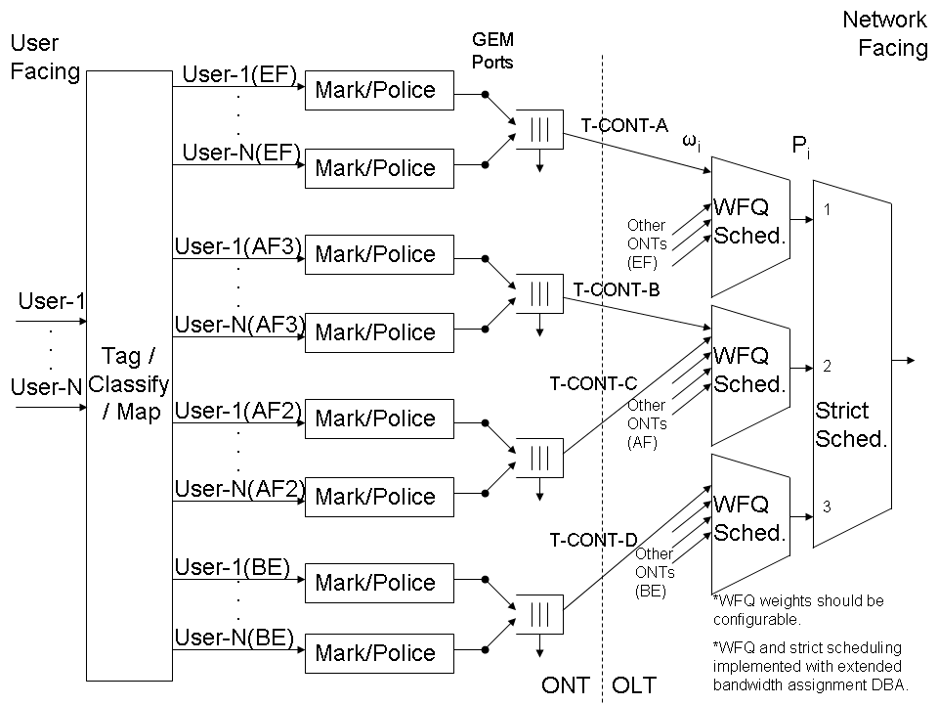
Figure ‎II.91Block Diagram Example of Diffserv Upstream QoS for G-PON

Metro Ethernet over G-PON
Metro Ethernet Forum Implementation Agreement #10 (MEF 10.1) describes an Ethernet Virtual Service (EVS), which is a layer 2 connection between Customer Edge (CE) devices. In the MEF model, the edge of the QoS domain is very clear – it is defined at the UNI (the ONT), where the marking/policing function is carried out. MEF 10.1 defines no specific per-hop behavior. Instead, it focuses on end-to-end delivery service level specifications in terms of delay, delay variation and packet delivery ratio. In this architecture, it is assumed that the UNI is a customer facing IEEE 802.3 (Ethernet) interface on the ONT.

The traffic management defined by the MEF 10.1 employs a 2-rate, 3-color policer (identical to RFC 4115 if the MEF10.1 variable CF is set to 0). The two rates are CIR and EIR (excess information rate), and are defined for both ingress frames and egress frames. If the frame (ingress or egress) length is less than the number of tokens in the committed token bucket, then the frame is declared green; else if the frame length is less than the number of tokens in the excess token bucket, then the frame is declared yellow; otherwise the frame is declared red. This policing takes place at the UNI.

According to MEF 10.1, traffic marked “green” is to be delivered according to the specifications of the service level specification, traffic marked “yellow” may be delivered, but is not bound to the service level specification, and traffic marked “red” is to be dropped.

The Metro Ethernet documents do not specify the means by which an Ethernet Virtual Connection (EVC) is designated within a service provider’s network. However, this appendix recommends using the IEEE 802.1ad method of 2-layers of VLAN tags: C-TAGs for customer use and S-TAGs for service provider use.

At the UNI, a VLAN S-TAG is added or translated to ingress (from the customer) frames and p-bits set appropriately. The S-TAG is removed or translated from egress (toward the customer) frames. The mapping to S-TAGs should be one per EVC.

Provisioning Considerations
Each S-TAG p-bit value (Class of Service) should be assigned its own T-CONT. In this way, the OLT can schedule grants to provide fair access to the shared G-PON bandwidth. For a given ONT, flows from different users but within the same class CoS should be policed separately and then placed in the same queue. OLTs should assign bandwidth using the extended bandwidth assignment model for DBA (G.984.3). T-CONTs containing flows from the same class but from different ONTs should be assigned the same priority, but should be assigned weights proportional to the cumulative data rate of those flows.

The DEI bit should indicate that “yellow” frames are eligible for discard. Red frames should be dropped in the ONT and never forwarded to the OLT. It is important that frames not be reordered. Therefore, all traffic for a given CoS (both green and yellow) must be kept in a single logical queue. During times of congestion, the ONT will drop “yellow” packets with higher probability than “green” packets. All ONTs should use Mode 1 status reporting and traffic management option 2.

The L2-OCM provisioning model defined in 9.3.1 is used to support MEF10.1. In this model, the GEM traffic descriptor ME is used to describe the behaviour of each traffic class in the ONT. The following considerations should be used when provisioning the GEM traffic descriptor:
- For each EVC, the CIR and PIR attributes should be set to the appropriate values for that EVC.
- The color mode attribute should be set to 1 to indicate a color aware traffic flow.
- The Ingress color marking and Egress color marking attributes should be set to a value of 2 to indicate DEI drop precedence marking.

_________________

IETF RFC 2475- An Architecture for Differentiated Services (December 1998)
IETF RFC 3246- An Expedited Forwarding PHB (Per-Hop Behavior) (March 2002)
IETF RFC 3247- Supplemental Information for the New Definition of the EF PHB (Expedited Forwarding Per-Hop Behavior) (March 2002)
IETF RFC 2597- Assured Forwarding PHB Group (June 1999)
IETF RFC 4115- A Differentiated Service Two-Rate, Three-Color Marker with Efficient Handling of in-Profile Traffic (July 2005)
MEF 10.1 - Ethernet Services Attributes Phase 2

