

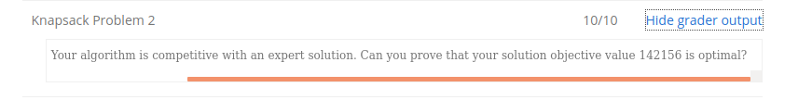

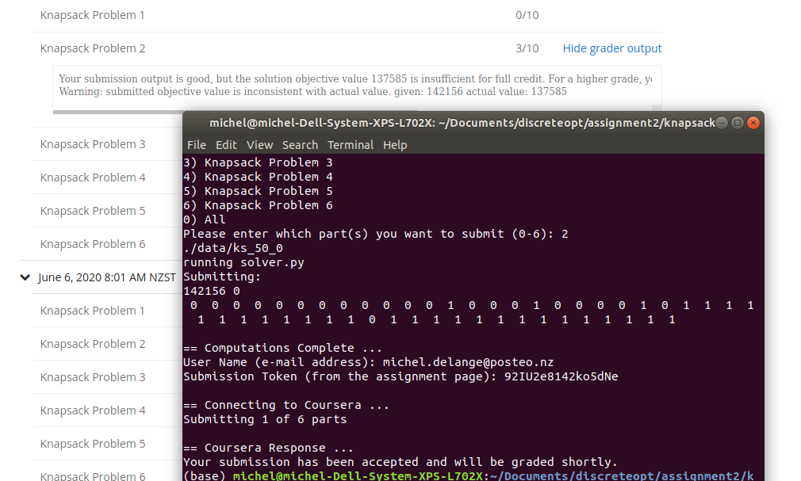
12248 0
0 0 1 0 0 1 0 1 0 0 0 0 1 1 0 0 0 0 0

sum: 12248
12248 0
0 0 1 0 0 1 0 1 0 0 0 0 1 1 0 0 0 0 0

sum: 11571
12248 0
0 1 0 0 0 0 0 0 0 0 1 1 1 1 0 1 1 1 0

sum: 11571
12248 0
0 1 0 0 0 0 0 0 0 0 1 1 1 1 0 1 1 1 0

