CD19posb20

Should I base my analysis on all mice, or just on the male mice? Are male and female mice so different, in regard to how the cell counts change over time, that I am best leaving out the females?

I fitted this model:

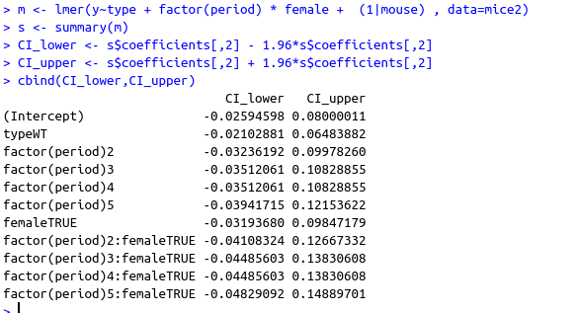

female is significant, as are the interactions with time.

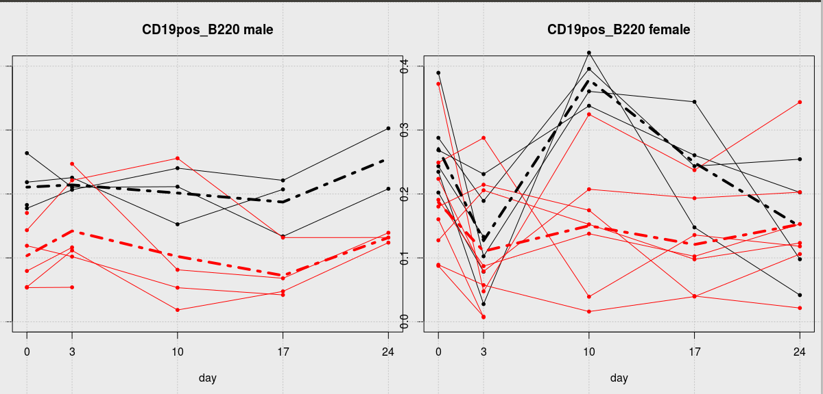
Here are the spaghetti plots, with the mean as dashed line. Black is WT, red is Pound.

It seems to me that females and males are really quite different, in how to respond over time, so I am going to leave the females out of the analysis altogether. I will have to check that again for other cell types.
So now this is my data:

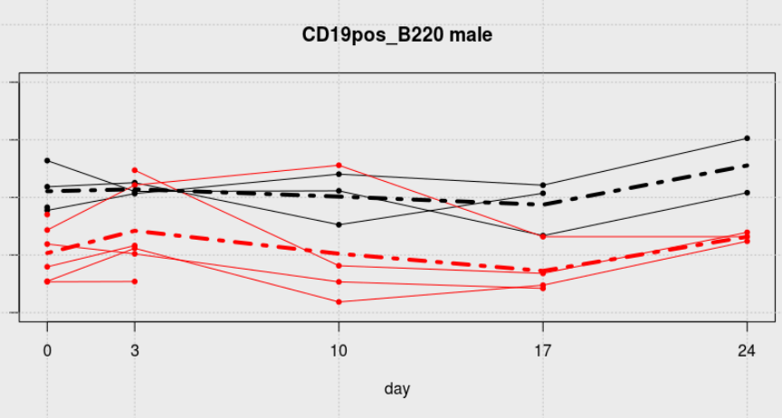

WT mice are black, Pound mice are red.

Wild type

Day0 3 10 17 24

6 0.18 0.21 0.24 0.22 0.3
7 0.26 0.21 0.21 0.13 0.21
23 0.22 0.23 0.15 0.21 NA
24 0.18 NA NA NA NA

Pound

8 0.14 0.22 0.26 0.13 0.13
9 NA 0.25 0.08 0.07 0.14
10 0.17 NA NA NA NA
19 0.05 0.11 0.02 0.05 0.12
20 0.12 0.1 0.05 0.04 NA
21 0.08 0.12 NA NA NA
22 0.05 0.05 NA NA NA

We have 38 observations on 11 mice, over 5 time periods.

We are not longing for a linear trend, but the hypothesis is that the Pound mice show a reduction in cell after t=0, and then revert to their pre-stroke level.
Let’s start by treating the proportions as Gaussian (i.e. Normal). Of course, this cannot be correct, because proportions are in the range from zero to one, but we can disregard that for now.

To start with, we can do t-tests at time=0,3,10,17,24:

In summary:

Period | CI for difference | p-value |  | N WT | N Pound
1: day 0 | 0.17;0.04 | 0.01 | * | 4 | 6
2:day 3 | -0.15;0.01 | 0.07 |  | 3 | 6
3:day 10 | -0.25; 0.06 | 0.16 |  | 3 | 4
4:day 17 | 0.21;0.02 | 0.03 | * | 3 | 4
5:day 24 | -0.70; 0.46 | 0.23 |  | 2 | 3

So the means are different at day 0 and 17, but not thereafter. In both cases, Pound mice are lower, on average by between approximately 0 and 20%.

We can also do paired t-tests (to account for correlation within mice over time), comparing individual mice at each period (i.e. comparing with period 1), separately for each type of mouse (WT or Pound). We get very high p-values, suggesting no evidence for difference over time, for both types.

Next, we fit a mixed model, with main effects type (WT, Pound) , sex, and time period (factor with levels 1,2,3,4,5) and a random intercept for each mouse. Our interest is in the interaction between time and type, because this will tell us whether the effect of time differs by type.

I have removed the PLT mice from the dataset, because we are not intested in them, and we suspect they are very different from the Pound mice, in which we are interested. First, I fit a model, which includes sex and a sex x time interaction. The results suggest that the sex x time interaction is significant. So girl mice and boy mice behave differently over time. Since our interest is in the male mice, I decided to leave the female mice out of the dataset, and proceeded with the male mice only.

So in R, I fitted this model:

And these are the Wald confidence intervals:

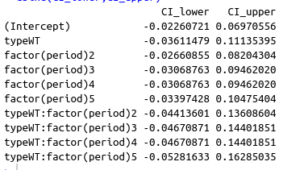

All intervals include the value zero, so nothing at all is statistically significant. We have no evidence that the cell counts for pound mice behave differently over time than those for wild type mice.

I have also fitted a model with stroke_size (scaled) as a covariate, but this turned out to be insignificant, and I dropped it from the model.
Let’s check our model assumptions. First, my favourite: The police line-up method: Here is plot of 9 sets of residuals simulated from the model, and 1 plot with the real residuals.

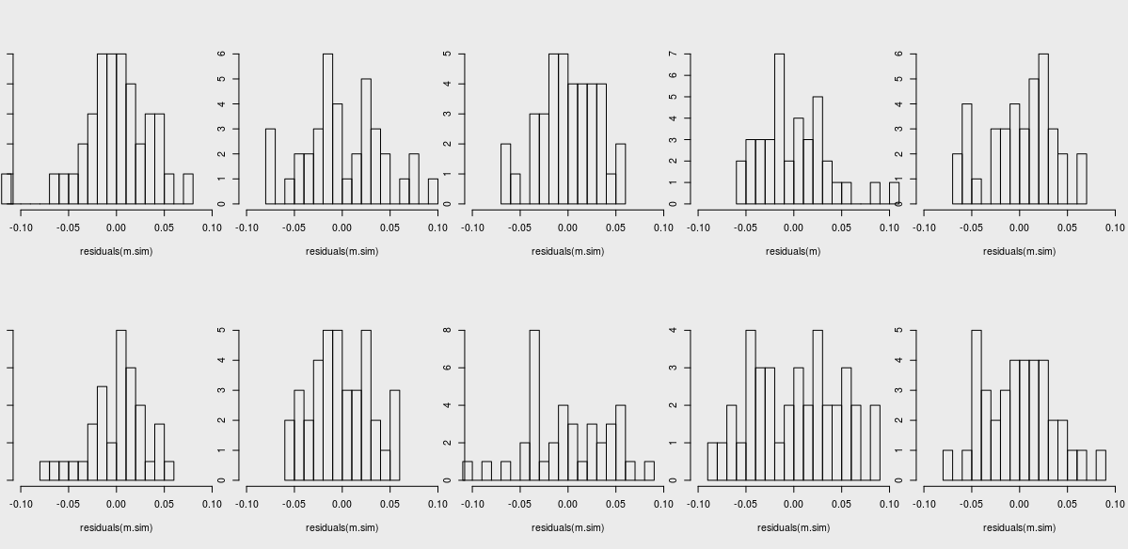

The reader has to guess which plot is the odd one out, and a correct guess shows poor adherence to assumptions. I guessed wrong, so – with N=1- the model does not appear to do to badly. To check your answer, translate the word ‘laugarrena’ from the Basque language.

Residual plots don’t reveal any interesting patterns:

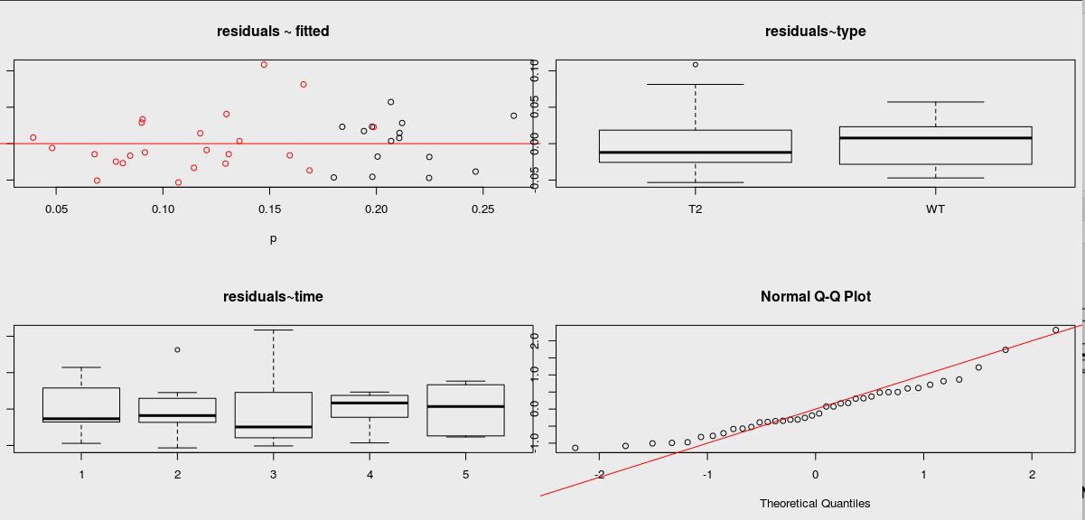
The Q-Q plot, however, shows that the residuals are not on the red line, and they are not normally distributed, particularly towards the extremes. This, I suspect, is because the data is limited to the range [0,1], and the model has no such restriction.

Here we have fitted vs. Observed: The model never fits outside the range [0,1], which is good. This looks pretty good, I think.

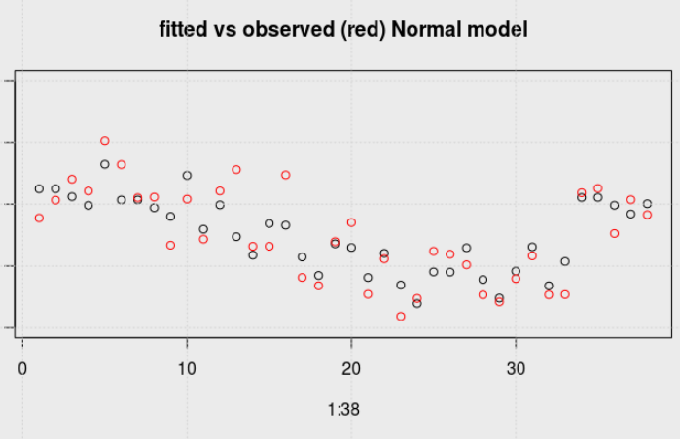
We can also fit a beta-regression model, which has the property that the dependent variable is in the range [0,1].

In R, we fit:

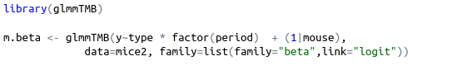

Here are the results:

Here are the coefficients:

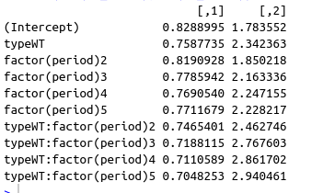

The confidence intervals are now for odds ratios. All include the value 1, so again nothing is significant.

Again, the police lineup method.

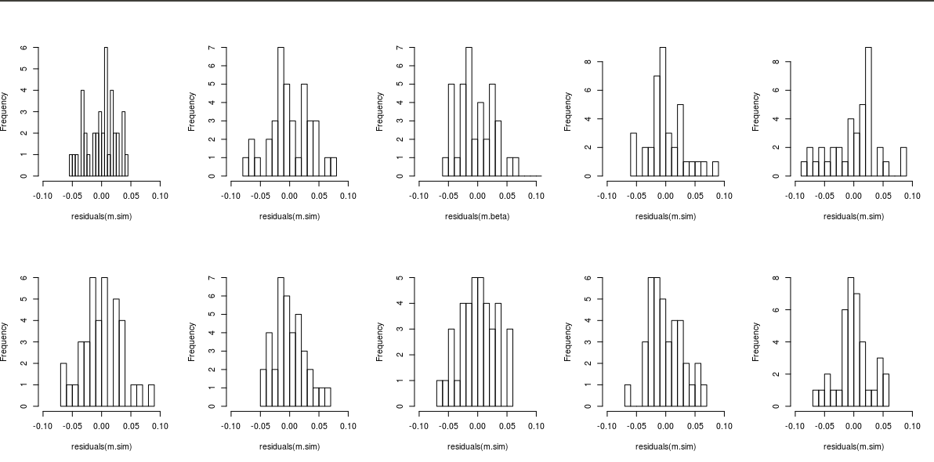

A Basque person would say the he true residuals are in plot hirugarrena.

Here are plots of residuals ~ fitted; residuals ~ type; residuals~ time:

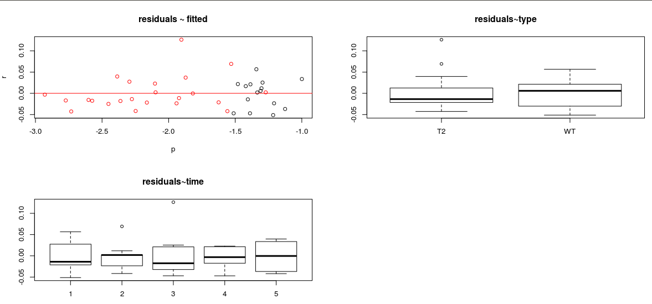

The observed vs. Fitted plot is almost identical to the one we saw for the Normal model.
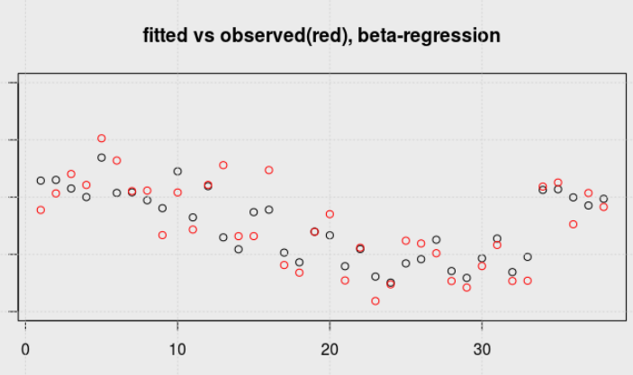

Conclusion

All in all, these models seem to behave very alike, and there is not much to choose from. In conclusion, I would say we have no evidence whatsoever that there is a difference between male WT and Pound mice with respect to this cell type. We don’t even have any evidence that stroke does anything at all to cell type CD19pos_B220.

That is almost identical to the Normal model.

