[Template for weekly studio submission]

Studio

Name and Student Id: KAIQI ZHUANG 25054554

Self-Evaluation {To be highlighted by Student only}:

|  |  |  |  |  |  |
| --- | --- | --- | --- | --- | --- |
| Need Help | Work in Progress | Pass | Credit | Distinction | High Distinction |

Tutor Evaluation {To be highlighted by Tutor only}:

|  |  |  |  |  |  |
| --- | --- | --- | --- | --- | --- |
| Incomplete | Needs improvement | Pass | Credit | Distinction | High Distinction |

Task {1.1}:

Screenshot of “Step 9” in the instructions:

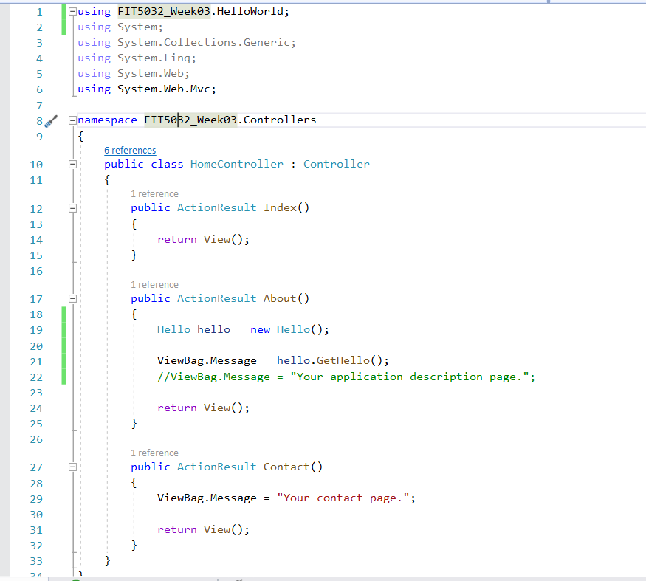

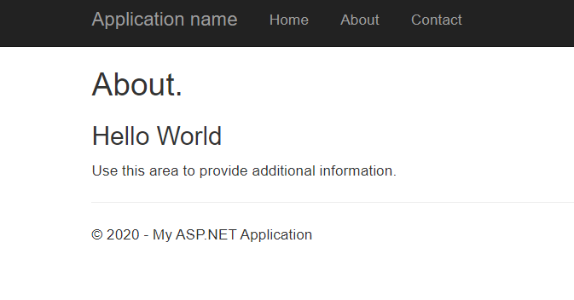

Task {1.2}:

# Declaration

I declare that this eFolio tasks and the linked code are my individual work. I have not copied from any other student’s work or from any other source except where due acknowledgment is made explicitly in the text and code, nor has any part of this submission been written for me by another person.

Signature of student: KAIQI ZHUANG